Algebra 1

Function Analysis
Unit Summary: In this unit, you will graph different types of functions, including piecewise linear functions, quadratic functions, exponential functions, and square root and cube root functions. You will differentiate each of these function types by exploring their key features or properties.
Lesson 2 – Piecewise Linear Functions
Key Words:
- intercept form – the equation of a straight line in the form $y=mx+b$ where m is the slope of the line and b is its y-intercept
- linear function – a mathematical function of the form $y=mx+b$ in which the variables appear only in the first degree, are multiplied by constants, and are combined only by addition and subtraction
- piecewise function – a function that is defined by different sub-functions, where each sub-function applies to a different interval slope
Formulas:
- Linear Function: $$f\left(x\right)=mx+b$$
- Linear Equation: $$y=mx+b$$
- Strict Inequalities: $$< or >$$
- Non-Strict Inequalities: $$≤ or ≥$$
Objective 1: In this section, you will graph piecewise linear functions given equations.
Mathematical Practice Standard: Model with mathematics.
Big Ideas:
- Recall that you have previously graphed linear function in the form $$f\left(x\right)=mx+b$$.
  - Recall that m is the slope and b is the y-intercept.
- Piecewise linear functions are composed of many liner functions, or pieces.
  - Each piece applies to a different interval indicated by an inequality.
- The transition spots from one interval to another often exist when there is a jump in the graph or a change in the slope.
  - These spots indicate that the function is changing from one specified interval to a different one.
- Intervals are determined by the inequalities that define the domain of the line.
Non-Strict Inequalities | Strict Inequalities
$$≤ or ≥$$  Represented by closed circles on the graph. | $$< or >$$  Represented by open circles on the graph.
- Recall the common methods used to graph linear functions:
Example: Graph the piecewise function.
- The first function, $$f\left(x\right)=−x+2$$, is graphed for all x values less than zero ($$x<0$$).
- Notice that there is an open circle on the endpoint of (0,2) because the function is defined for values strictly less than zero, but not including zero.
- The second function, $$f\left(x\right)=x$$, is graphed for all x values greater than or equal to zero ($$x≥0$$).
- Notice that there is a closed circle on the endpoint (0,0), because this function is defined for values greater than or equal to zero, including zero.

Objective 2: In this section, you will write equations of piecewise linear functions from graphs.
Mathematical Practice Standard: Model with mathematics.
Big Ideas:
- Recall how to represent linear equations in slope-intercept form: $$y=mx+b$$
  - m is the slope or rate of change
  - b is the y-intercept or starting point
- Writing a piecewise function given a scenario:
  - 1. Identify the intervals for the piecewise functions. Write the intervals using inequality notation.
  - 2. Identify the function assigned to each interval.
  - 3. Combine the information and write it as one single function using brackets. It is important to include the interval next to each function.
Example: Nuts and More charges different prices for nuts based on how many pounds are purchased. Write a piecewise function that represents the total cost y, in dollars, of purchasing x pounds of walnuts.
- Walnuts cost $3.75 per pound if 0 to 24 pounds are purchased
- $2.50 per pound if more than 24 but less than 50 pounds are purchased
- $2 per pound if 50 or more pounds are purchased
Step 1: Identify the intervals. | - The first interval is 0 to 24 pounds.  - Notice that 0 and 24 are included in this interval.  - $$0≤x≤24$$  - The second interval is more than 24 but less than 50 pounds.  - Notice that 24 and 50 are not included in this interval.  - $$24<x<50$$  - The third interval is 50 or more pounds.  - Notice that 50 is included.  - $$x≥50$$
Step 2: Write the function for each interval. | - Interval 1: $$0≤x≤24$$  - The cost per pound is $3.75.  - Function 1: $$y=3.75x$$  - Interval 2: $$24<x<50$$  - The cost per pound is $2.50.  - Function 2: $$y=2.50x$$  - Interval 3: $$x≥50$$  - The cost per pound is $2.  - Function 3: $$y=2x$$
Step 3: Combine the information and write it as one single function
- Writing a piecewise function given a graph:
  - For each piece:
    - 1. Identify the interval and write as an inequality.
    - 2. Identify the y-intercept (b). Where does the line cross the y-axis?
    - 3. Identify the slope (m). What is the change in y divided by the change in x between two points?
    - 4. Write the equation in slope-intercept form: $$y=mx+b$$.
  - Combine the information and write it as one single function using brackets.
Example: Write a piecewise function represented by the graph.
Function 1 | - Interval: $$x<0$$  - y-intercept: $$b=4$$  - slope: $$m=−2$$  - Equation: $$y=−2x+4$$
Function 2 | - Interval: $$x≥0$$  - y-intercept: $$b=−1$$  - slope: $$m=\frac{1}{2}$$  - Equation: $$y=\frac{1}{2}x−1$$
Piecewise Function

Practice Questions and Answers
 | Question | Answer
P 1 | In the graph of the following piecewise function, which coordinate point will have an open circle?  $$f\left(x\right)=\left\{\begin{aligned}2x+2 if x>4 \\ \frac{1}{2}x+1 if x≤2\end{aligned}\right.$$  (____, ____) | 4; 10
P 2 | Use the image to answer the question.  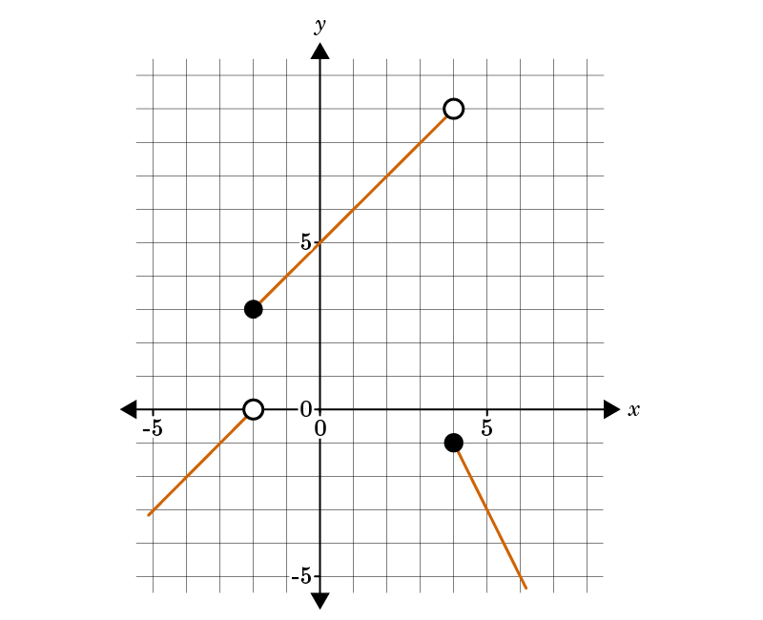  True or false: The graph represents the piecewise function $f\left(x\right)=\left\{\begin{aligned}x+2 if x<-2 \\ 5+x if-2≤x<4 \\ -2x+7 if x≥4\end{aligned}\right.$  Enter 1 for true or 2 for false. | 1
P 3 | Use the image to answer the question.  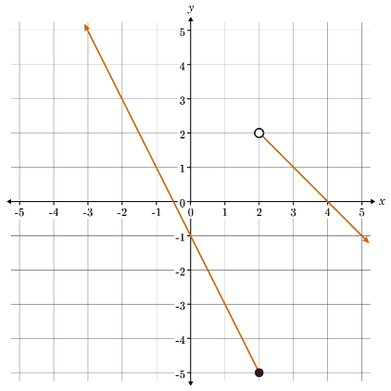  Determine which equations are the piecewise linear functions on the graphs.  Option #1: $f\left(x\right)=\left\{\begin{aligned}-2x-1, x≤2 \\ -x+4, x>2\end{aligned}\right.$  Option #2: $f\left(x\right)=\left\{\begin{aligned}2x-1, x≥2 \\ x+4, x<2\end{aligned}\right.$  Option #_____ is the correct piecewise function. | 1
P 4 | Use the image to answer the question.  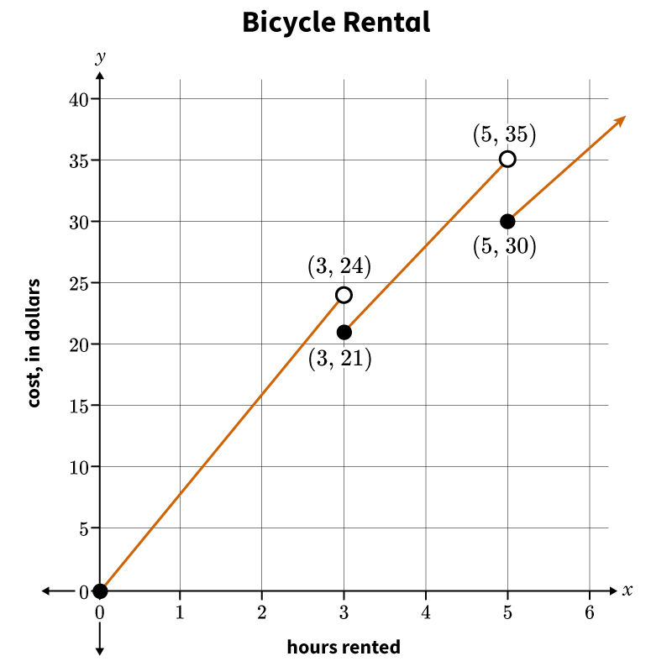  Choose the equation of the piecewise function shown in the graph. x represents the number of hours a bicycle is rented, and y represents the cost in dollars.  Option #1: $y=\left\{\begin{aligned}8x, 0≤x≤3 \\ 7x, 3<x<5 \\ 6x, x≥5\end{aligned}\right.$  Option #2: $y=\left\{\begin{aligned}8x, 0≤x<3 \\ 7x, 3≤x≤5 \\ 6x, x>5\end{aligned}\right.$  Option #3: $y=\left\{\begin{aligned}8x, 0≤x<3 \\ 7x, 3≤x<5 \\ 6x, x≥5\end{aligned}\right.$  Option #___ best describes the piecewise function. | 3
P 5 | Use the image to answer the question.  Determine the graph's correct piecewise function.  Option #1: $f\left(x\right)=\left\{\begin{aligned}2x+1, x>1 \\ -x+3, x<1\end{aligned}\right.$  Option #2: $f\left(x\right)=\left\{\begin{aligned}2x+1, x>1 \\ -x+3, x≤1\end{aligned}\right.$  Option #3: $f\left(x\right)=\left\{\begin{aligned}-2x+1, x>1 \\ x+3, x≤1\end{aligned}\right.$  Option #___ is the graph’s correct piecewise function. | 2

Quick Check Questions and Answers
 | Question | Answer
Q 1 | Graph the piecewise function $f\left(x\right)=\left\{\begin{aligned}x+5 if x≤-2 \\ 2x+3 if x>-2\end{aligned}\right.$. Will the graph have any open endpoints? If yes, where? | Yes, at (-2, -1).
Q 2 | Use the image to answer the question.  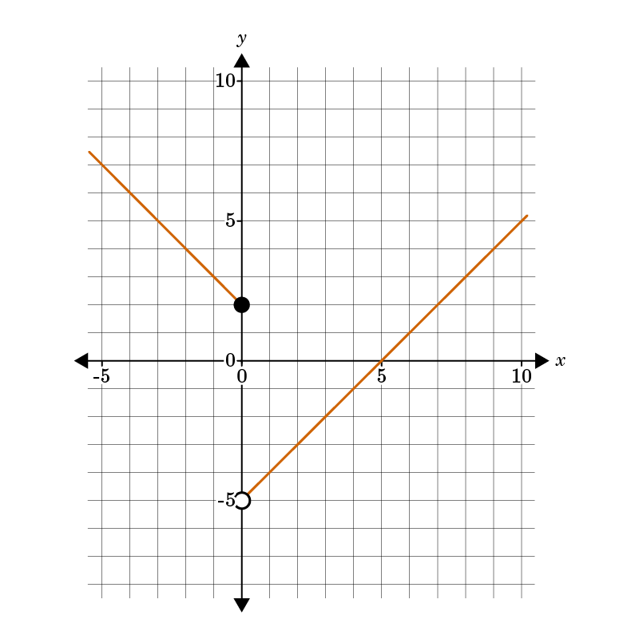  Which of the following piecewise functions matches the graph? | $$f\left(x\right)=\left\{\begin{aligned}2-x if x≤0 \\ x-5 if x>0\end{aligned}\right.$$
Q 3 | In order to write the equation for a piecewise linear function shown on a graph, what do you need to determine? | the equation of each linear segment and the interval for which it is applied
Q 4 | Use the image to answer the question.  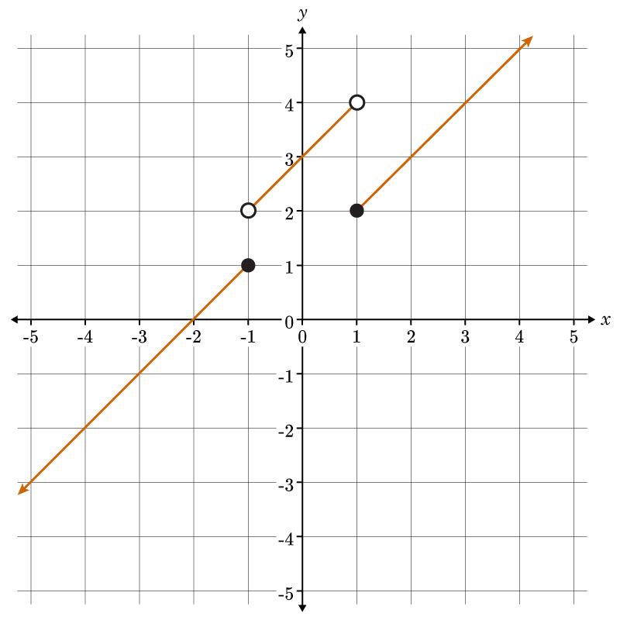  Select the equation of the piecewise function shown in the graph. | $$y=\left\{\begin{aligned}x+2, x≤-1 \\ x+3, -1<x<1 \\ x+1, x≥1\end{aligned}\right.$$
Q 5 | Use the image to answer the question.  Choose the correct piecewise function. | $$y=\left\{\begin{aligned}-2, x<0 \\ 3, x≥0\end{aligned}\right.$$

Lesson 3 – Quadratic Functions in the Vertex Form
Key Words:
- axis of symmetry of a parabola – the straight line that divides a parabola into two identical parts
- parabola – a curve where any point is equidistant from a fixed point (the focus) and a fixed straight line (the directrix); the focus may not lie on the directrix
- quadratic equation – any equation containing one term in which the unknown is squared and no term in which it is raised to a higher power
- vertex form – a way of writing a quadratic equation in which the coordinate points of the vertex are easily identifiable
- vertex of a parabola – the highest or lowest point of a parabola that crosses its axis of symmetry
Formulas:
- Vertex Form of a Quadratic Equation: $$y=a{\left(x−h\right)}^{2}+k$$
  - Vertex: $$\left(h,k\right)$$
  - Axis of Symmetry: $$x=h$$
Objective 1: In this section, you will graph quadratics given in vertex form.
Mathematical Practice Standard: Model with mathematics.
Big Ideas:
- Quadratic equations given in vertex form are helpful when finding key characteristics of a quadratic equation.
Vertex Form of a Quadratic Equation
$$y=a{\left(x−h\right)}^{2}+k$$
Finding the Vertex  $$\left(h,k\right)$$  - The vertex, or turnaround point is $$\left(h,k\right)$$.  - The sign in front of h, whether positive or negative, will always be flipped when writing the vertex.  - The sign in front of k will always be the same. | Finding the Axis of Symmetry  $$x=h$$  - After finding the vertex, you can identify the axis of symmetry, $$x=h$$.  - The axis of symmetry is the vertical line that cuts through the vertex, cutting the parabola in half.
Example: Given the equation $$y=−4{\left(x−8\right)}^{2}−1$$, identify the vertex and axis of symmetry.
- Find h. Recall that you will flip the sign of h. $$h=8$$
- Find k. Recall that the sign of k does not change. $$k=−1$$
- Vertex: $$\left(h,k\right)→\left(8,−1\right)$$
- Axis of Symmetry: $$x=h→x=8$$
- Review the steps to identify the key characteristics and graph a quadratic equation in vertex form:
  - 1. Identify the vertex $$\left(h,k\right)$$.
  - 2. Identify the axis of symmetry, $$x=h$$.
  - 3. Identify a point to the left and right of the axis of symmetry.
    - Do this by choosing an x-value to the right of the axis of symmetry.
    - Find its corresponding y-value by substituting x into the given equation.
    - Reflect that point over the axis of symmetry.
  - 4. Connect the three points to form a U-shaped parabola.
Example: Graph the quadratic equation $$y={\left(x+2\right)}^{2}+4$$ given in vertex form.
Step 1: Determine the vertex. | - From the equation, identify the values of h and k.  - $$h=−2$$, $$k=4$$  - Vertex: $$\left(−2,4\right)$$
Step 2: Determine the axis of symmetry. | - Use the h-value from the vertex.  - Axis of Symmetry: $$x=−2$$
Step 3: Graph what you have so far.
Step 4: Identify a point to the left and right of the axis of symmetry. | - Pick any point to the right of the axis of symmetry.  - Choose $$x=−1$$, one unit to the right of the axis.  - Find the corresponding y-value by substituting the x-value into the equation.  - The y-value is 5.  - A point to the right of the axis of symmetry is $$\left(−1,5\right)$$.  - Reflect that point over the axis of symmetry.  - Since the point $$\left(−1,5\right)$$ is one unit to the right of the axis, plot a point one unit to the left of the axis.  - The point is $$\left(−3,5\right)$$.
Step 5: Plot the points from Step 4 and connect the points with a curve.

Objective 2: In this section, you will write equations of quadratics in vertex form given a graph.
Mathematical Practice Standard: Model with mathematics.
Big Ideas:
- Recall the vertex form of a quadratic function.
  - $$y=a{\left(x−h\right)}^{2}+k$$
  - $$\left(h,k\right)$$ represents the vertex
  - $$x=h$$represents the axis of symmetry
  - The value of a represents how narrow or wide the parabola is, or if it opens up or down.
    - -a values: the parabola opens downward
    - +a values: the parabola opens upward
- Now you will learn to write a quadratic equation in vertex form given a graph by following these steps:
  - 1. Identify the vertex from the graph and get the values for h and k.
  - 2. Choose any point on the parabola, other than the vertex, and get the values for x and y.
  - 3. Plug the values for h, k, x and y coordinates into the variables of the equation $$y=a{\left(x−h\right)}^{2}+k$$.
  - 4. Solve for the variable that is left, which will be a.
  - 4. Plug a, h, and k back into the vertex form of the equation.
Example: Write the quadratic equation in vertex form that represents the quadratic below.
Step 1: Identify the vertex and values for h and k. | The vertex is (1,3). Therefore, $$h=1$$and $$k=3$$.
Step 2: Identify another point on the parabola and values for x and y. | Another point on this parabola is (0,6). Using this point, $$x=0$$ and $$y=6$$.
Step 3: Plug the values for h, k, x and y coordinates into the variables of the equation. | $$y=a{\left(x−h\right)}^{2}+k$$  $$h=1, k=3, x=0, y=6$$  $$6=a{\left(0−1\right)}^{2}+3$$
Step 4: Solve for a.
Step 5: Plug a, h, and k back into the vertex form of the equation. | $$y=a{\left(x−h\right)}^{2}+k$$  $$a=3, h=1, k=3$$  $$y=3{\left(x−1\right)}^{2}+3$$
Step 6: State the answer. | The quadratic equation for the given graph is $$y=3{\left(x−1\right)}^{2}+3$$.

Practice Questions and Answers
 | Question | Answer
P 1 | Use the image to answer the question.  What is the vertex form of the graphed equation?  $$y={(x-__)}^{2}+___$$ | 2; -14
P 2 | Use the image to answer the question.  What is the vertex form of the graphed equation?  $$y={(x-__)}^{2}+___$$ | -2; -8
P 3 | What is the equation for the axis of symmetry on the parabola created by $y=3{\left(x-1\right)}^{2}-12$  x = ____ | 1
P 4 | Use the image to answer the question.  In vertex form, write the equation for the quadratic function shown on the graph.  $$y=3{(x- )}^{2}+ _____$$ | 1; 3
P 5 | Use the image to answer the question.  Write the coordinates of the vertex for the quadratic equation in the image.  (____, ____) | 2; 3

Quick Check Questions and Answers
 | Question | Answer
Q 1 | Graph the equation $y=-5{(x)}^{2}+1$. Which of the following statements about the graph is correct? | The parabola will open downwards.
Q 2 | Use the image to answer the question.  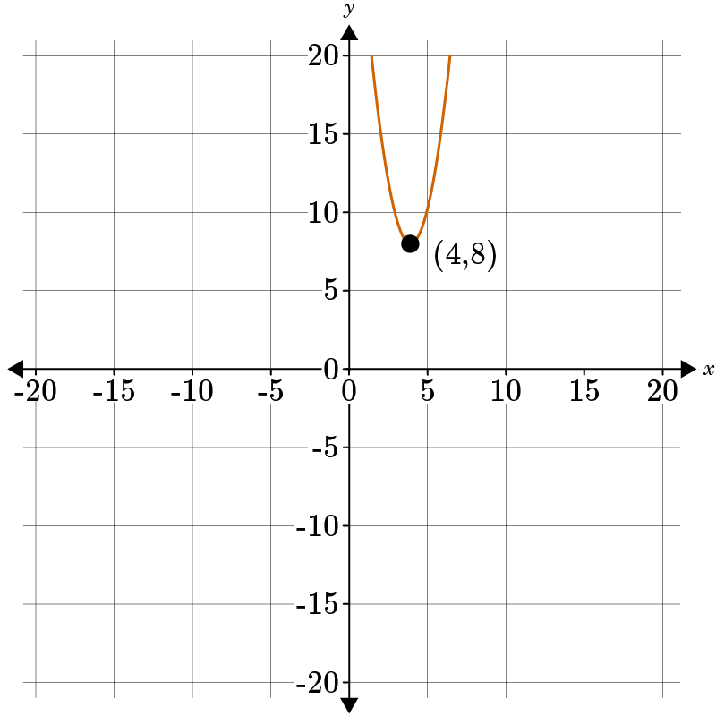  What is the vertex form of the graphed equation? | $$y=2{\left(x-4\right)}^{2}+8$$
Q 3 | Use the image to answer the question.  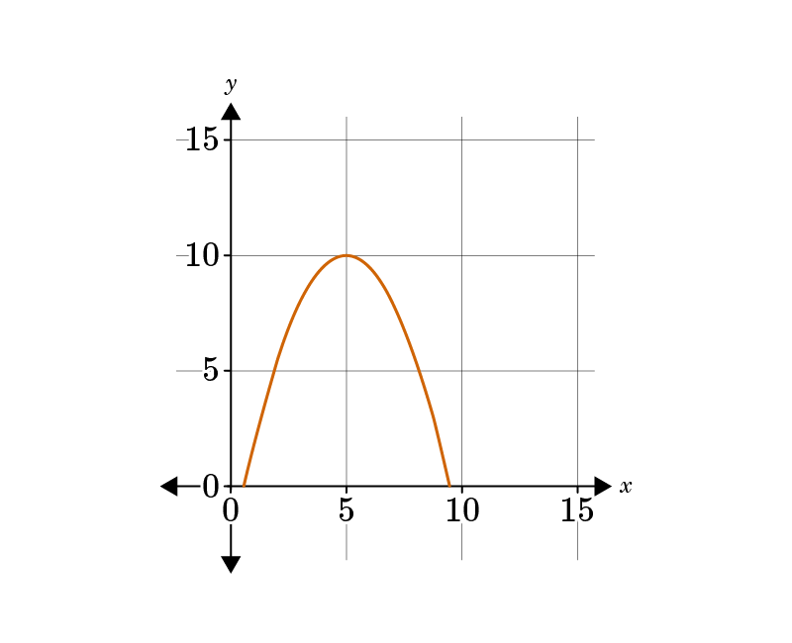  The graph shows the trajectory of a firework. Which equation in vertex form matches this graph? | $$y=-\frac{1}{2}{\left(x-5\right)}^{2}+10$$
Q 4 | Use the image to answer the question.  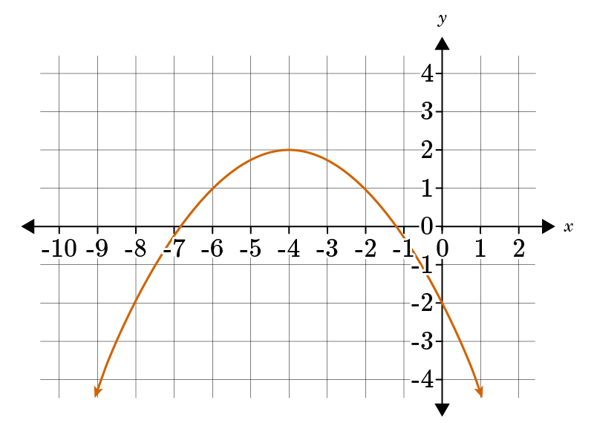  Which response is the correct way to write the equation in vertex form for the function? | $$y=-\frac{1}{4}{\left(x+4\right)}^{2}+2$$
Q 5 | Use the image to answer the question.  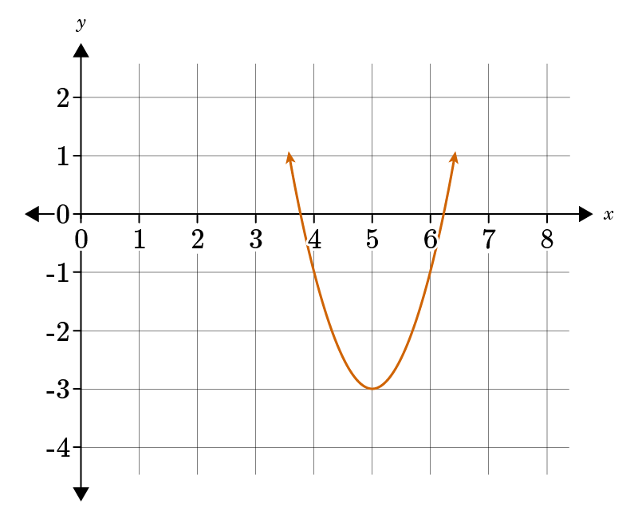  What is the equation for the function in the graph? | $$y=2{(x-5)}^{2}-3$$

Lesson 4 – Quadratic Functions in Standard Form
Key Words:
- axis of symmetry of a parabola – the straight line that divides a parabola into two identical parts
- parabola – a curve where any point is equidistant from a fixed point (the focus) and a fixed straight line (the directrix); the focus may not lie on the directrix
- quadratic equation – any equation containing one term in which the unknown is squared and no term in which it is raised to a higher power
- standard form of a quadratic equation – a form in which a quadratic equation is written as $ax^{2}+bx+c=0$, where $a≠0$
- vertex of a parabola – the highest or lowest point of a parabola that crosses its axis of symmetry
Formulas:
- Standard Form of a Quadratic Function: $$f\left(x\right)=ax^{2}+bx+c$$
- Standard Form of a Quadratic Equation: $$y=ax^{2}+bx+c$$
- Vertex Form of a Quadratic Equation: $$y=a{\left(x−h\right)}^{2}+k$$
- Vertex Formula: $$x=−\frac{b}{2a}$$
Objective 1: In this section, you will graph quadratic functions given in standard form.
Mathematical Practice Standard: Model with mathematics.
Big Ideas:
- A quadratic function is a function that has the highest exponent of two, written in standard form.
- Quadratic functions are also referred to as parabolas, which describes the U-shape of a quadratic.
Quadratic Function in Standard Form
$$f\left(x\right)=ax^{2}+bx+c$$
Where a, b, and c are real numbers and $$a≠0$$.
- In this form, you cannot directly identify the vertex, so you will use a formula instead.
Identifying the Vertex from Standard From
Formula: $$x=−\frac{b}{2a}$$
Where b and a are values taken from the quadratic equation in standard form: $$y=ax^{2}+bx+c$$

- Use the formula to solve for the x-coordinate of the vertex.
- Substitute the x-value back into the original equation to find the corresponding y-coordinate.

Example: Find the vertex of the quadratic $$y=x^{2}−4x−5$$.
Step 1: Identify the values of b and a from the given equation. | $$y=x^{2}−4x−5$$  $$a=1, b=−4$$
Step 2: Use the vertex formula to find the x-coordinate of the vertex. | $$x=−\frac{b}{2a}$$  $$x=−\frac{\left(−4\right)}{2\left(1\right)}=\frac{4}{2}=2$$  The x-coordinate of the vertex is 2.
Step 3: Substitute the x-coordinate into the original equation to find the y-coordinate of the vertex. | The y-coordinate of the vertex is –9.
Step 4: Write the vertex. | The vertex of the given quadratic is (2,-9).
- Review the steps for graphing a quadratic in standard form.
  - 1. Find the vertex using the vertex formula and steps.
  - 2. Plot the vertex.
  - 3. Identify a point to the left and right of the axis of symmetry.
    - Do this by choosing an x-value to the right of the axis of symmetry.
    - Find its corresponding y-value by substituting x into the given equation.
    - Reflect that point over the axis of symmetry.
  - 4. Connect the three points to form a U-shaped parabola.
Example: Graph the quadratic $$y=−x^{2}+6x−4$$.
Step 1: Find the vertex. | - Identify the b and a values from $$y=−x^{2}+6x−4$$.  - Use the vertex formula to find the x-coordinate of the vertex.  - $$x=−\frac{b}{2a}=−\frac{6}{2\left(−1\right)}=\frac{−6}{−2}=3$$  - The x-coordinate is 3.  - Substitute the value of x into the original equation to find the y-coordinate of the vertex.  - The y-coordinate is 5.  - The verted is $$\left(3,5\right)$$.
Step 2: Find the axis of symmetry. | - Recall that the axis of symmetry is the x-value, or h, from the vertex.  - Axis of symmetry: $$x=3$$
Step 3: Plot the vertex and axis of symmetry.
Step 4: Identify points to the left and right of the axis of symmetry. | - Pick any point to the right of the axis of symmetry.  - Choose $$x=2$$, one unit to the left of the axis.  - Find the corresponding y-value by substituting the x-value into the equation.  - The y-value is 4.  - A point to the left of the axis of symmetry is (2,4).  - Reflect that point over the axis of symmetry.  - Since the point (2,4) is one unit to the left of the axis, plot a point one unit to the right of the axis.  - The point is (4,4).
Step 5: Plot the two points found in step 4 and connect the them with the vertex in a U-shape.

Objective 2: In this section, you will write quadratic equations in standard form given a graph.
Mathematical Practice Standard: Model with mathematics.
Big Ideas:
- Recall the vertex form of a quadratic.
  - Vertex Form: $$y=a{\left(x−h\right)}^{2}+k$$, where $$\left(h,k\right)$$ is the vertex.
- When given a graph of a quadratic, it is easiest to write the equation of the quadratic in vertex form and then convert the equation to standard form using polynomial operations or factoring.
  - Standard Form: $$y=ax^{2}+bx+c$$
- Review the steps for writing a quadratic in standard form given a graph.
  - 1. Identify the vertex of the parabola, (h, k), and the values for h and k.
  - 2. Choose any point, other than the vertex, and identify an x and y value.
  - 3. Substitute the values for h, k, x, and y into the vertex form of a quadratic equation: $$y=a{\left(x−h\right)}^{2}+k$$. Solve for a, the leftover variable.
  - 4. Substitute the values for a, h, and k back into the vertex form.
  - 5. Convert from vertex form to standard form.
Example: Write an equation in standard form for the quadratic graphed below.
Step 1: Identify the vertex of the parabola, (h, k), and the values for h and k. | - The vertex, (h, k), is at (-1, -3).  - $$h=−1, k=−3$$
Step 2: Choose any point, other than the vertex, and identify an x and y value. | - Another point on the parabola is (0, -4).  - $$x=0, y=−4$$
Step 3: Substitute the values for h, k, x, and y into the vertex form of a quadratic equation. Solve for a. | - Substitute the values for h, k, x, and y into $$y=a{\left(x−h\right)}^{2}+k$$ and solve for a.
Step 4: Substitute the values for a, h, and k back into the vertex form. | - $$y=a{\left(x−h\right)}^{2}+k$$  - $$a=−1, h=−1, k=−3$$  The vertex form of the graphed quadratic is $$y=−{\left(x+1\right)}^{2}−3$$.
Step 5: Convert from vertex form to standard form.
Step 6: State the answer. | The standard form of the quadratic is $$y=−x^{2}−2x−4$$.

Practice Questions and Answers
 | Question | Answer
P 1 | Graph the quadratic $y=x^{2}+2x+4$. What is the axis of symmetry? | -1
P 2 | Graph the quadratic $y=x^{2}+2x+4$. What is the y-value of the y-intercept? | 4
P 3 | Convert the quadratic $y = 2{(x-5)}^{2} - 10$ from vertex form to standard form.  The standard form of the quadratic is $y= x^{2}+ x+ .$ | 2; -20; 40
P 4 | Use the image to answer the question.  Write the equation of the quadratic function in the graph in standard form.  The standard form of the quadratic is $y= x^{2}+ x+ .$ | 1; -6; 8
P 5 | Use the image to answer the question.  Write the equation of the quadratic function in the graph in standard form.  The standard form of the quadratic is $y= x^{2}+ x+ .$ | -1; -4; 1

Quick Check Questions and Answers
 | Question | Answer
Q 1 | Graph the quadratic $y=4x^{2}+3x-8$. What is the vertex of this quadratic? | (-0.375, -8.563)
Q 2 | Graph the quadratic $y=x^{2}+3x+8$. What is the x-intercept(s)? | There is no x-intercept.
Q 3 | Use the image to answer the question.  Determine whether the a-value is positive or negative. Provide an appropriate reason. | The a-value is negative because the graph is of a parabola that opens down.
Q 4 | Use the image to answer the question.  Which of the following is true based on the graph of the quadratic? | The c-value of the equation in standard form is −1.
Q 5 | Convert the equation from vertex form to standard form $y=-4{(x+5)}^{2}-3$. | $$y=-4x^{2}-40x-103$$

Lesson 5 – Exponential Functions
Key Words:
- exponential function – a function where x is a variable and a is a constant in the form $$f\left(x\right)=a⋅b^{x}$$
- asymptote – a line that the curve of a graph seems to approach, but never actually reaches; can be a vertical line or a horizontal line
- y-intercept – the y-coordinate of a point where a line, curve, or surface intersects the y-axis
Formulas:
- Exponential Function: $$f\left(x\right)=a⋅b^{x}$$
- Exponential Equation: $$y=a⋅b^{x}$$
- Negative Exponent Rule: $$x^{−a}=\frac{1}{x^{a}}$$
- Zero Exponent Rule: $$x^{0}=1$$
- Identity Exponent Rule: $$x^{1}=x$$
- Division Rule of Exponents: $$\frac{x^{a}}{x^{b}}=x^{a−b}$$
Objective 1: In this section, you will graph exponential functions given equations.
Mathematical Practice Standard: Model with mathematics.
Big Ideas:
- Recall the characteristics of exponential functions.
Format | Exponential Functions
Table | y-values have a constant multiplier or common ratio  Example: The x-values increase by 1 while the y-values are multiplied by 2.
  x | 4 | 5 | 6 | 7
  y | 2 | 4 | 8 | 16
Graph | Curve approaching an asymptote  Example:
Equation | Can be written in the form $$y=a⋅b^{x}$$  - a = initial value  - b = multiplier/growth or decay rate  - Growth: $$b=1+r$$  - Decay: $$b=1−r$$  - Where r is the % rate of growth or decay
- Exponential functions can increase or decrease exponentially.
Increasing Exponentially | Decreasing Exponentially
- Occurs when the multiplier b, in an exponential function, $$y=a⋅b^{x}$$ is greater than 1. | - Occurs when the leading coefficient a in an exponential function, $$y=a⋅b^{x}$$, is negative, or when the multiplier b is between 0 and 1.  - For example: $$y=−3{\left(2\right)}^{x}$$ and $$y=3{\left(\frac{1}{2}\right)}^{x}$$
- To graph an exponential function, follow these steps:
  - 1. Make a table of values by evaluating the function at different x-values.
    - Common x-values to use when creating a table are x = -2, -1, 0, 1, 2
  - 2. Plot the points.
  - 3. Connect the points with a smooth curve. Be sure to identify the asymptote.
- When evaluating exponential functions, keep these exponent rules in mind.
Exponent Rules

Example: Graph the exponential function $$y=3{\left(2\right)}^{x}$$.
Step 1: Make a table of values by evaluating the function at different x-values. | - Create a table by plugging in each x-value into the equation $$y=3{\left(2\right)}^{x}$$.
  x | y | Coordinate
  -2 | $$y=3{\left(2\right)}^{−2}=0.75$$ | $$\left(−2,0.75\right)$$
  -1 | $$y=3{\left(2\right)}^{−1}=1.5$$ | $$\left(−1,1.5\right)$$
  0 | $$y=3{\left(2\right)}^{0}=3$$ | $$\left(0,3\right)$$
  1 | $$y=3{\left(2\right)}^{1}=6$$ | $$\left(1,6\right)$$
  2 | $$y=3{\left(2\right)}^{2}=12$$ | $$\left(2,12\right)$$
Step 2: Plot the points. Connect the points with a smooth curve.
Step 3: Connect the points with a smooth curve. Be sure to identify the asymptote. | Notice that the curve is approaching the horizontal line $$y=0$$but never touches it. Therefore, $$y=0$$is an asymptote.

Objective 2: In this section, you will write equations for exponential functions given a graph.
Mathematical Practice Standard: Model with mathematics.
Big Ideas:
- Recall the equation for an exponential function.
- Recall the rules for exponents.
- To write an exponential function in the form $$y=a⋅b^{x}$$, both constants a and b must be known.
- Sometime, the exponential function to graph is not given. Only information about the function or a graph of the function is provided.
- Follow these steps to solve for the constants a and b when given a graph:
  - 1. Pick two points on the curve.
    - If possible, pick the y-intercept point, or the point (0,a) that intersects the y-axis.
    - If no y-intercept is given, choose another point.
  - 2. Substitute one chosen point into the equation and solve for a.
  - 3. Substitute the other chosen point, x and y, and the value of a, back into the equation. Solve for b.
  - 4. Substitute the value of b back into the equation from step 2 to solve for a.
  - 5. Substitute the values of a and b into the equation $$y=a⋅b^{x}$$.
Example: The graph represents the rising cost of a gallon of milk x years since 2020. In 2021, a gallon of milk cost $3. In 2022, a gallon of milk cost $4.50. Write an exponential equation to represent the cost of milk (y) x years after 2020.
Step 1: Pick two points on the curve. | Since the y-intercept is not given, we will choose two other points on the curve.  - First point: (2, 4.5)  - Second point: (1, 3)
Step 2: Substitute one chosen point into the equation and solve for a.
Step 3: Substitute the other chosen point, x and y, and the value of a, back into the equation. Solve for b. | $$y=a⋅b^{x}$$
Step 4: Substitute the value of b back into the equation from step 2 to solve for a.
Step 5: Substitute the values of a and b into the equation $$y=a⋅b^{x}$$. | $$y=a⋅b^{x}$$  $$y=2{\left(1.5\right)}^{x}$$

Practice Questions and Answers
 | Question | Answer
P 1 | Graph the function $y=3{(5)}^{2}$. What is the y-value if $x=-6$?  (-6, _____) | 0.000192
P 2 | Graph the function $y=\frac{1}{5}{(2)}^{x}$. What is the y-intercept?  (0, _____) | 0.2
P 3 | Use the image to answer the question.  Which option is the correct exponential equation for the graph?  Option #1: $y={2(3)}^{x}$  Option #2: $y={-2(3)}^{x}$  Option #3: $y={3(2)}^{x}$  Option #4: $y={3(6)}^{x}$  Option #____ is the correct equation for the graph. | 3
P 4 | Use the image to answer the question.  Given the graph of the exponential equation that goes through the points (0,6) and (1,3), which option is the correct exponential equation for the graph?  Option #1: $y={6(\frac{1}{2})}^{x}$  Option #2: $y={6(2)}^{x}$  Option #3: $y={-2(6)}^{x}$  Option #4: $y={-6(\frac{1}{2})}^{x}$  Option #___ is the correct equation for the graph. | 1
P 5 | Use the image to answer the question.  Given the graph of the exponential equation, which option is the correct exponential equation for the graph?  Option #1: $y={6(\frac{1}{3})}^{x}$  Option #2: $y={18(\frac{1}{3})}^{x}$  Option #3: $y={6(3)}^{x}$  Option #4: $y={18(3)}^{x}$  Option #____ is the correct equation for the graph. | 2

Quick Check Questions and Answers
 | Question | Answer
Q 1 | Graph the exponential function $y=0.5{(6)}^{x}$. Identify the y-intercept. | 0.5
Q 2 | Graph the function $y=5{(14)}^{x}$. Complete the ordered pairs for the x-values of −2, −1, 0, and 1 by finding the y-values. | (−2,80), (−1,20), (0,5), and (1,1.25)
Q 3 | Use the image to answer the question.  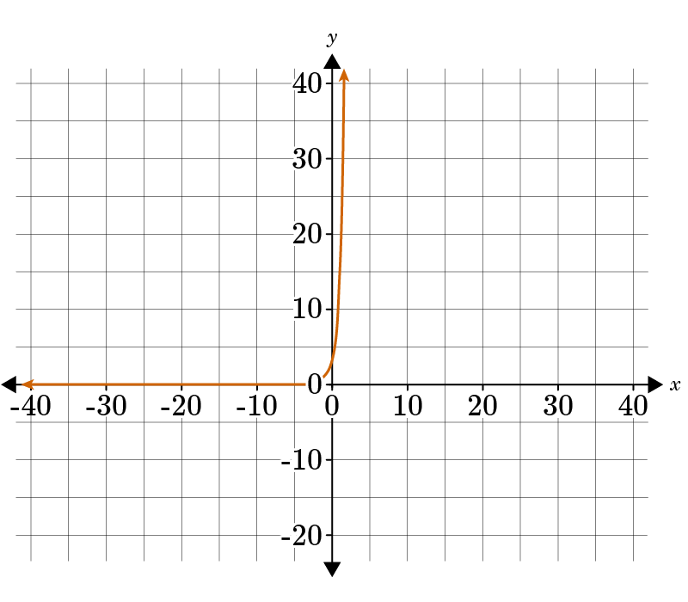  Which equation is modeled by the graph? | $$y=3.5{(4)}^{x}$$
Q 4 | Use the image to answer the question.  Given the graph of the exponential equation, write the correct exponential equation for the graph. | $$y={3\left(\frac{3}{2}\right)}^{x}$$
Q 5 | Use the image to answer the question.  Given the graph of the exponential equation representing the value of a car since purchase, which option is the correct exponential equation for the graph if the graph goes through the points (0, 30000) and (1, 22500)? | $$y={30,000\left(\frac{3}{4}\right)}^{x}$$

Lesson 6 – Square Root Functions
Key Words:
- domain – the set of all possible inputs (x-values) of a function
- function – an expression, rule, or law that defines a relationship between the independent variable and the dependent variable
- inverse operation – an operation (such as subtraction) that undoes the effect of another operation
- parabola – a curve where any point is equidistant from a fixed point (the focus) and a fixed straight line (the directrix); the focus may not lie on the directrix
- quadratic equation – any equation containing one term in which the unknown is squared and no term that is raised to a higher power
- range – the difference between the lowest and highest values
- square root – a factor of a number that when squared gives the number; for example, the square root of 9 is ±3
- square root function – a function that contains a square root with the independent variable under the square root
Objective 1: In this section, you will graph square root functions given equations.
Mathematical Practice Standard: Model with mathematics.
Big Ideas:
- The square root of a non-negative number is the inverse operation.
  - An inverse operation is one that reverses or undoes another operation.
  - For example, $$\sqrt{x^{2}}=x$$, and, similarly, $${\left(\sqrt{x}\right)}^{2}=x$$ for non-negative x.
- The graph of a square root function resembles half of the parabola of a quadratic function.
  - The negative values under a square root do not result in real numbers and are therefore excluded from the graph.
- Square root functions can be graphed like any other function:
  - Create a table of x- and y-values, plot them, and then connect the points.
  - The x-values used as inputs cannot produce a negative under the square root.
Example: Graph the square root function $$y=−2\sqrt{x−1}+3$$.
Step 1: Create a table to generate values for the square root function. | x must be greater than 0 to avoid a negative number under the square root. So, you will start the table with x = 1.
  x | y | Coordinate
  1 | $$y=−2\sqrt{1−1}+3=3$$ | (1, 3)
  2 | $$y=−2\sqrt{2−1}+3=1$$ | (2, 1)
  3 | $$y=−2\sqrt{3−1}+3=0.17$$ | (3, 0.17)
  4 | $$y=−2\sqrt{4−1}+3=−0.46$$ | (4, -0.46)
  5 | $$y=−2\sqrt{5−1}+3=−1$$ | (5, -1)
Step 2: Plot and connect the points.

Objective 2: In this section, you will identify key features of square root functions from graphs and compare them with related quadratic functions.
Mathematical Practice Standard: Model with mathematics.
Big Ideas:
- Square root functions are similar to a quadratic function. The square root function is one half of a parabola and laid on its side, where the quadratic function is a full parabola and upright.
Compare a Square Root Function and its Related Quadratic Function
$$f\left(x\right)=x^{2}$$ and $$f\left(x\right)=\sqrt{x}$$ are related functions.
- Algebraic steps can be used to identify the quadratic function that is related to a square root function.
  - 1. Interchange the variables x and y in the equation.
  - 2. Solve the new equation for y.
- By modeling the graph of a given square root function, you can identify the domain, range, and related quadratic function.
Example: Identify the key features of $$g\left(x\right)=\sqrt{x−7}+3$$ and find the related quadratic function.
Step 1: Model the function with a graph.
Step 2: Identify the minimum or maximum of the function. | The function has a minimum at (7,3).
Step 3: Use the minimum to identify the domain and range. | Domain:  - The x-value of the minimum is 7.  - The domain is all x-values greater than or equal to 7.  - $$x≥7$$or $$\left[7,∞\right)$$  Range:  - The y-value of the minimum is 3.  - The range is all y-values greater than or equal to 3.  - $$y≥3$$or $$\left[3,∞\right)$$
Step 4: Find a related quadratic function. | - Adjust the given function to be an equation.  - $$g\left(x\right)=\sqrt{x−7}+3 → y=\sqrt{x−7}+3$$  - Interchange the x and y values of the given function.  - $$y=\sqrt{x−7}+3 → x=\sqrt{y−7}+3$$  - Solve the new equation for y.  - $$x=\sqrt{y−7}+3$$  - $$x−3=\sqrt{y−7}$$  - $${\left(x−3\right)}^{2}={\left(\sqrt{y−7}\right)}^{2}$$  - Use inverse operations. Square each side to undo the square root.  - $${\left(x−3\right)}^{2}=y−7$$  - $${\left(x−3\right)}^{2}+7=y$$  - The related quadratic function is $$y={\left(x−3\right)}^{2}+7$$
Step 5: State the answer. | The related quadratic function is $$y={\left(x−3\right)}^{2}+7$$ or $$f\left(x\right)={\left(x−3\right)}^{2}+7$$ .

Practice Questions and Answers
 | Question | Answer
P 1 | Use the image to answer the question.  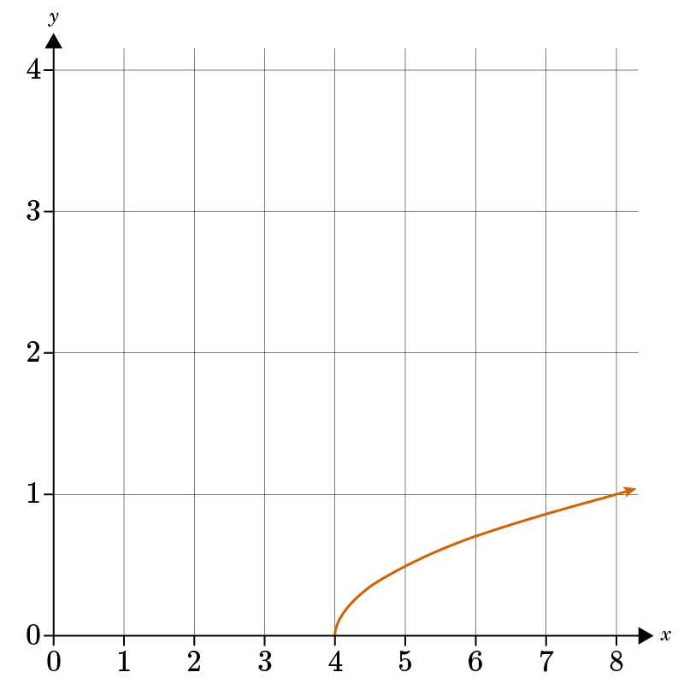  Jonathan graphed a square root function. What is the equation of the function Jonathan graphed?  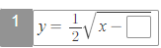 | $$y=\frac{1}{2}\sqrt{x-4}$$
P 2 | To graph the square root function $y=\frac{1}{3}\sqrt{x-3}+2,$ complete the table of data points for the function.  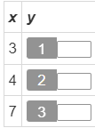 | 2; 2 $\frac{1}{3}$; 2 $\frac{2}{3}$
P 3 | In the graph of the square root function $y=3\sqrt{x-7}+2$, what are the coordinates of the point farthest to the left?  The x-coordinate is ___.  The y-coordinate is ___. | 7; 2
P 4 | Find the related square root function, $p(x)$, for the quadratic equation $h(x)=4x^{2}$ with the domain of (0,∞).  $p\left(x\right)=\sqrt{ax}$ where a = _____ | $$\frac{1}{4}$$
P 5 | Use the image to answer the question.  Consider the quadratic function that represents the inverse of the graphed square root function. What would be the vertex of the related quadratic function?  (___, ___) | 3; 7

Quick Check Questions and Answers
 | Question | Answer
Q 1 | What is the ordered pair of the endpoint in the standard form of a square root function $y=5\sqrt{x-4}-1$? | (4, -1)
Q 2 | Use the image to answer the question.  Rhianna graphed a square root function. What is the equation of the function she graphed? | $$y=\frac{1}{2}\sqrt{x+4}$$
Q 3 | Given the square root function, $y=\frac{1}{2}\sqrt{x+3}-9$, what is the y-value when x=13? | -7
Q 4 | Which of the following correctly identifies the quadratic function that is related to the square root function $k(x)=5\sqrt{x}$? | $$m\left(x\right)=\frac{1}{25}x^{2}$$
Q 5 | Use the image to answer the question.  What is the vertex of the quadratic function that is related to the square root function in the graph? | (0, -2)

Lesson 7 – Cube Root Functions
Key Words:
- cube root – a factor of a number that when cubed gives the number; for example, the cube root of 8 is 2 and the cube root of −8 is −2
- domain – the set of all possible inputs (x-values) of a function
- function – an expression, rule, or law that defines a relationship between the independent variable and the dependent variable
- range – the set of all outputs (y-values) of a function
- square root – a factor of a number that when squared gives the number; for example, the square root of 9 is ±3
Formulas:
- Cube Root Functions: $$y=a\sqrt[3]{\left(x−h\right)}+k$$
- Turning Point: (h, k)
Objective 1: In this section, you will graph cube root functions given equations.
Mathematical Practice Standard: Model with mathematics.
Big Ideas:
Cube Root Functions
Basic cube root function | $$f\left(x\right)=\sqrt[3]{x}$$
Cube Root Function – written form | All cube root functions can be written in the form $$y=a\sqrt[3]{\left(x−h\right)}+k$$  - where h and k are real numbers  - a is a real number not equal to 0
Domain and Range | A cube root function is defined for all real numbers.  - Domain: $$ℝ$$or $$\left(−∞,∞\right)$$  - Range: $$ℝ$$or $$\left(−∞,∞\right)$$
Turning Point | There is no endpoint for a cube root function.  - $$\left(h,k\right)$$ refers to the point where the function bends.
Table of Values | When creating a table of values for a cube root function you need to choose x-values that make the expression under the cube root a perfect cube.  - For example, for the function $$f\left(x\right)=\sqrt[3]{x}$$ you can use x = -8, -1, 0, 1, 8 as the input values.
- To graph a cube root function, use the following steps:
  - 1. Create a table of x- and y-coordinates.
  - 2. Plot the points.
  - 3. Connect with a smooth curve that has roughly the same shape as the function $$f\left(x\right)=\sqrt[3]{x}$$.
Example: Graph the cube root function $$y=\sqrt[3]{\left(x−1\right)}+2$$.
Step 1: Create a table of x- and y-coordinates. | - Recall that you should use x-values that result in a perfect cube under the cubed root.  - Since the expression under the cube root symbol is $$x−1$$, choose values –7, 0, 1, 2, and 9 as the inputs.  - Using these values will create the perfect cubes of -8, -1, 0, 1, 8.
  x | y | point
  -7 |  | (-7,0)
  0 |  | (0,1)
  1 |  | (1,2)
  2 |  | (2,3)
  9 |  | (9,4)
Step 2: Plot the points and connect with a smooth curve.

Objective 2: In this section, you will identify key features from the graph of a cube root function and compare them to the features of the graph of a square root function.
Mathematical Practice Standard: Model with mathematics.
Big Ideas:
- Recall the features of a square root function and a cube root function.
- Compare the features of each type of graph with the following example.
Example: Examine the graphs of the functions $$y=2\sqrt{x}$$ (orange) and $$y=2\sqrt[3]{x}$$ (blue).
 | Square Root Function: $$y=2\sqrt{x}$$(orange) | Cube Root Function: $$y=2\sqrt[3]{x}$$  (blue)
Domain and Range | Limited domain and range because square rooting a number only yields a positive result.  - Domain: $$x≥0$$  - Range: $$y≥0$$ | The function continues infinitely in both directions.  - Domain: $$ℝ$$or $$\left(−∞,∞\right)$$  - Range: $$ℝ$$or $$\left(−∞,∞\right)$$
Minimum or Maximum Value | Minimum value at (0,0). | No minimum or maximum value.

Practice Questions and Answers
 | Question | Answer
P 1 | Use the image to answer the question.  At what point does the graph of the cube root function intersect the yy-axis?  The point of intersection is (____, ____). | 0, 1
P 2 | To graph the cube root function $y=5\sqrt[3]{x+2}-4$, complete the table of data points for the function. | 1; -4; -9
P 3 | Use the image to answer the question.  Compare the graphs of $f\left(x\right)=\sqrt{x}+1$ and $g\left(x\right)=\sqrt[3]{x}+1$. Which of the following statements about the graphs is true?  Option #1: They have the same domain.  Option #2: They have the same range.  Option #3: They have the same y-intercept.  Option #____ is the true statement about the graphs. | 3
P 4 | Use the image to answer the question.  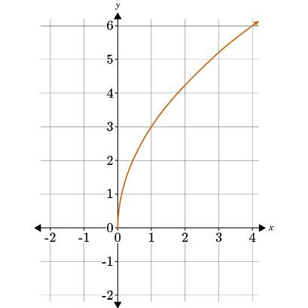  Given the graph of $f(x)=3\sqrt{x}$, which of the following statements about the graph of g$(x)=3\sqrt[3]{x}$must be true?  Option #1: Like f(x), g(x) is also increasing.  Option #2: Like f(x), g(x) has a domain of [0,∞].  Option #3: Like f(x), g(x) has a range of [0,∞].  Option #___ is the true statement about the graph. | 1
P 5 | Use the table to answer the question.  Which option contains true statements about the graph of $f\left(x\right)=\sqrt[3]{8x}$? | 1

Quick Check Questions and Answers
 | Question | Answer
Q 1 | Use the image to answer the question.  Sam graphed a cube root function. What is the equation of the function Sam graphed? | $$y=2\sqrt[3]{x-1}+3$$
Q 2 | Use the image to answer the question.  Select the description that corresponds to the graphed function. | The domain and range of the function are both the set of all real numbers.
Q 3 | Use the image to answer the question.  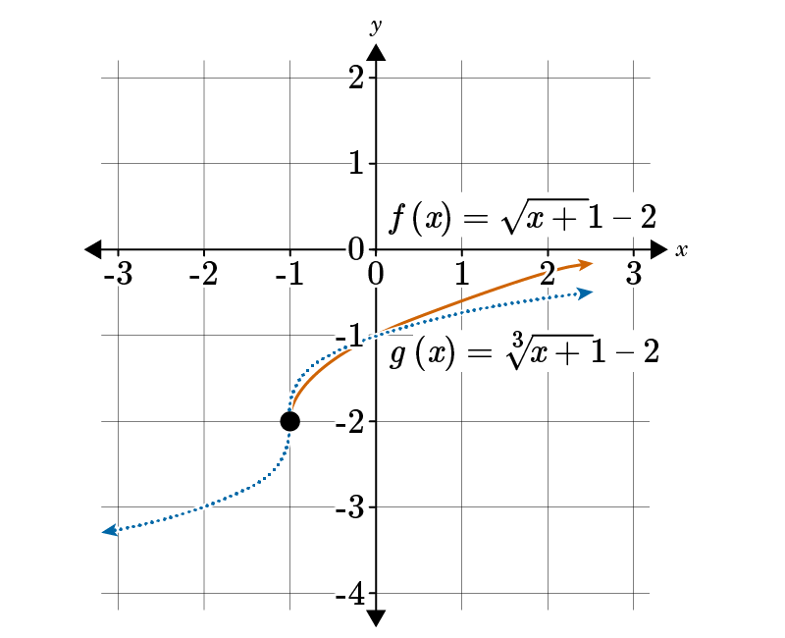  Compare the graphs of $f\left(x\right)=\sqrt{x+1}-2$ and $g\left(x\right)=\sqrt[3]{x+1}-2$. Identify which of the following features is true about the graphs. | The graphs have the same y-intercept.
Q 4 | Use the table to answer the question.  Compare the graphs of $f(x)=\sqrt{4x}$ and $g\left(x\right)=\sqrt[3]{4x}.$ Which of the options describing the graphs is true? | Option #4
Q 5 | Use the image to answer the question.  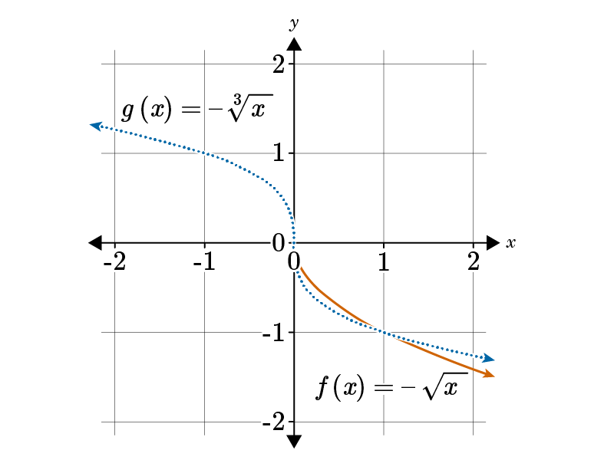  Compare the graphs of $f(x)=-\sqrt{x}$. And $g\left(x\right)=-\sqrt[3]{x}$ Which of the following features about the graphs is true? | The graphs are both decreasing.

Lesson 8 – Comparing Shapes of Functions
Key Words:
- asymptote – a line that the curve of a graph seems to approach, but never actually reaches; can be a vertical line or a horizontal line
- cube root – a factor of a number that when cubed gives the number; for example, the cube root of 8 is 2 and the cube root of –8 is –2
- cubic function – a function in the form $f(x)=ax^{3}+bx^{2}+cx+d$, where a, b, c, and d are real numbers and $a≠0$
- domain – the set of all possible inputs (x-values) of a function
- exponential function – a function where x is a variable and a is a constant
- function – a mathematical relation that assigns exactly one element of one set to each element of the same or another set
- linear function – a function in the form $f(x)=mx+b$, where m is the slope and b is the y-intercept
- quadratic function – a function in the form $f(x)=ax^{2}+bx+c$, where a, b, and c are real numbers and $a≠0$
- range – the set of all outputs (y-values) of a function
- square root – a factor of a number that when squared gives the number; for example, the square root of 9 is ±3
Formulas:
- Linear Function: $$f\left(x\right)=mx+b$$
- Quadratic Function: $$f\left(x\right)=ax^{2}+bx+c$$
- Exponential Function: $$f\left(x\right)=a⋅b^{x}$$
- Cubic Function: $$f\left(x\right)=ax^{3}+bx^{2}+cx+d$$
Objective 1: In this section, you will compare the shapes of linear, quadratic, exponential, and cubic functions.
Mathematical Practice Standard: Model with mathematics.
Big Ideas:
- Review and compare the key features and graph shapes of different functions.
- Adding, subtracting, multiplying, or dividing components of these functions by a real number can change these key features.
Function | Graph | Key Features
Linear: $$f\left(x\right)=mx+b$$ | $$f\left(x\right)=x$$ | - Domain: $$\left(−∞,∞\right)$$  - Range: $$\left(−∞,∞\right)$$  - Minimum: none  - Maximum: none  - x-intercept: (0,0)  - y-intercept: (0,0)
Quadratic: $$f\left(x\right)=ax^{2}+bx+c$$ | $$f\left(x\right)=x^{2}$$ | - Domain: $$\left(−∞,∞\right)$$  - Range: $$y≥0$$  - Minimum: (0,0)  - Maximum: none  - x-intercept: (0,0)  - y-intercept: (0,0)
Exponential: $$f\left(x\right)=a⋅b^{x}$$ | $$f\left(x\right)=2^{x}$$ | - Domain: $$\left(−∞,∞\right)$$  - Range: $$y>0$$  - Minimum: none  - Maximum: none  - x-intercept: none  - y-intercept: (0,1)
Cubic: $$f\left(x\right)=ax^{3}+bx^{2}+cx+d$$ | $$f\left(x\right)=x^{3}$$ | - Domain: $$\left(−∞,∞\right)$$  - Range: $$\left(−∞,∞\right)$$  - Minimum: none  - Maximum: none  - x-intercept: (0,0)  - y-intercept: (0,0)

Example: Compare the shapes of the functions $$f\left(x\right)=x+1$$ and $$g\left(x\right)=x^{3}−1$$. How are they the same? How are they different?
Step 1: Create a table of values for each function.
  x | $$f\left(x\right)=x+1$$ | $$g\left(x\right)=x^{3}−1$$
  -2 | -1 | -9
  -1 | 0 | -2
  0 | 1 | -1
  1 | 2 | 0
  2 | 3 | 7
Step 2: Plot the points on a graph.
Step 3: Compare the graphs. | - Both functions have the same domain and range: $$\left(−∞,∞\right)$$  - Both functions have no maximum and no minimum  - The linear function, $$f\left(x\right)=x+1$$, has an x-intercept at (-1,0) and a y-intercept at (0,1).  - The cubic function, $$g\left(x\right)=x^{3}−1$$, has an x-intercept at (1,0) and a y-intercept at (0, -1).  - When the value of x is less than or equal to 1, the y-values of $$f\left(x\right)=x+1$$ are greater than those of $$g\left(x\right)=x^{3}−1$$.  - From $$x=2$$onwards, the y-values of $$g\left(x\right)=x^{3}−1$$ are greater than those of $$f\left(x\right)=x+1$$.

Objective 2: In this section, you will compare the shapes of square root and cube root graphs.
Mathematical Practice Standard: Model with mathematics.
Big Ideas:
- Recall the features of a square root function and a cube root function.
Square Root Function | Cube Root Function
$$f\left(x\right)=\sqrt{x}$$  - Domain: $$\left[0,∞\right) or x≥0$$  - Range: $$\left[0,∞\right) or y≥0$$ | $$g\left(x\right)=\sqrt[3]{x}$$  - Domain: $$\left(−∞,∞\right)$$  - Range: $$\left(−∞,∞\right)$$
- By comparing the two functions on the same graph you can visually inspect the curve of each function over the given domain.
Comparing a Square Root and Cube Root Function

Practice Questions and Answers
 | Question | Answer
P 1 | Use the table to answer the question.  Compare the functions f(x) and g(x). At how many points do the functions intersect?  The functions f(x) and g(x) intersect at ___ data points. | 3
P 2 | Use the table to answer the question.  Compare the functions f(x) and g(x). When is f(x) greater than g(x)?  f(x) is greater than g(x) when ____< x <____. | -2; 0
P 3 | Use the image to answer the question.  Compare the following options and select the one that matches the graph.  Option #1: The graph of the function matches $f\left(x\right)=\sqrt[3]{x}$.  Option #2: The graph of the function matches $f\left(x\right)=\sqrt{x}$. | 1
P 4 | Use the image to answer the question.  Select the option that matches the graph.  Option #1: The graph of the function matches $f\left(x\right)=\sqrt[3]{x}$.  Option #2: The graph of the function matches $f\left(x\right)=\sqrt{x}$. | 2
P 5 | Determine which graph matches the function $f\left(x\right)=3\sqrt{x}$.  Option #1:  Option #2: | 2

Quick Check Questions and Answers
 | Question | Answer
Q 1 | Use the table to answer the question.  Compare the functions $f\left(x\right)=x^{3}+1$ and $g\left(x\right)=x+1$. Which of the following statements is true about the intercepts of the functions? | Both functions have an x-intercept of (−1,0) and a y-intercept of (0,1).
Q 2 | When comparing linear, quadratic, cubic, and exponential functions, what key feature do the all four function types share? | The domain of all four function types is all real numbers.
Q 3 | Compare the graphs and determine which one could be the graph of a square root function. | 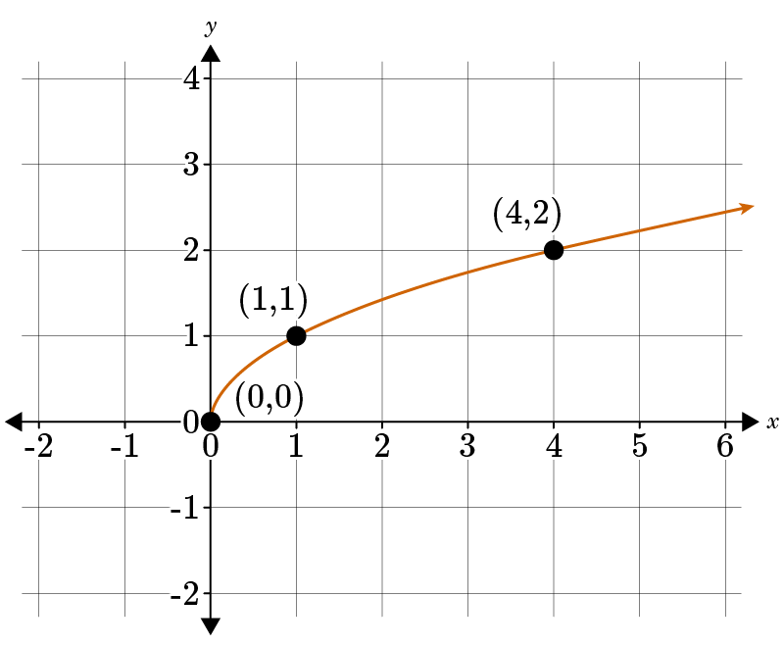
Q 4 | Use the image to answer the question.  Compare the graphs of $f\left(x\right)=\sqrt{x}+1$and $g\left(x\right)=\sqrt[3]{x}+1$. Which one of the following options is true? | Both functions are increasing on their domain.
Q 5 | Use the image to answer the question.  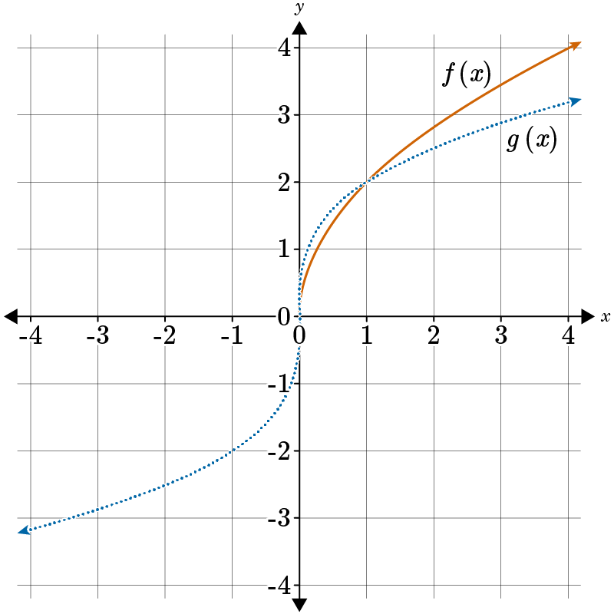  Compare the given graphs of $f\left(x\right)=2\sqrt{x}$ and $g\left(x\right)=2\sqrt[3]{x}$ and determine which of the following is true. | The graphs have different domains.

Lesson 9 – Average Rate of Change
Key Words:
- average rate of change – an average measure of how much the function changed per unit over a given interval
- function – a mathematical relation that assigns each element of one set (the domain) to exactly one element of another set (the range)
- interval – a set of real numbers between two numbers, either including or excluding one or both numbers
Formulas:
- Average Rate of Change Formula: $$\frac{f\left(b\right)−f\left(a\right)}{b−a}$$ given the interval $$\left[a,b\right]$$
Objective 1: In this section, you will calculate the average rate of change between two points using a variety of functions.
Mathematical Practice Standard: Model with mathematics.
Big Ideas:
- You can use the Average Rate of Change Formula to find the average rate of change of functions that are not constant.
- To find the average rate of change, divide the difference in the output values by the change in the input values given an interval.
Average Rate of Change Formula
$$\frac{f\left(b\right)−f\left(a\right)}{b−a}$$
Given the interval $$\left[a,b\right]$$.
- This formula can be used with a function given by table, a graph, or an equation.
  - 1. Identify two points that correspond to the given interval of x-values.
    - Table or Graph: the two points that correspond to the x-values from the interval
    - Equation: evaluate the function for the two x-values from the interval to find their corresponding y-values.
  - 2. Substitute the corresponding values into the average rate of change formula.
  - 3. Simplify.
Example: Find the average rate of change over the interval [-4,3] given the function table for $$f\left(x\right)=2x^{2}+3x−7$$.
Step 1: Identify two points that correspond to the given interval. | (-4,13) and (3,20)
Step 2: Substitute the corresponding values into the average rate of change formula and simplify. | $$\frac{f\left(b\right)−f\left(a\right)}{b−a}=\frac{20−13}{3−\left(−4\right)}=\frac{7}{7}=1$$  The average rate of change over the interval [-4,3] is 1.

Example: Find the average rate of $$f\left(x\right)=2^{x}$$ change over the interval [-2,2].
Step 1: Evaluate for the two interval endpoints. | - Interval: [-2,2]  - Evaluate for $$x=−2$$  - Evaluate for $$x=2$$
Step 2: Substitute the corresponding values into the average rate of change formula and simplify. | $$\frac{f\left(b\right)−f\left(a\right)}{b−a}=\frac{f\left(2\right)−f\left(−2\right)}{2−\left(−2\right)}=\frac{4−\frac{1}{4}}{4}=\frac{15}{16}$$  The average rate of change for the given equation on the interval [-2,2] is $$\frac{15}{16}$$.

Objective 2: In this section, you will describe function graphs in terms of average rates of change.
Mathematical Practice Standard: Model with mathematics.
Big Ideas:
- Recall the formula for the Average Rate of Change.
Example: Describe the average rate of change for each interval.
Line A | Interval: [-2,1]  Two points: (-2,9) and (1,3)  - $$\frac{f\left(b\right)−f\left(a\right)}{b−a}=\frac{3−9}{1−\left(−2\right)}=\frac{\left(−6\right)}{3}=−2$$  - decreasing with an average rate of change of -2
Line B | Interval: [1,3]  Two points: (1,3) and (3,7)  - $$\frac{f\left(b\right)−f\left(a\right)}{b−a}=\frac{7−3}{3−1}=\frac{4}{2}=2$$  - increasing with an average rate of change of 2
Line C | Interval: [3,5]  Two points: (3,7) and (5,7)  - $$\frac{f\left(b\right)−f\left(a\right)}{b−a}=\frac{7−7}{5−3}=\frac{0}{2}=0$$  - increasing with an average rate of change of 0
Line D | Interval: [5,10]  Two points: (5,7) and (10,2)  - $$\frac{f\left(b\right)−f\left(a\right)}{b−a}=\frac{2−7}{10−5}=\frac{−5}{5}=−1$$  - decreasing with an average rate of change of -1

Practice Questions and Answers
 | Question | Answer
P 1 | Use the formula $\frac{f\left(b\right)-f(a)}{b-a}$ to calculate the average rate of change over the interval [-2, 0] given the function table for $f\left(x\right)=x^{2}+6x+8$. Express your answer as an integer.  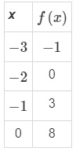  The average rate of change is ____. | 4
P 2 | Use the image to answer the question.  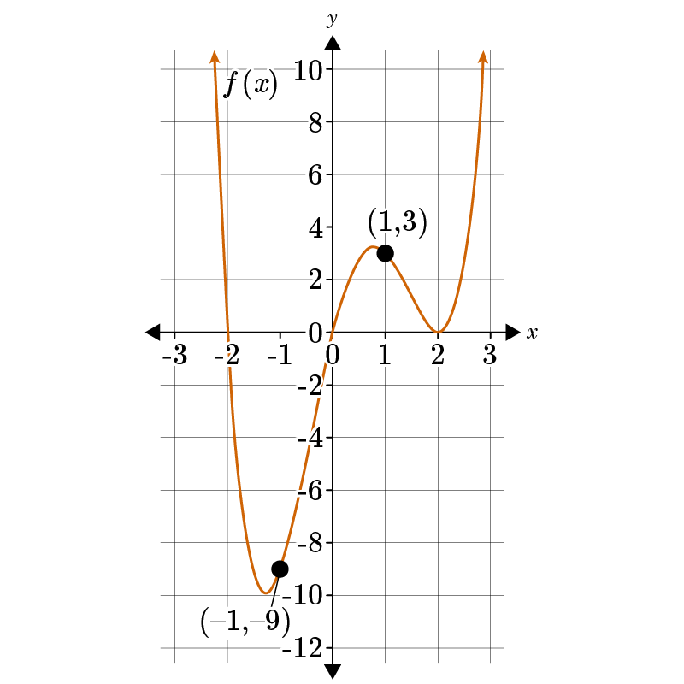  Calculate the average rate of change over the interval [−1,1] using the given graph of the function.  The average rate of change is ____. | 6
P 3 | Tyreke is an engineer and needs to design a rocket for an experiment. He has calculated that the height of the rocket, in feet, with respect to time, in seconds, can be modeled by the function $h(t)=-16t^{2}+160t$. Find the average rate of change of the rocket over the interval [4,5].  The average rate of change is ____ feet per second. | 16
P 4 | Use the image to answer the question.  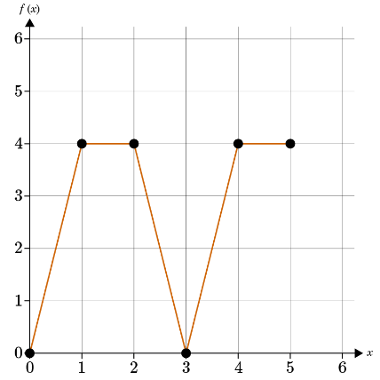  Describe the behavior of the function by determining over which interval the function has a negative average rate of change. Consider only intervals with consecutive endpoints shown on the graph.  The average rate of change is negative over the interval [___,___]. | 2; 3
P 5 | Use the images to answer the question.  Option #1:  Option #2:  Option #3:  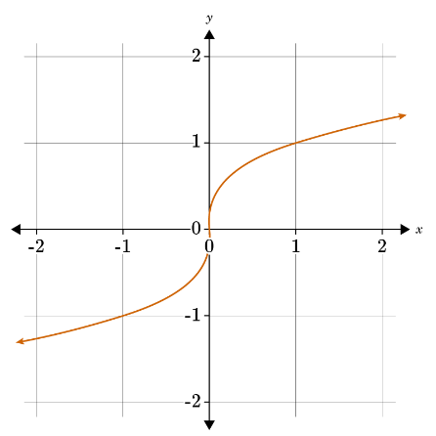  Which option is the graph of a function which has a positive average rate of change on the interval $[-\frac{1}{2},0]$?  Option #___ is the graph of the function which has a positive average rate of change on the interval $[-\frac{1}{2},0]$? | 3

Quick Check Questions and Answers
 | Question | Answer
Q 1 | Calculate the average rate of change over the interval [2,4] given the function table for $f(x)=-x^{2}+12$.  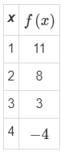 | -6
Q 2 | Use the image to answer the question.  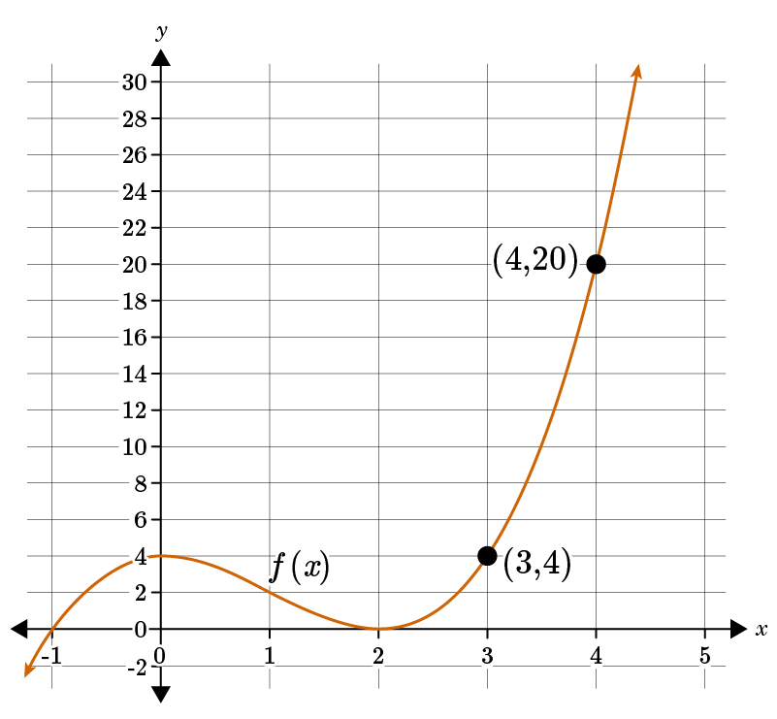  Calculate the average rate of change over the interval [3,4] of the given graph of the function. | 16
Q 3 | Use the image to answer the question.  Describe the graph of f(x) by selecting the correct statement. | The average rate of change is negative on the interval [1,3] and also on the interval [6,7].
Q 4 | Use the image to answer the question.  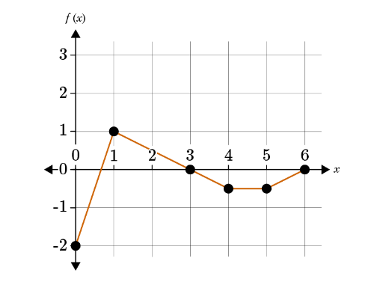  Given the graph of f(x), on which interval is the average rate of change the greatest? | The function has the greatest average rate of change over the interval [0,1].
Q 5 | Use the image to answer the question.  Use the average rate of change to describe the graph of f(x) over the interval [1,4]. | The average rate of change is $\frac{1}{3}$.

Lesson 10 – Comparing Average Rates of Change
Key Words:
- average rate of change – an average measure of how much the function changed per unit over a given interval
- cube root – a factor of a number that when cubed gives the number; for example, the cube root of 8 is 2 and the cube root of −8 is −2
- exponential equation – an equation in the form $y=a*b^{x}$, where a is the initial value and b is the multiplier.
- function – a mathematical relation that assigns exactly one element of one set to each element of the same set or another set
- interval – a set of real numbers between two numbers either including or excluding one or both of the numbers
- quadratic equation – any equation containing one term in which the unknown term is squared and no other term is raised to a higher power
- square root – a factor of a number that when squared gives the number; for example, the square root of 9 is ±3
Formulas:
- Average Rate of Change: $$\frac{f\left(b\right)−f\left(a\right)}{b−a}$$ for the given interval [a, b]
Objective 1: In this section, you will compare estimated average rates of change of quadratic and exponential functions.
Mathematical Practice Standard: Model with mathematics.
Big Ideas:
- How to find the estimated average rate of change of any function without specific interval:
  - 1. Identify the approximate two points on the graph: $$\left(a,f\left(a\right)\right) and \left(b,f\left(b\right)\right)$$
  - 2. Substitute the corresponding values in the average rate of change formula: $$\frac{f\left(b\right)−f\left(a\right)}{b−a}$$
  - 3. Simplify, if possible.
Example: Use the graphs of $$f\left(x\right)=x^{2}$$ and $$g\left(x\right)=2^{x}$$ to estimate their average rates of change over the interval [-1.5, 0].
$$f\left(x\right)=x^{2}$$ | $$g\left(x\right)=2^{x}$$
- The value of both functions at $$x=0$$can be accurately determined from the graphs.
- You can only estimate the value of each function at $$x=−1.5$$, so you must create a table of actual values.
x | $$f\left(x\right)=x^{2}$$ | $$g\left(x\right)=2^{x}$$
-1.5 | 2.2 | 0.4
0 | 0 | 1
- Use the Average Rate of Change formula to calculate the average rate of change over the given interval: [-1.5,0]
  - Quadratic Function: $$f\left(x\right)=x^{2}$$
  - Exponential Function: $$g\left(x\right)=2^{x}$$
The quadratic function decreases at the interval [-1.5,0] while the exponential function increases.

Practice Questions and Answers
 | Question | Answer
P 1 | Which function has the greater estimated average rate of change over the interval [0,1.1], the exponential function $y=4^{x}$ or the quadratic function $y=4x^{2}$?  Option 1: exponential function  Option 2: quadratic function  The function with the greater estimated average rate of change on the interval is option ____. | 2
P 2 | Approximately how much greater is the estimated average rate of change of the function $y=16⋅4^{x}$ over the interval [1.1,1.6] than the estimated average rate of change of the function $y=16x^{2}+4x$ over the same interval: 1, 10, or 100?  The estimated average rate of change of the function $y=16⋅4^{x}$ is approximately ____ greater than the estimated average rate of change of the function $y=16x^{2}+4x$ over the interval [1.1,1.6]. | 100
P 3 | Use the image to answer the question.  A quadratic function is graphed. Compare the estimated average rate of change for the quadratic function to the estimated average rate of change for the exponential function $y=-6^{x}$ on the interval [0,5]. Use one of the symbols <, =, or > to describe the comparison.  The estimated average rate of change of the quadratic function ____ the estimated average rate of change of the exponential function. | >
P 4 | Compare the estimated average rates of change of the functions $f\left(x\right)=\sqrt{3x-4}$ and $g\left(x\right)=2\sqrt[3]{x-\frac{4}{3}}$over the interval [2, 3]. State the difference in the estimated average rates of change to the nearest tenth.  The difference between the estimated average rates of change is approximately ____. | 0.2
P 5 | Use the image to answer the question.  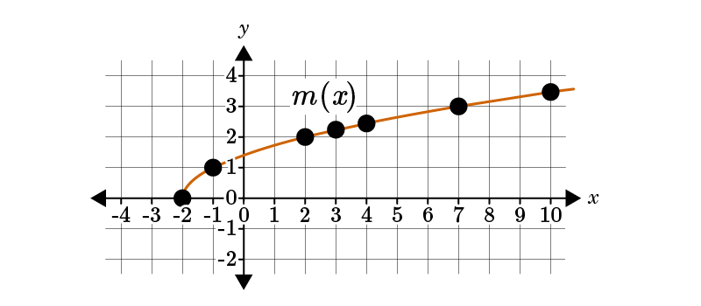  Compare the estimated average rates of the graphed square root function over the interval [2,7] to the estimated average rates of the cube root function $y=\sqrt[3]{x+2}$ over the same interval. To the nearest tenth, what is the difference between the estimated average rates of the graphed square root function and the estimated average rates of the cube root function?  The difference between the rates of change is ___. | 0.1

Quick Check Questions and Answers
 | Question | Answer
Q 1 | Compare the estimated average rate of change of the exponential function $y=9{(\frac{1}{3})}^{x}$ and the quadratic function $y=9x^{2}+\frac{1}{3}x$. Which function has a negative estimated average rate of change over the interval [0.1,0.6]? | the exponential function
Q 2 | Use the image to answer the question.  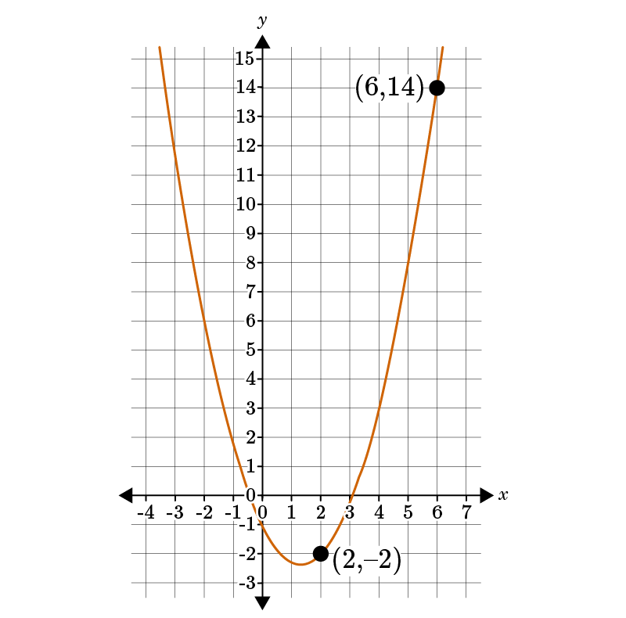  Compare the estimated average rate of change of the graphed quadratic function over the interval [2,6] to the average rate of change of the exponential function $y=\frac{3}{4}{(2)}^{x}$ over the same interval. | The estimated average rate of change of the exponential function is 7.25 greater than the estimated average rate of change of the quadratic function over the interval [2,6].
Q 3 | Use the image to answer the question.  Compare the average rates of change for the graphed square root function $p\left(x\right)=\sqrt{x+4}$ and the cube root function $f\left(x\right)=\sqrt[3]{x+4}$ over the interval [-4, -3]. | The functions have the same average rate of change of 1.
Q 4 | Consider the cubic function $d\left(x\right)=\sqrt[3]{2x-1}$ and the square root function $g\left(x\right)=\sqrt{2x+1}$. Select the interval where the square root function has the lower estimated average rate of change. | [0,4]
Q 5 | Use the image to answer the question.  Compare the estimated average rate of change for the graphed cubic function $b\left(x\right)=\sqrt[3]{3x+9}$ to the estimated average rate of change of the square root function $d\left(x\right)=\sqrt{-3x+9}$ over the interval [-12, -3]. Which comparison is true? | The estimated average rate of change of b(x) is greater than the estimated average rate of change of d(x) because b(x) is increasing over the interval but d(x) is decreasing.

