Guided Notes: Magnetism and Plate Tectonics
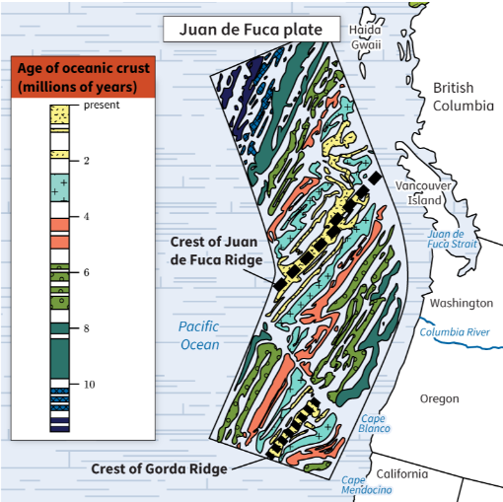
The ages of rocks along ____________ ridges reveal that the ____________ spreads outward from the ____________. As scientists investigated more rocks from the ____________ floor, they identified another important source of evidence. The rocks could be placed in categories according to their ____________ field direction. Some rocks had a ____________ direction similar to Earth’s current ____________ field (magnetic normal). Other rocks had ____________ fields oriented in the opposite direction (magnetic reverse). Scientists also discovered ____________ patterns in ____________ rock found on land.

Key Terms:
- Define paleomagnetism: _______________________________________________________________________________________

Key Concepts:
- Earth is always changing. It’s been evident over time that the ____________ are ____________.
- The culprits for this change are large pieces of Earth’s ____________ and ____________, known as ____________ plates, that are ____________ below Earth’s ____________.
- As these plates move apart, ____________ spews out. The ____________ in ____________ is ____________, so its molecules align with Earth’s ____________ field.
- Over millions of years, layers have been forming as plates ____________, lava ____________, and the lava ____________.
- Through ____________, the study of ancient ____________ fields, scientists discovered a uniqueness in the ____________ of lava.
- They found that the molecules of newer ____________ were aligned with the current ____________ and ____________ Poles, while molecules in ____________ layers of ____________ were ____________.
- The hypothesis of Earth’s poles drifting was proven inaccurate because same-____________ lava found on different ____________ was not ____________ aligned in the ____________ ways.
- Through this same finding, scientists determined that the hypothesis that the continents have drifted was ____________.
- The older layers of ____________ that appeared skewed were at one time aligned with Earth’s ____________ field. These findings about ____________ are the basis for our understanding of ____________ tectonics.
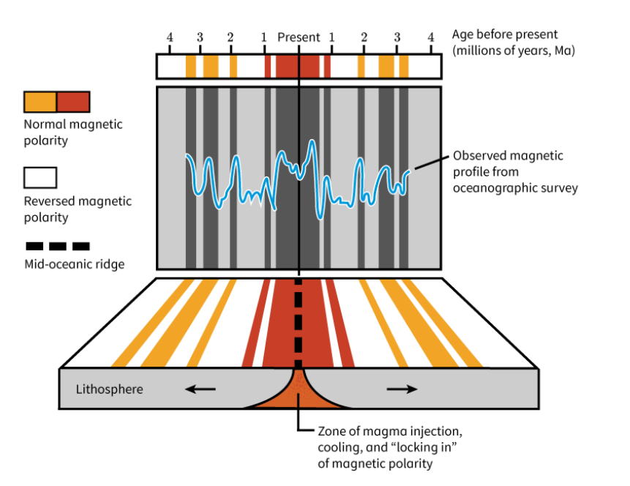
- Paleomagnetic Patterns Provide a Geologic Clock: When scientists construct ____________ showing the ____________ direction of rocks found at different distances from ____________ ridges, they find patterns of ____________, ____________ ____________ stripes. The stripes are ____________ images on either side of the ridge. Scientists can use the pattern to determine how fast ____________ rock is forming at the ____________, as well as how fast ____________ supported by the plate ____________ along Earth’s surface.
- Constructing Geologic History: ____________ patterns also help scientists know when plates ____________ or changed their movement ____________ to one another. In this way, scientists can piece together the ____________ history of a ____________ plate, which also supports ____________ plate theory.

