Guided Notes: Plate Tectonic Theory

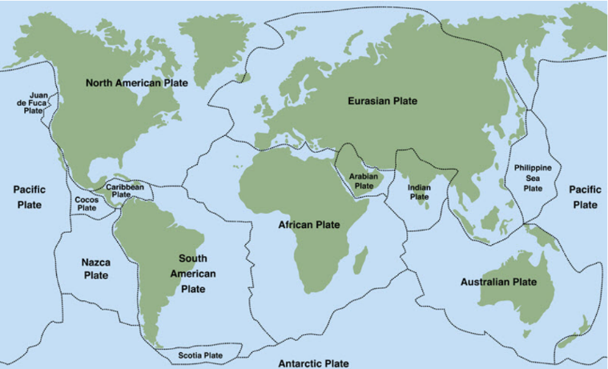
__________________ theorized that at one time, all the continents made up a single giant land mass. He decided to call this land mass __________________.
__________________ believed the continents slowly drifted apart, or slid across the ocean floor, due to the rotation of Earth over millions of years. He called this theory, the theory of __________________.

Key Terms:
- Define theory of continental drift: _______________________________________________________________________________________
- Define seafloor spreading: _______________________________________________________________________________________
- Define hotspot: _______________________________________________________________________________________
- Define transform fault: _______________________________________________________________________________________
- Define mantle convection: _______________________________________________________________________________________
- Define theory of plate tectonics: _______________________________________________________________________________________

Key Concepts:
- ____________ searched for data to support his theory of continental drift. He was looking for evidence of ____________ and ____________ life and ____________ features that were similar between ____________ even though the ____________ were far apart.
- He found supporting evidence for the following:
  - ____________ fit
  - ____________ fit
  - ____________ deposits
  - ____________ evidence
Jigsaw Fit
- Wegener used the fact that the ____________ fit together like ____________ pieces to support his theory.
- The ____________ coastline of ____________ and the ____________ coastline of ____________ showed the best fit. Still, gaps and overlaps existed which scientists explained as changes that had happened since the split of ____________ by:
  - ____________ erosion
  - ____________ deposition
  - ____________ in sea level
  - ____________ in land level
Geological Fit
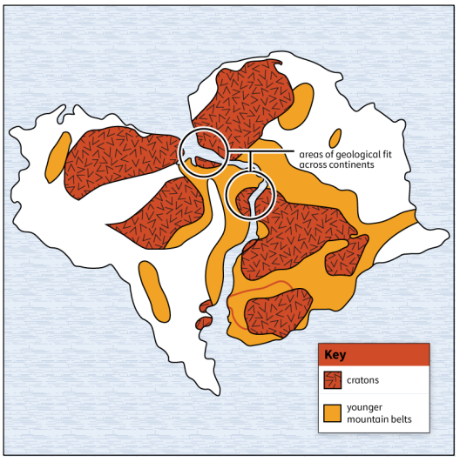

- ____________ also used ____________ fit as supporting evidence for his theory of continental drift. He found evidence that geological features, such as ____________, were ____________ between ____________. A ____________ is the stable ____________ portion of Earth’s ____________ that forms the nuclear mass of a ____________.
Glacial Deposits
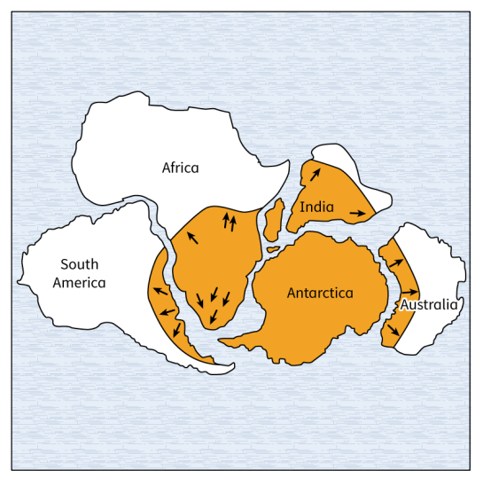
- Wegener believed that ____________, southern South ____________, and southern ____________, ____________, and ____________ were all joined around the ____________ polar region. ____________ deposits found on these continents supported this idea.
Fossil Evidence
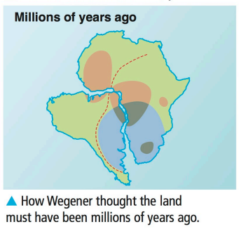
- Fossils of the same ____________ have been found on different ____________. This was more ____________ for ____________ theory.
- Opposition to Continental Drift: Despite the evidence Wegener presented, many scientists disputed his idea of how the ____________ had actually moved. Wegener thought that the ____________ of Earth created a ____________ force that caused ____________ to break apart and move away from the poles. Scientists rejected his theory that the Earth's ____________ force could move ____________.
- Wegener was not deterred and proposed that the ____________ pull of the ____________ could cause continents to move. This, too, was shown by scientists to be impossible.
- Scientists also had other ideas about how to explain some of the evidence for ____________ drift. Some suggested that ____________ had moved from one ____________ to another by ____________ bridges that had since ____________.
- After Wegener's death, scientists continued to refine his theory. New technologies in the 1950s allowed scientists to gather new evidence supporting continental drift, including:
  - ____________ spreading
  - ____________
  - transform ____________
  - mantle ____________

- Plate Boundaries: There are three types of tectonic plate boundaries. The different ways ____________ interact at ____________ help to connect the ideas of ____________ tectonic theory.
- ____________ plate boundaries and their ____________ can be summarized as follows:
  - ____________ move ____________ each other at ____________ boundaries
  - ____________ move ____________ from each other at ____________ boundaries
  - ____________ push ____________ each other at ____________ boundaries

