Guided Notes: Fossils and Plate Tectonics
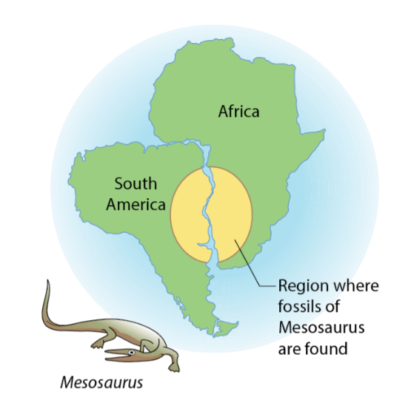
Alfred Wegener proposed a theory in 1915 that Earth's continents are not stationary, they ____________ . This theory was known as the theory of ____________ .
Some of Wegener’s strongest evidence was linked to ____________. He found several types of ____________ and ____________ traces and remains that seemed to prove the ____________ have ____________ over time.

Key Terms:
- Define fossil: _______________________________________________________________________________________
- Define subarctic climate: _______________________________________________________________________________________

Key Concepts:
- Wegener compiled ____________ evidence of ____________ animals that are now on ____________ landmasses, which at one time could have been ____________ . One example is ____________ .
- ____________ was a ____________ reptile that lived in ____________ water. Fossils of ____________, were found in southern ____________ and eastern ____________. Because ____________ is a ____________ animal, it does not have the ____________ to ____________ across a ____________ body of ____________ water such as the ____________ Ocean. This suggested that these continents were once ____________.

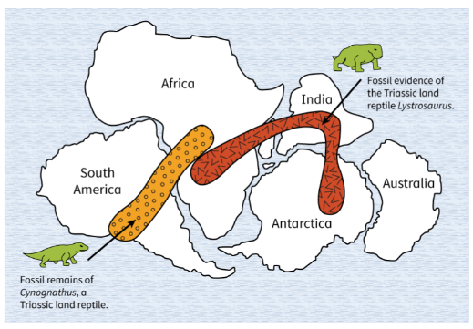
- Evidence from many parts of the world ____________ Wegener’s argument. It showed that ____________ animal species lived long ago on ____________ that today are ____________ by vast distances.
- Like ____________, fossils of ____________ were also found in South ____________ and ____________. ____________ was a ____________ reptile about ____________ feet in length that lived during the ____________. The areas where ____________ of this reptile were found are now ____________ by ____________ of miles of ____________.
- Wegener also presented ____________ from ____________.
- ____________ was a fern that grew in ____________. Investigations show that the ____________ left behind by the plant during the ____________ Era were found in what are now ____________, ____________, ____________, and South ____________. Later, an ____________ to the South Pole returned with ____________ fossils found in ____________.
- This suggested that these lands were ____________ in a ____________ climate region in the past.
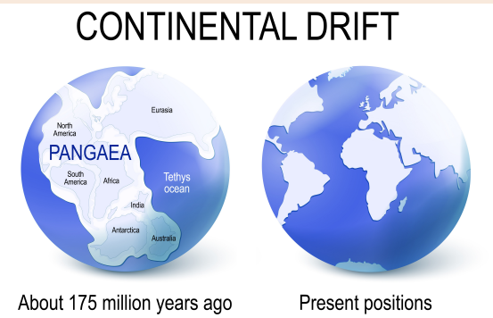
- Wegener believed that Earth’s ____________ were once one land mass called ____________. Over hundreds of years ____________ broke apart to form the ____________ we know today.
- Unfortunately, Wegener could not prove his theory. New ____________ in the mid-____________ allowed scientists to see ____________ ridges for the first time and begin to understand the ____________ of the ____________ from ____________ rifts.
- Decades of research and -____________ of -____________ and -____________ of Earth’s -____________ revealed that -____________ and -____________ are carried on several rocky -____________ plates. Evidence showed that as the -____________ spreads from the -____________ rift, -____________ moves up from Earth’s -____________ through the opening. New -____________ is created at the ridges of the opening, and old -____________ is recycled at the -____________.

