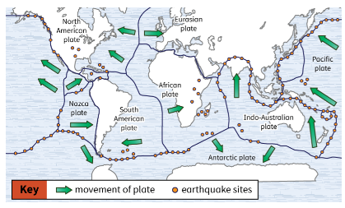
Guided Notes: Plates and Earthquakes
Earthquakes occur when Earth’s ____________ move against or past each other at their ____________.
This movement releases ____________ in ____________ that cause the ground to ____________.

Key Terms:
- Define fault: _______________________________________________________________________________________
- Define focus: _______________________________________________________________________________________
- Define epicenter: _______________________________________________________________________________________

Key Concepts:
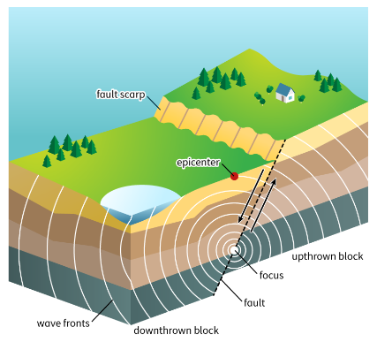
- The rock on both sides of a ____________ moves because Earth’s ____________ are always ____________.
- The ____________ edges of the ____________ get caught on each other at the ____________.
- As the ____________ continue to move, ____________ builds up where the ____________ are ____________.
- An ____________ begins when the ____________ finally move ____________ each other along the ____________, at a point called the ____________ (also called the ____________).
- The contact releases ____________ of ____________ that move ____________ from the ____________ in all directions and cause the ____________ that people feel.
- The ____________ of the earthquake, which is located directly above the ____________ at Earth’s surface, is often where the most ____________ takes place.
- Most earthquakes happen at a fairly shallow depth in Earth’s ____________.
- Some earthquakes have one or more ____________, which are smaller ____________ that happen before the ____________, or main ____________.
- All main earthquakes have ____________, which are smaller ____________ that happen after the ____________.
- ____________ and ____________ happen in the same place as the ____________.
- Scientists use sensitive instruments called ____________ to measure the strength of earthquakes.
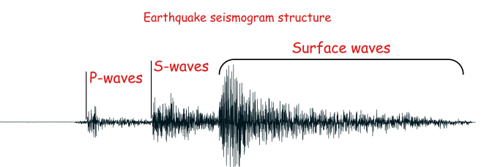
- When scientists detect ____________ waves on a ____________, they can send out an earthquake warning alert, which gives people seconds to minutes to get into a safer place before the stronger ____________ waves (and, later, the surface waves) arrive.
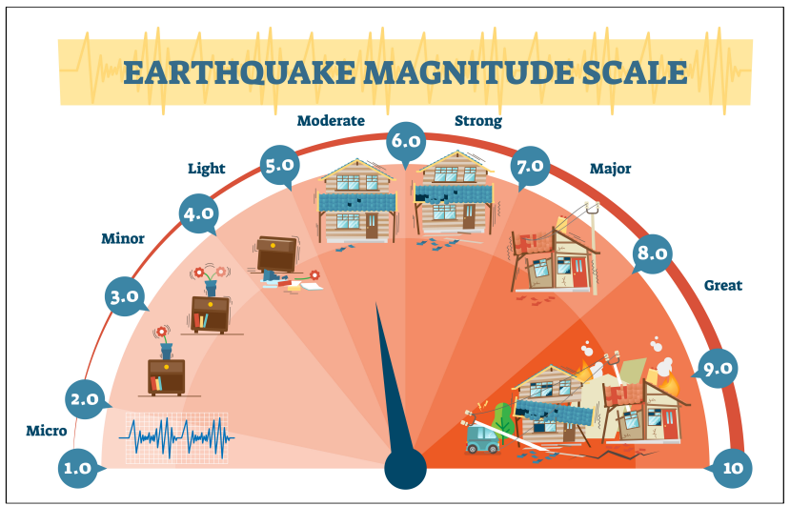
- The moment ____________ (Mw) scale measures the ____________ (size) of earthquakes, as determined from the information provided by ____________.
- The scale ranges from 1 to 10, with ____________ being the ____________ earthquake and ____________ the ____________.
- The ____________ and ____________ of an earthquake are affected by the ____________ of the ____________ involved and the type of ____________ between them.
- Some plates are composed of either thick ____________ crust or thinner ____________ crust, while other plates are composed of both ____________ and ____________ crust.
- There are three types of boundaries between plates: ____________, ____________, and ____________.
  - When two plates pull apart, they have a ____________ boundary. At the point where the plates pull apart, molten rock wells up from the mantle, cools, and forms new, thin crust. The weakest earthquakes occur at divergent boundaries.
  - With a ____________ boundary, two plates ____________ or ____________ past each other ____________. Earthquakes of middle strength tend to occur at ____________ boundaries, with somewhat ____________ earthquakes occurring when the ____________ boundary is ____________ (as most are).
  - With a ____________ boundary, two plates ____________. If one of the plates is composed mainly of ____________ oceanic crust, it will be forced ____________ the ____________ composed of mainly ____________ crust in a process called ____________. ____________ boundaries tend to spawn the ____________ earthquakes as the two plates ____________, with slightly ____________ earthquakes occurring as one plate continues to move ____________ the other.
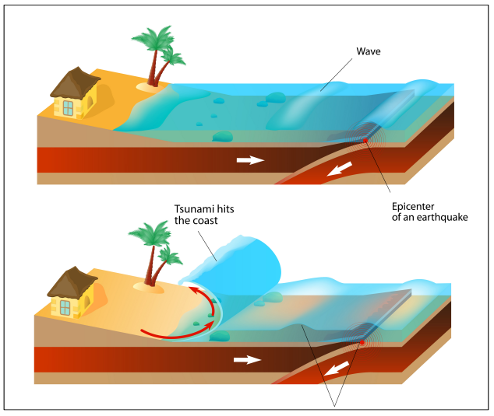
- A ____________ is a large ocean wave or series of waves caused by water ____________ triggered by an undersea ____________, ____________, or ____________ eruption.
- ____________ move ____________ in deep water and ____________ as they reach the shallower water near shore.
- In addition, the height of the waves ____________ as the water becomes ____________.
- The ____________ of Earth’s plates, including the resultant ____________, are responsible for the ____________ and ____________ of many different types of ____________.
- When plates are ____________ at ____________ boundaries, they often form deep ocean ____________. ____________ can also form ____________ ranges.
- ____________ boundaries form ____________ ridges.

