Guided Notes: Volcanoes
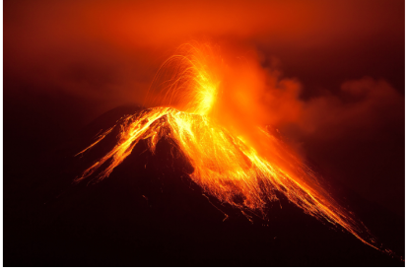
A ____________ is a ____________ in Earth’s ____________ where ____________ and ____________ can ____________ out onto the ____________ . The mountain formed by a ____________ eruption is also known as a volcano. A volcano is ____________ as ____________ if it has ____________ within the past 10,000 years and as ____________ if it has not. An ____________ volcano is never expected to ____________ again.

Key Terms:
- Define lava: _______________________________________________________________________________________

Key Concepts:
- Stratovolcano: More than half of the volcanoes on Earth are ____________. These tall volcanoes have a gentle slope near the base rising to ____________ sides and a ____________ cone at the top. The ____________ of a stratovolcano is ____________, causing it to build up ____________ with increasing ____________ until it suddenly ____________ with a dangerous ____________.
- Monitoring Volcanos: Predicting a volcanic ____________ is complicated. Many of the clues that an eruption is ____________ occur far below Earth’s ____________ where ____________ can pool.
- Scientists use a variety of ____________ to monitor volcanoes and give predictions that allow as much time as possible to ____________ the area.
  - ____________ placed near active volcanoes alert scientists that ____________ once ____________ in underground ____________ are beginning to ____________ through the ____________, indicating that an eruption may be ____________.
  - ____________ placed in ____________ near volcanoes monitor ____________ movements that indicate ____________ of ____________ rock. These ____________ can increase the ____________ on underground pools of ____________. A strong, rapid ____________ can eject the ____________ rock from the ____________.
  - ____________ using Global Positioning System (GPS) technology measure the ____________ of land around a volcano that indicates a ____________ of ____________ and ____________. ____________ can also monitor the ____________ of ____________ and ____________ of ____________ once an eruption has begun.
  - ____________ cameras near volcanoes take images that reveal ____________ in the ____________ or ____________ of ____________ or ____________.
  - ____________ imagers mounted on helicopters, drones, or satellites help identify active ____________ as well as ____________ spots where equipment can be placed.
- ____________ Volcano: A ____________ volcano gets its name from the resemblance of its ____________, ____________ shape similar to a knight’s ____________ lying on the ground. The ____________ that forms a ____________ volcano is less ____________, producing ____________ eruptions. The ____________ flows long distances from the summit or ____________ along the sides before ____________ into thin sheets.
- ____________ Cone: One of ____________ types of volcanoes is a ____________ cone, also known as a scoria cone. Compared to other types of volcanoes, ____________ cones are usually much ____________ and might form in just a few ____________ or ____________. The name ____________ cone refers to the single, ____________ cone at the top of a steep hill or mountain and the ____________ of ____________, called ____________, that are ____________ during an ____________ and quickly cool.

