**Guided Notes: Star Evolution**

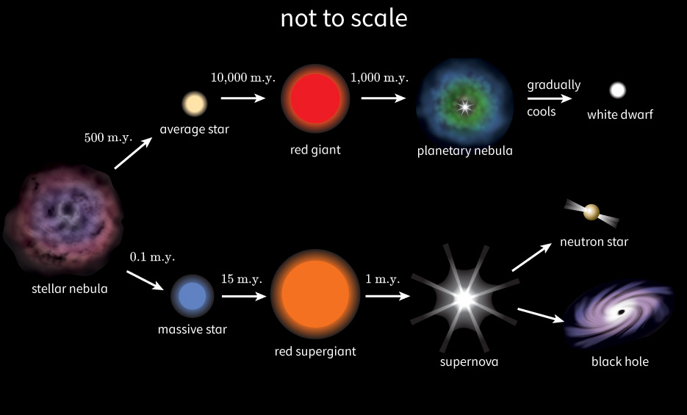

**Key Terms:**

* Define protostar: _______________________________________________________________________________________
* Define red giant: _______________________________________________________________________________________
* Define planetary nebula: _______________________________________________________________________________________
* Define white dwarf: _______________________________________________________________________________________
* Define supernova: _______________________________________________________________________________________
* Define neutron star: _______________________________________________________________________________________
* Define black hole: _______________________________________________________________________________________

**Key Concepts:**

* While stars are not alive, all stars do change over time.
* Because of this, scientists use to the term "life cycle" to metaphorically describe these changes: stars' ______________, ______________, and ” ______________.“
* When you look up at the night sky, every star you see is in some ______________ of its life ______________.
* Every star is "______________ " in a ______________ —a giant cloud of ______________ and ______________.
* Eventually, ______________ pulls the cloud’s ______________ together and the ______________ gas starts to ______________.
* The ______________ the gas ______________, the ______________ it becomes until a ______________ forms.
* When the temperature of the protostar reaches ______________ ° Celsius, it triggers ______________ fusion in its ______________.
* By converting ______________ into ______________, the protostar achieves the next stage in its life cycle: now it is a ______________, brightly-glowing star.
* This is called the main ______________.
* Stars remain in this main ______________ stage, creating heat through ______________ fusion, for ______________ to ______________ of years. Our sun is currently in the ______________ sequence stage.
* Eventually, stars have no more ______________ left to ______________, ending the main sequence.
* The ______________ of a star determines what happens at this point.
* When a ______________ star has no more hydrogen to fuse, and it has become only ______________, it is too small to fuse helium together.
* Nuclear ______________ ends and it is no longer considered a ______________.
* It expels its ______________ layers and becomes a ______________ dwarf, a small remnant of its former self.
* Over time, no longer able to make any energy, it ______________ until it no longer emits any ______________.
* When an ______________ -sized star has used up its ______________ fuel, it is big enough to use helium for nuclear ______________ instead.
* It becomes a red ______________ star, burning ______________ for ______________ billion years until all the helium fuses into ______________.
* Medium stars are not big enough to ______________ carbon.
* So at this point, medium stars “______________.”
* Their cores ______________, expelling the stars' outer ______________, which form a planetary ______________. The cores become ______________ dwarves.
* ______________ stars have more spectacular endings to their life cycles.
* These stars are 10 times or more the ______________ of the ______________.
* When a massive star runs out of ______________ fuel, its outer shell expands into an ______________ super red ______________ star.
* Nuclear ______________ in the core continues until it eventually creates an ______________ core.
* At this point, all ______________ stops, and the star “______________.”
* But massive stars do not die ______________ as white dwarves.
* Instead, their cores rapidly ______________, triggering a massive ______________ known as a ______________.
* The resulting shock ______________ causes more ______________, which creates the elements heavier than ______________, and sends a cloud of ______________ elements hurtling into space.
* The remaining ______________ of the ______________ star continues to ______________.
* At this point, the star can become a ______________ star.
* A ______________ star can be only a few kilometers across, but its matter is so ______________ that a teaspoon can weigh a ______________ tons.
* If the star is even ______________, it becomes a ______________ hole.
* The powerful gravity of a ______________ hole pulls all nearby ______________ and ______________ into its ______________. Nothing, not even light, can escape.

|  |  |  |  |
| --- | --- | --- | --- |
| **Star with Small Mass** | **Star with Medium Mass** | **Star with Large Mass** | **Star with Largest Mass** |
| Born in a nebula | Born in a nebula | Born in a ______________ | Born in a nebula |
| ______________ | Protostar | Protostar | ______________ |
| Main sequence star which fuses ______________ | Main sequence star which fuses hydrogen | Main sequence star which fuses ______________ | Main sequence star which fuses hydrogen |
| Death as a ______________ dwarf | Red ______________ star, which can fuse ______________ | Super red ______________ star, which can fuse helium and ______________ elements. | Super red ______________ star, which can fuse ______________ and heavier elements |
|  | Death as a ______________ dwarf | Death through a ______________ | Death through a ______________ |
|  |  | Can become ______________ star | Becomes a ______________ hole |

* The evolution of ______________ stars in the ______________ ends in one of two ways—the red ______________ either become ______________ stars or ______________ holes.
* But the ______________ that precedes one of these outcomes is the largest explosion that happens in ______________.
* With the exceptional technology available, astronomers ______________ find ______________.
* In 2013, one was discovered by chance a mere ______________ hours after it ______________.
* What scientists understand about ______________ and stellar ______________ is a mixture of what they have observed and theories they have developed.
* The more data scientists can gather, the clearer the picture will become.
* Stellar ______________ is inevitable because stars ______________.
* To burn, they need ______________, and as they burn, they ______________ their fuel sources.
* The stages of ______________ can be thought of as stages of fuel ______________.
* These stages are extremely important, because they are responsible for the ______________ of most of the ______________ in the universe—which in turn form new ______________, ______________, solar ______________, and ______________ like the Milky Way.
* The solar system that contains Earth revolves around one star, the ______________, which will eventually end its ______________ as a white ______________.