**Guided Notes: Star Elements**

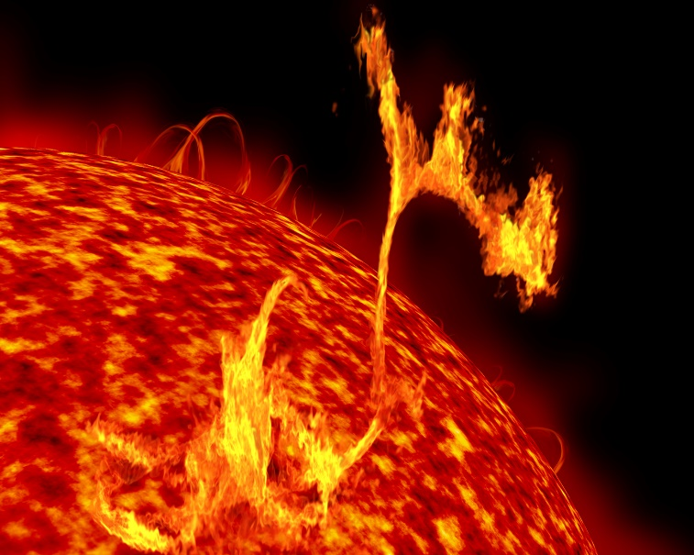Our sun is just like countless other stars in the universe. The ______________ and ______________ are two types of ______________ released by the sun during ______________ fusion reactions deep inside the sun. In a nuclear fusion reaction, two ______________ collide and are ______________ together to make a new ______________. Nuclear fusion ______________ also release a large amount of ______________, some of which can be transformed into light and ______________.

**Key Terms:**

* Define nuclear fusion: _______________________________________________________________________________________
* Define light element: _______________________________________________________________________________________
* Define heavy element: _______________________________________________________________________________________
* Define luminosity: _______________________________________________________________________________________

**Key Concepts:**

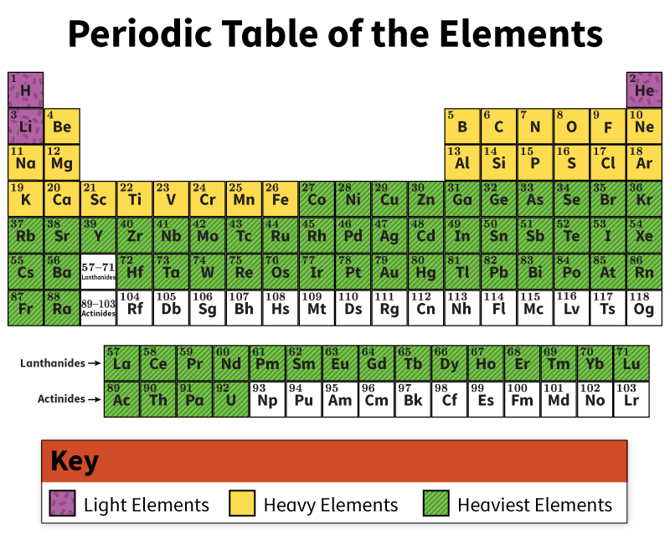

* Hydrogen, as the ______________ and simplest atom on the periodic table, has one ______________, sometimes a ______________, and one ______________.
* ______________ is the next largest, with two ______________, two ______________, and two ______________.
* Moving through the periodic table, the atoms get ______________ and become ______________ in ______________ because they are made up of more and more protons, neutrons, and electrons.
* Scientists call the first ______________ elements on the periodic table, the three smallest elements, the light elements. These elements—hydrogen, helium, and ______________ —have one, two, and three protons in their ______________, respectively.
* As the early universe ______________ after the big bang, clouds of the light elements ______________ into dense bodies.
* Due to high ______________ and ______________, hydrogen started undergoing nuclear ______________, and stars were born.
* In all but the smallest of these stars, additional ______________ fusion ______________ took place, forming atoms with even more ______________ in their ______________.
* In larger stars, the fusion reactions continued until ______________ was produced.
* These elements produced in stars by ______________ fusion are called the ______________ elements.
* Elements ______________ than ______________ are made in large to very ______________ stars.
* Their high ______________ creates more ______________ and higher ______________ in the interior, making it easier for nuclear fusion reactions to take place.
* Toward the end of the star’s life cycle, when the ______________ fuel has been used up, the star collapses in on itself and ______________ with tremendous energy.
* The explosion has enough energy for some of the elements in the star to fuse together to make even heavier elements.
* This process makes elements that are as heavy as ______________.
* The star’s explosion, or ______________, then scatters the ______________ across space to form the ______________ that can condense into new ______________ and ______________.
* The rest of the elements on the periodic table are ones that scientists have ______________ in the ______________.
* These elements are ______________ and exist ______________ before breaking down into other, ______________ atoms.
* Scientists are not sure if these elements can ______________ in the universe and be made by ______________.
* If stars are capable of making these elements, the elements do not last ______________, and scientists have not been able to ______________ them.