**Guided Notes: Sun’s Layers**

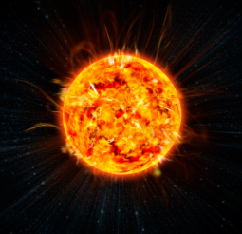Like all stars, the sun is composed of ______________, a type of super-heated ______________ in which the particles are ______________.

Streams of these particles, called a ______________ wind, ______________ the solar system. Most of the sun’s properties are generated by processes in its complex ______________.

**Key Terms:**

* Define plasma: _______________________________________________________________________________________
* Define nucleus: _______________________________________________________________________________________
* Define nuclear fusion: _______________________________________________________________________________________
* Define electromagnetic radiation: _______________________________________________________________________________________
* Define aurora: _______________________________________________________________________________________

**Key Concepts:**

* Using advanced techniques such as ______________ and X-ray astronomy, scientists have been able to identify ______________ layers that make up the sun.
* These layers, arranged from the ______________ outward, each show distinct characteristics we are only beginning to understand.
* Because of the sun’s intense ______________ and ______________, astronomers and astrophysicists cannot explore the layers directly.
* Instead, they ______________ the arrangement and ______________ of these ______________ by combining known facts with theoretical models of the sun’s composition.

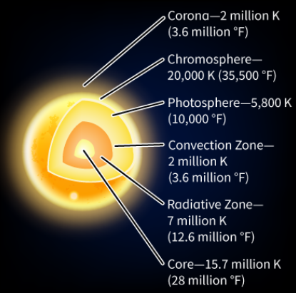

* The ______________ layers of the sun extend outward from the center like a series of nested spheres. The first three layers—______________, ______________ zone, and ______________ zone—compose the sun’s ______________ structure.
* The ______________ is the innermost layer where the sun’s energy is produced by fusion reactions.
* The energy travels slowly through the dense second layer, the ______________ zone.
* In the third layer, the ______________ zone, huge currents form and bubbles of hot ______________ rise to the surface.
* The sun’s three ______________ layers—______________, ______________, and corona—form its ______________, the part we see from Earth.
* The ______________ at the surface is where visible ______________ appears.
* The ______________ above it emits a bright ______________ glow as ______________ burns off.
* The final layer, the ______________, surrounds the ______________ like a crown of light and helps ______________ the sun’s ______________ into space.
* The ______________ and ______________ are visible to the naked eye only during a total solar eclipse.
* The temperatures of these ______________ layers vary widely and reach levels that are hard to imagine.
* The ______________, where energy is generated, is the ______________ layer, with a temperature of several ______________ degrees.
* Temperatures then decrease through the radiative and conduction zones until they reach “only” 5,800 K (10,000°F) in the ______________.
* Temperatures then rise again through the ______________ and the ______________, which is the hottest ______________ layer. Scientists have yet to understand why the sun’s outer atmosphere is several million degrees ______________ than its ______________.
* The sun, like all stars, emits large amounts of ______________. Because the total amount of matter and energy is ______________, this energy has its origin in matter and forces deep within the ______________.
* The sun has ______________ that transfer energy from its ______________.
* Eventually, some of this energy is ______________ to Earth through different processes. Evidence for this energy ______________ is the energy that enters Earth’s ______________, the plants that ______________ that energy, and the animals to which it is transferred. Some effects of changes in activity on the sun’s ______________ can be felt on ______________.

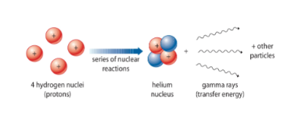

* ______________ is the element that ______________ the sun, and the center of each hydrogen atom is its ______________.
* Most of the energy that the sun emits is released when a strong ______________ attraction between hydrogen ______________ squeezes the hydrogen ______________ together.
* With enough pressure, four ______________ atoms can undergo ______________ fusion and form a ______________ atom, with the release of tremendous amounts of ______________ energy.
* The rest of the energy ______________ by the sun comes from ______________ reactions involving other types of ______________.
* Once this energy is released, it is ______________ through the ______________ of the sun and eventually through ______________ to Earth.
* Solar energy ______________ in all directions from the sun’s ______________ as ______________ radiation. It travels at the speed of ______________ and reaches Earth’s surface in about ______________ minutes.
* The surface of the sun is a very ______________, high-energy place. This release of ______________ is ______________ but not always ______________.
* When electrically charged ______________ move, they produce ______________ fields that are in ______________ motion. Depending on the ______________ of the ______________ fields, ______________ intense ______________ of energy and matter occur.