**Guided Notes: Spectroscopy**

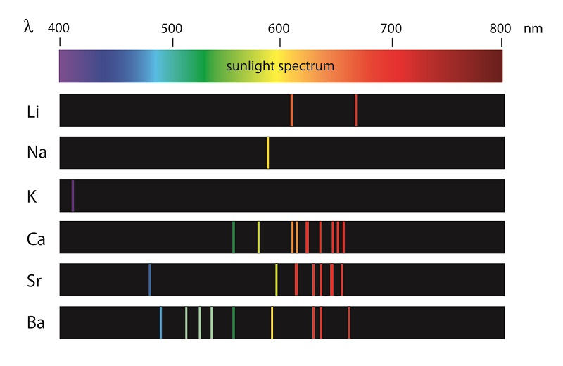 The ______________ spectrum is the range of all types of electromagnetic ______________, or different types of ______________, designated by ______________.

______________ light is electromagnetic ______________ that the unaided human eye can see.

**Key Terms:**

* Define visible light: _______________________________________________________________________________________
* Define non-visible light: _______________________________________________________________________________________
* Define wavelength: _______________________________________________________________________________________
* Define frequency: _______________________________________________________________________________________

**Key Concepts:**

* 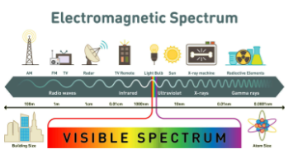
* ______________ light has wavelengths between ______________ nanometers (nm) and ______________ nm.
* Sources of visible light include the ______________, the ______________, and lightbulbs, such as fluorescent and LED bulbs.
* All of the other forms of ______________ radiation on the electromagnetic ______________ that are not visible light are ______________ light.
* Examples of non-visible light include ______________ waves, microwaves, ______________ light, and X-rays.
* ______________ light has more energy than ______________ light and ______________ between 400 nm and 10 nm.
* The natural source of ______________ light for Earth is the ______________.
* ______________ is the science of studying ______________ and ______________ patterns, called ______________.
* ______________ spectra show a ______________ spectrum with ______________ lines where wavelengths are absorbed by atoms.
* This information is most useful when presented ______________.
* In a graph, ______________ represent ______________ and the ______________ represent ______________ of certain wavelengths.
* The magnitude of the peaks and dips indicates ______________ intensity.

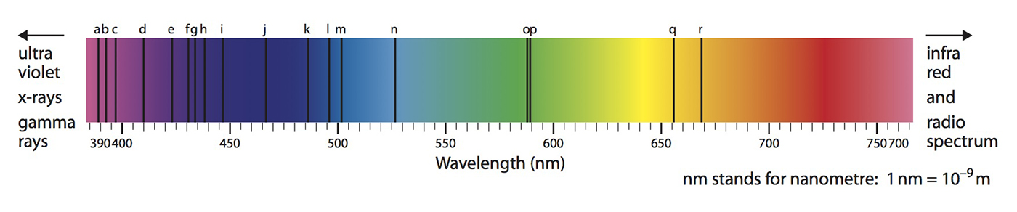

* Why do different stars have different lines? This is the question that leads to the classification of stars, The key factor at work is ______________.
* The temperature scientists are interested in is ______________ temperature of the star.
* All the variations in ______________ lines for different stars are due to the difference in the temperature of the gases located near the ______________ of the stars.
* The ______________ system ______________ the stars based on their ______________ temperatures.
* Stars fall in to one of the following ______________: O, B, A, F, G, K, M.
* These classes go from ______________ to ______________ with O being the ______________ and M, the ______________.
* The main thing to remember about stellar spectra is that they provide astronomers with detail about the ______________ characteristics of the star being analyzed.
* Spectral analysis reveals the surface ______________, motion and ______________ of objects in the universe.
* A star's surface ______________ can be determined from its ______________.
* This is done by using a simple formula for ______________ radiation and solving it for ______________.

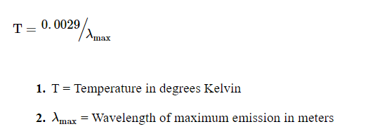

* Using the formula, the ______________ of any star can be determined from the ______________ at which it ______________ the maximum amount of light.
* The classification system ranks the stars based on their surface ______________.
* When something is moving, there is a shift in any of the ______________ emitted from that ______________.
* Think of a train traveling down the tracks while blowing its horn. As it moves ______________ you, the sound waves are shifted toward the ______________ end of the ______________ and you hear a ______________ pitched horn.
* As it passes and moves ______________ from you, the sound waves shift toward the ______________ end of the spectrum and the pitch gets ______________.
* The same thing that happens with ______________, also happens with ______________.
* Astronomers will compare the spectrum of the ______________ to the spectrum of an ______________ that is known to be ______________.
* If the star's ______________ is shifted to the ______________ (toward the ______________ end of the spectrum) then it is moving ______________ from the astronomer.
* If it is shifted to the ______________ (toward the ______________ end of the spectrum), it is moving ______________ the astronomer.
* Every element on the periodic table has a unique ______________ when it is burned. Astronomers compare the known ______________ of elements to the star's ______________ in order to determine if particular elements are being ______________ by the star.
* Spectral analysis has shown that ______________ is the most abundant element in the universe. By observing light ______________ by the hot glowing ______________ from distant galaxies, scientists noticed that ______________ lines for ______________ shifted to the ______________ frequency, the ______________ wavelength ______________ end of the visible spectrum.
* This ______________ Effect shift indicates that the viewer is moving ______________ from the source, which is the distant galaxy. In fact, all the ______________ are moving ______________ from us and ______________ from each other.