**Guided Notes: Star Types**

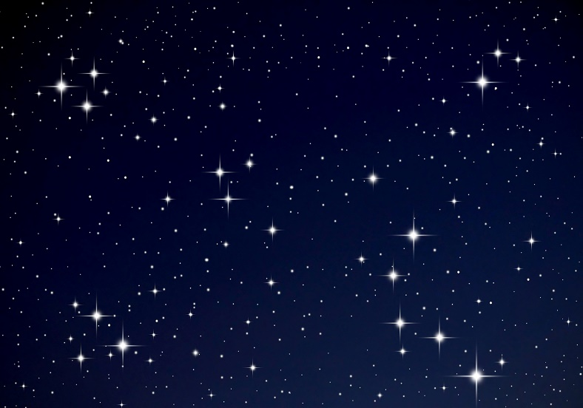On a clear, dark night, thousands of stars are visible in the sky. There are slight ______________, but they all look very much like ______________ points of ______________.

Yet they are ______________ bodies, often many times larger than the ______________. Because stars are not all alike, ______________ have found ways to ______________ them.

**Key Terms:**

* Define apparent magnitude: _______________________________________________________________________________________
* Define absolute magnitude: _______________________________________________________________________________________
* Define electromagnetic radiation: _______________________________________________________________________________________
* Define spectroscopy: _______________________________________________________________________________________
* Define spectral lines: _______________________________________________________________________________________
* Define spectrograph: _______________________________________________________________________________________
* Define light spectrum: _______________________________________________________________________________________
* Define absolute magnitude: _______________________________________________________________________________________
* Define luminosity: _______________________________________________________________________________________

**Key Concepts:**

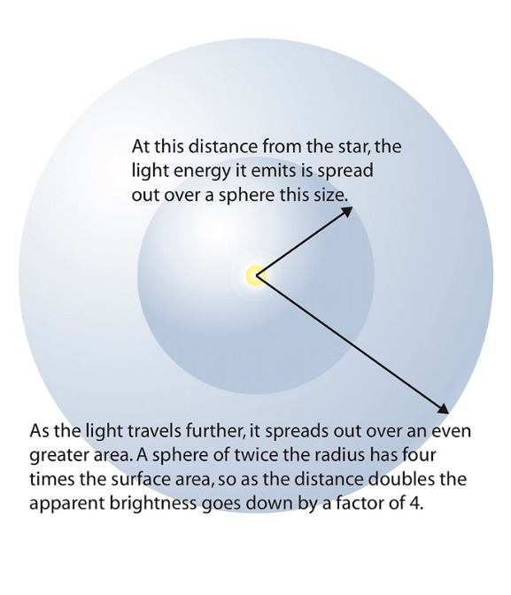

* An important ______________ characteristic of stars is ______________.
* All stars except the ______________ are so far away from Earth that many seem ______________ bright in the night sky.
* Astronomers call this measure of ______________ apparent ______________.
* It is independent of the star’s ______________ or ______________.
* Even a dim ______________ can appear ______________ compared to a much ______________ star if the brighter star is much ______________ away.

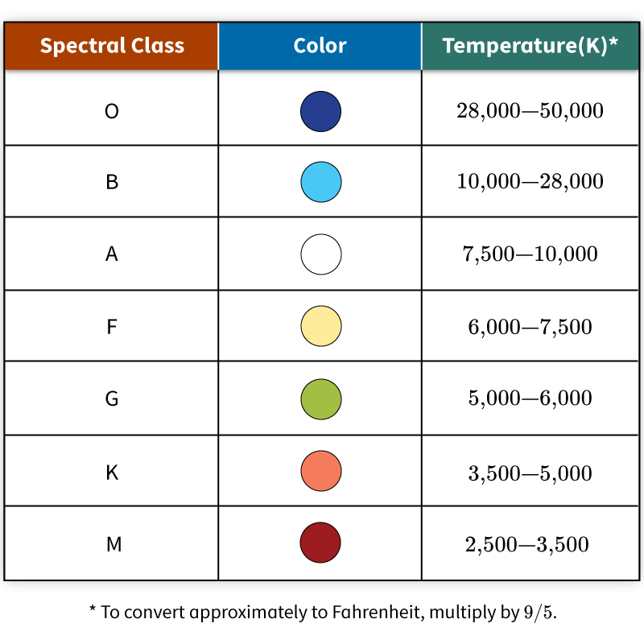

* Astronomers classify stars by their ______________ class.
* The spectral class of a star is dependent upon its ______________ and ______________.
* The ______________ stars are ______________ (Class M) and ______________ (Class K), while the ______________ stars are ______________ (Class O and Class B).
* Each spectral class is then subdivided, 0 to 9.
* The higher the ______________, the ______________ the star within that category.
* The ______________ is a Class ______________ yellow star, composed primarily of ______________ and ______________.

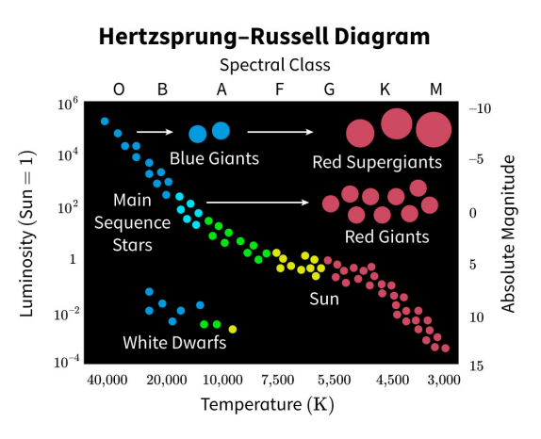

* The H-R Diagram shows the relationship between star ______________, such as ______________ (how bright a star is) and ______________.
* Luminosity is plotted on the ______________, with ______________ stars at the top.
* Temperature (Kelvin scale) is plotted on the ______________, with ______________ stars on the left.
* The Diagram shows that the stars fall into four ______________:
  + Main ______________ stars, such as our sun, are the most common. They are ______________ stars using ______________ in fusion reactions to create ______________.
  + ______________ are cool stars that have high ______________ because they are large. Main sequence stars that use up their ______________ fuel can become giants or ______________.
  + ______________ are smaller than supergiants but hotter, giving them only slightly less ______________ than supergiants.
  + ______________ dwarfs are hot but have low ______________ because they are ______________. These are the ______________ cores of old stars that have thrown off their ______________ layers.
* Astronomers can study exactly how the objects ______________, ______________, and ______________ electromagnetic radiation to learn more about them.
* They can use a ______________ to break up the electromagnetic ______________ into component colors.
* Stars also have light ______________.
* Astronomers use data from light ______________ of stars to ______________ stars.
* The light spectrum of a star allows astronomers to learn about what a star is ______________ of, its ______________, and its ______________.
* Astronomers can also estimate the ______________ and ______________ of a star from its ______________ spectrum.