**Guided Notes: Sun’s Magnetism**

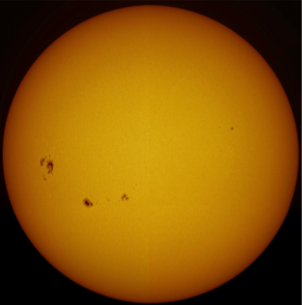

Like all stars, the sun is composed of ______________, a type of super-heated ______________ in which the particles are ______________.

Streams of these particles, called a ______________ wind, ______________ the solar system. Most of the sun’s properties are generated by processes in its complex ______________.

**Key Concepts:**

* While ______________ have been observed by people for perhaps ______________ of years, it is only recently that scientists have learned what causes them.
* The activity ______________ on the ______________ of the sun can be explained by the sun’s ______________ properties.
* On Earth most matter is made of ______________, ______________, or ______________.
* By contrast, most of the ______________ in the ______________, including the sun, is made of ______________.
* ______________ is matter that has been heated to such a degree that some of the ______________ are ______________ off their atoms, resulting in a swirling ______________ of charged ______________.
* A flow of electrically charged ______________ can generate a ______________ field.
* The sun ______________ around an ______________ much like Earth does, but because it is made of ______________, it does not ______________ evenly.
* A point on the sun’s ______________ takes 25 ______________ to make a full rotation, while a point on the ______________ takes up to 35 ______________.
* So the ______________ in the sun is constantly ______________ and ______________.
* The differential ______________ of ______________ results in ______________ fields that ebb and flow.
* This system that produces the magnetic fields of the sun is called the solar ______________, named after the device that generates an electric ______________ via a moving ______________ field.
* Often, the ______________ magnetic fields pop out of the sun’s ______________, acting like horseshoe ______________ with ______________ and ______________ end.
* These regions are slightly ______________ than the rest of the sun’s ______________, so they appear ______________ in ______________. These ______________ spots are what we observe as ______________.
* The ebbs and flows of the ______________ field of the sun are ______________.
* For several years the ______________ field of the sun tends to line up with the two ______________, and sunspots ______________ almost completely.
* This is called a solar ______________.
* Several years later, the magnetic fields grow more ______________, resulting in ______________ of ______________ and other activity on the surface of the sun.
* This is called a solar ______________. It takes about 11 years for the sun to go through one ______________.

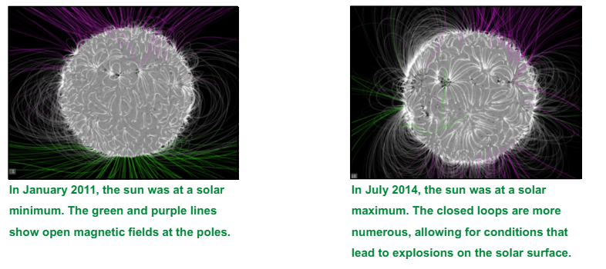

* The solar ______________ drives the sun ______________.
* At the solar ______________, the sun’s magnetic field is mostly ______________ out and its field lines are ______________ towards the North and South ______________.
* At the solar ______________, the field is more ______________, resulting in ______________ and ______________ solar events. Complex computer calculations model the positions of ______________ field lines.
* ______________ are not the only feature associated with the sun’s ______________.
* The ______________ magnetic field of the sun also results in dramatic ______________ of ______________ and ______________.
* These can even interfere with and ______________ electronic equipment on ______________.
* Solar ______________ and ______________ mass ejections are closely associated with ______________.
* These often, but not always, occur at ______________, and they ______________ occur at the ______________ time.
* The ______________ explosion in the solar system is a ______________ flare, which occurs when some of the ______________ energy of a ______________ is released, equal to the amount of ______________ in millions of 100-megaton hydrogen bombs ______________ at once.
* ______________ of almost every ______________ of the electromagnetic ______________, including ______________ light, is released.
* Solar ______________ can last from a few ______________ to an ______________.
* Solar ______________ can only be seen using specialized ______________ on Earth or in ______________ around Earth, but their ______________ can be ______________ when they ______________ with ______________ transmissions.
* Sometimes a large ______________ in a ______________ field of the sun can ______________ from the surface, usually at ______________, carrying with it an enormous bubble-shaped mass of solar ______________.
* This is called a ______________ mass ejection (CME).
* These ______________ expand as they ______________, carrying as much as a ______________ tons of matter ______________ of miles per hour through space.
* CMEs often occur at the same time as ______________ flares.