**Guided Notes: Stars and Constellations**

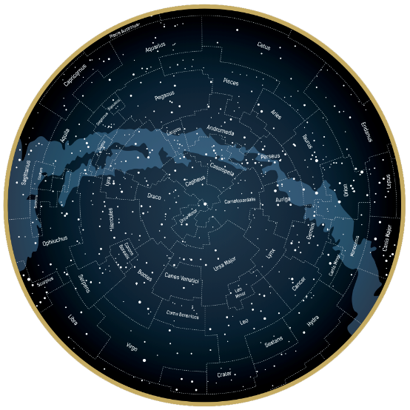 Astronomers first understood that the ______________ in the night ______________ were like our ______________ in the ______________ century, after the invention of the ______________ and the discovery of the laws of ______________ and ______________.

In the nineteenth century, the use of ______________ and ______________ allowed astronomers to understand the ______________, ______________, ______________, and life ______________ of stars. Today, astronomers learn about the invisible ______________ that comes from stars by using radio ______________ and ______________ that gather ______________ data.

**Key Terms:**

* Define constellation: _______________________________________________________________________________________
* Define plasma: _______________________________________________________________________________________

**Key Concepts:**

* Characteristics of stars include things like ______________, size, ______________, and brightness.
* Stars are mostly made up of ______________ and hydrogen, but they do contain small amounts of ______________ elements as well.
* Stars are giant, spherical collections of ______________ that generate ______________ and ______________ because of the ______________ reactions taking place within them.
* Small ______________ fuse together to form ______________ elements inside stars—a process that releases large quantities of ______________.
* This means that the ______________ that makes up all living things on Earth was formed inside ______________ stars.
* ______________ stars forming today include higher ______________ of ______________ elements than stars that formed when the universe was ______________.
* Stars differ in their ______________, ______________, surface ______________, ______________ (size), ______________, ______________ field strength, and ______________ (elements above helium within the star).
* Astronomers often compare stars to our ______________. For example, the masses of other stars are given in ______________ masses. Alpha Centauri is 1.08 solar masses. Betelgeuse, one of the brightest stars in the night sky, is approximately 20 solar masses.
* There are 88 ______________ recognized by the International ______________ Union (IAU) in the night sky.
* As more advanced ______________ and ______________ capture images of the night sky, more and more stars fill the pictures—so many that finding the shapes made by constellations becomes more difficult!
* So, the IAU defines ______________ by their ______________, not the ______________ made by their star ______________.
* Astronomers indicate the ______________ of newly discovered stars using the constellation ______________ within which they are found.
* This is particularly helpful for ______________ stars, which ______________ and ______________ instead of shining ______________.
* Many of the constellations recognized by the IAU were named by the ancient ______________, who learned about constellations from the ancient ______________, ______________, and ______________.