**The Age of Earth Guided Notes**

**Guided Notes: How Old is the Grand Canyon**

**Big Idea:** Scientists use __________ __________ to determine the relative ages of rock layers and fossils, but not the exact ages.

**Key Concepts:**

* The study of the structure of Earth is called ___________.
* The idea that processes today occurred the same way in the past is called _________________.
* _________ are traces or remains of once-living organisms.
* Matching rock layers between locations is called ____________.
* The law of __________ states that a rock layer is older than layers above it.
* The law of __________ states that something cutting across layers is younger.
* The law of __________ states that a rock contained inside another is older.

**Real World Examples:**

1. When a fault cuts across layers of rock, we know the fault is _________ than the layers it cuts through.
2. Marine fossil shells found in rock layers indicate that area was once under _______ ________.

**Guided Notes: Absolute Age of Rock and Fossils**

**Big Idea:** Scientists use ______ ______ and ______ _______ to determine the absolute ages of rocks and fossils.

**Key Concepts:**

* Carbon-14 is a radioactive ______ of carbon that decays into nitrogen-14 over time.
* The ______ of carbon-14 is about 5,700 years.
* After death, the carbon-14 in organisms begins to ______.
* By comparing the remaining carbon-14 to carbon-12 ratio, scientists can determine how long ago the organism ______.
* ______ _______ are fossils that existed for a short period of time geographically widespread.

**Real World Examples:**

1. You find a fossil scaphite, an extinct marine creature, embedded in a rock layer. Scaphites lived 145-66 million years ago during the ______ Period. This means the rock layer is from that time period.
2. Scientists estimate that by 2050, the atmospheric ratio of carbon-12 to carbon-14 will resemble materials that are 1,000 years old due to increased ______ pollution from burning fossil fuels.

**Guided Notes: Could Mesosaurus Swim Across the Ocean**

**Big Idea:** The locations of rocks and fossils around the world are due to the _________ of tectonic plates.

**Key Concepts:**

• Continental drift is the idea that _________ move over Earth's surface.

• Pangaea - the name of a single landmass that began to break apart _____ million years ago

• Mesosaurus was a reptile that lived in the _______ Period and its fossils were found in Africa and ______ __________.

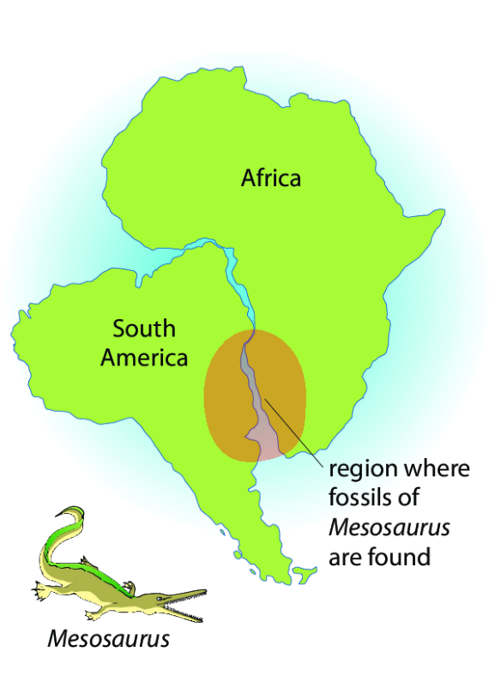

**Real World Examples:**

1. In 1998, Ben Lecomte swam across the _________ Ocean, covering about 3,700 miles in 73 days.
2. Animals that live in _________ have special adaptations that Mesosaurus did not seem to have.

**Guided Notes: The Growing Atlantic Ocean**

**Big Idea:** The Atlantic Ocean is getting larger due to the process of _________ ___________.

**Key Concepts:**

* The ocean floor has ________ _________ where new crust forms.
* Scientists use ________ to map the ocean floor by sending sound waves that bounce back.
* Harry Hess proposed the _________ _________ hypothesis based on sonar data.
* Evidence for seafloor spreading includes __________ ___________, ____________ activity, and ________ __________.

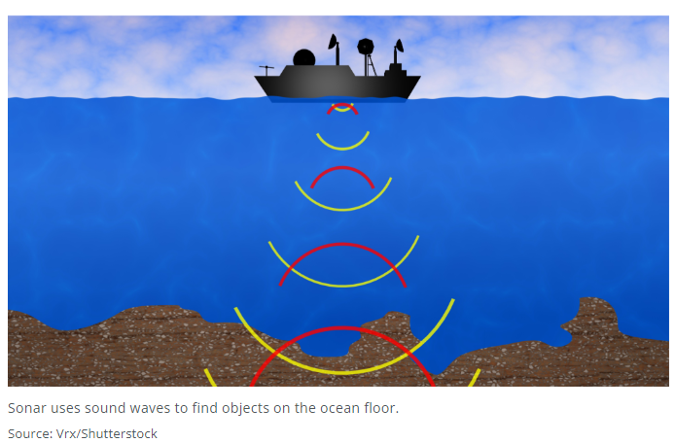

**Real World Examples:**

1. Over time, the __________ Ocean is getting larger, while the ________ Ocean is getting smaller.
2. Mapping the entire ocean floor could lead to damages if companies extract resources without considering the ___________ impact. There are also legal questions about who _______ any resources discovered.