**Solar System Guided Notes**

**Guided Notes: Gravity and Orbits**

**Big Idea:** Gravity, an attractive force between objects with __________, causes less massive objects to __________ around more massive objects in space.

**Key Concepts:**

* Gravity depends on the __________ of the objects involved and the __________ between them
* Objects with larger masses exert a stronger __________ pull
* As the distance between objects increases, the gravitational __________ decreases
* The sun's immense __________ causes the planets to orbit around it rather than drift away
* Artificial __________ can be created on spaceships by rotating to simulate gravity's effects

**Real World Examples:**

1. The __________ orbits around the more massive Earth due to Earth's stronger __________ pull on the moon.
2. Astronauts experience bone/muscle weakening in low__________, so rotating spaceships may create artificial gravity to address these health effects.

**Guided Notes: Moon and Planets**

**Big Idea:** The solar system is divided into two main groups of planets - the _________ planets and the __________ planets - that differ in their characteristics.

**Key Concepts:**

* The inner planets (Mercury, Venus, Earth, Mars) are __________ planets because they have rocky features similar to Earth.
* They have a crust, __________, and core structure.
* Their atmospheres vary - Venus has a thick ____________ atmosphere keeping it very hot.
* The outer planets (Jupiter, Saturn, Uranus, Neptune) are called _________ because they are mostly made of swirling gases and liquids.
* They have no solid surfaces and are much __________ than the inner planets.
* Saturn has prominent _________ made of dust, rock and ice particles.

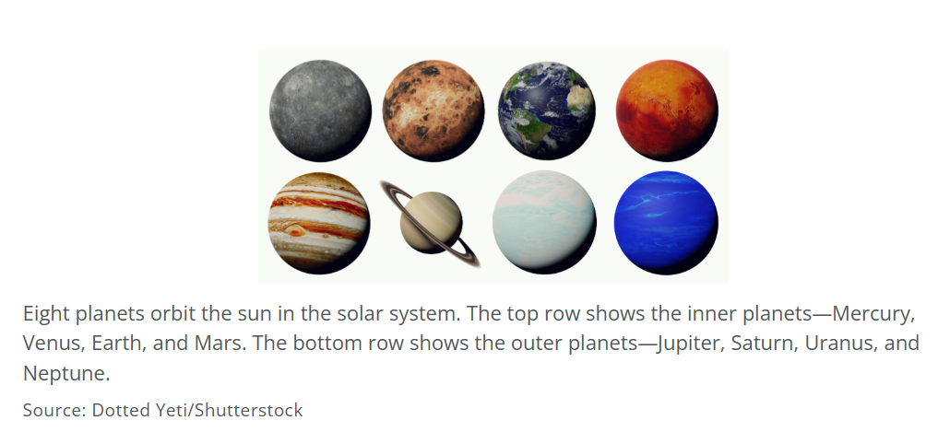

**Real World Examples:**

1. Global warming on Earth is caused by increased levels of ________________ in the atmosphere, acting like a blanket and trapping heat. This is similar to how the thick _____________ atmosphere on Venus makes it the hottest planet.
2. Plans have been proposed to establish a human colony on Mars in the future. Living on Mars would be very different than on Earth due to its thin __________ and harsh surface conditions.

**Guided Notes: Orbiting Bodies’ Properties**

**Big Idea:** The _______ _______ allows Earth's atmosphere to trap _______ from the sun, making Earth warm enough to support life as we know it.

**Key Concepts:**

* An __________ is a small, rocky object that orbits the sun.
* A __________ is a ball of ice and dirt that orbits the sun.
* A __________ is a large object in space that orbits a planet or asteroid.
* _______ _______ are gases that trap Earth's heat, like carbon dioxide, methane, and nitrous oxide.
* Without the greenhouse effect, Earth would be about ____°C (____°F) colder.
* Human activities like burning _______ _______ are increasing greenhouse gas levels in the atmosphere.

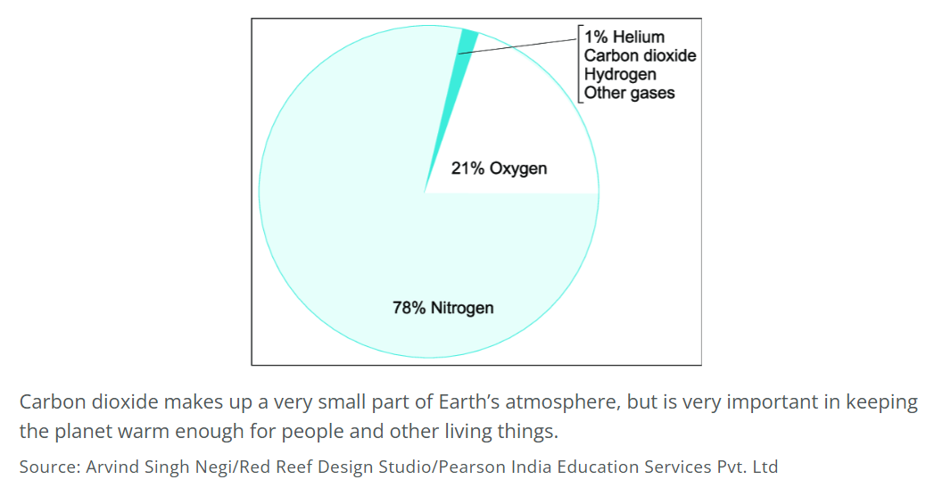

**Real World Examples:**

1. Venus has a very thick atmosphere made up mostly of _______ _______. This causes a runaway __________ effect, making the surface temperature 465°C (900°F).
2. Mars has a very _______ atmosphere that cannot trap much heat. As a result, Mars is extremely _______ and cannot support most life as we know it.

**Guided Notes: Galaxies and the Universe**

**Big Idea:** Earth and its ________ __________ are part of the _______ _______ galaxy, which is one of many galaxies in the universe.

**Key Concepts:**

* A _________ is a group of stars, gas, and dust held together by gravity.
* The Milky Way galaxy is about 100,000 ________-_________ across.
* The Milky Way contains 100 to 400 billion _________.
* At the center of the Milky Way is a supermassive ________ _________ which has extreme gravitational pull.
* The Milky Way is on a collision course with the ____________ galaxy in about 4 billion years.

**Real World Examples:**

1. When the Milky Way and Andromeda galaxies eventually collide, Earth likely won't be harmed because the stars are so far __________ from each other in the vastness of space.
2. You can think of Earth's place in the universe like an address. Earth is our home, the _______ ________ is our galactic neighborhood and the ______ _______ galaxy is the galactic city containing billions of neighborhoods.

**Guided Notes: Solar System Distances**

**Big Idea:** The solar system is huge! To understand the giant distances between planets, we use a special unit called the _________________ ________ (AU).

**Key Concepts:**

* The astronomical unit (AU) makes solar system _________ easier to think about instead of using large kilometer numbers.
* 1 AU = the distance from the Earth to the _____ (about 150 million km)
* We can model the distances by using the scale 1 AU = ____.

**Real World Examples:**

1. If your school is 2 cm away on your model, that's about the same as the __ AU distance from the Earth to the Sun!
2. Mars is about 3 cm away from the Sun model, which equals about ____AU in real distances.

**Guided Notes: Solar System Scale**

**Big Idea:** ___________ models are useful for visualizing and comparing very large or very small objects.

**Key Concepts:**

* A scale model is a _________ of an object that is smaller or larger than the actual object.
* Scientists use scale models to study:
  + Very _________ objects like parts of an atom
  + Very _________ objects like planets
* To create a scale model, a _________ is chosen to represent the actual size (e.g. 1 cm = 10,000 km)

**Real World Examples:**

1. Architects use scale models when planning new ___________ to visualize the layouts.
2. A model airplane is an example of a scale model, with the wings and wheels in the same proportion as a real plane but much _________.

**Guided Notes: Gravity**

**Big Idea:** Gravity is the __________ force that formed the solar system and keeps planets in __________ around the sun.

**Key Concepts:**

* Gravity is the attractive force between objects with __________.
* The strength of gravity depends on:
  + The __________ of the objects
  + The __________ between the objects
* The sun's immense mass allows its __________ to keep planets and other objects __________ around it.
* The planets’ __________ as they orbit the sun prevents the sun’s gravity from pulling all of the planets into it.
* The gravity of the sun and the moon pull the water in the oceans slightly upward, producing __________.

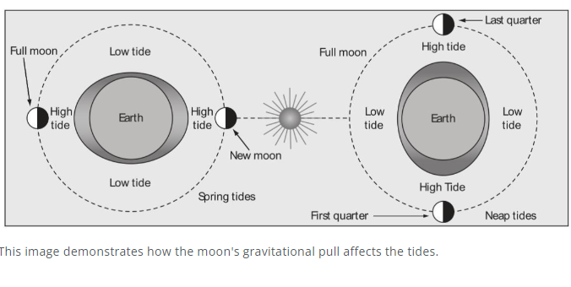

**Real World Examples:**

1. Earth's gravity prevents you from floating off into ___________.

2. _________ experiences the strongest gravitational pull from the sun, despite not being the closest planet, because of its huge __________.

**Guided Notes: Earth’s Formation**

**Big Idea:** Scientists use ____________ and _______________ reasoning to develop and test theories about how Earth formed based on ________________.

**Key Concepts:**

* Earth formed about _____ billion years ago from a rotating disk of space rocks and gases.
* Much of this material was pulled in by the _________ of the sun.
* Remaining material clumped together due to __________, eventually forming planets like Earth.

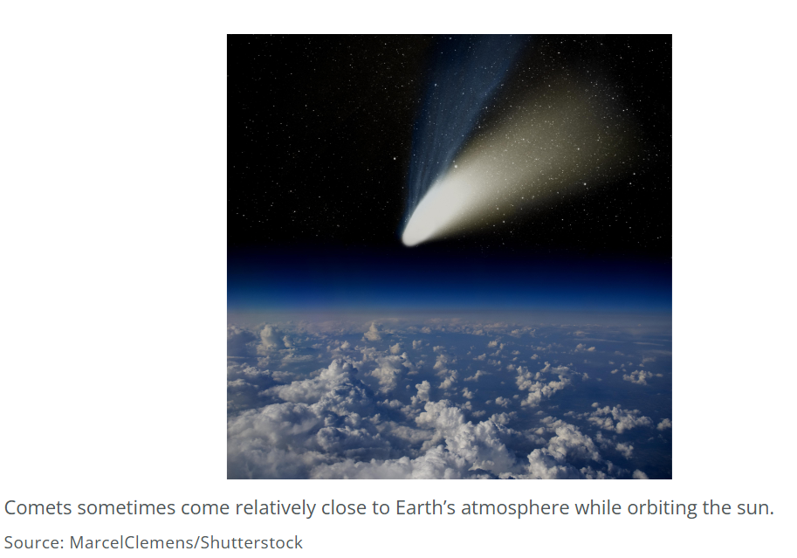

**Real World Examples:**

1. Analysis of __________ shows they carry water, supporting the idea that water was brought to Earth by icy space rocks after it formed.

2. Similarities between _________ rocks and Earth rocks support the giant impact theory that the Moon formed from debris after a collision with Earth.

**Guided Notes: Geologic Time Scale**

**Big Idea:** The __________ __________ __________ is used to organize Earth's history into blocks of time based on evidence.

**Key Concepts:**

* Rocks and the __________ they contain provide evidence about the history of Earth
* __________ rock layers formed first, so the oldest rocks/fossils are in the lower layers
* Important events in Earth's history mark the divisions between periods on the __________ __________.

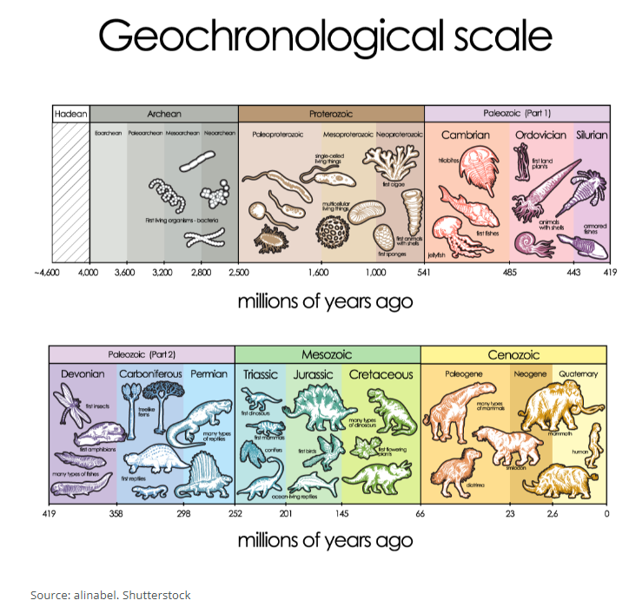

**Real World Examples:**

1. Finding _________ levels in rock layers provided evidence that a massive asteroid struck Earth 65 million years ago, causing the extinction of the ___________.

2. The Tyrannosaurus Rex fossil was found in the _______ period of the Mesozoic Era, while simpler life forms like __________ are found in lower, older rock layers.