**Earth’s Energy Systems Guided Notes**

**Guided Notes: The Structure of Earth**

**Big Idea:** Earth's interior is composed of different __________ with varying __________, __________, and __________.

**Key Concepts:**

* The topmost layer is the __________, which is solid and rocky
* Below the crust is the __________, Earth's thickest layer
* The mantle can be divided into the __________, __________, and _____
* The center of Earth is the __________, divided into the __________ and __________.
* The outer core is __________ while the inner core is __________.

**Real World Examples:**

1. When an __________ occurs, seismologists can detect the different types of __________ waves to study Earth's interior layers.

2. The __________ layer of Earth is where we live and is the only layer with liquid __________.

**Guided Notes: Earth’s Interior Energy**

**Big Idea:** There is a great amount of _____ _____ that flows within Earth's interior and out from Earth's interior.

**Key Concepts:**

* Earth's interior has four layers: _____, _____, _____ _____, and _____ _____.
* _____ _____ are the movement of particles within a heated fluid.
* Plates on Earth's crust move due to _____ _____ in the mantle.
* Energy flows from Earth's interior through _____ _____ and volcanic eruptions.

**Real World Examples:**

1. When an _____ occurs, it shows the energy flowing out from Earth's interior.

2. Geysers like Old Faithful are evidence of the _____ _____ within Earth.

**Guided Notes: Radiation from the Sun**

**Big Idea:** The sun's __________ provides energy that is __________ to warm Earth and its __________.

**Key Concepts:**

* Earth's main source of energy is the __________.
* __________ is the transfer of energy by electromagnetic waves.
* __________ __________ is energy that travels by radiation.
* Earth __________ some of the sun's radiant energy and __________ some back into space.
* The __________ __________ keeps Earth warm by trapping heat from the sun.

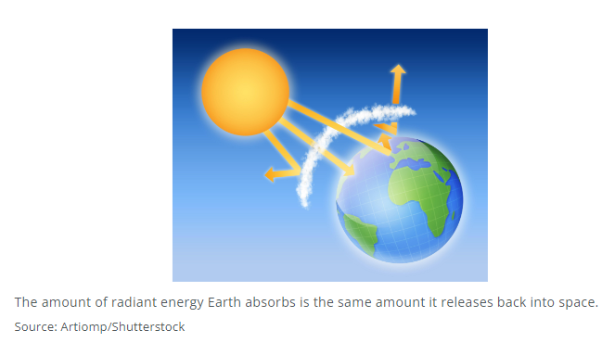

**Real World Examples:**

1. On a hot summer day, the __________ can make surfaces like __________ feel very warm when you walk on them.

2. A __________ works in a similar way to the greenhouse effect by trapping __________ inside while letting sunlight pass through.

**Guided Notes: The Water Cycle**

**Big Idea:** The ______ _____ is the constant movement of water between Earth and the air as water changes _____.

**Key Concepts:**

* Water is needed for _____ to exist.
* _____ is when liquid water turns into water vapor.
* _____ is when water vapor cools and forms water droplets/clouds.
* _____ is water that falls from clouds as rain, snow, sleet or hail.
* _____ is water that flows over land before entering bodies of water.

**Real World Examples:**

1. During the process of _____, plants release water through holes in their leaves.

2. When you see your _____ fog up a mirror, that is actually water vapor from your breath condensing on the cool surface.

**Guided Notes: Physical Weathering of Rock**

**Big Idea:** Physical weathering is the breaking down of rocks into smaller pieces without any ________ processes involved.

**Key Concepts:**

* __________ is the wearing or grinding away of rock due to friction or collision.
* __________ is when water that has entered cracks in rock freezes and expands.
* Factors that cause physical weathering include:
* ________ blowing sand/particles against rocks
* ________ waves crashing against rocks
* ________ changes causing expansion/contraction
* ________ roots growing in rock cracks
* ________ digging/burrowing

**Real World Examples:**

1. The ________ has shaped the rock in the desert over thousands of years by blowing sand particles that grind against it.
2. The tremendous force of ________ beating against the rocky shoreline causes pieces of rock to break off through abrasion.

**Guided Notes: Chemical Weathering of Rock**

**Big Idea:** Chemical weathering is the ________ of rocks due to chemical reactions.

**Key Concepts:**

* ________ causes some rocks to break down and form salt solutions and clay minerals inside.
* ________ occurs when oxygen combines with iron in rocks to form rust.
* ________ ________ is formed when carbon dioxide and rainwater mix, dissolving certain rocks.
* ________ ________ forms when pollutants mix with rainwater, causing faster rock breakdown.

**Real World Examples:**

1. The Lincoln Memorial shows cracks due to the chemical weathering of the ________ it is made from.
2. Many ________ release pollutants that mix with rainwater to create acid rain, causing chemical weathering.

**Guided Notes: The Rock Cycle**

**Big Idea:** The _________ _____________ is a continuous series of processes that changes one type of rock into another type of rock.

**Key Concepts:**

* There are three types of rocks: igneous, __________, and __________.
* Igneous rocks form from _____________ _____________.
* _____________ rocks are made of pieces of rock pressed/cemented together.
* Metamorphic rocks form from great heat and __________.
* Forces like weathering, erosion and deposition act on the __________.
* Heat and pressure inside Earth act on rocks in the __________.
* The processes of _____________ and _____________ move rocks between the surface and interior.

**Real World Examples:**

1. The beautiful arches in Arches National Park, Utah were formed by the _____________ of sandstone over millions of years.

2. Bauxite, used to produce aluminum, is a sedimentary rock where aluminum _____________ have cemented together over time.

**Guided Notes: Plate Tectonics and the Rock Cycle**

**Big Idea:** Heat energy from inside Earth's interior drives the movement of tectonic __________ and causes rocks to continuously change form in the __________ cycle.

**Key Concepts:**

* Earth's crust and upper mantle are divided into huge slabs of rock called __________ __________.
* Tectonic plates move due to convection __________ of hot magma in the mantle.
* Rocks change form through the rock cycle by processes like:
  + ____________, erosion, deposition (sedimentary rocks)
  + Heat and ____________ (metamorphic rocks)
  + Cooling of ____________ (igneous rocks)

**A diagram convection currents
**

**Real World Examples:**

1. As a pot of water boils, the hot water rises and cool water sinks, driven by __________ currents - just like how hot magma in the mantle causes tectonic plates to move.
2. An igneous rock on Earth's surface can break down into sediment, get buried and compacted into a __________ rock, then get heated deep underground to become a __________ rock over millions of years.