Geometry
Geometry Basics
Unit Summary: Geometry is a form of mathematics that focuses on sizes, shapes, angles, and dimensions. In this unit, you will learn the basics of geometry relating to lines, angles, and triangles. You have learned many of the basic ideas of these properties in the past. Remembering the definitions of parallel lines, perpendicular lines, and angles will be helpful in this unit. Additionally, you will recall the characteristics of a triangle and the theorems that prove those characteristics to be true.

Lesson 2 – Points, Lines, and Planes
Key Words:
- angle – the figure formed by two lines extending from the same point
- arc – a part of the circumference of a circle or other curve
- circle – a closed plane curve with every point on the curve equidistant from a fixed point within the curve
- conjecture – a statement that is made based on observations but is not yet proven
- definition – a statement that determines the meaning of a term or concept and describes what it is
- Euclidean geometry – the geometry based on Euclid's axioms
- line – a straight figure that has no thickness and extends infinitely in two opposite directions
- line segment – the finite section of a line between two points on that line
- parallel line – a straight line that always remains the same distance from another line and, therefore, never intersects it
- perpendicular line – a line that intersects another line at a 90-degree angle
- point – a geometric element that has zero dimensions and a location determinable by an ordered set of coordinates
- postulate – a statement that is accepted as true and has not been proved
- theorem – a statement that has been proved to be true using arguments and facts that are accepted as true
- undefined term – a term that does not need to be defined because it is explained using examples and descriptions, such as point, line, plane, and space

Objective 1: In this section, you will learn the precise definitions based on the undefined notions of point, line, distance along a line, and distance around a circular arc for the geometric concepts of angle, circle, perpendicular line, parallel line, and line segment.
Mathematical Practice Standard: Reason abstractly and quantitatively.
Big Ideas:
- All definitions in geometry are developed using the undefined notions of point, line, distance along a line segment, and distance along an arc.
Point | Line | Distance | Distance along an arc
Indicates a location and has no dimension.   | Only has one dimension, is straight, and extends forever in two opposite directions.  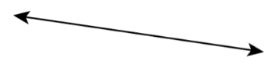 | Distance can only be defined once you know what measurement you are using. One way to measure distance is in a straight line.  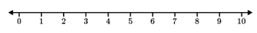 | Another way to measure distance is along the arc of a circle.  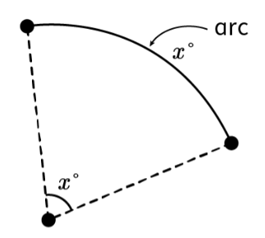
- Angles, segments, circles, and arcs are used to build various shapes in geometry. These shapes are built from undefined notions of points and lines.
Angles | Segments | Circles | Arc
The figure formed by two lines extending from the same point.  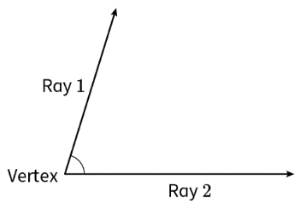 | The finite portion of a line between two points on the line.  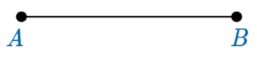 | The set of all points that are equidistant from the center point.  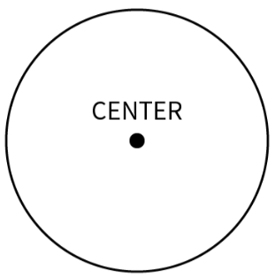 | Part of the circumference of a circle or other curve.  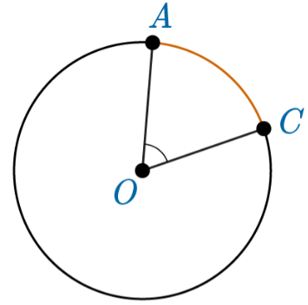
- Parallel lines and perpendicular lines have numerous applications in the real world.
Parallel Lines | Perpendicular Lines
Two lines that never intersect and are the same distance apart.  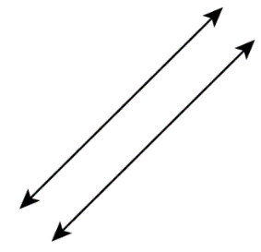 | Two lines that intersect at a right angle.  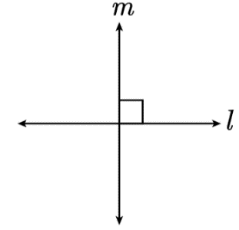

Objective 2: In this section, you will distinguish among undefined terms, definitions, conjectures, postulates, and theorems.
Mathematical Practice Standard: Reason abstractly and quantitatively.
Big Ideas:
- It’s important to be familiar with the key terms in this unit. You will use these key terms to understand how shape, distance, position, and size interact in a space.
- The essential building blocks of geometry are called undefined terms. The undefined terms in geometry are point, line, plane, and space. In geometry, these undefined terms create all shapes.
Undefined Term | Dimension | Real-World Connection
Point | No dimension | - A location on a map  - A pencil tip
Line | 1st dimension | - The yard lines on a football field  - Stripes on a flag
Plane  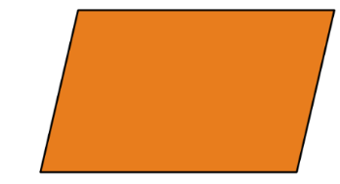 | 2nd dimension | - A windowpane  - A countertop
Space  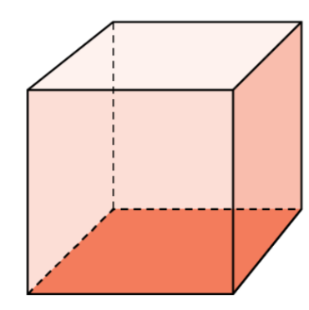 | 3rd dimension | - A room in a house  - A park
- There are five postulates that form the basis of geometry. Assumptions known as postulates are concepts that can’t be proven but must exist.
Five Postulates of Euclidean Geometry
- The shortest distance between any two points forms a straight-line segment.
- Any line segment can be extended forever in both directions to create a line.
- A circle may be described by a point at its center and any distance as its radius.
- All right angles are congruent.
- If a straight line intersects two other straight lines, so that the two interior angles one side of it are less than the right angles, then the other straight line will eventually meet at a point if they are extended far enough on the side on which the angles are less than right angles.
- Postulates lead to definitions, conjectures, and theorems used to assemble new concepts. They build on one another to explain the patterns in various shapes that are created from undefined terms.
Term | Definition | Geometry Example | Distinguishing Features
definition | A statement that explains the meaning of a term or concept. | Square- a four-sided shape with four right angles and four equal sides. | Tells you what a term means or what to do with a concept; assigns meaning.
conjecture | A statement that is made based on observations but is not yet proven. | All four-sided shapes have two diagonals. | Is an educated guess that must be proved true.
theorem | A statement that is proved true using arguments and facts that are accepted as true. | The interior angles of any triangle sum to 180 degrees. | Is a conjecture or concepts that has been proved true using definitions, postulates and/or other proved theorems.

Practice Questions and Answers
 | Question | Answer
P 1 | What are the undefined notions?  Option #1: point, line, distance along a line, and distance around a circular arc  Option #2: arc, parallel lines, perpendicular lines, and angle  Option #3: distance along a line, distance around a circular arc, angle, and arc  Option #4: line segment, angle, point, and arc | Option # 1
P 2 | Use the image to answer the question.    What is the precise definition of the figure in the image?  Option #1: two lines that intersects at a 90-degree angle  Option #2: two lines that never intersect and are the same distance apart  Option #3: two lines that intersect at a vertex point | Option #2
P 3 | Use the image to answer the question.  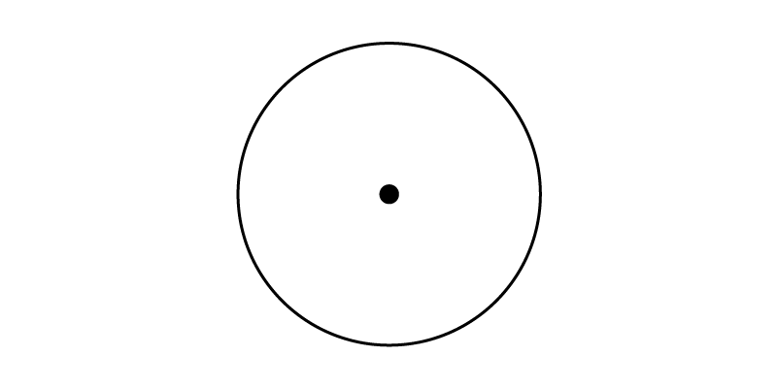  What is the precise definition of the figure in the image?  Option #1: the finite portion of a line between two points on the line  Option #2: a part of the circumference of a circle or other curve  Option #3: the figure formed by two lines extending from the same point  Option #4: the set of all points that are equidistant from a center point | Option #4
P 4 | Distinguish between the following statements. Which statement is a postulate?  Statement #1: A line contains at least two points.  Statement #2: All right angles are equal.  Statement #3: a + b = b + a | Statement #2
P 5 | Distinguish between the following statements. Which statement is a theorem?  Statement #1: All triangles have three sides and three angles.  Statement #2: The interior angles of any triangle sum to 180 degrees.  Statement #3: a + b = b + a | Statement #2

Quick Check Questions and Answers
 | Question | Answer
Q 1 | Precisely define an angle. | An angle is the figure formed by two lines extending from the same point.
Q 2 | What makes a line parallel? | A parallel line is a straight line that always remains the same distance from another line and never intersects it.
Q 3 | Which of the following is an example of an undefined notion? | A line is an example of an undefined notion.
Q 4 | Postulates, definitions, conjectures, and theorems each have distinguishing features that help identify them. Which of the following answer choices accurately represents the term’s distinguishing feature? | A postulate is assumed to be true, and it does not have to be proven.
Q 5 | The building blocks of geometry are the undefined terms of point, line, plane, and space. Which of the undefined terms has no dimension? | a point

Lesson 3 – Constructing Segments
Key Words:
- bisector – a straight line that divides an angle or a line segment into two equal parts
- compass – an adjustable, V-shaped implement with a pencil at one end and a point at the other that is used to draw and measure circles, arcs, and angles
- congruent – of the same shape and size; in geometry, congruent parts overlap perfectly when placed on top of one another
- construct – to create a shape or an object in geometry using appropriate tools
- endpoint – a point or value that marks the end of a line segment or interval
- line segment – the finite part of a line between two points
- midpoint – the exact middle of a line segment
- ray – an endpoint with a line extending forever in one direction
- segment – the finite part of a line between two points on the line
- segment bisector – a straight line that divides a line segment into two equal parts
- straightedge – a bar or piece of material (as of wood, metal, or plastic) with a straightedge for testing straight lines and surfaces or for cutting along or drawing straight lines
Objective 1: In this section, you will construct a segment and a copy of a segment.
Mathematical Practice Standard: Use appropriate tools strategically.
Big Ideas:
- Using key concepts from the previous lesson, you will construct segments, angles, and shapes using a compass and a straightedge. Constructions help mathematicians make conjectures and prove theorems from patterns.
- You can draw constructions using a piece of paper, a compass, and a straightedge. These steps are outlined in the tables below.
Constructing a Ray
Step 1: On a blank piece of paper, place a dot and label it with any capital letter to represent a point in space.   | Step 2: Use a straightedge to draw a line from the point in any direction. Place an arrow at the end.  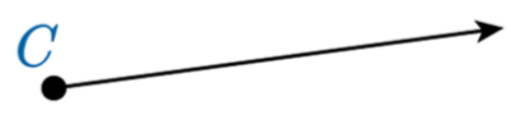  This resulting figure is a ray with an endpoint C.

Constructing a Line Segment
Step 1: On a blank piece of paper, place a dot and label it with any capital letter to represent a point in space.   | Step 2: Place the pointed end of the compass on the point you just drew. Open the compass and draw another point using the pencil end of the compass. Label the second point with a different capital letter.   | Step 3: Use the straightedge to draw a straight line connecting the two points.  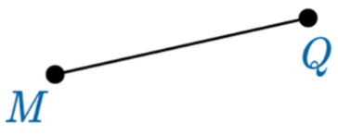  The resulting figure is a line segment MQ with endpoints at M and Q.
- Another useful skill is to construct copies of segments. This is useful when shapes have sides of equal length and you need to duplicate the same segment.
- When you create a copy of a line segment, or other shapes, you call the two segments congruent. Congruent means that the two objects are equal in size, shape, and length.
Constructing a Copy of a Segment
You can also practice copying a segment in this GeoGebra applet!
Step 1: Draw a line segment with two endpoints on a piece of paper. Make sure to mark each endpoint with a capital letter. (see the table above)  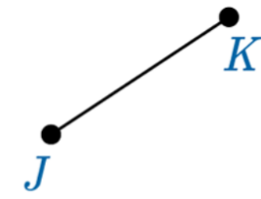 | Step 2: Using a compass, measure the segment by putting the pointed end of the compass on one of the two endpoints. Adjust the other side of the compass so that the pencil end rests on the other endpoint.  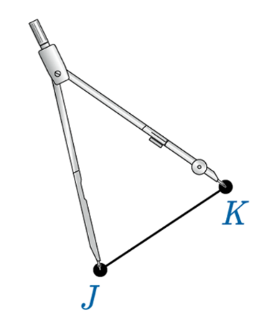 | Step 3: Place a point somewhere else on the paper and label it with a capital letter. Without changing the distance between the legs of the compass from step 2, place its pointed end on the new point. Then, use the pencil side to draw another point and label it with a capital letter.  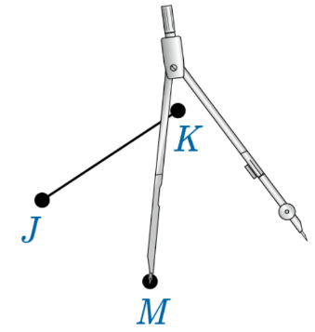 | Step 4: Use a straightedge to draw a line between the two new points.  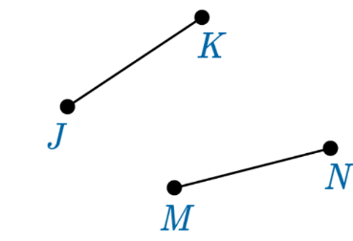

Objective 2: In this section, you will construct a bisector of a line segment.
Mathematical Practice Standard: Use appropriate tools strategically.
Big Ideas:
- It’s important to understand how to correctly write and name lines, segments, rays, and bisectors.
Line Segments and Lines
Line Segments  A line segment is named by its endpoints, with a bar on top of the letters. | This line segment has endpoints M and Q.   | The name of the line segment is $\overline{MQ}$, which is read “line segment MQ.”
Lines  A line can be named by two points on the line, using a line with arrows ( $↔$) on top of the letters. | There is a line that passes through points M and Q.  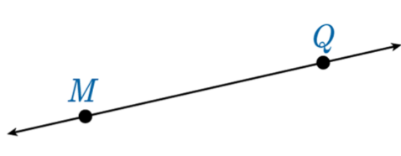 | To refer to the entire line, not just the segment $\overline{MQ}$, you write 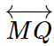.
Length of a Line Segment  To state the length of a line segment, remove the bar on top of the letters. |  | To state that line segment $\overline{MQ}$ is 5 inches long, write $MQ=5$inches.

Bisectors of Line Segments
Segment Bisector  A line, segment, or ray that divides the line segment into two equal parts.  Also known as a bisector of a line segment. | A ray intersects a line segment at its midpoint, A, creating a segment bisector.  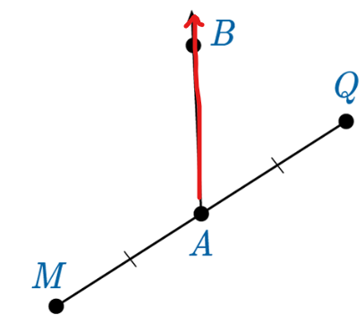 | 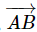 is a segment bisector of $\overline{MQ}$.
Congruent Line Segments  To state that two line segments are congruent, use the congruent symbol, $≅$, between the written statement of each line segment. | From the previous example of a segment bisector, the tick marks on $\overline{MA}$ and $\overline{AQ}$ tell us that these segments are congruent.  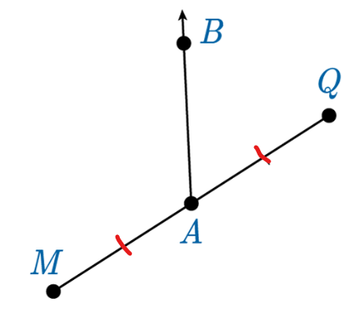 | $\overline{MA}≅\overline{AQ}$ is read as “line segment MA is congruent to line segment AQ”.
Length of Line Segments  To state that two line segments have the same length, remove the bars from the top letters. |  | $MA = AQ$is read as “the length of line segment MA is equal to the length of line segment AQ”.
- There are many methods for constructing segment bisectors, but they all rely on the same major steps.
Constructing a Segment Bisector
You can also practice constructing a segment bisector in this GeoGebra applet!
Step 1: Construct a Line Segment | Step 2: Construct the midpoint of the line segment. | Step 3: Draw a line, segment, or ray that passes through the midpoint of the line segment.

Practice Questions and Answers
 | Question | Answer
P 1 | Said constructed $\overline{AB}$ and then made a copy of the segment. If AB is 14 inches, what is the length of the copy of the segment Said constructed?  The length of the constructed copy of $\overline{AB}$ is _____ inches. | 14
P 2 | Use the image to answer the question.    Ava constructed $\overline{TP}$, as shown in the image. She then constructed $\overline{RA}$ as a copy of $\overline{TP}$. If TP = 189.34 millimeters, what is the measure of $\overline{RA}$?  The measure of $\overline{RA}$ is _____ millimeters. | 189.34
P 3 | Use the image to answer the question.    Jouri constructed $\overline{PT}$ using a compass and straightedge. She then placed point W so that it was not on the segment she just constructed, as shown in the image. What is the next step Jouri must take to construct a copy of $\overline{PT}$ using point W as one of her endpoints?  Option #1: Using a compass, measure the distance between point P and point W.  Option #2: Using a compass, measure the distance between point T and point W.  Option #3: Using a compass, measure the distance between point T and point P.  The next step Jouri needs to take is Option #_____. | 3
P 4 | Use the image to answer the question.  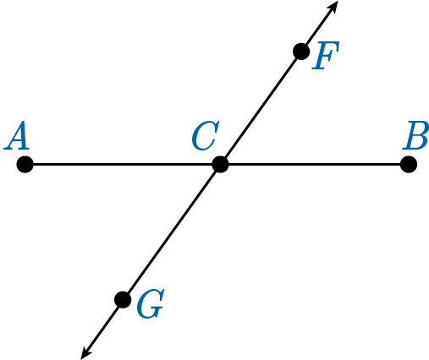  Aimee constructed $\overset{⃡}{GF}$, a line segment bisector of $\overline{AB}$, which passes through point C. If AB = 4 units, what is AC?  AC = _____ | 2
P 5 | Melvin has a line segment on his paper. He wants to construct a line segment bisector using the paper folding method. He has forgotten the steps to complete this construction. Help him by putting the following steps into the correct order.  Option #1: Use a straight edge to draw a line through the point you have created.  Option #2: Fold one endpoint of the line segment onto the other.  Option #3: Unfold the paper and label the intersection of the fold and the line segment with a point.  The first step is Option #_____. The second step is Option #_____. The third step is Option #_____. | 2, 3, 1

Quick Check Questions and Answers
 | Question | Answer
Q 1 | Use the image to answer the question.  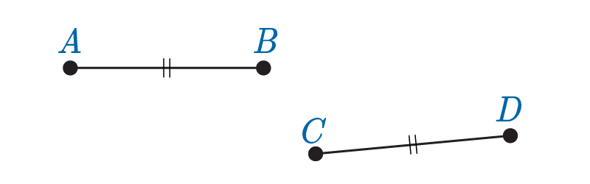  Lucia constructed $\overline{CD}$as a copy of $\overline{AB}$ using a straightedge and a compass. What can Lucia say about AB and CD? | $$AB = CD$$
Q 2 | Use the image to answer the question.  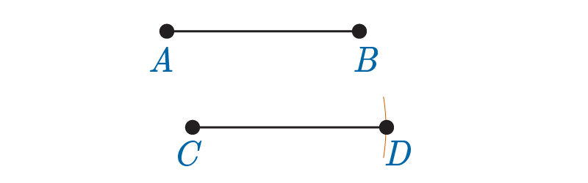  Wei constructed $\overline{CD}$ as a copy of $\overline{AB}$, as shown in the image. What was the last step that Wei did to complete his construction? | Using a straightedge, he constructed a line from point C to point D.
Q 3 | Use the image to answer the question.  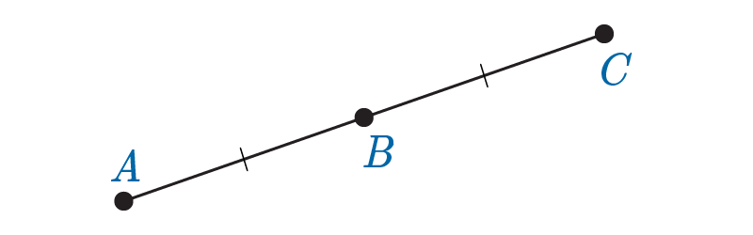  Nozomi constructed a copy of $\overline{AB}$ by using point B as an endpoint of the copy of $\overline{AB}$ and placing point C, as seen in the image. If the measure of $\overline{AB}$ is 22.3 millimeters, what is the measure of $\overline{AC}$? | The measure of $\overline{AC}$ is 44.6 millimeters.
Q 4 | Use the image to answer the question.  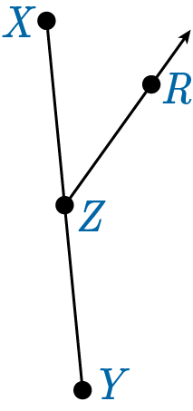  Aleph constructed $\vec{ZR}$, a line segment bisector of $\overline{XY}$. How does point Z relate to $\overline{XY}$? If XY = 22 units, what is ZY? | Point Z is the midpoint of $\overline{XY}$. ZY = 11 units.
Q 5 | Andy was given a line segment. He constructed a line segment bisector of the line segment using the paper folding method. He was told that the line segment bisector divided his line segment into pieces that are each 2.9 centimeters long. How long was Andy’s original line segment? | 5.8 cm

Lesson 4 – Constructing Angles
Key Words:
- angle – a figure formed by two rays extending from the same point
- angle bisector – a line or segment that divides an angle into two equal parts
- arc – a continuous portion (as of a circle or ellipse) of a curved line or a curved path
- auxiliary line – an extra line needed to construct other figures in geometry
- congruent – identical in both size and shape
- vertex – a point (as of an angle, polygon, polyhedron, graph, or network) that terminates a line or curve or comprises the intersection of two or more lines or curves
Objective 1: In this section, you will construct an angle and a copy of an angle.
Mathematical Practice Standard: Use appropriate tools strategically.
Big Ideas:
- An angle is the measure between two rays, lines, or line segments that meet at a common point called a vertex.
- Angles are measured in degrees that represent the spread between two rays or line segments.
Naming Angles
The symbol, $∠$ , is used for angles in math.  Angles are named by using their vertex letter.  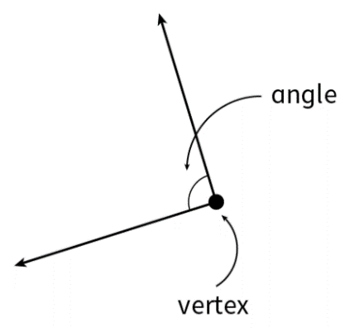 | If there is only one letter present, then only the vertex letter is used.  This angle is written as $∠J$.  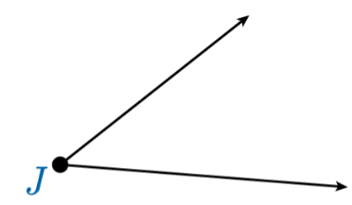 | Most angles are labeled using three letters, where the vertex letter is in the middle of the three letters.  This angle can be named $∠LJK$or $∠KJL$.  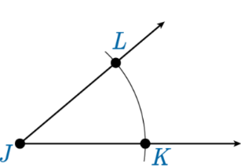
- You can construct an angle using a straightedge and a compass. The degree and distance of the angle can be measured with a compass.
Constructing an Angle
You can also practice constructions in this GeoGebra applet!
Step 1: Draw a ray using a straightedge and level the endpoint using a capital letter.  Remember that a ray has an arrow at the end to show that the ray goes on forever.  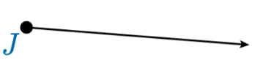 | Step 2: Draw another ray coming from the endpoint of the first ray.  The two rays meet and form an angle. The endpoint is now the vertex of the angle.  Each ray represents the side of the angle.
- Constructing copies of angles allows mathematicians to build congruent shapes and figures (two figures that are equal). You can construct a copy of an angle using an auxiliary line and arcs.
- Auxiliary lines are extra lines used in geometry to help construct shapes and figures.
Constructing a Copy of an Angle
You can also practice copying angles in this GeoGebra applet!
Step 1: Using an angle you have already constructed (like the above example), draw an auxiliary line somewhere else on your paper. Draw a point at the end of the auxiliary line.

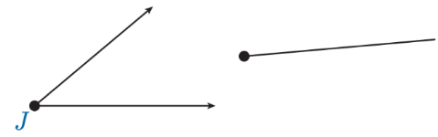

Note: Make sure the auxiliary line is longer than the rays you constructed for your angle.

Step 2: Using your compass, place the pointed end on the point at the vertex of the angle. Draw an arc by swinging the compass back and forth with the pencil end so that the arc intersects the angle on both sides.
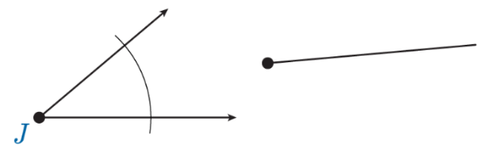

Step 3: In the two places the arc intersects with each ray, draw points. Label each point with a different capital letter.
Step 4: Taking care not to change the length of your compass, place the pointed end on the endpoint you constructed on the auxiliary line. Create an arc using the pencil side.
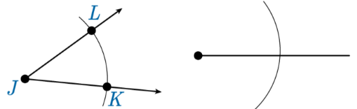

Step 5: Place a point at the intersection of the arc you just constructed and the auxiliary line. Label the point of the intersection and the endpoint with different capital letters.
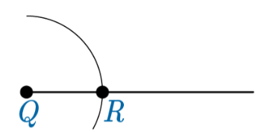

Step 6: Placing the tips of the compass on the points where the arc intersects the rays of your original angles, measure the distance between the two points.
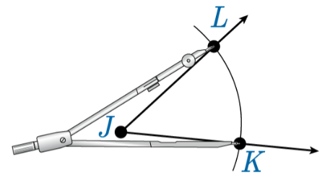
Step 7: Keeping your compass at the same distance, place the pointed end of the compass on the point of the auxiliary line that intersects with the arc you constructed. Draw another small arc with the pencil end so that it intersects the large arc.
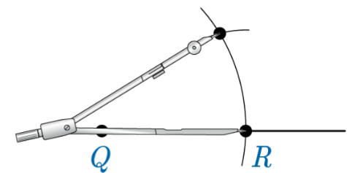

Step 8: Label the intersection of the small arc and the large arc using a different capital letter. Place a point at this new intersection that you have labeled.
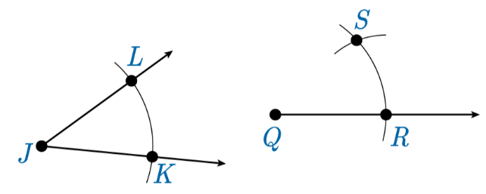

Step 9: Use a straightedge to draw a ray that connects the vertex angle to the new point you placed at the intersection of the large arc and the small arc.

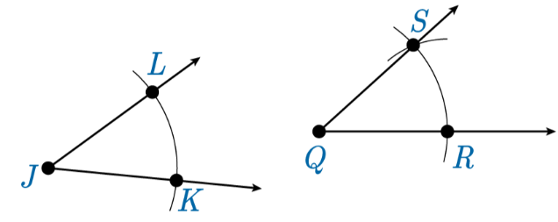
Note: Be sure to put arrows at the end of each ray.

Objective 2: In this section, you will construct a bisector of an angle.
Mathematical Practice Standard: Use appropriate tools strategically.
Big Ideas:
- Angle bisectors divide an angle into two smaller but equal parts. Angles can be bisected by any ray, line segment, or line.
- The two smaller angles created by the bisector are congruent meaning that each new angle will measure exactly half of the original angle.
  - Investigate this concept in GeoGebra!
Constructing an Angle Bisector
You can also practice constructing angle bisectors in this GeoGebra applet!
Step 1: Use a straightedge to draw an angle. Label the vertex point A.
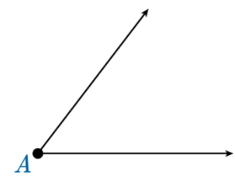
Step 2: Using a compass, place the pointed tip on the vertex. Draw an arc that is just over halfway on the rays of the angle. Draw the arc so that it intersects both sides of the angle.
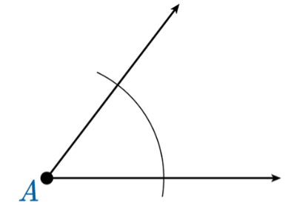
Step 3: Place points B and C where the arc intersects the sides of the angle.
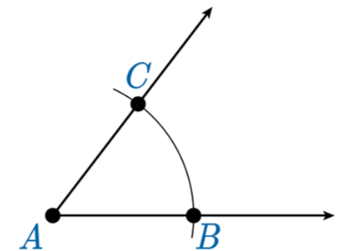
Step 4: Adjust the compass so that the distance between the points is slightly smaller than half the length of one ray of the angle. Place the pointed tip of the compass on point B.
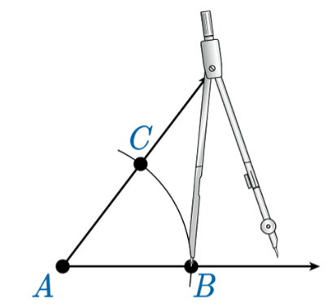

Step 5: With the pointed tip on point B, draw a small arc inside the angle and outside the initial arc you constructed. The small arc must extend past the halfway point of the angles spread.
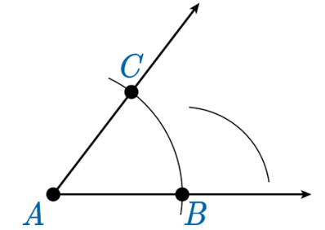
Step 6: Being careful not to change the distance between the compass’s points, place the pointed end on point C.
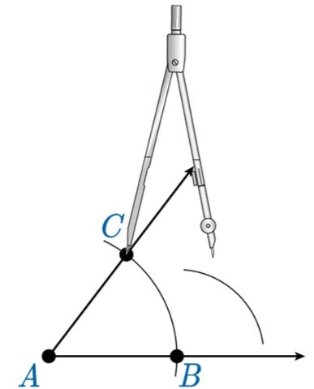
Step 7: Keeping the pointed end on point C, draw a second small arc inside the angle and above the initial arc you constructed.
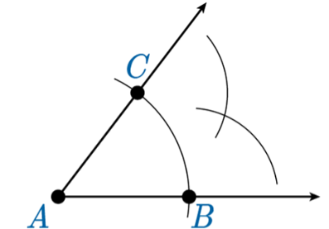
Step 8: Place point M at the intersection of the two smaller arcs. Use a straightedge to draw a ray from point A through point M.
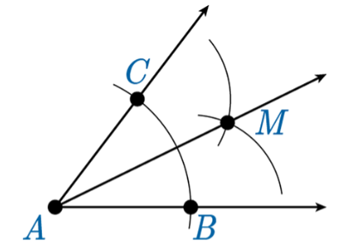
This new ray is an angle bisector that divides the original angle into two smaller but equal parts.
$$∠CAM≅∠BAM$$

There are now three angles that can be represented here. All with the same vertex of A.
$$∠CAB, ∠CAM, ∠BAM$$

Practice Questions and Answers
 | Question | Answer
P 1 | Use the image to answer the question.  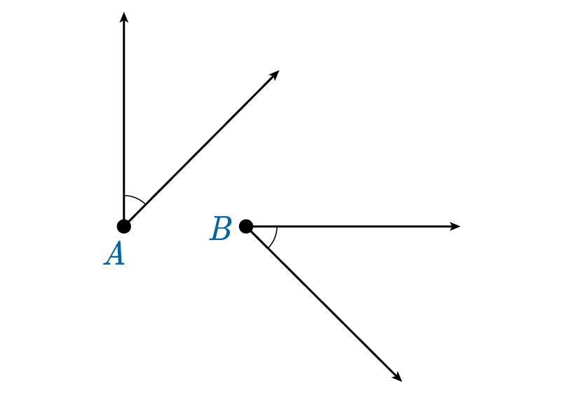  Sam constructed $∠B$ as a copy of $∠A$ using a straightedge and compass. If the measure of $∠A$ is 42 degrees, what is the measure of $∠B$?  The measure of the copy of the angle Elias created is _____ degrees. | 42
P 2 | Elias measured an angle he was given to be 81 degrees. He constructed a copy of this angle using a compass and straightedge. What is the measure of the copy of the angle he constructed?  The measure of the copy of the angle Elias created is _____ degrees. | 81
P 3 | Use the image to answer the question.  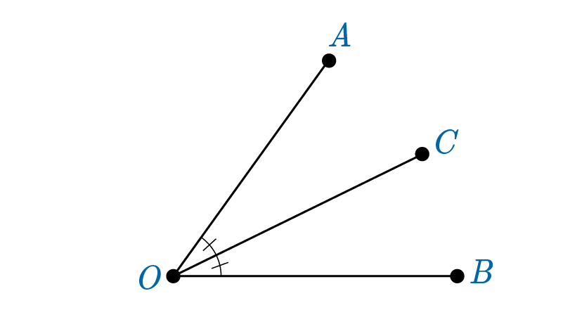  Javier constructed $∠AOB$ with ray OC as an angle bisector of $∠AOB$. If the measure of $∠AOB$ is 74 degrees, what is the measurement of $∠AOC$?  The $m∠AOC$ is _____ degrees. | 37
P 4 | Use the image to answer the question.  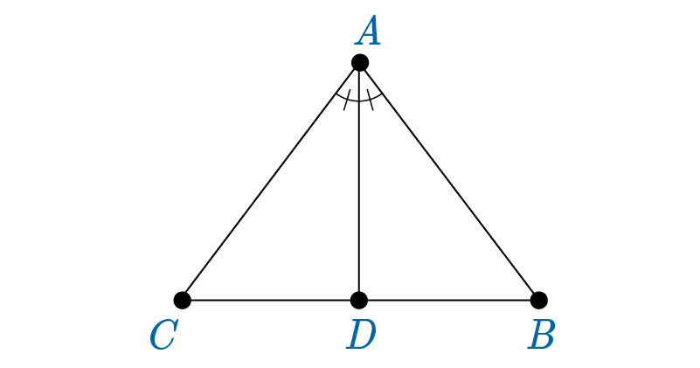  Ines examined the triangle and noticed that segment AD bisected $∠CAB$. She measured $∠BAD$ to be 21 degrees. What is the measure of $∠CAB$ in degrees?  The $m∠CAB$ is _____ degrees. | 42
P 5 | Use the image to answer the question.  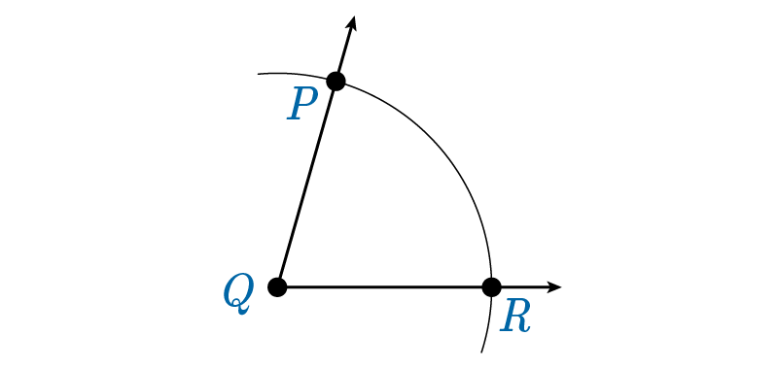  On her paper, Katarzyna wants to construct the angle bisector of angle $∠PQR$. She has drawn an arc from the vertex point Q that intersects both sides of the angle and has labeled the intersection of the arc with the sides of the angle with P and R. Using a compass and straightedge, what next step must she take to construct the angle bisector?  Option #1: Move the compass further apart and place the pointed end at point Q and draw another arc that intersects the sides of the angle.  Option #2: Place the pointed end of the compass on point P and draw another arc inside the first arc and between two sides of the angle.  Option #3: Place the pointed end of the compass on point P and draw another arc outside the first arc and between two sides of the angle.  Option #4: Draw a line extending from the vertex point Q through the middle of the angle  Katarzyna’s next step is Option #_____. | 3

Quick Check Questions and Answers
 | Question | Answer
Q 1 | Use the image to answer the question.  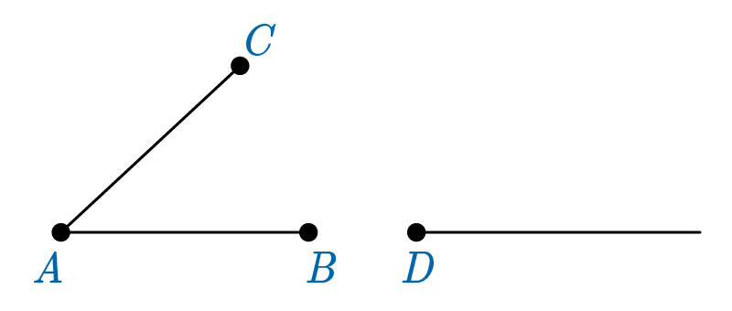  Saadiq constructed $∠BAC$ and an auxiliary segment where he placed point D at one end. With the help of a compass and straightedge, what next step should Saadiq do to construct a copy of $∠BAC$? | Saadiq needs to draw an arc through the sides of $∠BAC$.
Q 2 | Use the image to answer the question.  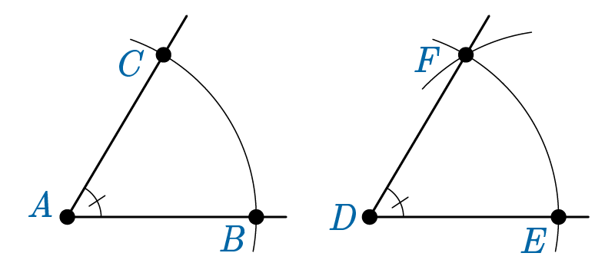  Fernanda constructed $∠CAB$. She then constructed a copy of $∠CAB$ and labeled it as $∠FDE$. Fernanda measures $∠FDE$ to be $59°$. What is the measure of the original angle, $∠CAB$, she constructed? | The measure of $∠CAB$ is $59°$.
Q 3 | Use the image to answer the question.  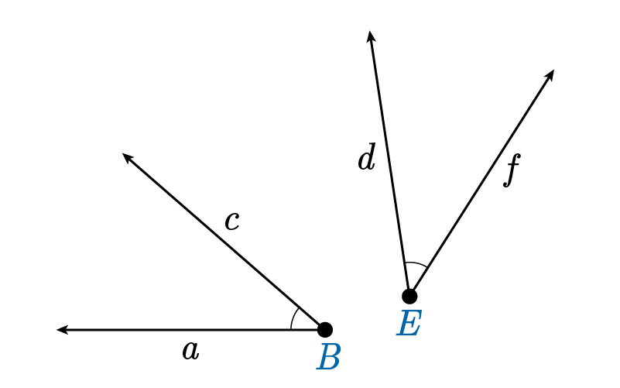  Jade constructed $∠cBa$ and then constructed a copy of $∠cBa$ and labeled it as $∠fEd$. What must be true about the two angles she constructed? | The angles have congruent measurements.
Q 4 | Use the image to answer the question.  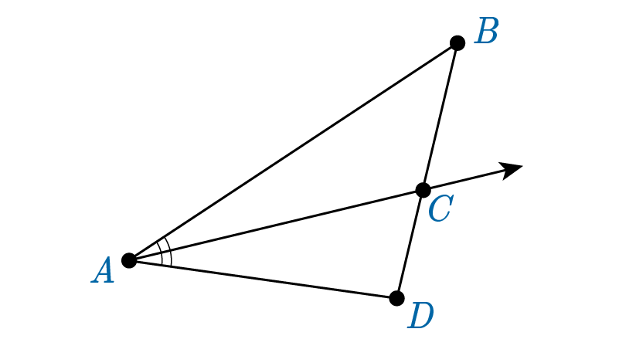  Anika constructed AC that bisected $∠A$. If the $m∠BAD$ is 46 degrees, what is the $m∠BAC$? | The $m∠BAC$ is 23 degrees.
Q 5 | Use the image to answer the question.  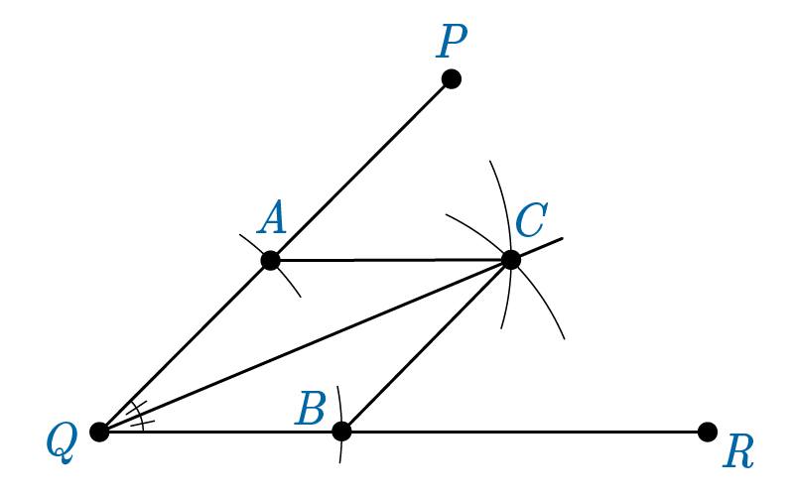  Laci constructed $∠PQR$ with line segments $\overline{QC}$, $\overline{AC}$, and $\overline{BC}$, as shown in the image. Which line segment is the angle bisector of $∠PQR$? | Line segment $\overline{QC}$ is the angle bisector of $∠PQR$.

Lesson 5 – Constructing Parallel and Perpendicular Lines
Key Words:
- midpoint – a point at the center or middle of a segment
- parallel lines – a pair of two lines that never intersect and have the same slope
- perpendicular – intersecting at a 90-degree angle
- perpendicular bisector – a line or line segment that divides another line segment into two equal parts and intersects it at a 90-degree angle
- right angle – an angle that measures exactly 90 degrees
Objective 1: In this section, you will construct perpendicular lines and a perpendicular bisector.
Mathematical Practice Standard: Use appropriate tools strategically.
Big Ideas:
- Recall that perpendicular lines intersect to and create a 90-degree angle, also known as a right angle.
- The symbol used for perpendicular lines is “$⊥$“.
Constructing a Perpendicular Line to a Line Segment
You can also practice constructing a perpendicular line in this GeoGebra applet!
Step 1: Construct a line segment with endpoints X and Y on a piece of paper.   | Step 2: Fold the paper so that endpoint X lands anywhere on the segment before point Y.  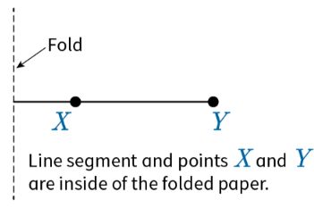 | Step 3: Unfold the paper. The fold forms a line that intersects with $\overline{XY}$.  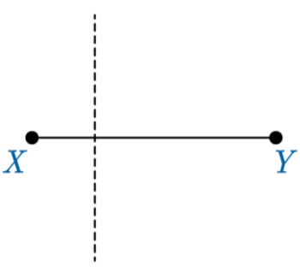 | Step 4: Line up a straightedge with the fold and dotted lines on the paper. Draw a line along the fold of the paper with arrows at both ends. Place a small square at the intersection of the lines to represent a 90-degree angle, or right angle.  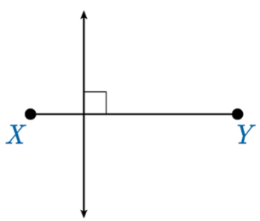
- A specific type of bisector intersects a segment at a 90-degree angle at its midpoint and is called a perpendicular bisector.
  - The perpendicular bisector creates a right angle and divides the segment into two smaller congruent segments.
  - The perpendicular bisector will go through the midpoint of the segment. The midpoint denotes the halfway point of a segment.
  - Explore perpendicular bisectors in GeoGebra!
Constructing a Perpendicular Bisector
You can also practice constructing perpendicular bisectors in this GeoGebra applet!
Step 1: Draw a line segment with endpoints A and B.
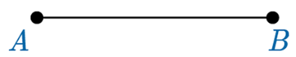
Step 2: Place the pointed end of the compass on point A and adjust the compass so that the pencil end is just past the middle of the segment.
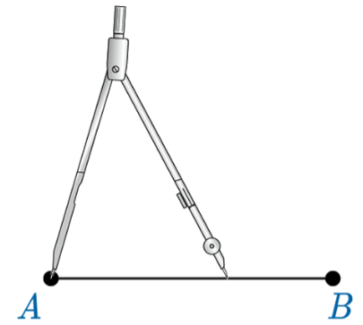
Step 3: Draw an arc that extends both above and below the segment by swinging the pencil end above and below the arc.
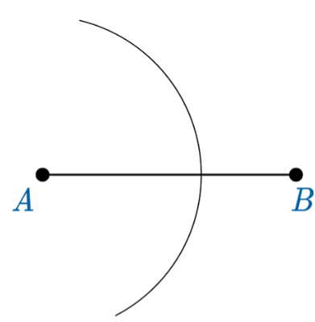
Step 4: Taking care not to change the distance between the legs of the compass, place the pointed end of the compass on point B. The pencil end of the compass will rest at a point past the middle of $\overline{AB}$.
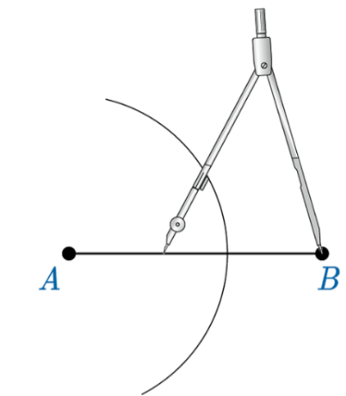
Step 5: Draw an arc that extends both above and below the segment by swinging the pencil end above and below the arc. The two arcs you have constructed should intersect both above and below $\overline{AB}$. The two arcs should face opposite directions.
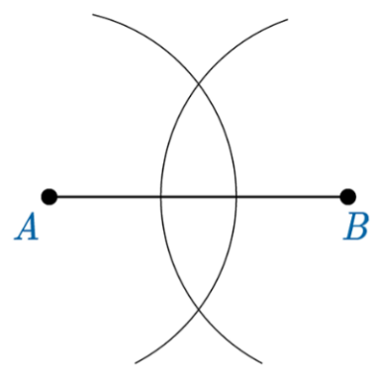
Step 6: At the intersection of the two arcs, above and below $\overline{AB}$, place points C and D.
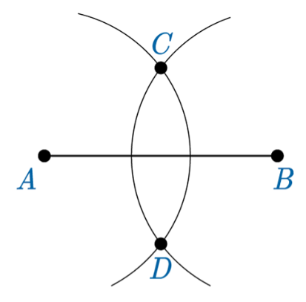
Step 7: Use a straightedge, draw a line between points C and D.
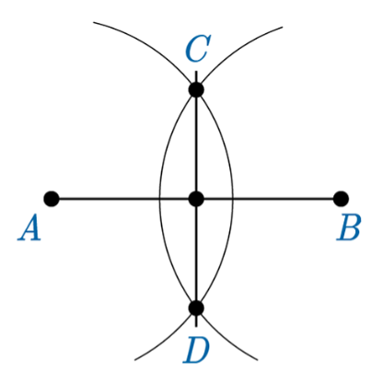
Step 8: Place point M at the intersection of $\overline{AB}$ and $\overline{CD}$.
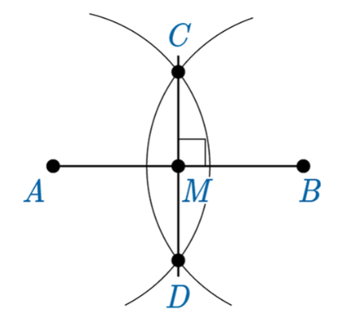
You have not constructed a line segment, $\overline{CD}$, that is perpendicular to bisector of $\overline{AB}$.
This figure can be written in shorthand as $\overline{AB}⊥ \overline{CD}$.

Objective 2: In this section, you will construct parallel lines and a parallel line through a point not on the line
Mathematical Practice Standard: Use appropriate tools strategically.
Big Ideas:
- Recall that a pair of lines that never intersect and have the same slope are called parallel lines.
- In math, the symbol “$∥$“ is used to indicate parallel lines.
Constructing a Parallel Line
Step 1: On paper, use a straightedge to construct a horizontal line.
Step 2: Using a straightedge, construct another line that intersects the original line you constructed.
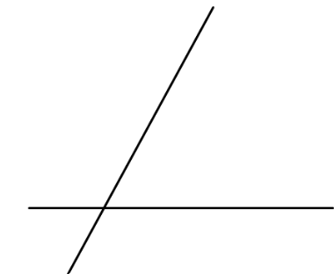
Step 3: Construct an arc that intersects those two lines.
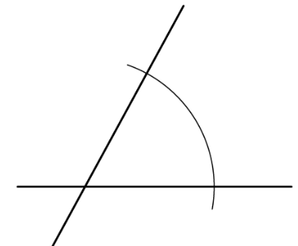
Step 4: Label the intersection of the two lines you constructed point A and then label the intersection of the arc with the two lines points B and C.
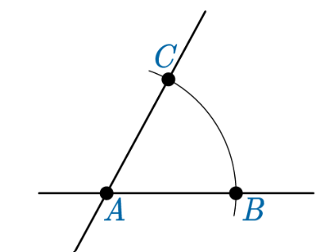
Step 5: Without changing the distance of the compass’s legs, draw a second, smaller arc by placing the pointed end of the compass on point C.
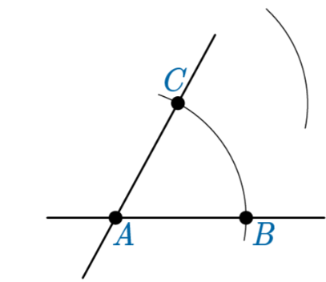
Step 6: Without changing the compass’s legs draw a third smaller arc by placin the pointed end of the compass on point B.
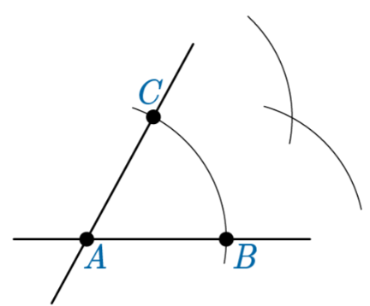
Step 7: At the intersection of the two smaller arcs between the intersecting lines, place point D.
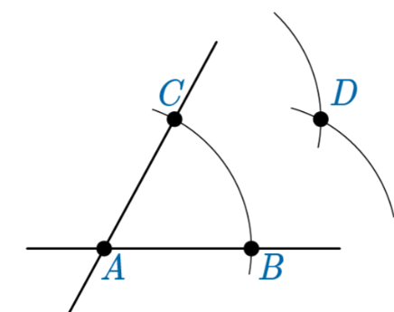
Step 8: Use a straightedge to draw a line through point C and point D.
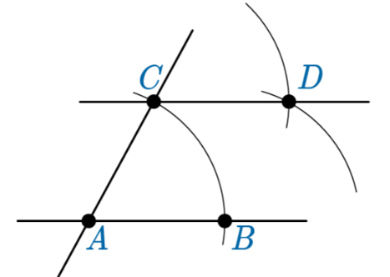
Line AB is parallel to line CD. The distance from A to C is the same as the distance from B to D.
- You can also construct a parallel line from a single point not on a line by constructing a copy of an angle. This method is used to make sure that two lines are a predetermined distance apart.
Constructing a Parallel Line Through a Point not on the Line
You can also practice constructing a parallel line in this GeoGebra applet!
Step 1: Use a straightedge to construct a line with point R not on the line.
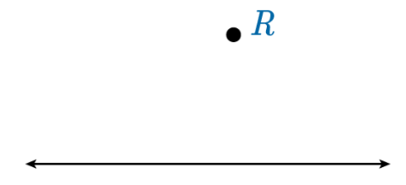
Step 2: Construct point P so that it is on the line. Make sure that point R is not directly above point P on the line.
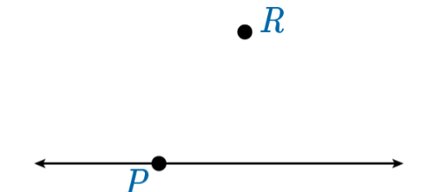
Step 3: Use a straightedge to draw a line through point P and R that intersects with the original line.
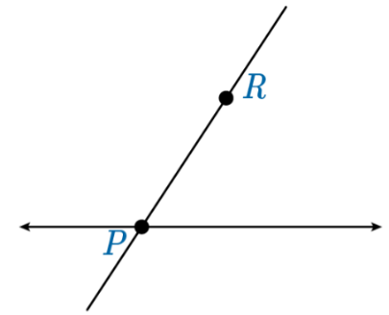
Step 4: Adjust the compass so that the span between its ends is shorter than the distance between points P and R.
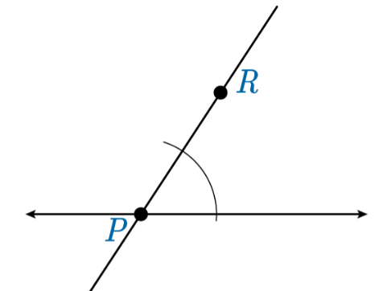
Step 5: Without changing the distance of the legs on the compass, place the pointed end on R and draw another arc above point R that intersects line . The arc needs to be approximately the size as the first arc you drew.
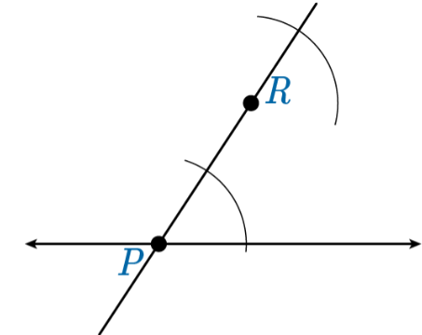
Step 6: Label the point where the arc intersects the upper line nearest to the vertex (P) point Q. Now place point S on the intersection of the arc and the line .
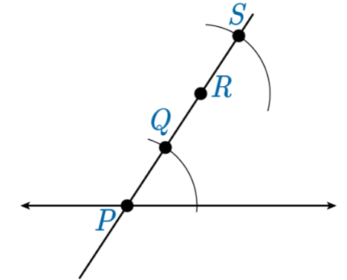
Step 7: Place the pointed end of the compass on point Q and adjust the compass so that the pencil end is on the point of intersection between that arc and the original line.
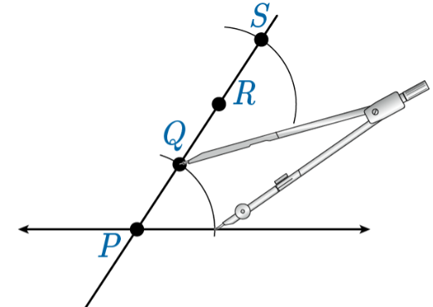
Step 8: Without changing the distance of the compass’s legs, place its pointed end on point R and draw another small arc. This arc should intersect the second arc you drew and be inside the two lines.
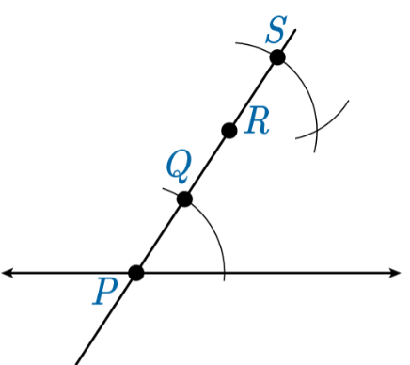
Step 9: Place point T at the intersection of the second and third arc constructed.
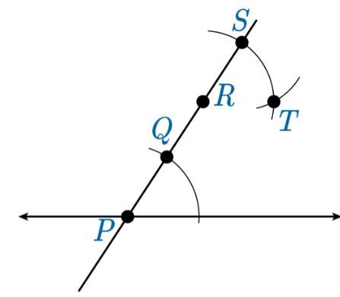
Step 10: Use a straightedge to construct a line through points R and T.
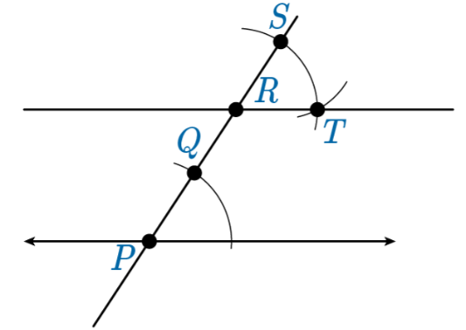
The line you have constructed is parallel to your original line.
Line P is parallel to line R, $P∥R$.

Practice Questions and Answers
 | Question | Answer
P 1 | Use the image to answer the question.  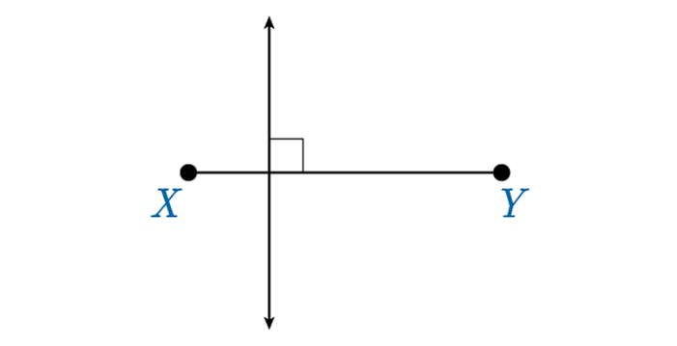  Complete the following statement by entering the correct number associated with your response based on the diagram shown. The square box on the diagram indicates the lines are  1) intersecting.  2) parallel.  3) perpendicular.  4) skewed.  The square box on the diagram indicates the lines are _____. | 3
P 2 | Use the image to answer the question.  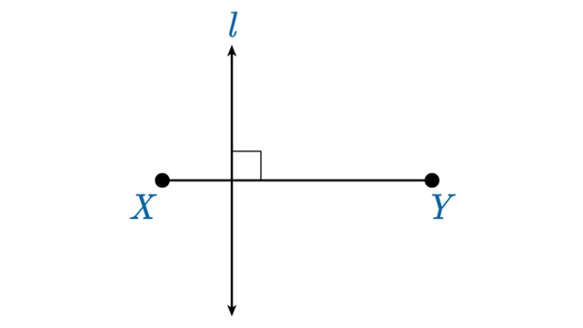  Based on the construction shown in the diagram, complete the statement by entering the correct symbol. | $$\overline{XY⊥l}$$
P 3 | Use the image to answer the question.  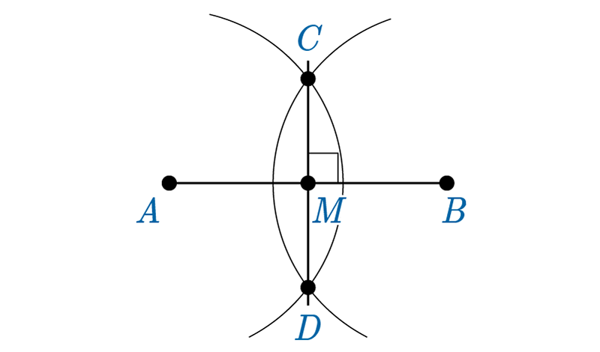  Based on the construction shown in the diagram, complete the statements with the correct symbol.  $\overline{AM}$_____ $\overline{BM}$  $\overline{AC}$_____ $\overline{CD}$ | $$\overline{AM} ≅\overline{BM}$$  $$\overline{AC} ⊥\overline{CD}$$
P 4 | The table shows the steps for constructing a parallel line to a given line through a point not on the line. Put the steps in the correct order by writing the order number in the response field next to the image.  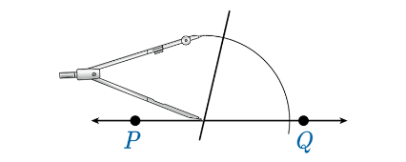  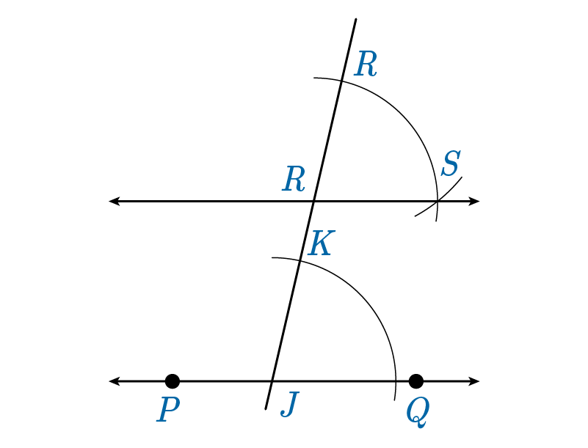  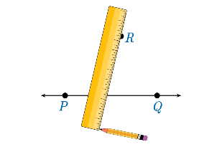  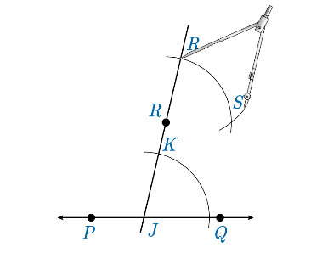  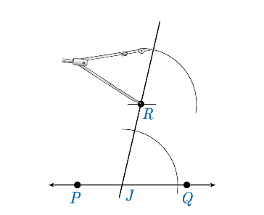  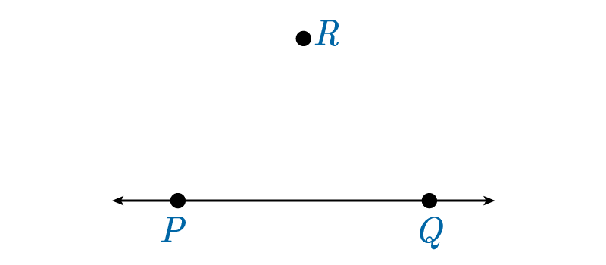  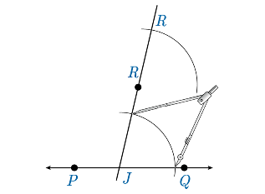 | 3, 7, 2, 6, 4, 1, 5
P 5 | Use the image to answer the question.  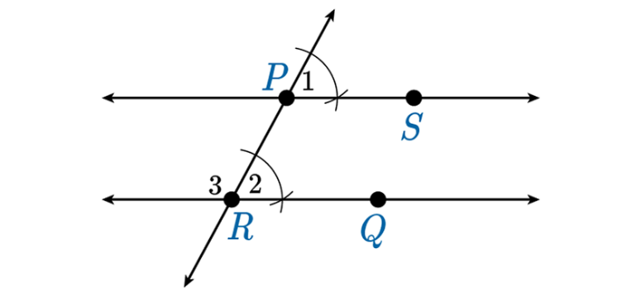  The diagram shows the final step of a construction. Insert the symbol that makes the statement true.  $\overset{⃡}{PS}$ _____ $\overset{⃡}{RQ}$. | $$∥$$

Quick Check Questions and Answers
 | Question | Answer
Q 1 | When performing a construction, what are the only tools needed to complete the construction? | a compass and a straightedge
Q 2 | Select the choice that indicates $\overset{⃡}{AB}$ is the perpendicular bisector of $\overset{⃡}{CD}$ if they intersect at P. | $\overline{AB}⊥ \overline{CD}$ and $\overline{CP}≅ \overline{DP}$
Q 3 | Identify which diagram represents a step in constructing a perpendicular line that is not a perpendicular bisector. | 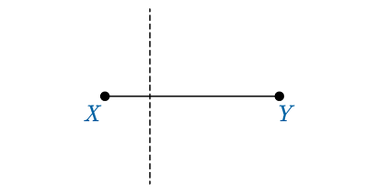
Q 4 | Identify one of the steps necessary to construct a parallel line to a given line through a point not on the line. | With the pointed tip of your compass on a point on the given line, draw an arc that intersects the given line and the line drawn from the point on the given line to the point not on the given line.
Q 5 | Which statement is true for all parallel lines? | Parallel lines have the same slope.

Lesson 6 – Sides of a Triangle
Key Words:
- polygon – a closed figure made up of line segments in a two-dimensional plane
- triangle – a polygon having three sides
- Triangle Inequality Theorem – the theorem stating that the sum of the lengths of any two sides of a triangle is greater than the length of the third side
Objective 1: In this section, you will determine if three side lengths will form a triangle.
Mathematical Practice Standard: Reason abstractly and quantitatively.
Big Ideas:
- Triangles are a type of polygon. Triangles have three segments called sides that enclose an area with three angles.
Types of Triangles
Equilateral - sides are all of equal length  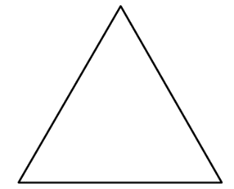 | Isosceles - two sides that are equal length  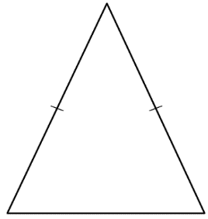 | Scalene - no sides of equal length  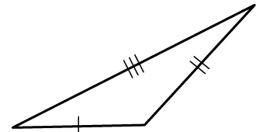 | Right - has a right angle (90 degrees)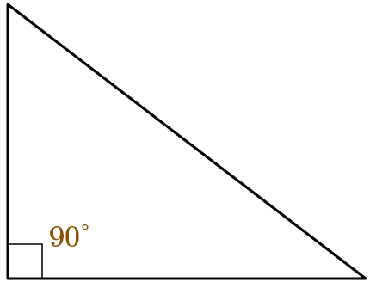
- Triangles can be constructed using three segments that meet at three vertices and enclose the figure entirely.
- For the segments to meet at the vertices, they must meet certain length requirements. Using the Triangle Inequality Theorem allows us to determine if three given lengths will form a triangle.
Triangle Inequality Theorem
The Triangle Inequality Theorem states that the sum of the lengths of any two sides of a triangle is greater than the length of the third side.
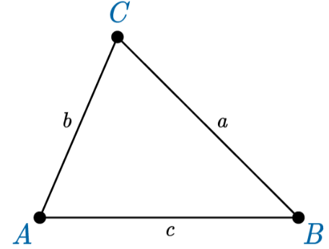
*Triangles are often labeled by their vertex letters, and their sides are labeled using lowercase forms of the vertex letters.
In symbolic form, the Triangle Inequality Theorem states the following about the sides of $△ABC$.
$$a+b>c$$
$$b+c>a$$
$$a+c>b$$
All three of these statements must be true for the three side lengths to form a triangle.
Example
Determine whether lengths of 7, 15, and 12 will form a triangle.  $$a=7$$  $$b=15$$  $$c=12$$ | $$a+b>c$$  $$7+15>12 true$$  $$b+c>a$$  $$15+12>7 true$$  $$a+c>b$$  $$7+12>15 true$$ | Yes, the three lengths will form a triangle since all statements are true.

Objective 2: In this section, you will determine the range of lengths of a third side that will make a triangle given the other two side lengths.
Mathematical Practice Standard: Look for and make use of structure.
Big Ideas:
- The Triangle Inequality Theorem enables you to make predictions about the length of an unknown side of a triangle given the lengths of the two other sides. The range of lengths can be represented using inequalities.
- Recall that an inequality is a formal statement that two quantities are greater than (>), greater than or equal to ($≥$), less than (<), or less than and equal to ($≤$).
- When solving for a range of lengths that a third side could be:
Steps | Example
Step 1: Use a variable, such as x, to represent the unknown side. | Given two lengths 12 and 7, determine the range of possible lengths that will make an enclosed triangle.  Let x = the length of the third side
Step 2: Assume that the unknown side is the smallest side of the triangle and solve the inequality for x. | If x is the smallest side, that means that 12 is the longest side, in this scenario.  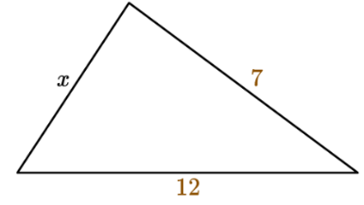  According to the Triangle Inequality Theorem, x+7 must be greater than 12 for this to be a triangle.  $$x+7>12$$  Solve for x:  $$x>5$$  The third side must be greater than 5.
Step 3: Then, assume that the unknown side is the largest side of the triangle and solve the inequality for x. | If x is the longest side, then the remaining two sides, 12 and 7, must add up to be greater than x.  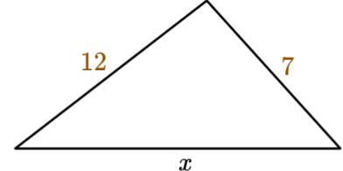  $$12+7>x$$  Solve for x:  $$19>x$$  The third side must be less than 19.
Step 4: Use the two results from steps two and three to create a compound inequality that represents the possible range of lengths. | The range of lengths that the unknown side can be is between 5 and 19.  $$5<x<19$$

Practice Questions and Answers
 | Question | Answer
P 1 | Leo has three straws. They are 4 inches, 8 inches, and 10 inches long. Can he make a triangle using these three straws?  Option 1 = Yes  Option 2 = No  Option _____ is the correct answer | 1
P 2 | Use the image to answer the question.  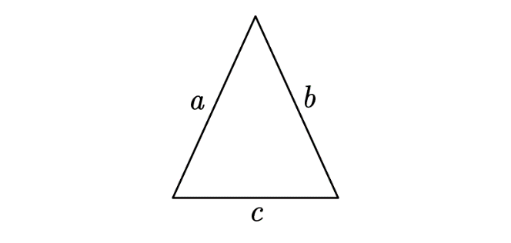  Which of the following options is not true?  Option 1: $a + b > c$  Option 2: $c + b = a$  Option 3: $a + c > b$ | 2
P 3 | Two sides of a triangle measure 34 and 51. Complete the inequality that indicates the possible values of the third side of the triangle using the Triangle Inequality Theorem.  _____ < x < _____ | 17, 85
P 4 | Use the image to answer the question.  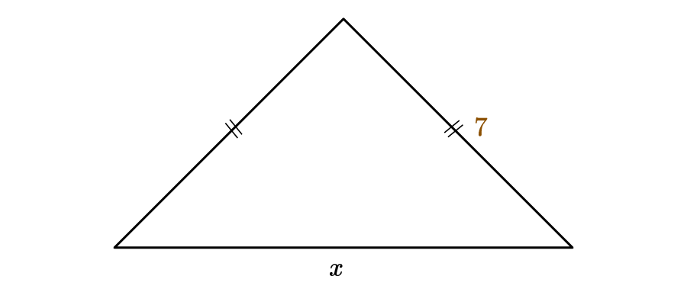  Find the range of values for the third side of the triangle, x, based on the diagram.  _____< x < _____ | 0, 14
P 5 | Use the image to answer the question.  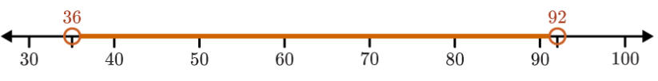  x is the length in inches of the third side of a triangle. The range of all possible values of x is shown on the number line. Which of the following options has possible lengths of the other two sides of the triangle? | 28 inches and 64 inches

Quick Check Questions and Answers
 | Question | Answer
Q 1 | Determine whether these three side lengths will form a triangle: 6 cm, 8 cm, and 10 cm. | They will form a triangle because the sum of any two of the side lengths is greater than the length of the third side.
Q 2 | Alisha wants to build a miniature bridge that will include a triangle made of wooden pieces. Which lengths of wood can she use to form a triangle? All lengths are given in inches. | 27, 12, and 16
Q 3 | Based on the Triangle Inequality Theorem, which of the following types of triangles is possible? | right isosceles
Q 4 | A triangle’s side lengths are whole numbers. If the measure of two of its sides are 1 cm and 13 cm, what is the measure of the third side? | 13 cm
Q 5 | Find the range of values for the third side of a triangle if two of its sides measure 42.7 mm and 38.03 mm. | $$4.67 < x < 80.73$$

