Geometry

**Formal Proofs**

**Unit Summary:** In this unit you will learn how to write formal geometric proofs. Many of the statements you will prove are properties that you have learned in the past. You will recall the definitions of parallel lines, triangles, parallelograms, and bisectors.

**Lesson 2 – Conditional Statements Discussion Day 1**

**Key Words:**

* **biconditional statement –** a sentence that joins the hypothesis and conclusion with the phrase "if and only if"; a combination of a conditional statement and its converse
* **conclusion** – the portion of a conditional statement that follows the word*then*
* **conditional statement** – a sentence that can be written in the form “If ____, then _____.”
* **contrapositive** – a statement formed by contradicting both the hypothesis and conclusion of a given statement and interchanging them
* **converse** – a statement formed by interchanging the hypothesis and conclusion of a given statement
* **hypothesis** – the portion of a conditional statement between the words *if*and *then*
* **inverse** – a statement formed by contradicting both the hypothesis and conclusion of a given statement
* **logic** – the science of the formal principles of reasoning
* **negate** – to deny the truth of

**Objective 1:** In this section, you will identify the converse, inverse, and contrapositive of a conditional statement.

*Mathematical Practice Standard: Construct viable arguments and critique the reasoning of others.*

**Big Ideas**:

* *Conditional statements* and logic are important to understand when writing formal proofs.
* *Conditional statements* are often referred to as *if-then* statements and are written as: “If statement 1 is true, then statement 2 must also be true.”
  + Statement 1 is called the *hypothesis*
  + Statement 2 is called the *conclusion*
  + Notice the words “*if*” and “*then*” are not part of the *hypothesis* or the *conclusion*.
* The *converse* of a *conditional statement* interchanges the *hypothesis* and the *conclusion*.
* The *inverse* of a *conditional statement* negates both the *hypothesis* and the *conclusion*.
  + To *negate* a statement means to find its opposite and you will usually add the word “*not*”.
* The *contrapositive* of a *conditional statement* negates both the *hypothesis* and the *conclusion* and then interchanges them.
* Use the following rules to help with writing converse, inverse, and contrapositive statements. Where *p* stands for the hypothesis and *q* stands for the conclusion.

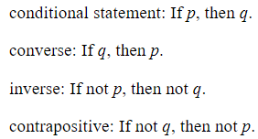

|  |  |
| --- | --- |
| **Example**: Rewrite the following sentence as a conditional statement in *if-then* form. Then find the converse, inverse, and contrapositive of the conditional statement.  *You are in Texas* ***if*** *you are at the Alamo.* | |
| Step 1: Identify the hypothesis and the conclusion. | Hypothesis (*p*): You are at the Alamo  Conclusion (*q*): You are in Texas |
| Step 2: Rewrite as a conditional statement in *if-then* form. | Conditional Statement: If you are at the Alamo, then you are in Texas. |
| Step 3: Write the converse. Recall that the converse switches the hypothesis and the conclusion. | Converse: If you are in Texas, then you are at the Alamo. |
| Step 4: Write the inverse. Recall that the inverse negates the hypothesis and the conclusion. | Inverse: If you are not at the Alamo, then you are not in Texas. |
| Step 5: Write the contrapositive. Recall that the contrapositive combines both the converse and the inverse. | Contrapositive: If you are not in Texas, then you are not at the Alamo. |

**Objective 2:** In this section, you will determine the validity of the converse, inverse, and contrapositive of a conditional statement.

*Mathematical Practice Standard: Construct viable arguments and critique the reasoning of others.*

**Big Ideas:**

* Recall how to write the *converse, inverse, and contrapositive* of *conditional statements*.
* Sometimes, the i*nverse, converse, or contrapositive* of a *conditional statement* are not true. Analyzing whether statements are true is an important part of critiquing the reasoning of others.
* *Conditional statements* do not have to be true and when they are true, its *converse* or its *inverse* may not also be true.
* A *conditional statement* will always have the same truth value as its *contrapositive*. They will either both be true or both be false.
* A *converse* will always have the same truth value as the *inverse*. They will either both be true or both be false.
* Recall the previous example above of Texas and the Alamo and decide if the statements are true or false.

|  |  |
| --- | --- |
| **Statements** | **Validity** |
| Conditional Statement: If you are at the Alamo, then you are in Texas. | True. There is only one Alamo, and it is in Texas, therefore if you are at the Alamo, you must be in Texas. |
| Converse: If you are in Texas, then you are at the Alamo. | False. You can be in Texas but not at the Alamo. |
| Inverse: If you are not at the Alamo, then you are not in Texas. | False. Even if you are not at the Alamo, you can still be in Texas at a different location. |
| Contrapositive: If you are not in Texas, then you are not at the Alamo. | True. Since the Alamo is only in Texas, you can’t be there if you are in a different state. |

* When a *conditional statement* and its *converse* are both true, it can be rewritten as a *biconditional statement*.
* A *biconditional statement* uses the phrase “*if and only if*” between the *hypothesis* and the *conclusion* to indicate that it is a combination of both the *conditional statement* and the *converse*.

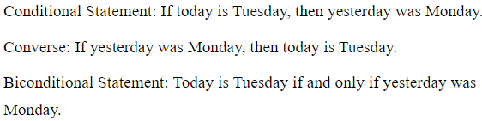

**Lesson 4 – Parallel and Perpendicular Lines**

**Key Words:**

* **Angle Addition Postulate –** a hypothesis that states that if point *D* lies in the interior of $∠ABC$, then $m∠ABD+m∠DBC=m∠ABC$
* **Angle-Angle Similarity Postulate –** a hypothesis that states that two triangles are similar if two of their corresponding angles are congruent
* **coefficient –** a number in front of a variable
* **constant –** a fixed value in the form of a number or a letter such as *a, b, or c*
* **coordinate plane** – a two-dimensional plane formed by the intersection of two number lines: the *x*-axis and the *y*-axis
* **opposite reciprocals –** two numbers where one number is the inverse of the other and has the opposite sign
* **parallel –** extending in the same direction, everywhere equidistant and not intersecting
* **parallel lines –** a pair of lines on the same plane that never intersect
* **perpendicular –** intersecting at a 90-degree angle
* **perpendicular lines –** lines that intersect at 90-degree angles
* **proof by contradiction –** a method of proving a statement by assuming the statement is false, writing a proof to show that it is false, and then running into a contradiction or impossibility which shows that the statement is in fact true
* **right angle –** an angle whose measure is 90 degrees
* **rise** – the number of units you move up or down from point to point; also known as the change in *y*, or ∆*y*
* **run** – the number of units you move left or right from point to point; also known as the change in *x*, or ∆*x*
* **Side-Side-Side Similarity Theorem –** a theorem that states that if the three sides of a triangle are proportional to the three sides of another triangle, then the two triangles are similar
* **similar triangles –** triangles that have corresponding sides in the same ratio and have congruent corresponding angles
* **slope** – the measure of the steepness of a line
* **slope-intercept form** – the equation $y=mx+b$ where *m* is the slope of the line and *b* is the *y*-intercept
* **Triangle Angle Sum Theorem –** the theorem that states that the measures of the interior angles of any triangle have a sum of 180°
* ***x*-coordinate** – the coordinate that identifies the exact location of a point on or parallel to the *x*-axis
* ***y*-coordinate** – the coordinate that identifies the exact location of a point on or parallel to the *y*-axis

**Formulas:**

* Slope: $$\frac{change in y}{change in x}=\frac{y_{2}−y_{1}}{x_{2}−x_{1}}=\frac{∆y}{∆x}$$

**Objective 1:** In this section, you willderive the formula for the slope of a line in a coordinate plane.

*Mathematical Practice Standard: Make sense of problems and persevere in solving them.*

**Big Ideas**:

* The *slope* of a line is based on its steepness and direction.

|  |  |  |
| --- | --- | --- |
| **Graph** | **Slope** | **Explanation** |
|  | Positive Slope | The line increases, or goes up, from left to right, which illustrates an uphill slope. |
|  | Negative Slope | The line decreases, or goes down, from left to right, which illustrates a downhill slope. |
|  | Zero Slope | The line has no steepness, up or down, so it has a slope of 0. |
|  | Undefined Slope | The line is so steep that it cannot be measured, so it has an undefined slope. |

* We can express the steepness of the line by calculating the *rise* (height), over the *run* (length).

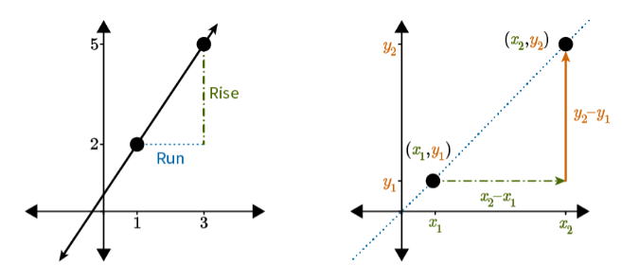

* To find the *rise* (height), you must calculate the difference between the *y-coordinates* ($$y_{2}−y_{1}$$).
* To find the *run* (length), you must calculate the difference between the *x-coordinates* ($$x_{2}−x_{1}$$).
* The *slope* of a line is equal to the ratio $$\frac{rise}{run}$$, so the formula for finding *slope* of any line is:

$$\frac{change in y}{change in x}=\frac{y_{2}−y_{1}}{x_{2}−x_{1}}=\frac{∆y}{∆x}$$

|  |  |
| --- | --- |
| Example: Find the slope of the line in this figure. | |
| Step 1: Identify two points on the line. | Point 1: $$\left(x_{1},y_{1}\right)→\left(1,2\right)$$ Point 2: $$\left(x_{2},y_{2}\right)→\left(3,5\right)$$ |
| Step 2: identify the *x* and *y* coordinates. | $$x_{1}=1$$ $$y_{1}=2$$ $$x_{2}=3$$ $$y_{2}=5$$ |
| Step 3: Substitute the values into the formula for slope and calculate. |  |
| Step 4: State the slope. | The slope of the line is $$\frac{3}{2}$$. Since the graph is increasing, the slope is positive. |

**Objective 2:** In this section, you will prove the slope criteria for parallel lines.

*Mathematical Practice Standard: Construct viable arguments and critique the reasoning of others.*

**Big Ideas:**

* Recall that *parallel lines* never intersect, therefore they must have the same *slope*.
  + Two distinct lines with the same *slope* are *parallel*.
  + Two distinct *parallel lines* have the same *slope*.
  + 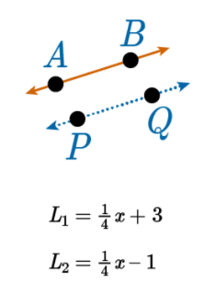
* All pairs of horizontal and vertical lines are parallel because they will have the same slopes.
  + Horizonal lines will always have a slope of 0.
  + Vertical lines will always have an undefined slope.
  + 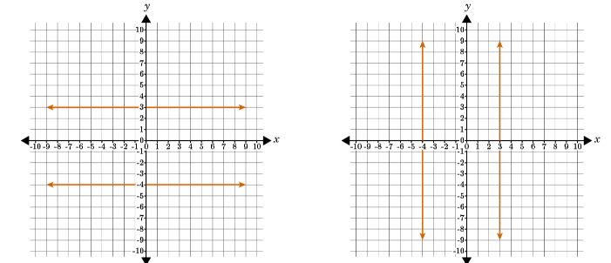
* An equation in *slope-intercept form* takes the form $$y=mx+b$$.
  + *m* represents the *slope* of the line and is always the *coefficient* of the *x*-term.
  + *b* represents the *y-*intercept and is always a *constant* in the equation.
  + 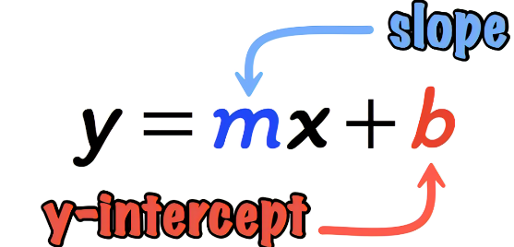
* To determine if two lines are parallel, use the slope formula to calculate each line's slope.
* Sometimes, you will be given two equations in slope-intercept form, rather than a graph with lines. You can use what you know about slope-intercept form to determine if two lines are parallel.

|  |  |  |
| --- | --- | --- |
| **Example**: Determine which pair of lines below is parallel. | | |
| Step 1: Identify the slope. Recall that, in slope-intercept form, $$y=mx+b$$, *m* represents the slope. | Example A: $$m_{1}=\frac{1}{2}$$ $$m_{2}=\frac{1}{2}$$ | Example B: $$m_{1}=−6$$ $$m_{2}=6$$ |
| Step 2: Recall that parallel lines will have the same slope and make your determination. | Example A: both lines have the same slope of $$\frac{1}{2}$$, therefore the lines are parallel.  Example B: The lines have different slopes; one is +6 and the other is –6. The lines are not parallel. | |

**Objective 3:** In this section, you will prove the slope criteria for perpendicular lines.

*Mathematical Practice Standard: Construct viable arguments and critique the reasoning of others.*

**Big Ideas:**

* Recall that *perpendicular lines* intersect at a 90-degree angle. This means that *perpendicular lines* have *opposite reciprocal* slopes.
  + Two lines whose slopes are *opposite reciprocals* are *perpendicular*.
  + Two *perpendicular lines* have slopes that are *opposite reciprocals*.
* *Opposite reciprocals* are two numbers where one number is the inverse of the other and has the opposite sign.
  + The *opposite reciprocal* of a slope, *m*, is $$−\frac{1}{m}$$.
  + For example, the *opposite reciprocal* of 5 is $$−\frac{1}{5}$$.
  + 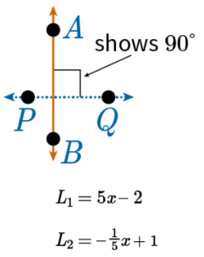
* To determine if two lines are *perpendicular*, use the slope formula to calculate each line's slope to determine if they are *opposite reciprocals*.
* You can verify two slopes are *opposite reciprocals* by multiplying the two slopes. If the slopes are in fact *opposite reciprocals*, the product will always be –1.
* Sometimes, you will be given two equations in *slope-intercept form*, rather than a graph with lines. You can use what you know about *slope-intercept form* to determine if two lines are *perpendicular*.

|  |  |  |
| --- | --- | --- |
| **Example**: Determine which pair of lines below is perpendicular. | | |
| Step 1: Identify the slope. Recall that, in slope-intercept form, $$y=mx+b$$, *m* represents the slope. | Example A: $$m_{1}=\frac{2}{3}$$ $$m_{2}=−\frac{3}{2}$$ | Example B: $$m_{1}=\frac{1}{3}$$ $$m_{2}=3$$ |
| Step 2: Recall that perpendicular lines will have slopes that are opposite reciprocals (that multiply to –1). |  |  |
| Step 3: Determine if the lines are perpendicular. | Example A: The slopes are opposite reciprocals and are therefore perpendicular lines. | Example B: The slopes are NOT opposite reciprocals and are therefore NOT perpendicular lines. |

**Practice Questions and Answers**

|  |  |  |
| --- | --- | --- |
|  | Question | Answer |
| P 1 | *Use the image to answer the question.*  A straight line is graphed on a coordinate plane.  The slope of this line is 1. Which of the following options shows how to correctly calculate the slope? Enter the number of the option that has calculated the slope correctly. | 3 |
| P 2 | *Use the image to answer the question.*  A coordinate plane shows two plots in the second and fourth quadrants joined by a line.  Calculate the slope of the line based on the two points in the graph. Leave the answer in simplest fraction form, if it applies. If the slope is undefined, enter a value of 100. | $$-\frac{1}{2}$$ |
| P 3 | *Use the image to answer the question.*  Four lines are plotted on a coordinate plane with the x-axis ranging from negative 10 to 10 in increments of 1 and the y-axis ranging from negative 8 to 8 in increments of 1.  Which of these lines is parallel to y-3x-5? Enter the option number of the correct answer.  Option #1: Line *A*  Option #2: Line *B*  Option #3: Line *C*  Option #4: Line *D* | 1 |
| P 4 | *Use the image to answer the question.*    Delaney is a city engineer and needs to create a scale map of the city. She has graphed several landmarks on Main Street, including the gas station and the post office. The gas station lies at the point (1, 1), and the post office lies at the point (3, 4). The line that passes through both of these points represents Main Street. The city is drawing up plans to construct a road **perpendicular** to Main Street. What must be the slope of the new road in order to prove it is **perpendicular** to Main Street? Express your answer as a whole number or fraction.  The slope of the new road must be ___. | $$-\frac{2}{3}$$ |
| P 5 | *Use the image to answer the question.*  A coordinate graph shows both the x and y axes ranging from negative 6 to 6 in unit increments. Two lines are plotted.  Find the slope of each of the lines in the diagram to prove one of the following options is true. Enter the number of the option that is true.  Option #1: The lines are parallel because they have the same slope.  Option #2: The lines are perpendicular because their slopes are opposite reciprocals.  Option #3: The lines are neither parallel nor perpendicular. | 2 |

**Quick Check Questions and Answers**

|  |  |  |
| --- | --- | --- |
|  | Question | Answer |
| Q 1 | Briella is trying to remember the formula for slope. Which of the following explanations of slope could help her figure out the formula? | Slope is the ratio of rise over run. When given two points, you can determine the rise by finding the difference between the *y*-coordinates. You can determine the run by finding the difference between the *x*-coordinates. |
| Q 2 | Misha writes the following proof that two distinct lines, *l* and *n*, with the same slope, *m*, are parallel. She uses a proof by contradiction. Which step did she do incorrectly?  1. Assume that distinct lines *l* and *n* have the same slope, *m*, but are not parallel.  2. Let *l* have the equation $y=mx+b$ and *n* have the equation $y=mx+c$. In order to be distinct lines, it must be true that $b≠c$.  3. Since they are assumed to not be parallel, they must have a point of intersection.  4. Set the equations for *l* and *n* equal to each other and solve to find the *x*-coordinate of the point of intersection.  5. Setting $mx+b$ equal to $mx+c$ results in $b=c$, which contradicts the condition that $b≠c$.  6. Therefore the assumption that two distinct lines with the same slope are not parallel is incorrect. It must be true that two distinct lines with the same slope are parallel. | Misha did all steps correctly. |
| Q 3 | Which of the following graphed lines is parallel to ? | A line is plotted on a coordinate plane with the x-axis ranging from negative 8 to 8 in increments of 1 and the y-axis ranging from negative 8 to 8 in increments of 1. |
| Q 4 | *Use the image to answer the question.*  A coordinate graph shows both the x and y axes ranging from negative 5 to 5 in unit increments. Four lines are plotted.  Lines *A*, *B*, *C*, and *D* are graphed and labeled. Based on their slopes, which two lines are perpendicular? | Line *A* is perpendicular to line *D*. |
| Q 5 | *Use the image to answer the question.*  Lines l and n intersect at point upper A. Line l is increasing from left to right and line n is decreasing from left to right. The bottom angle at the point upper A has a right angle symbol.  Given that lines *l* and *n* are perpendicular, which of the following is part of the proof that and have slopes that are opposite reciprocals? | $$∆ABC$$ is similar to $$∆EDA$$ |

**Lesson 5 – Proofs About Angles**

**Key Words:**

* **alternate exterior angles –** a pair of angles outside of two parallel lines that are crossed by a transversal that fall on opposite sides of the transversal
* **alternate interior angles –** a pair of angles inside two parallel lines that are crossed by a transversal that fall on opposite sides of the transversal
* **Alternate Exterior Angles Theorem –** the theorem that states that if two parallel lines are cut by a transversal, then each pair of alternate exterior angles is congruent
* **Alternate Interior Angles Theorem –** the theorem that states that if two parallel lines are cut by a transversal, then each pair of alternate interior angles is congruent
* **bisect –** to divide into two congruent parts
* **congruent –** having identical size and shape
* **consecutive exterior angles –** a pair of angles outside of two parallel lines that are crossed by a transversal that fall on the same side of the transversal
* **consecutive interior angles –** a pair of angles inside two parallel lines that are crossed by a transversal that fall on the same side of the transversal
* **Consecutive Exterior Angles Theorem –** the theorem that states that if two parallel lines are cut by a transversal, then each pair of consecutive exterior angles is supplementary
* **Consecutive Interior Angles Theorem –** the theorem that states that if two parallel lines are cut by a transversal, then each pair of consecutive interior angles is supplementary
* **corresponding angles –** the two angles located on the same side of the transversal and in the same corresponding position in the group of four corners created by both intersections
* **Corresponding Angles Postulate –** the postulate that states that if two parallel lines are cut by a transversal, then each pair of corresponding angles is congruent
* **CPCTC Theorem –** the theorem that states that if two or more triangles are congruent, then their corresponding angles and sides are also congruent; it stands for "corresponding parts of congruent triangles are congruent"
* **endpoint –** a point or value that marks the end of a line segment or interval
* **equidistant –** two given points at the same or equal distance from a third point
* **exterior –** the space outside of the lines crossed by a transversal
* **interior –** the space between the lines crossed by a transversal
* **linear pair –** the two adjacent angles that form a straight line
* **midpoint –** a point that is the exact middle of a line segment
* **parallel –** extending in the same direction, everywhere equidistant, and not meeting
* **perpendicular bisector –** a line or line segment that divides another line segment into two equal parts and intersects at a 90° angle
* **Perpendicular Bisector Theorem –** the theorem that states that any point on a perpendicular bisector is equidistant from the endpoints of the segment that it bisects
* **Reflexive Property of Congruence –** the property that states that an angle, line segment, or geometric figure is congruent to itself
* **Right Angle Congruence Theorem –** the theorem stating that all right angles are congruent because their measures are 90°
* **SAS Congruence Theorem –** the theorem stating that if two triangles have one pair of congruent angles between two pairs of congruent sides, then the triangles are congruent
* **segment –** the finite part of a line between two points in the line
* **segment bisector –** a line, ray, or segment that cuts another segment in half
* **supplementary –** a pair of angles whose sum is equal to 180 degrees
* **Transitive Property of Equality –** a formula that says that for all values of *a*, *b*, and *c*, if $a=b$, and $b=c$, then $a=c$
* **transversal –** a line that passes through two lines in the same plane at two distinct points
* **vertex –** a point (as of an angle, polygon, polyhedron, graph, or network) that terminates a line or curve or comprises the intersection of two or more lines or curves
* **vertical angles –** either of two angles lying on opposite sides of two intersecting lines that are diagonal to one another and share a common vertex
* **Vertical Angles Theorem –** the theorem that states that if two angles are vertical angles, then they are congruent

**Objective 1:** In this section, you will justify angle pair relationships formed by two parallel lines and a transversal.

*Mathematical Practice Standard: Construct viable arguments and critique the reasoning of others.*

**Big Ideas**:

* A *transversal* is a line that passes through two lines in the same plane at two distinct points. A *transversal* creates angles and special angle pairs.

|  |  |
| --- | --- |
| If $$L_{1}$$ and $$L_{2}$$ are parallel to each other, and $$L_{3}$$ is a transversal line, then some special relationships exist between certain pairs of angles. | |
| **Vertical Angles**  Either of two angles lying on opposite sides of two intersecting lines that are diagonal to one another and share a common vertex. | $$∠1 and ∠4, ∠2 and ∠3, ∠5 and ∠8, ∠6 and ∠7$$ |
| **Corresponding Angles**  The two angles are on the same side of the transversal and in the same corresponding position in the group of four corners created by both intersections. | $$∠2 and ∠6, ∠4 and ∠8, ∠1 and ∠5, ∠3 and ∠7$$ |
| **Linear Pairs**  The two adjacent angles that form a straight line. | $$∠1 and ∠3, ∠1 and ∠2, ∠2 and ∠4, ∠3 and ∠4,$$ $$∠5 and ∠6, ∠5 and ∠7, ∠6 and ∠8, ∠7 and ∠8$$ |
| **Alternate Interior Angles**  A pair of angles inside two parallel lines crossed by a transversal that falls on opposite sides. | $$∠3 and ∠6, ∠4 and ∠5$$ |
| **Alternate Exterior Angles**  A pair of angles outside of two parallel lines crossed by a transversal that falls on opposite sides. | $$∠1 and ∠8, ∠2 and ∠7$$ |
| **Consecutive Interior Angles**  A pair of angles inside two parallel lines crossed by a transversal that falls on the same side. | $$∠3 and ∠5, ∠4 and ∠6$$ |
| **Consecutive Exterior Angles**  A pair of angles outside of two parallel lines crossed by a transversal that fall on the same side. | $$∠1 and ∠7, ∠8 and ∠2$$ |

* There are also relationships with angle measures. If you know the measure of just one angle, and the lines are *parallel* cut by a *transversal*, you can determine the measure of all the other angles.

|  |  |
| --- | --- |
| Using the same example above: If $$L_{1}$$ and $$L_{2}$$ are parallel to each other and $$L_{3}$$ is a transversal line. | |
| **Supplementary Angles**  A pair of angles whose sum is equal to 180 degrees. Linear pairs create a straight line, and therefore are supplementary. | For example, $$∠1$$ and $$∠2$$ are linear pairs. $$m∠1+m∠2=180°$$ |
| **Vertical Angles Theorem**  States that if two angles are vertical angles, then they are congruent. | $$m∠1≅m∠4, m∠2≅m∠3,$$ $$m∠5≅m∠8, m∠6≅m∠7$$ |
| **Corresponding Angles Postulate**  States that if two parallel lines are intersected by a transversal, then each pair of corresponding angles is congruent. | $$m∠2≅m∠6, m∠4≅m∠8,$$ $$m∠1≅m∠5, m∠3≅m∠7$$ |
| **Alternate Interior Angles Theorem**  If two parallel lines are cut by a transversal, then each pair of alternate interior angles is congruent. | $$m∠3≅m∠6, m∠4≅m∠5$$ |
| **Alternate Exterior Angles Theorem**  If two lines are cut by a transversal, then each pair of alternate exterior angles is congruent. | $$m∠1≅m∠8, m∠2≅m∠7$$ |
| **Consecutive Interior Angles Theorem**  If two parallel lines are cut by a transversal, then each pair of consecutive interior angles is supplementary. | $$m∠3+m∠5=180°$$ $$m∠4≅m∠6=180°$$ |
| **Consecutive Exterior Angles**  If two parallel lines are cut by a transversal, then each pair of consecutive exterior angles is supplementary. | $$m∠1+m∠7=180°$$ $$m∠8+m∠2=180°$$ |

**Objective 2:** In this section, you will prove that the points on a perpendicular bisector are equidistant from the endpoints of a segment.

*Mathematical Practice Standard: Construct viable arguments and critique the reasoning of others.*

**Big Ideas:**

* When a *segment bisector* divides another line segment into two equal parts and intersects it at a 90-degree angle, it is a *perpendicular bisector*.
* The *Perpendicular Bisector Theorem* states that any point on a *perpendicular bisector* is equidistant from the endpoints of the segment that it bisects.

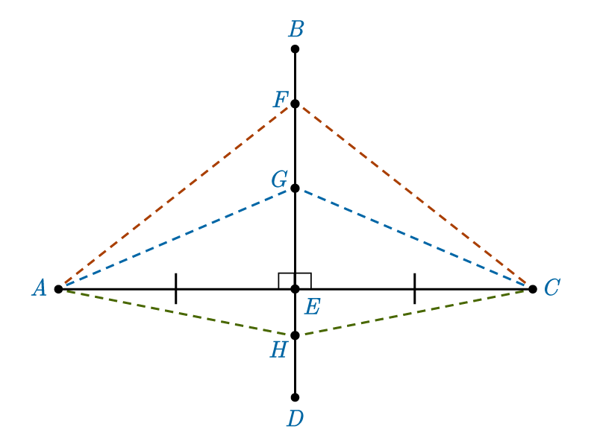

* *Right Angle Congruence Theorem*: All right angles are congruent because their measures are 90-degrees.
* *Reflexive Property of Congruence*: An angle, line segment, or geometric figure is congruent to itself.
* *CPCTC Theorem*: If two or more triangles are congruent, then their corresponding angles and sides are also congruent; it stands for “corresponding parts of congruent triangles are congruent”.
* *Side-Angle-Side (SAS) Congruence Theorem*: The theorem states that if two triangles have one pair of congruent angles between two pairs of congruent sides, then the triangles are congruent.
* These theorems can be used to complete proofs, like in the following example:

|  |  |
| --- | --- |
| **Example**: In the diagram, $$\overline{CA}$$ is the perpendicular bisector of $$\overline{BD}$$. Point $$F$$ is a point on the perpendicular bisector, $$\overline{CA}$$. Complete the proof to prove that $$F$$ is equidistant from $$B$$ and $$D$$. | |
| **Statement** | **Reason** |
| 1. is the perpendicular bisector of | given |
| 1. Point is on $$\overline{CA}$$. | given |
| $$\overline{BE}≅\overline{DE}$$ | definition of perpendicular bisector |
| 1. and are right angles | definition of perpendicular bisector |
| $$∠FEB≅∠FED$$ | Right Angle Congruence Theorem |
| $$\overline{FE}≅\overline{FE}$$ | Reflexive Property of Congruence |
| $$∆FEB≅∆FED$$ | SAS Theorem |
| $$\overline{FB}≅\overline{FD}$$ | CPCTC Theorem |

**Practice Questions and Answers**

|  |  |  |
| --- | --- | --- |
|  | Question | Answer |
| P 1 | *Use the image to answer the question.*  A horizontal line is intersected by two parallel lines lower m and lower n forming eight angles.  Kip writes the following proof.    What theorem or postulate has Kip proven?  Option #1: Corresponding Angles Postulate  Option #2: Alternate Interior Angles Theorem  Option #3: Vertical Angles Theorem | 3 |
| P 2 | *Use the image to answer the question.*  A vertical line is intersected by two parallel lines m and n forming eight angles.  Which of the following statements can be proven by the Corresponding Angles Postulate? Assume that $m∥n$.  Option 1: $∠D≅∠E$ Option 2: $∠C≅∠G$ Option 3: $∠A≅∠D$ | 2 |
| P 3 | *Use the image to answer the question.*  A horizontal line is intersected by two parallel lines lower s and lower t that slant from right to left forming eight angles.  Clancy wrote a proof to prove that alternate interior angles are congruent.    What is the missing statement in his proof?  Option 1: $m∠E=m∠A$ Option 2: $m∠C=m∠G$ Option 3: $m∠D=m∠H$ | 3 |
| P 4 | *Use the image to answer the question.*  An image is shown of perpendicular bisector VZ intersecting line segment WY at point X. Point U is a point on the perpendicular bisector.  Harriet has written a proof to prove that point *U* is equidistant from points *W* and *Y*. She knows that $\overline{ZV}$ is the perpendicular bisector of $\overline{WY}$.    What is the missing step in her proof?  Option 1: There is no missing step in Harriet’s proof.  Option 2: Harriet forgot the step where she proves that $∠XUW≅∠XUY$ because of the CPCTC Theorem.  Option 3: Harriet forgot the step where she proves that $∠WXU≅∠YXU$ because of the SAS Congruence Theorem. | 3 |
| P 5 | *Use the image to answer the question.*  The outline of a kite is in the shape of a diamond. The vertices of this diamond are labeled upper F, upper G, upper K, and upper J, respectively. Each of these points are connected via lines that intersect at a central, interior point: upper H.  In quadrilateral *FGKJ*, $\overline{FK}$ is a perpendicular bisector of $\overline{GJ}$. The length of $\overline{GF}$ is $6+x$ units, and the length of segment $\overline{JF}$ is $3x-5$ units. What is the value of *x*? | 5.5 |

**Quick Check Questions and Answers**

|  |  |  |
| --- | --- | --- |
|  | Question | Answer |
| Q 1 | *Use the image to answer the question.*  A horizontal line is intersected by two parallel lines lower s and lower t that slant from left to right forming eight angles.  If lines *s* and *t* are parallel, which pair of angles is supplementary and why? | $∠A$ and $∠D$ because they are consecutive exterior angles |
| Q 2 | *Use the image to answer the question.*  A vertical line is intersected by two parallel lines lower m and lower n forming eight angles.  Lines *m* and *n* are parallel. Angle *E* measures $(3x+18)$ degrees and angle *B* measures $(14x-8)$. What is the value of *x*? | 10 |
| Q 3 | Line segment $\overline{AC}$ is a perpendicular bisector of segment $\overline{BD}$, with the two segments meeting at point E. What is true of segment $\overline{BE}$? | It must be the same length as segment $\overline{DE}$. |
| Q 4 | Lenny wrote a paragraph proof of the Perpendicular Bisector Theorem. What mistake did Lenny make in his proof? $\overline{HK}$ is a perpendicular bisector of $\overline{IJ}$, and *L* is the midpoint of $\overline{IJ}$. *M* is a point on the perpendicular bisector, $\overline{HK}$. By the definition of a perpendicular bisector, I know that $\overline{IM}≅\overline{JM}$. By the definition of a perpendicular bisector, I also know that $∠MLI$ and $∠MLJ$ are right angles. $∠MLI≅∠MLJ$ because of the Right Angle Congruence Theorem. I can also say that $\overline{ML}≅\overline{ML}$ by the Reflexive Property of Congruence. With this information, I know that $∆MLI≅∆MLJ$ by the SAS Congruence Theorem. Since the triangles are congruent, the CPCTC Theorem allows me to know that $\overline{IL}≅\overline{JL}$. Knowing that these segments are congruent proves the Perpendicular Bisector Theorem. | The definition of a perpendicular bisector tells you that $\overline{IL}≅\overline{JL}$, not that $\overline{IM}≅\overline{JM}$. |
| Q 5 | $\overline{JL}$ is a perpendicular bisector of $\overline{KM}$. Hallie locates point *H* along line segment $\overline{JL}$. If the length of $\overline{KH}$ is given by $6y+3$ and the length of $\overline{HM}$ is given by $2y+7$, what is the length in units of segment $\overline{HM}$? | 9 |

**Lesson 6 – Triangle Proofs**

**Key Words:**

* **angle bisector –** a line that divides an angle into two angles of equal measure
* **Base Angles Theorem –** the theorem that states that the base angles of an isosceles triangle are congruent
* **base (of an isosceles triangle) –** the unequal side of an isosceles triangle
* **CPCTC Theorem –** the theorem that states that corresponding parts of congruent triangles are congruent
* **isosceles triangle –** a triangle in which two sides have the same length
* **leg (of an isosceles triangle) –** one of the two sides of an isosceles triangle that are the same length
* midpoint – a point at the center or middle
* **Reflexive Property of Congruence –** the property that states that an angle, line segment, or geometric figure is congruent to itself
* **SAS Congruence Theorem –** the theorem that states that if two sides and the included angle of one triangle are congruent to two sides and the included angle of another triangle, then the triangles are congruent
* **SSS Congruence Theorem –** the theorem that states that if three sides of one triangle are congruent to three sides of another triangle, then the triangles are congruent
* **Triangle Angle Sum Theorem –** the theorem that states that the interior angles of any triangle sum to 180°

**Objective 1:** In this section, you will prove that the interior angles of a triangle sum to 180°.

*Mathematical Practice Standard: Construct viable arguments and critique the reasoning of others.*

**Big Ideas**:

* The *Triangle Sum Theorem* states that the interior angles of any triangle sum $$180°$$.

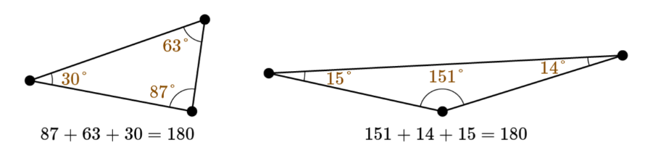

* Recall that if two parallel lines are cut by a transversal, then each pair of alternate interior angles is congruent. The *Triangle Angle Sum Theorem* can be proven with *alternate interior angles*.

|  |  |
| --- | --- |
| **Example**: Complete the proof.  Given: $$∆ABC$$ with  Prove: $$m∠A+m∠ABC+m∠C=180°$$ | |
| **Statements** | **Reasons** |
| 1. with | Given |
| $$∠DBA≅∠A; ∠EBC≅∠C$$ | and alternate interior angles are congruent when lines are parallel |
| $$m∠DBA≅m∠A; m∠EBC≅m∠C$$ | Definition of congruent angles |
| $$m∠DBA+m∠ABC+m∠EBC=180°$$ | Definition of a straight angle |
| $$m∠A+m∠ABC+m∠C=180°$$ | Substitution |

**Objective 2:** In this section, you will prove that the base angles of an isosceles triangle are congruent.

*Mathematical Practice Standard: Construct viable arguments and critique the reasoning of others.*

**Big Ideas:**

* An *isosceles triangle* is a triangle in which two sides are the same length. The two sides are called *legs*, and the third sides is called the *base*.
* The *Base Angles Theorem* says that the base angles of an *isosceles* triangle will always be congruent.
  + In this triangle, the base angles $$∠A$$ and $$∠C$$ are congruent.

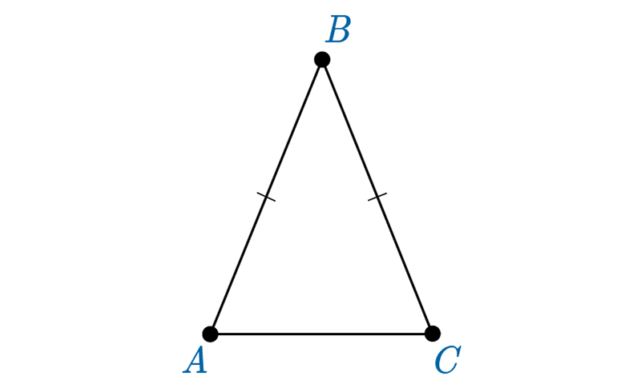

* Recall the five triangle congruence theorems used to prove that two triangles are congruent. The *SSS Congruence Theorem* and *SAS Congruence Theorem* are used to prove the *Base Angles Theorem*.
* Recall the *CPCTC Theorem* that states that corresponding parts of congruent triangles are *congruent*.
* The strategy for proving the *Base Angles Theorem* requires turning the *isosceles* triangle into two triangles that you can prove are *congruent*. Then the base angles of the *isosceles* triangle are congruent because they are corresponding parts of the congruent triangles.

|  |  |
| --- | --- |
| **Example**: Complete the proof.  Given: $$∆ABC$$ with $$\overline{AB}≅\overline{CB}$$ Prove: $$∠A≅∠B$$ | |
| **Statement** | **Reasons** |
| 1. Isosceles with | Given |
| 1. , the midpoint of $$\overline{AC}$$,  through points $$B$$ and $$D$$ | Construction |
| $$\overline{AD}≅\overline{CD}$$ | Definition of midpoint |
| $$\overline{BD}≅\overline{BD}$$ | Reflexive property of congruence |
| $$∆ABD≅∆CBD$$ | SSS Congruence Theorem |
| $$∠A≅∠C$$ | CPCTC Theorem |

**Practice Questions and Answers**

|  |  |  |
| --- | --- | --- |
|  | Question | Answer |
| P 1 | *Use the image to answer the question.*  An illustration shows a triangle with angles marked as 1, 2 and 3, clockwise beginning at the top angle. A line is drawn outside of the triangle, passing through the vertex with angle 3.  Fill in the blanks to complete the proof that $m∠1+m∠3+m∠2=180°$ given the diagram. | 1. 1 2. 5 3. 2 |
| P 2 | *Use the image to answer the question.*  An illustration shows a triangle with vertices labeled clockwise as upper A, upper B, and upper C, starting at the lower left vertex. A line with arrows at both ends is drawn above the triangle.  Consider the following proof of the Triangle Angle Sum Theorem. Which statement has a mistake?  Given: $∆ABC$ with $\overset{⃡}{DE}∥\overline{AC}$ Prove: $m∠A+m∠ABC+m∠C=180°$ | 4 |
| P 3 | *Use the image to answer the question.*  An isosceles triangle with a sideways orientation is marked counter-clockwise from the right as upper A upper B upper C. Sides upper A upper B and upper A upper C are marked with a single congruent tick mark. A line bisects the triangle.  Easton is working to prove the Base Angles Theorem. He starts with an isosceles triangle $∆ABC$ with $\overline{AB}≅\overline{AC}$. He then constructs point *D*, the midpoint of $\overline{BC}$. He knows he is supposed to prove that two triangles are congruent in order to prove the Base Angles Theorem. Help him to construct a viable argument. Which two triangles should he prove are congruent and by what reason are they congruent?  Option #1: $∆ABC≅∆ADC$ by the SSS Triangle Congruence Theorem.  Option #2: $∆ABD≅∆ACD$ by the SSS Triangle Congruence Theorem.  Option #3: $∆ABC≅∆ADC$ by the SAS Triangle Congruence Theorem.  Option #4: $∆ABD≅∆ACD$ by the SAS Triangle Congruence Theorem. | 2 |
| P 4 | *Use the image to answer the question.*  An isosceles triangle with a sideways orientation is marked counter-clockwise from the right as upper A upper B upper C. Sides upper A upper B and upper A upper C are marked with a single congruent tick mark. A line bisects the triangle.  Beatrix is working to prove the Base Angles Theorem. They start with an isosceles triangle $∆ABC$ with $\overline{AB}≅\overline{AC}$. Then they construct $\overline{AD}$, the angle bisector of point *A*. They know they are supposed to prove that two triangles are congruent in order to prove the Base Angles Theorem. They show how $∆ABD≅∆ACD$ by the SAS Congruence Theorem. They aren’t sure how to finish the proof. Help them construct a viable argument. What should Beatrix do next?  Option #1: Show that $∠BAD≅∠CAD$ by the definition of an angle bisector.  Option #2: Show that $∠C≅∠A$ by the CPCTC Theorem.  Option #3: Show that $∠B≅∠C$ by the CPCTC Theorem.  Option #4: Show that $\overline{BD}≅\overline{DC}$ by the definition of a midpoint. | 3 |
| P 5 | What does the Base Angles Theorem say?  Option #1: The base angles of an isosceles triangle are opposite the legs.  Option #2: The base angles of an isosceles triangle are complementary.  Option #3: The base angles of an isosceles triangle are supplementary.  Option #4: The base angles of an isosceles triangle are congruent. | 4 |

**Quick Check Questions and Answers**

|  |  |  |
| --- | --- | --- |
|  | Question | Answer |
| Q 1 | *Use the image to answer the question.*  An illustration shows a triangle with angles marked as 1, 2 and 3, clockwise beginning at the top angle. A line is drawn outside of the triangle, passing through the vertex with angle 3.  Sylvie has started a proof of the Triangle Angle Sum Theorem. Which answer choice correctly completes her proof?  Sylvie's Proof: Given the diagram shown, $∠1≅∠5$; $∠2≅∠4$ because alternate interior angles are congruent when lines are parallel. Then, I know that $m∠1=m∠5;m∠2=m∠4$ because congruent angles have equal measures. | $m∠5+m∠3+m∠4=180°$ by the definition of a straight angle. Finally, $m∠1+m∠3+m∠2=180°$ by substitution. |
| Q 2 | *Use the image to answer the question.*  An illustration shows a triangle with vertices labeled clockwise as upper A, upper B, and upper C, starting at the lower left vertex. A line with arrows at both ends is drawn above the triangle.  Consider the following proof of the Triangle Angle Sum Theorem. Which statement has a mistake? How should the mistake be fixed?  Given: $∆ABC$ with $\overset{⃡}{DE}∥\overline{AC}$ Prove: $m∠A+m∠ABC+m∠C=180°$ | Statement 2 has a mistake. It should say $∠DBA≅∠A; ∠EBC≅∠C$. |
| Q 3 | *Use the image to answer the question.*  An isosceles triangle is marked clockwise from the lower left vertex as upper A upper B upper C. The sides upper A upper B and upper B upper C are marked with single congruent tick marks.  Consider the following proof of the Base Angles Theorem. Which statement should fill in the blank?  PROOF: Given isosceles $∆ABC$ with $\overline{AB}≅\overline{BC}$, I can construct $\overset{⃡}{BD}$, the angle bisector of $∠B$. _____________________. I also know that line segments are congruent to themselves, so $\overline{BD}≅\overline{BD}$ by the reflexive property of congruence. I now have two pairs of sides and an included angle that are congruent, so I know that $∆ABC≅∆CBD$ by the SAS Congruence Theorem. Finally, corresponding parts of congruent triangles are congruent by the CPCTC Theorem, so $∠A≅∠C$. | Then, by the definition of an angle bisector, I know that $∠ABD≅∠CBD$. |
| Q 4 | *Use the image to answer the question.*  An isosceles triangle with a sideways orientation is marked counter-clockwise from the right as upper A upper B upper C. Sides upper A upper B and upper A upper C are marked with a single congruent tick mark. A line bisects the triangle.  Fox is working to prove the Base Angles Theorem. His proof is shown below. Critique his reasoning. Which statement or reason in his proof has a mistake? How can he fix his mistake?  Given: Isosceles $∆ABC$ with $\overline{AB}≅\overline{AC}$ Prove: $∠B≅∠C$ | Reason 5 has a mistake. It should say “SSS Congruence Theorem.” |
| Q 5 | Fill in the blank to make a true statement.  The ___________ of an isosceles triangle are congruent. | base angles |

**Lesson 7 – Parallelogram Proofs**

**Key Words:**

* **alternate interior angles –** the two sets of two angles located inside two parallel lines that are crossed by a transversal; the angles located diagonally across the transversal are equal to each other
* **Alternate Interior Angles Theorem –** the theorem that states that if two parallel lines are cut by a transversal, then each pair of alternate interior angles is congruent
* **ASA Congruence Theorem –** the theorem stating that if two triangles have one pair of congruent sides between two pairs of congruent angles, then the triangles are congruent
* **Bisect –** to divide into two congruent parts
* **congruent –** of the same shape and size; in geometry, congruent parts overlap perfectly when placed on top of one another
* **corresponding angles –** the two angles located on the same side of the transversal and in the same corresponding position in the group of four corners created by both intersections
* **Corresponding Angles Postulate –** the postulate that states that if two parallel lines are cut by a transversal, then each pair of corresponding angles is congruent
* **CPCTC Theorem –** the theorem stating that if two or more triangles are congruent, then their corresponding angles and sides are also congruent; it stands for "corresponding parts of congruent triangles are congruent"
* **diagonal -** a segment connecting two opposite vertices of a polygon
* **kite –** a four-sided figure with two pairs of adjacent, congruent sides
* **linear pair –** the two adjacent angles that form a straight line
* **parallelogram –** a quadrilateral with opposite sides parallel and equal
* **quadrilateral –** a polygon of four sides
* **rectangle –** a parallelogram whose angles are all right angles, especially one with adjacent sides of unequal length
* **Reflexive Property of Congruence –** the property that states that an angle, line segment, or geometric figure is congruent to itself
* **square –** a rectangle with all four sides equal
* **straight angle –** an angle whose sides lie in opposite directions from the vertex in the same straight line and which equals two right angles

**Objective 1:** In this section, you will prove that opposite sides and angles of a parallelogram are congruent.

*Mathematical Practice Standard: Construct viable arguments and critique the reasoning of others.*

**Big Ideas**:

* A *parallelogram* is a quadrilateral with opposite sides parallel and equal.
* Recall that when transversals cross parallel lines, many different angle pairs are created with special relationships.
* For angles of a parallelograms, the following are often used to prove that **opposite angles of parallelograms are always congruent.**
  + *Corresponding Angles Postulate*
  + *Alternate Interior Angles Theorem*
  + *Supplementary Angles (for linear pairs)*
  + For example, in the following figure of a parallelogram $$m∠4≅m∠13$$ and

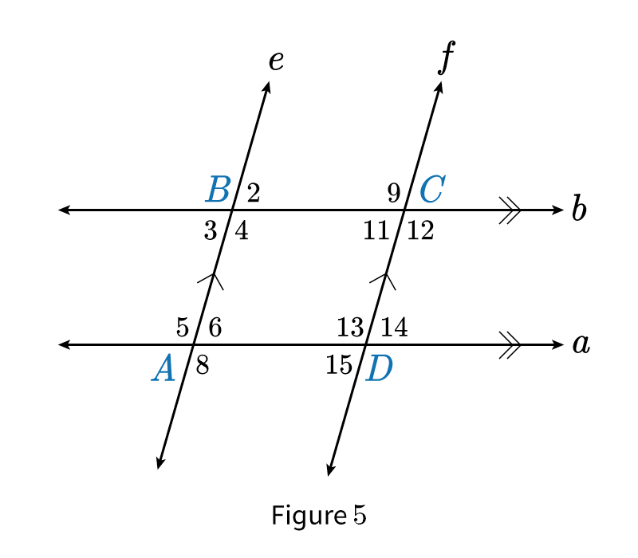

* Recall from previous units the congruence theorems used to prove triangle congruence.
* For sides of a parallelograms, the following are often used to prove that the **opposite sides of a parallelogram are always congruent**.
  + *ASA Congruence Theorem*
  + *CPCTC Theorem*
  + *Reflexive Property of Congruence*
  + For example, in the following figure of a parallelogram $$\overline{AB}≅\overline{CD}$$ and $$\overline{BC}≅\overline{DA}$$.

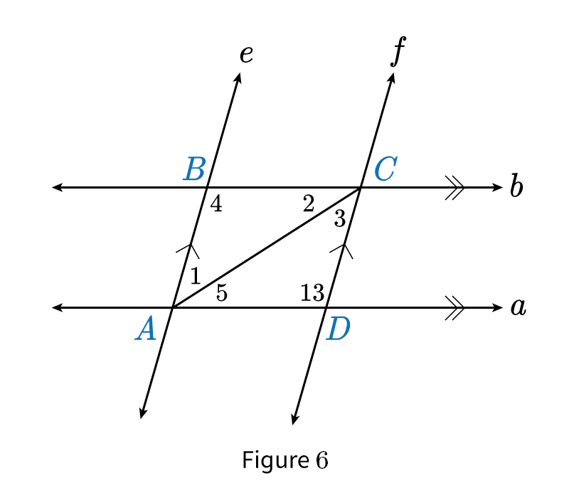

**Objective 2:** In this section, you will prove that the diagonals of a parallelogram bisect each other.

*Mathematical Practice Standard: Construct viable arguments and critique the reasoning of others.*

**Big Ideas:**

* A *diagonal* is a segment connecting two opposite vertices of a polygon.
* Observe the characteristics of *diagonals* in a *parallelogram*:

|  |  |
| --- | --- |
| **Parallelogram**: a quadrilateral with opposite sides parallel and equal.   * The diagonals intersect at point *O*. * The length of the diagonals are **not** congruent and **do not** create congruent angles. * Diagonals of parallelograms **will always *bisect* each other**. The length of the segments that are cut by the intersection point *O* are congruent. |  |

|  |  |
| --- | --- |
| **Example**: If quadrilateral *ABCD* is s parallelogram, what is the value of x? | |
| Step 1: Recall that the diagonals of a parallelogram must bisect each other, which means the segments *AE* and *CE* are congruent. | $$AE=CE$$ |
| Step 2: Substitute the values of *AE* and *CE*. | $$x+5=2x−3$$ |
| Step 3: Solve for *x* using properties of equality. |  |
| Step 4: State the answer. | Since the diagonals bisect each other, *x* must be equal to 8. |

**Practice Questions and Answers**

|  |  |  |
| --- | --- | --- |
|  | Question | Answer |
| P 1 | *Use the image to answer the question.*  Parallelogram upper J upper K upper L upper M is shown. Vertex upper J is on the top left. Vertex upper M is on the bottom left.  In the parallelogram *JKLM*, side *KL* measures 14 units. What is the length of side *JM*? | 14 |
| P 2 | *Use the image to answer the question.*  Parallelogram upper A upper B upper C upper D is shown. Vertex upper A is on the top left. Vertex upper D is on the bottom left.  If the interior angle of point *A* in this parallelogram measures 155 degrees, what is the interior angle measure of point *C*? | 155 |
| P 3 | *Use the image to answer the question.*  Parallelogram upper W upper X upper Y upper Z is shown with base upper Z upper Y shorter than the height upper W upper Z. Diagonals are drawn from upper W to upper Y and upper X to upper Z to meet at upper A.  Chole draws parallelogram *WXYZ* with diagonals *WY* and *XZ* meeting at point *A*. If *WY* measures 7 centimeters, what is the length of *AW*? | 3.5 |
| P 4 | *Use the image to answer the question.*  Parallelogram upper S upper T upper U upper V is shown with base upper V upper U shorter than the height upper U upper T. Diagonals are drawn from upper S to upper U and upper T to upper V to meet at upper R.  The diagonals of parallelogram *STUV* intersect at point *R*. If *SU* is equal to 11 inches, what is the length of *SR*? | 5.5 |
| P 5 | *Use the image to answer the question.*  Parallelogram upper J upper K upper L upper M is shown with base upper L upper M shorter than the height upper L upper K. Diagonals are drawn from upper J to upper L and upper K to upper M to meet at upper N.  In parallelogram *JKLM*, diagonals *KM* and *JL* meet at point *N*. The length of *KM* is equal to $5x+1$ units. The length of *NM* is equal to $2x+9$ units. What is the value of *x*? | 17 |

**Quick Check Questions and Answers**

|  |  |  |
| --- | --- | --- |
|  | Question | Answer |
| Q 1 | *Use the image to answer the question.*  Two parallel horizontal lines a and b, intersecting with two parallel slanted lines e and f. A parallelogram is formed in the center of the intersecting lines.  In the diagram, $a∥b$ and $e∥f$. Sylvia writes a proof to prove that opposite angles, $∠6$ and $∠11$, are congruent in the parallelogram. Drag and drop the statements and reasons into their correct locations in the two-column proof. | 1. Substitution Property of Equality 2. Subtraction Property of Equality |
| Q 2 | *Use the image to answer the question.*  Parallelogram upper A upper B upper C upper D is shown. Vertex upper A is on the top left. Vertex upper D is on the bottom left.  Maluwa draws parallelogram *ABCD*. If $BC=7$ cm and $CD = 5$ cm, what is the length of *AB*? | 5 cm |
| Q 3 | *Use the image to answer the question.*  Parallelogram upper X upper Y upper Z upper W is shown. Vertex upper X is on the top left. Vertex upper W is on the bottom left.  In parallelogram *WXYZ*, the interior angle *Y* measures 30 degrees. What is the measure of the interior angle at point *X*? | 150 degrees |
| Q 4 | *Use the image to answer the question.*  Parallelogram upper D upper E upper F upper G is shown. Diagonals are drawn from upper D to upper F and upper E to upper G to meet at upper H.  In parallelogram *DEFG*, which segment bisects $\overline{EG}$? | $$\overline{DF}$$ |
| Q 5 | *Use the image to answer the question.*  Parallelogram upper R upper S upper T upper U is shown with base upper T upper U larger than height upper S upper T. Diagonals are drawn from upper R to upper T and upper S to upper U to meet at upper V.  In parallelogram *RSTU*, *RV* measures $y+18$ units and *TV* measures 3y-10 units. How many units long is diagonal *RT*? | 64 |

**Lesson 8 – Converse Parallelogram Proofs**

**Key Words:**

* **Addition Property of Equality** – the property that states that when the same quantity is added to both sides of an equation, it produces an equivalent equation
* **Alternate Interior Angles Converse Theorem** – the theorem that states that if two lines and a transversal form alternate interior angles that are congruent, then the lines are parallel
* **Alternate Interior Angles Theorem –** the theorem that states that if two parallel lines are cut by a transversal, then each pair of alternate interior angles is congruent
* **bisect** – to divide into two usually equal parts
* **congruent** – of the same shape and size; in geometry, congruent parts overlap perfectly when placed on top of one another
* **consecutive angles** – any pair of angles each of which is on the same side of one of two lines cut by another line and on the same side of that other line
* **Consecutive Interior Angles Converse Theorem** – the theorem that states that if two lines are cut by a transversal so that consecutive interior angles are supplementary, then the lines are parallel
* **CPCTC Theorem** – the theorem stating that if two or more triangles are congruent, then their corresponding angles and sides are also congruent; it stands for "corresponding parts of congruent triangles are congruent"
* **diagonal** – a segment connecting two opposite vertices of a polygon
* **parallel** – extending in the same direction, everywhere equidistant, and not meeting
* **parallelogram** – a quadrilateral with opposite sides parallel and equal
* **quadrilateral –** a polygon of four sides
* **Reflexive Property of Congruence** – the property that states that an angle, line segment, or geometric figure is congruent to itself
* **SAS Congruence Theorem –** the theorem stating that if two triangles have one pair of congruent angles between two pairs of congruent sides, then the triangles are congruent
* **segment bisector –** a line, ray, or segment that cuts another segment in half
* **SSS Congruence Theorem** – the theorem stating that if two triangles have three pairs of congruent corresponding sides, then the triangles are congruent
* **Substitution Property of Equality** – the property that states that one value can replace another equal value in an expression or equation and the value will remain the same
* **supplementary** – a pair of angles whose sum is equal to 180 degrees
* **transversal** – a line that passes through two lines in the same plane at two distinct points
* **trapezoid –** a quadrilateral having only two sides parallel
* **vertical angles –** either of two angles lying on opposite sides of two intersecting lines that are diagonal to one another and share a common vertex
* **Vertical Angles Theorem –** the theorem that states all vertical angles are congruent

**Objective 1:** In this section, you will prove that a quadrilateral is a parallelogram if its opposite sides and angles are congruent.

*Mathematical Practice Standard: Construct viable arguments and critique the reasoning of others.*

**Big Ideas**:

* If both pairs of **opposite angles** of a quadrilateral are congruent, then it must be a parallelogram.
* If both pairs of **opposite sides** of a quadrilateral are congruent, then it must be a parallelogram.
* Recall the special properties of *parallelograms*:

|  |  |
| --- | --- |
| * Both pairs of opposite sides are parallel * Both pairs of opposite sides are congruent * Both pairs of opposite angles are congruent * The diagonals bisect each other * Consecutive angles are supplementary (add to 180-degrees) * The four angles of a parallelogram add up to 360-degrees |  |

|  |  |
| --- | --- |
| **Example:** Given quadrilateral *ABCD* with $$AD=24$$, $$AB=3y−5$$, $$BC=7x−4$$, and $$DC=25$$, what values would *x* and *y* need to be to guarantee that ABCD is a parallelogram? | |
| Step 1: For *ABCD* to be a parallelogram, both pairs of opposite sides or angles must be congruent. | $$AD=BC$$ $$AB=DC$$ |
| Step 2: Substitute the values for *AD* and *BC* and solve for *x.* |  |
| Step 3: Substitute the values for *AB* and D*C* and solve for *y.* |  |
| Step 4: State the solution. | If $$x=4$$ and $$y=10$$, then both pairs of opposite sides are congruent and quadrilateral *ABCD* must be a parallelogram. |

**Objective 2:** In this section, you will prove that a quadrilateral is a parallelogram if its diagonals bisect each other.

*Mathematical Practice Standard: Construct viable arguments and critique the reasoning of others.*

**Big Ideas:**

* You can also prove that a quadrilateral is a *parallelogram* using the relationship between the *diagonals*.
* If the *diagonals* of a quadrilateral ABCD *bisect* each other, which makes it a *parallelogram*.

|  |  |
| --- | --- |
| **Example**: If $$m=4$$ and $$n=6$$, is quadrilateral *ABCD* a parallelogram? | |
| Step 1: For quadrilateral ABCD to be a parallelogram, the diagonals must bisect each other. | $$DO=BO$$ $$AO=CO$$ |
| Step 2: Substitute the values for *m, n, DO* and *BO* and solve each side. |  |
| Step 3: Substitute the values for *m, n, AO* and C*O* and solve each side. |  |
| Step 4: State the solution. | Since $$AO≠CO$$, quadrilateral $$ABCD$$ is not a parallelogram. The diagonals do not bisect each other. |

**Practice Questions and Answers**

|  |  |  |
| --- | --- | --- |
|  | Question | Answer |
| P 1 | In parallelogram *WXYZ*, the interior angle of *X* measures 35 degrees and the interior angle of Z also measures 35 degrees. What are the interior angle measures of *W* and *Y*?  The interior angle of *W* measures _____ degrees and the interior angle of *Y* measures _____ degrees. | 145; 145 |
| P 2 | *Use the image to answer the question.*    Tiana draws quadrilateral *ABCD* as shown, with the measures of $∠A, ∠B, ∠C, and ∠D$ represented. For what values of *m* and *n* is Tiana guaranteed that *ABCD* is a parallelogram?  If *m* = ____ and *n* = ____ then Tiana is guaranteed that *ABCD* is a parallelogram. | 15; 34 |
| P 3 | *Use the image to answer the question.*  A parallelogram has vertices upper A, upper B, upper C, and upper D. Opposite vertices are connected via diagonal lines that intersect at an interior point labeled upper E.  In parallelogram *ABCD*, if the length of segment *BE* is 11 units, what is the length of *DE*? | 11 |
| P 4 | *Use the image to answer the question.*  A parallelogram has vertices upper R, upper S, upper U, and upper T. Opposite vertices are connected via diagonal lines that intersect at an interior point labeled upper V. The lines formed between each vertex and upper V are labeled.  If quadrilateral *RSTU* is a parallelogram, what are the lengths of the diagonals of the figure?  Diagonal *RT* is equal to _____ and diagonal *SU* is equal to _____. | 34; 28 |
| P 5 | *Use the image to answer the question.*  A parallelogram has vertices upper J, upper K, upper L, and upper M. Opposite vertices are connected via diagonal lines that intersect at an interior point labeled upper O. The lines formed between each vertex and upper O are labeled.  If quadrilateral *JKLM* is a parallelogram, what must be the value of *x*? | 1 |

**Quick Check Questions and Answers**

|  |  |  |
| --- | --- | --- |
|  | Question | Answer |
| Q 1 | *Use the image to answer the question.*  A parallelogram has its vertices labeled upper A upper B upper C upper D. Two sets of opposite sides are marked as congruent.  Prove that quadrilateral *ABCD* is a parallelogram. How do you know that the figure is a parallelogram? | Opposite sides of the figure are congruent. |
| Q 2 | Edwidge draws parallelogram STUV with a center at O. What must be true to prove that STUV is a parallelogram? | $\overline{ST}≅\overline{UV}$ and $\overline{TU}≅\overline{SV}$ |
| Q 3 | *Use the image to answer the question.*  A parallelogram has vertices upper A, upper B, upper C, and upper D. Opposite vertices are connected via diagonal lines that intersect at an interior point labeled upper O. The lines formed between each vertex and upper O are labeled.  To prove that quadrilateral *ABCD* is a parallelogram, what must be the value of *m*? | 11 |
| Q 4 | *Use the image to answer the question.*  A parallelogram has vertices upper Q, upper R, upper S, and upper T. Opposite vertices are connected via diagonal lines that intersect at an interior point labeled upper P. Sides upper Q upper R and upper T upper S are much longer than the other sides.  It is given that quadrilateral *QRST* is a parallelogram. Which segment of the figure must be congruent to segment $\overline{SP}$? | $$\overline{QP}$$ |
| Q 5 | *Use the image to answer the question.*  A parallelogram has vertices upper A, upper B, upper C, and upper D. Opposite vertices are connected via diagonal lines that intersect at an interior point labeled upper E. Sides upper A upper D and upper B upper C are much longer than the other sides.  If you were to prove that quadrilateral *ABCD* is a parallelogram, what would need to be true about *EB* and *ED*? | $\overline{EB}$ must be the same length as $\overline{ED}$. |

**Lesson 9 – Medians of a Triangle**

**Key Words:**

* **average** – the total of all the values divided by the number of values
* **concurrent lines** – a set of lines that intersect each other at exactly one point
* **congruent –** a term for identical in both size and shape
* **coordinates** – the numbers that describe the position of points along certain dimensions
* **coordinate geometry** – the study of geometric figures by plotting them on coordinate axes
* **median** – a segment that connects a vertex of a triangle to the midpoint of the opposite side
* **midpoint** – a point that is the exact middle of a line segment
* **point of concurrency** – a single point shared by three or more lines
* **x-coordinate** – the coordinate that identifies the exact location of a point on or parallel to the x-axis
* **y-coordinate** – the coordinate that identifies the exact location of a point on or parallel to the y-axis

**Formulas:**

* Weighted Average Formula: $$\frac{1}{3}\left(coordinates of vertex\right)+\frac{2}{3}\left(coordinates of midpoint\right)$$

**Objective 1:** In this section, you will prove that the medians of a triangle meet at a point.

*Mathematical Practice Standard: Construct viable arguments and critique the reasoning of others.*

**Big Ideas**:

* In this triangle, $$\overline{AB}$$ is called the *median* of the triangle which has the following properties:

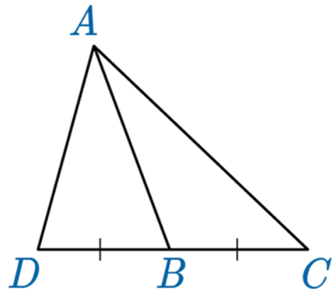

* + is a segment that connects a vertex of the triangle to its opposite side at the *midpoint*.
  + Because point B is a *midpoint*, it cuts $$\overline{DC}$$ into two smaller but equal segments; so $$\overline{DB}≅\overline{BC}$$.
* Since a triangle has three sides, it will also have three vertices, which means that you can draw three *medians*.

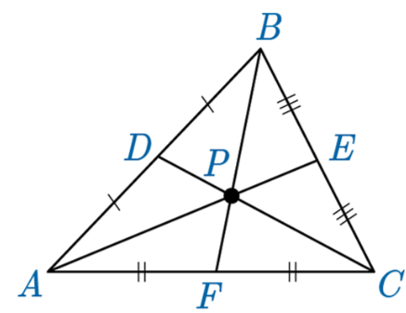

* The three medians will intersect at a single point, or centroid, known as the *point of concurrency.*
  + The *point of concurrency* divides the segment it cuts into a 2:1 ratio. Meaning that one section of the segment is twice as long as the other section of the segment.
  + In the above example, this means that $$2⋅PF=BP$$
* If you know the three vertices of a triangle, you can find the coordinates of its centroid, or *point of concurrency,* by using this formula.
  + Weighted Average Formula: $$\frac{1}{3}\left(coordinates of vertex\right)+\frac{2}{3}\left(coordinates of midpoint\right)$$

|  |
| --- |
| **Example:** The coordinates of the three vertices of a triangle are (4,3), (7,2), and (5,4). Find the coordinates of the centroid. |
| **Step 1**: Create the triangle on a coordinate grid and identify the midpoints of each side. Draw in the medians. |
| **Step 2**: Use the weighted average formula to calculate the intersection point (centroid). Identify one median and use the vertex and midpoint to calculate. For this example, we will use the median that connects vertex (4,3) and midpoint (6,3). $$\frac{1}{3}\left(coordinates of vertex\right)+\frac{2}{3}\left(coordinates of midpoint\right)$$   = $$\frac{1}{3}\left(4,3\right) + \frac{2}{3}\left(6,3\right)$$ $$\frac{1}{3}\left(4,3\right) + \frac{2}{3}\left(6,3\right)=\left(\frac{4}{3},1\right) + \left(4,2\right)$$ |
| **Step 3**: Add the x-coordinates and add the y-coordinates to create one coordinate point, the intersection point. $$\left(\frac{4}{3},1\right) + \left(4,2\right)$$ $$\left(\frac{4}{3}+4, 1+2\right)$$ $$\left(5\frac{1}{3},3\right)$$ |
| **Step 4**: State the answer.  The medians meet at the point $$\left(5\frac{1}{3},3\right)$$.  *Note: If you complete these calculations for any of other medians, you will arrive at the same answer. |

**Practice Questions and Answers**

|  |  |  |
| --- | --- | --- |
|  | Question | Answer |
| P 1 | *Use the image to answer the question.*  A coordinate plane's x-axis ranges from negative 4 to 5 and its y-axis ranges from negative 2 to 4, both by 1-unit increments. A right triangle is plotted. The coordinates of its vertices are labeled.  When the three medians of the triangle are drawn, they meet at a single point. What is the point of the centroid? Leave all results in fractions. | $$(\frac{1}{3},\frac{1}{3})$$ |
| P 2 | Triangle *ABC* is drawn on a coordinate plane with vertices *A* (4, 4), *B* (9, 1), and *C* (3, -1) and medians indicating the midpoint of each of the lines *AB*, *BC*, and *CA*. Prove the medians meet at a single point by finding the centroid. Express all results in fractions. | $$(\frac{16}{3},\frac{4}{3})$$ |
| P 3 | *Use the image to answer the question.*  A scalene triangle made up of vertices upper A, upper B, and upper C, is plotted on a grid. Each of its vertices have their coordinates labeled, and they are connected to an interior point labeled upper D.  The three medians of △ABC meet at a single point. What is the point of the centroid? Express all results in fractions. | $$(\frac{14}{3},\frac{11}{3})$$ |
| P 4 | △ABC is drawn on a coordinate plane with vertices 𝐴 (1, 3), 𝐵 (6, 6), and 𝐶 (3, 1) and with medians indicating the midpoint of each of the lines *AB*, *BC*, and *CA*. Prove that the medians meet at a single point by finding the centroid. Express all results in fractions. | $$(\frac{10}{3},\frac{10}{3})$$ |
| P 5 | Triangle *XYZ* is drawn on a coordinate plane with vertices X (0, 0), Y (3, 6), and Z (4, 3) and with medians indicating the midpoint of each of the lines *XY*, *YZ*, and *ZX*. Prove that the medians meet at a single point by finding the centroid. | $$(\frac{7}{3},3)$$ |

**Quick Check Questions and Answers**

|  |  |  |
| --- | --- | --- |
|  | Question | Answer |
| Q 1 | *Use the image to answer the question.*  A triangle and 7 points are plotted on a coordinate plane. Median lines connect the vertices and median points intersecting at a point in the center of the triangle.  One way to prove that the medians of a triangle all meet at one point is by using arbitrary coordinates (0, 0), (*a*, 0), and (*b*, *c*) to represent the three vertices of the triangle. Drag and drop the missing pieces of each step to complete the proof that all three medians intersect at point *P*. | 1. vertex 2. midpoint 3. (coordinates of vertex) + $\frac{2}{3}$ (coordinates of midpoint) 4. (a, 0) |
| Q 2 | *Use the image to answer the question.*  A coordinate plane's axes range from negative 7 to 7, both by 1-unit increments. A triangle made up of vertices upper A, upper B, and upper C is plotted. The coordinates of the vertices are given.  Prove that when the three medians of the triangle are drawn, they meet at a single point. What is the point of the centroid? | (-1, 1) |
| Q 3 | Triangle *ABC* is drawn on a coordinate plane with vertices *A* (-2, -3), *B* (4, 0), and *C* (-2, 2) and medians indicating the midpoint of each of the line segments $\overline{AB}$, $\overline{BC}$, and $\overline{CA}$. Prove the medians meet at a single point by finding the centroid. | $$(0, -\frac{1}{3})$$ |
| Q 4 | *Use the image to answer the question.*  A coordinate plane's axes range from 0 to 8, both by 1-unit increments. A triangle made up of vertices upper A, upper B, and upper C is plotted. The coordinates of the vertices are given.  To prove that all three medians of a triangle meet at the same point, the medians of each side must be found. What are the ordered pairs of the three median bisectors? | c = (2.5, 3.5  b = (5, 3.5)  a = (3.5, 2) |
| Q 5 | Triangle *ABC* is drawn on a coordinate plane with vertices *A* (-3, -3), *B* (0, 6), and *C* (4, -3) and medians indicating the midpoint of each of the lines *AB*, *BC*, and *CA*. Prove the medians meet at a single point by finding the centroid. | $$(\frac{1}{3}, 0)$$ |

**Lesson 10 – Rectangle Proofs**

**Key Words:**

* **bisect** – to divide into two congruent parts
* **coefficient –** a number in front of a variable
* **congruent** – a term for identical in both size and shape
* **consecutive angles –** a pair of angles formed when a line, known as the transversal line, crosses two lines
* **CPCTC Theorem** – the theorem stating that if two or more triangles are congruent, then their corresponding angles and sides are also congruent; it stands for "corresponding parts of congruent triangles are congruent"
* **definition of congruence –** the idea that two figures are the same size or measure if and only if they are congruent
* **diagonal** – a segment connecting two opposite vertices of a polygon
* **Division Property of Equality –** the property that states that when the same quantity is divided into both sides of an equation, it produces an equivalent equation
* **parallel** – extending in the same direction, everywhere equidistant, and not meeting
* **parallelogram** – a quadrilateral with opposite sides parallel and equal
* **quadrilateral** – a polygon of four sides
* **rectangle** – a four-sided shape that has four right angles and two pairs of opposite sides that are parallel and congruent
* **Reflexive Property of Congruence** – the property that states that an angle, line segment, or geometric figure is congruent to itself
* **right angle** – an angle whose measure is 90 degrees
* **SAS Congruence Theorem** – the theorem stating that if two triangles have one pair of congruent angles between two pairs of congruent sides, then the triangles are congruent
* **Segment Addition Postulate** – the postulate that states that if we are given two points on a line segment, *A* and *C*, then a third point, *B*, lies on the line segment *AC* if and only if the distances between the points meet the requirements of the equation $AB+BC=AC$
* **SSS Congruence Theorem -** the theorem stating that if two triangles have three pairs of congruent corresponding sides, then the triangles are congruent
* **Substitution Property of Equality** – the property that states that one value can replace another equal value in an expression or equation and the value will remain the same
* **supplementary** – a pair of angles whose sum is equal to 180 degrees
* **Transitive Property of Congruence** – the property that states that if two shapes are congruent to a third shape, then all the shapes are congruent

**Objective 1:** In this section, you will prove that the diagonals of a rectangle are congruent.

*Mathematical Practice Standard: Construct viable arguments and critique the reasoning of others.*

**Big Ideas**:

* *Rectangles* are *quadrilaterals* with special properties.

|  |  |
| --- | --- |
| Both pairs of opposite sides are *parallel*. |  |
| Both pairs of opposite sides are *congruent*. |  |
| Diagonals are congruent and bisect each other. Recall that to *bisect* means to cut in half. |  |
| All angles are *right angles*. |  |

* Recall the *SAS Congruence Theorem*: If two triangles have one pair of congruent angles between two pairs of congruent sides, then the triangles are congruent.
* Recall the *CPCTC Theorem*: corresponding parts of congruent triangles are congruent.
  + You can use *SAS Congruence Theorem* and the *CPCTC Theorem* to prove that diagonals of a rectangle are congruent.
  + For example: $$∆DAB≅∆CBA$$ by the SAS Congruence Theorem. So, using CPCTC, you know that $$\overline{AC}≅\overline{BD}$$**.**
  + 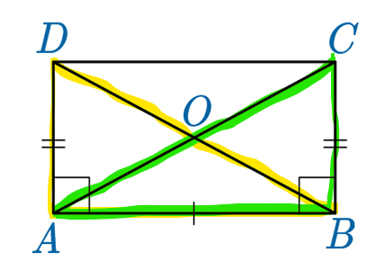
* Knowing that diagonals of a *rectangle* are congruent and *bisect* each other helps us solve problems.
  + We also know that segments of diagonals must be congruent.
  + We know that segments of a diagonal are half of the segment.

|  |  |
| --- | --- |
| **Example:** Given that quadrilateral *ABCD* is a rectangle, find the value of *x* if $$DO=5x−6$$ and $$CO=3x+8$$. | |
| **Step 1**: If *ABCD* is a rectangle, then its diagonals are congruent, and they bisect each other. The segments of the diagonals are also congruent. | $$DO=CO$$ |
| **Step 2**: Substitute the equations in. | $$5x−6=3x+8$$ |
| **Step 3**: Solve for *x* using properties of equality*.* | $$5x−6=3x+8$$ $$5x−6+6=3x+8+6$$ $$5x=3x+14$$ $$5x−3x=3x−3x+14$$ $$2x=14$$ $$\frac{2x}{2}=\frac{14}{2}$$ $$x=7$$ |
| **Step 4**: State the answer. | $$x=7$$ |

**Objective 2:** In this section, you will prove that a parallelogram is a rectangle if its diagonals are congruent.

*Mathematical Practice Standard: Construct viable arguments and critique the reasoning of others.*

**Big Ideas:**

* *Parallelograms* and *rectangles* have many of the same properties. This makes all *rectangles parallelograms*.
* The defining characteristic of a *rectangle* is that it has four right angles. That means all *parallelograms* are not *rectangles*.
* *Parallelograms* are not made up of four right angles and so *parallelograms* have diagonals that bisect each other **but are not congruent** to each other.

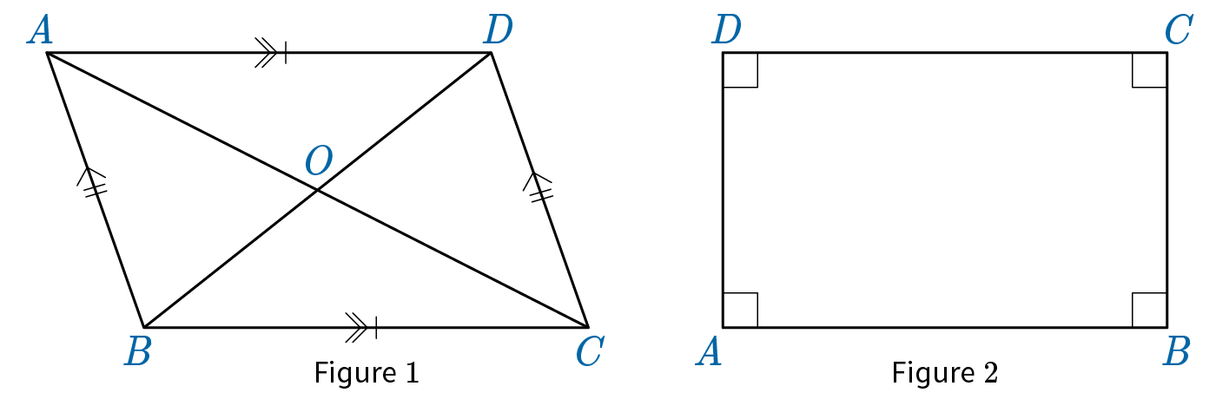

* To be a rectangle, the parallelogram must have congruent diagonals.

|  |  |
| --- | --- |
| Example: If you know that quadrilateral *ABCD* is a parallelogram, $$AC=12x−5$$, and $$DB=67$$, what value of *x* would guarantee that *ABCD* is a rectangle? | |
| **Step 1**: To be a rectangle, parallelogram *ABCD* must have congruent diagonals. | $$AC=DB$$ |
| **Step 2**: Substitute the values in for *AC* and *DB*. | $$12x−5=67$$ |
| **Step 3**: Solve for *x*. |  |
| **Step 4**: State the answer. | When $$x=6$$, *AC* is equal to *DB* and therefore *ABCD* is a rectangle. |

**Practice Questions and Answers**

|  |  |  |
| --- | --- | --- |
|  | Question | Answer |
| P 1 | *Use the image to answer the question.*  A quadrilateral upper A upper B upper C upper D. Two diagonals connect vertices upper A to upper C and upper B to upper D. The point of intersection is upper O.  Given that quadrilateral ABCD is a rectangle, which of the following statements, once proven, will prove that the diagonals of rectangle ABCD are congruent?  Statement #1: $△ADC ≅△CBA$ Statement #2: $△BCD ≅△DAB$ Statement #3: $△ADC ≅△BCD$ | 3 |
| P 2 | *Use the image to answer the question.*    Given that quadrilateral ABCD is a rectangle with $$AC=7x$$ and $BD=2x+5$, find the value of *x*. | 1 |
| P 3 | *Use the image to answer the question.*  A rectangle upper A upper B upper C upper D has diagonals between upper A upper C and upper B upper D. The diagonals insect at upper O, in the center. Segment upper A upper O is labeled 9 x minus 1. Segment upper D upper O is labeled 6 x plus 17.  Given the rectangle *ABCD* as shown, find *AC* if $AO = 9x-1$ and $DO = 6x+17$. | 106 |
| P 4 | *Use the image to answer the question.*  A parallelogram with vertices upper A upper B upper C upper D.  If , then $\overline{AC}$ (the diagonal of the quadrilateral) $≅\overline{AC}$ by which of the following properties?  Option #1: Division Property of Equality  Option #2: Reflexive Property of Equality  Option #3: Transitive Property of Equality  Option #4: Substitution Property of Equality | 2 |
| P 5 | Quadrilateral $ABCD≅LMNO≅STUV.$ If *STUV* is a rectangle and diagonal $\overline{SU}$ = 5 cm, what is the length of diagonals *AC* and *BD*? | 5 |

**Quick Check Questions and Answers**

|  |  |  |
| --- | --- | --- |
|  | Question | Answer |
| Q 1 | *Use the image to answer the question.*  A quadrilateral upper A upper B upper C upper D. Two diagonals connect vertices upper A to upper C and upper B to upper D. The point of intersection is upper O.  In a proof that the diagonals of rectangle *ABCD* are congruent, which statement comes just after the statements that $\overline{AD}≅\overline{BC}$, $\overline{AB}≅\overline{AB}$, and $∠DAB≅∠CBA$? | $$∆DAB≅∆CBA$$ |
| Q 2 | *Use the image to answer the question.*  A rectangle upper A upper B upper C upper D has diagonals between upper A upper C and upper B upper D. The diagonals insect at upper O, in the center. Segment upper A upper O is labeled 4 x minus 3. Segment upper B upper O is labeled 5 x minus 10.  Given that *ABCD* is a rectangle with $AO=4x-3$ and $BO = 5x-10$, what is the value of *x*? | $$x=7$$ |
| Q 3 | *Use the image to answer the question.*    The rectangle ABCD is given as shown. Find x if $$CO=−3x$$ and $$BD=x+21$$. | $$x=−3$$ |
| Q 4 | *Use the image to answer the question.*  A parallelogram with vertices upper A upper B upper C upper D.  Because congruent diagonals prove that a parallelogram is a rectangle, what value of *x* proves that parallelogram *ABCD* is a rectangle if *AC* = 48 and *DO* = $7x+3.$ | $$x=3$$ |
| Q 5 | *Use the image to answer the question.*  A quadrilateral upper A upper B upper C upper D. Two diagonals connect opposing vertices upper A to upper C and upper B to upper D. The point of intersection is upper O.  Drag and drop the statements and reasons into their correct locations in the two-column proof that parallelogram 𝐴𝐵𝐶𝐷 with congruent diagonals $\overline{DB}$ and $\overline{AC}$ is a rectangle. | 1. CPCTC Theorem of Congruence 2. Substitution Property of Equality |