Geometry

Probability
Unit Summary: In this unit, you will differentiate between theoretical and experimental probability and use two-way frequency tables. You will understand the relationship between sample space and the occurrence of events. Also, you will determine whether events are independent or dependent upon the outcome of another event. Finally, you will recognize, explain, and interpret conditional probability in everyday language and in terms of a model.
Lesson 1 – Events, Outcomes, and Intersections
Key Words:
- complement – the elements of events not included in a set
- empty set – a set or subset that contains no elements
- event – a subset of the possible outcomes of an experiment
- experiment – an action with a result determined by chance
- intersection – the elements that two or more sets have in common
- outcome – the result of an experiment
- sample space – a set of all possible outcomes from a given experiment
- union – the joining of two sets so that all elements in both sets are included
Objective 1: In this section, you will describe events as subsets of the set of all outcomes.
Mathematical Practice Standard: Reason abstractly and quantitatively.
Big Ideas:
- It’s important to understand the key terms in this unit as it will provide a solid understanding of how to describe events as the subset of all outcomes.
Experiment  An experiment is an action with the result being determined by chance. | Use the simple example of rolling dice. The outcome each time the dice is rolled is determined by chance, meaning it’s not predictable.  The experiment is rolling a die.  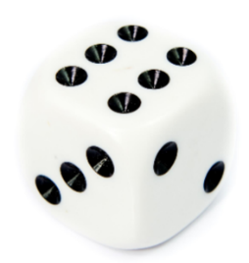
Outcome  The outcome is the result of an experiment. | The outcome of rolling a die is the number that the die shows after each roll. This could be any number 1-6.
Sample Space  The sample space is the set of ALL possible outcomes from a given experiment. | When rolling a die, there are six possible outcomes since the die has six sides numbered 1-6.  The sample space of this experiment can be defined as:  {1,2,3,4,5,6}  Brackets are used to define the set of all possible outcomes.
Event  The event is a subset of the possible outcomes of an experiment. | Continuing with the dice example, use the sample space {1,2,3,4,5,6} to write subsets of a specific event happening.  - Roll an odd number.  - {1,3,5}  - Roll an even number.  - {2,4,6}  - Roll a number greater than four.  - {5,6}

Objective 2: In this section, you will describe events as unions, intersections, or complements of other events.
Mathematical Practice Standard:
Big Ideas:
- Recall that an event is a subset of all possible outcomes of an experiment.
- Events can also be described in terms of unions, intersections, and complements of other events.
- It’s sometimes helpful to use a venn diagram to describe these types of subsets.
- Extra Practice: Notation for Set Operations – GeoGebra
Union  Two events with no overlapping outcome. The joining of two subsets of an event is called a union.  A union is represented by the symbol $∪$. You can also use the word “OR” to symbolize a union. | Experiment: roll two six-sided dice and add the sum of the two dice.  Event A: roll an odd sum  Event B: roll a sum of 12  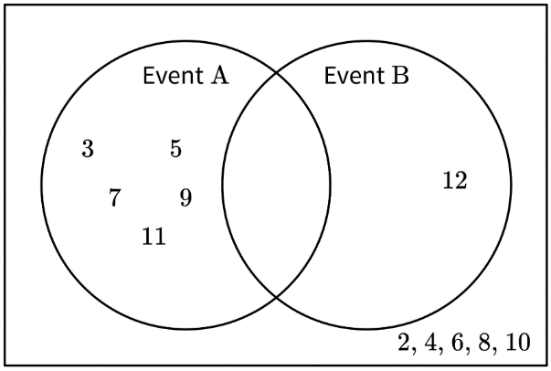  The union of the sets “odd sums” OR “sum of twelve” is written {3, 5, 7, 9, 11} $∪${12} = {3, 5, 7, 9, 11, 12}
Intersection  The intersection of two sets are the elements that are common to both sets.  An intersection is represented by the symbol $∩$. You can also use the word “AND” to represent an intersection. | Experiment: roll two six-sided dice and add the sum of the two dice.  Event A: the sum is odd  Event B: the sum is greater than 5  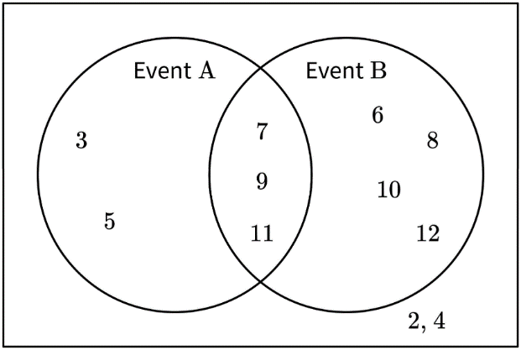  The overlapping portion of the venn diagram represents outcomes that are odd AND greater than five.  {3, 5, 7, 9, 11} $∩${6, 7, 8, 9, 10, 11, 12} = {7, 9, 11}
Complement  A complement considers the elements that are NOT included in the set.  The notation for a complement can be written in several ways. The complement of event A can be expressed as $A^{C} or ∼A$.  Extra Practice: Determining the Complement of a Spinner Event – GeoGebra | Experiment: roll on six-sided dice  Event A: roll an odd  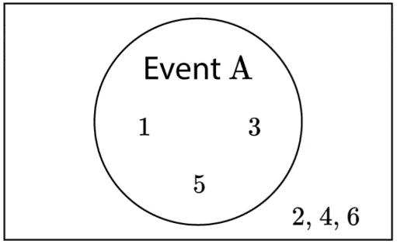  A = {1, 3, 5}  $A^{C}$= {2, 4, 6}

Practice Questions and Answers
 | Question | Answer
P 1 | If a deck of 52 cards is divided into two colors (red and black) and has four suits (the red suits diamonds and hearts and the black suits spades and clubs) with 13 different values per suit (Ace, numbers 2 through 10, Jack, Queen, and King), then what are the outcomes for drawing a red King?  Option #1: {King Hearts, King Diamonds}  Option #2: {King Spades, King Clubs}  Option #3: {King Hearts, King Diamonds, King Spades, King Clubs}  Option #4: {King Hearts} | The correct answer is option #1.
P 2 | If a typical 6-sided number cube is rolled, then list the outcomes for the event of rolling an odd number >3.  Option #1: {1, 3}  Option #2: {∅}  Option #3: {4, 5, 6}  Option #4: {5} | The correct answer is option #4.
P 3 | A bag has 12 numbered marbles inside, numbered 1–12. Without looking, you reach in and pull out one marble at a time, without returning the marble to the bag. The numbers you draw are 2, 5, and 11. Which of the following options describes the complement of the event of the numbers you drew?  Option #1: {empty set}  Option #2: {2, 5, 11}  Option #3: {1, 3, 4, 6, 7, 8, 9, 10, 12} | Option #3 describes the complement of the event.
P 4 | You and your friend are playing a game with two number cubes. If you roll doubles or two numbers that are both even, you get to take another turn and roll again. Which of the following options is a subset for either rolling doubles or both numbers being even?  Option #1: {evens} ∪ {doubles} {evens} ∪ {doubles}  Option #2: {evens} ∩ {doubles} {evens} ∩ {doubles}  Option #3: {1, 2, 3, 4, 5} | Option #1 is a subset for rolling two number cubes showing even numbers or doubles.
P 5 | In bowling, there are 10 pins that stand in a triangular shape. The idea is to knock down all the pins. A frame consists of two rolls (if you don’t knock all 10 pins down in the first roll). On your first roll, you knock down pins 2, 5, 8, and 10; in the second roll, you knock down pins 1 and 7. If the pins knocked down in each roll are considered separate events, which of the following options describes an intersection of the two events?  Option #1: {3, 4, 6, 9} {3, 4, 6, 9}  Option #2: {1, 2, 5, 7, 8, 10} {1, 2, 5, 7, 8, 10}  Option #3: {empty set} | Option #3

Quick Check Questions and Answers
 | Question | Answer
Q 1 | Describe the following event as a subset of the set of all outcomes. If a deck of 52 cards is divided into two colors (red and black) and 4 suits (the red suits diamonds and hearts and the black suits spades and clubs) with 13 different values per suit (Ace, numbers 2 through 10, Jack, Queen, and King), then list the outcomes for drawing a face card with a man on it. | {Jack Hearts, Jack Diamonds, Jack Clubs, Jack Spades, King Hearts, King Diamonds, King Clubs, King Spades}
Q 2 | Emory rolls a regular 10-sided number cube. List the outcomes for the event of rolling an even number < 5. | {2, 4}
Q 3 | A spinner has six different colors, all of equal portions: red, yellow, blue, green, orange, and purple. You and a friend each spin the spinner six times and record your results. Following are the spins.  You: {red, yellow, red, orange, orange, red} {red, yellow, red, orange, orange, red}  Friend: {blue, red, orange, purple, purple, red} {blue, red, orange, purple, purple, red}  Describe which subset would be considered a union of the two events. | {red, blue, yellow, orange, purple}
Q 4 | Mischa is throwing a birthday party for her sister and decides to survey all who are attending on which ice cream flavor they prefer: chocolate, vanilla, strawberry, or a mix. She finds that 8 prefer chocolate, 6 prefer vanilla, 2 prefer strawberry, 14 prefer a mix of the three, and 3 don’t eat ice cream. If you were to draw a Venn diagram of your findings, which number would be located in the intersection of the three flavors? | 14
Q 5 | Sam and Silvie go bowling. The following table shows how many total pins they knocked down in each of the 10 frames.  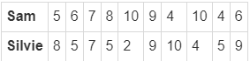  If the sample space is all of the possible numbers of pins that can be knocked down in a single frame, which subset would be considered a complement of the set of pins that Sam and Silvie knocked down? | {0, 1, 3}

Lesson 3 – Simple Probability
Key Words:
- disjoint – two events, A and B, that have no possible outcomes in common; also known as mutually exclusive events
- event – a subset of the possible outcomes of an experiment
- experiment – an action with a result determined by chance
- experimental probability – the ratio of the total number of desired outcomes compared to the total number of trials conducted for an experiment
- General Addition Rule of Probability – the rule stating that the probability of event A or event B is the sum of the probability of each event minus the probability of them both happening at the same time; symbolically P(A or B)=P(A∪B)=P(A)+P(B)−P(A∩B)
- independent – informally, two events in which the outcome of one does not affect the probability of the second event
- Law of Large Numbers – a law stating that the more trials are conducted in an experiment, the closer the probability will be to its theoretical value
- Multiplication Rule – the probability of both events A and B equals the product of probability B and event A given event B
- mutually exclusive – two events, A and B, that have no possible outcomes in common; also known as disjoint events
- outcome – the result of an experiment
- probability – the ratio of the number of desired outcomes to the total number of outcomes
- theoretical probability – the ability to calculate the ratio of the desired number of outcomes to the total number of possible outcomes
- trial – a performance of a random experiment
Formulas:
- Theoretical Probability: $P\left(E\right)=\frac{\# of desired outcomes}{Total number of outcomes}$
- Experimental Probability: $P\left(E\right)=\frac{\# of desired outcomes}{Total number of trials}$
- Addition Rule of Probability: $P\left(A or B\right)=P\left(A∪B\right)=P\left(A\right)+P\left(B\right)-P\left(A∩B\right)$
- Multiplication Rule of Probability: $P\left(A and B\right)=P\left(A∩B\right)=P\left(A\right)∙P\left(B\right)$
Objective 1: In this section, you will differentiate between experimental probability and theoretical probability.
Mathematical Practice Standard: Make sense of problems and persevere in solving them.
Big Ideas:
- Each time an experiment is conducted the outcome is unknown.
- The outcomes are based on probability, or the likelihood that the experiment will result in the desired outcome.
- The probability of an outcome is the ratio of the number of desired outcomes to the total number of possible outcomes.
- The notation for the probability of an event $E$is $P\left(E\right)$. You can use the name of the event in the notation.
- Extra Practice: Finding Theoretical and Experimental Probabilities Using a Spinner Simulation – GeoGebra
- Extra Practice: Predicting Outcomes Using Theoretical Probability – GeoGebra
Theoretical Probability  Predicts the probability of an event using the ratio of the number of desired outcomes divided by the total number of possible outcomes.  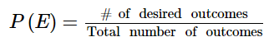  When you know the total number of outcomes and the number of desired outcomes, you are dealing with theoretical probability. | Experimental Probability  The number of desired results divided by the number of trials is the experimental probability.  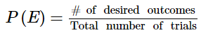  An experiment of a random event, such as flipping a coin, may not result in the same outcome as the theoretical probability.  When you are conducting a set number of trials and record the outcome to determine the probability, then you are dealing with experimental probability.
Example:  Finding the probability of a coin landing tails up.  There are two sides to a coin and tails up is one of two possible outcomes.  $$P\left(tails\right)=\frac{1}{2}$$ | Example:  You flip a coin 100 times. Each time, you record the result of heads or tails. Suppose the result is 63 heads out of 100.  $$P\left(heads\right)=\frac{63}{100}$$  This result is more than $\frac{1}{2}$ as determined for its theoretical probability.

Objective 2: In this section, you will determine the probability of an outcome.
Mathematical Practice Standard: Make sense of problems and persevere in solving them.
Big Ideas:
- The Law of Large Numbers: The more trials you perform, the closer the experimental probability will approach the theoretical probability of the event.
- To determine the probability of two events, A and B, happening at the same time or consecutively, you will use the Multiplication Rule.
- To determine the probability of one event or another happening, you will add the probability of each event using the Addition Rule.
Multiplication Rule of Probability  $$P\left(A and B\right)=P\left(A∩B\right)=P\left(A\right)∙P\left(B\right)$$  Determines the probability of two events, A and B, happening at the same time or consecutively. One indicator that you will use the Multiplication Rule is the word “and” in the outcome.  If events A and B are independent, the probability of events A and B happening at the same time is the product of probabilities, $P\left(A\right)∙P\left(B\right)$.  Two events are independent if knowing the outcome of one event does not affect the probability of the other.  Recall that the symbol $∩$stands for the intersection of events A and B. | Example:  Suppose you conduct the following events simultaneously and want to predict the outcome.  Event A: tossing a coin and observing heads or tails  Event B: rolling a dice and observing the number (1-6)  Desired outcome: the coin lands on heads and you roll a 3  Determining the probability of the desired outcome:  $$P\left(A and B\right)=P\left(A∩B\right)=P\left(A\right)∙P\left(B\right)$$  $$P\left(heads and 3\right)=P\left(heads\right)∙P\left(3\right)$$  $$P\left(heads\right)=\frac{1}{2}$$  $$P\left(3\right)=\frac{1}{6}$$  $$P\left(heads∩3\right)=\frac{1}{2}⋅\frac{1}{6}=\frac{1}{12}$$
Addition Rule of Probability  $$P\left(A or B\right)=P\left(A∪B\right)=P\left(A\right)+P\left(B\right)-P\left(A∩B\right)$$  When you want to find the probability of one event or another happening, you will add the probability of each event. One indicator that you will use the Addition Rule is the word “or” in the outcome.  When two events have no outcome in common, they are mutually exclusive, or disjoint, events. In those cases, the probability is as follows:  $P\left(A∩B\right)=0$, therefore, the addition rule becomes $P\left(A or B\right)=P\left(A∪B\right)=P\left(A\right)+P\left(B\right)$.  Recall that the symbol stands for the union of events A and B. | Example:  There are 52 cards in a standard deck of cards. Each suit has four cards.  Event A: draw a Jack  Event B: draw an Ace  Outcome: you draw a Jack OR and Ace  These two events are mutually exclusive, meaning they have no outcomes in common. You can’t draw a card that is both a Jack and an Ace.  $$P\left(A or B\right)=P\left(A∪B\right)=P\left(A\right)+P\left(B\right)$$  $$P\left(A∪B\right)=\frac{4}{52}+\frac{4}{52}=\frac{8}{52}=\frac{2}{13}$$

Practice Questions and Answers
 | Question | Answer
P 1 | If a spinner can land on four equal-sized, different-colored (red, yellow, blue, and green) sections, then what is the theoretical probability that it will land on blue? Respond using a fraction. | ¼
P 2 | What is the probability that a spinner with 26 spaces (labeled A to Z) lands on a vowel (A, E, I, O, or U)? Enter your response as a fraction. | $$\frac{5}{26}$$
P 3 | If you flip one coin and roll one six-sided number cube, find the probability of landing on tails and rolling an even number at the same time. Write your answer as a simplified fraction. | ¼
P 4 | Find the probability of rolling a sum of 6 or 11 when rolling two number cubes. Enter your response as a fraction. | $$\frac{7}{36}$$
P 5 | Consider a jar containing 20 marbles. There are 5 red, 3 green, 2 yellow with stripes, 7 blue, and 3 green with stripes. What is the probability of selecting a green or striped marble? Write your answer as a reduced fraction. | $$\frac{2}{5}$$

Quick Check Questions and Answers
 | Question | Answer
Q 1 | Differentiate between experimental and theoretical probability in the following question. Pashmina flips a double-sided coin 20 times, and it lands on heads 15 times. What is the theoretical probability that it will land on heads? | ½
Q 2 | If Talia spins a spinner with 26 equal spaces (labeled A to Z), what is the theoretical probability that she lands on any letter in the word “Mississippi”? | $$\frac{2}{13}$$
Q 3 | Sadiq rolls a regular six-sided number cube 10 times and gets an even number 7 times. How does his experimental probability compare to the theoretical probability? | The experimental probability was greater than the theoretical probability.
Q 4 | You are rolling a number cube to help you pick the number of minutes you will run in each of your workout sets. Determine the probability of rolling an odd number three times in a row. | $$\frac{1}{8}$$
Q 5 | Which of the following shows the correct calculation for finding the probability of rolling two number cubes and getting a sum of 6 or 11? | $$\frac{5}{36}+\frac{2}{36}$$

Lesson 4 – Independent and Dependent Probabilities
Key Words:
- conditional probability – the probability that a given event will occur if it is certain that another event has taken place or will take place
- dependent events – a pair of events from the same experiment where the probability of one event occurring depends on whether or not the other event occurs
- event – a subset of the possible outcomes of an experiment
- experiment – an action with a result determined by chance
- independent events – a pair of events from the same experiment where the probability of one event occurring does not depend on whether or not the other event occurs
- sample space – a set in which all of the possible outcomes of a statistical experiment are represented as points
Objective 1: In this section, you will mathematically determine if two events are independent of each other.
Mathematical Practice Standard: Attend to precision.
Big Ideas:
- Recall that an event is a subset of outcomes to an experiment. There are two types of events, independent and dependent.
Independent Events | Dependent Events
Two events from the same experiment are independent if the probability of one event occurring does not depend on whether the other occurs.  For example, flipping a coin three times or rolling a dice twice. | Two events from the same experiment are dependent if the probability of one event occurring depends on whether the other occurs.  For example, selecting a card from a deck, putting it aside, then selecting another card.
Mathematically, two events are independent if the product of their probabilities is equal to the probability of the events occurring together.  If two events, A and B, are independent, then:  $$P\left(A\right)*P\left(B\right)=P\left(A and B\right)$$ | Mathematically, two events are dependent if the product of their probabilities is NOT equal to the probability of the events occurring together.  If two events, A and B, are dependent, then:  $$P\left(A\right)*P\left(B\right)≠P\left(A and B\right)$$
Example:
Draw a card from a standard deck of cards. Determine if events A and B are independent of one another.

Event A: choose a red card
- Half of the deck is red, so there are 26 red cards in a deck.
- $P\left(A\right)=\frac{26}{52}=\frac{1}{2}$
Event B: choose a jack
- There are 4 jacks in a deck of cards.
- $P\left(B\right)=\frac{4}{52}=\frac{1}{13}$

$$P\left(A\right)*P\left(B\right)=\frac{1}{2}*\frac{1}{13}=\frac{1}{26}$$
$$P\left(A and B\right)=\frac{1}{26}$$

Because $P\left(A\right)*P\left(B\right)=P\left(A and B\right)$, the two events are independent.

Objective 2: In this section, you will recognize and explain the concept of independence in everyday language and everyday situations.
Mathematical Practice Standard: Communicate clearly.
Big Ideas:
- Sometimes, events can occur in connection with the occurrence of another event.
- Conditional probability measures the likelihood of event A occurring, given that event B has already happened.
- To find the conditional probability of event A, you have to consider the given event B.
  - Written as P(A|B) = the probability of A given B
- If the events are independent, the probability of event A given event B, P(A|B), will be the same as the probability of just event A.
  - Independent events: $P(A|B)=P(A)$, event B does not affect event A
  - Dependent events: $P(A|B)≠P(A)$, event B does affect event A
- Examples:
Independent Events | Dependent Events
Taking a card from a deck, replacing it, and then taking another card from the same deck | Taking a card from a deck, NOT replacing it, and then taking another card from the same deck
Rolling a dice more than once | Buying five lottery tickets and winning the lottery
You play basketball on Monday and then soccer on Wednesday | A teacher randomly chooses one student in a class to write on the board. The student does not sit back down, and the teacher chooses a different student to also write on the board.

Practice Questions and Answers
 | Question | Answer
P 1 | You are tossing a coin and rolling a number cube. What is the probability of obtaining tails and rolling a 3? Enter your answer as a fraction. | $$\frac{1}{12 }$$
P 2 | A standard deck of cards has 52 cards. You choose one card from the deck. Let event A be you choose a black card and event B be you choose a king. Find P (A) $∙$P (B), P (A and B), and determine whether events A and B are independent.  Enter 1 if events A and B are dependent. Enter 2 if events A and B are independent. | P (A) $∙$P (B) = $\frac{1}{26}$  P (A and B) = $\frac{1}{26}$  2
P 3 | Filip goes to a movie theater on weekends. On any given weekend, there is a 50% chance he will buy popcorn, there is a 40% chance he will buy juice, and there is a 20% chance he will buy both popcorn and juice. Mathematically determine whether the two events “buy popcorn” and “buy juice” are independent events. Enter 1 for dependent or 2 for independent. | 2
P 4 | Determine whether the following scenario describes independent or dependent events.  Everleigh and Logan decide to play the claw game at an arcade. They both have their eye on the same prize. Everleigh plays the game first but drops the prize after picking it up with the claw. Then Logan plays the game. | Dependent. Some of the prizes are likely to have shifted during Everleigh’s game, which would affect the probability of Logan winning the prize.
P 5 | Determine whether the following event is independent or dependent.  A bag contains 4 red apples and 2 green apples. You choose an apple without looking and eat it for your afternoon snack. Then your brother chooses an apple from the bag for his snack. | Dependent. After you select an apple for your snack, there are fewer apples from which your brother can choose his snack.

Quick Check Questions and Answers
 | Question | Answer
Q 1 | There are two events, A and B. How do you mathematically determine whether events A and B are independent. | P (A and B) = P (A) $∙$P (B)
Q 2 | There are 16 marbles in a jar: 5 red, 3 blue, and 8 yellow. What is the probability of selecting a blue marble and then, without replacing the blue marble, selecting a yellow marble? | $$\frac{1}{10}$$
Q 3 | Use the table to answer the question.  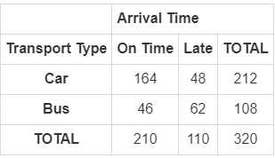  Let event A represent an on-time arrival and event B represent transportation by bus. What is P (A and B)? Round your answer to the nearest hundredth. | 0.14
Q 4 | Which of the following explains the concept of independence in everyday life experiences? | selecting a fruit from a basket without looking and replacing it until you get your desired fruit
Q 5 | A regular six-sided number cube is being used to determine the number of spaces a player is allowed to move in a game. What is the sample space of this number cube? | 1, 2, 3, 4, 5, 6

Lesson 5 – Two-Way Frequency Tables
Key Words:
- data – information collected for analysis
- frequency – the number of times the data occurs
- frequency table – a representation of how many times the data occurs
- two-way frequency table – a representation of the possible relationships between two sets of data
Objective 1: In this section, you will interpret two-way frequency tables of data.
Mathematical Practice Standard: Model with mathematics.
Big Ideas:
- A two-way frequency table represents the possible relationships between two sets of data.
- A two-way frequency table organizes the frequency of two variables, one variable as the rows and the other variable as the columns.
- A two-way table is filled with frequencies - the number of times the data occurs.
- You can use two-way frequency tables to interpret, make predictions, and draw conclusions about the surveyed group.
- In this example, the first variable is the flavor of ice cream represented as the rows. The second variable is the preferred way to dish ice cream, represented as the columns. If you owned an ice cream shop, you could determine what your customers prefer or are more likely to choose.
  - Are customers more likely to choose chocolate or vanilla ice cream?
    - Customers are more likely to choose vanilla ice cream: 242 of the customers preferred vanilla and 231 preferred chocolate.
 | Cone | Cup | Total
Vanilla | 160 | 82 | 242
Chocolate | 101 | 130 | 231
Total | 261 | 212 | 473

Objective 2: In this section, you will construct two-way frequency tables of data.
Mathematical Practice Standard: Model with mathematics.
Big Ideas:
- Sometimes, you will need to construct your own two-way frequency table from given data.
- When given the set of data, you will first need to determine the variables. Recall that a two-way frequency table consists of two variables, one for the rows, and one for the columns.
 | Variable #1a | Variable #1b | Variable #1c…
Variable #2a | data | data | data
Variable #2b | data | data | data
- For example, you collect data about people's favorite seasons and favorite flowers. The first variable is the seasons, and the second variable is the flowers.
 | Rose | Orchid | Total
Spring | 9 | 7 | 16
Fall | 8 | 6 | 14
Total | 17 | 13 | 30

  - How many people like roses?
    - In total, 17 people like roses.
 | Rose | Orchid | Total
Spring | 9 | 7 | 16
Fall | 8 | 6 | 14
Total | 17 | 13 | 30

  - What is the probability that a randomly selected person from this group prefers roses over orchids?
    - Recall that you can calculate the probability of an event by dividing the number of events of interest by the number of total possible outcomes. The number of people who like roses is 17 and the number of possible outcomes is 30, so the probability that a randomly selected person prefers roses over orchids is: $\frac{17}{30}≈0.57=57\%$.
Practice Questions and Answers
 | Question | Answer
P 1 | What is information collected for analysis called?  Option #1: details  Option #2: facts  Option #3: data  Option #4: statistics | 3
P 2 | Use the table to answer the question.  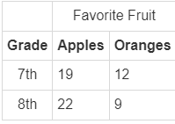  According to the table, if every student answered the survey about favorite fruit, how many students are in the seventh-grade class? | 31 students
P 3 | Use the table to answer the question.  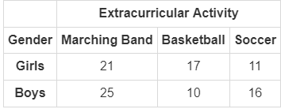  Students were surveyed about their extracurricular activities. The table records their responses. According to the table, how many girls were surveyed? | 49 girls
P 4 | You are doing a survey of 100 people about where and when they like to travel. Of those who prefer to travel in the summer, 26 like to go to the ocean, 8 like to go to the mountains, and 28 like to go to the city. Of those who prefer to travel in the winter, 15 like to go to the ocean, 19 like to go to the mountains, and 4 like to go to the city.  a) Which two-way frequency table accurately shows the data above?  b) What is the total number of people who like to travel during the summer? | a) 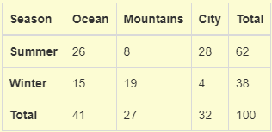  b) 62 people like to travel during the summer
P 5 | Use the table to answer the question.  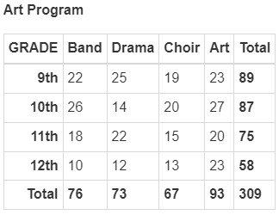  Students were surveyed about their favorite art program at school. Their responses are recorded in the table. Find the probability that a randomly selected ninth-grader enjoys drama the most. Round your answer to the nearest whole number. | 28%

Quick Check Questions and Answers
 | Question | Answer
Q 1 | Use the table to answer the question.  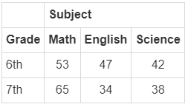  Sixth-grade and seventh-grade students were asked about their favorite subjects. Their answers are entered in the two-way frequency table. Interpret the table to find the total number of sixth-grade students that were surveyed. | 142
Q 2 | Use the table to answer the question.  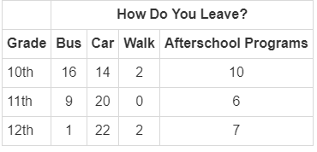  A survey at a high school sought to study how students leave the school in the afternoon. Their responses are recorded in the two-way frequency table. How many students stay for afterschool programs? | 23
Q 3 | Use the table to answer the question.  A survey at a high school sought to study how students leave the school in the afternoon. Their responses are recorded in the two-way frequency table. How many students ride in a bus or car? | 82
Q 4 | Use the table to answer the question.  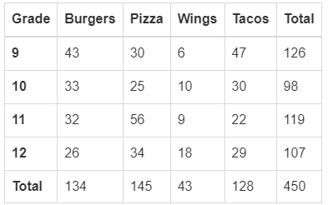  The school administration surveyed the student body to see what type of food they would prefer to have at the picnic on the last day of school. Their responses are recorded in the table. According to the table, what is the probability that a randomly selected student is in 9th grade and chose pizza? | 7%
Q 5 | Use the table to answer the question.  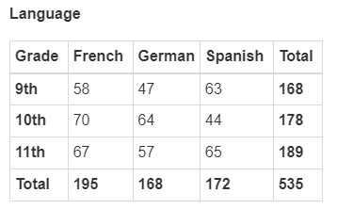  Students were surveyed about their language class. Their responses are recorded in the table. Interpret the table to determine how many tenth-graders are taking a foreign language other than German. | 114

Lesson 6 – Using Two-Way Tables
Key Words:
- independent event – an event that is not affected by any previous event
- sample space – a set of all possible outcomes from a given experiment
- two-way frequency table – a representation of the possible relationships between two sets of data
Formulas:
- Determine independence: $P\left(A and B\right)=P\left(A\right)*P\left(B\right)$
Objective 1: In this section, you will use a two-way table as a sample space to decide if events are independent.
Mathematical Practice Standard: Look for and make use of structure.
Big Ideas:
- Recall that if one event does not depend on another event in mathematics, then they are independent events.
- Events that are independent have their own probability.
- If you want to determine if two events, event A and event B, are independent, you can check if $P\left(A and B\right)=P\left(A\right)*P\left(B\right).$
- You can use a two-way frequency table to determine if events are independent. From a frequency table, you can calculate $P\left(A\right), P\left(B\right), P\left(A and B\right).$
Example: The two-way frequency table provides music and book preferences for a group of people. Use the table to answer the question.  Are the following events independent?  Event A: a person likes books  Event B: a person likes music | 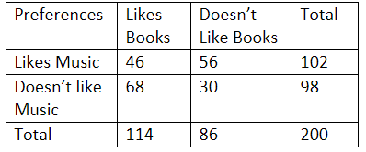
Step 1:  Use the two-way frequency table to find $P\left(A and B\right), P\left(A\right), and P\left(B\right)$. | Event A: There are 200 people that completed the survey. Of those 200, there were 114 in total that like books.  $$P\left(A\right)=\frac{114}{200}$$  Event B: Of the 200 surveyed, 102 like music.  $$P\left(B\right)=\frac{102}{200}$$  P(A and B): There are 46 people who like books and music.  $$P\left(A and B\right)=\frac{46}{200}$$
Step 2:  If events A and B are independent, then the following probabilities must be equal.  $$P\left(A and B\right)=P\left(A\right)⋅P\left(B\right)$$ | $$P\left(A\right)⋅P\left(B\right)=\frac{114}{200}⋅\frac{102}{200}=0.26$$  $$P\left(A and B\right)=\frac{46}{200}=0.23$$  $$P\left(A and B\right)≠P\left(A\right)⋅P\left(B\right)$$  $P\left(A and B\right) and P\left(A\right)⋅P\left(B\right)$ are not equal. Therefore, the events are not independent.

Practice Questions and Answers
 | Question | Answer
P 1 | Use the table to answer the question.  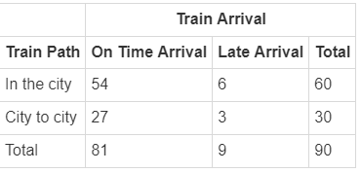  Let A be the train that is on time and B be the city to city train. What is P (A and B)? | $$\frac{27}{90}$$
P 2 | Use the table to answer the question.  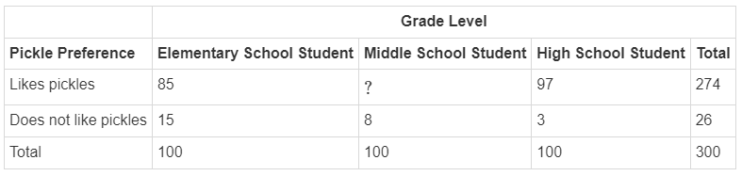  What is the missing value in the two-way frequency table? | 92
P 3 | Use the table to answer the question.  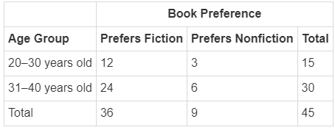  What is the probability that a randomly selected person is 20–30 years old and prefers fiction books? Round to the nearest hundredths, if necessary. | $$\frac{12}{45}$$
P 4 | Use the table to answer the question.  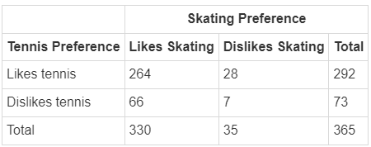  Based on the two-way frequency table, how many people surveyed liked skating? | 330 people
P 5 | The probability that an event may occur from a two-way frequency table is 11 out of a total of 20. What is another way to write this probability? | $$\frac{11}{20}$$

Quick Check Questions and Answers
 | Question | Answer
Q 1 | How do you decide if two events are independent using a two-way frequency table? | Show that the product of the two individual probabilities is equal to the combined probability of both from the two-way frequency table.
Q 2 | What is an independent event? | an event that is not affected by any previous event
Q 3 | Consider randomly pulling marbles from a bag that contains 3 blue, 5 red, and 6 yellow marbles. What is the probability of pulling a red marble? | $$\frac{5}{14}$$
Q 4 | If P (A) = $\frac{5}{9}$ and P (B) = $\frac{2}{9}$ and the two events are independent, what is P (A and B)? | $$\frac{10}{81}$$
Q 5 | If P (A) = 51% and P (B) = 65%, what must P (A and B) equal to prove that P (A) and P (B) are independent events? | 33%

Lesson 9 – Conditional Probability
Key Words:
- conditional probability – the probability of an event happening given that another event has already occurred
- independent event – an event that is not affected by any previous event
- Multiplication Rule – the probability of both events A and B equals the product of probability B and event A given event B
Formulas:
- Conditional Probability
  - $P\left(A | B\right)=\frac{P\left(A and B\right)}{P\left(B\right)}$or $P\left(A|B\right)=\frac{n\left(A and B\right)}{n(B)}$
  - $P\left(B | A\right)=\frac{P\left(A and B\right)}{P\left(A\right)}$ or $P\left(B | A\right)=\frac{n\left(A and B\right)}{n\left(A\right)}$
- Events A and B are independent if any of the following are satisfied:
  - $P\left(A and B\right)=P\left(A\right)⋅P\left(B\right)$
  - $P\left(A | B\right)=P\left(A\right)$
  - $P\left(B | A\right)=P\left(B\right)$
- Multiplication Rule: $P\left(A and B\right)=P\left(A\right)⋅P\left(B | A\right)$

Objective 1: In this section, you will find the conditional probability of one event given the outcome of another event.
Mathematical Practice Standard: Reason abstractly and quantitatively.
Big Ideas:
- Sometimes, the probability of an event can be changed if you know that a related event has occurred.
- Conditional probability is the probability of an event happening given that another event is happening. In other words, the occurrence of one event affects the occurrence of another event.
- The conditional probability of event A happening given event B has already happened is denoted by $P\left(A|B\right)$.
- Conditional probability is represented by the following formula:
  - $P\left(A | B\right)=\frac{P\left(A and B\right)}{P\left(B\right)}$
  - Where $P\left(A and B\right)$ is the probability of event A and B to occur and $P\left(B\right)$ is the probability of event B to occur.
  - Sometimes, you will see the formula written as: $P\left(A|B\right)=\frac{n\left(A and B\right)}{n(B)}$. This is often used when there is a two-way frequency table with data. The “$n$“ represents the number of occurrences for a given event, represented as data in the table.
Example: A survey asked people about their favorite winter sport and favorite winter drink. Use the two-way frequency table to find the conditional probability, $P\left(A | B\right)$.  Event A: a person likes skiing  Event B: a person likes hot cocoa | Skiing Snowboarding Total  Tea 27 32 59  Hot Cocoa 34 46 80  Total 61 78 139
Use the following formula to find the probability that a person likes skiing given that they also like hot cocoa.  $$P\left(A|B\right)=\frac{n\left(A and B\right)}{n(B)}$$ | $n\left(A and B\right)$is the number of people that like skiing and hot cocoa.  $$n\left(A and B\right)=34$$  $n\left(B\right)$ is the number of people that like hot cocoa.  $$n\left(B\right)=80$$  $$P\left(A|B\right)=\frac{n\left(A and B\right)}{n(B)}=\frac{34}{80}≈43\%$$

Objective 2: In this section, you will mathematically determine whether the outcome of one event is dependent upon the outcome of a previous event.
Mathematical Practice Standard: Attend to precision.
Big Ideas:
- Sometimes, it can happen that $P\left(A | B\right)=P\left(A\right)$. This means that event B has no effect on event A. In other words, events A and B are independent events. The same is true if event A has no effect on event B,$P\left(B | A\right)=P\left(B\right)$.
- To summarize, you can say that events A and B are independent if any of the following are satisfied:
  - $P\left(A and B\right)=P\left(A\right)⋅P\left(B\right)$
  - $P\left(A | B\right)=P\left(A\right)$
  - $P\left(B | A\right)=P\left(B\right)$
- Recall the formula for conditional probability:
  - $P\left(A | B\right)=\frac{P\left(A and B\right)}{P\left(B\right)}$
  - $P\left(B | A\right)=\frac{P\left(A and B\right)}{P\left(A\right)}$, notice that the denominator for $P\left(B | A\right)$ changes to $P\left(A\right)$.
- To calculate the probability that two events will occur together can be written as $P\left(A and B\right)=P\left(A\right)⋅P\left(B | A\right)$. This formula is called the Multiplication Rule.
Example: You select two cards from a deck one after another. You do not replace the first card. Find the probability of selecting a queen and then ace.
Step 1: Define the events.

Event A: the first card is a queen
Event B: the second card is an ace

Step 2: Use the Multiplication Rule to find the probability of event A and event B occurring together.

Multiplication Rule: $P\left(A and B\right)=P\left(A\right)⋅P\left(B | A\right)$

$P\left(A\right)$: There are 4 aces in a deck of 52 cards
$$P\left(A\right)=\frac{4}{52}$$

$P\left(B | A\right)$: The probability that you draw a queen, after you have already drawn an ace from the deck. There are now 51 cards in the deck, and there are still 4 queens.
$$P\left(B\left|A\right|\right)=\frac{4}{51}$$

$$P\left(A and B\right)=\frac{4}{52}⋅\frac{4}{51}≈0.006=6\%$$

The probability of drawing a queen and then an ace is about 6%.

Practice Questions and Answers
 | Question | Answer
P 1 | Use the table to answer the question.  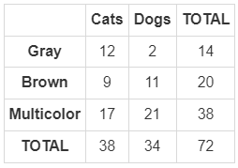  Using the two-way frequency table about your local animal shelter, find the conditional probability P (A|B) where event A is a person selects a brown animal and event B is a person selects a cat. Round your answer to the nearest whole number. | P (A|B) is 24%
P 2 | Use the spinner to answer the question.  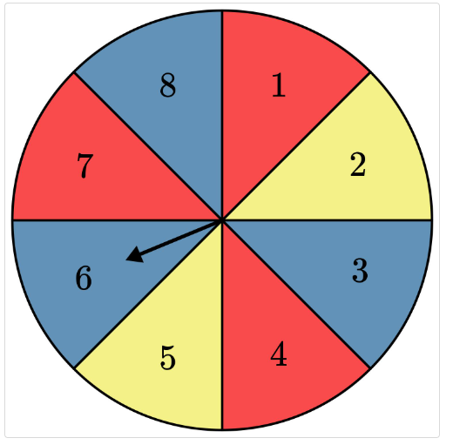  Given that the spinner lands on blue, what is the probability that it will land on an even number? | 67%
P 3 | Use the spinner to answer the question.  Given that the spinner lands on red, what is the probability that it lands on an odd number? | 67%
P 4 | Use the table to answer the question.  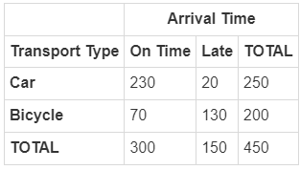  Let event A represent a late arrival and event B represent transportation by car. What would the product of P(A) and P(B) need to equal to show that the events are independent? Express the answer as a decimal to the nearest hundredth. | 0.04
P 5 | If you toss a coin and roll a number cube, what is the probability of obtaining a head and rolling a 6? Round your answer to the nearest hundredth if using a decimal. | $$\frac{1}{12}$$

Quick Check Questions and Answers
 | Question | Answer
Q 1 | Use the table to answer the question.  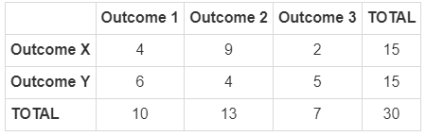  The table shows the various outcomes of two different events. In order to find the probability of Outcome Y given that Outcome 2 occurs, what number would you use in the denominator of your fraction when using the formula P (A|B) = $\frac{n\left(A and B\right)}{n\left(B\right)}$? | 13
Q 2 | Use the image to answer the question.  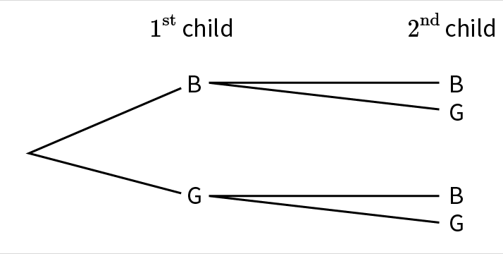  Newlyweds Katherine and Matthias plan to have two children. Assuming it is equally likely to be a boy or a girl, use the tree diagram to help you find the probability that their second child is a girl, given that their first child is a boy | $$\frac{1}{2}$$
Q 3 | Use the image to answer the question.  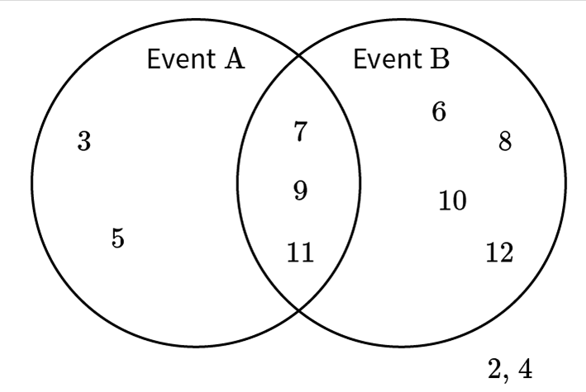  The Venn diagram represents the results of the experiment of rolling two fair, six-sided number cubes and adding the sum of the two rolls. Consider event A as “sum is odd” and event B as “sum is 6 or greater.” Find the probability that the sum is odd, given that the sum is 6 or greater. | $$\frac{3}{7}$$
Q 4 | How do you determine if the outcome of two events is independent? | Show that P (A and B) = P (A) $∙$P (B).
Q 5 | Use the table to answer the question.  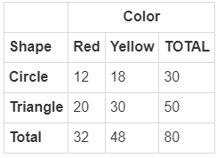  If event A is that a shape is a triangle and event B is that a shape is yellow, are the two events independent? Explain. | Yes, because P (A|B) = P (A).

Lesson 10 – Using Conditional Probabilities
Key Words:
- conditional probability – the chance that a certain event will occur given another event has already occurred
- dependent event – an event that is affected by a previous event
- independent event – an event that is not affected by any previous event
- Multiplication Rule – the probability of both events A and B equals the product of probability B and event A given event B
Formulas:
- Conditional Probability
  - $P\left(A | B\right)=\frac{P\left(A and B\right)}{P\left(B\right)}$or $P\left(A|B\right)=\frac{n\left(A and B\right)}{n(B)}$
  - $P\left(B | A\right)=\frac{P\left(A and B\right)}{P\left(A\right)}$ or $P\left(B | A\right)=\frac{n\left(A and B\right)}{n\left(A\right)}$
- Events A and B are independent if any of the following are satisfied:
  - $P\left(A and B\right)=P\left(A\right)⋅P\left(B\right)$
  - $P\left(A | B\right)=P\left(A\right)$
  - $P\left(B | A\right)=P\left(B\right)$
- Multiplication Rule: $P\left(A and B\right)=P\left(A\right)⋅P\left(B | A\right)$
- Calculate the probability of:
  - Dependent Events: $P\left(A and B\right)=P\left(A\right)⋅P\left(B | A\right)$ or $P\left(A and B\right)=P\left(B\right)⋅P\left(A | B\right)$
  - Independent Events: $P\left(A and B\right)=P\left(A\right)*P(B)$
Objective 1: In this section, you will recognize and explain the concept of conditional probability in everyday language and everyday situations.
Mathematical Practice Standard: Communicate clearly.
Big Ideas:
- In real life, conditional probability is a probability in which additional information is known.
  - For example, to forecast weather, past data is used to predict the chance of rain in the future.
- You can calculate the probability of two events that occur in sequence. The formula depends on if these events are dependent or independent.
  - Dependent Events: $P\left(A and B\right)=P\left(A\right)⋅P\left(B | A\right)$ or $P\left(A and B\right)=P\left(B\right)⋅P\left(A | B\right)$
  - Independent Events: $P\left(A and B\right)=P\left(A\right)*P(B)$
  - Recall the formulas for conditional probability.
- Example:
Find the probability that a person is going to ride a bike given the following:
- The day is sunny.
- The probability of a person going outside to ride when the day is sunny is 49%.
- The probability that the day is sunny is 85%.
Step 1: Define the events. | Event A: a person rides their bike  Event B: the day is sunny
Step 2: Use the conditional probability formula. | You are asked to determine the probability that someone rides their bike, given that it is sunny outside.  In other words, what is the probability of event A given event B, P(A|B)?  Use the conditional probability formula.  $$P\left(A | B\right)=\frac{P\left(A and B\right)}{P\left(B\right)}$$
Step 3: Calculate the probability. | The probability of A and B occurring together:  $$P\left(A and B\right)=49\%=0.49$$  The probability that the day is sunny:  $$P\left(B\right)=85\%=0.85$$  $$P\left(A | B\right)=\frac{P\left(A and B\right)}{P\left(B\right)}=\frac{0.49}{0.85}≈0.58=58\%$$  The probability that a person rides their bike and it is sunny is 58%.

Objective 2: In this section, you will interpret conditional probability in terms of a model.
Mathematical Practice Standard: Reason abstractly and quantitatively.
Big Ideas:
- Recall the formulas to calculate the probability of dependent and independent events.
- Recall the Multiplication Rule, which is useful when you need to determine the probability of two events occurring in a sequence.
- Recall the formulas that determine if two events are independent.
- Remember, the probability of event A given event B occurred, is P(A|B), and the probability of two events happening together is P(A and B).
Practice Questions and Answers
 | Question | Answer
P 1 | You are playing a game that involves 2 number cubes. What is the probability that the sum of the 2 cubes equals 8? Write your answer as a simplified fraction. | $$\frac{5}{36}$$
P 2 | Let P (A) = $\frac{1}{6}$ and P (B) = $\frac{1}{5}$. What is P (A and B)? Round your answer to the nearest hundredth if using a decimal. | $$\frac{1}{30}$$
P 3 | Today, you want to go on a run. The probability of the day being windy is 52%. The probability of going for a run when it is windy is 23%. What is the probability of going on a run, given that it is a windy day? | 44%
P 4 | Ryan has a pack of 10 pens. 3 pens are red, 4 are black, and 3 are blue. What are the chances that he pulls out a red pen and a black pen? Assume that the pens are pulled without replacement. Round to the nearest whole number. | 13 percent
P 5 | Sasha is working on a magic trick with a standard deck of cards. She chooses an ace, puts it back, then chooses a red card. What is P(ace|red)? Round to the nearest tenth. | 7.7 percent

Quick Check Questions and Answers
 | Question | Answer
Q 1 | Which of the following formulas is used to mathematically recognize and explain the conditional probability of event A, given event B? | $$P\left(A | B\right)=P(A and B)/P\left(B\right)$$
Q 2 | Which of the following represents a dependent event? | picking 2 snacks from the pantry without looking and keeping the first one before selecting the second one
Q 3 | There are 100 trading cards in a bin. They include 5 rare cards, 35 limited cards, and the remainder are common cards. Which of the following correctly interprets the probability of choosing 2 rare cards from the bin? Assume that the cards are pulled without replacement. | $$\frac{5}{100}∙\frac{4}{99}$$
Q 4 | Mr. Jay has 100 pairs of shoes in his closet. He has 26 brown pairs, 12 navy pairs, 47 black pairs, and 15 white pairs. What is P (brown|black)? | $$\frac{26}{100}$$
Q 5 | Bathsheba has 5 paintings in her house, 1 each in a color palette of red, yellow, blue, green, and purple. She hangs them randomly in a horizontal order. What is the probability of hanging the blue painting first, and then the green? | $$\frac{1}{5}∙\frac{1}{4}$$

Lesson 11 – Two-Way Tables and Conditional Probabilities
Key Words:
- conditional probability – the chance that a certain event will occur given another event has already occurred
- frequency – the number of items in a particular category in a set of data
- sample space – a set of all possible outcomes from a given experiment
- two-way frequency table – a representation showing the frequencies of all possible outcomes for two variables, with one variable as the rows and the other as the columns
Formulas:
- Conditional Probability: $P\left(A | B\right)=\frac{P\left(A ∩ B\right)}{P\left(B\right)} or P\left(B | A\right)=\frac{P\left(B ∩ A\right)}{P\left(A\right)}$
Objective 1: In this section, you will use two-way tables to approximate conditional probabilities.
Mathematical Practice Standard: Look for and make use of structure.
Big Ideas:
- Recall that the symbol $∩$ is the intersection symbol and is used when we calculate probabilities with the word “and”. So, $P(A and B)=P\left(A∩B\right).$
- This means that you will sometimes see the formula for conditional probability written as:
  - $P\left(A | B\right)=\frac{P\left(A ∩ B\right)}{P\left(B\right)} or P\left(B | A\right)=\frac{P\left(B ∩ A\right)}{P\left(A\right)}$
- Two-way frequency tables can help to approximate conditional probabilities. This gives us insight into how one variable is related to another variable.
- A two-way table shows us the number of outcomes where certain events intersect, as well as the total possible events based on each variable. This allows you to set up your conditional probability formula by quickly identifying the frequency of a given occurrence and the total possible outcomes.
- Use the following example and consider the steps and key takeaways for using a two-way frequency table to calculate conditional probabilities:
Given that a student is in 9th grade, what is the probability that they will prefer soccer over football?

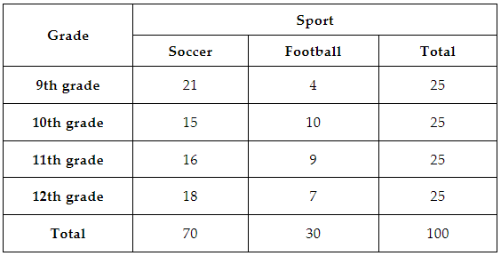

Step 1: Determine event A and event B. | The two variables are grade and sport. Let event A represent the grade and event B represent the sport.  Event A: a student is in 9th grade  Event B: a student prefers soccer
Step 2: Determine the formula needed to calculate conditional probability. | A student prefers soccer given that they are in 9th grade, P(B|A).  $$P\left(B | A\right)=\frac{P\left(B ∩ A\right)}{P\left(A\right)}$$
Step 3: Use the table to quickly identify the frequency of events.  A common mistake made during this step is dividing by the total number of events. When finding conditional probability, you have to specifically consider the total number of events that come from the given condition. Remember to use the formula and the organization of the table to find the important parts. | From the table, the frequency of B and A is 21. You can see this in the table where soccer and 9th graders intersect.  $$P\left(B ∩ A\right)=21$$  The frequency of a student being in 9th grade is 25. You can see this in the table under the total number of 9th graders.  $$P\left(A\right)=25$$  $$P\left(B | A\right)=\frac{P\left(B ∩ A\right)}{P\left(A\right)}=\frac{21}{25}≈84\%$$  If a student is in 9th grade, the probability that they prefer soccer over football is 84%.

Practice Questions and Answers
 | Question | Answer
P 1 | Use the table to answer the question.  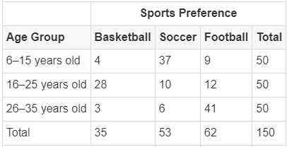  Given that someone prefers soccer, what is the probability that they are 26-35 years old? Express your answer as a percentage rounded to the nearest whole number? | 11%
P 2 | Use the table to answer the question.  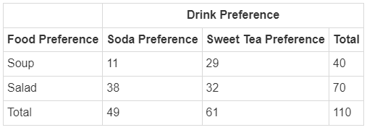  Given that someone prefers sweet tea, what is the probability that they also prefer salad? Leave your answer as a reduced fraction. | $$\frac{32}{61}$$
P 3 | Use the table to answer the question.  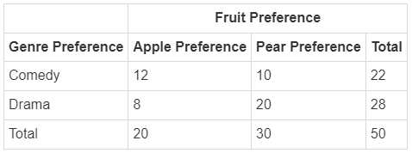  Given that someone likes comedy, what is the probability that they also like apples? Leave your answer as a reduced fraction? | $$\frac{12}{22}$$
P 4 | Use the table to answer the question.  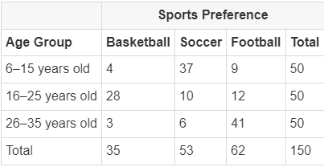  What value must be in the denominator for the probability that someone is 6-15 years old and prefers basketball? | 50
P 5 | Use the table to answer the question.  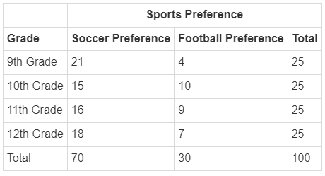  What value must be in the numerator for the probability that someone is in the 11th grade and prefers soccer? | 16

Quick Check Questions and Answers
 | Question | Answer
Q 1 | How is a two-way frequency table used to approximate conditional probabilities? | by writing the ratio of the intersection of the two conditions with the given condition in the denominator and the preference in the numerator
Q 2 | What is conditional probability? | the chance that a certain event will occur given that another event has occurred
Q 3 | What is the term for the number of items in a particular category in a set of data? | frequency
Q 4 | Use the table to answer the question.  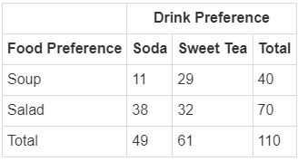  How many people were surveyed in the table? | 110
Q 5 | Use the table to answer the question.  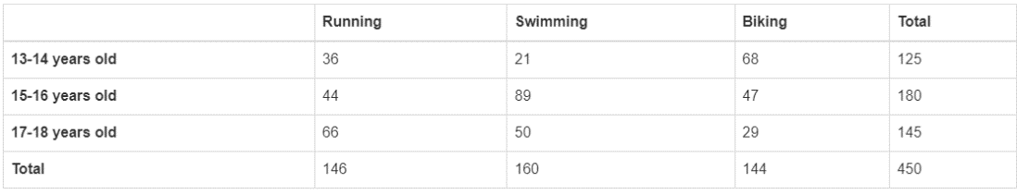  Given that someone is 15-16 years old, what is the probability that they will prefer biking? | 26%

Lesson 12 – The Addition Rule
Key Words:
- Addition Rule – the rule used to find the probability of compound events; given two events, it is the probability that at least one of those events will occur
- event – a subset of the possible outcomes of an experiment
- probability – the chance that a given event will occur
- two-way frequency table – a representation of the possible relationships between two sets of data
- Venn diagram – a graph that uses overlapping circles to represent logical relationships
Formulas:
- The Addition Rule: $P\left(A or B\right)=P\left(A\right)+P\left(B\right)-P(A and B)$
Objective 1: In this section, you will determine the probability that at least one of two given events will occur.
Mathematical Practice Standard: Reason abstractly and quantitatively.
Big Ideas:
- In the previous lessons, there has been a heavy focus on conditional probability, when two events occur together. We refer to these as “and “ probabilities.
- In this lesson you will focus on “or” probabilities. This type of probability helps to determine the chances of at least one of two events occurring.
- Given events A and B, you can use the Addition Rule to determine the probability of at least one of those events occurring.
  - The Addition Rule: $P\left(A or B\right)=P\left(A\right)+P\left(B\right)-P(A and B)$
- Two-way frequency tables and Venn diagrams are other ways of representing all the possible events that may occur with two or more variables. Here is an example of using a Venn diagram and the Addition Rule.
If you select one person at random from this survey, what is the probability that at least one of these two events occurs: the person prefers chocolate or the person prefers eating ice cream from a cone?

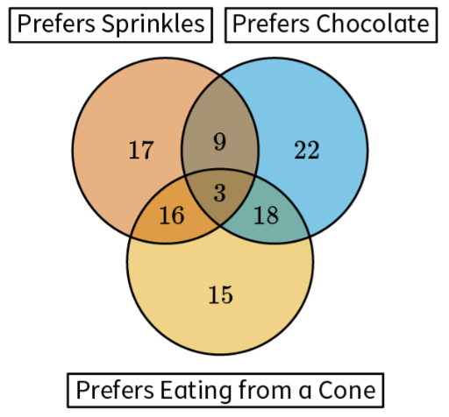
Step 1: Determine event A and event B. | Event A: person prefers chocolate  Event B: person prefers a cone
Step 2: Determine the formula needed to calculate the probability. | Use the Addition Rule to determine the probability of preferring chocolate or a cone.  $$P\left(A or B\right)=P\left(A\right)+P\left(B\right)-P(A and B)$$
Step 3: Use the Venn diagram to quickly identify the frequency of events and calculate each probability.  A common mistake made during this step is dividing by the total number of events. When finding conditional probability, you have to specifically consider the total number of events that come from the given condition. Remember to use the formula and the organization of the table to find the important parts. | There are a total of 100 survey responses.  There are 52 people that prefer chocolate, so, $P\left(A\right)=\frac{52}{100}$.  *(add up all of the numbers in the blue circle)  There are 52 people that prefer cones, so, $P\left(B\right)=\frac{52}{100}.$  *(add up all of the numbers in the yellow circle)  There are 21 people that prefer chocolate and cones, so, $P\left(A and B\right)=\frac{21}{100}.$  *(add up all of the numbers where the blue and yellow circle overlap)
Step 4: Use the Addition Rule to calculate the probability. | $$P\left(A or B\right)=P\left(A\right)+P\left(B\right)-P(A and B)$$  $$P\left(A or B\right)=\frac{52}{100}+\frac{52}{100}-\frac{21}{100}=\frac{83}{100}=83\%$$  The probability that a randomly selected survey respondent prefers either chocolate or a cone is 83%.

Objective 2: In this section, you will interpret the answer of an “Or” probability in the context of a given situation.
Mathematical Practice Standard: Reason abstractly and quantitatively.
Big Ideas:
- When events are mutually exclusive, the probability of them occurring at the same time is 0.
- Finding the probability that both A and B occur means looking for the intersection of those two events then dividing by the total number of possible events.
- Finding the probability that A or B occurs, you need to consider the probability of A occurring combined with the probability that B occurs, then subtracting the overlapping intersection of both events. (The Addition Rule)
- Here is an example to practice:
 | Math | History | Science | Total
A-day | 22 | 11 | 13 | 46
B-day | 15 | 20 | 19 | 54
Total | 37 | 31 | 32 | 100
100 high schoolers were surveyed about their favorite class from their block schedule and which day that class occurred on. Based on the data in the two-way frequency table, interpret each of the following probabilities.
- The probability that a randomly selected student said a B-day class was their favorite. | Event A: student says B-day is their favorite  Of the 100 students surveyed, there are a total of 54 that chose B-day as their favorite.  $$P\left(A\right)=\frac{54}{100}$$
- The probability that a randomly selected student said math and an A-day class was their favorite. | Event A: student says math is their favorite  Event B: student says A-day is their favorite  Of the 100 students surveyed, 22 chose math and A-day as their favorite.  $$P\left(A and B\right)=\frac{22}{100}$$
- The probability that a randomly selected student said that math or an A-day class was their favorite. | Event A: student says math is their favorite  Event B: student says A-day is their favorite  $$P\left(A or B\right)=P\left(A\right)+P\left(B\right)-P\left(A and B\right)$$  $$P\left(A or B\right)=\frac{37}{100}+\frac{46}{100}-\frac{22}{100}=\frac{61}{100}$$
- The probability that a randomly selected student said that math or science was their favorite. | Event A: student says math is their favorite  Event B: student says science is their favorite  These two events are mutually exclusive, meaning, they can’t occur at the same time. A student can only select one subject as their favorite. So, the probability of a student selecting both is 0.  $$P\left(A or B\right)=P\left(A\right)+P\left(B\right)-P\left(A and B\right)$$  $$P\left(A or B\right)=\frac{37}{100}+\frac{32}{100}-0=\frac{69}{100}$$

Practice Questions and Answers
 | Question | Answer
P 1 | Use the table to answer the question.  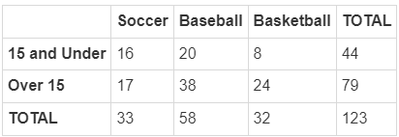  A survey was conducted at a local sports club about the participation of children in various sports. The children were split into two age groups, 15 and under and over 15, and they recorded the number of children who play soccer, baseball, and basketball. What is the probability that a student chosen at random is over 15 or plays basketball? Enter your answer as a fraction; you do not need to reduce the fraction. | The probability that the student is over 15 or plays basketball is $\frac{87}{123}$.
P 2 | Use the image to answer the question.  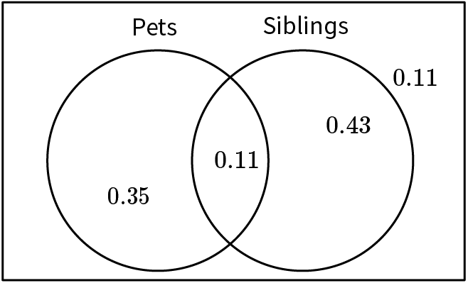  The Venn diagram displays the probability that a particular child in Mr. Brown’s class has a pet or a sibling, or both. What is the probability that the child has a pet or a sibling? Enter your response as a decimal. | The probability that the child has a pet or a sibling is 0.89.
P 3 | Use the table to answer the question.  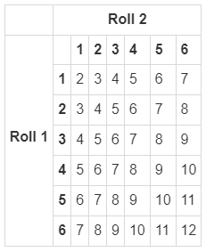  The table illustrates the sum of two rolls of a number cube. What is the probability that the first roll was a 4 or the sum of the two rolls was 6? Leave your answer as a reduced fraction. | The probability is $\frac{5}{18}$.
P 4 | Use the table to answer the question.  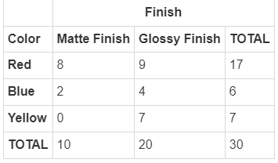  Find the P (blue or matte). Provide the answer in fraction form. | $$\frac{14}{30}$$
P 5 | Max is looking at a table that compares the four seasons of the year and when people like to travel. She is trying to find P (spring or likes to travel). Based on the following equation, what value represents the intersection of spring and likes travel from the table?  $$\frac{13}{100}+\frac{77}{100}-\frac{?}{100}= \frac{81}{100}$$ | 9

Quick Check Questions and Answers
 | Question | Answer
Q 1 | If you roll a standard number cube, determine the probability that you roll an even number or a 5. | $$\frac{2}{3}$$
Q 2 | What is the probability of choosing a diamond or a queen in a standard deck of cards? | $$\frac{13}{52}+\frac{4}{52}-\frac{1}{52}$$
Q 3 | Use the image to answer the question.  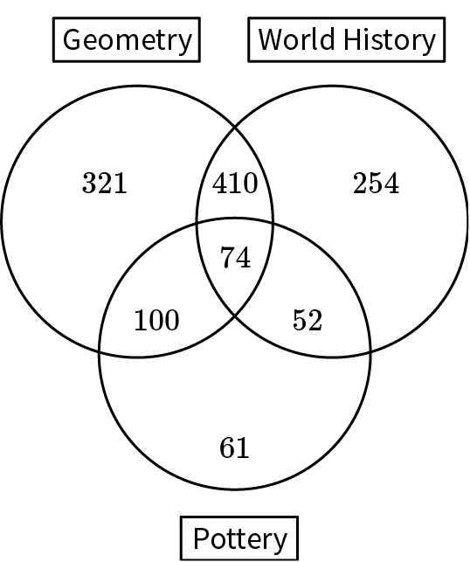  A survey was conducted of the courses taken by the 1,272 sophomores at a local high school. Determine the probability that a student is currently taking geometry or pottery. State your answer as a fraction. You do not have to reduce the fraction. | $$\frac{1,018}{1,272}$$
Q 4 | What formula is used to interpret the answer to an or probability scenario that involves P (A) as one event and P (B) as the other event? | P (A) + P (B) - P (A and B)
Q 5 | Use the table to answer the question.  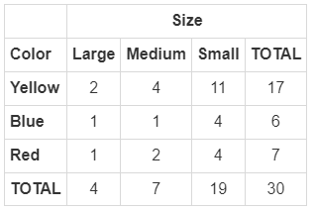  What is P (blue or medium)? | $$\frac{12}{30}$$

