Dear [Recipient],
Welcome to [Program Name] for the [insert school year] school year!
This letter confirms your student’s online course enrollment.
IMPORTANT: Your student’s enrollment details are being finalized, and it may take 2-3 days to complete. Once completed, course information will appear on the student’s home page. Work can only begin on the designated start date. For course placement questions, contact your school's Program Coordinator.
Please proceed with the following. If you prefer video-based instructions, refer to the following videos.
- Student Initial Login Video
- Caretaker Initial Login Video
Step 1:
- Log into Pearson Connexus at: [Insert school URL https://NAME.lms.pearsonconnexus.com]
Step 2:
- Log into Pearson Connexus using the information below:
  - Student:
    - Username: XXX
    - Password: XXX
  - Caretaker:
    - Username: XXX
    - Password: XXX
Step 3 (Include only if users can change their own password per domain settings. Otherwise, delete.):
- Customize Your Account Password on first login by clicking "Change Password" from the Login Icon or contact your Program Coordinator.

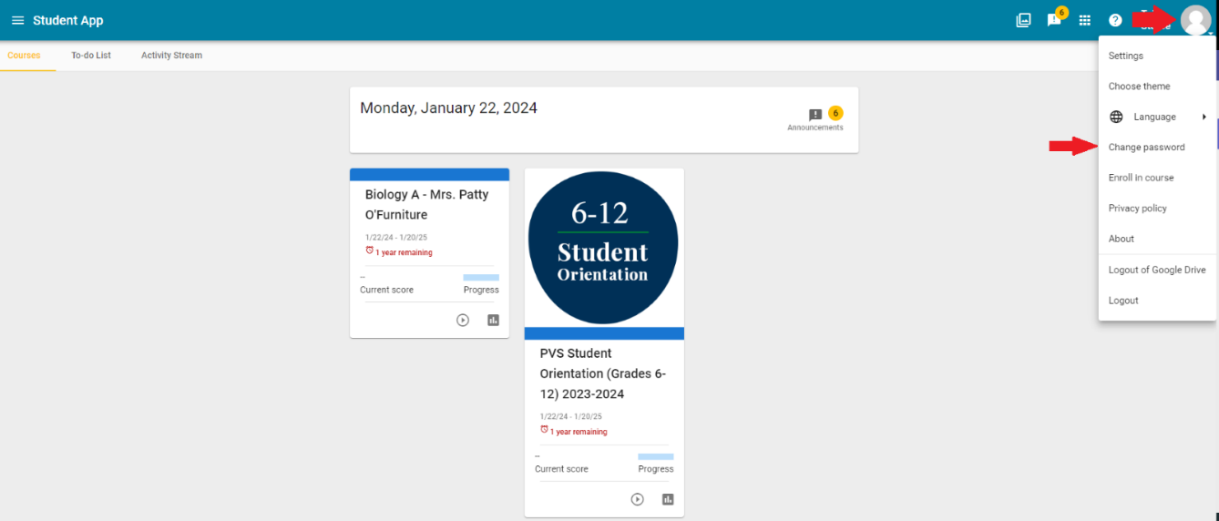

NOTE: If you have a current login, disregard the above information.
Forgot your password? Call support at 1-844-597-3224.
Step 4:
- Identify a quiet study space for your student to complete their daily work. Having a consistent workspace and daily structure is beneficial for optimum learning.
- Create a daily check-in plan between student and caretaker to ensure work is complete and the student gets help needed.
- Review this Student Daily Tasks for Success help article.
- Review the Your Family Plan for Success help article.
Step 5:
- Log into Pearson Connexus and select the "PVS Student Orientation" course card for platform navigation. Complete the orientation before coursework begins.

If you have any questions, please feel free to reach out to our support line at 1-844-597-3224 and a representative will help you.
Thank you and welcome to Pearson Online & Blended Learning!
Yours sincerely,

