Bivariate Datasets
Formula Sheet
Name | Definition | Formula
Joint Relative Frequency | The ratio of frequency in a particular category to the total number of data points. (Two-way frequency table) | $$\frac{joint frequency}{total surveyed}$$
Marginal Relative Frequency | The ratio of a sum of joint relative frequencies to the total number of data points. (Two-way frequency table) | $$\frac{category total}{total surveyed}$$
Conditional Relative Frequency | Finding the ratio of frequency in a particular category to the total number of data points in a particular category. (Two-way frequency table) | $$\frac{joint frequency}{category total}$$
Least Squares Regression | A method of fitting a curve to a set of points representing statistical data in such a way that the sum of the squares of the distances of the points from the curve is a minimum. | Use GeoGebra to find the precise equation for the line of best fit.  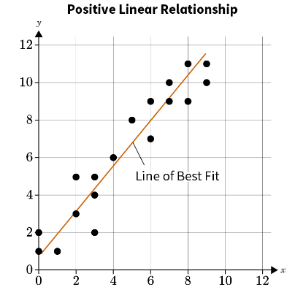
Residual | The vertical distance between a data point and the line of best fit; the result of subtracting the predicted y-value from the actual y-value. | Residual = $$y−\hat{y}$$  $$y=actual value$$  $$\hat{y}=predicted value$$
Correlation Coefficient | A number (usually represented with the variable r) in the range of −1 ≤ r ≤ 1  that indicates how accurately an equation represents the data being examined. | Use GeoGebra to find the precise correlation coefficient. 