**2024-2025 Literacy Instruction Protocol Grades K-5**

|  |  |  |  |  |  |
| --- | --- | --- | --- | --- | --- |
| **1. All students will receive daily instruction in English Language Arts** | | | **2. All students will be assessed** | | **3. Identified students will receive intensive instruction** |
| Core Live Lesson instruction includes:   * explicit, well-organized, and engaging whole group instruction * small-group instruction, differentiated based on student need   Curriculum includes:   * Pearson Online Curriculum (including Decoding Routines) * Teacher-created lessons aligned to state standards | | | Benchmarks will:   * be given BOY, MOY, EOY * include PSF, NWF, ORF   Diagnostics will be used to:   * identify skillset needs * plan interventions   Progress will be monitored:   * to ensure gaps are closing | | Tiered instruction includes:   * **some** students receiving 30 minutes of targeted skill-based instruction daily in addition to CORE with skill specific groups of 5-8 students. Progress monitored bi-weekly. * **few** students, enrolled for an additional 60 minutes daily in addition to CORE, with groups of 1-5 students. Certified teacher recommended. (Kdg. 30 additional minutes) Progress monitored weekly. |
| **Daily Recommended Allocation of CORE Instructional Time (Tier 1)** | | | **Recommended Benchmark** | **Recommended Diagnostics** | **Recommended Interventions** |
| **Simple View of Reading** | **Decoding** | **Language Comprehension** | [**Are students on track**](https://dibels.uoregon.edu/materials/dibels#progress)**?** | [**What skills are missing?**](https://www.connexus.com/library/default.aspx?lineage=%2fHome%2fInstructional+Partners%2fCompanion+Site+Resources%2fEnglish%2fDiagnostic+Resources%2f&category=Diagnostic+Resources) | **Interventions/Resources: Pearson Provided** |
| Kindergarten  90 min. | 50% of time (45 min.)   * Phonological Awareness * Alphabet Knowledge * Decoding Primary (*including sound-spelling correspondence, letter formation, and dictation*) | 50% of time (45 min.)   * Vocabulary & Oral Language * Background Knowledge * Language Structures (includes writing) * Verbal Reasoning * Literacy Knowledge | Phoneme Segmentation Fluency: BOY 5, MOY 29, EOY 44  Nonsense Word Fluency: BOY 9, MOY 25, EOY 31 | Phonological Awareness Assessment  Quick Phonics Screener | ABC Knowledge: Letter Arc instruction, Alphabet Routines  Decoding: Pearson Decoding Routines K-5  Online Programs: Freckle and IXL Reading  *Caution: *Students who need to close their achievement gaps require direct, explicit instruction from a teacher. Utilizing online intervention programs in and of themselves will not likely provide the support students required* |
| **Interventions/Resources: School Funds Required** |
| 1st Grade  110 min. | 40% of time (40-45 min.)   * Phonological Awareness * Decoding Primary (*including sound-spelling correspondence & sight recognition*) * Handwriting | 60% of time (65-70 min.)   * Vocabulary & Oral Language * Background Knowledge * Language Structures (includes writing) * Verbal Reasoning * Literacy Knowledge | Nonsense Word Fluency: BOY 30, MOY 52, EOY 55  Oral Reading Fluency: BOY 10, MOY 21, EOY 39 | Phonological Awareness Assessment  Quick Phonics Screener | PA: Heggerty Online Videos, Heggerty Instructional Manual  Decoding: UFLI Routines, 95% Group Phonics, Florida Center for Reading Research Resources  Language Structures: Step up to Writing, The Process Writing Routine  Comprehension: 95% Group Comprehension  Online Programs: Lexia Core 5, Read180, Reading Plus, iReady  *Caution: *Students who need to close their achievement gaps require direct, explicit instruction from a teacher. Utilizing online intervention programs in and of themselves will not likely provide the support students require* |
| 2nd Grade  110 min. | 40% of time (40-45 min.)   * Decoding Primary *(including sound-spelling correspondence & sight recognition*) * Handwriting | 60% of time (65-70 min.)   * Vocabulary & Oral Language * Background Knowledge * Language Structures (includes writing) * Verbal Reasoning * Literacy Knowledge | Oral Reading Fluency: BOY 49, MOY 78, EOY 94 | Phonological Awareness Assessment  Quick Phonics Screener |
| 3rd – 5th Grade  110 min. | 30% of time (30-35 min.)   * Decoding Intermediate * Advanced Word Study * Handwriting | 70% of time (75-80 min.)   * Vocabulary & Oral Language * Background Knowledge * Language Structures (includes writing) * Verbal Reasoning * Literacy Knowledge | Oral Reading Fluency:  3rd - BOY 73, MOY 105, EOY 114  4th - BOY 87, MOY 121, EOY 125  5th - BOY 103, MOY 122, EOY 137 | Quick Phonics Screener  Spelling Inventory |

References:

DIBELS 8th Edition Benchmark Goals: [Microsoft Word - DIBELS8thEditionGoals 08182020.docx (uoregon.edu)](https://dibels.uoregon.edu/sites/default/files/2021-06/DIBELS8thEditionGoals.pdf)

|  |
| --- |
| LETRS 3rd Edition, Vol. 1; p. 324-325; Voyager Sopris Learning. |

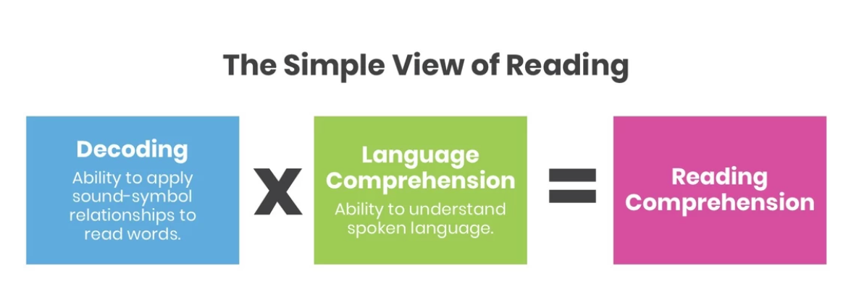

Gough, P. and Tunmer, W. (1986). Decoding, reading, and reading disability. *Remedial and Special Education*, 7, 6–10.