Univariate Datasets
Formula Sheet
Name | Definition | Formula
Dot Plot | A visual representation of data that consists of individual data points plotted as dots on a graph. | 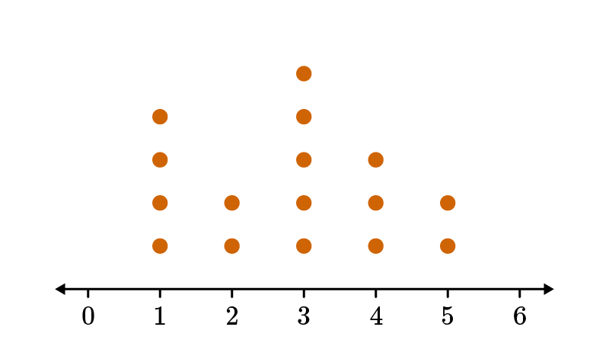
Histogram | A representation of a frequency distribution by means of rectangles whose widths represent class intervals and whose areas are proportional to the corresponding frequencies. | 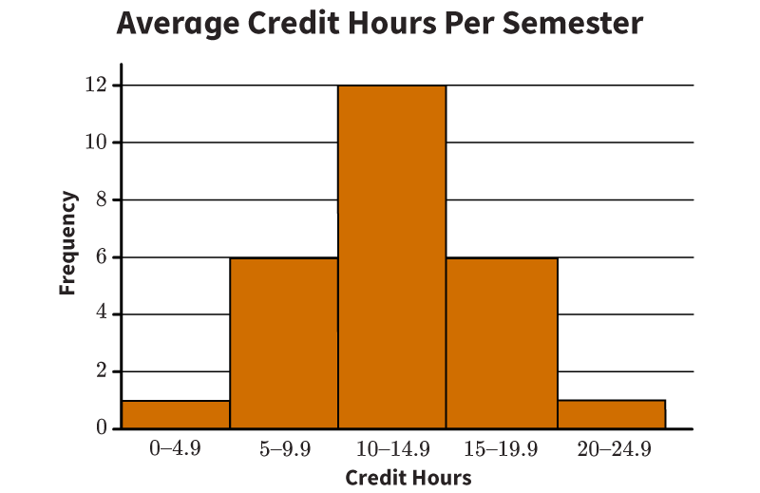
Box Plot | A visual representation that shows the five-number summary of a dataset. | 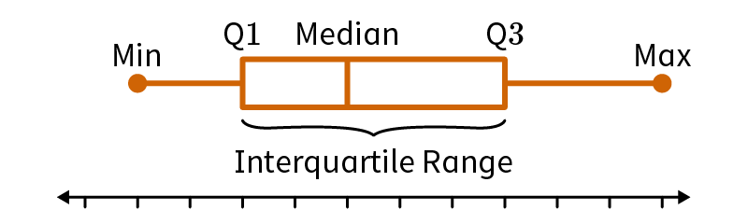
Interquartile Range | The measure of variability of a dataset that is the difference between the first quartile and third quartile. | - $$Q1$$is the first quartile  - $$Q3$$is the third quartile
Mean | A measure of the center of a dataset found by adding all items in a set and dividing by the total number of items. | $$\frac{\left(x_{1}+x_{2}+x_{3}+…\right)}{n}$$  $$x_{n}$$ is the value of the data point  $$n$$is the total number of values in the data set
Median | The middle value in an ordered set of data, or the mean of the two middle numbers. | Odd number of data points:  - The median is the exact middle number.  - 2, 6, 9, 16, 20  Even number of data points:  - Take the average of the two middle numbers.  - 2, 6, 9, 11, 16, 20  - Median = $$\frac{\left(9+11\right)}{2}=10$$
Symmetrical Distribution | A distribution in which the left and right sides mirror each other. | The mean and median are the same in symmetric distributions.  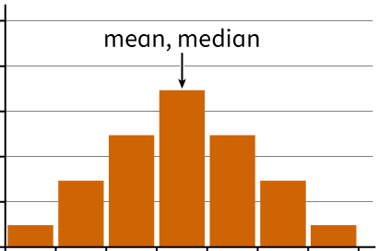
Skewed Distribution | A distribution in which the chart's tail is longer on one side than the other. | Left-Skewed:  - Tail on the left  - Data clustered to the right  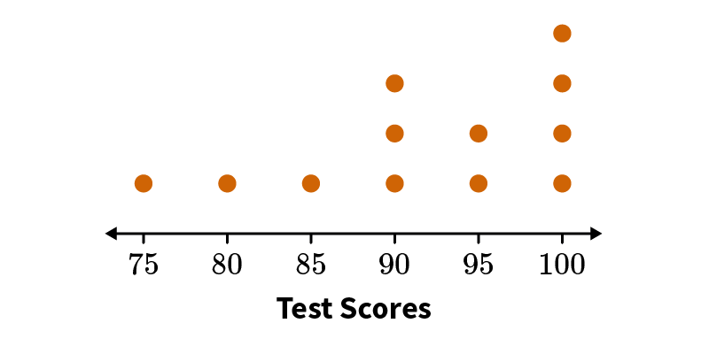  Right-Skewed:  - Tail on the right  - Data clustered to the left  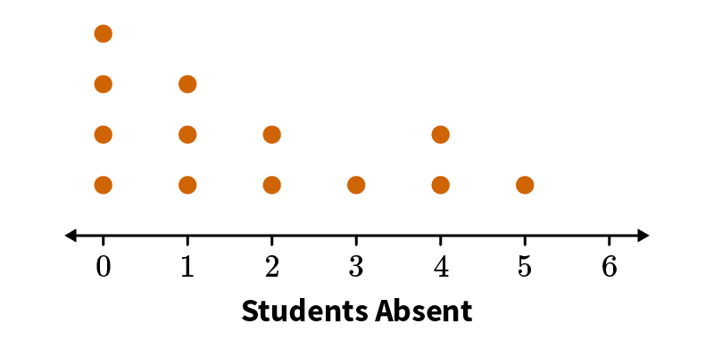
Standard Deviation | A measure of variation whose calculation is based on the distance between each data value and the mean. | $$s=\frac{\sqrt{Σ{\left(Χ−\overline{x}\right)}^{2}}}{n−1}$$  $$Χ$$is the data point value  $$\overline{x}$$ is the mean  $$n$$is the number of values in the data set

