**Unit 2: Cells**

**Guided Notes: Characteristics of Cells**

**Big Idea:** All living things are made up of building blocks called __________.

**Key Concepts:**

* A __________ is the smallest unit that can be considered alive.
* The __________ __________ describes the three criteria for determining living things.
* The five __________ of living things are the criteria that an object must have to be considered alive.
* __________ organisms consist of many cells of different types.
* __________ organisms consist of one cell.

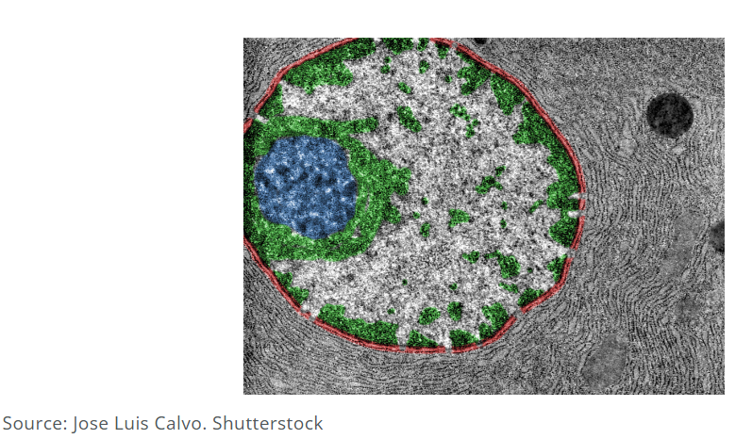

**Real World Examples:**

1. A house is made of pieces of wood, bricks, or stone building blocks. Similarly, living things are made up of building blocks called __________.
2. During the flu season, many people get sick because the influenza ________ (a nonliving particle that infects a cell and causes the cell to make multiple copies of the virus).

**Guided Notes: Plant and Animal Cells**

**Big Idea:** The main idea of this lesson is to compare the __________ and __________ of plant and animal cells.

**Key Concepts:**

* The __________ __________ surrounds a cell and is also called a cell membrane.
* __________ are specialized cell parts within cells.
* __________ is the gelatin-like fluid that fills a cell and contains all the organelles except for the nucleus.
* The __________ supports the structure of a cell and gives it its shape.
* The __________ is a large organelle that contains the hereditary material of a cell.
* The __________ is an organelle where cellular respiration takes place.
* __________ are small organelles that produce proteins.
* The __________ __________ modifies and packages proteins and lipids for transport.
* The __________ __________ __________ has attached ribosomes and is involved in the transport of materials.
* The __________ __________ __________ has smooth surfaces and transports materials.
* __________ are green organelles where photosynthesis takes place in plant cells.
* The __________ __________ is a large sac in plant cells that stores water and maintains internal cell pressure.
* __________ are small organelles that take part in cell division.

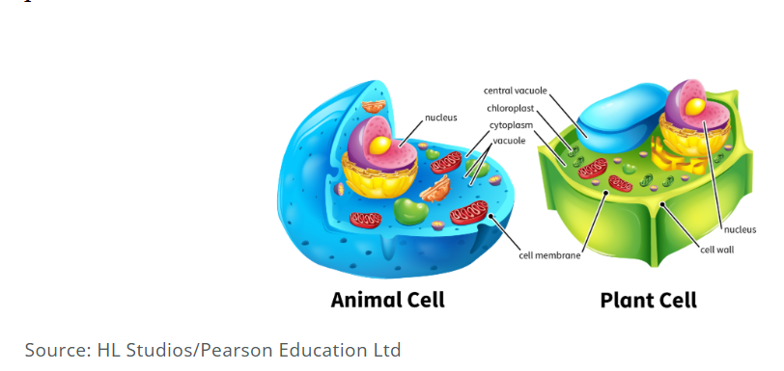

**Real World Examples:**

1. Think of the __________ __________ like a balloon inside a box. When the balloon is full, it presses against the sides of the box, making it rigid. This is similar to how the __________ __________ provides support to a plant cell.

2. Imagine a plant’s leaves turning brown in the fall. This happens because the __________ in the leaves can no longer retain the nutrients needed when sunlight becomes less available.

**Guided Notes: Modeling Cells**

**Big Idea:** Cells are the basic building blocks of all living things, and they contain smaller parts called ____________ that each perform specific functions necessary for life.

**Key Concepts:**

* __________ are specialized cell parts within cells.
* __________ is the gelatin-like fluid that fills a cell and contains all the organelles except for the nucleus.
* The ____________ is the large structure in the cell that contains the hereditary material.
* ____________ is the hereditary material in a cell that carries instructions for making proteins.
* The ____________ ____________ surrounds and protects the nucleus.
* ____________ are small structures that occur freely or are attached to the endoplasmic reticulum and function in protein synthesis.
* The ____________ ____________ ____________ is a network of membranes with attached ribosomes that processes and modifies proteins and transports them throughout the cell.
* The ____________ ____________ ____________ is a network of membranes having smooth surfaces that transports materials other than proteins.
* The ____________ ____________ transports, modifies, and packages proteins and lipids in a cell.
* ____________ are organelles in which cellular respiration takes place, providing energy for the cell.

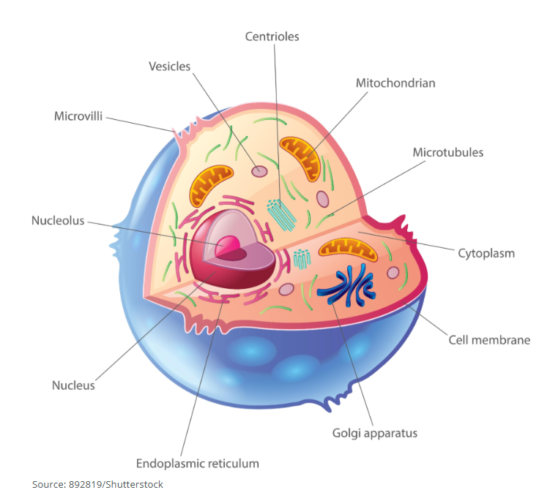

**Real World Examples:**

1. Imagine your school is like a cell. The principal's office would be the ____________, where all the important decisions are made, and instructions are given out.
2. Think of your school's cafeteria. It can be compared to the ____________ ____________ ____________ because it processes and serves food (proteins) to the students (cell).

**Guided Notes: Organelles**

**Big Idea:** Cells contain various ____________ that each perform specific functions necessary for the cell’s survival and overall function.

**Key Concepts:**

* The ____________ ____________ is a tough and rigid structure that surrounds a plant cell but not an animal cell. It provides shape, support, and protection.
* The ____________ ____________ surrounds all cells, holding the cell together and controlling which substances go in and out.
* ____________ is the gelatin-like fluid that fills the inside of a cell, along with the organelles other than the nucleus.
* The ____________ is where the cell’s genetic material is stored.
* ____________ are organelles in which cellular respiration takes place, providing energy for the cell.

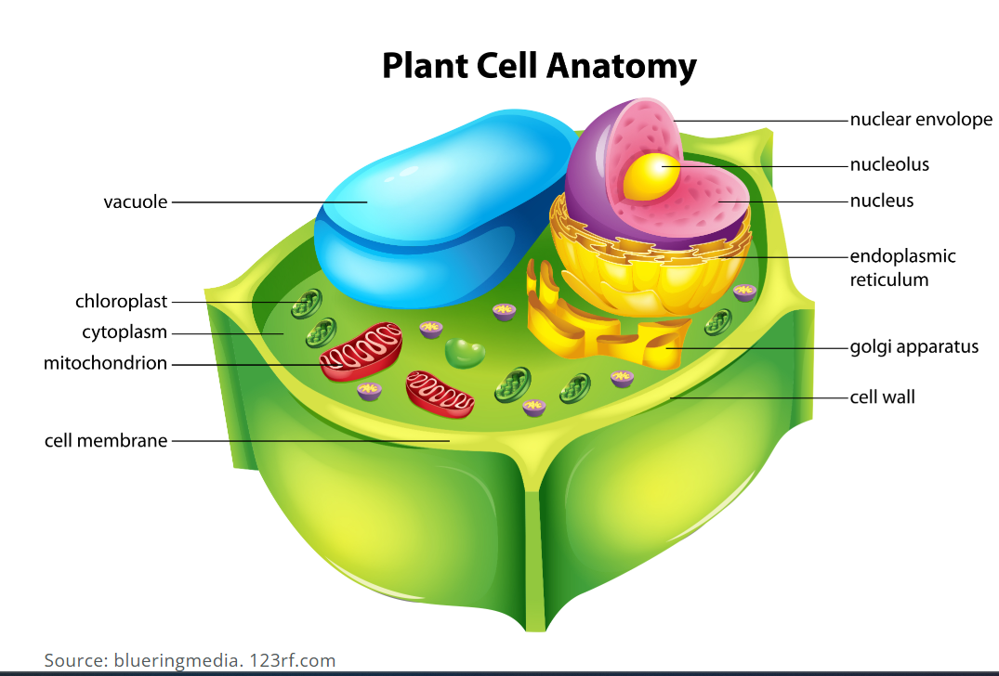

**Real World Examples:**

1. Imagine your school is like a cell. The school fence or walls would be the ____________ ____________, providing protection and support to the entire school.
2. Think of your classroom. The door to your classroom can be compared to the ____________ ____________ because it controls what comes in and out of the room.

**Guided Notes: Unicellular and Multicellular**

**Big Idea:** Unicellular organisms have bodies made of only ____________ cell, while multicellular organisms have bodies made of ____________ cells, each specialized for different functions.

**Key Concepts:**

* ____________ ____________ is the reproduction of a cell by division into two equal parts.
* A ____________ ____________ is an organelle in a unicellular organism that expels water from the cell.
* ____________ organisms have many cells.
* A ____________ is a single-celled organism classified in Kingdom Protista.
* A ____________ is a temporary projection of cytoplasm that serves in locomotion in an amoeba.
* A ____________ ____________ ____________ is a specialized cell that carries oxygen in the blood.
* ____________ organisms have one cell.
* A ____________ ____________ ____________ is a specialized cell that fights infection.

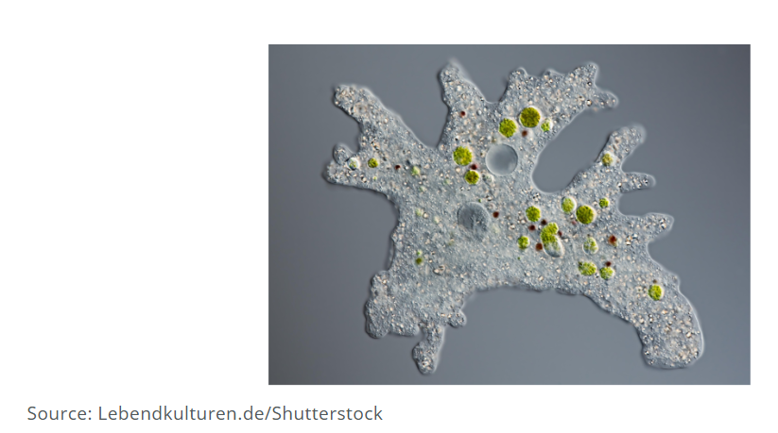

**Real World Examples:**

1. Imagine your school is like a multicellular organism. The janitor is like a ____________ ____________ ____________ because they help clean up and fight off "infections" (messes) in the school.
2. Think of a sports team. The players are like ____________ ____________ ____________ because they each have a specific role (like carrying oxygen) and work together to win the game.

**Guided Notes: Specialized Cells**

**Big Idea:** Multicellular organisms use specialized ____________ to perform complex life functions, with each type of cell having a unique ____________ that helps it do its job.

**Key Concepts:**

* ____________ — long tail-like part of a nerve cell
* ____________ — finger-like projections on a nerve cell body
* ____________ — having many cells
* ____________ — nerve cell
* ____________ — having one cell

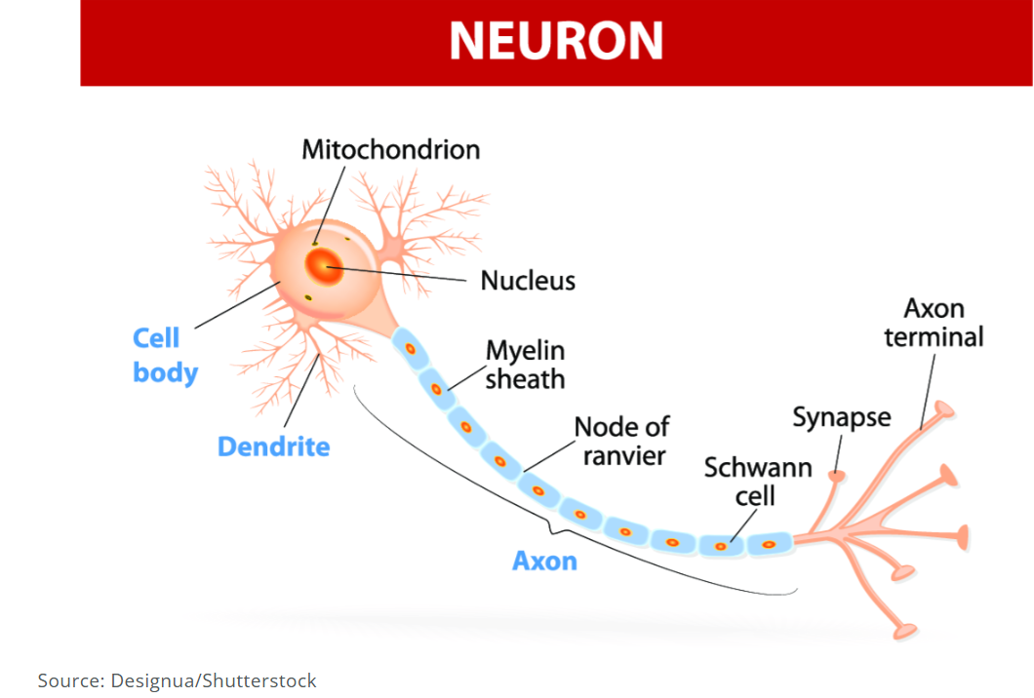

**Real World Examples:**

1. Imagine your school is like a multicellular organism. The teachers are like ____________ because they send messages and instructions to students, just like nerve cells transmit messages in the body.
2. Think of your favorite basketball team. The players are like ____________ because each player has a specific role, just like different types of cells have specific functions in the body.

**Guided Notes: Mitosis**

**Big Idea:** Mitosis is the process by which body cells ____________ to allow for growth and ____________ in multicellular organisms.

**Key Concepts:**

* ____________ — a disease that occurs because of uncontrolled mitosis
* ____________ ____________ — a sequence of stages in the life of a cell
* ____________ — the process by which body cells divide
* ____________ — a mass of cancer cells that form as cancer cells divide repeatedly

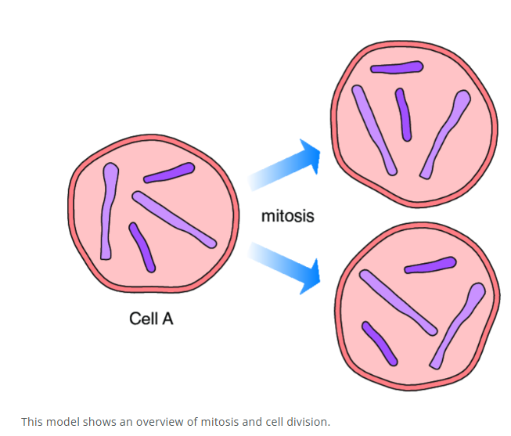

**Real World Examples:**

1. Imagine your body is like a construction site. The workers are like cells undergoing ____________, constantly building and repairing structures to keep the site functioning.
2. Think of your skin. When you get a cut, your skin cells undergo ____________ to produce new cells that repair the wound.