**Unit 4: Reproductive Success**

**Guided Notes: Reproduction in Flowering Plants**

**Big Idea:** Flowers are the reproductive structures of certain plants, and each part of a flower has a specific function in the process of ____________.

**Key Concepts:**

* ____________ – part of the stamen where pollen is made
* ____________ – a stalk, found in the stamen, that supports the anther
* ____________ – the male part of a flower
* ____________ – the female part of a flower
* ____________ – sticky top part of the pistil that captures pollen
* ____________ – slender stalk that connects the stigma and ovary
* ____________ – swollen base of the stigma that contains the female sex cells

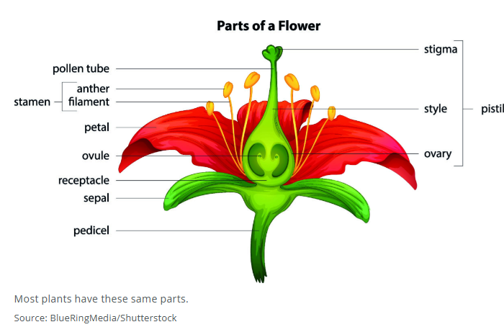

**Real World Examples:**

1. Imagine a flower with colorful petals and a sweet smell. The ____________ attract bees, which help move pollen from one flower to another.
2. Think of a flower growing in a garden. The wind blows and carries pollen from the ____________ of one flower to the ____________ of another, allowing fertilization to occur.

**Guided Notes: Non-Flowering Plants Reproduction**

**Big Idea:** Non-flowering plants reproduce using different structures and processes compared to flowering plants, involving ____________ and ____________.

**Key Concepts:**

* ____________ – sex cell, like egg or sperm
* ____________ – single cell that can produce a plant without fusing with another cell
* ____________ – generation of the plant that produces spores
* ____________ – generation of the plant that produces gametes
* ____________ – group of non-flowering plants that produce seeds; also called conifers

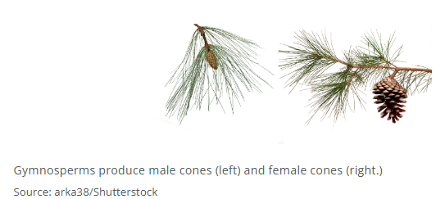

**Real World Examples:**

1. Imagine a moss growing in a damp forest. The green moss you see is in the ____________ stage, producing gametes for reproduction.
2. Think of a pine tree in a park. The tree produces ____________ that contain ____________, which can grow into new trees without the need for flowers.

**Guided Notes: Successful Plant Reproduction**

**Big Idea:** Certain plant structures and interactions with pollinators increase the likelihood of successful ____________.

**Key Concepts:**

* ____________ – part of reproduction where a sperm cell and an egg cell come together
* ____________ – the movement of pollen from where it is made to where fertilization can occur
* ____________ – an animal that carries pollen during pollination
* ____________ – changes in two organisms over a long period of time that help both living things survive and reproduce

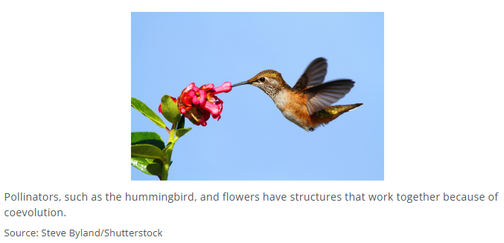

**Real World Examples:**

1. Bees help flowers make seeds by moving _______________ from one flower to another. The bee is a _______________ because it carries the pollen.
2. Some flowers and insects have changed together over time to help each other survive. This is called _______________. It helps flowers with _______________ by joining pollen and egg cells.

**Guided Notes: Animal Behaviors**

**Big Idea:** Animal behaviors, such as courtship and territorial behaviors, play a crucial role in ensuring successful ____________.

**Key Concepts:**

* ____________ ____________ – behavior used to attract a mate
* ____________ – animal of the same kind but of the opposite sex
* ____________ – the production of offspring
* ____________ ____________ – behavior used to protect an area in which an animal lives
* __________ reduces the energy required for survival

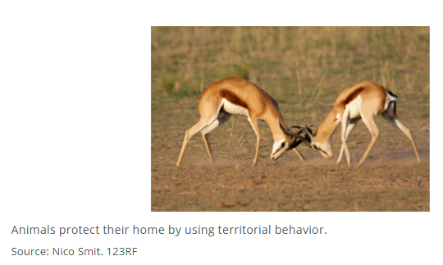

**Real World Examples:**

1. Imagine a ____________ showing off its colorful feathers and dancing to attract a mate. This is an example of ____________ ____________.
2. Think of a ____________ marking its territory with scent to warn other animals to stay away. This is an example of ____________ ____________.

**Guided Notes: Analyzing Factors**

**Big Idea:** The main idea of this lesson is understanding how animal behaviors, and the availability of resources affect the probability that animals will successfully _________.

**Key Concepts:**

* ____________ ____________ - The number of offspring that are born and survive to reproduce.
* ____________ - The way an animal interacts with other animals and with the nonliving things in its environment.
* ____________ - A conclusion based on evidence and reasoning.
* ____________ - An animal of the same kind but opposite sex that is needed for reproduction.
* All animals need ____________ such as food and shelter to survive and reproduce.
* Scientists look for _________, or patterns of change, in data to understand reproductive success.
* Adding more animals to an environment can create too much ____________ for resources, affecting reproductive success.

**Real World Examples:**

1. In a freshwater lake, tiny animals like rotifers and water fleas compete for resources. When water fleas are added to the environment, the number of rotifers _________ because of increased competition.
2. On the plains of Africa, lions and zebras have a predator-prey relationship. When the zebra population increases, there is more _________ for the lions, supporting more offspring. However, if there are too many lions, they overhunt the zebras, causing the zebra population to _________ and then the lion population to also decrease.