**Unit 7: Matter and Energy**

**Guided Notes: Making Food**

**Big Idea:** The main idea of this lesson is to explain the steps in the process of __________.

**Key Concepts:**

* __________ is a green pigment that absorbs energy from sunlight.
* __________ __________ is the process by which plants take in carbon dioxide and release oxygen through tiny pores called stomata.
* __________ is the process that captures energy from sunlight and uses it to make oxygen and glucose from carbon dioxide and water.
* __________ are openings in leaves through which gases enter and leave.

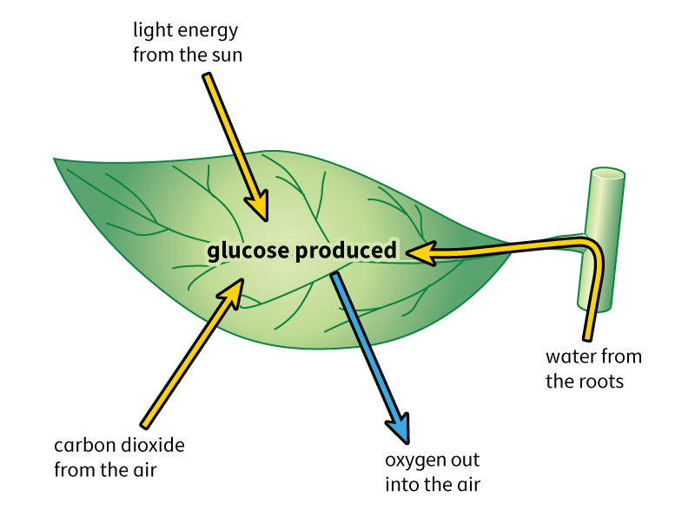

**Real World Examples:**

1. Plants can grow well because they perform __________, using __________ to capture energy from the sun and make its own food.
2. Think about how you breathe in oxygen and breathe out carbon dioxide. Plants do the opposite during __________, taking in carbon dioxide and releasing __________ through their __________.

**Guided Notes: Breaking Down Food**

**Big Idea:** The main idea of this lesson is to explain the steps in the process of __________ __________.

**Key Concepts:**

* __________ is a molecule that provides energy in a usable form for cells; stands for adenosine triphosphate.
* __________ __________ is the process that uses oxygen to break down glucose in food to form carbon dioxide and water and provide energy.
* __________ __________ __________ is a series of proteins that convert energy to ATP that the cell can use.
* __________ is the process that splits glucose into two small molecules for use during cellular respiration.
* __________ __________ is the part of cellular respiration in which oxygen is used to release energy from glucose.

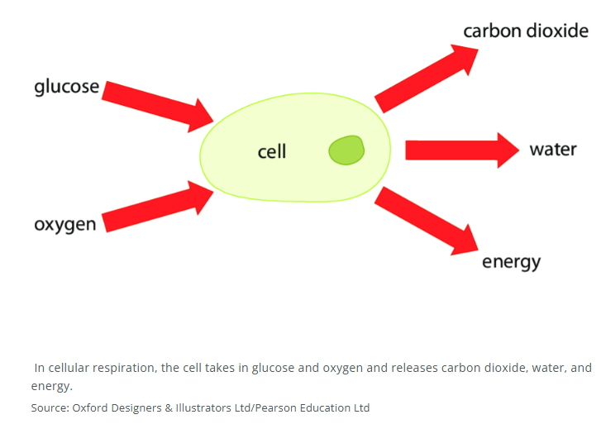

**Real World Examples:**

1. When you eat food, your body breaks down the food into glucose, which is then used in __________ __________ to release energy that your cells can use to perform functions like moving, growing, and thinking.
2. When you run or exercise, your muscles need more energy. This energy comes from the process of __________ __________, where glucose and oxygen are used to produce __________, which powers your muscles.

**Guided Notes: Recycling Matter by Plants**

**Big Idea:** The main idea of this lesson is to understand how plants support matter __________ through processes like photosynthesis and cellular __________.

**Key Concepts:**

* __________ __________ is the process that uses oxygen to break down glucose in food to form carbon dioxide and water and provide energy.
* __________ is the process that captures energy from sunlight and uses it to make oxygen and glucose from carbon dioxide and water.
* __________ means to reuse something for a different purpose.

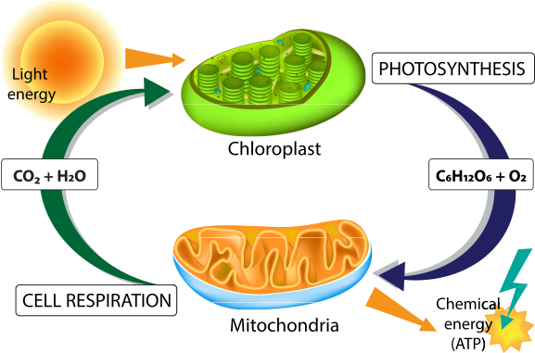

**Real World Examples:**

1. Imagine you are eating an apple. The carbon atoms in the apple were once part of carbon dioxide in the air that the apple tree used for __________. Now, those carbon atoms are part of the glucose in the apple that you are eating.
2. When you breathe in, you take in oxygen which your body uses for __________ __________. The carbon dioxide you breathe out was once part of the glucose you ate.

**Guided Notes: Flow of Energy**

**Big Idea:** The main idea of this lesson is to understand how plants support __________ flow in an ecosystem.

**Key Concepts:**

* __________: a producer
* __________: an organism that eats only animals
* __________: an organism that eats other organisms
* _________ __________: a diagram that shows how energy moves through organisms in an ecosystem
* __________: an organism that eats only plants
* __________: the chemical reactions that support life
* __________: an organism that eats both plants and animals
* __________ __________: an organism in the second level of an energy pyramid; feeds on producers
* __________: an organism that makes its own food using the energy from the sun
* __________ __________: an organism in the third level of an energy pyramid; feeds on primary consumers
* __________ __________: an organism in the fourth level of an energy pyramid; feeds on secondary consumers
* __________ __________: a level or a position in a food chain, a food web, or an ecological pyramid

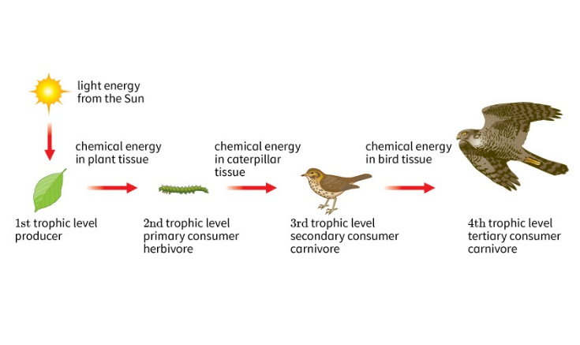

**Real World Examples:**

1. Bread comes from wheat, a __________ that uses sunlight to make its own food. When you eat bread, you are getting energy that originally came from the __________.
2. A lion is a __________ that eats other animals. The energy that the lion gets from its prey originally came from the __________ that the prey ate.

**Guided Notes: Recycling of Carbon**

**Big Idea:** The main idea of this lesson is to understand the __________ __________, which describes the movement of carbon atoms from the atmosphere into organisms and back into the atmosphere.

**Key Concepts:**

* __________ __________: nature's way of reusing carbon atoms, which travel from the atmosphere into organisms in the Earth and then back into the atmosphere over and over again
* __________: place where a certain kind of material is stored, or resides, for some period of time until it is used again
* __________ __________: anything that absorbs more carbon from the atmosphere than it releases

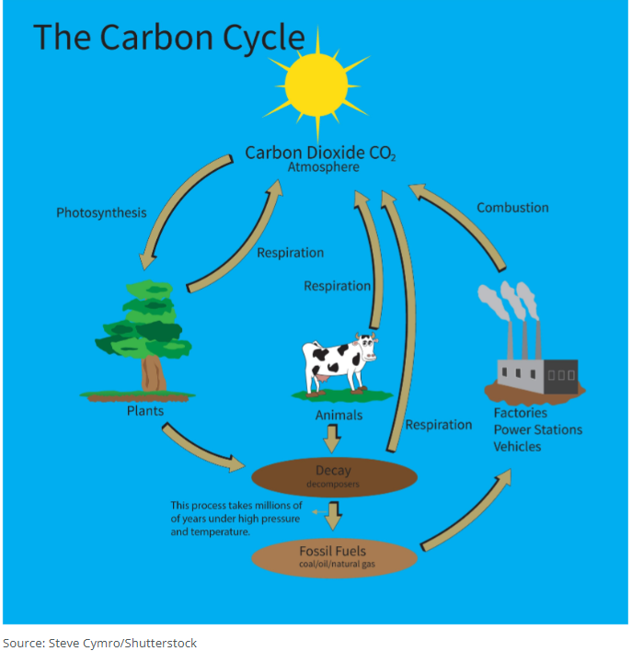

**Real World Examples:**

1. When you breathe out, you release carbon dioxide into the atmosphere. This carbon dioxide can be taken in by plants during __________ to make glucose.
2. Burning fossil fuels like coal and oil releases carbon dioxide into the atmosphere, which is a part of the __________ __________.

**Guided Notes: Recycling of Nitrogen**

**Big Idea:** The main idea of this lesson is to understand the __________ __________, which describes the movement of nitrogen from one form to another in an ecosystem.

**Key Concepts:**

* __________: process that changes nitrates and nitrites to nitrogen gas
* __________: process by which microorganisms that changes ammonia into nitrites and then nitrates, a usable form of nitrogen
* __________ __________: movement of nitrogen from one form to another in an ecosystem
* __________ __________: process that converts nitrogen gas into ammonia
* __________: a place in which a form of matter is kept in storage until it is used
* __________: a natural system that stores matter

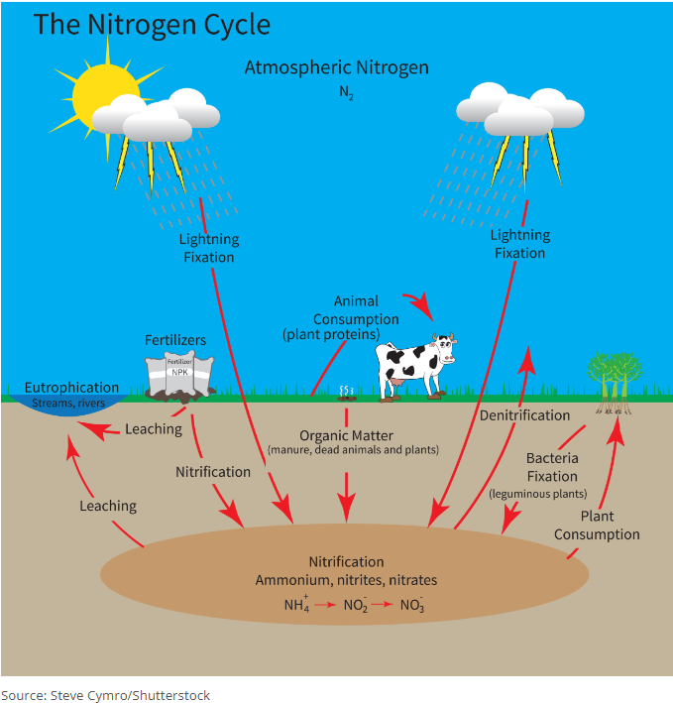

**Real World Examples:**

1. Farmers often plant legumes like beans to improve soil quality. These plants have root nodules where bacteria perform nitrogen fixation, converting nitrogen gas into __________.
2. When you see lightning during a storm, know that it is helping convert nitrogen gas into a usable form for plants through the process of __________ __________.

**Guided Notes: Energy and Matter in an Ecosystem**

**Big Idea:** The main idea of this lesson is to understand how the cycling of __________ and the flow of __________ occur among living and nonliving parts of an ecosystem.

**Key Concepts:**

* __________: an organism that carries out photosynthesis
* __________: an organism that eats other organisms
* __________: an organism that breaks down matter and returns it to the environment
* __________ __________: a model that shows overlapping food chains in an ecosystem
* __________: an animal that eats only plants
* __________: an animal that eats only animals
* __________: an animal that eats both plants and animals

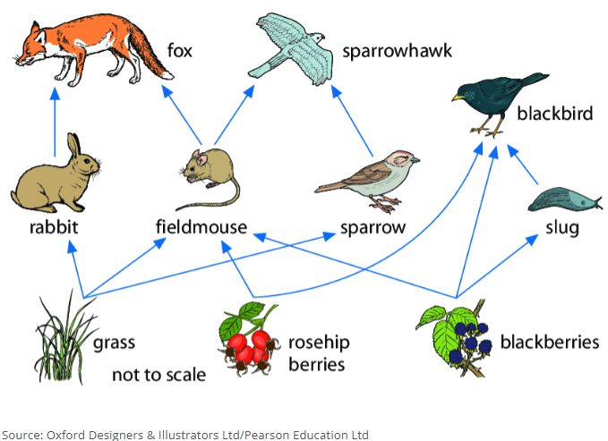

**Real World Examples:**

1. Think about a simple food chain: grass → rabbit → fox. The grass is a __________, the rabbit is a __________, and the fox is a __________.
2. Imagine you have a compost bin at home. The decomposers in the compost bin, like bacteria and fungi, break down the food scraps and return nutrients to the soil. These decomposers are an example of __________.