**Unit 3: Body Systems**

**Guided Notes: Multicellular Organisms**

**Big Idea:** Multicellular organisms are made up of different types of cells that work together to perform ____________ life functions, such as growth, development, and maintaining ____________.

**Key Concepts:**

* __________ is the process of maintaining a stable internal state within a cell or organism.
* Cells need to ____________ to a change or condition in their environment.
* ____________ cell types are cell types with different characteristics and functions.
* An ____________ is a rigid bone cell.

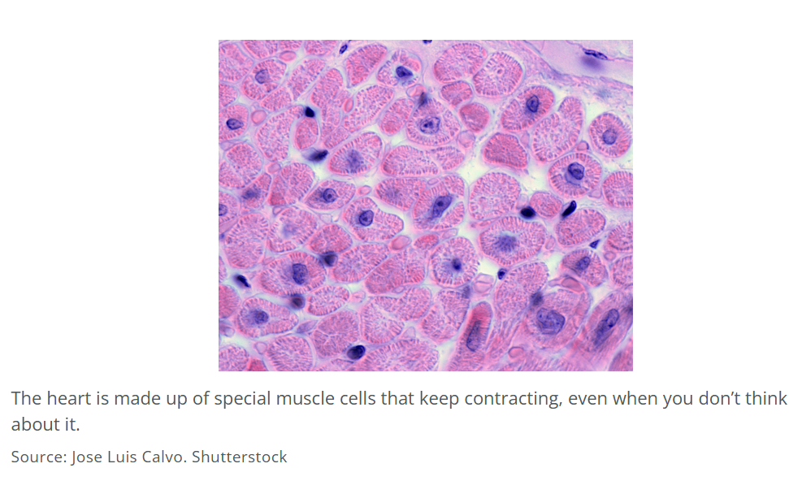

**Real World Examples:**

1. Imagine your body is like a well-organized ____________. Different workers (cells) have specific jobs to keep everything running smoothly.
2. Think your favorite song. Each lyric (cell) has unique words to build a verse, like a ____________ cell providing structure or a neuron sending messages, and they all work together to make a catchy beat.

**Guided Notes: Body Systems Hierarchy**

**Big Idea:** Multicellular organisms are organized from ____________ through ____________ ____________ to perform complex life functions.

**Key Concepts:**

* The __________ is the basic living unit of all organisms.
* An __________ is a body structure with a specific function and is made up of one or more types of tissue.
* An __________ __________ is a group of organs that work together to do a certain job.
* An __________ is an individual, complete living thing.
* A __________ is a group of the same type of cells.

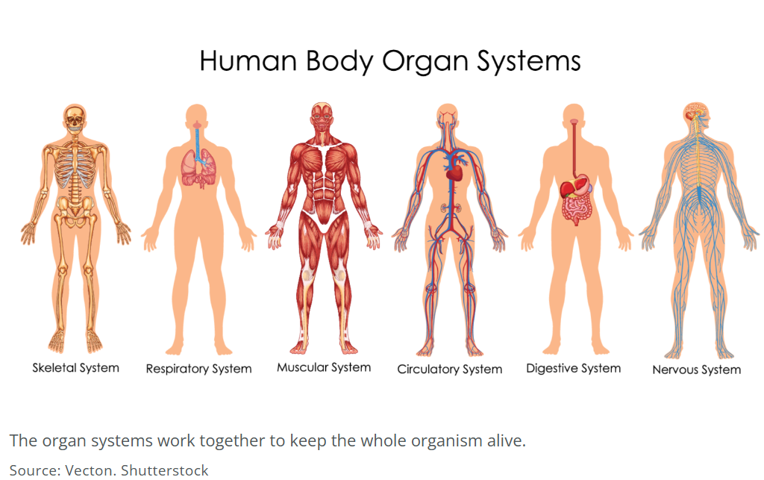

**Real World Examples:**

1. Imagine your body is like a ____________. Each room (organ) has a specific function, and all the rooms together make up the entire house (organism).
2. Think of a band. Each musician is like a ___________ is like a cell who has a specific role, and together they form a team of musicians (organ system) that work towards a common goal.

**Guided Notes: Respiratory and Circulatory Systems**

**Big Idea:** The respiratory and circulatory systems work together to deliver ____________ to the body and remove ____________ ____________.

**Key Concepts:**

* ____________ ____________ – the inside of the nose
* ____________ – upper part of the pharynx, near the nasal cavity
* ____________ – airway from the nose and mouth to the larynx
* ____________ – airway from the pharynx to the trachea; holds the vocal cords
* ____________ – airway from the larynx to the bronchi
* ____________ – airway from the trachea to the lungs
* ____________ – network of tubes that take air throughout the lungs
* ____________ – organ that moves oxygen into the body and moves carbon dioxide out of the body
* ____________ – organ that pumps blood
* ____________ – the main artery that moves oxygenated blood away from the heart and to the body

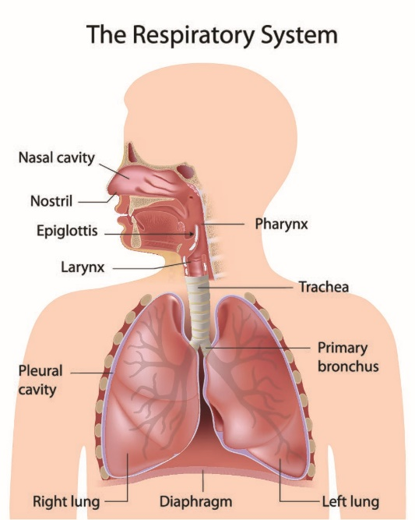

**Real World Examples:**

1. When you take a deep breath in, air enters your ____________ and passes through the ____________. The air then moves through the ____________ and reaches the ____________. From there, it travels down the ____________ and into the ____________. Finally, the air reaches the ____________ where oxygen is exchanged with carbon dioxide.
2. The ____________ circulates blood throughout the body. Oxygenated blood is pumped from the left ventricle into the ____________. Deoxygenated blood from the upper body returns to the heart through the ____________, while blood from the lower body returns through the ____________. The right atrium receives this deoxygenated blood and passes it into the ____________, which then sends it to the lungs for oxygenation.

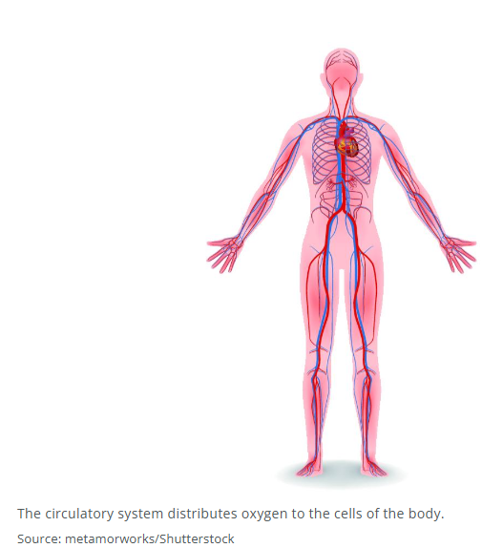

**Guided Notes: Digestive and Excretory Systems**

**Big Idea:** The digestive and excretory systems work together to obtain ____________ from food and remove ____________ from the body.

**Key Concepts:**

* ____________ – organ that stores urine until it can be expelled from the body
* ____________ ____________ – system that digests food and absorbs its nutrients
* ____________ – carries food from the mouth to the stomach
* ____________ ____________ – system that removes cellular waste and excess materials from the body
* ____________ – organ that filters the blood
* ____________ ____________ – organ that absorbs water from food and moves the waste out of the body
* ____________ – beginning of the digestive system
* ____________ – structures in the kidneys that remove waste material and return water and glucose to the blood
* ____________ ____________ – organ that absorbs nutrients from the food
* ____________ – organ that breaks down food chemically and physically

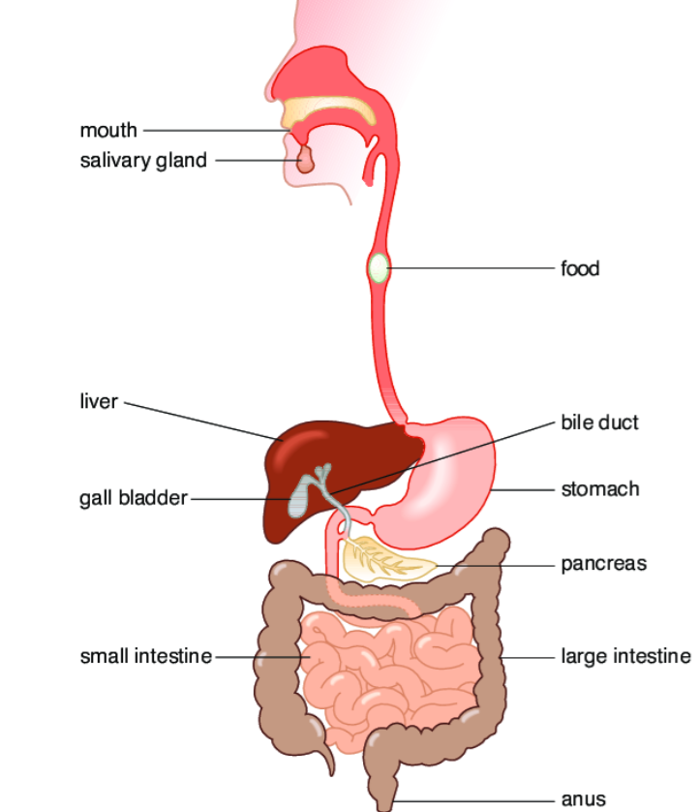

**Real World Examples:**

1. When you eat a meal, the food enters your ____________ and travels down the ____________. In the ____________, the food is mixed with digestive juices. The partially digested food then moves into the ____________, where most of the nutrients are absorbed into the bloodstream. Finally, the remaining waste moves into the ____________ before being expelled from the body.
2. The ____________ includes several organs that help filter and remove waste. The ____________ play a crucial role by removing waste products and excess substances from the blood. These waste products, including ____________, are then transported through the ____________ to the ____________. When it is time to urinate, the urine passes through the ____________ and is expelled from the body.

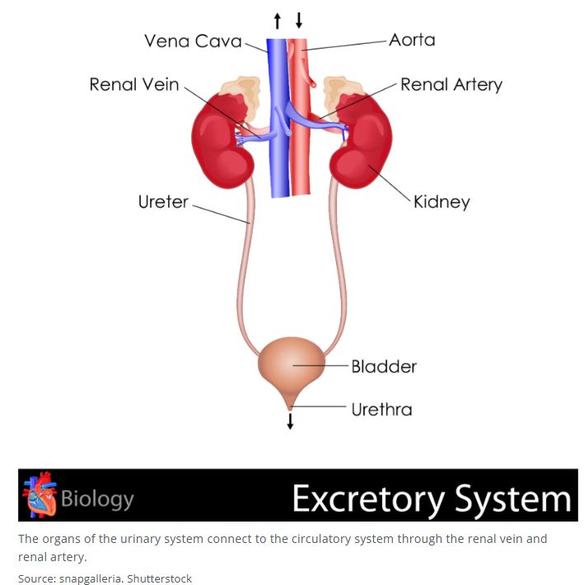

**Guided Notes: Nervous System**

**Big Idea:** The nervous system is a complex network that allows the body to ____________ to stimuli and maintain ____________.

**Key Concepts:**

* ____________ – basic cell of the nervous system
* ____________ – nerve cells
* ____________ – part of the neuron that contains the nucleus
* ____________ – part of the neuron that transmits information away from the cell body
* ____________ – part of the neuron that carries information to the cell body
* ____________ ____________ – neurons that take in sensory information and send it to the brain
* ____________ – neurons that connect other neurons together
* ____________ ____________ – neurons that tell the body how to respond to stimuli
* ____________ ____________ ____________ – the part of the nervous system made up of the brain and spinal cord
* ____________ ____________ ____________ – the network of nerve tissue that spreads out throughout the body

**Real World Examples:**

1. When you touch a hot surface, ____________ in your skin detect the heat and send signals through ____________ to your ____________. The signals travel through the ____________ of the neurons and reach the ____________. Here, ____________ connect with other neurons to relay the message. Finally, ____________ send signals to your muscles to pull your hand away from the hot surface.
2. The ____________ consists of the brain and spinal cord, which process information and coordinate responses. The ____________ spreads out throughout the body, connecting different parts of the body to the central nervous system. When you step on a sharp object, the ____________ in your foot detect the pain and send signals to your brain. The brain then sends signals through the ____________ to the muscles in your leg, causing you to lift your foot away from the sharp object.

**Guided Notes: Sensory Receptors**

**Big Idea:** Sensory receptors detect different types of ____________ and send information to the ____________ for processing.

**Key Concepts:**

* ____________ ____________ – special cells that detect sensory stimuli
* ____________ – sensory receptors that detect visible light
* ____________ – sensory receptors that detect mechanical stimuli, such as pressure
* ____________ – sensory receptors that detect hot and cold temperatures
* ____________ – sensory receptors that detect chemical stimuli

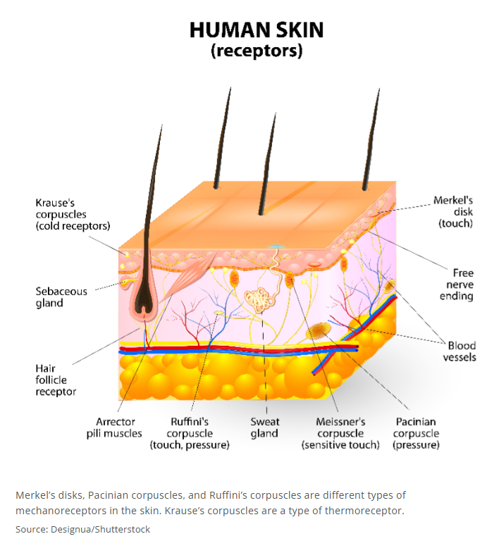

**Real World Examples:**

1. When you step outside on a sunny day, your eyes use ____________ to detect visible light, allowing you to see your surroundings. At the same time, your skin uses ____________ to detect the warmth of the sun, helping you to feel the temperature.
2. When you press your hand against a surface, ____________ in your skin detect the pressure, allowing you to feel the touch. If you taste something spicy, ____________ in your mouth detect the chemical stimuli, giving you the sensation of spiciness.

**Guided Notes: The Eye**

**Big Idea:** The eye is a complex organ that works as a system to receive and process ____________ ____________.

**Key Concepts:**

* ____________ ____________ – information about images sent from photoreceptors in the retina through the optic nerve to the brain
* ____________ – the white part of the eye
* ____________ – front part of the eye through which light enters
* ____________ – colored part of the eye that surrounds the pupil
* ____________ – part of the eye that controls how much light is allowed to enter the eye
* ____________ ____________ – muscles that change the shape of the lens so the eye can focus
* ____________ – part of the eye that focuses light on the retina
* ____________ – part of the eye that turns light into visual signals
* ____________ – sensory receptors that detect light
* ____________ ____________ – the nerve that passes visual signals from the eye to the brain
* ____________ ____________ – tissue that connects and holds the parts of the body together
* ____________ ____________ – tissue that covers the outer surface and lines the inner passages of the body
* ____________ ____________ – tissue made up of nerve cells
* ____________ ____________ – tissue made up of muscle cells

**Real World Examples:**

1. When you look at an object, light first enters your eye through the ____________ and then passes through the ____________. The ____________ controls how much light is allowed to enter by adjusting the size of the ____________. The light then passes through the ____________, which focuses it onto the ____________. Here, ____________ detect the light and convert it into ____________. These signals are then sent to the brain via the ____________.
2. Think of your eye as a ____________. The lens adjusts to focus on objects at different distances, like how a camera lens adjusts to take clear pictures.

**Guided Notes: Homeostasis**

**Big Idea:** Homeostasis is the process by which organisms maintain ____________ ____________ despite changes in their environment.

**Key Concepts:**

* ____________ – process of maintaining a stable internal state
* ____________ ____________ – those things outside your body that can affect your internal stability, including temperature, stress, and disease

**Real World Examples:**

1. Imagine you are mowing the lawn on a hot day. Your body starts to sweat to cool down and maintain ____________.
2. Think of an arctic fox. The thick fur on its feet helps it maintain a stable ____________ ____________ in a very cold environment.