**Unit 5: Reproductive Strategies**

**Guided Notes: Asexual Reproduction Strategies**

**Big Idea:** The main idea of this lesson is to understand the different processes of _________ reproduction.

**Key Concepts:**

* _________ _________ - the production of offspring from one parent
* _________ - egg or sperm cells
* _________ _________ - A form of asexual reproduction in which one organism splits into two.
* _________ - A form of asexual reproduction in which offspring form on the surface of the parent.
* _________ - A form of asexual reproduction in which pieces of a parent can develop into identical copies.
* _________ _________ - A form of asexual reproduction in plants where a modified stem or root of the parent organism grows offspring that stay attached.
* _________ - A horizontal plant stem that takes root at points along its length to form new plants.

**Real World Examples:**

1. Bacteria like E. coli reproduce asexually through _________ _________. This process allows them to multiply quickly and spread easily.
2. Some plants reproduce asexually through _________ reproduction, where a modified stem or root grows new plants that stay attached to the parent.

**Guided Notes: Modeling Asexual Reproduction**

**Big Idea:** The main idea of this lesson is to understand why asexual reproduction leads to offspring with _________ genetic information.

**Key Concepts:**

* _________ - a plant’s stem that is modified for storage
* _________ _________ - A form of asexual reproduction in plants in which a modified stem or root of the parent organism grows offspring that stay attached.
* _________ _________ - A form of asexual reproduction where one organism splits into two identical organisms.
* _________ _________ - offspring that have the same DNA as their parent

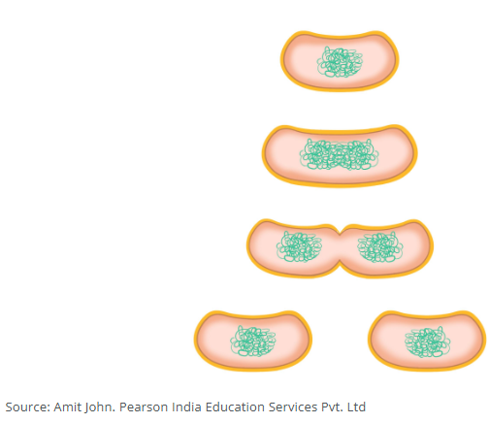

**Real World Examples:**

1. Potatoes reproduce using _________, which grow from the potato’s eyes.
2. People who breed plants like these want all plants to be identical. The plants are bred for their appearance, and they must be consistent in appearance to meet customers’ expectations. Using __________ __________ they can be sure to get identical plants because the genes of the offspring will be identical to the parent.

**Guided Notes: Asexual and Sexual Reproduction**

**Big Idea:** The main idea of this lesson is to compare _________ and _________ reproduction.

**Key Concepts:**

* _________ _________ - the production of offspring from one parent
* _________ _________ - the production of offspring from two parents
* _________ - egg or sperm cells
* Sexual reproduction creates more _________ _________.

**Real World Examples:**

1. The sandhill crane reproduces sexually, which gives its offspring greater _________ _________ since it receives genetic information from two parents instead of one.
2. The starfish can reproduce asexually through _________, which does not require gametes to combine and can result in more offspring.

**Guided Notes: Modeling Sexual Reproduction**

**Big Idea:** The main idea of this lesson is to explain why sexual reproduction leads to offspring with _________ _________.

**Key Concepts:**

* _________ _________ - the fusion of an egg and a sperm
* _________ _________ - the production of an identical genetic copy of a parent
* _________ - variations of genes
* _________ - a variant form of a gene
* _________ _________ is the result of offspring receiving genetic information from two parents.
* _________ _________ - traits such as eye color, hair color, and skin color which are inherited
* _________ _________ - an allele that is dominant over another allele for a particular trait

**Real World Examples:**

1. Sarah has blue eyes, even though both her parents have brown eyes. This is because Sarah's parents each carry an _________ for blue eyes.
2. Hwan was born with a rare form of eye cancer called retinoblastoma (RB), even though neither of his parents had it. This is because genetic diseases like RB can _________ generations before appearing again.