Contents
Physical Science B
Force and Work
Force and Work Relationships
Pulleys and Incline Planes
Levers
Efficiency of Machines
Force and Work Practice
Force and Work Unit Test
Gravity
Gravitational Force, Attraction, and Mass
Investigating Gravity
Analyzing Gravitational Data
Gravity and Air Resistance
Gravity Practice
Gravity Unit Test
Energy of Motion
Kinetic and Potential Energy
Factors that Affect Kinetic Energy
Predicting Changes in Kinetic Energy
Potential Energy of a System
Energy Transfer and Kinetic Energy
Using Potential and Kinetic Energy
Conservation of Mechanical Energy
Energy of Motion Practice
Energy of Motion Unit Test
Energy and Forces
Two Object Interaction
Stored Energy Changes I
Stored Energy Changes II
Cause and Effect
Energy of Four Forces
Energy and Forces Practice
Energy and Forces Unit Test
Thermal Energy
Kinetic and Thermal Energy
Matter and Temperature Quick Check
Energy Transfer and Temperature
Kinetic Energy
Thermal Energy Transfer
Thermal Energy Practice
Thermal Energy Unit Test
Non-Contact Forces
Strength of Electrical Forces
Conductors and Insulators
Electrical Energy Properties
Electrical Circuits
Strength and Magnetic Forces
Non-Contact Forces Practice
Non-Contact Forces Unit Test
Waves
Lens and Mirrors
Wave Characteristics
Sound and Wave Phenomena
Beat Frequency
Characteristics of Waves
Frequency and Wavelength
The Speed of Sound
Waves in Different Media
Wavelength in Different Media
Wave Application
Digital and Analog Systems
Pros and Cons of Digital Systems
Waves Practice
Waves Unit Test
Semester Review and Exam
Semester Practice
Semester Exam

Physical Science B

Force and Work

Force and Work Relationships
What is the mathematical relationship between force and work?
Responses
- W= $\frac{F}{d}$
- W=F×a
- W×d=F
- W=F×d

If W=F×d, which of the following equations shows work being calculated using the correct units?
Responses
- 113 N=(17.4 J)×(6.51 m)
- 113 J=(17.4 N)×(6.51 m
- 113 N=(17.4 J)×(6.51 ft)
- 113 J=(17.4 N)×(6.51 ft)

A force of 57.1 Newtons is applied for 0.977 meters; what work was done on the object?
Responses
- 58.4 J
- 55.8 J
- 58.1 J
- 56.1 J

A car applies a force of 36.8 Newtons for a 668-meter loop; what was the work done?
Responses
- 24,600 J
- 18.2 J
- 705 J
- 0 J

A 8.43-Newton force was applied for an unknown displacement; however, it is known that 376 joules of work was done. What is the value of the mystery displacement?
Responses
- 44.6 m
- 384 m
- 3170 m
- 368 m

Pulleys and Incline Planes
How can you calculate the mechanical advantage a simple machine provides?
Responses
- divide the output displacement by the input displacement
- Simple machines do not provide a mechanical advantage.
- divide the output force by the output displacement
divide the output force by the input force

How can a simple fixed pulley make a job easier?
Responses
- by decreasing the force required to lift the object
- by decreasing the work done
- by changing the direction at which the force needs to be applied
- by decreasing the distance that the force needs to be applied

A pulley system has a mechanical advantage of 3, and an object weighing 9 Newtons must be lifted 15 meters. How much force must be applied to lift the object? Use the following equation to find the answer: MA = F_{o}/F_{i}
Responses
- 3 N
- 1.7 N
- 0.3 N
- 27 N

How is the work energy theorem represented as an equation?
Responses
- W = E
- ΔW = E
- ΔW = ΔE
- W = ΔE

A simple machine increases the distance that a force needs to be applied from 3 meters to 27 meters, and the work done is 216 Joules. How much force is applied?
Responses
- 81 N
- 9 N
- 72 N
- 8 N

Levers
A class __ lever never has a mechanical advantage. A class __ lever always has a mechanical advantage. A class __ lever could go either way.
Responses
- 2; 3; 1
- 2; 1; 3
- 3; 2; 1
- 1; 2; 3
A lever is used to lift an object with a weight of 60 Newtons. The effort force is 15 mete from the fulcrum, while the load force is 5 meters from the fulcrum. What is the mechanical advantage?
Responses
- 12
- 75
- 3
- 4

With which class of levers is it possible to increase the force that must be applied?
Responses
- Class 1 and 2
- Class 3 and 4
- Class 2 and 3
- Class 1 and 3

600 Joules of work is used to lift a box from the ground to a height of six meters. How much work would have been done if a lever would have been used with an effort arm of 12 meters and a load arm of meters?
Responses
- 50 J
- 100 J
- 72 J
- 600 J

A lever with an effort arm of 10 meters and a load arm of 2 meters used to lift an object weighing 220 Newtons to a height of 4 meters. If 400Joules of work is done, how much force must have been applied?
Responses
- 800 N
- 100 N
- 1600 N
- 4000 N

Efficiency of Machines
Which is the equation for a machine’s efficiency?
Responses
- $$Efficiency =\frac{output energy}{input energy }∙ 100$$
- $$Efficiency =input energy + output energy$$
- $$Efficiency =\frac{input energy}{output energy }∙ 100$$
- $$Efficiency =input energy − output energy$$

A rotating space heater used 1,400 joules of energy while heating a room. Of that total, 896 joules produced thermal energy, 181 joules produced kinetic energy, 203 joules produced light energy, and 120 joules produced sound energy. What is the space heater’s efficiency?
Responses
- 64%
- 56.25%
- 156.25%
- 36%

Lenore is on an inclined plane next to her truck. Holding her hands steady, she pushes a box up the plane and into her truck. Where can energy be lost?
Responses
- Friction between the truck and the inclined plane.
- Friction between the box and the inclined plane.
- Friction between Lenore’s hands and the box.
- Friction between Lenore and the ground.

Ronald pushes a box up an inclined plane with 35% efficiency. If 224 joules of energy went into moving the box, how much energy did Ronald put into the inclined plane?
Responses
- 145.6 joules
- 640 joules
- 78.4 joules
- 189 joules
1000 joules of energy are put into a pulley system, and 400 joules come out. What does the Law of Conservation of Energy imply about the lost energy?
Responses
- The lost energy is not truly lost, but it changed into a different form.
- The pulley system could be improved to conserve some of the lost energy.
- The lost energy is caused by friction
- The lost energy cannot be recovered.

Force and Work Practice
A bowling ball is rolling down a lane at a bowling alley. How can you know that a force has acted on the bowling ball?
Responses
- by timing how long the bowling ball takes to reach the end of the lane
- by measuring the mass of the bowling ball
- by determining a change in the direction of the bowling ball as it rolls down the alley
- by determining the direction of the bowling ball
What is the advantage of using a simple machine to do work?
Responses
- A simple machine reduces the time needed to do the work.
- A simple machine reduces the work that has to be done.
- A simple machine reduces the displacement required to do the work.
- A simple machine reduces the force needed to do the work.
Students measure how much work it takes to lift an object two meters. They use an inclined plane that is 3 meters long, an inclined plane that is 4 meters long, and a compound pulley. Which statement is correct?
Responses
- The 3-meter plane will require the least amount of work.
- The compound pulley will require the least amount of work.
- The 4-meter plane will require the least amount of work.
- All three simple machines will require the same amount of work.
What is the advantage of using an inclined plane to move boxes into a truck?
Responses
- You will use less force.
- You will walk less distance.
- You will use less energy.
- You will need to do less work.
How can the mechanical advantage of a lever be calculated?
Responses
- Divide the output distance by the input distance.
- Divide the length of the load arm by the length of the effort arm.
- Divide the input force by the output force.
- Divide the length of the effort arm by the length of the load arm.
A student makes a class 1 lever to lift a box, but he finds that he cannot apply enough force to lift the box. How can he modify the lever to reduce the amount of force he needs?
Responses
- He can lengthen the part of the lever he pushes on.
- He can shorten the part of the lever he pushes on.
- He can use a taller fulcrum.
- He can lengthen the part of the lever bearing the load.
Using a class 1 lever, students lift a bucket of water 0.3 meters. They push on the lever a distance of 1.8 meters. If they use 312 Newtons of force, how much force would they need to lift the bucket without the lever?
Responses
- 561.6 N
- 93.6 N
- 1,872 N
- 52 N
Which equation shows the relationship between work and energy?
Responses
- W = ΔE
- W = $$E_{o}+E_{i}$$
- W = $$E_{o}×E_{i}$$
- W = $$\frac{E_{o}}{E_{i}}$$
A gardener uses a lever to pry a rock out of the ground. She presses the lever down 0.9 meters and applies 30 Newtons of force. How much work does she do?
Responses
- 29.1 J
- 30.9 J
- 270 J
- 27 J
A robot vacuum cleaner cleans the Potters’ front room. Which is the vacuum cleaner’s useful output energy?
Responses
- electric energy that recharges the robot’s battery
- thermal energy that warms the robot
- kinetic energy that moves the robot and its brush
- sound energy that makes a whirring noise

A worker uses a pulley to lift a bale of hay from a truck into a barn. If she expends 390 Joules of energy, and 358 Joules lift the box, what is the pulley’s efficiency?
Responses
- 108.9%
- 0.918%
- 8.2%
- 91.8%
Nadia pushes a box up an inclined plane. She expends 2,000 Joules of energy, but only 1,540 Joules are applied to the box. What happens to the other 460 Joules of energy?
Responses
- They are transferred to another simple machine.
- They are transferred back into Nadia.
- They are converted to other forms of energy.
- They are destroyed.
Students invent a game that uses a lever to flip beanbags toward a target. How could they make the lever more efficient?
Responses
- Use lighter beanbags.
- Use a fulcrum with a sharper point.
- Use a taller fulcrum.
- Make the target larger.

Force and Work Unit Test
What is the relationship among force, mass, and acceleration?
Responses
- Force equals mass times acceleration.
- Force equals mass minus acceleration.
- Force equals mass plus acceleration.
- Force equals mass divided by acceleration.
Anne exerts a force of 34.1 N to pitch a softball. She moves the ball 1.8 meters before releasing it. What amount of work did Anne do on the ball?
Responses
- 35.9 J
- 32.3 J
- 18.9 J
- 61.38 J
Which equation can you use to calculate the mechanical advantage of a simple machine?
Responses
- $$MA=\frac{∆x_{o}}{∆x_{i}}$$
- $$MA=∆x_{i}−∆x_{o}$$
- $$MA=\frac{∆x_{i}}{∆x_{o}}$$
- $$MA=∆x_{i}×∆x_{o}$$
Harold uses an inclined plane to move a washing machine from the sidewalk into his house. The vertical distance from the sidewalk to the house is 0.8 meters. If the plane has a mechanical advantage of 2.3, how long is the plane?
Responses
- 1.84 m
- 0.35 m
- 3.1 m
- 1.5 m
Sarah uses an inclined plant to load a chest into her truck. If she does 84 Joules of work, and the inclined plane is 3 meters long, how much force does she expend?
Responses
- 87 N
- 252 N
- 81 N
- 28 N
Alan will use a compound pulley to lift a crate from the floor of his garage to a storage shelf. The shelf is 3.5 meters above the floor. Alan pulls 10.5 meters of rope to lift the crate. Which statement is correct?
Responses
- Alan uses three times the force he would have used without the compound pulley.
- Alan will save work by using the compound pulley.
- Alan uses the same amount of force with the compound pulley as he would without it.
- Alan uses one-third the force he would have needed without the compound pulley.
To directly lift a crate 0.6 meters, Joaquin would need to apply 312 newtons of force. Instead, he uses a lever with a mechanical advantage of 3 to lift the crate. How much force does he save by using the lever?
Responses
- 208 N
- 104 N
- 936 N
- 309 N
Samantha builds a lever to lift objects in a science experiment. The load arm is 0.4 meters. If she wants the lever to have a mechanical advantage of 8, how long should the effort arm be?
Responses
- 0.05 m
- 3.2 m
- 8.4 m
- 7.6 m
Luisa uses a nutcracker to crack walnuts. She has to squeeze the handles 12 centimeters to crack a walnut. The part of the arms holding the walnut only move 0.3 centimeters. If Luisa applies 21 Newtons of force to crack the walnut, how much force would she need without the nutcracker?
Responses
- 61 N
- 0.525 N
- 840 N
- 84 N
Mark needs to clean up a broken glass on the floor. He can use a hand brush or a broom. Why should he choose the broom?
Responses
- He will have to move the broken glass less distance with the broom than he would with the brush.
- He will use less force with the broom than he would with the brush.
- He will do less work with the broom than he would with the brush.
- He will apply force to the broom over a shorter distance than he would to the brush.
Which statement about simple machines is correct?
Responses
- Simple machines always increase the distance that force is applied to do work.
- Simple machines increase the amount of work done.
- Simple machines do not change the amount of work done.
- Simple machines always reduce the force needed to do move a load.
What happens when you use a lever to lift a box?
Responses
- The lever transfers mechanical energy from the fulcrum to box.
- You use force to transfer mechanical energy into the lever, which transfers the energy to the box.
- You use force from the lever to lift the box.
- The lever reduces the amount of mechanical energy stored in the box.
What is the mathematical representation of a machine’s efficiency?
Responses
- $$Efficiency=\frac{E_{i}}{E_{o}}$$
- $$Efficiency=\frac{E_{o}}{E_{i}100}$$
- $$Efficiency=\frac{E_{i}}{E_{o}}100$$
- $$Efficiency=\frac{Eo}{E_{i}}100$$
Larry uses a lever to lift a box. Where does inefficiency occur in the lever?
Responses
- where Larry applies force to the bar
- under the feet of Larry
- where the fulcrum touches the bar
- where the box is placed
Which is the best statement of the Law of Conservation of Energy?
Responses
- The amount of energy put out by a simple machine must equal the amount of energy put into the machine.
- The amount of energy put out by a simple machine depends on its efficiency.
- The amount of energy put out by a simple machine is always less than the amount of energy put into the machine.
- The amount of energy put into a simple machine should be conserved.
In 1–2 sentences, explain how to calculate the efficiency of a toaster.
Responses
Free response
A student uses a pulley to lift a log. In 1–2 sentences, explain how she can calculate the pulley’s efficiency.
Responses
Free response
In 1–2 sentences, describe an efficient simple machine.
Responses
Free response

Gravity

Gravitational Force, Attraction, and Mass
What information is needed to calculate the gravitational force of an object?
Responses
- the mass of the two objects
- the distance between the two objects
- the mass of the object subtracted from the distance between the object and the planet’s core
- the mass of the object and the planet’s gravitational acceleration
When interplanetary space travel becomes viable, doctors may suggest to people with arthritis that they vacation on a planet with lower gravitational attraction and do more walking. The gravitational acceleration on Earth is 9.8 m/s², while the gravitational acceleration on Mars is 3.7 m/s². How much less force would the vacationer be applying to their joints when walking on Mars?
Responses
- 2.6 times less force
- 6.1 times less force
- 36.26 times less force
- 13.5 times less force
Which of the following is true about the relationship between the gravitational force of Earth and the Moon?
Responses
- The Moon has a greater gravitational attraction than the Earth.
- The Earth has a greater gravitational attraction than the Moon.
- The Earth has no impact on the gravitational attraction of the Moon.
- The Earth has identical gravitational attraction to that of the Moon.
A high school athlete is in the weight room training for wrestling season. He is trying to bench press a bar loaded with 100 kg. How much force must he exert to lift the loaded bar and overcome the force of gravity? Remember that a= 9.8 m/s².
Responses
- 980 N
- 109.8 N
- 10.2 N
- 9800 N
A group of extraterrestrial athletes travel from the Moon to Earth to train. How would the amount of force they exert to move change on Earth?
Responses
- The force needed to move on the Earth is less than the force needed to move on the moon.
- The force would need to be greater, so they would not perform as well.
- The force needed would be less, so they would perform at a higher level.
- The force would be the same.

Investigating Gravity
Which statement about mass is correct?
Responses
- The mass in an object is variable.
- Mass is measured in Newtons (N).
- Mass is a force that attracts objects toward each other.
- Mass is the measure of the amount of matter in an object.
A student designs a gravity experiment. She will time how long it takes different objects to fall from her school’s roof to the ground. She will use three objects: a 2-foot-long board, a toy car, and a paper bag. What is wrong with her experiment’s design?
Responses
- Gravity will not affect how long it takes for the objects to fall to the ground.
- The objects do not have the same size, shape, or mass, so any differences in drop times cannot be attributed to one variable.
- The experiment does not test enough objects.
- The school roof is not tall enough to test the effect of gravity on different objects.
Which statement about gravity is correct?
Responses
- Gravity varies with the size of an object.
- Gravity varies with the mass of an object.
- Gravity is a measure of an object’s matter.
- Gravity is a force that attracts objects with mass toward each other.
A team of students performs an experiment to test the effect of gravity on different objects with the same mass. They measure how long it takes the objects to fall from the top of the school’s bleachers. How can they ensure they get accurate data?
Responses
- by repeating the experiment several times
- by dropping the objects in random order
- by using a high-tech stopwatch
- by dropping all the objects at once
Students analyze their data from a gravity experiment. They find that objects fall at a greater speed from a greater height than from a lower height. What can they conclude?
Responses
- The longer an object falls, the greater its mass.
- Students must have mismeasured the objects’ drop times.
- The longer an object falls, the more gravity increases its speed.
- The experiment must have a design flaw.

Analyzing Gravitational Data
Melissa is working on the roof of her house. She drops a hammer and a nail. Why do both objects hit the ground at the same time?
Responses
- Earth’s gravity causes both objects to fall at the same rate.
- Drag causes both objects to fall at the same rate.
- Air resistance causes both objects to fall at the same rate.
- Velocity causes both objects to fall at the same rate.
Which of the following statements about gravitational mass is true?
Responses
- The more mass an object has, the more gravitational acceleration it will experience.
- The less mass an object has, the less gravitational acceleration it will experience.
- Gravitational acceleration is always equal to mass.
- Gravitational acceleration is irrespective of mass.
Two objects fall from an apartment windowsill at the same time. Object 1 lands on the sidewalk in 3.6 seconds. Object 2 lands on the sidewalk in 3.3 seconds. What can be concluded about the objects?
Responses
- Object 1 has less surface area than Object 2.
- Object 2 weighs less than Object 1.
- Object 1 has more surface area than Object 2.
- Object 2 has more mass than Object 1.
A company uses drones to fly food to people in regions that have experienced natural disasters. The food is packed in boxes that are attached to parachutes. How can the company change the design of its parachute to reduce the number of boxes that are damaged when they hit the ground?
Responses
- The company can design a heavier parachute.
- The company can design a parachute with more surface area.
- The company can design a smaller parachute.
- The company can design a lighter parachute.
Students want to design an experiment to study gravity. They decide they will drop four objects with the same mass from the top of their school’s bleachers. They will time how long each object takes to reach the ground. How can they improve confidence in the experiment’s results?
Responses
- Drop each object 10 times and use the average of each object’s fall times.
- Drop all four objects at once.
- Randomly select the order in which the objects are dropped.
- Let a different student time the drop of each object.

Gravity and Air Resistance
What happens when a falling object reaches terminal velocity?
Responses
- It stops accelerating.
- It hits the ground and stops.
- It slows down.
- It speeds up.
How does a falling object’s surface area affect calculations of terminal velocity?
Responses
- The greater the object’s surface area, the more air resistance it encounters.
- The greater the object’s surface area, the greater its terminal velocity.
- Surface area does not affect an object’s terminal velocity.
- The greater the object’s surface area, the greater the air density.
Which is the equation for terminal velocity?
Responses
- $$V_{t}=\sqrt{\frac{w}{2dAC_{d}}}$$
- $$V_{t}=\sqrt{\frac{2m}{dAC_{d}}}$$
- $$V_{t}=\sqrt{\frac{dAC_{d}}{2w}}$$
- $$V_{t}=\sqrt{\frac{2w}{dAC_{d}}}$$
A ball falls from a tall bridge. The ball has a mass of 0.15 kg. The air density is 1.225 kg/m². The ball’s surface area is 0.0026 m². The ball’s coefficient of drag is 0.007. What is the ball’s terminal velocity?
Responses
- 164 m/s
- 402 m/s
- 363 m/s
- 30.4 m/s
Hanna wants to calculate the terminal velocity of a typical meteorite just before it hits Earth. She researches meteorites at the library and on the internet. What information does she need to find?
Responses
- a typical meteorite’s mass and average velocity
- a typical meteorite’s weight, surface area, and coefficient of drag; air density close to Earth
- a typical meteorite’s surface area and coefficient of drag; air density close to Earth
- a typical meteorite’s weight, surface area, and coefficient of drag

Gravity Practice
Why would the weight of a landing module be different on different planets?
Responses
- Planets have different diameters.
- The landing module’s mass is different on different planets.
- Gravitational force is different on different planets.
- Planets are different distances from the Sun.
Astronauts collected a lunar rock with a mass of 73 grams. What was the rock’s weight when they brought it back to Earth?
Responses
- 0.007 N
- 715 N
- 0.118 N
- 0.715 N
A gardener needs to load a lawnmower into a truck. The lawnmower has a mass of 146 kilograms. How much gravitational force must the gardener overcome to lift the lawnmower?
Responses
- 14.9 N
- 155.8 N
- 1,430.8 N
- 136.2 N
Which statement about gravitational force is correct?
Responses
- For gravitational force to affect two objects, they must be near each other.
- Any two objects in the universe exert gravitational force on each other.
- Gravitational force only affects the objects within the solar system.
- Only objects on the surface of a planet or a moon experience gravitational force.
Which statement best describes the relationship between gravity and mass?
Responses
- Mass is a kind of gravity that attracts objects toward each other.
- Gravity is a force that attracts objects with mass toward each other.
- Gravity is a measure of the mass in objects.
- Gravity and mass are forces that attract objects toward each other.
Students set up an experiment to test the effect of gravity on different objects. They fill balloons with different amounts of water and drop them from the third-floor window of their school. They time how long each balloon takes to reach the ground. They repeat the process three times. What is the experiment’s variable?
Responses
- height of the window
- mass of the balloons
- number of times the drops were repeated
- times that the balloons take to drop
Stephen is on a ladder picking apples from a tree. He grabs for two apples but misses them. They fall and hit the ground at the same instant. What can Stephen conclude?
Responses
- Gravity causes both apples to fall at the same rate.
- Air resistance must not affect the apples.
- The apples must have the same mass.
- The apples must have the same weight.
At the end of its flight, a toy rocket begins to fall to Earth. When will it reach terminal velocity?
Responses
- when the force of gravity on the rocket is greater than the force of air resistance
- as soon as the rocket’s trajectory turns downward
- when the rocket stops accelerating downward
- when the rocket hits the ground
How does air density affect the terminal velocity of a skydiver?
Responses
- Air density does not affect the terminal velocity of a skydiver.
- Air density decreases closer to the ground, so it will reduce the skydivers’ terminal velocity less as she approaches the ground.
- Air density is constant, so it will not affect the skydiver’s terminal velocity.
- Air density increases closer to the ground, so it will reduce the skydiver’s terminal velocity more as she approaches the ground.
A piece of hail has a mass of 0.08 kilograms. It presents an area of 0.0014 square meters, and has a drag coefficient of 0.4. Air density near the ground is 1.225 kilograms per cubic meter. What is the hail’s terminal velocity as it approaches the ground? $$V^{t}=\sqrt{\frac{2w}{ρAC_{d}}}$$
Responses
- 30.2 meters per second
- 15.3 meters per second
- 47.7 meters per second
- 2,274 meters per second

Gravity Unit Test
What is the equation for finding the gravitational force of an object?
Responses
- $$F=m+g$$
- $$F=\frac{m}{g}$$
- $$F=m\frac{m}{s_{2}}$$
- $$F=mg$$
An astronaut has a mass of 59 kilograms. What will her gravitational force be on the Moon? The gravitational attraction on the Moon is 1.62 m/s₂.
Responses
- 95.58 N
- 36.42 N
- 578.2 N
- 60.62 N
Which statement best describes the gravitational force of an object?
Responses
- The greater the object’s mass and the closer it is, the greater its gravitational force.
- The object only has gravitational force when it is on the surface of a massive body, such as Earth.
- The farther away an object is, the greater its gravitational force will be.
- The greater the object’s mass, the less its gravitational force will be.
On Earth, the gravitational force of a robotic helicopter is 17.65 N. What is the helicopter’s gravitational force on Mars? On Earth, g = 9.8 m/s_{2.} On Mars, g = 3.71 m/s₂.
Responses
- 6.68 N
- 2.64 N
- 0.49 N
- 17.64 N
Marcus wants to test the effect of gravity on objects with different masses. He drops two footballs from a first-floor window, a second-floor window, and a third-floor window. In each case, he times how long it takes the footballs to reach the ground. What is wrong with his experiment’s design?
Responses
- The windows are not high enough to show significant differences in drop times.
- It does not include objects with different masses.
- It does not include objects with different shapes.
- The drops are not repeated.
An astronaut drops two pieces of paper from the door of a lunar landing module. One piece of paper is crumpled, and the other piece is folded into an airplane. Why do the two pieces of paper land on the Moon’s surface at the same time?
Responses
- The Moon’s gravity is much weaker than Earth’s.
- The pieces of paper were not dropped from a sufficient height for air resistance to affect their falls.
- The Moon has practically no atmosphere, so there is no air resistance.
- The mass of the paper folded into an airplane must be greater than the mass of the crumpled paper.
Why doesn’t an object falling from an airplane continue to accelerate?
Responses
- Hitting the ground stops the object’s acceleration.
- Gravity’s force diminishes as the object nears the ground.
- The object’s weight varies as it nears the ground.
- Air resistance on the object will eventually equal the force of force of gravity.
Which of the following descriptions best describes all of the factors that need to be considered when determining an object’s terminal velocity?
Responses
- the object’s weight, length, and width
- the object’s weight and area it presents
- air density and the object’s drag coefficient
- the object’s weight and area it presents, as well as air density
In 1–2 sentences, outline how you could test the effect of gravity on objects with different masses.
Responses
Free response
In 1–2 sentences, explain why two objects with the same mass, when dropped from the same height, may not reach the ground at the same time.
Responses
Free response

Energy of Motion

Kinetic and Potential Energy
Which object has potential energy?
Responses
- unlit lightbulb
- stereo speaker
- can of gasoline
- rock on the ground
Which statement about energy is correct?
Responses
- Energy can be classified as one of three types: potential energy, kinetic energy, and chemical energy.
- Energy can be created in a power plant.
- Energy is destroyed when a car uses gasoline.
- Energy can be changed from one form to another.
Which object has kinetic energy?
Responses
- electric heater
- soccer ball flying through goalposts
- apple in a tree
- battery in a remote-control car
Teresa wants to explore the relationship between kinetic energy and potential energy. How could she use innovative problem-solving?
Responses
- Study the relationship between kinetic and potential energy in her science textbook.
- Find an example of kinetic and potential energy in her own life and create an experiment to illustrate their relationship.
- Follow the instructions of her science teacher for performing an experiment about kinetic and potential energy.
- Search the internet for ways to show the relationship between kinetic and potential energy
Which scenario shows an object gaining potential energy and losing kinetic energy?
Responses
- roller-coaster car slowing as it moves up a hill
- roller-coaster car stopped while it picks up passengers
- roller-coaster car slowing to a stop to pick up passengers
- roller-coaster car accelerating as it moves down a hill

Factors that Affect Kinetic Energy
Which is the equation for an object’s kinetic energy?
Responses
- $$KE=2m^{2}v$$
- $$KE=2mv^{2}$$
- $$KE=\frac{1}{2}mv^{2}$$
- $$KE=\frac{1}{2}m^{2}v$$
A comet speeds up as it approaches the Sun. Which statement about its kinetic energy is correct?
Responses
- The comet’s kinetic energy decreases.
- The comet’s kinetic energy stays the same.
- The comet has no kinetic energy because it is in outer space.
- The comet’s kinetic energy increases.
A student rides her bicycle down a hill. Together, she and the bicycle have a mass of 56 kilograms. She is moving at 11 meters per second. What is her kinetic energy?
Responses
- 6,776 J
- 17,248 J
- 13,552 J
- 3,388 J
Mark is conducting an experiment to show how an object’s kinetic energy is affected by its mass and velocity. First, he lets an empty wagon roll down a hill and calculates its kinetic energy. Next, he repeats the experiment after placing a bag of sand in the wagon. Which is the best prediction for the second part of his experiment?
Responses
- The wagon will have less kinetic energy than when it was empty.
- The wagon will have less velocity than when it was empty.
- The wagon will have more kinetic energy than when it was empty.
- The wagon will have the same amount of kinetic energy as when it was empty.
How could you use creative thinking to show the relationship between velocity and kinetic energy?
Responses
- Read about kinetic energy in your science textbook and highlight sentences in the book that seem important.
- Find two objects with the same mass and think of a way to demonstrate their kinetic energies at different velocities.
- Write down and perfectly follow your teacher’s instructions for performing the experiment.
- Research a kinetic energy experiment online and follow the steps exactly when performing the experiment.

Predicting Changes in Kinetic Energy
What does an object’s kinetic energy depend on?
Responses
- its weight and speed
- its mass and speed
- its speed and trajectory
- its potential energy
Two city buses are traveling at 24 miles per hour. The buses are the same model and year. One bus has 30 passengers. The other bus has 12 passengers. Which is the best prediction?
Responses
- The buses’ kinetic energies will depend on their routes.
- The buses will have the same amount of kinetic energy.
- The bus with 12 passengers will have less kinetic energy.
- The bus with 30 passengers will have less kinetic energy.
A softball player hits a ball at 78 miles per hour. Then she hits a ball at 80 miles per hour. Which is the best prediction?
Responses
- The ball hit at 78 miles per hour will have more kinetic energy.
- The balls will have the same amount of kinetic energy.
- The balls’ kinetic energies will depend on the distances they travel.
- The ball hit at 80 miles per hour will have more kinetic energy.
A hawk is chasing a sparrow. At the beginning of the chase, the hawk’s kinetic energy is 5.1 Joules. At the end of the chase, the hawk doubles its speed. What is the best prediction for its kinetic energy at the end of the chase?
Responses
- 2.55 J
- 20.4 J
- 10.2 J
- 5.1 J
A student rolls two marbles down an inclined plane. One marble has a mass of 4.8 grams. The student calculates its kinetic energy to be 0.0035 Joules when it reaches the end of the plane. The second marble has a mass of 2.4 grams. What is the best prediction for its kinetic energy at the end of the plane?
Responses
- 0.00175 J
- 0.007 J
- 0.014 J
- 0.0035 J

Potential Energy of a System
Which is the equation for an object’s potential energy?
Responses
- $$PE=mgh$$
- $$PE=mg^{2}h$$
- $$PE=\frac{1}{2}mgh$$
- $$PE=2mgh$$
In a baseball game, Joseph hits a ball to the outfield. When does the ball have the most potential energy?
Responses
- when the ball reaches its greatest velocity
- when the ball is caught
- when the ball reaches its highest point
- when the bat hits the ball
The roof of an apartment building is 58 meters high. A water tank on the roof has a mass of 38,000 kilograms. What is the potential energy of the water tank?
Responses
- 10,799,600 J
- 2,204,000 J
- 21,599,200 J
- 211,672,160 J

Which statement best describes an object’s potential energy?
Responses
- The object’s mass and height determine its potential energy.
- The object’s mass and velocity determine its potential energy.
- The object’s kinetic energy determines its potential energy.
- The object’s mass, gravity, and height determine its potential energy.
Which scenario shows how to use collaborative learning to explore potential energy?
Responses
- A teacher divides a class into teams, outlines a plan, and tells the teams how to carry out the plan.
- One student directs a team, assigning tasks to individual members.
- Members of a team work together to create a plan, and then members choose different tasks to carry out the plan.
- Members of a team work together to create a plan, and then one student does the work.

Energy Transfer and Kinetic Energy
Terry kicks a soccer ball that is sitting motionless on the field. What is the best description of the energy transfer?
Responses
- Kinetic energy in Terry’s foot is changed to potential energy in the soccer ball.
- Kinetic energy is transferred from the soccer ball to Terry’s foot.
- Kinetic energy is transferred from Terry’s foot to the soccer ball.
- Potential energy is transferred from Terry’s foot to the soccer ball.
Which of the following scenarios best shows the transfer of kinetic energy?
Responses
- a baseball player holds a baseball at their side
- a baseball sits on a bench
- a baseball bat strikes a baseball
- a baseball flies through the air
A bowling ball is traveling at 7.6 meters per second when it hits a pin. If the bowling ball has a mass of 6 kilograms, how much kinetic energy does it have when it hits the pin? $$KE=\frac{1}{2}mv^{2}$$
Responses
- 173.28 J
- 693.12 J
- 22.8 J
- 346.65 J
What happens when a tennis racket hits a ball?
Responses
- Potential energy in the racket is transferred to the ball.
- Kinetic energy is created.
- Kinetic energy is transferred from the racket to the ball.
- Kinetic energy is transferred from the ball to the racket.
A micrometeor has a mass of 0.005 grams. When it enters Earth’s atmosphere, it travels at 21,000 meters per second. What is its kinetic energy when it enters Earth’s atmosphere? $$KE=\frac{1}{2}mv^{2}$$
Responses
- 1,102,500 J
- 1,102.5 J
- 2,205 J
- 0.0525 J

Using Potential and Kinetic Energy
Which is the best description of potential energy?
Responses
- Objects’ potential energy can be destroyed if the chemical bonds are broken.
- All objects have potential energy stored in their chemical bonds and will have more potential energy when they are in motion.
- All objects have potential energy stored in their chemical bonds and will have more potential energy when they are positioned above Earth’s surface.
- Only some objects have potential energy stored in their chemical bonds
Nan’s suitcase has a mass of 14 kilograms. How much potential energy does it gain when she lifts it onto a bench that is 40 centimeters tall? $$PE=mgh$$
Responses
- 5,488 J
- 5.6 J
- 54.88 J
- 24.2 J
A baseball is sitting on a raised bench. A player accidentally knocks the baseball o the bench. Which statement best describes what will happen to the baseball’s energy during its fall?
Responses
- Most of the baseball’s potential energy will be converted to kinetic energy.
- All of the baseball’s potential energy will be converted to kinetic energy.
- The baseball will lose kinetic energy during its fall.
- None of the baseball’s potential energy will be converted to kinetic energy.
Nan’s suitcase is on a bench. The suitcase has a mass of 14 kilograms. Nan accidentally knocks the suitcase off the bench, and the suitcase falls at a speed of 2.7 meters per second. How much kinetic energy does the suitcase have just before it hits the floor? $$KE=\frac{1}{2}mv^{2}$$
Responses
- 51.03 J
- 102.06 J
- 204.12 J
- 18.9 J
Which factors does an object’s potential energy depend on?
Responses
- the object’s mass and height, and acceleration due to gravity
- the object’s mass and height
- the object’s mass, height, and kinetic energy
- the object’s mass and velocity

Conservation of Mechanical Energy
Ball A was carried to the top of a hill in a straight line, while ball B was carried in a longer, zigzag path. At the top of the hill, both balls were left at rest. A student draws a graph that depicts each ball's final potential energy. Which statement describes the final potential energy of the balls?
Responses
- Ball A has more potential energy.
- Neither ball has any potential energy.
- Ball B has more potential energy.
- Both balls have equal potential energy
A swimmer jumps from a diving board into a pool. What would a graph of the swimmer's potential energy and total mechanical energy look like?
Responses
- Potential energy would remain constant, while total mechanical energy would decrease.
- Potential energy would decrease, while total mechanical energy would remain constant.
- Potential energy would increase, while total mechanical energy would remain constant.
- Potential energy would remain constant, while total mechanical energy would increase.
A student wants to design an experiment to study the transformation of mechanical energy. Which object can be used to investigate how gravitational potential energy transforms into kinetic energy?
Responses
- a spring
- a slide
- a rug
- a flat race car track
A ball falls from a shelf. Assuming there is no friction, why is the conservation of mechanical energy independent of mass?
Responses
- The displacement of the ball is insignificant compared with Earth's size.
- Mass is eliminated when equating gravitational potential energy with kinetic energy.
- The mass of the ball is insignificant compared with the mass of Earth.
- Mass is eliminated when equating elastic potential energy with kinetic energy.
A marble is attached to a compressed horizontal spring and is then released. Which equation correctly shows the conservation of mechanical energy for this system?
Responses
- $$mgh=\frac{1}{2}kx^{2}$$
- $$\frac{1}{2}mv^{2}=kx^{2}$$
- $$\frac{1}{2}mv^{2}=\frac{1}{2}kx^{2}$$
- $$mgh=kx^{2}$$

Energy of Motion Practice
Which sentence best describes what happens when you turn on a light?
Responses
- Potential energy is changed into kinetic energy.
- Chemical energy is changed into electrical energy and light energy.
- Electrical energy is changed into light energy and thermal energy.
- Light energy is created.
Ellen drops a stick from her window. Which statement best describes the stick’s energy?
Responses
- The stick’s potential energy decreases while its kinetic energy increases.
- The stick’s potential energy is changed to thermal energy.
- The stick’s kinetic energy increases but its potential energy remains the same.
- The stick’s kinetic energy decreases while its potential energy increases.
Ms. Smith is driving her car to the store. She drives on a street where the speed limit is 35 mph. Then she turns onto a street where the speed limit is 30 mph. What happens to the kinetic energy of her car?
Responses
- When she slows from 35 mph to 30 mph, the car’s kinetic energy increases.
- When she slows from 35 mph to 30 mph, the car’s kinetic energy is changed to potential energy.
- When she slows from 35 mph to 30 mph, the car’s kinetic energy stays the same.
- When she slows from 35 mph to 30 mph, the car’s kinetic energy decreases.
A pitcher pitches a baseball at 91 miles per hour, which is equivalent to 40.7 meters per second. The ball has a mass of 145 grams. What is the ball’s kinetic energy? $$KE=\frac{1}{2}mv^{2}$$
Responses
- 3.0 J
- 120,095.5 J
- 1,656.5 J
- 120.1 J
When Jane falls, her skateboard rolls down a ramp at a speed of 2.6 meters per second. If the skateboard has a mass of 3 kilograms, how much kinetic energy does it have? $$KE=\frac{1}{2}mv^{2}$$
Responses
- 3.9 J
- 11.7 J
- 10.14 J
- 20.28 J
Which object has kinetic energy?
Responses
- person standing at the top of stairs
- person standing on an escalator
- marble sitting under a couch
- bird perched on telephone wire
Which object has potential energy?
Responses
- shovel on the ground
- acorn sitting on a roof
- soccer ball rolling across a field
- person walking down a hallway
Roberta puts a bucket of paint on top of a ladder. The bucket has a mass of 19 kilograms. The top of the ladder is 2.4 meters tall. How much potential energy does the bucket have? $$PE=mgh$$
Responses
- 45.6 J
- 446.9 J
- 21.4 J
- 31.2 J
Edgar and his cousin are driving bumper cars at an amusement park. When his cousin gets stuck in a corner, Edgar drives his car into his cousin’s car. The combined mass of Edgar and his bumper car is 268 kilograms. Edgar is traveling at 2.2 meters per second. How much kinetic energy does Edgar have when he hits his cousin’s car? $$KE=\frac{1}{2}mv^{2}$$
Responses
- 648.56 J
- 1,297.12 J
- 2,594.24 J
- 294.8 J
Which is an example of the transfer of kinetic energy?
Responses
- An air conditioner cools a room.
- A marble rolls into a corner.
- A student walks to school.
- A cat knocks a vase over.
Which is the formula for an object’s kinetic energy?
Responses
- $$KE=\frac{1}{2}mv^{}$$
- $$KE=mgh$$
- $$KE=\frac{1}{2}mv^{2}$$
- $$KE=2mv^{2}$$
A boulder sits on a steep mountain slope. After a heavy rain storm, the boulder rolls down the mountain. Which is the best prediction of the rock’s kinetic energy?
Responses
- The boulder’s kinetic energy will not be converted into potential energy.
- All of the boulder’s potential energy is converted to kinetic energy.
- A small portion of the boulder’s potential energy is converted to kinetic energy.
- Most of the boulder’s potential energy is converted into kinetic energy.

Energy of Motion Unit Test
A city gets its electricity from a dam, where water is stored in a reservoir. How does the water provide the city with its power?
Responses
- Mechanical energy in the water is transferred to turbines that spin a generator, which changes the mechanical energy into electricity.
- Potential energy in the water becomes kinetic energy as it moves through turbines, which turn kinetic energy into mechanical energy that spins a generator, which changes mechanical energy into electricity.
- Chemical energy in the water becomes thermal energy as it moves through turbines, which change thermal energy into electricity.
- Kinetic energy in the water becomes potential energy as the water moves through turbines, where kinetic energy becomes mechanical energy that spins a generator.
An acorn rolls off a roof and falls to the ground. Which statement best describes the change in energy?
Responses
- The acorn’s kinetic energy increases until it hits the ground.
- The acorn’s potential energy decreases as its kinetic energy increases.
- The acorn’s potential energy is changed to mechanical energy.
- The acorn’s potential energy and kinetic energy increase and decrease together.
An airplane carries 320 passengers from Phoenix to Los Angeles flying at an average speed of 490 miles per hour. On the return flight, the plane carries 164 passengers and travels at the same average speed. What happens to the plane’s kinetic energy?
Responses
- On the return flight, the plane has more kinetic energy.
- The plane’s kinetic energy is the same on both flights.
- The plane’s kinetic energy is changed to potential energy when it lands.
- On the return flight, the plane has less kinetic energy.
A racehorse is running at 42 miles per hour, equivalent to 18.8 meters per second. The horse and its jockey have a combined mass of 512 kilograms. How much kinetic energy do they have? $$KE=\frac{1}{2}mv^{2}$$
Responses
- 90,480.6 J
- 180.961.3 J
- 451,584.0 J
- 4,812.8 J
Which object has kinetic energy?
Responses
- bowling ball on a rack
- balloon rising in the sky
- water stored in a tank
- turtle resting on a log
Mr. Starr pushed a cart full of groceries to his car. After emptying the cart, he pushed it back to the store. He pushed the cart at a speed of 2 meters per second each way. Which is the best prediction?
Responses
- The cart had the same kinetic energy going each way.
- When it was full, the cart had less kinetic energy.
- The cart’s kinetic energy depends on Mr. Starr’s mass.
- When it was empty, the cart had less kinetic energy.
A student fires a toy rocket into the sky. When does the rocket have the most potential energy?
Responses
- when the rocket reaches its greatest velocity
- when the rocket hits the ground
- when the rocket has the most fuel
- when the rocket reaches its highest point
What is the best description of one billiard ball hitting a second billiard ball?
Responses
- Most of the kinetic energy in the first ball is transferred to the second ball.
- All of the kinetic energy in the first ball is transferred to the second ball.
- Potential energy is transferred from the first ball to the second ball.
- Kinetic energy in the second ball is transferred to the first ball.
A roller-coaster car is at the top of a hill. The car and its passengers have a combined mass of 1,088 kilograms. If the hill is 62 meters tall, how much potential energy does the car have? $$PE=mgh$$
Responses
- 67,456 J
- 661,068.8 J
- 1,159.8 J
- 330,534.4 J
A roller-coaster is at the top of a 62-meter hill. The car and its passengers have a total mass of 1,088 kilograms. By the time the car reaches the bottom of the hill, its speed is 74 miles per hour (33 meters per second). How much kinetic energy does the car have at the bottom of the hill? $$KE=\frac{1}{2}mv^{2}$$
Responses
- 1,184,832 J
- 17,952 J
- 592,416 J
- 2,978,944 J
A diagram is drawn showing a swing set with a swing pulled backward prior to release. The diagram shows how the swing will move forward and then backward after it is initially released. At which point in the diagram is all of the energy gravitational potential energy?
Responses
- just after release of the swing
- when the swing is pulled back prior to release
- at the highest point as the swing moves forward
- as the released swing begins moving backward
In 1–2 sentences, describe how a student could use collaborative learning to investigate potential energy.
Responses
Free response
In 1–2 sentences, explain how you could find the kinetic energy of a baseball when it hits a window.
Responses
Free response

Energy and Forces

Two Object Interaction
Why do two electrons repel when they interact
Responses
- because they both form part of different atoms
- because they both are subatomic particles
- because they both have similar negative electric charge
- because they both have similar mass
Which of the following has kinetic energy?
Responses
- a spring traveling down a flight of stairs
- a compressed spring
- a stretched spring
- a spring still at the top of a flight of stairs
When is the kinetic energy of an electron transformed into potential energy?
Responses
- when it interacts with neutrons, increasing its speed
- when it interacts with neutrons without changing its speed
- when it interacts with other electrons, decreasing its speed
- when it interacts with other electrons without changing its speed
Atoms bond to form molecules. Which structures or regions of the atoms interact in these bonds?
Responses
- electric fields of particles with negative charge
- electric fields of particles with opposite charges
- electric fields of particles with positive charge
- electric fields of particles with no charge
In particle accelerators such as the one shown, fields are employed to separate different subatomic particles. What type or types of fields are employed, and what characteristics do these particles need to have in order to be separated?
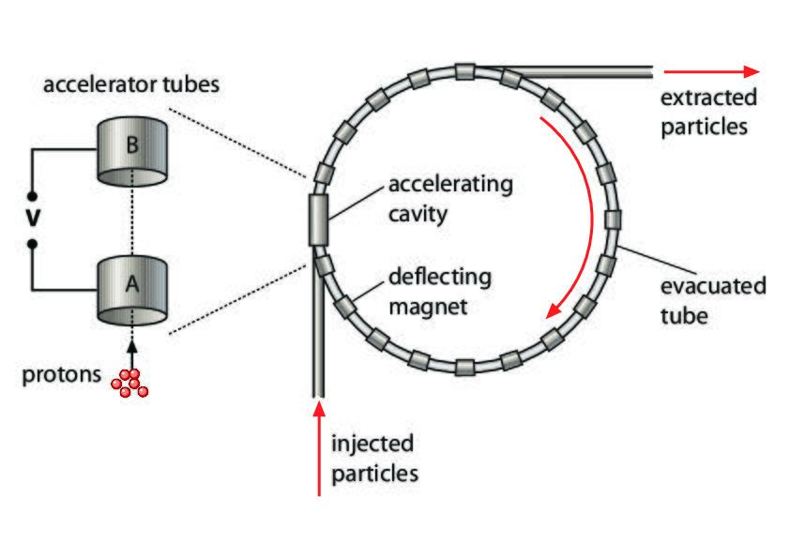
Responses
- Both electric and magnetic fields are applied. Particles need to have the same mass.
- Both electric and magnetic fields are applied. Particles need to be charged.
- Magnetic fields are applied. Particles need to lack charge.
- Electric fields are applied. Particles need to come from the same type of atom.

Stored Energy Changes I
A horseshoe magnet is moved toward a pile of iron shavings. The iron shavings divide and attach to both ends of the magnet. How does the kinetic energy of the system change?
Responses
- Kinetic energy increases because iron shavings move in the direction of magnetic force.
- Kinetic energy decreases because iron shavings move in the direction of magnetic force.
- Kinetic energy increases because iron shavings move in the opposite direction of magnetic force.
- Kinetic energy decreases because iron shavings move in the opposite direction of magnetic force.
Two bar magnets are held in place with their north poles facing each other. Both magnets are released at the same time. Which statement describing changes to the energy of the system is correct?
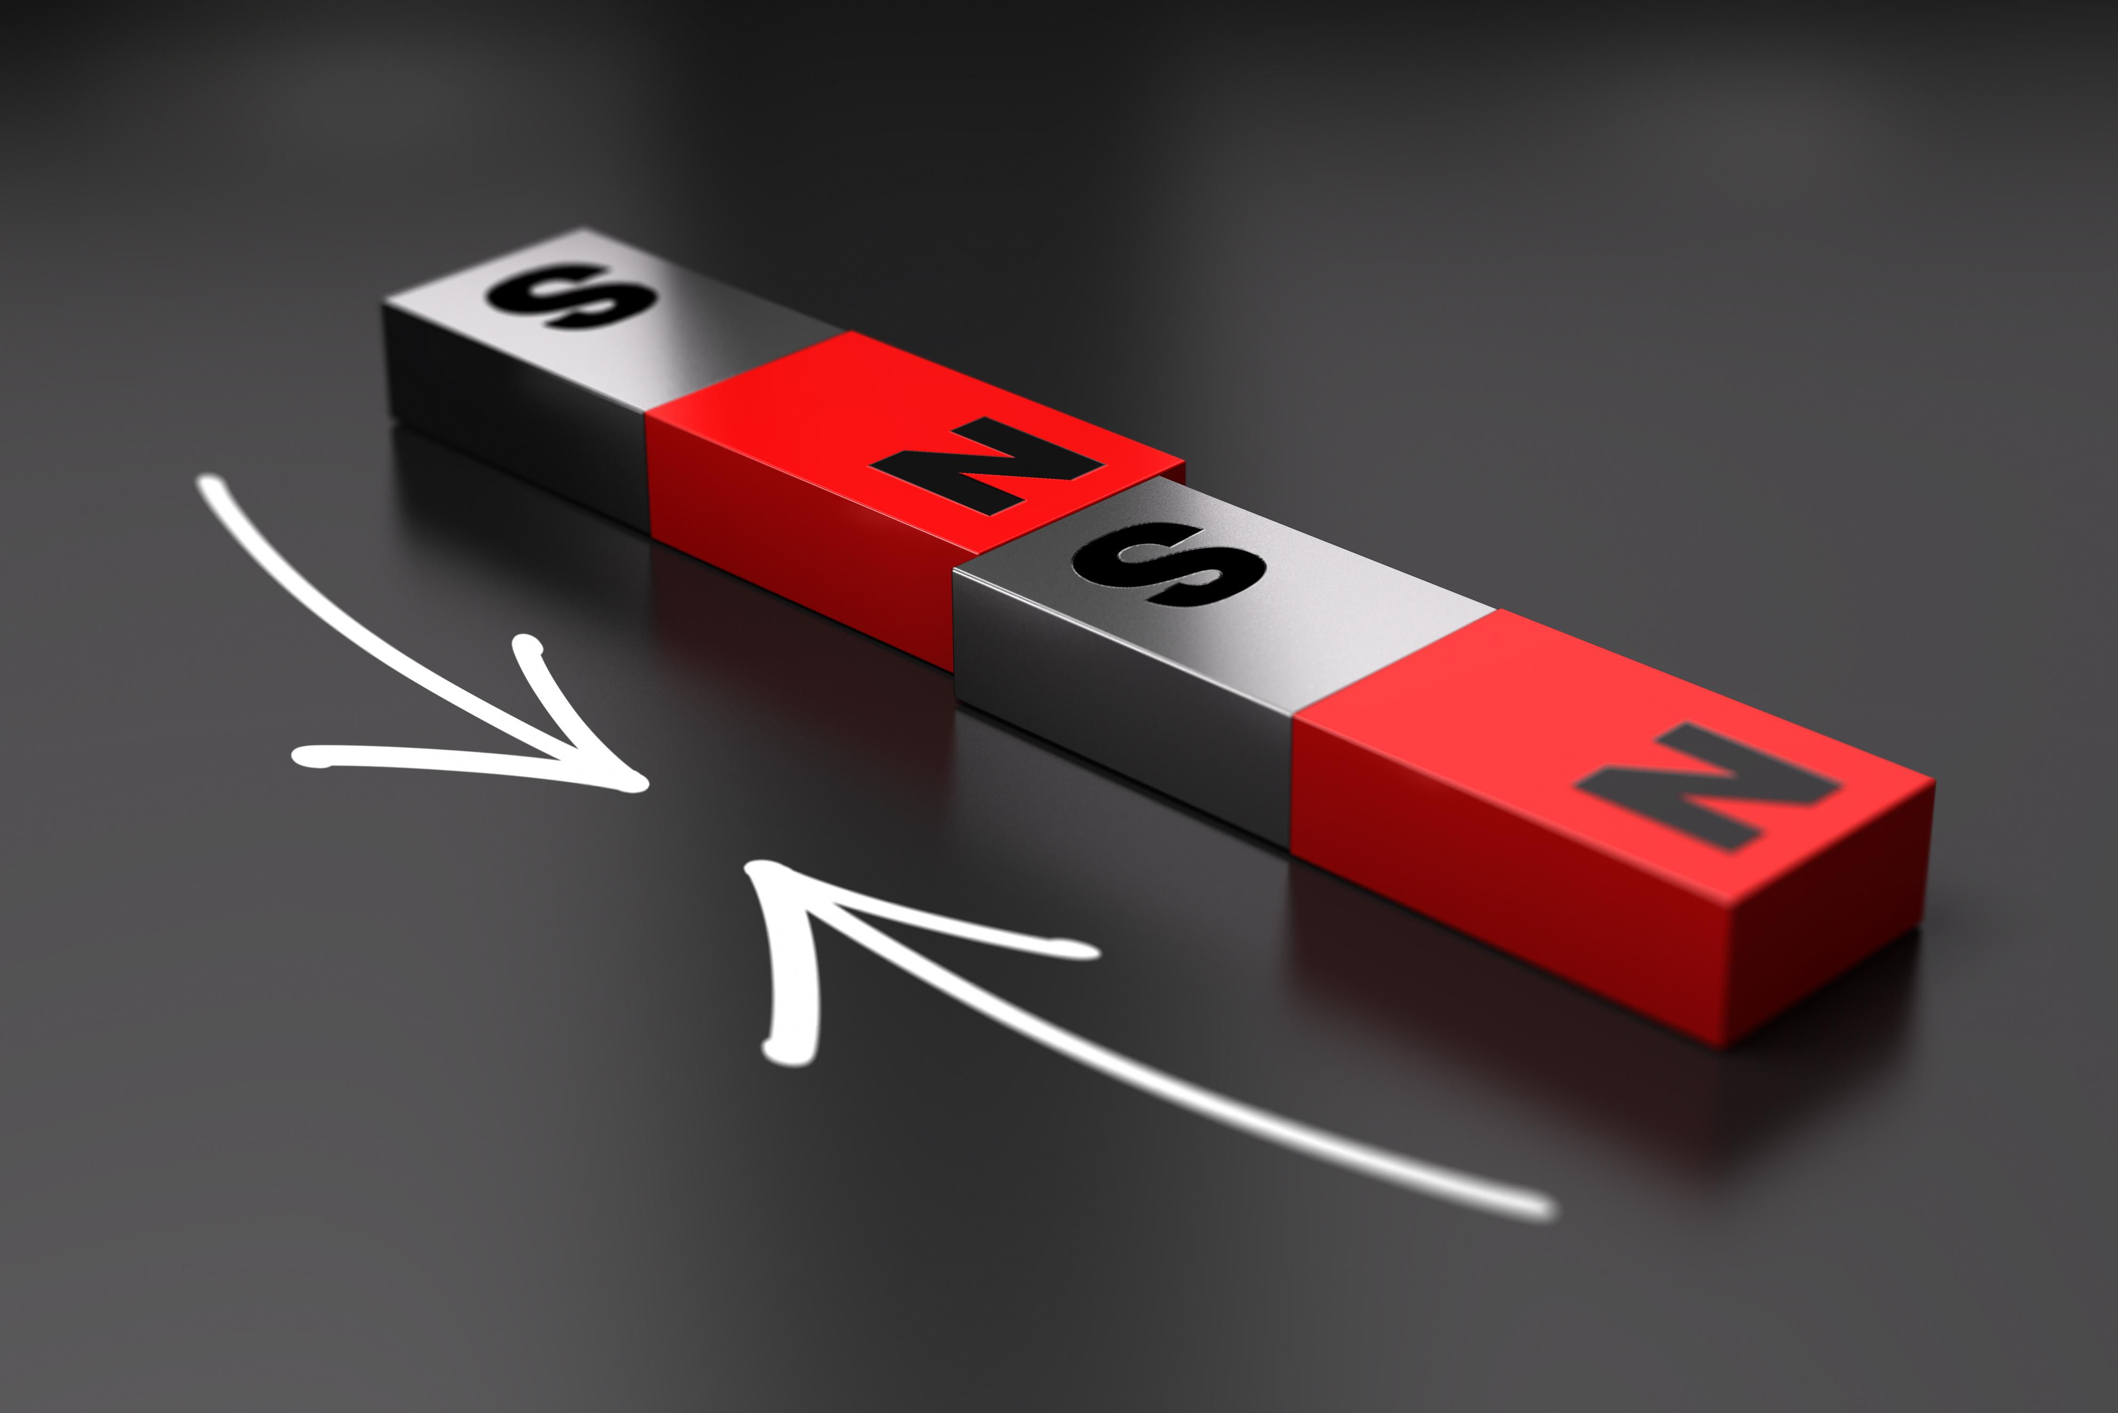
Responses
- Potential energy increases, kinetic energy decreases, and thermal energy increases.
- Potential energy decreases, kinetic energy increases, and thermal energy decreases.
- Potential energy decreases, and kinetic and thermal energy increase.
- Potential energy increases, and kinetic and thermal energy decrease.
Two bar magnets are held in place in the configuration shown. If the magnets are pulled apart, which statement correctly describes the changes that will take place in the energy of the system?
Responses
- Potential energy increases because movement is in the opposite direction of the magnetic field.
- Potential energy decreases because movement is in the opposite direction of the magnetic field.
- Potential energy increases because movement is in the direction of the magnetic field.
- Potential energy decreases because movement is in the direction of the magnetic field.
The south poles of two bar magnets are 10 cm from each other. The poles are brought to 5 cm apart and then moved back to their original positions. How does the energy of the system change?
Responses
- The total change in the energy of the system is zero.
- The potential energy of the system first decreases and then increases.
- Both the potential and kinetic energy of the system decrease.
- The kinetic energy of the system decreases because some of it is transferred to thermal energy.

Stored Energy Changes II
Two magnets are held apart. Once released, the south pole of one magnet moves toward the north pole of another magnet until the magnets collide. How does the graph reflect the changes in energy that occur?
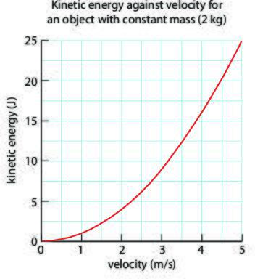
Responses
- The velocity and kinetic energy of the system increase as the energy stored in the magnetic field increases.
- Kinetic energy is at its peak when the magnets are first released, then it decreases steadily. Energy stored in the magnetic field becomes zero.
- The kinetic energy of the system is derived from the thermal energy created by increased velocity. Energy stored in the magnetic field does not change.
- Kinetic energy and velocity are at zero when the magnets are held apart, and both increase rapidly when they are released and move together. Energy stored in the magnetic field decreases.
Two magnets are placed on a table, and they immediately move to attach to each other. Which statement is correct about the energies in the system?
Responses
- The energy stored in the system is converted to kinetic energy.
- The energy stored in the system is converted to kinetic and thermal energy.
- The energy stored in the system is converted to thermal and sound energy.
- The energy stored in the system is converted to kinetic, thermal, and sound energy.
A magnet is moved close to a rubber band. How does the energy stored in the magnetic field change?
Responses
- The energy stored in the magnetic field increases.
- The energy stored in the magnetic field decreases.
- The energy stored in the magnetic field does not change.
- The energy stored in the magnetic field first increases and then decreases.
Two donut-shaped magnets are stacked on top of each other with a wooden dowel in the center. The south poles of the magnets are facing each other. Once the upper magnet is released, it accelerates downward and stops 1 cm above the lower magnet. How does the energy stored in the magnetic field change?
Responses
- Some of the energy stored is converted into kinetic, thermal, and gravitational energy.
- All of the energy stored is converted into kinetic and thermal energy.
- All of the energy stored is converted into kinetic, thermal, and gravitational energy.
- Some of the energy stored is converted into kinetic and thermal energy.
Which interaction between magnets demonstrates the greatest change in kinetic energy?
Responses
- Two attracting magnets are released while moving away from one another.
- Two large repelling magnets hold each other in place.
- Two small repelling magnets hold each other in place.
- Two attracting magnets are released while moving towards one another.

Cause and Effect
Metal paper clips do not attract or repel each other. When an electromagnet is placed nearby, the paper clips can be observed to move toward it. Which statement describes this phenomenon?
Responses
- Paper clips turn into permanent magnets after exposure to a magnetic field.
- The electromagnet reacts to the strong force of attraction from paper clips.
- Magnetic domains within the paper clips align with the magnetic field.
- Electrons ow freely into the magnetic field, causing the paper clips to move.
An experiment modeled the interaction between magnetic force and the change of energy of an object influenced by the magnetic force. The experiment’s researchers observed that the metal wheels of a small car turned as they experienced the force exerted by a magnetic field, drawing the car closer to the magnet. What energy is being gained by the car?
Responses
- thermal energy
- potential energy
- kinetic energy
- electrical energy
Which statement about the current and magnetic field correctly describes this figure as well as all electromagnets?
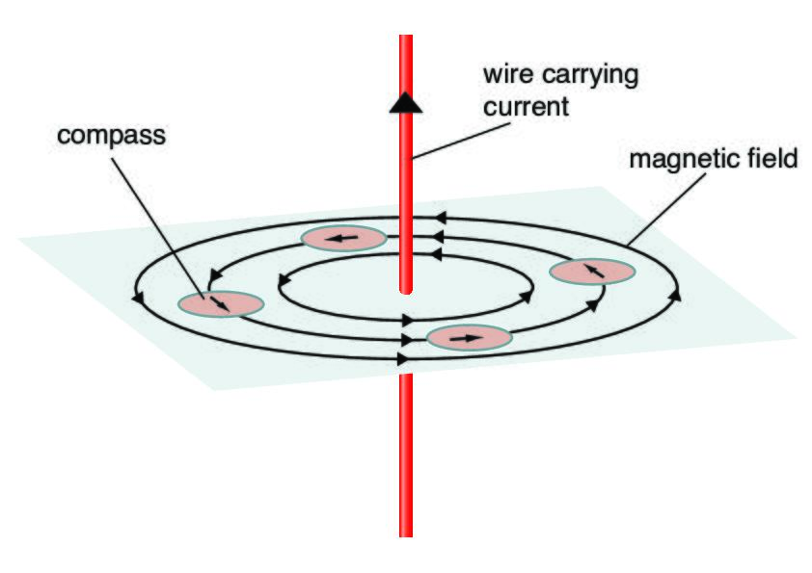
Responses
- The current, which points upward, is generated by the sporadic magnetic field.
- The current generates the magnetic field and is parallel and opposite to the direction of the magnetic field.
- The current generated by the magnetic field is parallel and points in the same direction as the magnetic field.
- The current generates and is perpendicular to magnetic field.
Domains are the regions in a material in which the magnetic fields of many of the atoms are aligned facing the same direction. What is the relationship between the electrical current and the alignment of atoms responding to the current?
Responses
- As current decreases, the alignment becomes continuous.
- As current increases, the alignment becomes more organized.
- As current increases, the alignment reverts to its random arrangement.
- The alignment of atoms has nothing to do with the changing current.
An electromagnet is built using a 9-volt battery connected to a switch via conducting wire that is coiled around an iron nail. A pile of metal paper clips is moved close to the iron nail, yet no attraction is apparent between the electromagnet and the paper clips. What is the most likely conclusion to explain this result?
Responses
- The switch is turned off.
- The paper clips are made of a nonmagnetic metal.
- The switch is turned on.
- There are not enough coils of wire around the iron nail.

Energy of Four Forces
What is the electromagnetic force?
Responses
- a force that acts on charged particles
- a force that attracts objects with mass towards each other
- a force that governs how elements break down naturally
- a force that holds atomic nuclei together
What is the strong nuclear force?
Responses
- a force that governs how elements break down naturally
- a force that holds atomic nuclei together
- a force that acts on charged particles
- a force that attracts objects with mass towards each other
Which represents the order of the forces from weakest to strongest?
Responses
- weak nuclear, gravity, electromagnetic, strong nuclear
- gravity, weak nuclear, electromagnetic, strong nuclear
- strong nuclear, electromagnetic, weak nuclear, gravity
- electromagnetic, weak nuclear, strong nuclear, gravity
Which force controls the size of an atomic nucleus?
Responses
- weak nuclear force
- gravitational force
- strong nuclear force
- electromagnetic force
What is a major division between gravity and the electromagnetic force on one hand and the nuclear forces on the other?
Responses
- Gravity and the electromagnetic force have very small ranges while the nuclear forces have infinite ranges.
- Gravity and the electromagnetic force act on small objects while the nuclear forces act on large objects.
- Gravity and the electromagnetic force act on large objects while the nuclear forces act on small objects.
- Gravity and the electromagnetic force have infinite ranges while the nuclear forces have very small ranges.

Energy and Forces Practice
Why do charged particles interact with each other?
Responses
- because of their electric and magnetic fields
- because they are in the same molecule
- because they are small
- because they have opposite charges
What is an electric field?
Responses
- a region around a neutral particle where forces are exerted on other neutral particles
- a force that is exerted by a charged particle
- a region around a charged particle where forces are exerted on other charged particles
- a force that is exerted by a neutral particle
Which example describes an interaction driven by forces in an electric or magnetic field?
Responses
- a balloon stuck to a wall with tape
- a balloon with static charge stuck to a curtain
- a balloon rolling down a hill
- a helium-filled balloon floating away
The interaction of charged particles leads to changes in the energy stored in their electric fields. How do these changes occur?
Responses
- through changes in the particle's size and position
- through changes in the particle's size, position, and velocity
- through changes in the particle's position and velocity
- through changes in the particle's size and velocity
Electrons are subatomic particles. Which statement describes characteristics of electrons?
Responses
- They are made of atoms, they are positively charged, and they all have equal mass.
- They form part of atoms, they are negatively charged, and they all have equal mass.
- They are made of atoms, they are negatively charged, and their mass can vary.
- They form part of atoms, they are negatively charged, and their mass can vary.
Which kind of force pushes or pulls charged subatomic particles that are interacting?
Responses
- electric force
- air resistance force
- frictional force
- mechanical force
The north pole of a bar magnet is moved toward the south pole of a stationary magnet. How does the energy in the system change?
Responses
- Potential energy increases, and kinetic energy decreases.
- Potential energy decreases, and kinetic energy decreases.
- Potential energy decreases, and kinetic energy increases.
- Potential energy increases, and kinetic energy increases.
The distance between two bar magnets increases. The bar magnets are parallel to each other with their north poles facing. Which statement is correct about the energy stored in the system?
Responses
- The energy stored in the system decreases because the magnets push each other away.
- The energy stored in the system decreases because the magnets pull toward each other.
- The energy stored in the system increases because the magnets pull toward each other.
- The energy stored in the system increases because the magnets push each other away.
When a magnet freely moves in a magnetic field, what happens to the energy stored in the magnet?
Responses
- The energy stored in the magnet decreases.
- There are no changes in the energy stored in the magnet.
- The changes in energy stored depend on the direction of the field.
- The energy stored in the magnet increases.
A bar magnet approaches a pile of iron shavings, and the shavings accelerate toward the pole facing them. Which statement is correct about the energy stored in the field?
Responses
- The energy stored remains the same, and kinetic energy increases.
- The energy stored converts into the kinetic energy of the shavings and some thermal energy.
- The energy stored remains the same, but kinetic energy decreases.
- The energy stored converts into the kinetic energy of the shavings, thermal energy, and gravitational energy.
A wire is wrapped around an iron core such as a nail and is connected to a 9-V battery. What is the role of the iron core or nail in this case?
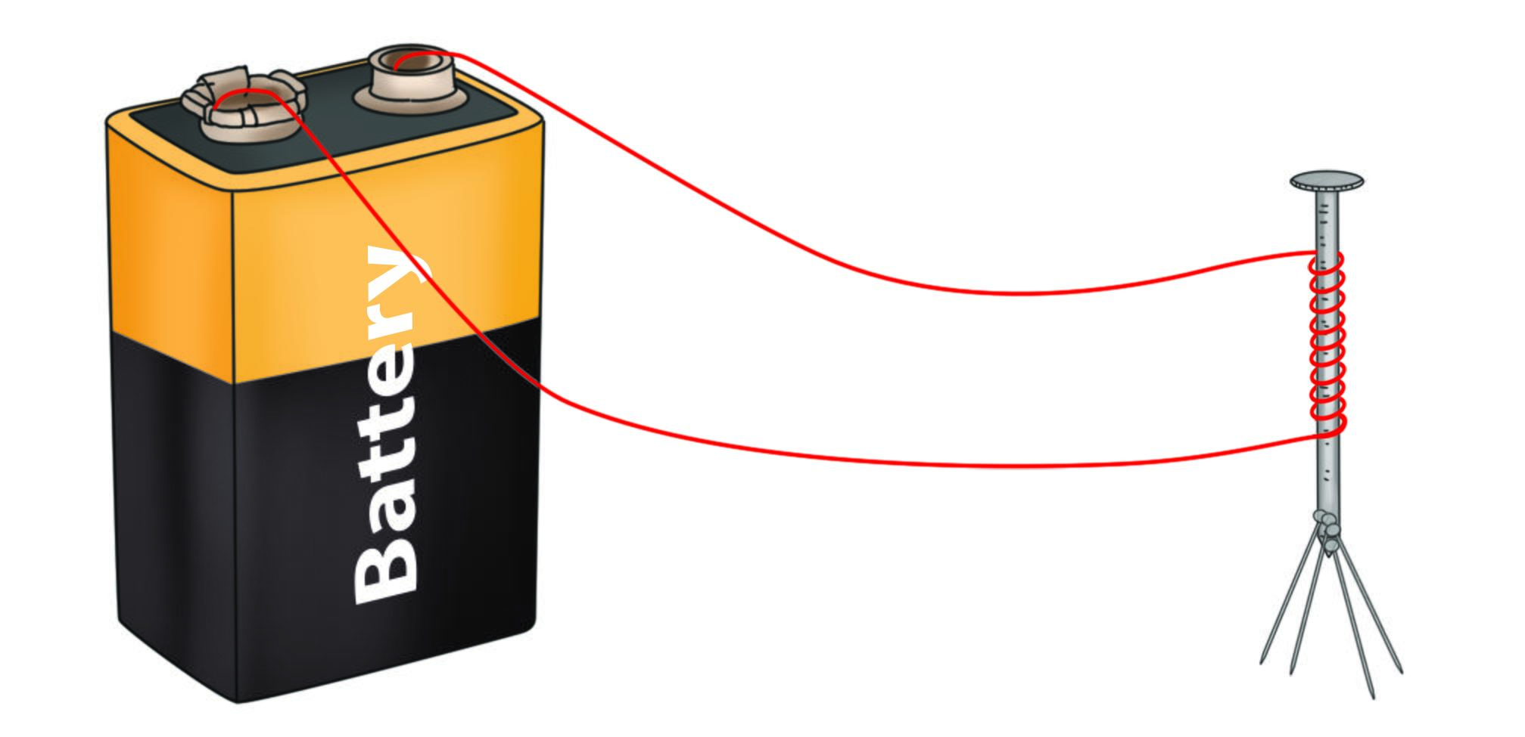
Responses
- It changes the direction of the electron flow.
- It slows down the current.
- It increases the voltage to twice its original value.
- It amplifies the magnetic field.
Which statement is correct?
Responses
- The coiled wire and nail become a magnet when the battery is removed.
- The wire generates the magnetic field.
- The nail stores electric current.
- The battery supplies the energy for electrons to flow.
What is gravity?
Responses
- a force that acts on charged particles
- a force holding atomic nuclei together
- a force that governs how elements break down naturally
- a force that attracts objects with mass towards each other
Which force acts against the electromagnetic and the weak nuclear forces?
Responses
- gravity
- charge
- the radioactive force
- the strong nuclear force
Which force is responsible for the existence of isotopes?
Responses
- gravitational force
- weak nuclear force
- electromagnetic force
- strong nuclear force

Energy and Forces Unit Test
In models of magnetic and electric fields, why are field vectors depicted by arrows?
Responses
- because they represent both their magnitude and direction
- because they represent their direction, but not their magnitude
- because they represent their magnitude, but not their direction
- because they represent a parameter that is neither their magnitude nor direction
A model depicts two balloons of the same size with identical negative charges being moved toward one another at the same speed. How will the balloons interact with each other?
Responses
- They will attract, moving in the same direction at the same speed.
- They will repel, moving in opposite directions at the same speed.
- They will repel, moving in the same direction at different speeds.
- They will attract, moving in opposite directions at different speeds.
A model shows a machine that works using electrical fields. What would this machine need for the electrical field to function properly?
Responses
- all neutral components
- moving parts, for kinetic energy
- springs, to store potential energy
- at least two charged, interacting parts
Which diagram would represent kinetic energy and launched particles?
Responses
- an arrow drawn on a bow, with the bow string pulled back
- an arrow released from the bow
- an arrow being strung on a bow, with the bow string straight
- an arrow released and stuck in a target
During chemical reactions, bonds between atoms break and form. What does this mean in terms of subatomic particles?
Responses
- Electrical fields of neutral particles interact, bonding those with the same charge.
- Electrical fields of charged particles interact, bonding those with the same charge.
- Electrical fields of neutral particles interact, bonding those with opposite charges.
- Electrical fields of charged particles interact, bonding those with opposite charges.
What is the driving force behind chemical reactions between elements?
Responses
- the attraction of protons of different atoms
- the attraction of electrons of different atoms
- the interaction of the electric fields of protons and electrons
- the interaction of the electric fields of neutrons and electrons
A community seeks to develop a maglev train operation. Which of the following is most likely their technical motivation for choosing this option?
Responses
- They seek a rail line not affected by friction.
- They need trains that can cover particularly long distances.
- They hope to employ lighter weight materials that reduce costs.
- They do not want to rely on any supply of electricity.
The north and south poles of two magnets are attached to each other. A student pulls the poles apart and hold them at a distance of 10 cm. How does the energy stored in the system change?
Responses
- The energy stored in the system decreases.
- The energy stored in the system increases.
- The energy stored in the system does not change.
- The energy stored in the system first increases and then decreases.
A student places two horseshoe magnets next to each other, and the poles of the magnets attach to each other. How does the kinetic energy of the system change?
Responses
- Kinetic energy increases because the magnets move in the direction of the field.
- Kinetic energy decreases because the magnets move in the direction of the field.
- Kinetic energy increases because the magnets move in the opposite direction of the field.
- Kinetic energy decreases because the magnets move in the opposite direction of the field.
A giant magnet moves above a debris pile with many pieces of iron buried in it. Which statement is correct about the energy stored in the magnetic field?
Responses
- Iron pieces accelerate toward the magnet, and the energy stored in the system increases.
- Iron pieces accelerate toward the magnet, and the energy stored in the system decreases.
- Iron pieces accelerate away from the magnet, and the energy stored in the system decreases.
- Iron pieces accelerate away from the magnet, and the energy stored in the system increases.
The north pole of a bar magnet is moved close to the north pole of another bar magnet that is suspended by a thread. How does the energy stored in the magnetic field change?
Responses
- The energy stored in the field decreases because the magnet moves in the direction of the field.
- The energy stored in the field increases because there is no friction.
- The energy stored in the field decreases because there is no friction.
- The energy stored in the field increases because the magnet moves in the direction of the field.
Two magnets with like poles facing each other are brought close to each other and then released. How does the energy stored in the system change?
Responses
- The energy stored increases.
- The energy stored decreases and then increases.
- The energy stored decreases.
- The energy stored increases and then decreases.
The model shows a simple electromagnet that does not attract metal objects. Which observation or inference is correct?
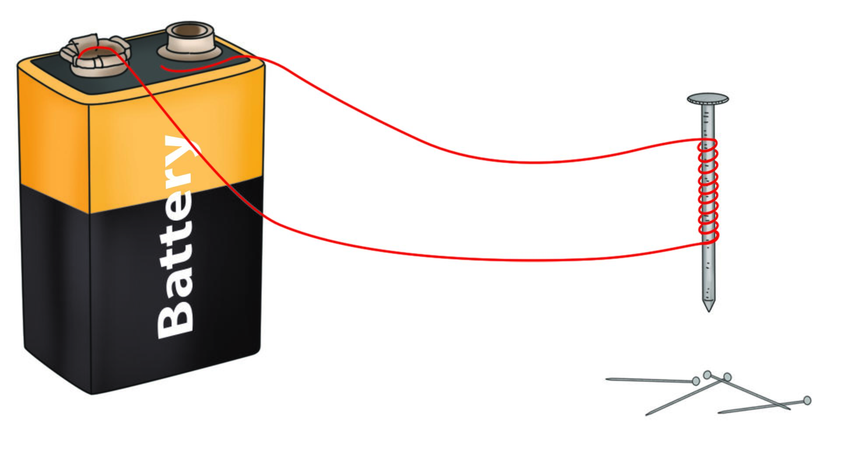
Responses
- The wire was not connected to the source.
- The model needs a switch in order to work.
- The metallic objects lost their magnetic domains.
- The battery was replaced with a lower voltage.
More coils are produced when the wire is wrapped tightly around the iron core. What will happen to the property of the electromagnet with an increasing number of coils?
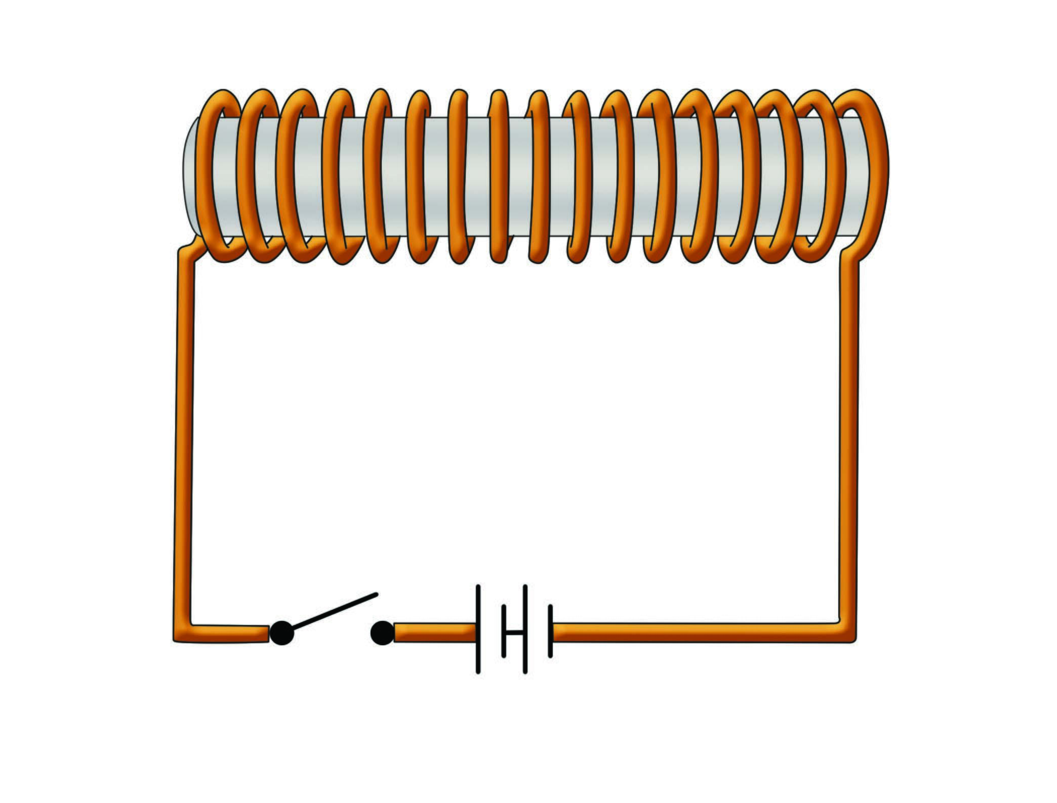
Responses
- The electromagnet will become a permanent magnet.
- The electromagnet will lose its magnetic properties.
- The electromagnet will become more powerful.
- The electromagnetic properties will not be affected by the coil of wire.
What is the weak nuclear force?
Responses
- a force that acts on charged particles
- a force that governs how elements break down naturally
- a force that attracts objects with mass towards each other
- a force that holds atomic nuclei together
On which planet is gravity strongest?
Responses
- Jupiter
- Earth
- Mars
- Mercury
In 3–4 sentences, describe how a particle accelerator works and give an example of the applications of the discoveries made with them.
Responses
Free response
A magnet is removed from a refrigerator door and placed on a table. In 1–2 sentences, explain how the potential energy of the system changes in this process.
Responses
Free response
Using a simple model of an electromagnet, describe the factors that increase the magnetic field strength of an electromagnet.
Responses
Free response
In 3-5 sentences, explain how gravity causes Earth's tides.
Responses
Free response

Thermal Energy

Kinetic and Thermal Energy
What is the best description of thermal energy?
Responses
- Thermal energy is a measure of an object or substance’s heat.
- Thermal energy is the kinetic energy contained in an object or substance due to the movement of its atoms and/or molecules.
- Thermal energy is the energy stored in an object’s chemical bonds.
- Thermal energy is kinetic energy.
What does temperature measure?
Responses
- kinetic energy of objects or substances
- average kinetic energy of the particles in an object or substance
- relative heat of an object or substance compared to its environment
- potential energy stored in the chemical bonds of an object or substance
What would happen to a substance at the theoretical temperature of 0 K?
Responses
- The substance’s particles would accelerate.
- The substance would turn from liquid to solid.
- The substance’s particles would stop moving.
- The substance would turn from solid to gas.
What happens when thermal energy is applied to a substance?
Responses
- Its atoms gain potential energy.
- All substances will melt.
- Its atoms gain kinetic energy.
- Its particles slow down.
Which is the best description of a student applying lifelong learning skills as she investigates kinetic and thermal energy?
Responses
- She learns that temperature is the measure of a type of kinetic energy and relates that to what she already knows about kinetic energy.
- She reads that thermal energy is a form of kinetic energy and dismisses the statement, thinking it must be a mistake.
- She memorizes how to convert temperatures among the three scales.
- She asks her teacher to give her the answer to a problem she is working through about the connection between temperature and kinetic energy.

Matter and Temperature Quick Check
Which is the best description of thermal energy?
Responses
- Thermal energy is the energy stored in the chemical bonds of an object or substance.
- Thermal energy is the energy stored in an object due to its position relative to Earth.
- Thermal energy is heat energy.
- Thermal energy is the energy in matter due to the movement of its atoms and/or molecules.
An athlete hurts their wrist. They put an ice directly on the wrist. In which direction is the thermal energy moving?
Responses
- The thermal energy is moving from the ice pack to the air around the wrist.
- The thermal energy is moving from the ice pack to the wrist.
- There is no thermal energy in this scenario.
- The thermal energy is moving from the wrist to the ice pack.
What happens when two substances with different temperatures come into contact?
Responses
- Potential energy is transferred from the warmer substance to the cooler substance.
- Thermal energy is transferred from the cooler substance to the warmer substance.
- Heat is transferred from the warmer substance to the cooler substance.
- Thermal energy is transferred from the warmer substance to the cooler substance.
Which is the best description of what happens when thermal energy is removed from a substance?
Responses
- It gains potential energy.
- Its particles lose kinetic energy and move more slowly.
- It loses potential energy.
- Its particles gain kinetic energy and move more quickly.
Which of the following is typically part of the knowledge base of research and development scientists working on heating devices?
Responses
- substances and their properties
- marketing strategies
- engineering rules and principles
- sales projections

Energy Transfer and Temperature
What is the best description of thermal energy?
Responses
- Thermal energy is the average kinetic energy of the particles in an object or substance.
- Thermal energy is a type of kinetic energy.
- Thermal energy is heat energy.
- Thermal energy is a type of potential energy
Which scenario correctly illustrates heat?
Responses
- bathtub full of hot water gets even warmer in a cold room
- ice in a cold glass of water remains ice and never melts
- cold person gets even colder when they sit in a sauna with a temperature of 105° F
- cold person’s hands get warmer by holding a rock that has been sitting in the sun
What happens when two substances with different temperatures come into contact?
Responses
- Potential energy is transferred from the warmer substance to the cooler substance.
- Both substances gain thermal energy.
- Thermal energy is transferred from the cooler substance to the warmer substance.
- Thermal energy is transferred from the warmer substance to the cooler substance.
Why do restaurants wash their dishes with hot water?
Responses
- The molecules of hot water have more kinetic energy than the molecules of cold water, so they will more easily break up grease and leftover food.
- Hot water has more potential energy than cold water so it is more effective at removing grease and food scraps.
- The molecules of hot water have less kinetic energy than cold water, so they are easier to control during dishwashing.
- Hot water is cheaper than cold water.
Which is the best example of a thermal conductor?
Responses
- ceramic stovetop
- plastic ice-cube tray
- copper plating on bottom of a skillet
- down jacket

Kinetic Energy
What is the relationship between kinetic energy and thermal energy?
Responses
- As the kinetic energy in a substance’s atoms increases, its thermal energy decreases, and vice versa.
- Kinetic energy is the transfer of thermal energy.
- As the kinetic energy in a substance’s atoms increases, its thermal energy increases, and vice versa.
- Kinetic energy is a measure of thermal energy.
What happens when a bowl of ice cream is left uneaten on a counter in a warm room?
Responses
- Thermal energy is transferred from the air to the ice cream, warming the ice cream.
- Potential energy is transferred from the air to the ice cream.
- Thermal energy is transferred from the ice cream to the air, cooling the air.
- Heat is transferred from the air to the ice cream.
What is the relationship between kinetic energy and temperature?
Responses
- Kinetic energy is the energy of motion and does not have a relationship with temperature.
- As the kinetic energy of a substance’s atoms decreases, its temperature increases.
- As the kinetic energy of a substance’s atoms decreases, its temperature may decrease or increase.
- As the kinetic temperature of a substance’s atoms decreases, its temperature decreases, and vice versa.
What is the best description of heat?
Responses
- a type of kinetic energy due to the movement of a substance’s particles
- thermal energy
- the flow of thermal energy from a warmer substance to a cooler substance
- the flow of thermal energy from a cooler substance to a warmer substance
When thermal energy is applied to water, the water’s temperature rises until 100° C and then stays the same. Which is the best explanation?
Responses
- When the water reaches 100° C, the ow of thermal energy reverses, maintaining an equilibrium.
- When the water reaches 100° C, any increase in thermal energy goes to breaking the bonds between water molecules as the water boils and becomes steam.
- When the water reaches 100° C, any increase in thermal energy becomes potential energy.
- When the water reaches 100° C, it can no longer absorb thermal energy

Thermal Energy Transfer
What is the relationship between a substance’s thermal energy and its kinetic energy?
Responses
- A substance’s thermal energy is the same as its kinetic energy.
- There is no relationship between a substance’s thermal energy and kinetic energy.
- As the substance’s thermal energy increases, the kinetic energy of its particles increases, and vice versa.
- As the substance’s thermal energy increases, the kinetic energy of its particles decreases, and vice versa.
Why does air in a room rise when it gains thermal energy from a heater?
Responses
- Warm air always rises.
- Its molecules move around more quickly, so there is more space between them, reducing its mass.
- Its molecules move around more slowly, so there is more space between them, making it less dense than the air above it.
- Its molecules move around more quickly, so there is more space between them, making it less dense than the air above it.
How does a simmering pot of spaghetti sauce illustrate convection currents?
Responses
- Warmer sauce at the top of the pot is denser, so it sinks to the bottom of the pot, where it is warmed even more.
- The pot is only simmering, so there are no convection currents.
- Warmer sauce at the bottom of the pot is less dense, so it rises, forcing cooler sauce down, where it is warmed.
- Warmer sauce at the bottom of the pot is denser, so it rises, forcing cooler sauce down, where it is warmed.
Which scenario shows conduction?
Responses
- Hot soup rises to the top of a pot.
- Bowl of hot soup warms the air around it.
- Hot soup warms the bowl where it sits.
- Air above a pot of simmering soup rises, forcing cooler air downward.
Which is the best description of radiation?
Responses
- transfer of thermal energy between two substances that are touching
- transfer of thermal energy through infrared waves
- transfer of thermal energy within a gas
- transfer of thermal energy within a liquid

Thermal Energy Practice
What happens when thermal energy is removed from a substance?
Responses
- The substance’s atoms lose kinetic energy.
- The substance loses potential energy.
- The substance’s particles speed up.
- All substances will freeze.
Water boils at 100° C and 212° F. What is water’s boiling temperature in Kelvins?
Responses
- 485.15 K
- –61.15 K
- –173.15 K
- 373.15 K
What happens when thermal energy is added to an object?
Responses
- It gains potential energy.
- Its particles lose kinetic energy and move more slowly.
- It loses potential energy.
- Its particles gain kinetic energy and move more quickly.
A stone has been sitting in the sun all day. A construction worker picks it up without gloves. What do you expect to happen to the thermal energy in this scenario?
Responses
- The thermal energy will move from the rock to the construction worker’s hand, cooling the rock.
- The thermal energy will move from the construction worker’s hand to the rock, cooling the rock.
- The thermal energy will not move because the construction worker is also outside.
- The thermal energy will disappear once the construction worker picks up the rock.
Which is the best example of a thermal insulator?
Responses
- plastic handle of tea pot
- apartment radiator
- stainless-steel cooking pot
- glass flask
Why does honey dissolve more quickly in hot water than in cold water?
Responses
- The molecules of hot water have more potential energy than the molecules of cold water.
- The molecules of hot water move around less than the molecules of cold water.
- Honey molecules are attracted to molecules of hot water.
- The molecules of hot water have more kinetic energy than the molecules of cold water.
What happens when a hot piece of pizza is left uneaten on a plate in a cool room?
Responses
- Heat is transferred from the pizza to the plate and air, warming them.
- Thermal energy is transferred from the plate to the pizza, cooling the pizza.
- Potential energy is transferred from the pizza to the plate and air.
- Thermal energy is transferred from the pizza to the plate and air, warming them.
A team of students carries out a science experiment about the transfer of kinetic energy between substances. Why should they support their conclusion with reasoning?
Responses
- Reasoning is a good way to make the team’s project stand out from other projects.
- Reasoning lets others understand the team’s thoughts and explains how the team reached its conclusion.
- Reasoning proves that the team is correct.
- Reasoning lets others see that the team worked well together
What happens when a fluid’s thermal energy increases?
Responses
- The fluid’s atoms or molecules gain kinetic energy, so they move around more quickly.
- The fluid loses potential energy.
- The fluid gains potential energy.
- The fluid’s atoms or molecules lose kinetic energy, so they move around more slowly.
Which layer of the Earth is the source of the thermal energy that creates convection currents?
Responses
- crust
- lithosphere
- core
- Mantle
Which is the best description of conduction?
Responses
- transfer of thermal energy within a liquid
- transfer of thermal energy through infrared waves
- transfer of thermal energy within a gas
- transfer of thermal energy between two substances or objects that are in contact
Which scenario is an example of radiation?
Responses
- A glass warms when hot tea is placed in it.
- A glass of tea warms when it sits in the sun.
- Hot tea melts ice cubes in a glass.
- Hot tea rises in a teapot, forcing cooler tea to the bottom of teapot.

Thermal Energy Unit Test
How can a stationary metal sphere have kinetic energy, the energy of motion?
Responses
- The metal sphere can be rolled.
- The metal’s molecules are moving around.
- The metal is made of atoms, which store potential energy.
- The metal is made of atoms, which are vibrating in place.
What do you measure when you and a substance’s temperature?
Responses
- kinetic energy of the substance
- absolute heat of the substance
- potential energy of the substance
- average kinetic energy of the particles in the substance
What happens when thermal energy is applied to an ice cube?
Responses
- Its water molecules lose potential energy.
- Its water molecules lose kinetic energy, so the ice cube melts.
- Its water molecules gain kinetic energy and move around more.
- Its water molecules gain potential energy.
Why does an ice cube melt even in a cold glass of water?
Responses
- The water is still warmer than the ice cube, so thermal energy moves from the water to the ice cube.
- Ice cubes must always melt eventually.
- The ice cube is still colder than the water, so thermal energy moves from the ice cube to the water.
- The air around the water melts the ice cube.
Which scenario best describes a scientist who is studying thermal energy?
Responses
- She works with a team, telling each member exactly what to do.
- She works alone to research and carry out the project.
- She works on a team, with each member carrying out all of the same tasks together.
- She works on a team, with each member performing a different role on the project.
What is the best description of the conclusion of a scientific investigation?
Responses
- The conclusion states that the results are correct.
- The conclusion uses reasoning to justify the investigation.
- The conclusion is the final step of the investigation before it is written.
- The conclusion uses reasoning to explain and interpret the results.
How does a heater in one corner of a fish aquarium warm the whole aquarium?
Responses
- The heater warms the air above the aquarium, which warms the water.
- The heater adds thermal energy evenly to the aquarium’s water.
- The heater creates convection currents, which transfer warmer water away from the heater and cooler water toward the heater.
- The heater warms the glass of the aquarium, which warms the water.
What happens when a cold spoon is placed in hot soup?
Responses
- The soup’s molecules have more potential energy, so they transfer thermal energy to the spoon.
- The soup’s molecules have the same kinetic energy as the spoon’s molecules, so there is no transfer of thermal energy.
- The spoon’s molecules have less kinetic energy, so they transfer thermal energy to the soup.
- The soup’s molecules have more kinetic energy, so they transfer thermal energy to the spoon.
In 1–2 sentences, describe the relationship between heat and thermal insulators.
Responses
Free response
When thermal energy is applied to ice, the ice’s temperature rises until 0° C and then stays the same for a period of time. In 1–2 sentences, explain why this takes place.
Responses
Free response
A pot of water is being heated on the stovetop. The water molecules closest to the burner rise in the pot when they gain thermal energy. In 1–2 sentences, explain why the water rises.
Responses
Free response
A baker uses oven mitts to open an oven, take a loaf of bread out, and place it on a plate. In 3–4 sentences, identify three examples of thermal energy transfer in the scenario.
Responses
Free response

Non-Contact Forces

Strength of Electrical Forces
Which of the following statements about electrical charges is true?
Responses
- When a combination of negative and positive charges are present, the charges of opposite signs repel one another.
- Two positive charges repel each other.
- Two negative charges attract each other.
- Two positive charges attract each other.
Observing a set of pith balls with positive charges, how does the distance between the pith balls affect the electric electrical charge?
Responses
- The greater the distance between the pith balls, the greater the amount of electric charge that exists between them.
- The distance between the pith balls will not affect the electric charge.
- The lesser the distance between the pith balls, the greater the amount of electric charge that exists between them.
- The greater the distance between the pith balls, the lesser the amount of electric charge that exists between them.
Which of the following interactions in the data set below will have an attractive electrical force?
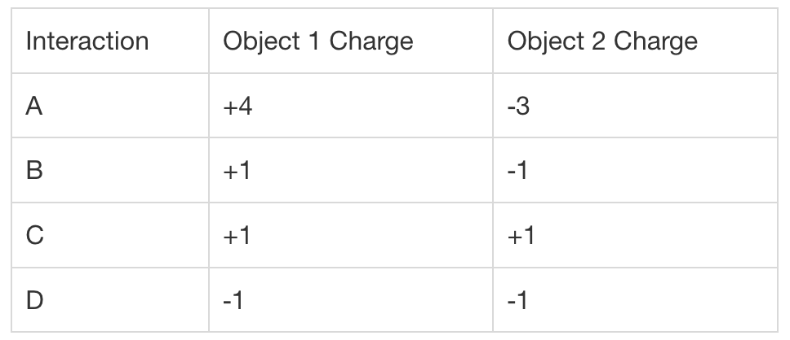
Responses
- Interaction A and B
- Interaction C and D
- Interaction B
- Interaction C
In which of the following interactions will the amount of force between the two objects be the strongest?
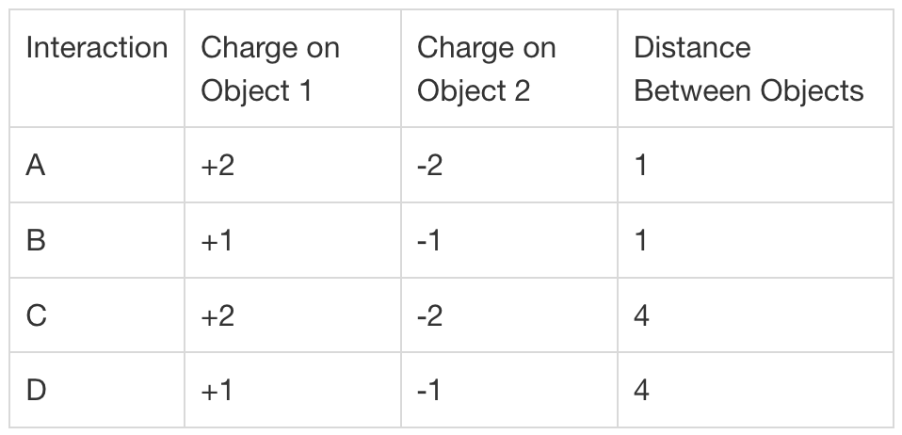
Responses
- Interaction A
- Interaction C
- Interaction B
- Interaction D
Which of the following statements accurately reflects the relationship between force and distance in Coulomb’s Law?
Responses
- They are proportional; as distance increases, the force between two charges will also increase.
- They are proportional; as distance increases, the force between two charges will decrease.
- They are inversely proportional; as distance increases, the force between two charges will decrease.
- They are inversely proportional; as distance increases, the force between two charges will also increase.

Conductors and Insulators
Why is copper wire a better conductor of electricity than carbon fiber?
Responses
- Carbon (C) does not have any valence electrons.
- The electrons in copper (Cu) are loosely bound to the nucleus.
- Copper (Cu) is a metal, and only metals can conduct electricity.
- Copper (Cu) has no loose electrons.
Which of the following best describes a direct current?
Responses
- the flow of electric charges through a conductor
- an electrical current that flows in one direction
- an electrical current that flows in alternating directions back and forth
- a stationary electrical charge
Which of the following substances would allow an electric current to ow through it easily?
Responses
- glass
- carbon (C)
- rubber
- aluminum (Al)
Which of the following statements about electrical charges is true?
Responses
- Like charges and opposite charges have no effect on one another.
- Like charges attract one another.
- Opposite electrical charges repel one another.
- Opposite charges attract one another.
Which of the following statements best describes the relationship between atoms and conductivity?
Responses
- Atoms with a full valence shell make good conductors.
- Atoms with few electrons make good conductors.
- Atoms with a nearly empty valence shell make good conductors.
- Atoms with many electrons make good insulators.

Electrical Energy Properties
Which analogy best describes voltage?
Responses
- diameter of a pipe through which water move
- pressure of water moving through a pipe
- length of the pipe through which water moves
- turbine or mill inserted into a ow of water
Which analogy best describes amperage?
Responses
- pressure of water moving through a pipe
- diameter of a pipe through which water moves
- length of the pipe through which water moves
- turbine or mill inserted into a flow of water
Which analogy best describes resistance?
Responses
- turbine or mill inserted into a ow of water
- pressure of water moving through a pipe
- length of the pipe through which water moves
- diameter of a pipe through which water moves
The current in a circuit is halved. What happens to the resistance? $$V=IR$$
Responses
- The resistance is tripled.
- The resistance is doubled.
- The resistance is halved.
- The resistance stays the same.
A flashlight has four 1.5-volt batteries. The bulb has a resistance of 2.4 ohms. What is the amperage of the circuit? $$V=IR$$
Responses
- 14.4 A
- 0.625 A
- 0.4 A
- 2.5 A

Electrical Circuits
Which statement about energy is correct?
Responses
- All energy can be categorized as kinetic energy or potential energy.
- Energy is the force that causes objects to be displaced.
- There are many types of energy. Energy can be light energy, sound energy, thermal energy, chemical energy, and electrical energy
- All energy comes from one of two sources: chemical bonds in an object’s molecules, or the state or position or position of the object.
How do electrons flow through an electric circuit?
Responses
- The device that is using the electricity pulls electrons through the circuit.
- The electrons flow out of the positive end of the battery, through the wires of the circuit, and back into the negative end of the battery.
- The electrons flow out of the negative end of the battery, through the wires of the circuit, and back into the positive end of the battery.
- The power source pushes electrons through the circuit.
In an electric circuit, which of these is the load?
Responses
- battery
- wiring
- on-o switch
- fan
A team of students is building an electric circuit with a light bulb, battery, and switch. Which is the best description of the circuit when it is complete?
Responses
- The circuit has all of the necessary parts: battery, wires, load, and switch.
- The switch is open.
- The students have finished building the circuit.
- There is a path from the battery to the light bulb, and back to the battery.
Imagine a string of holiday lights, with many bulbs connected to each other by wires. One bulb burns out, causing the bulbs next on the string not to work either. What type of circuit must the holiday lights be using?
Responses
- parallel
- resistor
- series
- fuse

Strength and Magnetic Forces
What provides an electric current in an electromagnet?
Responses
- wire
- battery
- iron or steel core
- paper clips
Students built two electromagnets. The electromagnets are the same except that one has 20 wire coils around its core, and the other has 40 wire coils around its core. Which is the best comparison?
Responses
- The electromagnet with 40 coils will be exactly twice as strong as the electromagnet with 20 coils.
- The electromagnet with 40 coils will be stronger than the electromagnet with 20 coils.
- The electromagnets will be equally strong.
- The electromagnet with 20 coils will be stronger than the electromagnet with 40 coils.
Samuel builds four electromagnets and tests them by picking up paperclips. Here are his partial results.

Which is the best prediction for the number of paperclips the electromagnet with 30 coils will pick up?
Responses
- 1 paperclip
- 8 paperclips
- 14 paperclips
- 11 paperclips
Which scenario describes how students can work together creatively to explore electromagnets?
Responses
- Three students research different electromagnets at the library, then communicate what they have learned to one another.
- Three students independently research and build their own electromagnet.
- Three students research an electromagnet in their science textbook. They then build an electromagnet exactly like the one in their textbook.
- Three students follow the directions of their teacher for building an electromagnet.
You are working with a team to improve an electromagnet. Which is an effective way to communicate your ideas?
Responses
- Tell other students that their ideas for improving the electromagnet won’t work without offering solutions.
- Listen to other students’ ideas, then get their attention and clearly explain your ideas about how to improve the electromagnet.
- Build your own electromagnet and then tell other students how you did it.
- Listen to other students’ ideas and follow their suggestions for improving the electromagnet, without adding any input yourself.

Non-Contact Forces Practice
Two pith balls hang from strings. The strings are attached to a bar, 6 centimeters apart. One ball has a positive charge, and the other ball has a negative charge. What does the distance between the balls reveal?
Responses
- The distance between the balls is not related to their electric charges or to the electric force between them.
- The shorter the distance between the balls, the greater the electric force between them.
- The greater the distance between the balls, the greater the electric force between them.
- The shorter the distance between them, the lesser the electric charges on the balls.
Which pair of objects will have a repulsive electric force?
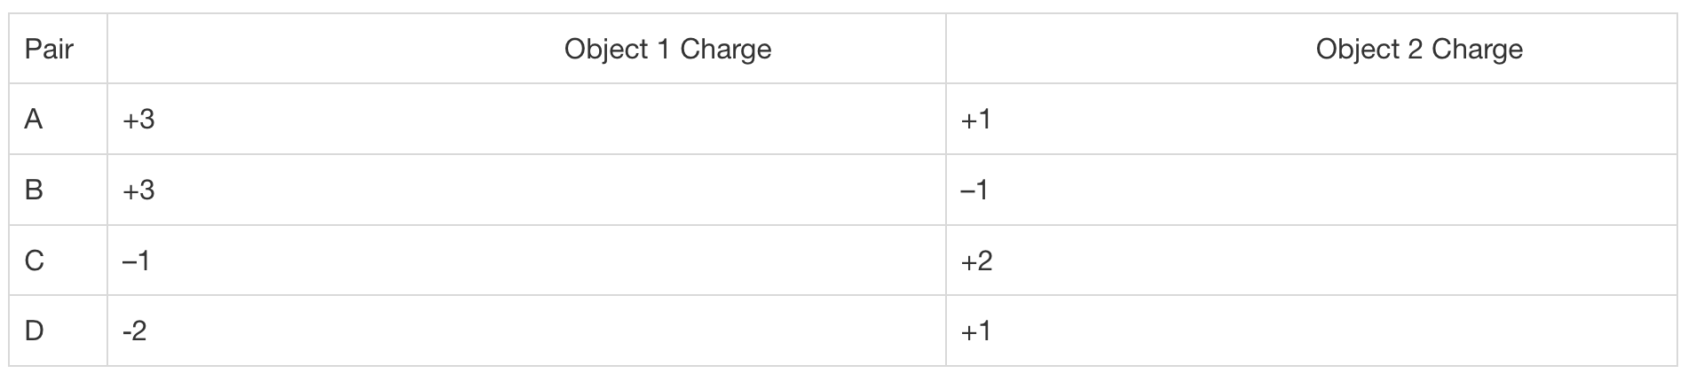
Responses
- Pair B
- Pair D
- Pair A
- Pair C
What makes a substance such as wood an insulator?
Responses
- The atoms of substances such as wood are negatively charged.
- The atoms of substances such as wood are positively charged.
- The atoms of substances such as wood have too many electrons to allow electric current.
- The atoms of substances such as wood do not have loose electrons in their outer shells.
What happens in a circuit with alternating current?
Responses
- The circuit’s poles alternate between negative and positive, so the ow of electrons starts and stops.
- The circuit’s poles alternate between negative and positive, so the ow of electrons accelerates.
- The circuit’s poles alternate between negative and positive, so the ow of electrons changes direction.
- The circuit’s poles alternate between negative and positive, so the wire becomes a conductor.
The resistance in a circuit is increased by a factor of 4. What happens to the current? $$V=IR$$
Responses
- The current is halved.
- The current is reduced by a factor of 4.
- The current is doubled.
- The current stays the same.
A toy robot has two 9-volt batteries. The current is 8 amps. What is the resistance of the circuit? $$V=IR$$
Responses
- 1.125 A
- 2.25 A
- 8 A
- 0.44 A
A toy car is powered by a battery. Why doesn’t the amount of electrical energy leaving the negative end of the battery equal the amount of electrical energy arriving at the positive end of the battery?
Responses
- The missing electrical energy is used to power the robot.
- Some of the electrical energy is used to overcome resistance in the circuit, and some of the electrical energy is converted to kinetic energy, sound energy, and heat energy.
- Some electrical energy is destroyed in the robot’s motor as it tries to convert to kinetic energy, sound energy, and heat energy.
- The missing electrical energy overcomes resistance in the circuit.
Which is the best description of the source of an object’s potential energy?
Responses
- An object’s potential energy comes from an electrical circuit.
- An object’s potential energy comes from its movement.
- An object’s potential energy comes from the chemical bonds in its molecules and from the object’s state or position.
- An object’s potential energy comes from its ability to do work.
What is the function of the conductor in an electric circuit?
Responses
- The conductor provides a path through which electrical energy flows.
- The conductor converts electrical energy into other forms of energy.
- The conductor provides energy for the circuit.
- The conductor controls the flow of energy through the circuit.
Students build an electric circuit. The load is a robotic arm. Why should they insert a switch in the circuit?
Responses
- A switch will allow students to power the arm.
- A switch will allow students to turn the arm on and off.
- A switch will let students control the arm.
- A switch will let students include more than just the arm in their circuit.
What is the function of the wire in an electromagnet?
Responses
- The wire produces the magnetic force.
- The wire is the source of the current.
- The wire is the part that becomes magnetized.
- The wire is the conductor through which electric current flows.
Leandra makes an electromagnet with a 1.5-volt battery. She coils wire around a 4-inch nail 25 times. Her electromagnet picks up 27 sewing needles. Sean makes an electromagnet with the same materials, but he coils the wire around the nail 20 times. Which is the best prediction?
Responses
- Sean’s electromagnet will pick up more than 27 needles.
- Sean’s electromagnet will pick up fewer than 27 needles.
- Sean’s electromagnet will pick up 27 needles.
- Sean’s electromagnet will pick up exactly 24 needles.
What is the best description of magnetic force?
Responses
- iron or steel core of an electromagnet
- attractive or repellant force produced by magnetically charged objects
- movement of electrons through a conductor such as a wire
- coiled wire of an electromagnet
Why might maglev trains use less energy than conventional trains?
Responses
- Maglev trains have less mass than conventional trains.
- Maglev trains do not experience friction with the tracks.
- The diesel engines of maglev trains are smaller.
- Maglev trains are more aerodynamic than conventional trains.

Non-Contact Forces Unit Test
Which statement about electric charges is correct?
Responses
- An object with a positive charge and an object with a negative charge will repel each other.
- An object with a negative charge and an object with a positive charge will attract each other.
- Two objects with positive charges will attract each other.
- Two objects with negative charges will attract each other.
A group of students sets up an electric circuit with wires, a battery, and a light bulb. Why is their circuit called a direct circuit?
Responses
- The circuit is complete, so electrons can flow freely.
- The light bulb is directly connected to the battery.
- The electrons flow back and forth through the circuit.
- The flow of electrons travels in one direction.
Sally puts on wool socks and rubs her feet on a nylon carpet. How does static electricity build up in Sally?
Responses
- The friction causes electrons from the wool socks to move to Sally, giving Sally a negative charge.
- When electrons from the wool socks move into the carpet, Sally and her socks gain a negative charge.
- Electrons from the wool socks move into the carpet, giving Sally and her socks a positive charge.
- Electrons from the carpet move into the wool socks, giving Sally and her socks a positive charge.
The resistance in a circuit is halved. What happens to the voltage? $$V=IR$$
Responses
- The voltage is halved.
- The voltage is doubled.
- The voltage is increased by a factor of 4.
- The voltage remains the same.
How does a flashlight illustrate the Law of Conservation of Energy?
Responses
- Potential chemical energy in the battery is converted to electrical energy, which is converted to light energy and heat energy.
- Potential energy in the battery will be converted to kinetic energy.
- It is an electric circuit through which electrical energy flows.
- All of the electrical energy leaving the battery will travel through the circuit and return to the battery.
Which is an example of a load in an electric circuit?
Responses
- 9-volt battery
- speaker
- wiring
- on-off lever
Which of the following best describes an electric circuit that powers a load?
Responses
- Electric current flows from an energy source through a conductor to a load and back to the energy source.
- Electric current flows from an energy source directly to the load.
- Electric current flows from an energy source through a conductor and back to the energy source.
- Electric current is generated in a conductor and flows through wires to a load.
Hal makes an electromagnet with a 9-volt battery, wire, and a steel rod. What is the function of electric current in his electromagnet?
Responses
- Electric current powers the electromagnet.
- Electric current attracts or repels charged objects.
- Electric current creates a magnetic field that charges the rod.
- Electric current determines the strength of the magnet.
What is the function of the core of an electromagnet?
Responses
- The core is the flow of electrons that charges the magnet.
- The core is the part that becomes magnetized.
- The core provides the magnet with electric energy.
- The core provides the conductor through which electric current flows.
In 1–2 sentences, describe a setup of pith balls that have negative charges and are hanging from the same point.
Responses
Free response
In 1–2 sentences, describe the factors that affect the current (amperage) in an electric circuit.
Responses
Free response
A team of students builds an electrical circuit with a battery and a fan. In 1–2 sentences, describe how energy is changed from one form to another in their electric circuit.
Responses
Free response
In 1–2 sentences, explain how to make an electromagnet.
Responses
Free response
In 1–2 sentences, explain how electromagnets move a maglev train.
Responses
Free response

Waves

Lens and Mirrors
Which of these best describes the relationship between the incident ray, the reflected ray, and the normal for a curved mirror?
Responses
- The angle that the incident ray makes with the normal is the same as the angle that the reflected ray makes with the normal. Different points on a curved mirror have a different normal.
- The angle that the incident ray makes with the normal is different than the angle that the reflected ray makes with the normal. All points on a curved mirror have the same normal.
- The angle that the incident ray makes with the normal is different than the angle that the reflected ray makes with the normal. Different points on a curved mirror have a different normal.
- The angle that the incident ray makes with the normal is the same as the angle that the reflected ray makes with the normal. All points on a curved mirror have the same normal.
Which defines a concave mirror?
Responses
- A concave mirror curves outward with the edges of the mirror pointing away from the viewer.
- A concave mirror curves outward with the edges of the mirror pointing towards the viewer.
- A concave mirror curves inward with the edges of the mirror pointing away from the viewer.
- A concave mirror curves inward with the edges of the mirror pointing towards the viewer.
Parallel light waves bounce off a smooth surface. Which behavior of light does this describe?
Responses
- diffraction
- absorption
- superposition
- reflection
Which statement explains why white objects appear white and black objects appear black?
Responses
- White objects absorb all colors of light, and black objects absorb only black light.
- White objects reflect all colors of light, and black objects reflect only black light.
- White objects absorb all colors of light, and black objects reflect all colors of light.
- White objects reflect all colors of light, and black objects absorb all colors of light.
Which statement correctly describes the refraction of light?
Responses
- As light waves enter a different medium, they bend away from the normal regardless of whether the light waves slow down or speed up.
- As light waves enter a different medium, they bend away from the normal if they slow down and bend towards the normal if they speed up.
- As light waves enter a different medium, they bend towards the normal if they slow down and bend away from the normal if they speed up.
- As light waves enter a different medium, they bend towards the normal regardless of whether the light waves slow down or speed up.

Wave Characteristics
Which type of wave needs a medium to travel?
Responses
- sound waves, because they travel by oscillating electromagnetic fields
- light waves, because they travel by oscillating molecules
- sound waves, because they travel by oscillating molecules
- light waves, because they travel by oscillating electromagnetic fields
What do both sound and light waves transfer?
Responses
- matter
- energy
- air
- Electricity
How does an increase in amplitude affect sound and light waves?
Responses
- higher-pitched sound and longer wavelengths for light
- louder sound and brighter light
- louder sound and longer wavelengths for light
- higher-pitched sound and brighter light
What happens to the wavelength when the frequency increases?
Responses
- The wavelength stays the same
- The wavelength increases
- The wavelength decreases.
- The wavelength increases if the speed increases
Which of the following is true about sound waves?
Responses
- Sound would move faster in a pool of water than in a pool of Jello.
- Sound moves faster in the ocean than in the air.
- Sound moves faster in a lake than in the ocean.
- Sound would move faster in a pool of rubber than in a pool of diamonds.

Sound and Wave Phenomena
A person moves away from a stationary sound source. Which phrase describes the sound perceived by the person?
Responses
- lower pitch and longer wavelength
- lower pitch and shorter wavelength
- higher pitch and longer wavelength
- higher pitch and shorter wavelength
The images show the pressure waves created by a passing sound source.
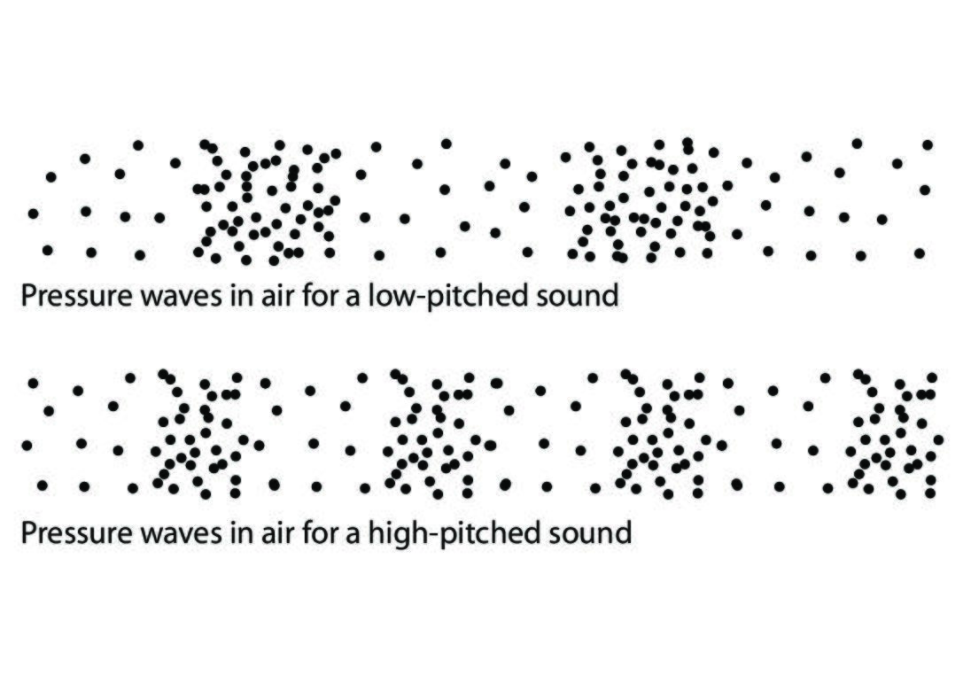
Which image corresponds to what moment in time?
Responses
- The low-pitched sound corresponds to the sound source getting closer; its wavelength is shorter. The high-pitched sound corresponds to the sound source moving away; its wavelength is longer.
- The low-pitched sound corresponds to the sound source moving away; its wavelength is longer. The high-pitched sound corresponds to the sound source getting closer; its wavelength is shorter.
- The low-pitched sound corresponds to the sound source moving away; its wavelength is shorter. The high-pitched sound corresponds to the sound source getting closer; its wavelength is longer.
- The low-pitched sound corresponds to the sound source getting closer; its wavelength is longer. The high-pitched sound corresponds to the sound source moving away; its wavelength is shorter.
A stationary source produces a sound wave at a frequency of 100 Hz. The wave travels at 1125 feet per second. A car is moving toward the sound source at a speed of 100 feet per second. What is the wavelength of the stationary sound source and the wavelength that a person in the car perceives?
Responses
- wavelength of the stationary source: 10.25 ft; perceived wavelength: 11.25 ft
- wavelength of the stationary source: 11.25 ft; perceived wavelength: 10.25 ft
- wavelength of the stationary source: 12.25 ft; perceived wavelength: 11.25 ft
- wavelength of the stationary source: 11.25 ft; perceived wavelength: 12.25 ft
When a guitar string is plucked, what part of the standing wave is found at the fixed ends of the string?
Responses
- the nodes
- the antinodes
- the resonance
- the harmonics
A person is singing in the shower. They notice that as certain notes become very loud, the shower walls vibrate. Which statement describes this effect?
Responses
- The note is one of the harmonic resonance for the shower.
- The note is one of the natural amplitudes for the shower.
- The note is one of the nodes for the shower.
- The note is one of the antinodes for the shower.

Beat Frequency
A piano tuner hears a beat frequency when using a tuning fork to tune a piano wire. The piano tuner should adjust the tension in the wire to
Responses
- decrease the amount of interference and increase the beat frequency.
- increase the amount of interference and decrease the beat frequency.
- increase the amount of interference and increase the beat frequency.
- decrease the amount of interference and decrease the beat frequency.
In which case will a beat frequency most likely occur?
Responses
- two different instruments playing notes at the same frequency
- two of the same instrument playing notes at slightly different frequencies
- two of the same instrument playing notes at the same frequency
- two different instruments playing notes at very different frequencies
How can a person sing into a piano and cause a piano wire to vibrate?
Responses
- The person sings at the same frequency as the piano wire, called the beat frequency.
- The person sings at the same frequency as the piano wire, called the resonance frequency.
- The person sings at a different frequency than the piano wire, called the beat frequency.
- The person sings at a different frequency than the piano wire, called the resonance frequency.
What term is used to describe the combination of two traveling waves in the same material, which can be constructive or destructive depending on whether the waves meet in phase or out of phase?
Responses
- beat frequency
- resonance frequency
- wavelength
- Interference
The wires in a piano vibrate, but fractions of the wire also vibrate at different frequencies than the whole wire. What is the term for the softer notes produced by these different frequencies?
Responses
- interference
- harmonics
- pitch
- Resonance

Characteristics of Waves
Which characteristic is defined as the distance traveled by a wave crest in a given time?
Responses
- amplitude
- wavelength
- speed
- Frequency
How many complete wavelengths are shown in this image? Do not count any partial wavelengths.
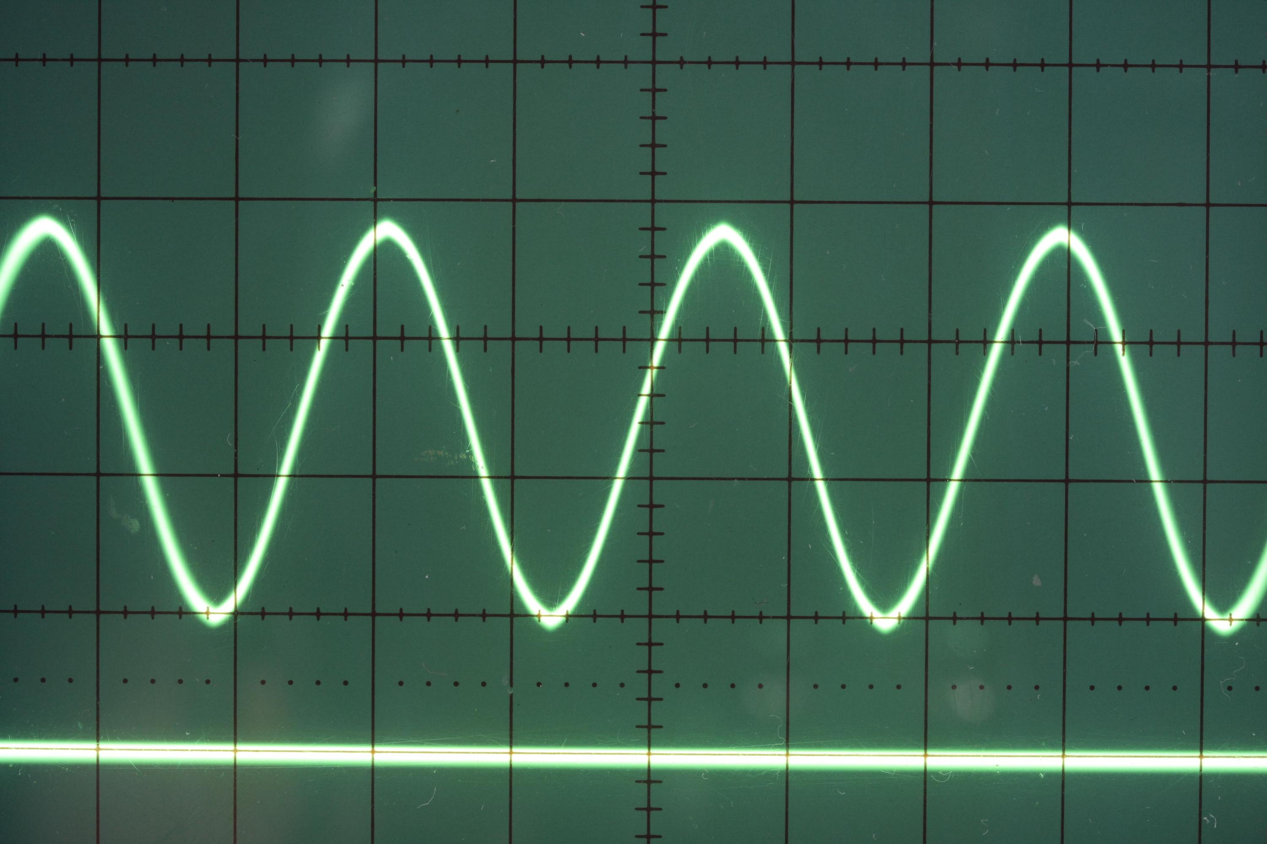
Responses
- 1
- 4
- 3
- 7
Which term describes the distance from the crest of a wave to the next crest?
Responses
- amplitude
- frequency
- speed
- wavelength
Which wave measure is changing by the greatest amount in the image?
Responses
- speed
- wavelength
- amplitude
- Frequency
A surfer talks about riding a 20-foot wave. Which measurement of waves is the surfer describing?
Responses
- frequency
- speed
- wavelength
- amplitude

Frequency and Wavelength
What is the period of a wave with a wavelength of 8 cm and a frequency of 0.5 hertz?
Responses
- 0.125 seconds
- 2 seconds
- 4 seconds
- 0.0625 seconds
Two ropes are identical. A wave traveling through the rst rope has a frequency of 1.5 hertz and a wavelength of 6 meters. What is the frequency of a wave in the second rope if its wavelength is 2 meters?
Responses
- 9 hertz
- 3 hertz
- 1.5 hertz
- 4.5 hertz
If the wavelength of a wave in a particular medium is tripled, what will happen to the frequency of the wave?
Responses
- It will depend on the speed of the wave.
- It will become one third of its original value.
- It will become triple its original value.
- It will remain constant.
If the speed of sound in air is 340 m/s, approximately how long will it take the sound of a clap of thunder to travel 2 kilometers?
Responses
- 1.7 seconds
- 3.4 seconds
- 2.9 seconds
- 5.9 seconds
In music, the note G above middle C has a frequency of about 392 hertz. If the speed of sound in the air is 340 m/s, what is the approximate wavelength of this note?
Responses
- 0.87 meters
- 8.7 meters
- 1.2 meters
- 0.0026 meters

The Speed of Sound
Which statement correctly compares the speed of sound in solids and gases?
Responses
- The speed of sound is generally faster in solids than in gases, because solids are denser than gases.
- The speed of sound is generally faster in solids than in gases, because solids are less dense than gases.
- The speed of sound is generally slower in solids than in gases, because solids are denser than gases.
- The speed of sound is generally slower in solids than in gases, because solids are less dense than gases.
The speed of sound through diamond is about 12,000 m/s. The speed of sound through wood is about 3,300 m/s. Which statement explains why the speed of sound is different through these materials?
Responses
- They have different temperatures.
- They have different phases of matter.
- They have different rigidities.
- They have different salinities.
The table below shows the speed of sound in water at different temperatures and salinities.
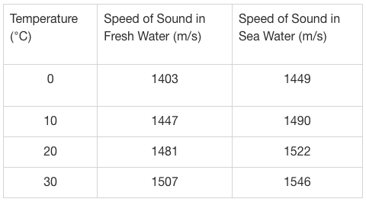
Based on the table, which statement describes the relationship between temperature and the speed of sound in water?
Responses
- Sound travels slower in warmer water, but this occurs only in fresh water.
- Sound travels slower in warmer water, both in fresh water and sea water.
- Sound travels faster in warmer water, both in fresh water and sea water.
- Sound travels faster in warmer water, but this occurs only in fresh water.
A student conducts an experiment in which sound waves pass through air and then through water. Which statement describes the wave speed as it passes from air to water?
Responses
- The speed of sound increases.
- The speed of sound becomes zero.
- The speed of sound decreases.
- The speed of sound remains the same.
The speed of sound in different media at increasing temperatures is shown in the data table below.
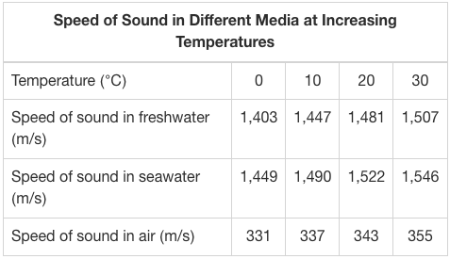
Why does sound travel the slowest in air?
Responses
- The kinetic energy of the molecules of air is too low to transport sound waves.
- The wind blocks the sound waves and carries them in all directions.
- The distance between molecules of air is greater than for molecules of water.
- The temperature of air varies more than the temperature of water.

Waves in Different Media
Which measure does not change when a wave moves from one medium to another?
Responses
- frequency
- amplitude
- wavelength
- Speed
Water waves approaching the shore will slow down. Which statement describes another change that occurs?
Responses
- The frequency decreases.
- The wavelength increases.
- The wavelength decreases.
- The frequency increases.
As a wave travels from one medium to another, its wavelength triples. Which statement describes the speed and frequency in the new medium?
Responses
- The speed will stay the same, and the frequency will also stay the same.
- The speed will stay the same, and the frequency will triple.
- The speed will triple, and the frequency will stay the same.
- The speed will triple, and the frequency will also triple.
Sonar systems used in water send out sound waves that reflect off the environment and then are detected. As water gets denser, the speed of sound in water increases. What would happen to the wavelength of a sonar wave as it moves into water with a 5% higher speed of sound?
Responses
- The wavelength would change to match the new frequency.
- The wavelength would increase by 5%.
- The wavelength would stay the same.
- The wavelength would decrease by 5%.
An earthquake sends seismic waves outward from the epicenter. The waves travel through different media in different directions. What will be true for all people who feel the earth shaking?
Responses
- The earth will rise and fall with the same frequency.
- The seismic waves will travel outward at the same speed in all directions.
- The seismic waves will be equally far apart for all observers.
- The amplitude of the shaking will be the same for all observers.

Wavelength in Different Media
The sound of a plucked guitar string travels through the air and strikes the eardrum of a person in the same room. How does the sound wave change when it transfers from the air to the person’s eardrum?
Responses
- Neither the speed nor the wavelength of the sound change.
- Neither the frequency nor the wavelength of the sound change.
- Both the speed and the wavelength of the sound change.
- Both the frequency and the wavelength of the sound change.
The table shows the speed of sound in various media. Which list orders the media from shortest wavelength to longest wavelength for sound waves that pass through them?
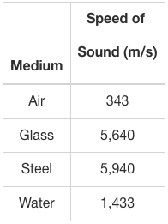
Responses
- air, steel, glass, water
- air, water, glass, steel
- steel, glass, water, air
- glass, steel, air, water
Two different types of rope with different properties are fused together to make one long rope. When a wave transfers from the first type of rope to the second type of rope, the wavelength becomes one-fourth of what it was before the transfer. What is true about the speed of the wave?
Responses
- The speed of the wave becomes double its original speed after the transfer.
- The speed of the wave becomes one-fourth its original speed after the transfer.
- The speed of the wave becomes four times its original speed after the transfer.
- The speed of the wave remains the same after the transfer.
The table shows the speed of sound in various media. If a sound wave transitions from one medium to another, which transition would result in a shortening of the wavelength of the sound wave?
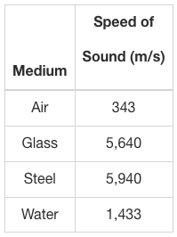
Responses
- air to glass
- air to steel
- water to glass
- steel to water
The table shows the speed of ultrasound waves in different tissues in the human body. If an ultrasound wave moves from one tissue to another tissue in the body, which of the following transitions will result in the largest change in the wavelength of the ultrasound wave?
Responses
- liver to muscle
- fat to liver
- blood to fat
- muscle to kidney

Wave Application
A wave travels at 1,500 m/s with a frequency of 5 hertz. What is its wavelength?
Responses
- 1,505 m
- 1,495 m
- 7,500 m
- 300 m
Humans can hear thunder at dierent frequencies. These correspond to wavelengths ranging from 2.75 to 16.5 meters. If the speed of sound is approximately 330 m/s, what frequencies of thunder can humans hear?
Responses
- 20 to 120 hertz
- 0.0083 to 0.05 hertz
- 2.75 to 16.5 hertz
- 907.5 to 5,445 hertz
Two similar waves X and Y travel through the same medium. Wave X has a frequency of 200 hertz and a wavelength of 35 meters. Wave Y has a frequency of 700 hertz. What is the wavelength for wave Y?
Responses
- 10 meters
- 122.5 meters
- 4,900,000 meters
- 0.1 meter
While traveling in the same medium, sound A has a wavelength of 5 meters, while sound B has a wavelength of 10 meters. Which sound will have a higher pitch?
Responses
- sound A, because it has a higher frequency
- sound A, because it has a lower frequency
- sound B, because it has a higher frequency
- sound B, because it has a lower frequency
California sea lions communicate underwater at frequencies ranging from 500 to 4,000 hertz. The speed of sound in sea water is approximately 1,500 m/s. What are the approximate wavelengths of sound with which the California sea lions communicate?
Responses
- 2,000 to 5,500 meters
- 750,000 to 6,000,000 meters
- 0.375 to 3 meters
- 0.33 to 2.66 meters

Digital and Analog Systems
What kind of code is generally used for sending digital information?
Responses
- analog code 1s and 0s
- analog code continuous waves
- binary code 1s and 0s
- binary code continuous waves
Which statement describes a drawback of digital medical records over paper records?
Responses
- Digital records would be less safe if there was a fire.
- Digital records have no way to limit access to private information.
- Digital medical records might be impossible to access in a power outage.
- Digital records may be more difficult to read than handwritten records.
Which statement is a fair comparison of the advantages and disadvantages of paper versus digital financial records?
Responses
- Digital records are easier to permanently destroy.
- Digital records are easier to access if they are nearby.
- Paper records are easier to send to another person.
- Digital records are easier to store.
Which phrase describes an analog signal and not a digital signal?
Responses
- smooth sinusoidal waves
- binary code
- discrete units of transmission
- very little noise

Pros and Cons of Digital Systems
Which statement presents an advantage and a disadvantage of online banking?
Responses
- Online banking can be done remotely, but there is no noise immunity.
- Online banking is more convenient, but personal information can be stolen.
- Online banking is more accurate, but it breaks down easily.
- Online banking offers more banking options, but a device is required for access.
Which statement describes an advantage and a disadvantage of using cash versus a debit card to make a purchase?
Responses
- Cash can be damaged, but some businesses may not accept it.
- Cash can be used without a device, but it takes up space.
- Cash takes up space, but it may be lost.
- Cash is always accessible, but it can be used when card readers are not available.
Which statement describes an advantage of researchers posting the results of their research online?
Responses
- Other researchers around the world can access it.
- The results may not have noise immunity.
- Special equipment is needed to access the research.
- Hackers may steal the personal information of researchers.
Which statement presents an advantage of using digital systems for voting?
Responses
- The system cannot be hacked to change the results.
- Results will be accurately recorded every time.
- Noise, or signal interference, is unlikely to impact the results.
- People may not know how to work with the system.
Which statement presents a disadvantage of using punch cards instead of paper ballots for voting?
Responses
- A voter’s choice may be hacked through the computer system.
- More ballots end up being thrown away due to noise than with paper ballots.
- There may be multiple holes punched or not punched all the way.
- There are no backups to recount the votes in case of an error.

Waves Practice
Which statement best describes the position of the image of an object viewed in a plane mirror?
Responses
- The image is the same distance from the mirror but on the other side of the mirror as the original object.
- The image is the same distance from the mirror and on the same side of the mirror as the original object.
- The image is a different distance from the mirror and on the other side of the mirror as the original object.
- The image is a different distance from the mirror but on the same side of the mirror as the original object.
Which equation connects the focal length, $$f$$, the position of the viewed object, $$x_{o}$$ and the position of the image, $$x_{i}$$, for a convex lens?
Responses
- $$\frac{1}{f}=\frac{1}{x_{i}}+\frac{1}{x_{o}}$$
- $$f=\frac{1}{x_{i}}+\frac{1}{x_{o}}$$
- $$f=\frac{1}{x_{i}}−\frac{1}{x_{o}}$$
- $$\frac{1}{f}=\frac{1}{x_{i}}−\frac{1}{x_{o}}$$
Which behavior of light does the picture illustrate?
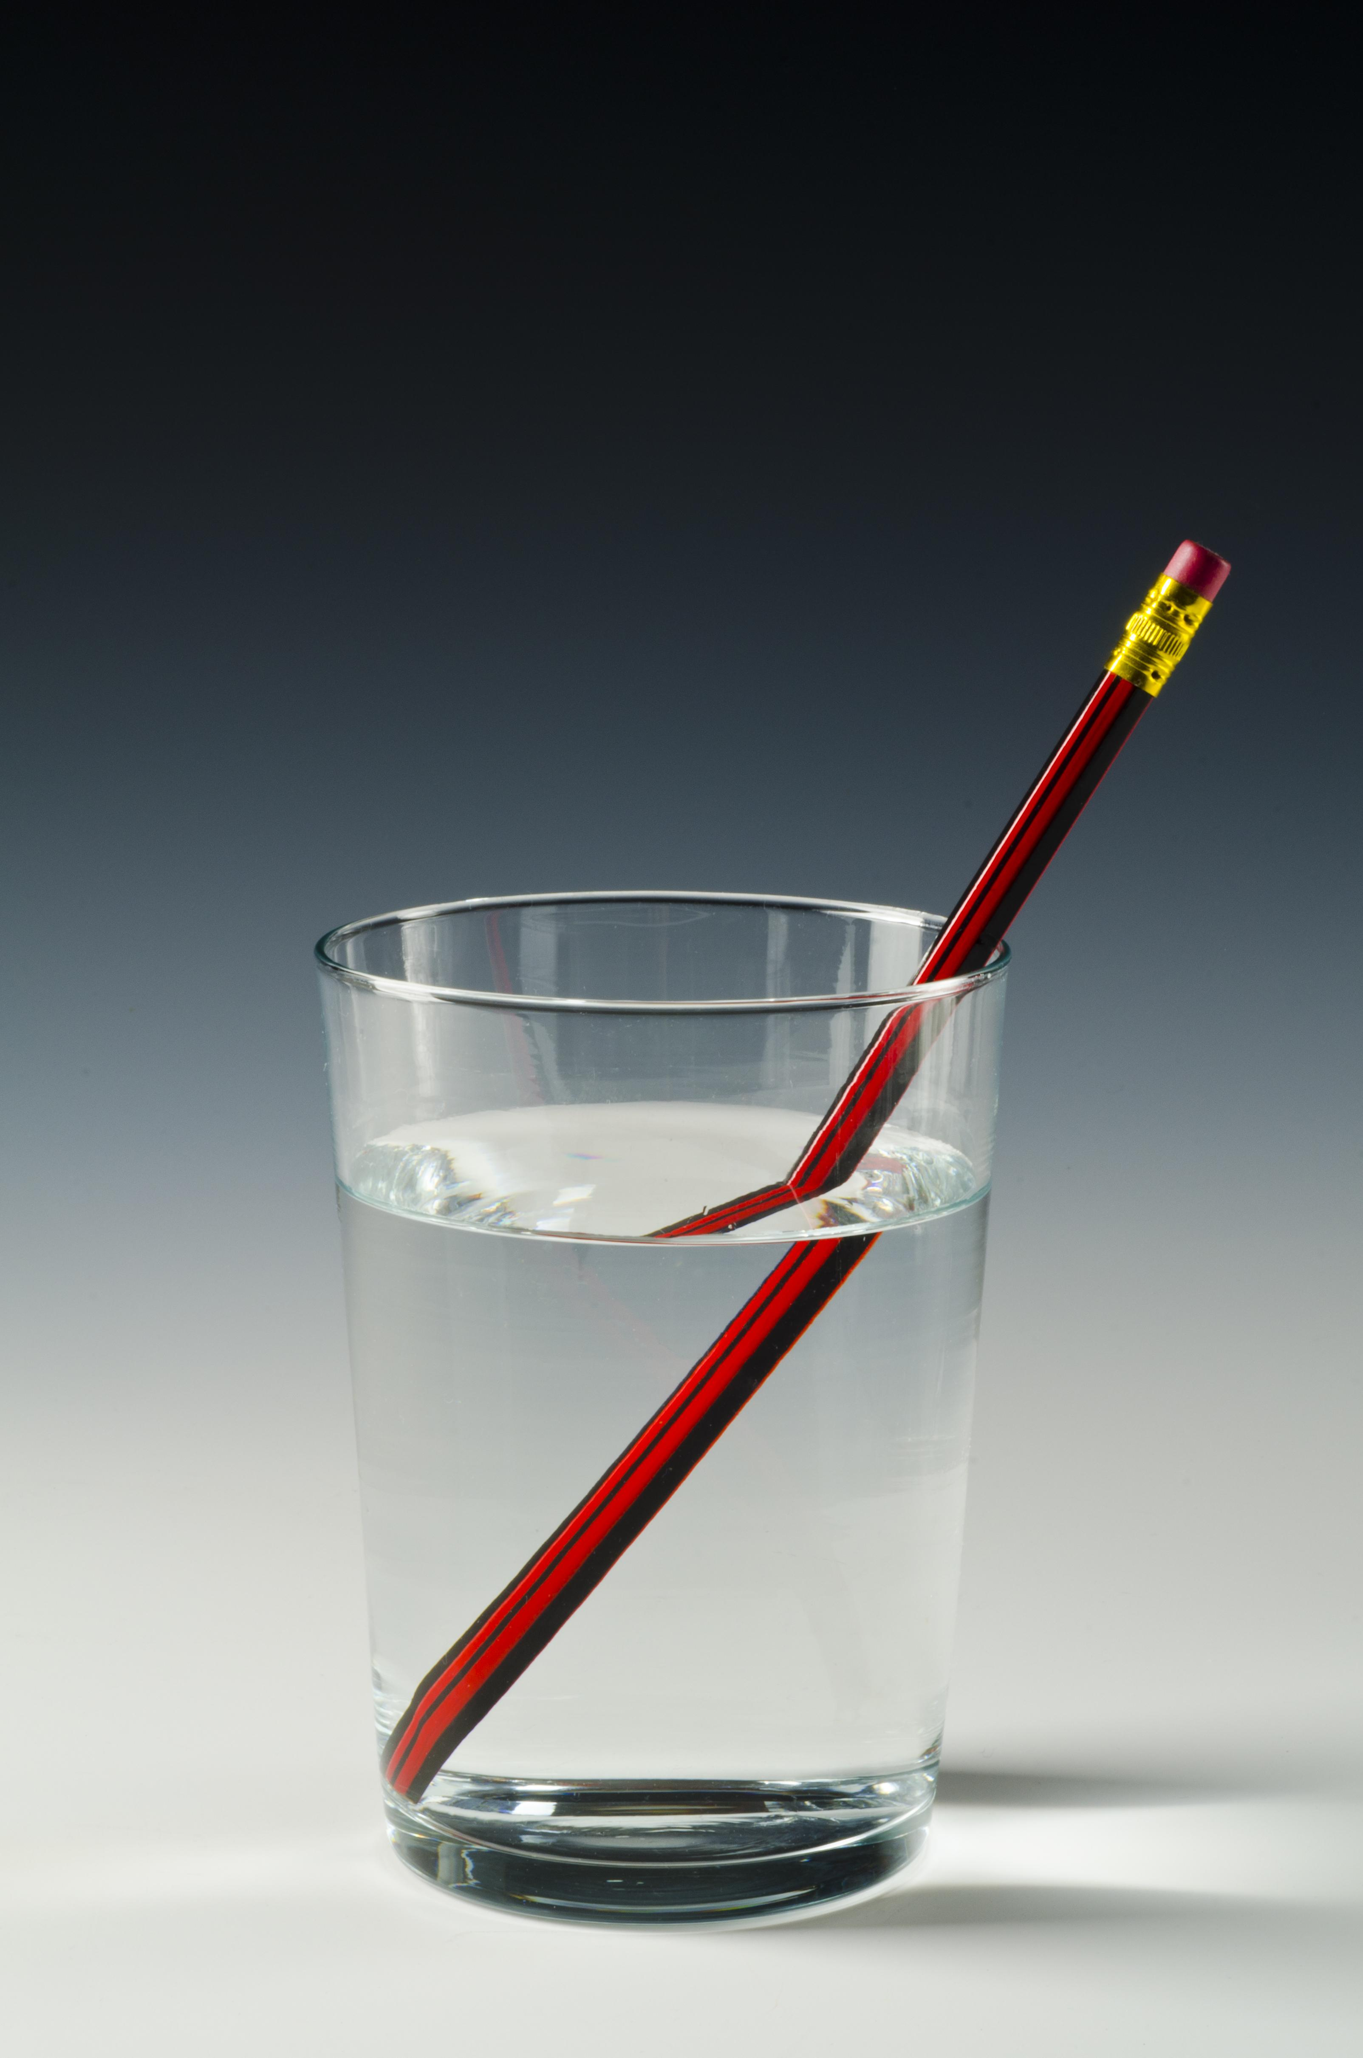
Responses
- superposition
- absorption
- diffraction
- refraction
In spring and summer, the leaves of a maple tree appear green. In autumn, the leaves appear orange. Which statement explains this phenomenon?
Responses
- In spring and summer, the leaves absorb green light and reflect all other colors of light. In autumn, the leaves absorb orange light and reflect all other colors of light.
- In spring and summer, the leaves reflect orange light and absorb all other colors of light. In autumn, the leaves reflect green light and absorb all other colors of light.
- In spring and summer, the leaves absorb orange light and reflect all other colors of light. In autumn, the leaves absorb green light and reflect all other colors of light.
- In spring and summer, the leaves reflect green light and absorb all other colors of light. In autumn, the leaves reflect orange light and absorb all other colors of light.
What should column A be titled?
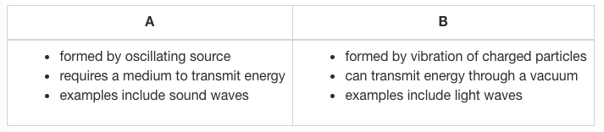
Responses
- surface waves
- seismic waves
- electromagnetic waves
- mechanical waves
A person moves rapidly toward a stationary sound source. Which phrase describes the sound perceived by the person?
Responses
- higher pitch and shorter wavelength
- lower pitch and shorter wavelength
- lower pitch and longer wavelength
- higher pitch and longer wavelength
Which statement best describes the relationship between the column of air (length L) in a trumpet and the notes that it can produce?
Responses
- The wavelengths of the standing waves can be expressed as fractions or whole number multiples of L.
- The wavelengths of the standing waves can be expressed as whole number multiples of L.
- The frequencies of the standing waves can be expressed as fractions of L.
- The frequencies of the standing waves can be expressed as whole number multiples of L.
A frequency of 300 hertz is in interference with another frequency of 302 hertz. Which value is the beat frequency after these frequencies meet?
Responses
- 602 hertz
- 4 hertz
- 300 hertz
- 2 hertz
A person counts the number of water waves reaching the shore every minute. What property of waves does the person observe?
Responses
- wavelength
- speed
- frequency
- Amplitude
Which equation correctly relates the speed of a wave ($$v$$) with its frequency ($$f$$) and its wavelength ($$λ$$)?
Responses
- $$v=\frac{f}{λ}$$
- $$v=fλ$$
- $$λ=\frac{f}{v}$$
- $$λ=fv$$
What is the speed of a wave that has a frequency of 0.6 hertz and a wavelength of 12 meters?
Responses
- 7.2 m/s
- 20 m/s
- 0.005 m/s
- 12.6 m/s
Which statement describes how the speed of sound changes based on the density and temperature of the medium it travels through?
Responses
- The speed of sound increases as density increases, and it increases as temperature increases.
- The speed of sound increases as density decreases, and it increases as temperature decreases.
- The speed of sound increases as density decreases, and it increases as temperature increases.
- The speed of sound increases as density increases, and it increases as temperature decreases.
You are standing next to a pool, singing a song to your friend, who is underwater and waiting patiently for the end of your song. Sound waves move at about 330 m/s in the air and at about 1,480 m/s in the water. Which statement describes the sound waves as they move from air to water?
Responses
- The pitch will become higher.
- The pitch will remain the same.
- The wavelength will become shorter.
- The wavelength will remain the same.
If a sound wave transfers from air to water, which statement is true?
Responses
- The frequency of the wave will remain constant.
- The speed of the wave will become zero.
- The wavelength of the wave will remain constant.
- The speed of the wave will remain constant.
The speed of a wave doubled when it traveled from one medium to another. Which statement about the wave is true?
Responses
- The frequency was doubled when the wave traveled from the first medium to the second medium.
- The frequency was halved when the wave traveled from the first medium to the second medium.
- The wavelength was halved when the wave traveled from the first medium to the second medium.
- The wavelength was doubled when the wave traveled from the first medium to the second medium.
A wave travels at a speed of 330 m/s. The distance between two adjacent wave crests is 30 meters. What is the frequency of the wave?
Responses
- 9,900 hertz
- 11 hertz
- 300 hertz
- 360 hertz
A wave travels from one medium to another. Its frequency stays the same. If the speed in the first medium is greater than the speed in the second medium, how do the wavelengths compare?
Responses
- The wavelength in the first medium is longer than the wavelength in the second medium.
- The wavelength in the first medium is shorter than the wavelength in the second medium.
- The wavelengths are the same because wavelengths can never change.
- The wavelengths are the same because the frequency stays the same.
Which method allows for accurate transmission of information nearly instantly across the world?
Responses
- digital
- analog
- paper
- continuous
What is a disadvantage of landline phones over digital phones?
Responses
- Landline phones require regular software upgrades.
- Landline phones require expensive and complicated repairs.
- With longer distance, there is more signal interference.
- With shorter distance, there is more signal interference.
Which is an advantage of digital systems?
Responses
- ability to store information more reliably
- ability to store information more securely
- ability to transfer information more securely
- ability to transfer information quickly

Waves Unit Test
Suppose that the mirror is moved so that the tree is between the focus point F and the mirror. What happens to the image of the tree?
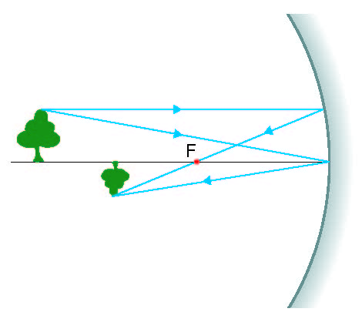
Responses
- The image appears taller and on the same side of the mirror.
- The image stays the same.
- The image moves behind the curved mirror.
- The image appears shorter and on the same side of the mirror.
Which statement best describes the refraction of light as it moves from air to glass?
Responses
- Light undergoes diffraction due to the difference in the speed of light in air and glass.
- Although the light changes speed, it continues in the same direction as before.
- Light bends due to the difference in the speed of light in air and glass.
- Although the light bends, its speed remains the same as before.
What is one way that light waves differ from sound waves?
Responses
- Light waves transfer energy.
- Light waves all have the same frequency.
- Light waves do not require a medium to propagate.
- Light waves travel by oscillation.
How do the frequencies and the speeds of yellow light and blue light compare?
Responses
- The frequency of blue light is greater than that of yellow light, while the speeds of both colors of light are the same.
- The frequency of blue light is greater than that of yellow light, while the speed of yellow light is faster than that of blue light.
- The frequency of yellow light is greater than that of blue light, while the speed of blue light is faster than that of yellow light.
- The frequency of yellow light is greater than that of blue light, while the speeds of both colors of light are the same.
A stationary source produces a sound wave at a frequency of 100 Hz. The wave travels at 1125 feet per second. A car is moving toward the sound source at a speed of 200 feet per second. What is the wavelength of the stationary sound source and the wavelength that a person in the car perceives?
Responses
- wavelength of the stationary source: 11.25 ft; perceived wavelength: 13.25 ft
- wavelength of the stationary source: 11.25 ft; perceived wavelength: 9.25 ft
- wavelength of the stationary source: 13.25 ft; perceived wavelength: 11.25 ft
- wavelength of the stationary source: 9.25 ft; perceived wavelength: 11.25 ft
When the string on a violin vibrates, waves move in both directions along the string, interfering with each other. Sometimes these waves interact to make nodes and antinodes. These waves do not appear to move along the string. What are these kinds of waves called?
Responses
- frequency waves
- longitudinal waves
- transverse waves
- standing waves
Which phrase correctly denes the amplitude of a wave?
Responses
- the vertical distance from the crest or trough of a wave to the equilibrium
- the horizontal distance from the crest of one wave to the crest of the next wave
- the horizontal distance from the trough of one wave to the trough of the next wave
- the vertical distance from the trough of a wave to the crest
The speed of a wave is 2$$\frac{m}{s}$$, and its wavelength 0.4 meters. What is the period of the wave? Remember that period is not the same as frequency.
Responses
- 0.2 seconds
- 0.8 seconds
- 2 seconds
- 5 seconds
The table below shows the speed of sound in water at different temperatures and salinities. Which statement about the speed of sound in freshwater and in seawater is true?
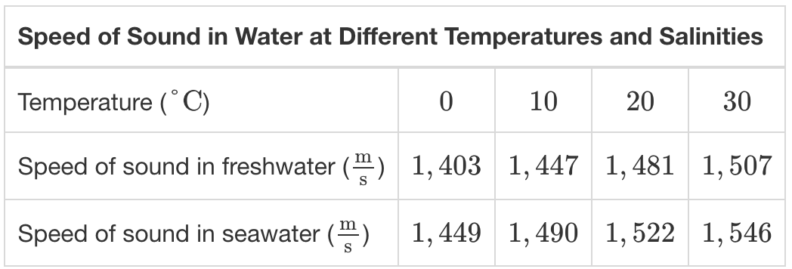
Responses
- The speed of sound increases as the temperature of water increases.
- At 80°C, the speed of sound in freshwater and seawater will be the same.
- Both temperature and salinity decrease the speed of sound in water.
- The speed of sound increases as the salinity of water decreases.
As a wave travels from one spring to another spring with a different mass, its wavelength decreases by 25%. Which statement describes the change in the speed of the wave?
Responses
- The speed decreases by 25% because speed and wavelength are inversely proportional.
- The speed decreases by 25% because speed and wavelength are directly proportional.
- The speed increases by 25% because speed and wavelength are inversely proportional.
- The speed increases by 25% because speed and wavelength are directly proportional.
The table shows the speed of ultrasound waves in different tissues in the human body. What happens to an ultrasound wave that moves from muscle to bone?
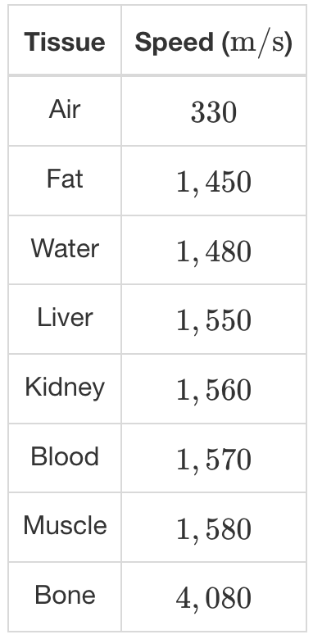
Responses
- The frequency of the wave increases.
- The frequency of the wave decreases.
- The wavelength of the wave increases.
- The wavelength of the wave decreases.
If a wave transfers from one medium to another medium with different properties, which statement is true?
Responses
- The frequency changes, while the wavelength and the speed of the wave remain the same.
- The frequency remains constant.
- The period and the speed of the wave change proportionally.
- The period changes, while the wavelength and the speed of the wave remain the same.
Two waves are traveling at the same speed. Wave $$Α$$has a frequency that is 3 times that of wave $$Β$$. How do their wavelengths compare?
Responses
- $$λ_{Α}=\frac{1}{9}λ_{Β}$$
- $$λ_{Α}=λ_{Β}$$
- $$λ_{Α}=\frac{1}{3}λ_{Β}$$
- $$λ_{Α}=3λ_{Β}$$
Which of these describes digital transmissions and not analog transmissions?
Responses
- smooth
- sine waves
- 1s and 0s
- Continuous
Why might someone choose to use film, rather than digital methods, for photography?
Responses
- Digital images are more difficult to share.
- Film allows you to study a picture immediately.
- Digital photographs are more difficult to store in large quantities.
- Some film methods allow you to print a picture from anywhere without electricity.
Which statement presents an advantage of using electronic ballots?
Responses
- Ballots are immune to electronic bugs and errors.
- Results can be quickly and accurately counted and shared.
- Voters can quickly and accurately learn to use the system.
- Hackers cannot access the system to change the results.
In one or two sentences, make and justify a claim about two aspects of the picture that illustrate behaviors of light.

Responses
Free response
In one to two sentences, describe the relationship between harmonics and resonance frequency in a piano.
Responses
Free response
Sound travels through a guitar string at 600 m/s, making a sound wave in the air with a speed of 333 m/s. In 1–2 sentences, explain how the wavelength and frequency of the wave in the string compare to the wavelength and frequency of the wave in the air.
Responses
Free response
A graphic designer has the choice to download design software on her computer and then design a logo or to use an online version of the software to design the logo. Identify one advantage and one disadvantage of using the online software to design the logo.
Responses
Free response

Semester Review and Exam

Semester Practice
Which statement about class 2 levers is correct?
Responses
- The fulcrum is located between the load and effort.
- The load is located between the fulcrum and the effort.
- The effort is located between the fulcrum and the load.
- The location of the load depends on the height of the fulcrum.
A housepainter uses a lever to open a can of paint. Which statement is correct?
Responses
- The force that the painter applies to the lever is the same as the force that the lever applies to the lid.
- The force that the painter applies to the lever is greater than the force that the lever applies to the lid.
- The painter can use less force if he presses on the lever closer to the can.
- The force that the painter applies to the lever is less than the force that the lever applies to the lid.
Which is an example of a simple machine?
Responses
- remote-control toy car
- teeter-totter
- freezer
- Yardstick
Why would a lunar rock weigh more when it is brought back to Earth?
Responses
- Earth’s gravitational acceleration is greater than the Moon’s.
- The Moon’s gravitational acceleration is greater than Earth’s.
- The rock’s mass will increase when it reaches Earth.
- Earth is closer to the Sun than the Moon is.
A student reads about a block of ice that falls from an airplane into a person’s backyard. What information does she need in order to calculate the block’s terminal velocity?
Responses
- the block’s area presented to air and drag coefficient; air density
- the block’s mass and average velocity
- the block’s weight, area presented to air, and drag coefficient; air density
- the block’s weight, area presented to air, and coefficient of drag
Which student is using creative thinking to explore the factors that affect kinetic energy?
Responses
- Melissa watches several demonstrations of kinetic energy online and then writes a report.
- Jaime finds two objects with different masses and figures out a way to demonstrate their kinetic energies at the same velocity.
- Ryan records the work of a team of students who is helping perform a demonstration of kinetic energy.
- Tiffany watches her science teacher demonstrate kinetic energy and then does the demonstration at home for her brother.
A mass of 0.25 kg is attached to a spring with a spring constant of 12.25 N/m and held vertically. The mass drops for 80 cm before it stops moving. Which statement describes the mechanical energy in the system?
Responses
- The system demonstrates conservation of mechanical energy because the increase in elastic potential energy equals the decrease in gravitational potential energy.
- The system does not demonstrate conservation of mechanical energy because the increase in elastic potential energy does not equal the decrease in gravitational potential energy.
- The system demonstrates conservation of mechanical energy because the decrease in elastic potential energy equals the increase in gravitational potential energy.
- The system does not demonstrate conservation of mechanical energy because the decrease in elastic potential energy equals the increase in gravitational potential energy.
A company invents a device that prints logos on t-shirts by pushing ink through the fabric using an electric field. What characteristic must the ink have?
Responses
- It must be made of charged particles.
- It must be made of powder.
- It must be liquid.
- It must be available in different colors.
Two donut-shaped magnets are stacked on top of each other with a dowel rod through their centers. The north poles of the magnets are facing each other, and a heavy weight is placed on top. The weight is then removed, and the magnets are free to move. Which statement accurately describes the kinetic energy of the system?
Responses
- Kinetic energy decreases because the upper magnet will move in the direction of the magnetic field.
- Kinetic energy increases because the upper magnet will move in the direction of the magnetic field.
- Kinetic energy increases because the upper magnet will move in the opposite direction of the magnetic field.
- Kinetic energy decreases because the upper magnet will move in the opposite direction of the magnetic field.
An electromagnet’s wire is reoriented such that the current is now moving straight out of this page or screen. Which statement describes the direction of the magnetic field?
Responses
- It is moving straight out of this page or screen.
- It is moving in a counterclockwise direction.
- It is moving toward this page or screen.
- It is moving in a clockwise direction.
What describes a similarity and difference between gravity and the electromagnetic force?
Responses
- Both vary with mass but the electromagnetic force only acts on charged matter.
- Both act on all matter but the influence of the electromagnetic force varies with mass.
- Both vary with mass but gravity only acts on charged matter.
- Both act on all matter but the influence of gravity varies with mass.
Which example best shows a student using lifelong learning skills to explore kinetic and thermal energy?
Responses
- He learns that adding thermal energy to a substance increases the kinetic energy of its atoms, and connects that information to what he already knows about kinetic energy.
- He tries to remember everything his teacher says about thermal energy and kinetic energy.
- He reads that adding thermal energy to a substance increases its kinetic energy.
- He takes notes about the connection between thermal energy and kinetic energy because he believes it will be on an exam, but he does not review the notes.
What is the best description of heat?
Responses
- thermal energy
- the transfer of thermal energy from a warmer object or substance to a cooler object or substance
- the transfer of potential energy from one object or substance to another
- the measure of the average kinetic energy of the particles in an object or substance
Why does powder tea dissolve more quickly in warm water than in cold water?
Responses
- The molecules of warm water have more kinetic energy than molecules of cold water.
- The molecules of warm water have more potential energy than molecules of cold water.
- Powder tea is attracted to molecules of warm water.
- The molecules of warm water move around less than the molecules of cold water.
Which scenario shows conduction?
Responses
- People warm their hands in front of a fireplace.
- A book warms in the sun.
- Ice cubes are placed in a glass of water.
- Hot tomato sauce rises to the top of a pot, pushing cooler sauce to the bottom.
A student is testing the strength of his electromagnet after changing the number of coils of wire around its core. He uses the electromagnet to pick up paperclips. Why should he use only one size of paperclip?
Responses
- because it will be easier to count the paperclips
- so there is only one variable, the number of coils of wire
- because the electromagnet will be able to pick up more paperclips
- so that the experiment can be reproduced
A team of students wants to build an electromagnet. What do they need to do?
Responses
- They need to coil a wire around an iron or steel core at least ten times.
- They need to attach a wire to one end of a battery, coil the wire around an iron or steel core several times, and attach the other end of the wire to the other end of the battery.
- They need to use a wire to connect one end of a battery with an iron or steel core, then use another wire to connect the other end of the battery to the core.
- They need to attach one end of a wire to a battery, then attach the other end of the wire to an iron or steel core.
Which statement is true about the image of an object when viewed in a concave or convex mirror?
Responses
- When viewed in a concave mirror, the image is always upright and behind the mirror.
- When viewed in a concave mirror, the image is always inverted and in front of the mirror.
- When viewed in a convex mirror, the image is always inverted and in front of the mirror.
- When viewed in a convex mirror, the image is always upright and behind the mirror.
Which two behaviors of light both involve the bending of light waves?
Responses
- refraction and absorption
- refraction and diffraction
- reflection and diffraction
- reflection and absorption
In an orchestra, a tympani player tunes two drums so that one drum plays a lower note than the other drum. Which statement about the waves formed by striking the drums is true?
Responses
- The wavelength of the wave from the drum with the lower note is longer.
- The frequency of the wave from the drum with the lower note is greater.
- The wavelengths of the waves formed by striking both drums are the same.
- The frequencies of the waves formed by striking both drums are the same.
What causes a wave to stretch out when moving to a different medium?
Responses
- an increase in frequency
- an increase in wave speed
- a decrease in frequency
- a decrease in wave speed
In 1 minute, 1,200 cycles of a wave pass through a given point. If the wavelength of this wave is 10 meters, at what speed is the wave traveling?
Responses
- 120 m/s
- 2 m/s
- 12,000 m/s
- 200 m/s
Which statement accurately evaluates the benefits of different options for storing information?
Responses
- Digital files are beneficial because no specialized equipment is needed to access them.
- Digital files are beneficial because they can be accessed without electricity.
- Paper files are beneficial because they are harder to steal and distribute.
- Paper files are beneficial because they do not degrade over time.
Ultraviolet waves are more dangerous to humans than microwaves of the same intensity because they
Responses
- have a larger frequency and shorter wavelength and therefore less energy.
- are faster and therefore have more energy.
- have a larger frequency and shorter wavelength and therefore more energy.
- have a shorter frequency and longer wavelength and therefore more energy.

Semester Exam
A gardener uses a wheelbarrow to move 20 kilograms of soil from a compost pile to a flower bed, a distance of 53 meters. The wheelbarrow has a mass of 17 kilograms. He expends 94.5 Newtons of force. How much work does the gardener do?
Responses
- 5,008.5 N
- 135.4 N
- 3,496.5 N
- 1,961 N
A mechanic wants to use a compound pulley to lift a go-kart from the ground to work table, a distance of 1.2 meters. Without the pulley, 1,620 Newtons of force would be needed to lift the gokart. If the pulley has a mechanical advantage of 4, how much force must the mechanic expend?
Responses
- 5,400 N
- 405 N
- 1,616 N
- 1,350 N
What is the advantage of class 3 lever?
Responses
- It decreases the distance over which force needs to be applied.
- It decreases the amount of work that needs to be done.
- It increases the mechanical advantage compared with other levers.
- It decreases the amount of force that needs to be applied.
Gardeners would need to use 960 Newtons of force to lift a potted tree 45 centimeters onto a deck. Instead, they set up a lever. If they press the lever down 2 meters, how much force do they use to lift the tree?
Responses
- 216 N
- 432 N
- 21,600 N
- 1,920 N
A team of students builds a lever as a science project. They expend 10,300 Joules of energy to lift some bricks with the lever. If 6,283 Joules of energy are applied to the bricks, what is the lever’s efficiency?
Responses
- 164%
- 0.61%
- 61%
- 39%
The gravitational force of a lunar rover is 1,607.2 Newtons on Earth. What will the rover’s gravitational force be on the Moon? On Earth, g = 9.8
𝑚𝑠2ms2
On the Moon, g = 1.62
𝑚𝑠2ms2

Responses
- 265.7 N
- 2,603.7 N
- 164 N
- 992.1 N
Which sentence best describes how a self-directed learner might investigate gravity?
Responses
- She would only follow her teacher’s instructions for testing the effects of gravity.
- She would think of a way to test the effect of gravity, develop a plan, and carry out the investigation.
- She would only join a team of students that is carrying out a gravity experiment.
- She would only repeat a gravity experiment that she researched online.
Which sentence best describes a self-directed learner?
Responses
- She makes sure to complete all class projects and homework.
- She uses her own initiative to set learning goals, find resources, and plan how to carry out investigations.
- She rushes through a project very quickly.
- She always gets good grades.
Which student is using innovative problem-solving to investigate potential energy and kinetic energy?
Responses
- Meghan replicates a demonstration of potential energy and kinetic energy she found in her science textbook.
- William searches the internet for experiments involving potential and kinetic energy, chooses one, and carries it out.
- Lisa thinks about ways that potential energy and kinetic energy occur in her own life, chooses one, and designs a demonstration to show the relationship between the two kinds of energy.
- Pedro researches potential and kinetic energy at the library and writes a report on the relationship between them.
How much more kinetic energy does a 6-kilogram bowling ball have when it is rolling at 16 mph (7.1 meters per second) than when it is rolling at 14 mph (6.2 meters per second)? $$KE=\frac{1}{2}mv^{2}$$
Responses
- 151.2 J
- 35.9 J
- 266.5 J
- 1.3 J
Where do the forces that make atoms interact come from?
Responses
- from the electric fields of neutral molecules
- from the electric fields of charged molecules
- from the electric fields of charged subatomic particles
- from the electric fields of neutral subatomic particles
When two charged particles are moving toward each other, their velocities decrease until they eventually come to a stop. What happens afterward?
Responses
- They accelerate in opposite directions.
- They bond and accelerate together.
- They remain in the same place without moving.
- They accelerate toward each other.
A bar magnet is held in place while another bar magnet is placed near it. The second bar magnet spins around and attaches to the first magnet on one end. Which statement is correct about the energy stored in the magnetic field?
Responses
- The increase in the energy stored in the system is proportional to the decrease in kinetic energy.
- The decrease in the energy stored in the system is proportional to the increase in kinetic energy.
- The decrease in the energy stored in the system is proportional to the decrease in kinetic energy.
- The increase in the energy stored in the system is proportional to the increase in kinetic energy.
Which of the following factors would decrease the magnetic eld strength of an electromagnet?
Responses
- increasing the distances between the turns of the coil
- increasing the number of turns in the coil of wire
- using an iron core or nail
- increasing the current or using a higher-voltage power source
What happens when thermal energy is applied to water?
Responses
- The water creates steam as soon as thermal energy is applied.
- Its molecules gain kinetic energy.
- Its molecules lose kinetic energy.
- Its molecules gain potential energy.
What is the best description of heat?
Responses
- thermal energy
- the transfer of thermal energy from a warmer object or substance to a cooler object or substance
- the transfer of potential energy from one object or substance to another
- the measure of the average kinetic energy of the particles in an object or substance
What is the relationship between heat and thermal conductors?
Responses
- Thermal conductors allow all of the thermal energy in one object or substance to be easily transferred to another object or substance.
- Thermal conductors facilitate heat, the transfer of thermal energy.
- Thermal conductors have no effect on heat.
- Thermal conductors impede heat, the transfer of thermal energy.
Which scenario shows radiation?
Responses
- Eggs boil in a pot of water.
- Air warmed by a floor radiator rises to the top of a room, forcing cooler air downward.
- Eggs cook in a skillet.
- The air under a reading lamp is warmed.
Which pair of objects will have an attractive electric force?
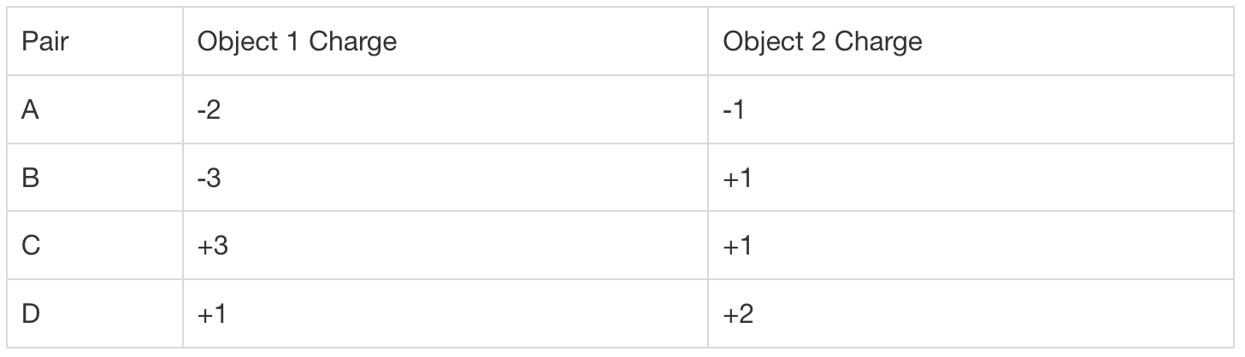
Responses
- Pair A
- Pair B
- Pair D
- Pair C
How does the structure of atoms in a substance determine the substance’s conductivity?
Responses
- If an atom’s outer shell of electrons is loosely bound to the nucleus, the substance is a good conductor.
- If an atom’s outer shell of electrons is positively charged, the substance is a good conductor.
- If an atom’s outer shell of electrons is tightly bound to the nucleus, the substance is a good conductor.
- If an atom’s nucleus is positively charged, the substance is a good conductor.
Students build four electromagnets and test them by picking up metal tacks. Here are their partial results.
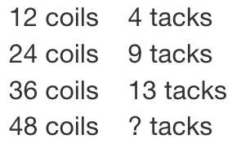
Which is the best prediction for the number of nails the electromagnet with 48 coils will pick up?
Responses
- 20 tacks
- 12 tacks
- 16 tacks
- 13 tacks
How do electromagnets cause a maglev train to levitate above the track?
Responses
- Magnets in the track and magnets in the bottom of the train repel each other.
- Magnets in the sides of the tracks constantly repel and attract magnets in the sides of the train.
- Batteries provide electric energy to the electromagnets in the train.
- Magnets in the track and magnets in the bottom of the train attract each other.
Which of these best describes the type of lens shown in the ray diagram?
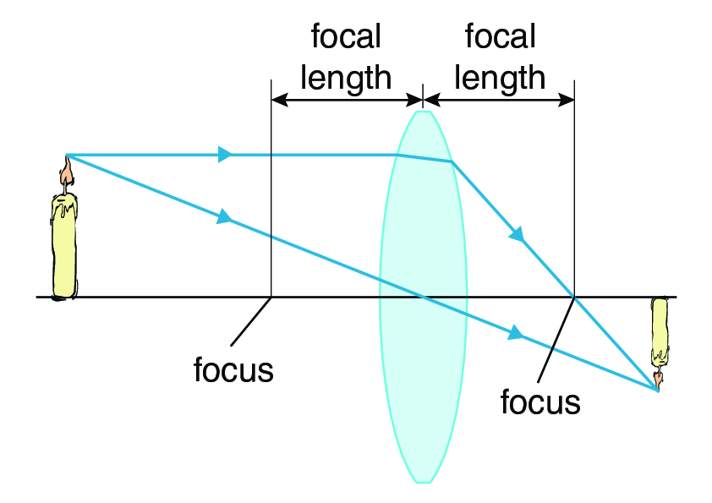
Responses
- It shows a concave lens. For this type of lens, the image position depends on the object's position relative to the focus point.
- It shows a convex lens. For this type of lens, the image is always on the opposite side of the lens as the original object.
- It shows a concave lens. For this type of lens, the image is always on the opposite side of the lens as the original object.
- It shows a convex lens. For this type of lens, the image position depends on the object's position relative to the focus point.
What happens to sound waves from an object as it moves toward you?
Responses
- The pitch gets higher because of an increase in frequency.
- The pitch gets higher because of an increase in wavelength.
- The pitch gets lower because of an increase in wavelength.
- The pitch gets lower because of an increase in frequency.
Which combination of frequencies would produce the lowest beat frequency?
Responses
- 10 Hz and 20 Hz
- 10 Hz and 15 Hz
- 500 Hz and 501 Hz
- 500 Hz and 600 Hz
A sound has a higher pitch than a bell. Which quantity must also be higher in this sound than in the bell?
Responses
- speed
- frequency
- amplitude
- wavelength
Which statement regarding sound traveling in air is correct?
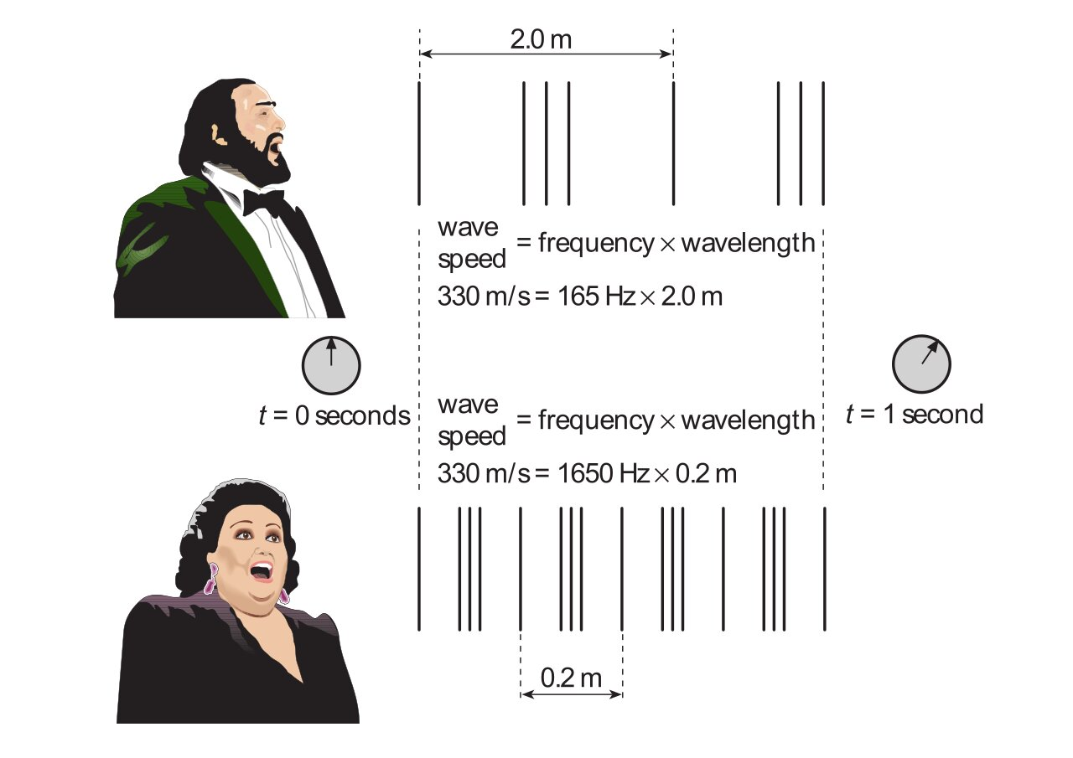
Responses
- A wave with a shorter wavelength is always faster than one with a longer wavelength.
- The frequency of a sound does not affect the speed at which it travels.
- As the wavelength increases, the frequency also increases.
- A loud sound travels faster than a quiet sound.
Which statement about the effect of temperature on the speed of sound is correct?
Responses
- As temperature increases, the speed of sound increases because the medium becomes denser.
- As temperature increases, the speed of sound decreases because molecules in the medium collide less frequently.
- Changes in temperature have no effect on the speed of sound.
- As temperature increases, the speed of sound increases because molecules in the medium collide more frequently.
Which forms of electromagnetic radiation are arranged in order of increasing energy?
Responses
- gamma rays, ultraviolet, microwaves, infrared
- microwaves, infrared, ultraviolet, gamma rays
- microwaves, ultraviolet, infrared, gamma rays
- infrared, gamma rays, microwaves, ultraviolet
A student is using a weak computer to design a logo. If the weak computer is the only constraint, should the student use the online version or downloaded version of a graphic design software?
Responses
- The downloaded version, because the online version may have limited bandwidth that limits how quickly the designer can work.
- The online version, because the downloaded version may have limited bandwidth that limits how quickly the designer can work.
- The downloaded version, because the online version usually requires better equipment than the downloaded version.
- The online version, because the downloaded version usually requires better equipment than the online version

