Geometry A Unit Test Guide

Transformations Unit Test

Item | Lesson Coverage | Objective | Mathematical Practice Standard | Lesson Page | Assessment Item
1 | Lesson 2: Translations | In this section, you will apply geometric descriptions of rigid motions to translate figures. | Look for and express regularity in repeated reasoning. | p. 1-6 | Use the image to answer the question.  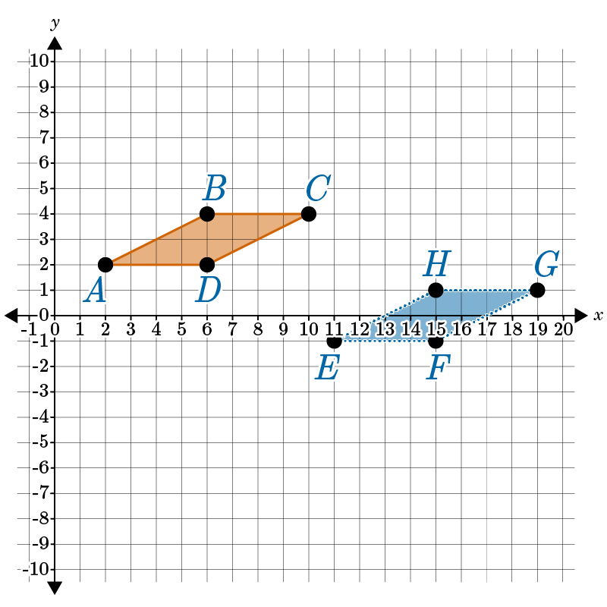  What kind of translation has been done to quadrilateral ABCD?  Quadrilateral ABCD has been translated _____ units to the right and _____ units down.  Answer: 9; 3  Transformation Unit Test Item #1 - GeoGebra
2 | Lesson 2: Translations | In this section, you will draw a geometric figure that undergoes a translation in the coordinate plane. | Attend to precision. | p. 7-16 | Use the image to answer the question.  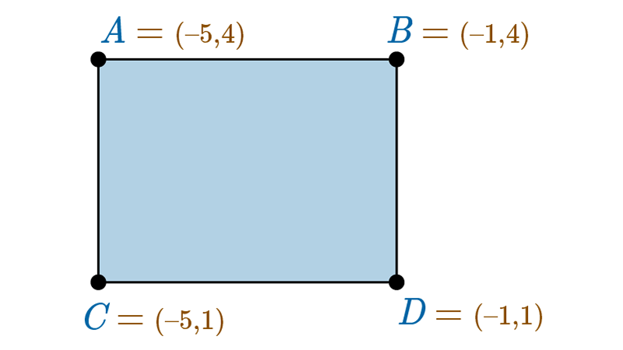  Jarvis wants to translate rectangle ABCD horizontally by -4 and vertically by +3 to produce rectangle A’B’C’D’. What will be the coordinates of C’ after Jarvis completes this translation?  (___, ___)  Answer: -9; 4  Transformations Unit Test Item #2 - GeoGebra
3 | Lesson 3: Translations as Functions | In this section, you will use a function to translate a figure on a coordinate plane. | Look for and make use of structure. | p. 1-7 | Lucy draws a line with the equation $y = 3x + 2$. She translates the line by shifting it one unit to the right and two units up. Which is the equation of the new line?  Answer: $y = 3x + 1$  Transformations Unit Test Item #3 - GeoGebra
4 | Lesson 3: Translations as Functions | In this section, you will create a function that describes a given translation on a coordinate plane. | Look for and make use of structure. | p. 8-15 | A point is translated on the coordinate plane from (4, -1) to (4, 2). Journey writes the function $g(y)=y+k$ to describe the translation. What is the value of k?  Answer: 3
5 | Lesson 4: Reflections | In this section, you will apply geometric descriptions of rigid motions to reflect figures. | Look for and express regularity in repeated reasoning. | p. 1-6 | Use the image to answer the question.  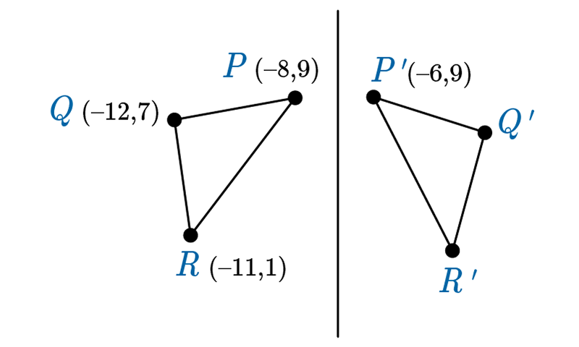  Triangle PQR is reflected over a vertical line of reflection to create triangle P’Q’R’. What are the coordinates of point R’?  Answer: (-3, 1)  Transformations Unit Item Test #5 - GeoGebra
6 | Lesson 4: Reflections | In this section, you will draw a geometric figure that undergoes a reflection in the coordinate plane. | Attend to precision. | p. 7-17 | Use the image to answer the question.  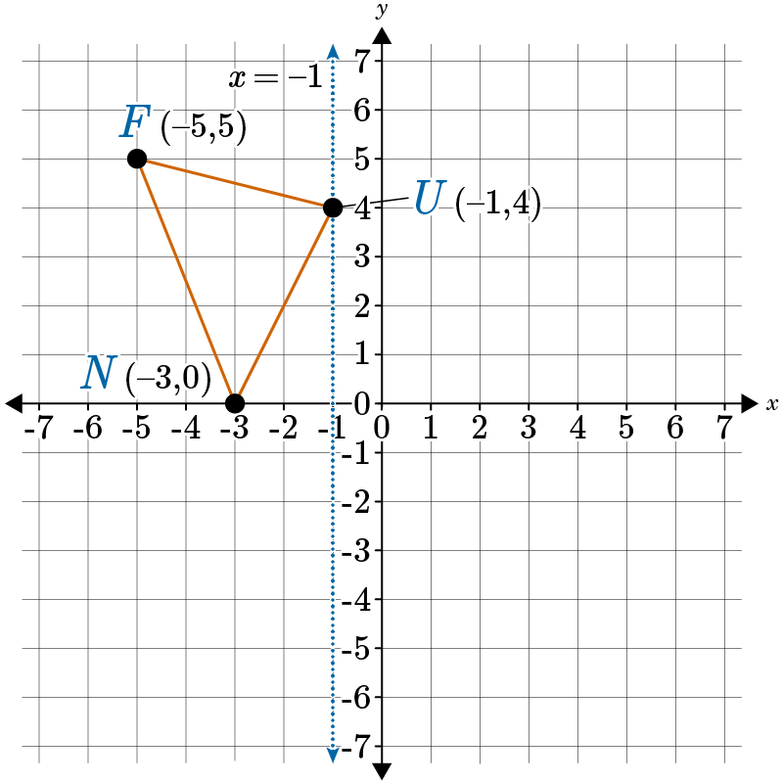  For $∆FUN, x=-1.$ What are the coordinates for F’ after a reflection?  Answer: F’ (3, 5)  Transformation Unit Test Item #6 - GeoGebra
7 | Lesson 5: Reflections as Functions | In this section, you will use a function to reflect a figure in the coordinate plane. | Identify and make use of structure. | p. 1-6 | The coordinate point Q (0, 10) is reflected over the y-axis. Identify the x- and y-coordinates of its image, Q’.  The coordinates of Q’ are (___, ___) after a reflection over the y-axis.  Answer: 0; 10  Transformations Unit Test Item #7 - GeoGebra
8 | Lesson 5: Reflections as Functions | In this section, you will create a function that describes a given reflection in the coordinate plane. | Identify and make use of structure. | p. 7-12 | The function $f\left(x\right)=x^{2}-1$ is reflected over the y-axis. Choose the equation that correctly identifies $g(x)$.  Answer: $g\left(x\right)=x^{2}-1$  Transformation Unit Test Item #8 - GeoGebra
9 | Lesson 6: Rotations | In this section, you will apply geometric descriptions of rigid motions to rotate figures. | Look for and express regularity in repeated reasoning. | p. 1-7 | The point P (-1, 2) is rotated to become P’ (2, 1). Describe the rotation by degree and direction.  Answer: $-90°$ rotation  Transformations Unit Test Item #9 - GeoGebra
10 | Lesson 6: Rotations | In this section, you will draw a geometric figure that undergoes a rotation in the coordinate plane. | Attend to precision. | p. 8-14 | The point Q (-5, -9) is rotated $-270°$ about the origin. Select the location of Q’.  Answer: Q’ (9, -5)  Transformations Unit Test Item #11 - GeoGebra
11 | Lesson 7: Rotations as Functions | In this section, you will use a function to rotate a figure in the coordinate plane. | Identify and make use of structure. | p. 1-6 | A quadrilateral with vertices G (−10, 1), E (−6, −4), O (2, 0), and M (0, 4) is rotated about the origin 270 degrees (counterclockwise). Apply rotation mapping rules to find the image of M.  M’ (___, ___)  Answer: 4; 0  Transformations Unit Test item #11 - GeoGebra
12 | Lesson 7: Rotations as Functions | In this section, you will create a function that describes a given rotation in the coordinate plane. | Look for and make use of structure. | p. 7-13 | A figure is rotated 90 degrees counterclockwise about the origin. Which of the following function mappings was applied? Enter the number of the correct option.  Option #1: $(x, y) → (y, -x)$  Option #2:$(x, y) → (-y, x)$  Option #3: $(x, y) → (-x, -y)$  Option #4: $(x, y) → (y, x)$  The mapping for a 90-degree counterclockwise rotation is Option #___.  Answer: 2
13 | Lesson 8: Symmetry | In this section, you will summarize the rotations that transform a rectangle, parallelogram, trapezoid, or regular polygon onto itself. | Identify and express regularity in repeated reasoning. | p. 1-7 | Provide two different degrees of rotation less than $150°$but greater than $0°$ that will turn a regular pentagon onto itself.  A regular pentagon will turn onto itself after a ___$°$ and ___$°$rotation.  Answer: 72; 144
14 | Lesson 8: Symmetry | In this section, you will summarize the reflections that carry a rectangle, parallelogram, trapezoid, or regular polygon onto itself. | Look for and express regularity in repeated reasoning. | p. 8-14 | Use the image to answer the question.  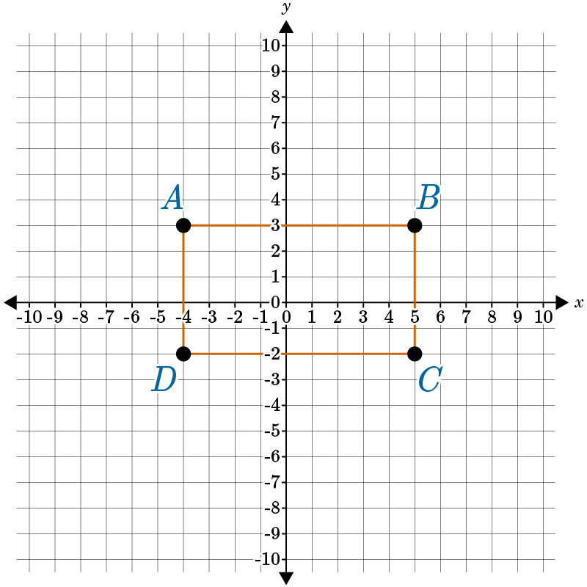  Complete the equations identifying both lines of reflection that will flip the given figure onto itself.  The lines of reflection are x = ___ and y =___.  Answer: 0.5; 0.5
15 | Lesson 10: Comparing Rigid Transformations | In this section, you will create definitions of rotations, reflections, and translations in terms of angles, circles, perpendicular lines, parallel lines, and line segments. | Make sense of problems and persevere in solving them. | p. 1-8 | Use the image to answer the question.  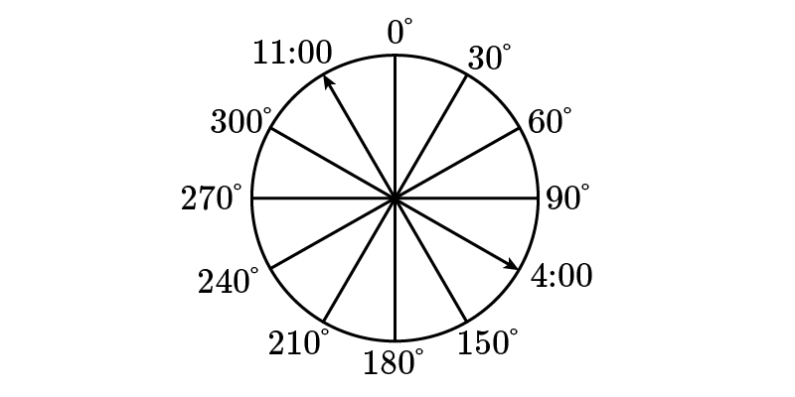  A circle measures 360 degrees. If this circle were marked with numbers like a clock, every number would represent 30 degrees farther from 0 and closer to 360 degrees. If an angle marker typically found at 11:00 were to rotate to the place normally marked for 4:00, what is the degree measure of the angle formed moving clockwise?  Answer: 150 degrees
16 | Lesson 10: Comparing Rigid Transformations | In this section, you will compare transformations that preserve distance and angle measure to those that do not. | Look for and express regularity in repeated reasoning. | p. 9-14 | Use the image to answer the question.  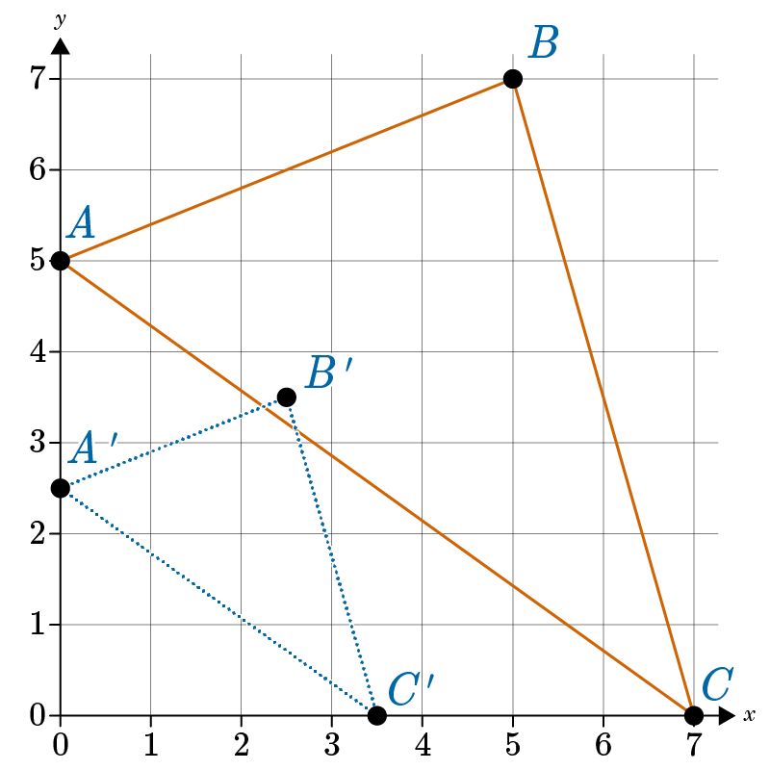  What type of transformation can map $∆ABC→∆A'B'C'$?  Answer: no rigid transformation can make this transformation
17 | Lesson 11: Making Predictions with Transformations | In this section, you will apply geometric descriptions of rigid motions to predict the effect of a given rigid motion on a given figure | Identify and express regularity in repeated reasoning. | p. 1-6 | A double reflection of a preimage across perpendicular lines produces the same result as a:  Answer: 180-degree rotation.
18 | Lesson 9: Compositions of Transformations | In this section, you will use the definition of congruence as it applies to rigid motions to assess two figures and determine whether they are congruent. | Look for and express regularity in repeated reasoning. | p. 1-6 | Use the image to answer the question.  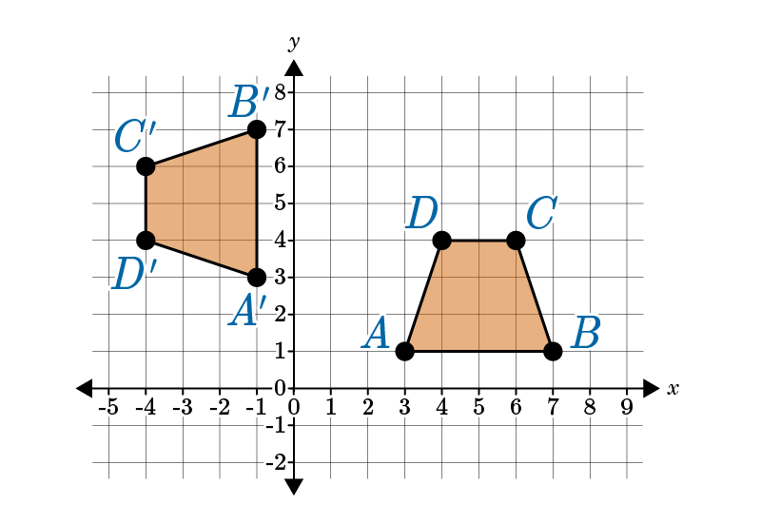  Which explanation for the congruency of the trapezoids is correct?  Statement #1: The trapezoids are congruent because ABCD was reflected over the line $y=x$.  Statement #2: The trapezoids are congruent because ABCD was translated left 4 units and up 2 units.  Statement #3: The trapezoids are congruent because ABCD was rotated $270°$(counterclockwise).  Statement #4: The trapezoids are congruent because ABCD was rotated $90°$ (counterclockwise).  Statement #___ is correct.  Answer: 4
19 | Lesson 9: Compositions of Transformations | In this section, you will identify a sequence of transformations that will carry a given figure onto another. | Look for and express regularity in repeated reasoning. | p. 7-12 | What composition transformation rule has $∆LMN$, $L (1, 1), M (7, 2), and N (5, 7)$ map onto $∆L"M"N"$, $L" (2, -1), M" (-4, 0), and N" (-2, 5)$?  Answer: a reflection across the y-axis and a move to the right by 3 and down by 2  Transformations Unit Test Item #19 - GeoGebra
20 | Lesson 8: Symmetry | In this section, you will summarize the rotations that transform a rectangle, parallelogram, trapezoid, or regular polygon onto itself. | Identify and express regularity in repeated reasoning. | p. 1-7 | In 3–5 sentences, summarize the rotations that carry a regular pentagon onto itself.  Answer: Student answers should state that a regular pentagon is a five-sided figure that has all its sides and interior angles congruent. An example looks like the following diagram:  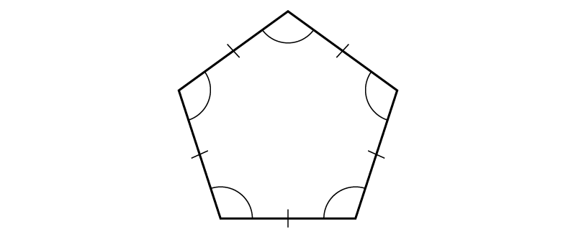  Each interior angle measures $108°((180∙3)÷5)$. A regular pentagon can make 5 turns (5 vertices) in multiples of $72°\left(360°÷5\right)$before coming around full circle. The degree turns are $72°$, $144°$, $216°$, $288°$, and $360°$. A regular pentagon can be turned counterclockwise or clockwise onto itself. Since a regular pentagon can make turns less than $360°$onto itself, a regular pentagon has rotational symmetry.
21 | Lesson 11: Making Predictions with Transformations | In this section, you will apply geometric descriptions of rigid motions to predict the effect of a given rigid motion on a given figure | Identify and express regularity in repeated reasoning. | p. 1-6 | Use the function rules to find the coordinates of $ΔA " B " C "$ and predict the quadrant it will be in after the transformations. $ΔABC$, with coordinates $A (-8, 4), B(-5, 8), and C (-3, 3)$, is transformed by $(x, y) → (x + 4, y - 6)$ to produce $ΔA 'B 'C '$. $ΔA 'B 'C '$ is transformed by the rule $(x, y) → (x + 5, y - 3)$. Create the rule for the composition transformation and predict what quadrant the image will be in.  Answer: Student answers should state that $ΔA " B " C "$ will be in Quadrant IV. The two rules can be combined into $(x, y) → (x + 9, y - 9)$. The coordinates are as follows:  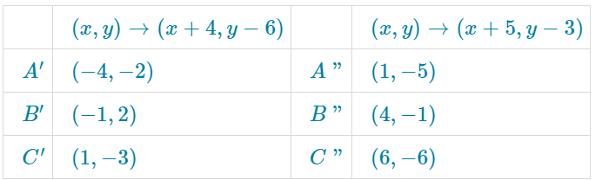
22 | Lesson 9: Compositions of Transformations | In this section, you will use the definition of congruence as it applies to rigid motions to assess two figures and determine whether they are congruent. | Look for and express regularity in repeated reasoning. | p. 1-6 | Use the image to answer the question.  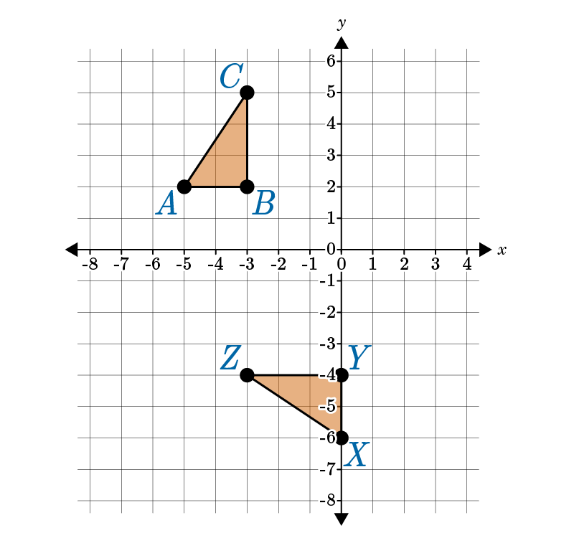  What transformations were made to $∆ABC$ to produce $∆XYZ$? Assess whether the two triangles are congruent. How do you know? Show your work.  Answer: Students should note that$∆ABC$ was rotated $90°$ (counterclockwise), then translated 2 units to the right and 1 unit down. Students should write out the mapping equations for counterclockwise rotation and translation, as such:  Mapping equation for $90°$ (counterclockwise):  $$A\left(x,y\right)→A^{'}\left(-y,x\right)$$  $$A\left(-5, 2\right)→A^{'}\left(-2, -5\right);B\left(-3, 2\right)→B^{'}\left(-2, -3\right);C\left(-3, 5\right)→C'(-5, -3)$$  Mapping equation for the translation:  $$A\left(x,y\right)→A^{'}\left(x+2, y-1\right)$$  $$A^{'}\left(-2, -5\right)→A"\text{(0, -6); B'(-2, -3)→B}\left(0, -4\right);C^{'}\left(-5, -3\right)→C"(-3, -4)$$  Students should use these mapping equations to conclude that points A”, B”, and C” are the same as points X, Y, and Z, and therefore, $∆ABC≅∆XYZ.$
23 | Lesson 9: Compositions of Transformations | In this section, you will identify a sequence of transformations that will carry a given figure onto another. | Look for and express regularity in repeated reasoning. | p. 7-12 | Use the image to answer the question.  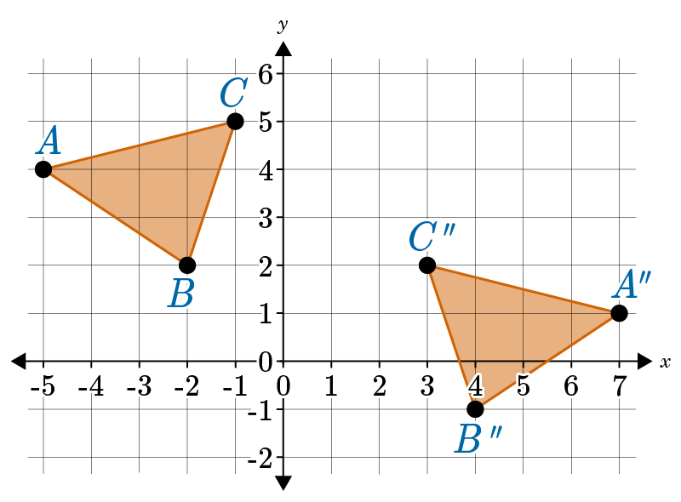  In 1-2 sentences, identify what composition transformation maps $∆ABC→∆A$” B” C”.  Answer: Student answers should state that $∆ABC$is reflected across the y-axis and then translated right 2 and down 3. The rule would be $\left(x,y\right)→(x+2, y-3)$.

