**Guided Notes: Kinetic and Thermal Energy**

**Big Idea:**

In this lesson, you will explain the relationship between the energy resulting from motion and heat energy.

**Key Concepts:**

• Kinetic energy is the energy of ___________________.

• Thermal energy describes the ___________________ energy of a group of particles.

• The particles in a cup of liquid water have ___________________ energy.

• Thermal energy includes the kinetic energy of all the particles in a group on a ___________________ level.

• Thermal energy also includes ___________________ energy, which relates to the distances between particles and their ability to move around.

• Liquid water has greater ___________________ energy because its particles have more freedom to move around.

• The liquid water particles have greater ___________________ energy than the solid water particles.

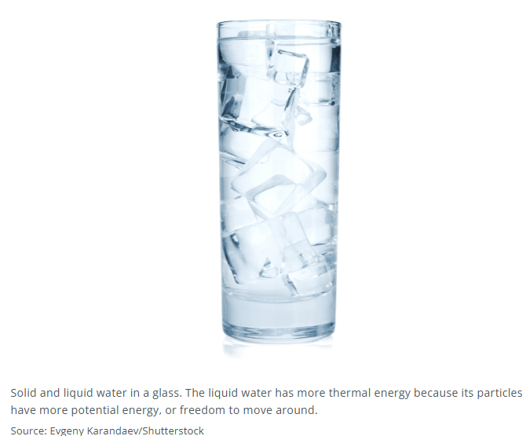

**Real World Examples:**

1. Hot chocolate has a higher temperature, so the ___________________ energy of its particles is higher. Lemonade has a lower temperature, so the ___________________ energy of its particles is lower.

2. When a piece of candy melts in your hand, the liquid part has greater ___________________ energy because its particles have more freedom to move around.

**Guided Notes: Matter and Temperature**

**Big Idea:**

In this lesson, you will identify and describe properties of matter in relation to energy resulting from motion and heat energy as measured by temperature.

**Key Concepts:**

• Matter is composed of small particles: ___________________ and ___________________.

• These particles are constantly in ___________________.

• Because these particles are in motion, they have ___________________ energy.

• The energy that weakens or strengthens the bond causing a change of state is ___________________ energy.

• Temperature is a measure of the ___________________ kinetic energy of particles.

• As kinetic energy increases, ___________________ also increases.

• An increase in thermal energy leads to an increase in ___________________ energy.

• Once a substance reaches its melting or boiling point, a ___________________ of state occurs.

**Real World Examples:**

1. As water boils, both ___________________ and ___________________ (steam) exist at the same temperature. The water vapor has greater ___________________ energy because its particles have more freedom to move around.

2. Baking at a higher temperature means the ___________________ energy of the cookie dough is higher. Baking at a lower temperature means the ___________________ energy of the cookie dough is lower.

**Guided Notes: Energy Transfer and Temperature**

**Big Idea:**

In this lesson, you will analyze data collected about how the transfer of energy resulting from motion affects the matter in relation to the temperature of a sample of the matter.

**Key Concepts:**

• Molecules in substances are always in ___________________.

• Molecules with more kinetic energy will move at a ___________________ rate.

• Temperature is a measurement of the ___________________ kinetic energy of all the particles in a substance.

• The higher the temperature, the greater the amount of ___________________ energy in the substance.

• Heat is the ___________________ of thermal energy from one substance to another.

• Heat always flows from ___________________ areas to ___________________ areas.

• As a substance's kinetic energy increases, its ___________________ also increases.

• Temperature is a measure of the ___________________ kinetic energy of particles in a substance.

**Real World Examples:**

1. Hot coffee has a higher temperature, so the ___________________ energy of its molecules is higher. Iced coffee has a lower temperature, so the kinetic energy of its molecules is __________.

2. A warm blanket has a higher temperature, so the kinetic energy of its particles is __________. A cold floor has a lower temperature, so the ___________________ energy of its particles is lower.

**Guided Notes: Kinetic Energy Transfer**

**Big Idea:**

In this lesson, you will analyze data from an investigation about how the energy that results from motion affects matter in relation to the temperature of the sample.

**Key Concepts:**

• Kinetic energy is the ___________________ of motion.

• Kinetic energy directly influences the ___________________ of matter.

• When thermal energy is absorbed or lost, it affects the ___________________ energy of a substance.

• Potential energy is the energy based on ___________________ position.

• As thermal energy increases, the kinetic energy of particles increases, resulting in increased ___________________ and _____________________.

• Solid particles have low ___________________ energy since they are close together.

• Liquids and gases have higher ___________________ energy since particles have more space.

• An increase in a substance's kinetic energy causes its ___________________ to increase.

• Temperature is a measure of the ___________________ kinetic energy of particles.



**Real World Examples:**

1. When running, your body has a higher temperature, so the ___________________ energy of your particles is higher. When sitting still, your body has a lower temperature, so the ___________________ energy of your particles is lower.

2. Boiling water has a higher temperature, so the ___________________ energy of its molecules is higher. Ice water has a lower temperature, so the ___________________ energy of its molecules is lower.

**Guided Notes: Thermal Energy Transfer**

**Big Idea:**

In this lesson, you will explain with the aid of a model how heat energy is transferred within fluids from hotter regions into colder ones.

**Key Concepts:**

• Convection is a type of heat transfer that occurs within ___________________ (liquids or gases).

• Convection creates a cycle where energy is transferred between ___________________ and ___________________ particles.

• As particles gain thermal energy, their ___________________ energy increases.

• Particles with more kinetic energy are less ___________________ (compacted together).

• Warmer, less dense particles ___________________ towards the top.

• Cooler, denser particles with less kinetic energy ___________________ towards the bottom.

• This rising and sinking of particles creates a ___________________ current.

• Convection currents happen in both ___________________ and ___________________.

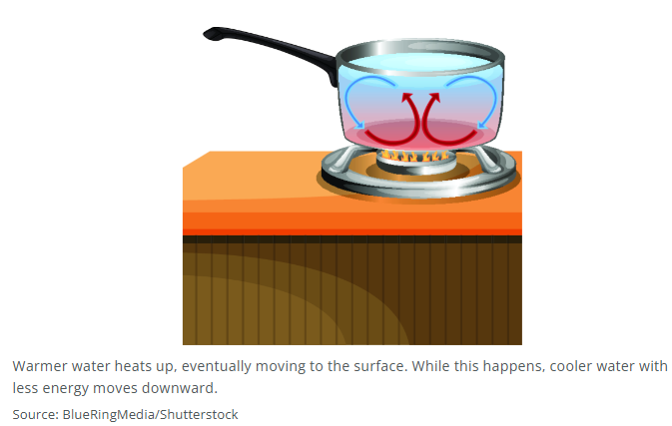

**Real World Examples:**

1. On a sunny beach, the air has a higher temperature, so the ___________________ energy of air particles is higher. In a shaded forest, the air has a lower temperature, so the ___________________ energy of air particles is lower.

2. In boiling soup, the liquid has a higher temperature, so the ___________________ energy of molecules is higher. In a refrigerated drink, the liquid has a lower temperature, so the ___________________ energy of molecules is lower.