**Guided Notes: Position, Distance, and Displacement**

**Big Idea:**

In this lesson, you will distinguish between various terms that describe how an object's position changes and how fast its position and direction change.

**Key Concepts:**

• Distance is how far an object has ___________________.

• Displacement is how far an object is from its ___________________ position, in the direction from the starting point to the ending point.

• Speed describes how ___________________ an object is moving.

• Velocity describes the ___________________ of an object in a given direction.

• A position-time graph shows the ___________________ of an object over time.

• On a position-time graph, time is the ___________________ variable on the x-axis.

• On a position-time graph, position is the ___________________ variable on the y-axis.

• A horizontal line on a position-time graph means the object is ___________________.

**Real World Examples:**

1. If you run one block away from home and one block back, the ___________________ you traveled is two blocks. But your ___________________ at the end is zero, since you returned to your original position.

2. When driving in a straight line, your velocity is ___________________. When driving around a curve, your velocity is ___________________.

**Guided Notes: Magnitude and Direction of Force**

**Big Idea:**

In this lesson, you will explain that forces have an extent and direction; they affect the motion of objects.

**Key Concepts:**

• Forces have ___________________ and ___________________.

• Magnitude is the ___________________ or size of a force.

• A stronger push has a greater ___________________ of force.

• A __________ push has a smaller ___________________ of force.

• The direction of a force affects the ___________________ of an object.

• If forces are balanced, an object's motion ___________________ change.

• If forces are unbalanced, an object's motion ___________________ change.

• Newton's Third Law states: For every action, there is an ___________________ and ___________________ reaction.

**Real World Examples:**

1. Kicking the ball harder gives it more ___________________. Kicking the ball softer gives it __________speed.

2. Pushing the box harder requires more ___________________. Pushing the box gently requires less ___________________.

**Guided Notes: Forces that Change Motion**

**Big Idea:**

In this lesson, you will describe forces that change an object's motion.

**Key Concepts:**

• A force is a ___________________ or ___________________ exerted on an object.

• Balanced forces have a ___________________ of zero, so they do not change an object's motion.

• Unbalanced forces do not have a sum of zero, so they __________ an object's motion.

• Unbalanced forces can cause an object at rest to ___________________ or cause an object in motion to change ___________________ or ___________________.

• Gravity is an unbalanced ___________________ force that pulls objects downward.

• Momentum is the ___________________ of motion of an object.

• Momentum is the product of an object's ___________________ and ___________________.

**Real World Examples:**

1. Throwing a ball applies an unbalanced ___________________ that causes it to start moving. The harder you throw, the greater the ball's ___________________.

2. Pressing the gas pedal provides an unbalanced ___________________ that increases the car's speed. Turning the steering wheel provides an unbalanced ___________________ that changes the car's direction.

**Guided Notes: Newtons First Law**

**Big Idea:**

Newton's First Law of Motion states that an object at rest stays at rest, and an object in motion stays in motion at the same speed and direction unless acted upon by an unbalanced force.

**Key Concepts:**

* Inertia refers to the _____________ of an object to a change in its motion.
* An unbalanced force is a force that is not ____________ by an equal opposing force, causing a change in an object's speed and/or direction.
* ___________ forces can cause an object's speed to increase or decrease.
* ____________ is the speed of an object in a particular direction.
* The net force is the ____________ of all forces acting on an object.
* To calculate net force when forces act in the same direction, you _______ them.
* To calculate net force when forces act in opposite directions, you ________ them.
* The unit for force in the net force equation is ____________.
* If all forces on an object are ____________, it will not move or change motion.

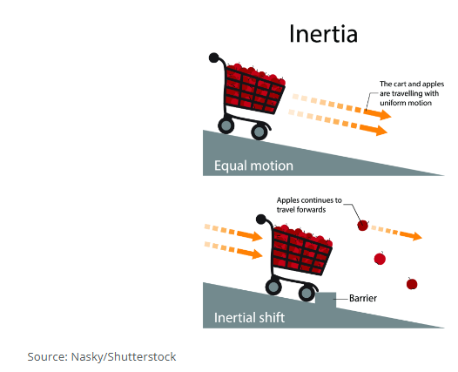

**Real World Examples:**

1. When a car stops suddenly, passengers tend to keep moving forward due to _________. The seatbelt provides the ___________ force to stop their forward motion.

2. When pouring water into a glass, the water initially keeps moving downward due to _________. The glass provides the ___________ force that stops the water's downward motion.

**Guided Notes: Newton’s Second Law**

**Big Idea:**

Newton's Second Law of Motion describes the relationship between an object's mass, the force applied to it, and the resulting acceleration.

**Key Concepts:**

* ____________ is the rate of change in velocity of an object.
* ____________ is a push or pull exerted on an object.
* ____________ is the measure of the amount of matter in an object.
* The net force is the ____________ of all forces acting on an object.
* A ____________ is the unit of force required to cause a 1 kg mass to accelerate at $1\frac{m}{s^{2}}$.
* The force (F) acting on an object equals its mass (m) times its ____________ (a).

**Real World Examples:**

1. A batter needs to apply more ____________ to hit a baseball farther for a home run.

2. __________ force is required to accelerate a heavy couch compared to a light chair.

**Guided Notes: Newton’s Third Law**

**Big Idea:**

Newton's Third Law of Motion states that for every action force, there is an equal and opposite reaction force.

**Key Concepts:**

* Newton's Third Law states that for every __________ __________ there is an equal and opposite __________ __________.
* A ________ is the force that drives an object forward or upwards.
* Even if the forces are equal, the ________ of the objects may differ depending on their masses.
* The reaction force is equal in ________ but opposite in _________ to the action force.
* Newton's Third Law applies to objects at _______ and objects in ________.

**Real World Examples:**

1. The exhaust gases from the rocket engine provide the ________ force that propels the rocket upwards.

2. When a boxer's glove hits an opponent with a force, the opponent's body exerts an equal ________ force back on the glove.

**Guided Notes: Collision Forces**

**Big Idea:**

Collision forces can be calculated using Newton's laws of motion, which relate an object's mass, acceleration, and the forces acting on it.

**Key Concepts:**

* An ____________ force is a force that changes an object's motion.
* According to Newton's Second Law, force (F) equals ____________ times ____________.
* Newton's Third Law states that for every action force, there is an equal and opposite ____________ force.
* The reaction force is equal in ____________ but opposite in ____________ to the action force.

**Real World Examples:**

1. If a 1500 kg car hits a wall at 14 $\frac{m}{s^{2}}$, the force of the car hitting the wall is ____________. The wall will exert an equal ____________ force back on the car.

2. If a 0.15 kg baseball is hit with a force of 200 N, it will accelerate in the direction of the ____________ force. The ball will exert an equal 200 N ____________ force back on the bat.