**Guided Notes: Thermal Energy**

**Big Idea:** Thermal energy causes changes in particle motion, temperature, and state of matter.

**Key Concepts:**

• __________ __________ is the energy associated with the motion and positions of particles.

• __________ is a measure of the average kinetic energy of particles due to their random motions.

• Kinetic energy causes particles to move __________.

• __________ __________ is the stored energy of particles, often due to their positions.

• The __________ __________ __________ __________ __________states that energy cannot be created nor destroyed.

• When thermal energy increases, __________ __________ or __________ __________ must increase.

• At the __________ point, temperature remains constant as thermal energy increases and particles spread out more (increasing potential energy).

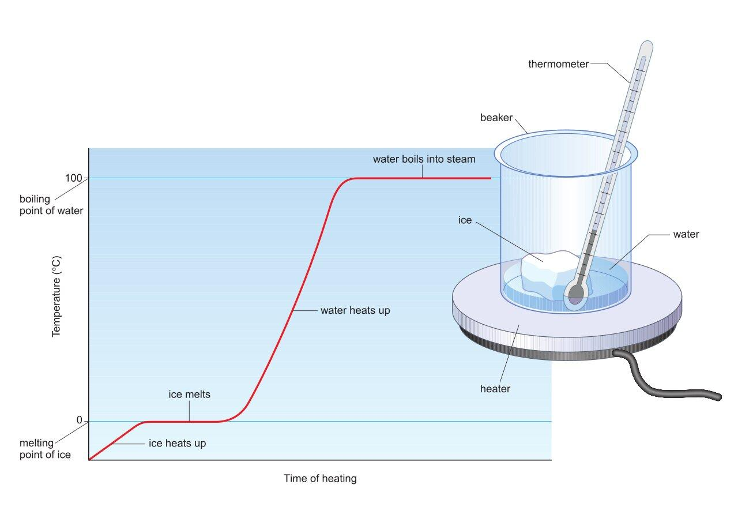

**Real World Examples:**

1. Making popcorn: When you heat popcorn kernels, the __________ from the hot air popper provides thermal energy to increase the __________ __________ of the water molecules inside, causing them to __________ __________and pop into fluffy popcorn.

2. Ice melting in your drink: The __________ __________ from the room temperature surroundings supplies thermal energy to the ice cubes, increasing the __________ __________ so the water particles can break away from their fixed positions and __________ into liquid water.

**Guided Notes: A Mystery Investigation**

**Big Idea:** Pure substances can be distinguished based on their characteristic properties observed through chemical tests.

**Key Concepts:**

• A ____________ ____________ is a physical or chemical quality that helps identify a substance.

• A ____________ ____________ produces a chemical change where new substances are formed.

• A ____________ ____________ is a test guided by a hypothesis that collects data.

• ____________ are used to identify substances based on chemical reactions.

**Real World Examples:**

1. Performing the iodine test: A few drops of iodine indicator are added to a food sample. A black color change is a positive result, indicating the presence of the __________ __________ of starch.

2. Doing the vinegar test: Vinegar is an indicator added to a white powder sample. Bubbles and foaming occur if the __________ __________ is positive, identifying the substance as baking soda based on its characteristic property.

**Guided Notes: Mass, Weight, and Density**

**Big Idea:** Mass, weight, and density are related but distinct properties of matter that help explain why objects sink or float.

**Key Concepts:**

• Mass is the __________ of matter in an object, measured in grams or kilograms.

• Weight is the __________ pull of gravity on an object, measured in newtons (N).

• Weight is calculated by multiplying mass (kg) by the __________ of gravity (9.8 m/s^2 on Earth).

• __________ is the tendency of an object to resist changes in its motion.

• Density is the __________ of an object's mass to its volume.

• The density equation is Density = __________

**Real World Examples:**

1. Seatbelts in cars are needed because of __________ - an object in motion wants to stay in motion unless acted on by an unbalanced force.

2. If you tried to kick a bowling ball and a basketball with the same force, the basketball would accelerate faster because it has less __________.

**Guided Notes: Separating Mixtures**

**Big Idea:** Mixtures of substances can be separated based on their chemical and physical properties.

**Key Concepts:**

• A __________ is a substance made by mixing two or more parts that do not chemically combine.

• A __________ __________ consists of only one specific element or compound throughout.

• __________ is the measure of how well a substance can dissolve in another substance.

• __________ is the gas phase of a substance.

• __________ is a method used to separate a mixture with different physical states.

**Real World Examples:**

1. __________ can be used to separate a mixture of iron filings and sand.

2. Distilling saltwater produces __________ that can then condense back into a liquid.

**Guided Notes: Synthetic Materials, Natural Resources**

**Big Idea:** Human-made synthetic materials come from natural resources found in nature.

**Key Concepts:**

• A __________ __________ is a material found in nature like fossil fuels, forests, soil, minerals, etc.

• A __________ is a repeating chain formed when different molecules link together.

• A __________ __________ is manufactured through chemical processes, sometimes mimicking natural objects.

**Real World Examples:**

1. Plastic water bottles are a synthetic material made from the natural resources __________ and _____________.

2. The polyester in athletic clothing is a synthetic __________ made from natural resources.