**Guided Notes: Kinetic and Potential Energy**

**Big Idea:** Energy can be described as either kinetic energy (the energy of motion) or potential energy (the energy that an object has because of its position).

**Key Concepts:**

• Kinetic energy is the energy of ___________________.

• Potential energy is ___________________ energy that depends on an object's position relative to the ___________________.

• As an object's potential energy ___________________, its kinetic energy ___________________.

• As an object's kinetic energy ___________________, its potential energy ___________________.

• The law of ___________________ of ___________________ states that energy cannot be created or destroyed, only transferred between forms.

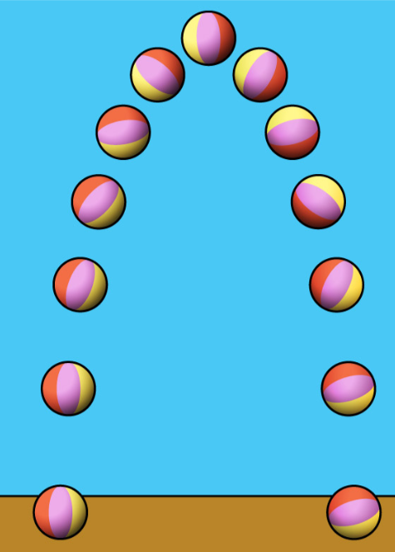

**Real World Examples**

1. When you toss a ball into the air, as it moves upward, its ___________________ energy decreases while its ___________________ energy increases. At the top of its path, the ball has maximum ___________________ energy and minimum ___________________ energy for an instant before falling back down.

2. A ___________________ car uses a solar panel to convert light energy from the sun into ___________________ energy, which is then converted into ___________________ energy to move the car.

**Guided Notes: Factors that Affect Kinetic Energy**

**Big Idea:** The mass and speed of an object affect its kinetic energy (energy of motion).

**Key Concepts:**

• An object with greater ___________________ has greater kinetic energy.

• An object moving with greater ___________________ has greater kinetic energy.

• As an object's mass ___________________, its kinetic energy ___________________.

• As an object's speed ___________________, its kinetic energy ___________________.

**Real World Examples:**

1. When bowling, to make the ball hit the pins with more kinetic energy, you need to either ___________________ the ball's speed or use a ball with ___________________ mass.
2. When a ___________________ is thrown, it has more kinetic energy and creates a bigger splash than when it is just ___________________ into water from the same height.

**Guided Notes: Predicting Changes in Kinetic Energy**

**Big Idea:** The kinetic energy of an object depends on its mass and speed/velocity.

**Key Concepts:**

• Kinetic energy is the energy an object possesses because of its ________.

• Two factors affect kinetic energy: ________ and _________/_________.

• An object with a higher ________ at a given speed will have more kinetic energy than an object with a lower mass at the same speed.

• An object has more kinetic energy at higher _________/___________.

• __________ is the speed of an object in a particular direction.

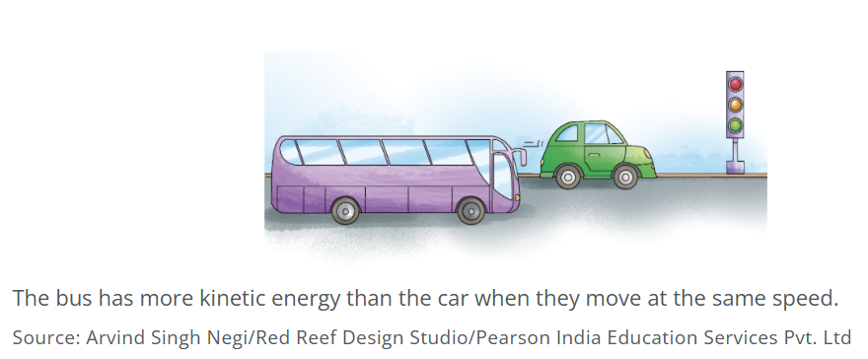

**Real World Examples:**

1. Seatbelts in cars work by providing the _________ force to stop your forward motion when the car suddenly stops, since your body wants to keep moving at the same speed due to inertia.

2. Skateboarders going downhill have increasing __________ energy as their speed increases but decreasing ____________ energy as their height decreases.

**Guided Notes: Potential Energy of a System**

**Big Idea:** The positioning of multiple objects in a system can influence the system's stored energy (potential energy).

**Key Concepts:**

• Potential energy is the energy stored by an object because of its _________________.

• A _________________ consists of multiple objects that can have an effect on each other.

• More _________________ objects have a greater effect on other objects in the system.

• As an object gets farther away from another object in the system, its _________________ __________increases.

• The potential energy of the _________________ increases when the objects within it are farther apart.

**Real World Examples**

1. A rollercoaster at an amusement park is a good example to understand potential energy. As the rollercoaster goes up a hill, its distance from the _________________ increases, causing the potential energy of the system to increase.

2. A swing and the Earth form a system. At the highest point of the swing, the potential energy of the system is _________________ because the distance between the swing and the Earth is greatest.

**Guided Notes: Energy Transfer and Kinetic Energy**

**Big Idea:** Energy can be transferred from one object to another through the movement of objects (kinetic energy).

**Key Concepts:**

• Kinetic energy is the energy of objects in _______________.

• When objects touch or collide, kinetic energy can ________________ between them.

• ________________ thinking skills help solve problems by analyzing how parts interact.

**Real World Examples**

1. In hockey, when a player uses their body's energy to move the stick, the ________________ ________________ transfers from their body to the hockey stick. When the moving hockey stick touches the puck, the energy transfers to it, making it move across the ice.

2. Waves in the ocean are an example of ________________ ________________ in nature. The moving air has kinetic energy. As the air touches the water's surface, it moves it, transferring ________________ ________________ to the water causing a wave.

**Guided Notes: Using Potential and Kinetic Energy**

**Big Idea:** Humans use technology to store energy resulting from an object's position relative to Earth (potential energy) and/or use energy resulting from an object's motion (kinetic energy).

**Key Concepts:**

• An object that is elevated above the Earth's surface has __________ __________.

• An object in motion has __________ __________.

• As an elevated object falls, its __________ __________ is converted to __________ __________.

• In hydroelectric dams, the __________ __________ of stored water is converted to __________ __________ as it moves through the dam.

• The _________________ energy of the moving water rotates the turbines to generate _________________.

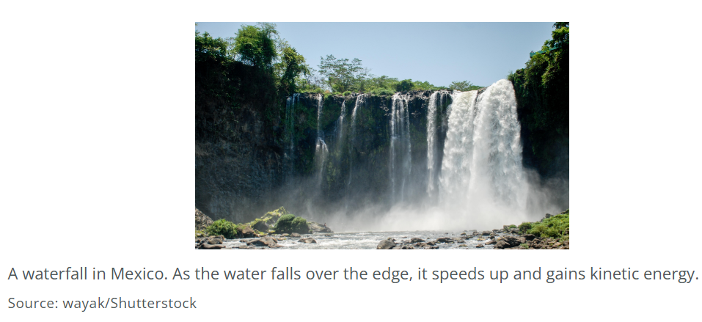

**Real World Examples**

1. A waterfall involves conversion of potential to kinetic energy. The higher the water at the top, the greater the _________________ __________ it stores initially. As the water falls, this is converted to __________ __________.

2. Windmills connected to turbines work similarly to hydroelectric dams. The __________ __________ of the wind causes the turbine blades to spin, converting wind's kinetic energy to rotational kinetic energy to generate electricity.