**Guided Notes: The Composition of Atoms**

**Big Idea:** Atoms are made up of subatomic particles - protons, neutrons, and electrons - that can be modeled and their numbers determined using the periodic table.

**Key Concepts:**

• The __________ is the center of the atom, composed of protons and neutrons.

• The __________ __________ is the area outside the nucleus where electrons move.

• A __________ is a positively charged particle in the nucleus.

• The __________ __________ indicates the number of protons.

• A __________ is a neutral particle in the nucleus.

• The __________ __________ is the sum of protons and neutrons.

• An __________ is a negatively charged particle outside the nucleus.

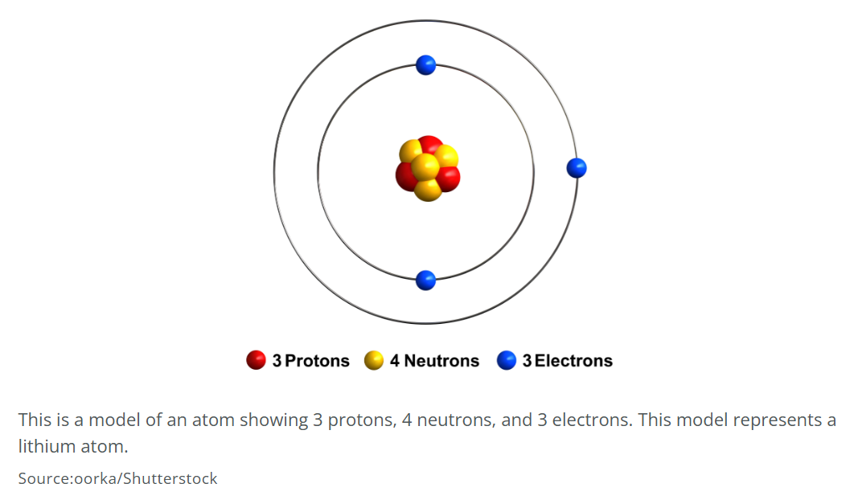

**Real World Examples:**

1. The element __________ has an atomic number of 26, so all iron atoms have _____ protons.

2. Elements like __________ have a low atomic number but high mass number, meaning they have many __________ in the nucleus.

**Guided Notes: Molecules and Structures**

**Big Idea:** Atoms bond together to form molecules and extended structures, which can be represented by molecular models.

**Key Concepts:**

• A __________ is a group of two or more atoms joined together with bonds.

• A __________ is the force that holds atoms together to form molecules.

• A __________ __________ shows the proportion of atoms in a molecule.

• A __________ __________ is a 3D representation of a molecule.

• An __________ __________ is an organized structure made by arranging the same molecule repeatedly.

• __________ are charged particles formed when atoms gain or lose electrons.

**Real World Examples:**

1. Table salt (__________) is an ionic compound formed from an extended structure of sodium and chlorine ions.

2. The __________ molecule is made up of one carbon atom bonded to four hydrogen atoms.

**Guided Notes: The Periodic Table**

**Big Idea:** The periodic table organizes elements based on their properties and atomic structure, revealing patterns that allow us to predict an element's behavior.

**Key Concepts:**

• Elements are organized into __________ (rows) by their number of electron shells/orbitals.

• Elements are organized into __________ (columns) by their number of valence electrons.

• __________ __________ are the most reactive metals, with 1 valence electron.

• __________ __________ metals are reactive metals with 2 valence electrons.

• __________ are highly reactive nonmetals with 7 valence electrons.

• __________ __________ are inert, nonreactive gases with full outer shells.

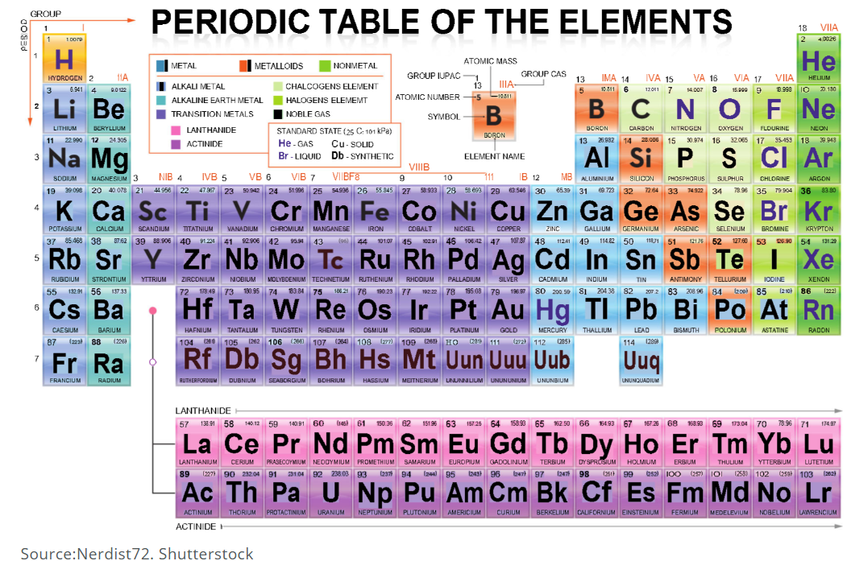

**Real World Examples:**

1. The alkali metal __________, used to treat low sodium levels, has 1 valence electron making it highly reactive.

2. The halogen __________ is a reactive nonmetal used to treat drinking water and swimming pools.

**Guided Notes: Physical vs. Chemical Change**

**Big Idea:** Changes in matter can be classified as either physical or chemical changes based on whether the chemical identity/makeup of the substance changes.

**Key Concepts:**

• A __________ __________ is a change where the chemical makeup is not altered.

• A __________ __________ involves rearranging atoms to form new substance(s).

• Physical changes include changes of __________, such as melting, freezing, or boiling.

• Chemical changes often involve __________ like gas release, color change, or temperature change.

**Real World Examples:**

1. Tearing a sheet of paper into pieces is a __________ __________ since it's still paper.

2. Burning wood is a __________ __________ because the wood chemically reacts with oxygen to form new substances like carbon dioxide.

**Guided Notes: Chemical Reactions**

**Big Idea:** Chemical reactions involve rearranging atoms to form new substances, following the law of conservation of mass.

**Key Concepts:**

• A __________ __________ is a process that rearranges atoms to form new substance(s).

• A __________ __________ uses symbols and numbers to represent a chemical reaction.

• In a reaction, the __________ are the original substances, and the __________ are the new substances formed.

**Real World Examples:**

1. Combustion reactions like __________ __________ in a car engine involve fuel reacting with oxygen.

2. Photosynthesis is a __________ __________ where plants use carbon dioxide and water to produce glucose and oxygen.

**Guided Notes: Law of Conservation of Matter**

**Big Idea:** According to the law of conservation of matter, matter cannot be created or destroyed, only rearranged in chemical and physical changes.

**Key Concepts:**

• The __________ __________ __________ __________ _________states that matter cannot be created or destroyed.

• In any chemical reaction, the total mass of the __________ equals the total mass of the __________.

• The number of __________ present before and after a chemical change remains the same.

• In physical changes like melting or splitting, the __________ stays constant.

**Real World Examples:**

1. When a piece of paper burns, the __________ does not disappear but is rearranged into new substances like carbon dioxide.

2. The ingredients in a cake batter have the same total __________ as the finished baked cake.

**Guided Notes: Conservation in Chemical Reactions**

**Big Idea:** The total number of atoms is conserved in a chemical reaction - atoms are neither created nor destroyed, only rearranged.

**Key Concepts:**

• __________ are the starting substances that react in a chemical reaction.

• __________ are the new substances formed from the reactants after the reaction.

• In a balanced chemical equation, the number of __________ of each element is the same on both sides.

• Since atoms have definite masses, the total __________ is also conserved in a reaction.

**Real World Examples:**

1. In __________, plants use carbon dioxide and water to produce glucose and oxygen, rearranging atoms.

2. When a __________ burns, the wax molecules rearrange but no atoms are created or destroyed.