**The Universe Guided Notes**

**Guided Notes: Galaxies**

**Big Idea:** The universe contains billions of __________ held together by gravity.

**Key Concepts:**

* There are three main types of galaxies:
  + _________ galaxies - shaped like a pinwheel with a bright center and arms
  + _________ galaxies - oval shaped, containing older dimmer stars
  + _________ galaxies - no distinct shape, mixture of old and new stars
* The ______ ____ is a spiral galaxy that contains over 200 billion stars, including our sun.
* Most galaxies are grouped into clusters like the ________ Group that the Milky Way belongs to.

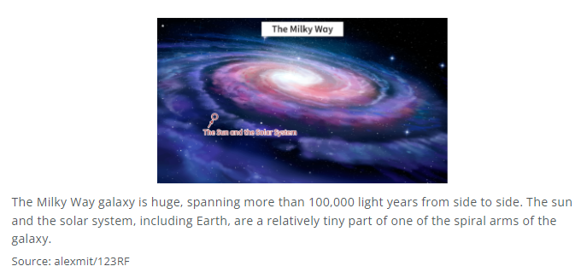

**Real World Examples:**

1. Looking at the night sky, you can see the ______ _____ galaxy as a hazy band of stars.

2. The universe is mostly ________ space, with galaxies making up only about 5% of it.

**Guided Notes: Characteristics of the Universe**

**Big Idea:** The _____________ universe includes all objects that can be observed and detected.

**Key Concepts:**

* Our __________ system contains the Sun and all objects orbiting it, including planets and moons.
* ___________ are clouds of gas and dust where new stars are formed.
* A __________ is a huge group of stars held together by gravity.
* Stars go through a life cycle of formation, main sequence, and eventual _________ (explosion or white dwarf stage).
* ____________ are rocky objects orbiting the Sun.
* ____________ are frozen objects made of dust, gases and ice that develop tails when passing close to the Sun.
* ___________ are space rocks that create streaks of light when passing through Earth's atmosphere.

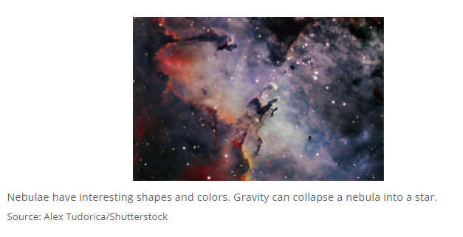

**Real World Examples:**

1. The _________ Space Telescope has allowed scientists to observe distant galaxies and stars.

2. Meteor showers like the __________ occur when Earth passes through the debris trail of a comet.

**Guided Notes: Theories about the Universe**

**Big Idea:** The widely accepted _______ _______ _______ proposes that the universe began as an extremely hot and dense single point that rapidly expanded outward around 13.7 billion years ago.

**Key Concepts:**

* In ancient times, the _________ model proposed that Earth was the center of the universe.
* The ____________ model, originally proposed by __________ placed the Sun at the center, with planets revolving around it.
* __________ discovered galaxies moving away from each other, supporting an expanding universe.
* Cosmic _____________ ____________ pervading space provides evidence of the Big Bang.
* The early universe was an extremely hot dense state with hydrogen and ___________ as the dominant elements

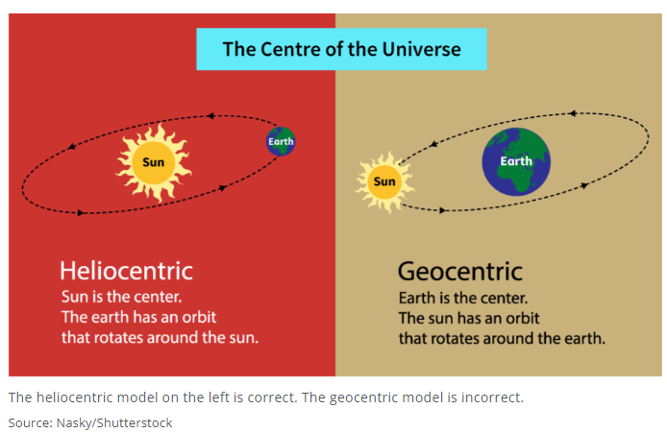

**Real World Examples:**

1. ___________ ____________ discovered the Andromeda Galaxy was not a gas cloud, but a distant galaxy, realizing there were many galaxies beyond the Milky Way.
2. In 1964, researchers accidentally detected __________ ________________ ________________ while studying the Milky Way, which matched predictions of residual radiation from the Big Bang.