**Earth’s Changing Surface Guided Notes**

**Guided Notes: Plate Tectonics**

**Big Idea:** The _______ ___ _______ _________ states that Earth's crust is made up of several rock plates that move across the surface.

**Key Concepts:**

* __________ currents pull and push tectonic plates causing them to smash together, pull apart, or grind past each other.
* __________ plates float on top of the __________, Earth’s layer of soft, hot rock between the crust and the core.
* The three types of plate boundaries are:
  + ____________ (plates move together)
  + ____________ (plates move apart)
  + ____________ (plates slide past each other horizontally)
* ___________ is when the denser plate is pushed under the less dense plate at a convergent boundary.
* Most volcanoes form at ____________ plate boundaries.
* Plates move slowly at around ___ to ___ inches per year.

**Real World Examples:**

1. _____ ___________ _______ is a location where two plates are sliding past each other, causing major earthquakes in California.

2. The __________ __________ formed as the Pacific plate moved over a hot spot, creating the chain of volcanic islands.

**Guided Notes: Rocks Under Pressure**

**Big Idea:** Tectonic plate motions and the resulting __________ and __________ on rocks within the plates formed the shapes of continents and structures on the seafloor.

**Key Concepts:**

* A ________ is a break in Earth's crust where movement occurs.
* A __________ fault is produced by compression/squeezing forces.
* A __________ fault is produced by tension/stretching forces.
* A __________ fault is produced by shear/sideways sliding forces.

**Real World Examples:**

1. The ___________ __________ are an example of fold mountains formed by compression at a convergent plate boundary where the Indian and Eurasian plates collide.
2. The _______ ______ _______ is a divergent plate boundary in the Atlantic Ocean where plates are pulling apart, causing a rift valley.

**Guided Notes: Ring of Fire**

**Big Idea:** Most volcanic eruptions and earthquakes occur in an area around the rim of the Pacific Ocean called the "________ __ _______".

**Key Concepts:**

* __________ and ____________ often occur at plate boundaries.
* The Ring of Fire has many plate boundaries due to the large _________ Plate.
* Volcanoes form when _________ rises to the surface, often at convergent or divergent plate boundaries.
* Deep _________ in the ocean floor form where one plate bends and dives under another at a convergent boundary.

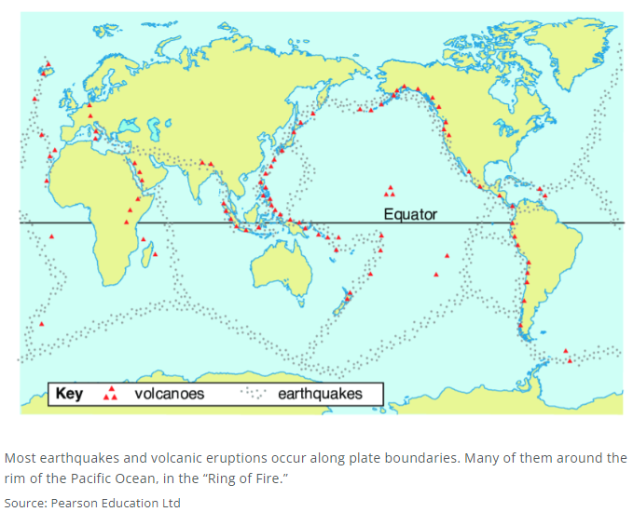

**Real World Examples:**

1. The volcano _______ _______ in Washington state is located within the Ring of Fire.

2. The 2011 Tōhoku earthquake and tsunami that devastated _______ occurred in the Ring of Fire region.

**Guided Notes: Volcanoes Change Earth’s Surface**

**Big Idea:** Volcanoes can change Earth's surface very quickly through _________ events.

**Key Concepts:**

* A __________ is a crater left by the explosion and collapse of the top of a volcano.
* A __________ is a very hot area of the mantle that causes magma to rise and erupt, forming volcanoes.
* __________ is hot, molten rock from deep within Earth.
* __________ is magma that reaches Earth's surface.

**Real World Examples:**

1. __________ __________ discovered the volcanic Andromeda Galaxy was not a gas cloud, realizing there were many galaxies beyond the Milky Way.

2. In 1964, researchers accidentally detected __________ ________________ ________________ while studying the Milky Way, matching predictions of residual radiation from the Big Bang.

**Guided Notes: Earthquakes and Tsunamis**

**Big Idea:** Earthquakes and ____________ have changed Earth's surface through destructive events.

**Key Concepts:**

* An earthquake is a sudden movement in Earth's ________.
* Most earthquakes occur around the ________ _______, at or near plate boundaries.
* A __________ is an ocean wave caused by a disturbance on the ocean floor, often an earthquake
* Tsunamis can cause rapid _________ of coastlines as water sweeps away soil and rocks

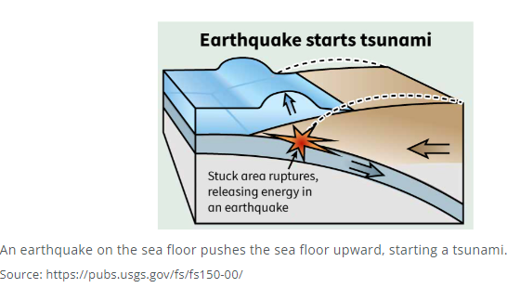

**Real World Examples:**

1. The 1964 ____________ earthquake struck the coast, causing damage and triggering tsunamis.
2. In 2011, a powerful ____________ near Japan generated a tsunami that tore a chunk off the coast of Antarctica.

**Guided Notes: Physical Weathering**

**Big Idea:** __________ _____________ is the breaking of rock into smaller pieces without any chemical changes to the rock.

**Key Concepts:**

* __________ is the wearing, grinding or rubbing away of rock by friction.
* ____________ is the peeling off of outer layers of rock due to temperature changes.
* ______ _________ is the breaking of rock due to water expanding as it freezes in cracks.

**Real World Examples:**

1. _______ __________ occurs when plant roots grow in existing cracks in rock, widening the cracks as the plant grows.

2. The actions of ____________ animals can move soil and rock, contributing to weathering.

**Guided Notes: Soil**

**Big Idea:** Soil is a natural _____ that allows plants to grow.

**Key Concepts:**

• Soil forms very _____ from the weathering of rocks over a long time.

* _____ weathering breaks rocks (temperature changes, abrasion).
* _____ weathering breaks down rocks using chemical reactions.
* _____ weathering is caused by living things.

• Factors that affect how soil forms include the __________ __________ it formed from, the climate of an area, the __________ and __________ living there, and the __________ of the land.

• Soil has four main parts: _____, _____, _____, and _____

• Soil layers from top to bottom:

- O Layer: __________: organic matter

- A Layer: __________: organics mixed with mineral matter

- B Layer: __________: mixture sand, silt or clay

- C Layer: __________: parent rock

- R Layer: __________: unweathered parent material

• Soil type is based on particle sizes:

* Sand: _____ particles; Silt: _____ particles; Clay: _____ particles

**Real World Examples:**

1. Soil left behind by melting glaciers is called __________ __________.

2. In the Midwest, wind blew in fertile soil made from rock called __________.

**Guided Notes: Chemical Weathering**

**Big Idea:** Chemical weathering is the ____________ breakdown of rock to form new substances.

**Key Concepts:**

* Hydrolysis occurs when _______ reacts chemically with minerals in rock to produce new substances.
* Carbonation occurs when _________ _______ combines with water to produce carbonic acid.
* _________ occurs when oxygen in water combines chemically with substances in rock.
* Chemical weathering can also be caused by _________ things like lichens and acid precipitation from human activities.

**Real World Examples:**

1. The miles of caves at Carlsbad Caverns were formed by chemical weathering of __________ rock as the result of carbonation.

2. You have probably seen ______ (iron oxide), which forms when oxygen and iron combine in the presence of water through oxidation.

**Guided Notes: Shaping Earth’s Surface**

**Big Idea:** Weathering, erosion, and deposition have _________ Earth's surface over time.

**Key Concepts:**

* Erosion is the process of wearing rocks down into smaller pieces and _________ them away.
* Water, ice, and wind are agents of _________.
* Meteoroids are rocky objects that can impact Earth, forming _________ and affecting the climate.

**Real World Examples:**

1. The Grand Canyon was formed largely by _________ from the Colorado River over millions of years.

2. The blast from a large meteoroid that exploded in Russia in 1908 _________ trees for 830 square miles.

**Guided Notes: Plate Boundaries**

**Big Idea:** The movement of Earth's ______ _______ has affected where minerals and energy resources are found.

**Key Concepts:**

* Most mineral deposits occur at present or past ______ ___________.
* At divergent boundaries, minerals ____________ out of superheated water as it cools.
* Metamorphism, the changing of rock due to heat and pressure, can create mineral deposits where the edge of a plate is pushed into the ________.
* Petroleum is often found in _________ mountains where plates collide.
* An impermeable rock is one that _______ cannot move through it.

**Real World Examples:**

1. Salt deposits and fossils of land animals indicate the ________________ Sea was once dry land, blocked off by plate movements.

2. Fossils of marine animals in the Grand Canyon show that area was once the __________ of an ocean.

**Guided Notes: Mining Groundwater**

**Big Idea:** ________ _________ means removing much more groundwater than nature can replace.

**Key Concepts:**

* An ____________ is an underground layer of porous and permeable rock that holds water.
* The Ogallala Aquifer is being depleted because __________ is being removed faster than it can be replenished.
* Another problem with the Ogallala is ____________ from farm fields seeping into the groundwater.
* Mining groundwater from the Central Valley Aquifer in California may be causing ______________ movement at the nearby San Andreas Fault.

**Real World Examples:**

1. Signs show the land surface in California's Central Valley had dropped about _____ feet by 1977 due to groundwater withdrawal.

2. Christopher's family lost access to their well because the part of the ________ ________ where their well was drilled has run dry.