**Guided Notes: Moon Phases**

**Big Idea:** The ________________ of the moon are caused by the _________________ between the Earth, Sun, and Moon.

**Key Concepts:**

• The moon _________________ around Earth while Earth _________________ around the sun.

• The moon does not produce its own light, it only _________________ sunlight.

• The moon rotates at the same rate as its _________________ around Earth, keeping the same side facing Earth.

• Half of the moon is always _________________ by the sun, just like half of Earth.

• From Earth's perspective, we see different _________________ of the lit portion of the moon.

• The moon cycles through 8 main phases: ____________, ____________, _____________, _____________, full moon, _____________, _____________, ____________.

• When the moon's lit side is facing Earth it is a _________________.

• When the lit side is facing away from Earth it is a _______________.

• The moon goes through a cycle of _________________ (getting more illuminated) and _________________ (getting less illuminated).

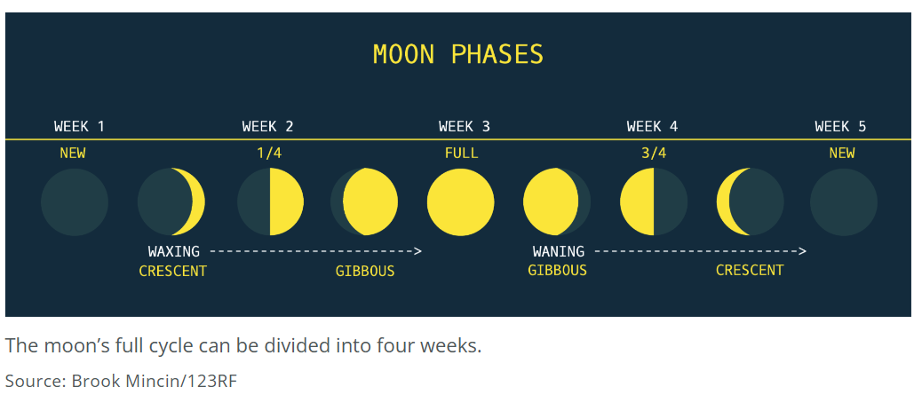

**Real World Examples:**

1. Just as the tilt of Earth's axis causes day/night and seasons from our perspective of the sun's illumination, the _________________ of the Earth, Sun and Moon causes the _________________ to appear illuminated differently each night.

2. Many cultures traditionally use the _________________ to mark time and schedule events, since it is a _________________ cycle in nature.

**Guided Notes: Eclipses**

**Big Idea:** Eclipses occur when one ________________ body moves into the ________________ of another.

**Key Concepts:**

• A ________________ eclipse occurs when the moon moves between the ________________ and Earth.

• This causes the moon to cast its ________________ on Earth's surface, blocking the sun from view.

• A ________________ eclipse can only occur during the ________________ moon phase.

• A ________________ eclipse occurs when Earth moves between the ________________ and moon.

• This causes Earth to cast its ________________ on the moon's surface.

• A lunar eclipse can only occur during the ________________ moon phase.

• During a total lunar eclipse, the moon appears to go from ________________ to ________________.

• The moon has a reddish appearance during a total lunar eclipse due to ________________ effects.

**Real World Examples:**

1. Special ________________ glasses are needed to safely view a solar eclipse, since looking directly at the sun can ________________ your eyes.

2. Some cultures historically scheduled important events like festivals and ceremonies based on the ________________ cycles.

**Guided Notes: Reason for the Seasons**

**Big Idea:** The ________________ of Earth's axis relative to the ________________ causes the seasons.

**Key Concepts:**

• Earth ________________ around its tilted ________________.

• Earth also ________________ around the ________________ in an oval orbit.

• When a hemisphere is tilted ________________ the sun, it receives more ________________ rays and experiences ________________.

• When a hemisphere is tilted ________________ from the sun, it receives less ________________ rays and experiences ________________.

• The ________________ is when Earth's axis is tilted sideways, so both hemispheres receive equal sunlight.

• The ________________ is when one hemisphere's tilt toward/away from the sun is at its maximum.

• The beginning of each season marks a ________________, ________________, ________________ or ________________ in Earth's orbit.

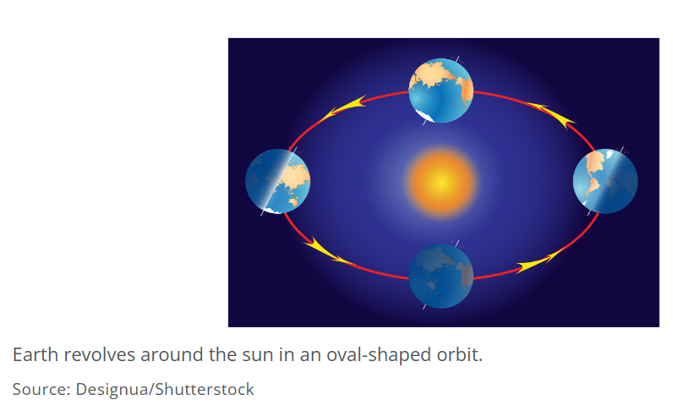

**Real World Examples:**

1. The changing length of ____________________ and sun positions throughout the year is caused by the change of the seasons.

2. The timing of plant growth is based on the varying amount of ________ at different times of year.

**Guided Notes: Not Enough Hours**

**Big Idea:** The tilt of Earth's __________ combined with its __________ around the sun causes the changing day lengths and seasons throughout the year.

**Key Concepts:**

* Earth rotates on a tilted __________ which causes different parts of Earth to face the sun at different times throughout the year's orbit.
* When the Northern Hemisphere is tilted __________ the sun, it experiences longer daylight hours (summer). When tilted __________ from the sun, it has shorter daylight hours (winter).
* The Spring and Fall __________ occur when neither hemisphere is tilted toward or away from the sun, resulting in 12 hours of daylight everywhere.
* The __________ mark when one hemisphere is tilted most toward the sun (longest day) and the other is tilted most away (shortest day).

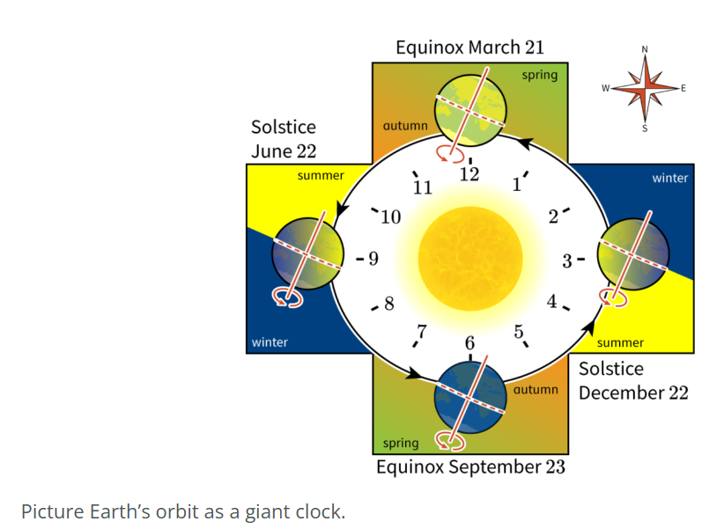

**Real World Examples:**

1. At the __________ Pole on the summer solstice, the sun is in the sky for a full __________ hours because the North Pole is tilted directly toward the __________ at that point in the orbit.
2. In Ecuador, near the equator, the length of daylight changes very little throughout the year because its low __________ means it doesn't experience an extreme tilt toward or away from the sun.