**Language Arts K B Structured Literacy Teacher Implementation Guide**

**Document Overview:** This implementation guide has been outlined based on the [K-5 Structured Literacy Companion](https://www.connexus.com/library/launch.aspx?id=99368) resource. It includes high-level information about Structured Literacy as well as detailed student learning information and Learning Coach and/or teacher instruction for each unit in Language Arts KA.

**Structured Literacy Components:**

[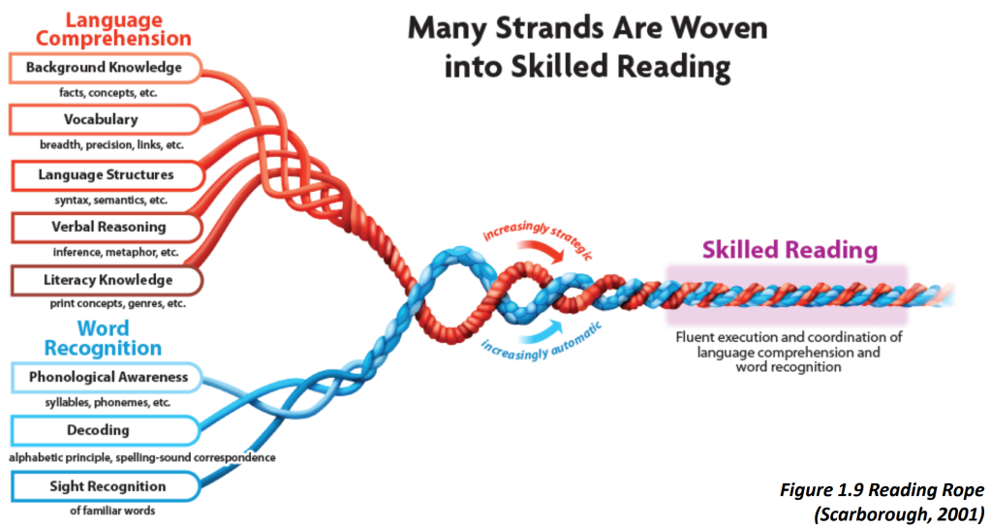](https://www.connectionsacademy.com/teacher-companion-site/ela-companion-site/ela-companion-site-sor/)

*\*Click on the image above for additional Science of Reading & Structured Literacy information on the Teacher Companion Site.*

**Literacy Framework:**

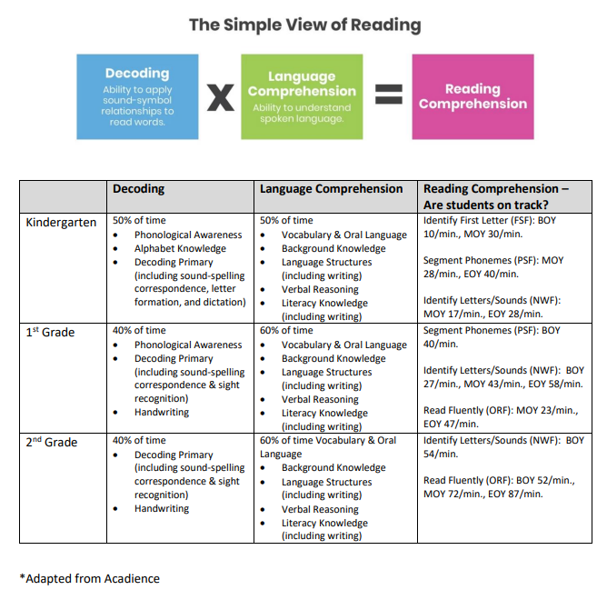

**Phonological Awareness Continuum:**

[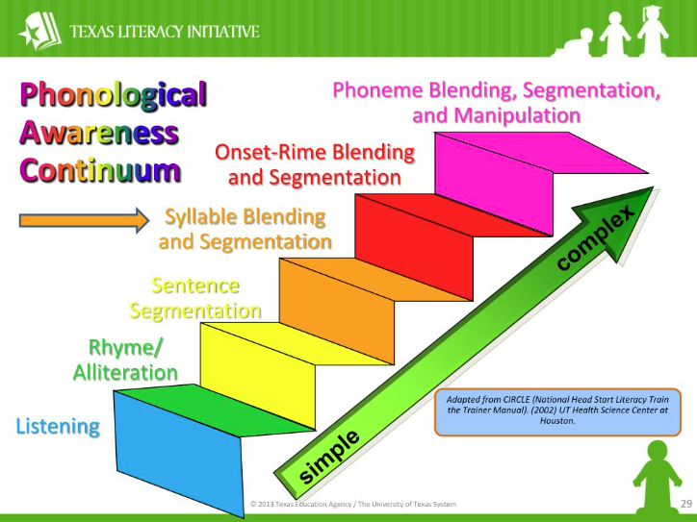](https://www.understood.org/en/articles/building-phonological-awareness-in-your-child?_sp=f4954afa-56e3-411d-8a98-f761c2b64260.1658075744853)

*\*Click on the image above for additional information and activities for Phonological Awareness from Understood®*

**Table of Contents, by unit name:**

* We Learn About the World
* Now I Can Do It
* Say Goodbye to Fear!
* On Our Own
* Help Can Be a Surprise
* Help Can Be Anywhere
* Small Helpers
* Ways We Help
* Where the Wind Blows
* Ready for the Rain
* Snowy Days
* All About Fog
* Good Food for You
* A World of Healthy Food
* Many Ways to Eat a Food
* Chefs Cook

**Unit: We Learn About the World**

In this unit, your student will be learning about how we learn about the world as we grow.

* Word Recognition Learning Goals for this unit:
  + Repeat, identify and match high-frequency words.
  + Form plural nouns by adding -*s* or -*es*.
  + Pronounce the /r/ sound at the beginning and end of words.
  + Pronounce the /v/ sound in words at the beginning of words.
  + Identify similarities in written and spoken words (e.g., word endings, onset, and rime).
  + Arrange high-frequency words with letters.
  + Identify the /r/ and /v/ sounds in words.
* Language Comprehension Learning Goals for this unit:
  + Use key details to make predictions, with prompting and support.
  + Identify nouns.
  + Use key details to answer questions about a story, with prompting and support.
  + Answer questions about characters in a story, with prompting and support.
  + Identify common and proper nouns.
  + Practice writing uppercase and lowercase *Rr* and *Vv*.
  + Answer questions about the settings in a story, with prompting and support.
  + Read a book of choice with support.
  + Answer questions about major events in a story, with prompting and support.
  + Describe familiar things, providing additional detail with prompting and support.
  + Read emergent readers with high-frequency words fluently.
  + Unit vocabulary:

|  |  |
| --- | --- |
| Unit: We Learn About the World | |
| Lesson 1 | **author** – the person who wrote the words  **noun** – a word that names a person, animal, place, or thing  **title** – the name of a story |
| Lesson 2 | **details** – information about someone or something  **noun** – a word that names a person, animal, place, or thing  **plural** – more than on |
| Lesson 3 | **character** – a person or animal in a story  **common noun** – a noun that names any person, animal, place, or thing  **details** – information about someone or something  **noun** – a word that names a person, animal, place, or thing  **proper noun** – a noun that names a special person, animal, place, or thing |
| Lesson 4 | **details** – information about someone or something  **setting** – where a story takes place |
| Lesson 5 | **details** – information about someone or something  **events** – things that happen |

Synchronous Instruction:

* High Frequency Words: they, have
* Decoding Pattern: Consonants: r, v
* From Pearson Curriculum Learning Coach Guide – Can also be used for LiveLessons:
  + Day 1: [ELA KB U2 Day 1 Letter Rr (slides 1-26)](https://docs.google.com/presentation/d/1_fh_R2HrRS5ONxPNcibUXC5X08Rnhfgb/edit?usp=drive_link&ouid=108083634139011951925&rtpof=true&sd=true)
    - Found in Learning Coach Guide –We Learn About the World Lesson 1 Page 4
    - Phonological Awareness, blending, segmenting, alphabet knowledge, write the letter Rr
  + Day 2: [ELA KB U2 Day 2 Letter Rr (slides 27-41)](https://docs.google.com/presentation/d/1_fh_R2HrRS5ONxPNcibUXC5X08Rnhfgb/edit?usp=drive_link&ouid=108083634139011951925&rtpof=true&sd=true)
    - (Same file as previous day) Not in Learning Coach Guide for this lesson, it can be found in We Learn About the World Lesson 1 Page 4; slides 27-41
    - Alphabet knowledge, high frequency words, decodable texts
  + Day 3: [ELA KB U2 Day 3 Letter Vv (slides 1-25)](https://docs.google.com/presentation/d/12hqW3be06kGxvI3PuLTJq2akS-EEc6h_/edit?usp=drive_link&ouid=108083634139011951925&rtpof=true&sd=true)
    - Found in Learning Coach Guide – We Learn About the World Lesson 3 Page 2
    - Phonological Awareness, blending, segmenting, alphabet knowledge, write the letter Cc
  + Day 4: [ELA KB U2 Day 4 Letter Vv (slides 26-39)](https://docs.google.com/presentation/d/12hqW3be06kGxvI3PuLTJq2akS-EEc6h_/edit?usp=drive_link&ouid=108083634139011951925&rtpof=true&sd=true)
    - (Same file as previous day) Not in Learning Coach Guide for this lesson, it can be found in We Learn About the World Lesson 3 Page 2
    - Alphabet knowledge, high frequency words, decodable text
  + Day 5: Teacher’s choice (based on LLs and assessments, what do your students need to practice?):
    - Additional Decodable Readers: (small group LL, send to STs in newsletter, etc):
      * [The Red Van](https://www.connexus.com/library/launch.aspx?id=99122)
      * [Pet Cats](https://ufli.education.ufl.edu/wp-content/uploads/2022/07/20_Decodable_UFLIFoundations.pdf) (not in decoding routine)
      * [What is a Vet?](https://ufli.education.ufl.edu/wp-content/uploads/2022/07/33_Decodable_UFLIFoundations.pdf) (not in decoding routine)
      * [Phrase cued text](https://www.connexus.com/library/launch.aspx?id=103109)
    - Read aloud (teacher selected or from [Read Aloud](https://www.connexus.com/library/default.aspx?lineage=%2fHome%2fInstructional+Partners%2fCompanion+Site+Resources%2fEnglish%2fKindergarten%2fAdditional+Resources%2fVocabulary%2c+Comprehension%2c+and+Writing%2fRead+Alouds%2f&category=Read+Alouds) section)
    - [Alphabet Arc Activities](https://docs.google.com/document/d/13KeQYCUnolescf9ikJHsw06iGcnkDr6a/edit)
    - [Blending & Segmenting](https://drive.google.com/file/d/1UaKx5kAgE7avll8Nnkfn0fFv_Lv4XPd3/view)
    - [High Frequency Words](https://www.connexus.com/library/launch.aspx?id=99387)

**Unit: Now I can Do It**

In this unit, your student will be learning about doing more things for themselves at different ages.

* Word Recognition Learning Goals for this unit:
  + Repeat, identify and match high-frequency words.
  + Pronounce words with the /j/ sound.
  + Pronounce words with the /k/ sound spelled *k*.
  + Identify similarities in written and spoken words (e.g., word endings, onset, and rime).
  + Arrange high-frequency words with letters.
  + Identify the /j/ and /k/ sounds in words.
* Language Comprehension Learning Goals for this unit:
  + Use key details to make predictions, with prompting and support.
  + Identify action verbs.
  + Use key details to answer questions about a story, with prompting and support.
  + Identify linking verbs (*is, are*).
  + Describe characters in a literary text, with prompting and support.
  + Identify that a complete sentence has two parts.
  + Practice writing uppercase and lowercase *Kk* and *Jj*.
  + Describe a character’s actions, with prompting and support.
  + Read a book of choice with support.
  + Draw conclusions about characters in a literary text, with prompting and support.
  + Describe familiar events, providing additional detail with prompting and support.
  + Read emergent readers with high-frequency words fluently.
  + Unit vocabulary:

|  |  |
| --- | --- |
| Unit: Now I can Do It | |
| Lesson 1 | **author** – the person who wrote the words  **illustrator** – the person who drew the pictures  **title** – the name of a story  **verb** – an action word |
| Lesson 2 | **details** – information about someone or something  **verb** – an action word |
| Lesson 3 | **character** – a person or animal in a story  **describe** – to use details to tell about someone or something  **details** – information about someone or something  **sentence** – a group of words that tell a complete thought |
| Lesson 4 | **character** – a person or animal in a story  **describe** – to use details to tell about someone or something  **details** – information about someone or something |
| Lesson 5 | **characters** – people or animals in a story  **details** – information about someone or something  **events** – things that happen |

Synchronous Instruction:

* High Frequency Words: went, have
* Decoding Pattern: Consonants: k, j
* Decoding routines from Pearson Curriculum– Can also be used for LiveLessons:
  + Day 1: [ELA KB U3 Day 1 Letter Kk (slides 1-25)](https://docs.google.com/presentation/d/1xc8UL-4cLg-UuftFcZRK5w7Pr2hxh99S/edit?usp=drive_link&ouid=108083634139011951925&rtpof=true&sd=true)
    - Found in Learning Coach Guide –Now I Can Do It Lesson 1 Page 4
    - Phonological Awareness, blending, segmenting, alphabet knowledge, write the letter Kk
  + Day 2: [ELA KB U3 Day 2 Letter Kk (slides 26-38)](https://docs.google.com/presentation/d/1xc8UL-4cLg-UuftFcZRK5w7Pr2hxh99S/edit?usp=drive_link&ouid=108083634139011951925&rtpof=true&sd=true)
    - (Same file as previous day) Not in Learning Coach Guide for this lesson, it can be found in Now I Can Do It Lesson 1 Page 4; slides 26-38
    - Alphabet knowledge, high frequency words, decodable texts
  + Day 3: [ELA KB U3 Day 3 Letter Jj (slides 1-26)](https://docs.google.com/presentation/d/1GTBGbb3vng7GZv9ozr_YSjF7lfMslnXG/edit?usp=drive_link&ouid=108083634139011951925&rtpof=true&sd=true)
    - Found in Learning Coach Guide – Now I Can Do It Lesson 3 Page 2
    - Phonological Awareness, blending, segmenting, alphabet knowledge, write the letter Jj
  + Day 4: [ELA KB U2 Day 4 Letter Jj (slides 27-38)](https://docs.google.com/presentation/d/1GTBGbb3vng7GZv9ozr_YSjF7lfMslnXG/edit?usp=drive_link&ouid=108083634139011951925&rtpof=true&sd=true)
    - (Same file as previous day) Not in Learning Coach Guide for this lesson, it can be found in Now I Can Do It Lesson 3 Page 2; slides 27-38
    - Alphabet knowledge, high frequency words, decodable text
  + Day 5: Teacher’s choice (based on LLs and assessments, what do your students need to practice?):
    - Additional Decodable Readers: (small group LL, send to STs in newsletter, etc):
      * [The Tub](https://www.connexus.com/library/launch.aspx?id=99121)
      * [The Red Cat and the Rat](https://ufli.education.ufl.edu/wp-content/uploads/2022/07/24_Decodable_UFLIFoundations.pdf) (not in decoding routine)
      * [Kip is the Best Pup](https://ufli.education.ufl.edu/wp-content/uploads/2023/12/22_Decodable_UFLIFoundations-k.pdf) (not in decoding routine)
      * [Phrase cued text](https://www.connexus.com/library/launch.aspx?id=103110)
    - Read aloud (teacher selected or from [Read Aloud](https://www.connexus.com/library/default.aspx?lineage=%2fHome%2fInstructional+Partners%2fCompanion+Site+Resources%2fEnglish%2fKindergarten%2fAdditional+Resources%2fVocabulary%2c+Comprehension%2c+and+Writing%2fRead+Alouds%2f&category=Read+Alouds) section)
    - [Alphabet Arc Activities](https://docs.google.com/document/d/13KeQYCUnolescf9ikJHsw06iGcnkDr6a/edit)
    - [Blending & Segmenting](https://drive.google.com/file/d/1UaKx5kAgE7avll8Nnkfn0fFv_Lv4XPd3/view)
    - [High Frequency Words](https://www.connexus.com/library/launch.aspx?id=99387)

**Unit – Say Goodbye to Fear!**

In this unit, your student will be learning about overcoming fears as they grow up.

* Word Recognition Learning Goals for this unit:
  + Identify the sounds that differ in similarly spelled words.
  + Repeat, identify and match high-frequency words.
  + Pronounce words with the /w/ sound.
  + Pronounce words with the /y/ sound.
  + Build words with /w/ and /y/.
* Language Comprehension Learning Goals for this unit:
  + Add *-ed* to verbs to show that an action happened in the past.
  + Add *-ing* to verbs to show that an action is happening now.
  + Use verbs correctly in sentences (when to add *-s* for subject verb agreement).
  + Use key details to make predictions, with prompting and support.
  + Use key details to make predictions, with prompting and support.
  + Use key details to identify a character’s problem, with prompting and support.
  + Practice writing uppercase and lowercase *Ww* and *Yy*.
  + Use key details to identify how the character solves the problem, with prompting and support.
  + Retell how a character in a story solves a problem, with prompting and support.
  + Ask questions to clarify if something is not understood about a text read aloud or about information presented orally or through another medium.
  + Fluently read emergent readers with high-frequency words.
* Unit vocabulary:

|  |  |
| --- | --- |
| Unit: Say Goodbye to Fear! | |
| Lesson 1 | **author** – the person who writes the words  **illustrator** – the person who draws the pictures  **past** – a time that has already happened  **title** – the name of a book  **verb** – an action word |
| Lesson 2 | **characters** – people or animals in a story  **details** – important information  **events** – what happens in a story  **verb** – an action word |
| Lesson 3 | **characters** – people or animals in a story  **details** – important information  **problem** – something that goes wrong or is hard to do |
| Lesson 4 | **details** – important information  **problem** – something that goes wrong or is hard to do  **solves** – to find a way to fix a problem |
| Lesson 5 | **events** – what happens in a story  **problem** – something that goes wrong or is hard to do  **solves** – to find a way to fix a problem |

Synchronous Instruction:

* High Frequency Words: went, like
* Decoding Pattern: Consonants: w, y
* Decoding routines from Pearson Curriculum– Can also be used for LiveLessons:
  + Day 1: [ELA KB U4 Day 1 Letter Ww (slides 1-25)](https://docs.google.com/presentation/d/1eDACv7sa8Wr5xhWHLp9ZtG36Ize8_11I/edit?usp=drive_link&ouid=108083634139011951925&rtpof=true&sd=true)
    - Found in Learning Coach Guide –Say Goodbye to Fear! Lesson 1 Page 4
    - Phonological Awareness, blending, segmenting, alphabet knowledge, write the letter Ww
  + Day 2: [ELA KB U4 Day 2 Letter Ww (slides 26-38)](https://docs.google.com/presentation/d/1eDACv7sa8Wr5xhWHLp9ZtG36Ize8_11I/edit?usp=drive_link&ouid=108083634139011951925&rtpof=true&sd=true)
    - (Same file as previous day) Not in Learning Coach Guide for this lesson, it can be found in Say Goodbye to Fear! Lesson 1 Page 4; slides 26-38
    - Alphabet knowledge, high frequency words, decodable texts
  + Day 3: [ELA KB U4 Day 3 Letter Yy (slides 1-23)](https://docs.google.com/presentation/d/1efOXF7ZkFaD6obCQdOaThq0LQ9_UObl7/edit?usp=drive_link&ouid=108083634139011951925&rtpof=true&sd=true)
    - Found in Learning Coach Guide – Say Goodbye to Fear! Lesson 3 Page 2
    - Phonological Awareness, blending, segmenting, alphabet knowledge, write the letter Yy
  + Day 4: [ELA KB U4 Day 4 Letter Yy (slides 24-37)](https://docs.google.com/presentation/d/1efOXF7ZkFaD6obCQdOaThq0LQ9_UObl7/edit?usp=drive_link&ouid=108083634139011951925&rtpof=true&sd=true)
    - (Same file as previous day) Not in Learning Coach Guide for this lesson, it can be found in Say Goodbye to Fear! Lesson 3 Page 2; slides 24-37
    - Alphabet knowledge, high frequency words, decodable text, sentence dictation
  + Day 5: Teacher’s choice (based on LLs and assessments, what do your students need to practice?):
    - Additional Decodable Readers: (small group LL, send to STs in newsletter, etc):
      * [What I like](https://www.connexus.com/library/launch.aspx?id=99117)
      * [A Hog in the Mud](https://ufli.education.ufl.edu/wp-content/uploads/2024/02/28_Decodable_UFLIFoundations.pdf) (not in decoding routine)
      * [Yams! Yum!](https://ufli.education.ufl.edu/wp-content/uploads/2022/07/30_Decodable_UFLIFoundations.pdf) (not in decoding routine)
      * [Phrase cued text](https://www.connexus.com/library/launch.aspx?id=103111)
    - Read aloud (teacher selected or from [Read Aloud](https://www.connexus.com/library/default.aspx?lineage=%2fHome%2fInstructional+Partners%2fCompanion+Site+Resources%2fEnglish%2fKindergarten%2fAdditional+Resources%2fVocabulary%2c+Comprehension%2c+and+Writing%2fRead+Alouds%2f&category=Read+Alouds) section)
    - [Alphabet Arc Activities](https://docs.google.com/document/d/13KeQYCUnolescf9ikJHsw06iGcnkDr6a/edit)
    - [Blending & Segmenting](https://drive.google.com/file/d/1UaKx5kAgE7avll8Nnkfn0fFv_Lv4XPd3/view)
    - [High Frequency Words](https://www.connexus.com/library/launch.aspx?id=99387)

**Unit – On Our Own**

In this unit, your student will be learning about doing more things on their own.

* Word Recognition Learning Goals from the unit:
  + Substitute sounds (phonemes) in one-syllable words to make new words.
  + Repeat, identify and match high-frequency words.
  + Pronounce words with short *a* and short *e*.
  + Identify words with short *a* and *e*.
  + Arrange letters to build high-frequency words.
  + Build words with short *a* and *e*.
  + Blend words with short *a* and *e*.
* Language Comprehension Learning Goals from the unit:
  + Use key details to make predictions, with prompting and support.
  + Identify that a telling sentence begins with a capital letter and ends with a period.
  + Use key details to answer questions about a story, with prompting and support.
  + Identify that an asking sentence begins with a capital letter and ends with a question mark.
  + Practice writing lowercase *a* and *e*.
  + Ask questions to make inferences in a story, with prompting and support.
  + Identify that an exclamation sentence begins with a capital letter and ends with an exclamation mark.
  + Use clues to draw conclusions in a story, with prompting and support.
  + Read a book of choice with support.
  + Fluently read emergent readers with high-frequency words.
* Unit vocabulary:

|  |  |
| --- | --- |
| Unit: On Your Own | |
| Lesson 1 | **author** – the person who wrote the words  **illustrator** – the person who draws the pictures  **noun** – a word that names a person, place, or thing  **sentence** – a group of words that tell a complete thought  **title** – the name of a story  **verb** – an action word |
| Lesson 2 | **character** – the people and animals in a poem  **details** – important information  **events** – what happens in a poem  **setting** – where the events happen  **telling sentence** – a sentence that tells about something |
| Lesson 3 | **asking sentence** – a sentence that asks a question  **details** – information about someone or something  **inference** – use details to get more information |
| Lesson 4 | **details** – information about someone or something  **draw conclusions** – use details together with what you know about the details |

Synchronous Instruction:

* High Frequency Words: to, like
* Decoding Pattern: Vowels: short a, e
* Decoding routines from Pearson Curriculum– Can also be used for LiveLessons:
  + Day 1: [ELA KB U5 Day 1 Letter Aa (slides 1-24)](https://docs.google.com/presentation/d/1PWV-TpAfYzlYtBTARrrfZntgAFNR7ILQ/edit?usp=drive_link&ouid=108083634139011951925&rtpof=true&sd=true)
    - Found in Learning Coach Guide –On Our Own Lesson 1 Page 4
    - Phonological Awareness, blending, segmenting, alphabet knowledge, write the letter Aa
  + Day 2: [ELA KB U5 Day 2 Letter Aa (slides 25-36)](https://docs.google.com/presentation/d/1PWV-TpAfYzlYtBTARrrfZntgAFNR7ILQ/edit?usp=drive_link&ouid=108083634139011951925&rtpof=true&sd=true)
    - (Same file as previous day) Not in Learning Coach Guide for this lesson, it can be found in On Our Own Lesson 1 Page 4; slides 25-36
    - Alphabet knowledge, high frequency words, decodable texts
  + Day 3: [ELA KB U5 Day 3 Letter Ee (slides 1-24)](https://docs.google.com/presentation/d/1zJ-2DpAsbGwFMFVyES2hnPHrtQEOEVZh/edit?usp=drive_link&ouid=108083634139011951925&rtpof=true&sd=true)
    - Found in Learning Coach Guide – On Our Own Lesson 3 Page 2
    - Phonological Awareness, blending, segmenting, alphabet knowledge, write the letter Ee
  + Day 4: [ELA KB U5 Day 4 Letter Ee (slides 25-37)](https://docs.google.com/presentation/d/1zJ-2DpAsbGwFMFVyES2hnPHrtQEOEVZh/edit?usp=drive_link&ouid=108083634139011951925&rtpof=true&sd=true)
    - (Same file as previous day) Not in Learning Coach Guide for this lesson, it can be found in On Our Own Lesson 3 Page 2; slides 25-37
    - Alphabet knowledge, high frequency words, decodable text, sentence dictation
  + Day 5: Teacher’s choice (based on LLs and assessments, what do your students need to practice?):
    - Additional Decodable Readers: (small group LL, send to STs in newsletter, etc):
      * [What Can They Do?](https://www.connexus.com/library/launch.aspx?id=99118)
      * [The Drums](https://ufli.education.ufl.edu/wp-content/uploads/2022/07/25_Decodable_UFLIFoundations.pdf) (not in decoding routine)
      * [Cubs in the Den](https://ufli.education.ufl.edu/wp-content/uploads/2022/07/25_Decodable_UFLIFoundations.pdf) (not in decoding routine)
      * [Phrase cued text](https://www.connexus.com/library/launch.aspx?id=103112)
    - Read aloud (teacher selected or from [Read Aloud](https://www.connexus.com/library/default.aspx?lineage=%2fHome%2fInstructional+Partners%2fCompanion+Site+Resources%2fEnglish%2fKindergarten%2fAdditional+Resources%2fVocabulary%2c+Comprehension%2c+and+Writing%2fRead+Alouds%2f&category=Read+Alouds) section)
    - [Alphabet Arc Activities](https://docs.google.com/document/d/13KeQYCUnolescf9ikJHsw06iGcnkDr6a/edit)
    - [Blending & Segmenting](https://drive.google.com/file/d/1UaKx5kAgE7avll8Nnkfn0fFv_Lv4XPd3/view)
    - [High Frequency Words](https://www.connexus.com/library/launch.aspx?id=99387)

**Unit: Help Can Be a Surprise**

In this unit, your student will be learning that help can be surprising when it comes from unexpected people.

* Word Recognition Learning Goals in this unit:
  + - Repeat, identify and match high-frequency words.
    - Pronounce words with short *i*, short *o*, short *u*.
    - Identify words with short *i*, short *o*, short *u*.
    - Arrange high-frequency words with letters.
    - Build words with short *i*, short *o*, short *u*.
* Language Comprehension Learning Goals in this unit:
  + - Use key details to make predictions, with prompting and support.
    - Use question words *who*, *what*, *where* in asking sentences.
    - Explore a number of books about a topic to express opinions about them.
    - Use key details to answer questions about a story, with prompting and support.
    - Practice writing lowercase *i*, *o*, and *u*.
    - Express an opinion about a book to participate in shared writing projects.
    - Compare characters in stories, with prompting and support.
    - Use question words *when*, *why*, *how* in asking sentences.
    - Ask questions about a book to understand others' opinions.
    - Contrast characters in stories, with prompting and support.
    - Practice writing capital *I*, *O*, and *U*.
    - Identify an opinion in a text.
    - Contrast events in stories, with prompting and support.
    - Express thoughts, feelings, and ideas clearly when presenting information.
    - Read emergent readers with high-frequency words fluently.
* Unit vocabulary:

|  |  |
| --- | --- |
| Unit: Help Can Be a Surprise | |
| Lesson 1 | **asking sentence** – a sentence that asks a question  **author** – the person who wrote the words  **illustrator** – the person who draws the pictures  **opinion** – what a person thinks or feels about something  **title** – the name of a story |
| Lesson 2 | **details** – important information  **events** – what happens in a story  **opinion** – what a person thinks or feels about something |
| Lesson 3 | **asking sentence** – a sentence that asks a question  **characters** – people and animals in a story  **compare** – tell how two things are alike  **contrast** – tell how two things are different  **details** – important information |
| Lesson 4 | **characters** – people and animals in a story  **contrast** – tell how two things are different  **details** – important information |
| Lesson 5 | **contrast** – tell how two things are different  **details** – important information  **events** – what happens in a story |

**Nonsense Word Fluency Check in Lesson 5**

* Learning Coaches are asked to facilitate the assessment with their student.
* Learning Coaches are provided these two DIBELS documents within the Skills Check Assessment:
  + - [DIBELS 8th Edition Nonsense Word Fluency K 1](https://cite-media.pearson.com/legacy_paths/a85aa271-0498-40fe-a90b-d9e01fc8f9c3/DIBELS%208th%20Edition%20Nonsense%20Word%20Fluency_pages_2_and_3.pdf)
    - [DIBELS 8th Edition Nonsense Word Fluency pages 2 and 3](https://cite-media.pearson.com/legacy_paths/8afdf756-cdf2-4206-ae84-a8948e2bcb08/DIBELS%208th%20Edition%20Nonsense%20Word%20Fluency_K_1.pdf)
* For additional details about how to administer the Nonsense Word Fluency (NWF) assessment in order to support Learning Coaches, please see pages 65-68 of the [DIBELS 8 Administration and Scoring Guide](https://dibels.uoregon.edu/sites/default/files/2024-01/dibels8_admin_scoring_guide.pdf).
* Here is a screenshot of the assessment:

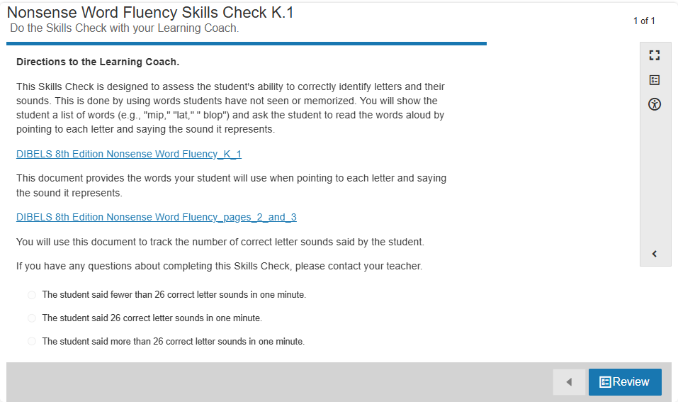

Synchronous Instruction:

* High Frequency Words: to, my
* Decoding Pattern: Vowels: short i, o, u
* Decoding routines from Pearson Curriculum– Can also be used for LiveLessons:
  + Day 1: Please find link in course
    - Found in Learning Coach Guide – Help Can Be a Surprise Lesson 1 Page 4
    - Phonological Awareness, blending, segmenting, alphabet knowledge, write the letters Ii, Oo, Uu
  + Day 2: Please find link in course
    - (Same file as previous day) Not in Learning Coach Guide for this lesson, it can be found in Help Can Be a Surprise Lesson 1 Page 4
    - Alphabet knowledge, high frequency words, decodable text
  + Day 3: [ELA KB U6 Day 3 Letter Ii Oo Uu (slides 1-26)](https://docs.google.com/presentation/d/1xdWWVrzG3vRB6ml_1PciD1HDHlhUaHrv/edit?usp=drive_link&ouid=108083634139011951925&rtpof=true&sd=true)
    - Found in Learning Coach Guide – Help Can Be a Surprise Lesson 3 Page 2
    - Phonological Awareness, blending, segmenting, alphabet knowledge, write the letters Ii, Oo, Uu
  + Day 4: [ELA KB U6 Day 4 Letter Ii Oo Uu (slides 27-40)](https://docs.google.com/presentation/d/1xdWWVrzG3vRB6ml_1PciD1HDHlhUaHrv/edit?usp=drive_link&ouid=108083634139011951925&rtpof=true&sd=true)
    - (Same file as previous day) Not in Learning Coach Guide for this lesson, it can be found in Help Can Be a Surprise Lesson 3 Page 2
    - Alphabet knowledge, high frequency words, decodable text, sentence dictation
  + Day 5: Teacher’s choice (based on LLs and assessments, what do your students need to practice?):
    - Additional Decodable Readers: (small group LL, send to STs in newsletter, etc):
      * [My Dog](https://www.connexus.com/library/launch.aspx?id=99128)
      * [Slugs on a Plant](https://ufli.education.ufl.edu/wp-content/uploads/2022/07/27_Decodable_UFLIFoundations.pdf) (not in decoding routine)
      * [A Bug on the Bus](https://ufli.education.ufl.edu/wp-content/uploads/2022/07/27_Decodable_UFLIFoundations.pdf) (not in decoding routine)
      * [Phrase cued text](https://www.connexus.com/library/launch.aspx?id=103113)
    - Read aloud (teacher selected or from [Read Aloud](https://www.connexus.com/library/default.aspx?lineage=%2fHome%2fInstructional+Partners%2fCompanion+Site+Resources%2fEnglish%2fKindergarten%2fAdditional+Resources%2fVocabulary%2c+Comprehension%2c+and+Writing%2fRead+Alouds%2f&category=Read+Alouds) section)
    - [Alphabet Arc Activities](https://docs.google.com/document/d/13KeQYCUnolescf9ikJHsw06iGcnkDr6a/edit)
    - [Blending & Segmenting](https://drive.google.com/file/d/1UaKx5kAgE7avll8Nnkfn0fFv_Lv4XPd3/view)
    - [High Frequency Words](https://www.connexus.com/library/launch.aspx?id=99387)

**Unit: Help Can Be Anywhere**

In this unit, your student will be learning that help can be found in surprising places.

* Word Recognition Learning Goals for this unit:
  + Repeat, identify and match high-frequency words.
  + Pronounce words with the /z/ sound.
  + Pronounce words with /kw/ spelled *qu*.
  + Arrange high-frequency words with letters.
  + Identify words with /z/ and /kw/ *qu*.
* Language Comprehension Goals for this unit:
  + Use key details to make predictions, with prompting and support.
  + Identify the difference between a telling, asking, and exclamatory sentence.
  + State an opinion about a book or topic by dictating.
  + Use key details to answer questions about a story, with prompting and support.
  + Practice writing capital and lowercase *Zz* and *Qq*.
  + Dictate a topic sentence where a topic and opinion are stated.
  + Identify what a fairy tale is, with prompting and support.
  + Write different kinds of sentences, with support as necessary.
  + Write sentences with a reason for an opinion when writing an opinion piece, with support as needed.
  + Identify what happens in the beginning, middle, and end of a fairy tale.
  + Use capital letters and punctuation marks correctly in sentences.
  + Retell a fairy tale using illustrations.
  + Speak with appropriate enunciation in order to express thoughts, feelings, and ideas clearly.
* Read emergent readers with high-frequency words fluently.
* Vocabulary:

|  |  |
| --- | --- |
| Unit: Help Can Be Anywhere | |
| Lesson 1 | **asking sentence** – a sentence that asks a question  **author** – the person who wrote the words  **exclamation** – a sentence that shows a strong feeling  **illustrator** – the person who drew the pictures  **opinion** – what a person thinks or feels about something  **telling sentence** – a sentence that tells about something  **title** – the name of a story  **topic** – what a text is mostly about |
| Lesson 2 | **characters** – the people and animals in a story  **details** – important information  **events** – what happens in a story  **opinion** – what a person thinks or feels about something |
| Lesson 3 | **asking sentence** – a sentence that asks a question  **characters** – the people and animals in a story  **events** – what happens in a story  **exclamation** – a sentence that shows a strong feeling  **fairy tale** – a story that is about make-believe events and has a happy ending  **make believe** – something that cannot happen in real life  **problem** – something that goes wrong or is hard to do  **reason** – a detail that tells why someone has an opinion  **setting** – where the story takes place  **telling sentence** – a sentence that tells about something |
| Lesson 4 | **asking sentence** – a sentence that asks a question  **details** – information about someone or something  **events** – what happens in a story  **exclamation** – a sentence that shows a strong feeling  **fairy tale** – a story that is about make-believe events and has a happy ending  **problem** – something that goes wrong or is hard to do  **telling sentence** – a sentence that tells about something |
| Lesson 5 | **retell** – to tell events in order |

Synchronous Instruction:

* High Frequency Words: go, my
* Decoding Pattern: Consonants: z, qu
* Decoding routines from Pearson Curriculum– Can also be used for LiveLessons:
  + Day 1: [ELA KB U7 Day 1 Letter Qq and FLSZ rule (slides 1-25)](https://docs.google.com/presentation/d/1PWV-TpAfYzlYtBTARrrfZntgAFNR7ILQ/edit?usp=drive_link&ouid=108083634139011951925&rtpof=true&sd=true)
    - Found in Learning Coach Guide –Help Can Be Anywhere Lesson 1 Page 4
    - Phonological Awareness, blending, segmenting, alphabet knowledge, write the letter Qq
  + Day 2: [ELA KB U7 Day 2 Letter Qq and FLSZ rule (slides 26-38)](https://docs.google.com/presentation/d/1PWV-TpAfYzlYtBTARrrfZntgAFNR7ILQ/edit?usp=drive_link&ouid=108083634139011951925&rtpof=true&sd=true)
    - (Same file as previous day) Not in Learning Coach Guide for this lesson, it can be found Help Can Be Anywhere Lesson 1 Page 4; slides 26-38
    - Alphabet knowledge, high frequency words, decodable texts
  + Day 3: [ELA KB U7 Day 3 Letter Zz (slides 1-24)](https://docs.google.com/presentation/d/1NLyo-69FLSpvm1fIdOt8ztQAyRSC2e-p/edit?usp=drive_link&ouid=108083634139011951925&rtpof=true&sd=true)
    - Found in Learning Coach Guide – Help Can Be Anywhere Lesson 3 Page 2
    - Phonological Awareness, blending, segmenting, alphabet knowledge, write the letter Zz
  + Day 4: [ELA KB U7 Day 4 Letter Zz (slides 25-36)](https://docs.google.com/presentation/d/1zJ-2DpAsbGwFMFVyES2hnPHrtQEOEVZh/edit?usp=drive_link&ouid=108083634139011951925&rtpof=true&sd=true)
    - (Same file as previous day) Not in Learning Coach Guide for this lesson, it can be found in Help Can Be Anywhere Lesson 3 Page 2; slides 25-36
    - Alphabet knowledge, high frequency words, decodable text
  + Day 5: Teacher’s choice (based on LLs and assessments, what do your students need to practice?):
    - Additional Decodable Readers: (small group LL, send to STs in newsletter, etc):
      * [We Can Go](https://www.connexus.com/library/launch.aspx?id=99119)
      * [Zip the Tent](https://ufli.education.ufl.edu/wp-content/uploads/2022/07/34_Decodable_UFLIFoundations.pdf) (not in decoding routine)
      * [Do Not Quit!](https://ufli.education.ufl.edu/wp-content/uploads/2022/07/32_Decodable_UFLIFoundations.pdf) (not in decoding routine)
      * [Phrase cued text](https://www.connexus.com/library/launch.aspx?id=103114)
    - Read aloud (teacher selected or from [Read Aloud](https://www.connexus.com/library/default.aspx?lineage=%2fHome%2fInstructional+Partners%2fCompanion+Site+Resources%2fEnglish%2fKindergarten%2fAdditional+Resources%2fVocabulary%2c+Comprehension%2c+and+Writing%2fRead+Alouds%2f&category=Read+Alouds) section)
    - [Alphabet Arc Activities](https://docs.google.com/document/d/13KeQYCUnolescf9ikJHsw06iGcnkDr6a/edit)
    - [Blending & Segmenting](https://drive.google.com/file/d/1UaKx5kAgE7avll8Nnkfn0fFv_Lv4XPd3/view)
    - [High Frequency Words](https://www.connexus.com/library/launch.aspx?id=99387)

**Unit: Small Helpers**

In this unit, your student will be learning about how small helpers can help.

* Word Recognition Learning Goals in this unit:
  + Repeat, identify and match high-frequency words.
  + Replace sounds with one-syllable words to make new words.
  + Pronounce words with long *a*.
  + Identify words with long *a* (VC*e*; CVC*e*).
  + Arrange high-frequency words with letters.
  + Build words with long *a*.
* Language Comprehension Learning Goals in this unit:
  + Use key details to make predictions, with prompting and support.
  + Identify describing words in sentences.
  + Use key details to answer questions about a story, with prompting and support.
  + Use the suffixes *-er* and *-est* to show comparison.
  + Trace circle strokes in writing.
  + Identify what a fable is, with prompting and support.
  + Expand sentences by adding describing words.
  + Explain how a character solves a problem in a fable, with support as needed.
  + Practice writing uppercase and lowercase *Cc*, *Dd*, *Oo*.
  + Read a book of choice with support.
  + Retell a fable using key details, with prompting and support.
  + Speak at an appropriate rate in order to express thoughts, feelings, and ideas clearly.
  + Read emergent readers with high-frequency words fluently.
* Vocabulary:

|  |  |
| --- | --- |
| Unit: Small Helpers | |
| Lesson 1 | **adjective** – a word that describes a person, an animal, a place, or a thing  **details** – important information  **events** – what happens in a story  **noun** – a word that names a person, an animal, a place, or a thing  **word family** – a group of words that have the same ending letters. |
| Lesson 2 | **adjective** – a word that describes a person, an animal, a place, or a thing  **characters** – people or animals in a story  **details** – important information  **events** – what happens in a story  **make-believe** – not able to happen in real life  **noun** – a word that names a person, an animal, a place, or a thing  **setting** – where events happen |
| Lesson 3 | **adjective** – a word that describes a person, animal, place, or thing  **author** – the person who wrote the story  **details** – important information  **illustrator** – the person who drew the pictures |
| Lesson 4 | **author** – the person who wrote the story  **characters** – people or animals in a story  **detail** – information about someone or something  **events** – what happens in a story |
| Lesson 5 | **events** – what happens in a story |

Synchronous Instruction:

* High Frequency Words: go, me
* Decoding Pattern: Vowel: long a, a-e
* Decoding routines from Pearson Curriculum– Can also be used for LiveLessons

(**There is only one decoding routine file for this unit.** It can be found in the Learning Coach Guide in Small Helpers – Lesson 1 Page 4.)

* + Decoding routine to use for unit: [ELA KB Unit 8 Day 1 and 2 Long a_ a-e](https://docs.google.com/presentation/d/1P-sp5k6WgDFMtvk2W5OlJhPNAfNseFlt/edit?usp=drive_link&ouid=108083634139011951925&rtpof=true&sd=true)
    - Day 1: Slides 1-8
      * Phonological awareness, blending, segmenting, letter-sound correspondence
    - Day 2: Slides 9-29
      * Decoding pattern, letter-sound correspondence, high-frequency words, decodable texts
    - Day 3: Slides 30-47
      * Decoding pattern, letter-sound correspondence, high-frequency words, decodable texts
    - Day 4: Slides 41-53
      * high-frequency words, decodable texts, sentence dictation, alphabet practice (if needed)
    - Day 5: Teacher’s choice (based on LiveLessons and assessments, what do your students need to practice?)
      * Decodable texts from this unit:
        + [The Cake](https://www.connexus.com/library/launch.aspx?id=99123)
        + [Phrase cued texts](https://www.connexus.com/library/launch.aspx?id=103115)
        + [Cave in the Maze](https://ufli.education.ufl.edu/wp-content/uploads/2023/08/54_Decodable_UFLIFoundations.pdf) (not in decoding routine)
    - Read aloud (teacher selected or from [Read Aloud](https://www.connexus.com/library/default.aspx?lineage=%2fHome%2fInstructional+Partners%2fCompanion+Site+Resources%2fEnglish%2fKindergarten%2fAdditional+Resources%2fVocabulary%2c+Comprehension%2c+and+Writing%2fRead+Alouds%2f&category=Read+Alouds) section)
    - [Alphabet Arc Activities](https://docs.google.com/document/d/13KeQYCUnolescf9ikJHsw06iGcnkDr6a/edit)
    - [Blending & Segmenting](https://drive.google.com/file/d/1UaKx5kAgE7avll8Nnkfn0fFv_Lv4XPd3/view)
    - [High Frequency Words](https://www.connexus.com/library/launch.aspx?id=99387)

**Unit: Ways We Help**

In this unit, your student will be learning about ways we help each other and ourselves.

* Word Recognition Learning Goals in this unit:
  + Repeat, identify and match high-frequency words.
  + Pronounce words with short *a* and long *a*.
  + Identify rhyming words.
  + Identify words with short *a* and long *a*.
  + Arrange high-frequency words with letters.
  + Pronounce words with /x/ (ks).
  + Identify words with the /x/ (ks) sound.
* Language Comprehension Learning Goals in this unit:
  + Use details to answer questions about poems, with prompting and support.
  + Change the meaning of an action word by adding *re-.*
  + Identify what a poem is, with prompting and support.
  + Practice writing uppercase and lowercase *Xx*.
  + Identify parts of a poem, including rhyming words.
  + Identify rhyme and rhythm in a poem.
  + Change the meaning of an action word by adding *un-.*
  + Use rhyming words to create structure when writing a draft of a poem.
  + Use details to answer questions about a poem.
  + Write a poem with rhyming words, with prompting and support.
  + Read emergent readers with high-frequency words fluently.
* Vocabulary:

|  |  |
| --- | --- |
| Unit: Ways We Help | |
| Lesson 1 | **poem** – writing that has short lines that are grouped together  **rhyme** – have the same ending sounds  **stanza** – a group of lines in a poem  **verb** – an action word  **word part** – a letter or group of letters |
| Lesson 2 | **poem** – writing that has short lines that are grouped together  **rhyme** – ends with the same sound  **rhyming words** – words that end with the same sound  **stanza** — a group of lines in a poem  **title** – the name of a poem |
| Lesson 3 | **rhyme** – end with the same sound  **rhyming** words – words that end with the same sound  **rhythm** – beats that repeat  **word part** – a letter or group of letters |
| Lesson 4 | **poem** – writing that has short lines that are grouped together  **rhyme** – end with the same sound  **song** – a piece of music with words |

Synchronous Instruction:

* High Frequency Words: said, me
* Decoding Pattern: Consonant: x; Vowels: short a, long a
* Decoding routines from Pearson Curriculum– Can also be used for LiveLessons

(**There is only one decoding routine file for this unit.** It can be found in the Learning Coach Guide in Ways We Help – Lesson 1 Page 4.)

* + Decoding routine to use for unit: [ELA KB Unit 9 Day 1 and 2 Long and Short a](https://docs.google.com/presentation/d/1IDF71NWCn8u6Wy0nvacOIV3lv3-o1BZ1/edit?usp=drive_link&ouid=108083634139011951925&rtpof=true&sd=true)
    - Day 1: Slides 1-8
      * Phonological awareness, blending, segmenting, letter-sound correspondence
    - Day 2: Slides 9-29
      * Decoding pattern, letter-sound correspondence, high-frequency words, decodable texts
    - Day 3: Slides 30-47
      * Decoding pattern, letter-sound correspondence, high-frequency words, decodable texts
    - Day 4: Slides 41-53
      * high-frequency words, decodable texts, sentence dictation, alphabet practice (if needed)
    - Day 5: Teacher’s choice (based on LiveLessons and assessments, what do your students need to practice?)
      * Decodable texts from this unit:
        + [The Vase](https://www.connexus.com/library/launch.aspx?id=99120)
        + [Phrase cued texts](https://www.connexus.com/library/launch.aspx?id=103116)
        + [Bag of Hats and Caps](https://ufli.education.ufl.edu/wp-content/uploads/2022/07/35a_Decodable_UFLIFoundations.pdf) (not in decoding routine)
        + [Let's Plan a Trip](https://ufli.education.ufl.edu/wp-content/uploads/2022/07/35b_Decodable_UFLIFoundations.pdf) (not in decoding routine)
    - Read aloud (teacher selected or from [Read Aloud](https://www.connexus.com/library/default.aspx?lineage=%2fHome%2fInstructional+Partners%2fCompanion+Site+Resources%2fEnglish%2fKindergarten%2fAdditional+Resources%2fVocabulary%2c+Comprehension%2c+and+Writing%2fRead+Alouds%2f&category=Read+Alouds) section)
    - [Alphabet Arc Activities](https://docs.google.com/document/d/13KeQYCUnolescf9ikJHsw06iGcnkDr6a/edit)
    - [Blending & Segmenting](https://drive.google.com/file/d/1UaKx5kAgE7avll8Nnkfn0fFv_Lv4XPd3/view)
    - [High Frequency Words](https://www.connexus.com/library/launch.aspx?id=99387)

**Unit: Where the Wind Blows**

In this unit, your student will be learning about the wind as a kind of weather.

* Word Recognition Learning Goals in this unit:
  + Repeat, identify, match high-frequency words.
  + Pronounce words with long *i*.
  + Identify a syllable by pointing out its vowel sound.
  + Identify words with short *i* and long *i* (VCe; CVCe).
  + Arrange high-frequency words with letters.
  + Build words with short *i* and long *i*.
* Language Comprehension Language Goals in this unit:
  + Use key details to make predictions, with prompting and support.
  + Use action words correctly that are opposites.
  + Use key details to answer questions about a text, with prompting and support.
  + Use describing words correctly that are opposites.
  + Practice writing uppercase and lowercase *I i*, *Ff*, and *Tt*.
  + Ask *who* and *when* questions to make inferences in an informational text, with prompting and support.
  + Use words and phrases to respond to text.
  + Answer *when* and *what* questions to make inferences in an informational text, with prompting and support.
  + Read a book of choice with support.
  + Answer *why* and *how* questions to draw conclusions in an informational text, with prompting and support.
  + Ask questions in order to clarify something that is not understood.
  + Read emergent readers with high-frequency words fluently.
* Vocabulary:

|  |  |
| --- | --- |
| Unit: Where the Wind Blows | |
| Lesson 1 | **antonyms** – words that have opposite meanings  **author** – the person who wrote the words  **opposite** – different  **syllable** – a word or word part with one vowel sound  **title** – the name of a story  **verb** – an action word  **vowels** – the letters a, e, i, o, and u |
| Lesson 2 | **antonyms** – words that have opposite meanings  **describing word** – a word that describes a person, animal, place, or thing  **details** – important information  **opposite** – different |
| Lesson 3 | **details** – important information  **topic** – who or what a text is about |
| Lesson 4 | **details** – important information  **opinion** – how you think or feel about something  **topic** – who or what an information text is about |
| Lesson 5 | **details** – important information |

**Nonsense Word Fluency Skills Check in Lesson 5**

* Learning Coaches are asked to facilitate the assessment with their student.
* Learning Coaches are provided these [DIBELS](https://cite-media.pearson.com/legacy_paths/3cb5a14c-d731-4b5d-825a-024c8d0d7413/DIBELS%208th%20Edition%20Phonemic%20Segmentation%20Fluency_%20page%203.pdf) document within the Skills Check Assessment.
  + - [DIBELS 8th Edition Nonsense Word Fluency K 2](https://cite-media.pearson.com/legacy_paths/7c9995e2-2d6c-4a15-88d5-25e967169a9f/ELA_K_SoR_0005_page_K_2.pdf)
    - [DIBELS 8th Edition Nonsense Word Fluency pages 4 and 5](https://cite-media.pearson.com/legacy_paths/03faa520-7d81-4901-ada2-0ecf481804e3/ELA_K_SoR_0005_pages%204_and_5.pdf)
* For additional details about how to administer the Nonsense Word Fluency (NWF) assessment in order to support Learning Coaches, please see pages 65-68 of the [DIBELS 8 Administration and Scoring Guide](https://dibels.uoregon.edu/sites/default/files/2024-01/dibels8_admin_scoring_guide.pdf).
* Here is a screenshot of the assessment:

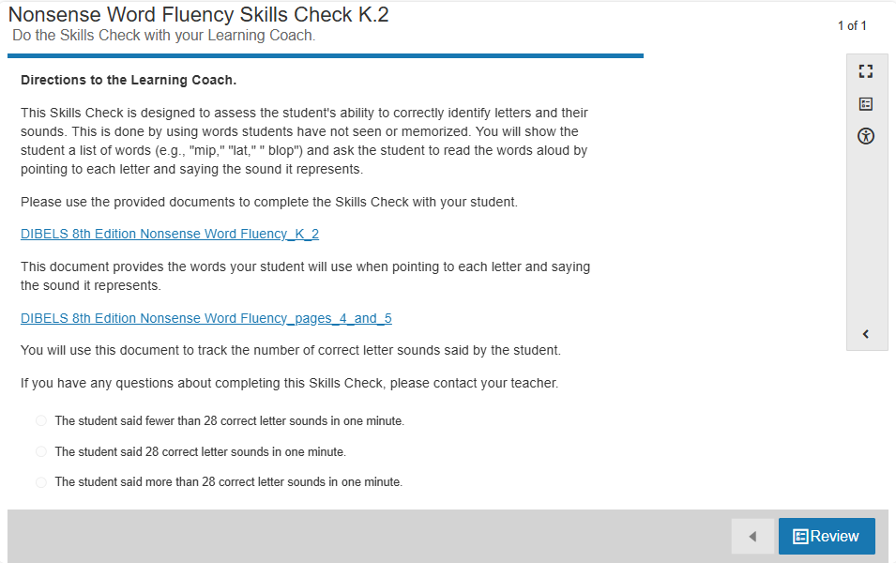

Synchronous Instruction:

* High Frequency Words: said, am
* Decoding Pattern: Vowels: short i, long i, i-e
* Decoding routines from Pearson Curriculum– Can also be used for LiveLessons

(**There is only one decoding routine file for this unit.** It can be found in the Learning Coach Guide in Where the Wind Blows– Lesson 1 Page 4.)

* + Decoding routine to use for unit: [ELA KB Unit 10 Day 1 and 2 Long i_i-e](https://docs.google.com/presentation/d/1B7LNY9d-2omflS1HPZPITdHWmUE0XpRB/edit?usp=drive_link&ouid=108083634139011951925&rtpof=true&sd=true)
    - Day 1: Slides 1-8
      * Phonological awareness, blending, segmenting, letter-sound correspondence
    - Day 2: Slides 9-28
      * Decoding pattern, letter-sound correspondence, high-frequency words, decodable texts
    - Day 3: Slides 29-47
      * Decoding pattern, letter-sound correspondence, high-frequency words, decodable texts
    - Day 4: Slides 41-52
      * high-frequency words, decodable texts, sentence dictation, alphabet practice (if needed)
    - Day 5: Teacher’s choice (based on LiveLessons and assessments, what do your students need to practice?)
      * Decodable texts from this unit:
        + [I Can, We Can](https://www.connexus.com/library/launch.aspx?id=99130)
        + [Phrase cued texts](https://www.connexus.com/library/launch.aspx?id=103117)
        + [Gil and His Pig](https://ufli.education.ufl.edu/wp-content/uploads/2022/07/36a_Decodable_UFLIFoundations.pdf) (not in decoding routine)
        + [Trip to the Pond](https://ufli.education.ufl.edu/wp-content/uploads/2022/07/36b_Decodable_UFLIFoundations.pdf) (not in decoding routine)
    - Read aloud (teacher selected or from [Read Aloud](https://www.connexus.com/library/default.aspx?lineage=%2fHome%2fInstructional+Partners%2fCompanion+Site+Resources%2fEnglish%2fKindergarten%2fAdditional+Resources%2fVocabulary%2c+Comprehension%2c+and+Writing%2fRead+Alouds%2f&category=Read+Alouds) section)
    - [Alphabet Arc Activities](https://docs.google.com/document/d/13KeQYCUnolescf9ikJHsw06iGcnkDr6a/edit)
    - [Blending & Segmenting](https://drive.google.com/file/d/1UaKx5kAgE7avll8Nnkfn0fFv_Lv4XPd3/view)
    - [High Frequency Words](https://www.connexus.com/library/launch.aspx?id=99387)

**Unit: Ready for the Rain**

In this unit, your student will be learning about the rain and how to stay dry.

* Word Recognition Learning Goals in this unit:
  + Repeat, identify and match high-frequency words.
  + Add individual sounds (phonemes) to one-syllable words to make new words.
  + Pronounce words with long *o*.
  + Identify words with long *o* (CVC*e*).
  + Arrange high-frequency words with letters.
  + Build words with long *o*.
* Language Comprehension Learning Goals in this unit:
  + Ask *why* and *how* questions to figure out ideas in an information text, with prompting and support.
  + Identify prepositions.
  + Use key details to answer questions about a text, with prompting and support.
  + Use prepositions in sentences.
  + Practice writing numbers 1–5.
  + Describe the connection between two individuals in an information text, with prompting and support.
  + Identify real-life connections between words and their use.
  + Identify similarities between two information texts on the same topic, with prompting and support.
  + Read a book of choice with support.
  + Identify differences between two information texts on the same topic, with prompting and support.
  + Answer questions in order to clarify something that is not understood.
  + Read emergent readers with high-frequency words fluently.
* Vocabulary:

|  |  |
| --- | --- |
| Unit: Ready for the Rain | |
| Lesson 1 | **author** – the person who wrote the words  **illustrator** – the person who drew the pictures  **prepositions** – words that tell where someone or something is  **title** – the name of a story |
| Lesson 2 | **detail** – information about someone or something  **prepositions** – words that tell where someone or something is  **topic** – what a text is mostly about |
| Lesson 3 | **details** – important information |
| Lesson 4 | **author** – the person who wrote the words in the book  **photograph** – pictures that are made using a camera  **topic** – what the book is mostly about |
| Lesson 5 | **authors** – the people who write the words in the book  **drawings** – pictures that are drawn by an illustrator  **photographs** – pictures that are made using a camera |

Synchronous Instruction:

* High Frequency Words: and, am
* Decoding Pattern: Vowel: long o, o-e
* Decoding routines from Pearson Curriculum– Can also be used for LiveLessons

(**There is only one decoding routine file for this unit.** It can be found in the Learning Coach Guide in Ready for the Rain – Lesson 1 Page 4.)

* + Decoding routine to use for unit: [ELA KB Unit 11 Day 1 and 2 Short and Long o](https://docs.google.com/presentation/d/10lCDn8IuudCY-mmzLQAxGz-apCkG0jYi/edit?usp=drive_link&ouid=108083634139011951925&rtpof=true&sd=true)
    - Day 1: Slides 1-9
      * Phonological awareness, blending, segmenting, letter-sound correspondence
    - Day 2: Slides 10-29
      * Decoding pattern, letter-sound correspondence, high-frequency words, decodable texts
    - Day 3: Slides 30-48
      * Decoding pattern, letter-sound correspondence, high-frequency words, decodable texts
    - Day 4: Slides 41-52
      * high-frequency words, decodable texts, sentence dictation, alphabet practice (if needed)
    - Day 5: Teacher’s choice (based on LiveLessons and assessments, what do your students need to practice?)
      * Decodable texts from this unit:
        + [Rose and Max](https://www.connexus.com/library/launch.aspx?id=99125)
        + [Phrase cued texts](https://www.connexus.com/library/launch.aspx?id=103118)
        + [The Box](https://ufli.education.ufl.edu/wp-content/uploads/2022/07/31_Decodable_UFLIFoundations.pdf) (not in decoding routine)
        + [The Drive Home](https://ufli.education.ufl.edu/wp-content/uploads/2022/08/56_Decodable_UFLIFoundations.pdf) (not in decoding routine)
    - Read aloud (teacher selected or from [Read Aloud](https://www.connexus.com/library/default.aspx?lineage=%2fHome%2fInstructional+Partners%2fCompanion+Site+Resources%2fEnglish%2fKindergarten%2fAdditional+Resources%2fVocabulary%2c+Comprehension%2c+and+Writing%2fRead+Alouds%2f&category=Read+Alouds) section)
    - [Alphabet Arc Activities](https://docs.google.com/document/d/13KeQYCUnolescf9ikJHsw06iGcnkDr6a/edit)
    - [Blending & Segmenting](https://drive.google.com/file/d/1UaKx5kAgE7avll8Nnkfn0fFv_Lv4XPd3/view)
    - [High Frequency Words](https://www.connexus.com/library/launch.aspx?id=99387)

**Unit – Snowy Days**

In this unit, your student will be learning about how snow can be fun but sometimes dangerous.

* Word Recognition Learning Goals in this unit:
  + Repeat, identify and match high frequency words.
  + Decode closed one-syllable words.
  + Pronounce words with short *o* and long *o*.
  + Identify words with short *o* and long *o* (CVCe).
  + Arrange high-frequency words with letters.
  + Build words with short *o* and long *o*.
* Language Comprehension Learning Goals in this unit:
  + Use key details to make predictions, with prompting and support.
  + Define pronouns.
  + Use key details to answer questions about a text, with prompting and support.
  + Understand pronouns used in sentences. (antecedents)
  + Practice writing numbers 6–10.
  + Identify key details that tell about the main topic of an information text.
  + Use pronouns in sentences. (capitalize the pronoun *I*)
  + Use a table of contents to locate key facts and information in an information text.
  + Read a book of choice with support.
  + Practice writing number words 1–5.
  + Identify key details in photographs/illustrations that tell about a topic.
  + Follow oral instructions, with prompting and support as needed.
  + Read emergent readers with high-frequency words fluently.
* Vocabulary:

|  |  |
| --- | --- |
| Unit: Snowy Days | |
| Lesson 1 | **author** – the person who wrote the words  **blend** – mix together  **illustrators** – the person who drew the pictures  **noun** – a word that names a person, animal, place, or thing  **pronoun** – a word that can take the place of a noun  **title** – the name of a story |
| Lesson 2 | **details** – important information  **noun** – a word that names a person, animal, place, or thing  **pronoun** – a word that takes the place of a noun |
| Lesson 3 | **details** – important information  **pronoun** – a word that takes the place of a noun  **topic** – what the text is mostly about |
| Lesson 4 | **table of contents** – a page at the beginning of a book that names each part and the page number the part begins on |

Synchronous Instruction:

* High Frequency Words: and, so
* Decoding Pattern: Vowel: short o, long o, o-e, FLSZ rule
* Decoding routines from Pearson Curriculum– Can also be used for LiveLessons

(**There is only one decoding routine file for this unit.** It can be found in the Learning Coach Guide in Ways We Help – Lesson 1 Page 4.)

* + Decoding routine to use for unit: [ELA KB Unit 12 Day 1 and 2 Long o_o-e and FLSZ rule](https://docs.google.com/presentation/d/1vQHTSeQul6CDWSG_hnQa1OkJrgw1NmTJ/edit?usp=drive_link&ouid=108083634139011951925&rtpof=true&sd=true)
    - Day 1: Slides 1-9
      * Phonological awareness, blending, segmenting, letter-sound correspondence
    - Day 2: Slides 10-29
      * Decoding pattern, letter-sound correspondence, high-frequency words, decodable texts
    - Day 3: Slides 30-49
      * Decoding pattern, letter-sound correspondence, high-frequency words, decodable texts
    - Day 4: Slides 41-54
      * high-frequency words, decodable texts, sentence dictation, alphabet practice (if needed)
    - Day 5: Teacher’s choice (based on LiveLessons and assessments, what do your students need to practice?)
      * Decodable texts from this unit:
        + [Pop Pop and I](https://www.connexus.com/library/launch.aspx?id=99126)
        + [Phrase cued texts](https://www.connexus.com/library/launch.aspx?id=103119)
        + [It's Hot!](https://ufli.education.ufl.edu/wp-content/uploads/2022/07/37a_Decodable_UFLIFoundations.pdf) (not in decoding routine)
        + [Lost](https://ufli.education.ufl.edu/wp-content/uploads/2022/07/37b_Decodable_UFLIFoundations.pdf) (not in decoding routine)
    - Read aloud (teacher selected or from [Read Aloud](https://www.connexus.com/library/default.aspx?lineage=%2fHome%2fInstructional+Partners%2fCompanion+Site+Resources%2fEnglish%2fKindergarten%2fAdditional+Resources%2fVocabulary%2c+Comprehension%2c+and+Writing%2fRead+Alouds%2f&category=Read+Alouds) section)
    - [Alphabet Arc Activities](https://docs.google.com/document/d/13KeQYCUnolescf9ikJHsw06iGcnkDr6a/edit)
    - [Blending & Segmenting](https://drive.google.com/file/d/1UaKx5kAgE7avll8Nnkfn0fFv_Lv4XPd3/view)
    - [High Frequency Words](https://www.connexus.com/library/launch.aspx?id=99387)

**Unit – All About Fog**

In this unit, your student will be learning about fog.

* Word Recognition Learning Goals in this unit:
  + Repeat, identify and match high-frequency words.
  + Pronounce words with long *e*.
  + Identify words with long *e* (e, ee).
  + Arrange high-frequency words with letters.
  + Build words with long *e*.
  + Blend words with long e.
* Language Comprehension Learning Goals in this unit:
  + Use key details to make predictions, with prompting and support.
  + Find words using a picture or word dictionary, with support as needed.
  + Define conjunctions.
  + Use key details to answer questions about a text, with prompting and support.
  + Identify conjunctions in sentences.
  + Practice writing number words 6–10.
  + Determine the main topic of an information text, with prompting and support.
  + Use conjunctions to combine two sentences.
  + Identify key details of an information text, with prompting and support.
  + Read a book of choice with support.
  + Read emergent readers with high-frequency words fluently.
  + Vocabulary:

|  |  |
| --- | --- |
| Unit: All About Fog | |
| Lesson 1 | **alphabetical** – put in a, b, c order  **author** – the person who wrote the words  **conjunction** – a joining word  **dictionary** – book of word meanings and pictures  **illustrator** – the person who drew the pictures  **title** – the name of a book |
| Lesson 2 | **details** – important information  **topic** – what a text is mostly about |
| Lesson 3 | **details** – important information  **facts** – information that is true  **topic** – who or what an informational text is about |
| Lesson 4 | **detail** – important information  **fact** – a detail that is true |

Synchronous Instruction:

* High Frequency Words: it, so
* Decoding Pattern: Vowel: long e, ee
* Decoding routines from Pearson Curriculum– Can also be used for LiveLessons

(**There is only one decoding routine file for this unit.** It can be found in the Learning Coach Guide in All About Fog– Lesson 1 Page 4.)

* + Decoding routine to use for unit: [ELA KB Unit 12 Day 1 and 2 Long e ee](https://docs.google.com/presentation/d/1tHQmfPPICr9YGZYs64CLK0OMv8exeHel/edit?usp=drive_link&ouid=108083634139011951925&rtpof=true&sd=true)
    - Day 1: Slides 1-9
      * Phonological awareness, blending, segmenting, letter-sound correspondence
    - Day 2: Slides 10-29
      * Decoding pattern, letter-sound correspondence, high-frequency words, decodable texts
    - Day 3: Slides 30-48
      * Decoding pattern, letter-sound correspondence, high-frequency words, decodable texts
    - Day 4: Slides 41-53
      * high-frequency words, decodable texts, sentence dictation, alphabet practice (if needed)
    - Day 5: Teacher’s choice (based on LiveLessons and assessments, what do your students need to practice?)
      * Decodable texts from this unit:
        + [The Bee and Me](https://www.connexus.com/library/launch.aspx?id=99124)
        + [Phrase cued texts](https://www.connexus.com/library/launch.aspx?id=103120)
        + [Deep in the Green Forest](https://ufli.education.ufl.edu/wp-content/uploads/2022/08/85_Decodable_UFLIFoundations.pdf) (not in decoding routine)
    - Read aloud (teacher selected or from [Read Aloud](https://www.connexus.com/library/default.aspx?lineage=%2fHome%2fInstructional+Partners%2fCompanion+Site+Resources%2fEnglish%2fKindergarten%2fAdditional+Resources%2fVocabulary%2c+Comprehension%2c+and+Writing%2fRead+Alouds%2f&category=Read+Alouds) section)
    - [Alphabet Arc Activities](https://docs.google.com/document/d/13KeQYCUnolescf9ikJHsw06iGcnkDr6a/edit)
    - [Blending & Segmenting](https://drive.google.com/file/d/1UaKx5kAgE7avll8Nnkfn0fFv_Lv4XPd3/view)
    - [High Frequency Words](https://www.connexus.com/library/launch.aspx?id=99387)

**Unit: Good Food for You**

In this unit, your student will be learning about why it is important to eat healthy foods.

* Word Recognition Learning Goals in this unit:
  + Repeat, identify and match high-frequency words.
  + Pronounce words with short *e* and long *e*.
  + Identify words with short *e* and long *e* (*e*, *ee*, CVC*e*).
  + Arrange high-frequency words with letters.
  + Build words with short *e* and long *e*.
  + Understand how the suffix -*ful* changes the meaning of a word.
  + Understand how the suffix -*less* changes the meaning of a word.
* Language Comprehension Learning Goals in this unit:
  + Use key details to make predictions, with prompting and support.
  + Identify the purpose of “how-to” books, with support.
  + Use key details to answer questions about a text, with prompting and support.
  + Practice writing uppercase *A–M*.
  + Identify the topic of a “how-to” book.
  + Use headings to locate key details about a topic.
  + Describe the purpose of the drawings and illustrations in a how-to book.
  + Answer questions about key details in a diagram.
  + Practice writing uppercase *N–Z*.
  + Select the topic for a “how-to” book, drawing or dictating to brainstorm ideas.
  + Retell information presented on a diagram.
  + Restate simple two-step directions.
  + Read emergent readers with high-frequency words fluently.
  + Compose the steps for the process in a how-to book, using digital tools.
  + Vocabulary:

|  |  |
| --- | --- |
| Unit: Good Food for You | |
| Lesson 1 | **author** – the person who wrote the words  **details** – important information  **how-to-book** – a book that tells how to do something  **illustrator** – the person who drew the pictures  **photograph** – a picture that is made using a camera  **title** – the name of a book |
| Lesson 2 | **details** – important information  **how-to-book** – a book that tells how to do something  **topic** – who or what the information in a text is about |
| Lesson 3 | **details** – important information  **headings** – the title of a part of a book  **steps** – actions you do to make or do something |
| Lesson 4 | **details** – important information  **diagram** – a picture that gives information  **topic** – who or what the information in a text is about |

**Nonsense Word Fluency Skills Check in Lesson 5**

* Learning Coaches are asked to facilitate the assessment with their student.
* Learning Coaches are provided these [DIBELS](https://cite-media.pearson.com/legacy_paths/3cb5a14c-d731-4b5d-825a-024c8d0d7413/DIBELS%208th%20Edition%20Phonemic%20Segmentation%20Fluency_%20page%203.pdf) document within the Skills Check Assessment.
  + - [DIBELS 8th Edition Nonsense Word Fluency K 3](https://cite-media.pearson.com/legacy_paths/e2d01c1d-a8a6-4899-8c5b-7ed0ec649948/ELA_K_SoR_0006_page_K_3.pdf)
    - [DIBELS 8th Edition Nonsense Word Fluency pages 6 and 7](https://cite-media.pearson.com/legacy_paths/5c0764d3-40ab-4256-a540-1ace74a3bbe2/ELA_K_SoR_0006_pages_6_and_7.pdf)
* For additional details about how to administer the Nonsense Word Fluency (NWF) assessment in order to support Learning Coaches, please see pages 65-68 of the [DIBELS 8 Administration and Scoring Guide](https://dibels.uoregon.edu/sites/default/files/2024-01/dibels8_admin_scoring_guide.pdf).
* Here is a screenshot of the assessment:

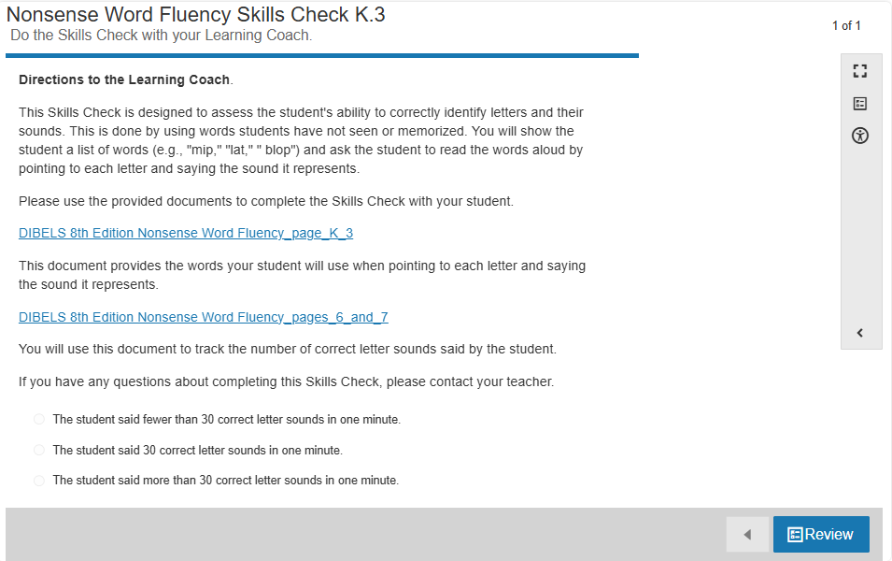

Synchronous Instruction:

* High Frequency Words: it, was
* Decoding Pattern: Vowels: short e, long e, ee
* Decoding routines from Pearson Curriculum– Can also be used for LiveLessons

(**There is only one decoding routine file for this unit.** It can be found in the Learning Coach Guide in Good Food for You – Lesson 1 Page 4.)

* + Decoding routine to use for unit: [ELA KB Unit 10 Day 1 and 2 Long e ee review](https://docs.google.com/presentation/d/1iebDK4R0Xu3d7JFkjnzFkmM_dzKXmaly/edit?usp=drive_link&ouid=108083634139011951925&rtpof=true&sd=true)
    - Day 1: Slides 1-9
      * Phonological awareness, blending, segmenting, letter-sound correspondence
    - Day 2: Slides 10-29
      * Decoding pattern, letter-sound correspondence, high-frequency words, decodable texts
    - Day 3: Slides 30-43
      * Decoding pattern, letter-sound correspondence, decodable texts
    - Day 4: Slides 41-48
      * decodable texts, sentence dictation, alphabet practice (if needed)
    - Day 5: Teacher’s choice (based on LiveLessons and assessments, what do your students need to practice?)
      * Decodable texts from this unit:
        + [My Pets](https://www.connexus.com/library/launch.aspx?id=99127)
        + [Phrase cued texts](https://www.connexus.com/library/launch.aspx?id=103123)
        + [The Pet Hen](https://ufli.education.ufl.edu/wp-content/uploads/2022/07/40a_Decodable_UFLIFoundations.pdf) (not in decoding routine)
        + [Fred and the Tent](https://ufli.education.ufl.edu/wp-content/uploads/2022/07/40b_Decodable_UFLIFoundations.pdf) (not in decoding routine)
    - Read aloud (teacher selected or from [Read Aloud](https://www.connexus.com/library/default.aspx?lineage=%2fHome%2fInstructional+Partners%2fCompanion+Site+Resources%2fEnglish%2fKindergarten%2fAdditional+Resources%2fVocabulary%2c+Comprehension%2c+and+Writing%2fRead+Alouds%2f&category=Read+Alouds) section)
    - [Alphabet Arc Activities](https://docs.google.com/document/d/13KeQYCUnolescf9ikJHsw06iGcnkDr6a/edit)
    - [Blending & Segmenting](https://drive.google.com/file/d/1UaKx5kAgE7avll8Nnkfn0fFv_Lv4XPd3/view)
    - [High Frequency Words](https://www.connexus.com/library/launch.aspx?id=99387)

**Unit – A World of Healthy Food**

In this unit, your student will be learning about healthy foods around the world.

* Word Recognition Learning Goals in this unit:
  + Repeat, identify and match high-frequency words.
  + Pronounce words with long *u*.
  + Identify words with long *u* (CVC*e*).
  + Arrange high-frequency words with letters.
  + Build words with long *u*.
  + Understand how the prefix -*pre* changes the meaning of words.
  + Use words with the affixes -*ful*, -*less*, *pre*-.
* Language Comprehension Learning Goals in this unit:
  + Use key details to make predictions, with prompting and support.
  + Create drawings that support the steps in a how-to book.
  + Use key details to answer questions about a text, with prompting and support.
  + Practice writing your favorite word.
  + Share your how-to book with a peer.
  + Identify the author's purpose for writing a text.
  + Respond to questions from peers about your how-to book.
  + Use an illustration (simple graphic) to retell the steps in a sequence.
  + Respond to suggestions from peers about your how-to book.
  + Describe how an illustration (simple graphic) supports a text.
  + Follow simple two-step directions.
  + Read emergent readers with high-frequency words fluently.
  + Add details to your how-to book to strengthen writing as needed.
  + Vocabulary:

|  |  |
| --- | --- |
| Unit: A World of Healthy Food | |
| Lesson 1 | **author** – the person who wrote the words  **title** – the name of a story or text |
| Lesson 2 | **details** – information about someone or something  **topic** – what a text is mostly about |
| Lesson 3 | **author** – the person who wrote the words  **author’s purpose** – the reason an author writes a text  **details** – information about something or someone  **topic** – what a text is mostly about |
| Lesson 4 | **details** – important information  **retell** – use your own words to tell what happens |
| Lesson 5 | **details** – important information  **topic** – what a text is mostly about |

Synchronous Instruction:

* High Frequency Words: up, was
* Decoding Pattern: vowel- long u
* Decoding routines from Pearson Curriculum– Can also be used for LiveLessons

(**There is only one decoding routine file for this unit.** It can be found in the Learning Coach Guide in A World of Healthy Food – Lesson 1 Page 4.)

* + Decoding routine to use for unit: [ELA KB Unit 15 Day 1 and 2 Long u_u-e](https://docs.google.com/presentation/d/1yo0AhV4D_udbx-DWSJRUY8yLJLdinLvz/edit?usp=drive_link&ouid=108083634139011951925&rtpof=true&sd=true)
    - Day 1: Slides 1-9
      * Phonological awareness, blending, segmenting, letter-sound correspondence
    - Day 2: Slides 10-31
      * Decoding pattern, letter-sound correspondence, high-frequency words, decodable texts
    - Day 3: Slides 32-47
      * Decoding pattern, letter-sound correspondence, decodable texts
    - Day 4: Slides 45-52
      * decodable texts, sentence dictation, alphabet practice (if needed)
    - Day 5: Teacher’s choice (based on LiveLessons and assessments, what do your students need to practice?)
      * Decodable texts from this unit:
        + [June the Mule](https://www.connexus.com/library/launch.aspx?id=99129)
        + [Phrase cued texts](https://www.connexus.com/library/launch.aspx?id=103124)
        + [June's Flute](https://ufli.education.ufl.edu/wp-content/uploads/2022/08/58_Decodable_UFLIFoundations.pdf) (not in decoding routine)
    - Read aloud (teacher selected or from [Read Aloud](https://www.connexus.com/library/default.aspx?lineage=%2fHome%2fInstructional+Partners%2fCompanion+Site+Resources%2fEnglish%2fKindergarten%2fAdditional+Resources%2fVocabulary%2c+Comprehension%2c+and+Writing%2fRead+Alouds%2f&category=Read+Alouds) section)
    - [Alphabet Arc Activities](https://docs.google.com/document/d/13KeQYCUnolescf9ikJHsw06iGcnkDr6a/edit)
    - [Blending & Segmenting](https://drive.google.com/file/d/1UaKx5kAgE7avll8Nnkfn0fFv_Lv4XPd3/view)
    - [High Frequency Words](https://www.connexus.com/library/launch.aspx?id=99387)

**Unit – Many Ways to Eat a Food**

In this unit, your student will be learning about foods that can be eaten in different ways.

* Word Recognition Learning Goals in this unit:
  + Repeat, identify and match high-frequency words.
  + Identify groups of words that begin with the same sound.
  + Pronounce words with short *u* and long *u*.
  + Identify words with short *u* and long *u* (CVCe).
  + Arrange high-frequency words with letters.
  + Build words with short *u* and long *u*.
* Language Comprehension Learning Goals in this unit:
  + Use key details to make predictions, with prompting and support.
  + Identify words with more than one meaning.
  + Use key details to answer questions about a text, with prompting and support.
  + Identify new meanings for familiar words.
  + Identify bold words in informational texts.
  + Identify the relationship between words with similar meanings (toss, pitch, throw).
  + Practice writing lowercase *a-m*.
  + Determine the meaning of multiple-meaning words as they are used in an informational text.
  + Read a book of choice with support.
  + Find the meaning of words using a glossary.
  + Give simple two-step directions.
  + Read emergent readers with high-frequency words fluently.
* Vocabulary:

|  |  |
| --- | --- |
| Unit: Many Ways to Eat a Food | |
| Lesson 1 | **author** – the person who wrote the words  **illustrator** – the person who drew the pictures  **title** – the name of a story or text |
| Lesson 2 | **details** – important information  **table of contents** – a list at the beginning of a book that lists each part and the page number the part begins on  **topic** – what the book is mainly about |
| Lesson 3 | **bold** – in dark print  **topic** – what a text is mostly about |
| Lesson 4 | **action word** – a word that tells what a person, animal, or thing does  **naming word** – a word that names a person, place, or thing |
| Lesson 5 | **glossary** – a list of words and what the words mean |

Synchronous Instruction:

* High Frequency Words: up, at
* Decoding Pattern: Vowels: short u, long u
* Decoding routines from Pearson Curriculum– Can also be used for LiveLessons

(**There is only one decoding routine file for this unit.** It can be found in the Learning Coach Guide in Many Ways to Eat a Food – Lesson 1 Page 4.)

* + Decoding routine to use for unit: [ELA KB Unit 16 Day 1 and 2 Long u_u-e Review](https://docs.google.com/presentation/d/15siouqc7N83fS67KCaPqCIzB8jM2pxHK/edit?usp=drive_link&ouid=108083634139011951925&rtpof=true&sd=true)
    - Day 1: Slides 1-9
      * Phonological awareness, blending, segmenting, letter-sound correspondence
    - Day 2: Slides 10-32
      * Decoding pattern, letter-sound correspondence, high-frequency words, decodable texts
    - Day 3: Slides 33-47
      * Decoding pattern, letter-sound correspondence, decodable texts
    - Day 4: Slides 41-52
      * decodable texts, sentence dictation, alphabet practice (if needed)
    - Day 5: Teacher’s choice (based on LiveLessons and assessments, what do your students need to practice?)
      * Decodable texts from this unit:
        + [Dude](https://www.connexus.com/library/launch.aspx?id=99131)
        + [Phrase cued texts](https://www.connexus.com/library/launch.aspx?id=103125)
        + [Cub and Pup](https://ufli.education.ufl.edu/wp-content/uploads/2022/07/39a_Decodable_UFLIFoundations.pdf) (not in decoding routine)
        + [Gus the Pup](https://ufli.education.ufl.edu/wp-content/uploads/2022/07/39b_Decodable_UFLIFoundations.pdf) (not in decoding routine)
    - Read aloud (teacher selected or from [Read Aloud](https://www.connexus.com/library/default.aspx?lineage=%2fHome%2fInstructional+Partners%2fCompanion+Site+Resources%2fEnglish%2fKindergarten%2fAdditional+Resources%2fVocabulary%2c+Comprehension%2c+and+Writing%2fRead+Alouds%2f&category=Read+Alouds) section)
    - [Alphabet Arc Activities](https://docs.google.com/document/d/13KeQYCUnolescf9ikJHsw06iGcnkDr6a/edit)
    - [Blending & Segmenting](https://drive.google.com/file/d/1UaKx5kAgE7avll8Nnkfn0fFv_Lv4XPd3/view)
    - [High Frequency Words](https://www.connexus.com/library/launch.aspx?id=99387)

**Unit – Chefs Cook**

In this unit, your student will be learning about chefs.

* Word Recognition Learning Goals in this unit:
  + Repeat, identify and match high-frequency words.
  + Spell words with short *a*.
  + Spell words with short *e*.
  + Arrange high-frequency words with letters.
  + Spell words with short *i*.
  + Spell words with short *o* and short *u*.
* Language Comprehension Learning Goals in this unit:
  + Use key details to make predictions, with prompting and support.
  + Strengthen informative writing by revising, with guidance and support from adults as needed.
  + Name numbers 0–100.
  + Use key details to answer questions about a text, with prompting and support.
  + Practice writing lowercase *n*–*z*.
  + Strengthen informative writing by editing, with guidance and support from adults as needed.
  + Find text evidence to answer questions, with prompting and support.
  + Expand sentences by adding details that tell how many.
  + Complete your how-to book, using digital tools.
  + Use text evidence to answer questions, with prompting and support.
  + Publish your how-to book for others to read, with guidance and support from adults as needed.
  + Read emergent readers with high-frequency words fluently.
  + Vocabulary:

|  |  |
| --- | --- |
| Unit 17: Chefs Cook | |
| Lesson 1 | **author** – the person who wrote the words  **revise** – reread what you wrote and make changes  **title** – the name of a book |
| Lesson 2 | **detail** – information about someone or something  **edit** – read what you write and fix mistakes  **topic** – what a text is mostly about |
| Lesson 3 | **adjective** – a word that describes a person, animal, place, or thing  **details** – information about someone or something  **text evidence** – details in a text  **title** – the name of a book  **topic** – what a text is mostly about |
| Lesson 4 | **text evidence** – details in a text  **topic** – what a text is mostly about |

Synchronous instruction:

* No decoding routines are included in lessons.
* Use your assessment results to identify skills that students have not mastered and provide additional instruction in those areas.

**Resources:**

[**Teacher Companion Site**](https://www.connectionsacademy.com/teacher-companion-site/ela-companion-site/) **– ELA Resources**