**Guided Notes: Heating Patterns**

The sun's uneven heating of Earth's surface is the primary driver of Earth's climate patterns.

**Key Concepts:**

* ____________ refers to the general weather in a region over a long period of time.
* To ____________ means to change from a liquid to a gas.
* A ____________ ____________ is a climate characterized by average temperatures of less than 50°F (10°C).
* A ____________ ____________ is a climate characterized as not having temperature or precipitation extremes.
* A ____________ ____________ is a climate characterized by relatively constant warm temperatures.

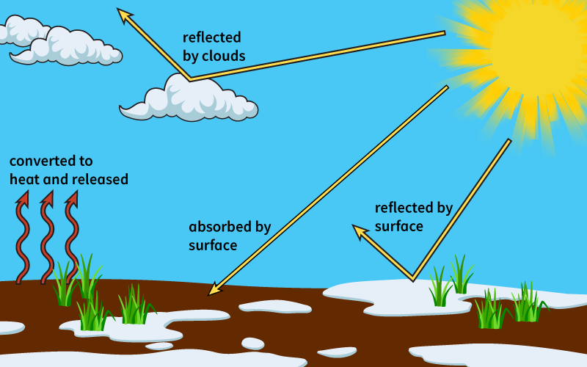

**Real World Examples:**

1. In __________ regions near the equator, where the sun's rays strike the Earth most directly, the climate is warm and humid year-round due to the intense heat and evaporation of water.

2. In __________ regions like Antarctica and the Arctic, the sun's rays strike at a very low angle, resulting in a polar climate with extremely cold average temperatures below 50°F (10°C).

**Guided Notes: Atmospheric Currents**

Earth's rotation and uneven heating create atmospheric circulation patterns that generate global wind systems.

**Key Concepts:**

* The ____________ ____________ is the movement of air to the right in the northern hemisphere and to the left in the southern hemisphere due to Earth's rotation.
* ____________ ____________ are cold winds that blow from east to west between 60°N and 90°N and between 60°S and 90°S.
* ____________ ____________ are winds that blow from east to west between 30°N and 30°S.
* ____________ are winds that blow from west to east between 30°N and 60°N and between 30°S and 60°S.

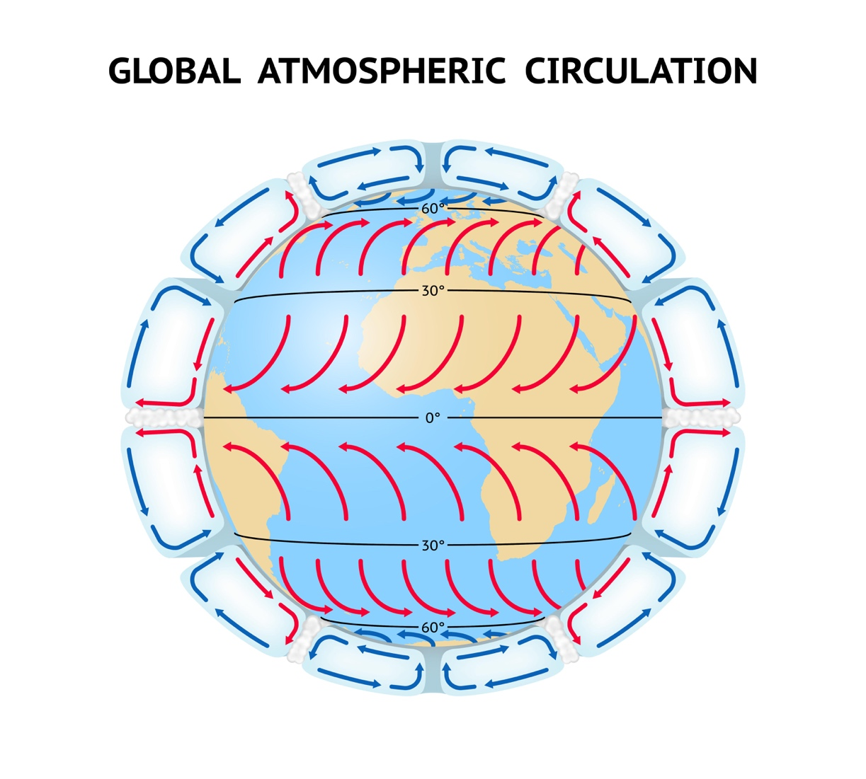

**Real World Examples:**

1. Early explorers and traders utilized the predictable __________ _______ blowing from east to west near the equator to help propel their ships across the oceans when sailing west.

2. Soaring birds like eagles take advantage of thermal updrafts of rising ________ air to gain altitude and conserve energy rather than constantly flapping their wings.

**Guided Notes: Ocean Currents**

Ocean currents are caused by the heating and rotation of Earth and they have a major influence on global climate patterns.

**Key Concepts:**

* Benjamin Franklin discovered the __________ __________, a warm current that flows from the Gulf of Mexico across the Atlantic Ocean.
* A ____________ is the continuous movement of ocean water in a specific direction.
* Ocean currents are caused by _____________ _____________ blowing over the water's surface.
* __________ __________ air and water circulation patterns generate the prevailing winds that cause currents.
* The _____________ _____________ causes currents to turn right in the Northern Hemisphere and left in the Southern Hemisphere.
* The _____________ _____________ is a warm current that flows down the east coast of South America.
* Changes in ocean currents like __________ __________ can have widespread impacts on global climate patterns.
* During an El Niño year, the _____________ _____________ weaken, causing warm water to shift eastward in the Pacific Ocean.

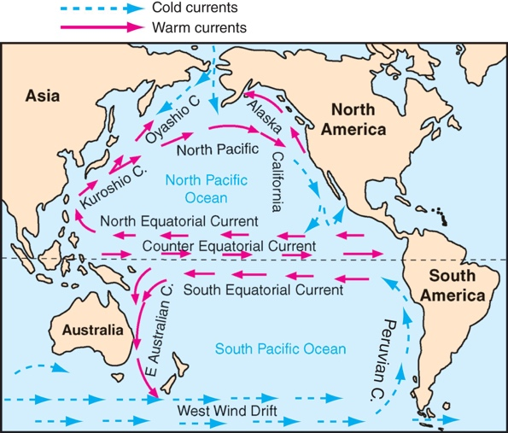

**Real World Examples:**

1. If the Gulf Stream current weakens, it could lead to _______________ temperatures and _______________ conditions in northern Europe in the future.

2. During an El Niño year, areas that are usually _______________ may experience heavy _______________, while typically _______________ regions can have _______________.

**Guided Notes: Atmospheric Circulation**

Atmospheric circulation patterns caused by variations in air pressure significantly influence regional and global climate patterns.

**Key Concepts:**

* Air ____________ is the weight of the air above the Earth's surface.
* A ____________ measures air pressure to help predict weather.
* Rising air creates a ____________ ____________ system with clouds and precipitation.
* Sinking air creates a ____________ ____________ system with warm, dry conditions.
* Areas between 0-30° latitude and 60-90° latitude are dominated by ____________ ____________ that circulate air.
* The ____________ ____________ is a narrow band of strong winds in the upper atmosphere that forms at 60° latitude.
* The ____________ ____________ is a natural process that traps heat from the sun's rays in the atmosphere.
* Human activities are increasing levels of ____________ gases like carbon dioxide, intensifying the greenhouse effect.



**Real World Examples:**

1. Many of the world's ____________ are located around 30° latitude because the sinking air has lost its moisture by that latitude, creating a dry ____________ climate.

2. During an El Niño year, the ____________ ____________ weaken, causing warm water in the Pacific to shift eastward, altering precipitation and temperature patterns worldwide.

**Guided Notes: Ocean Circulation**

Ocean currents play a major role in regulating the climate patterns across the globe.

**Key Concepts:**

* The _______________ is a warm-water current that brings warm temperatures from the equator to Northern Europe.
* The __________ __________ is a cold-water current that brings cold temperatures to the western coast of the United States.
* Ocean water absorbs __________ __________ from the sun and can hold onto it for long periods of time.
* Warm ocean currents carry __________ __________ water from the equator towards the poles.
* Cold ocean currents carry _______________ water from the poles towards the equator.
* Warm currents are _______________ currents, while cold currents are _______________ currents.
* Ocean currents affect the __________ __________ above them, influencing climate patterns.
* _______________ refers to the long-term weather patterns in a specific place.

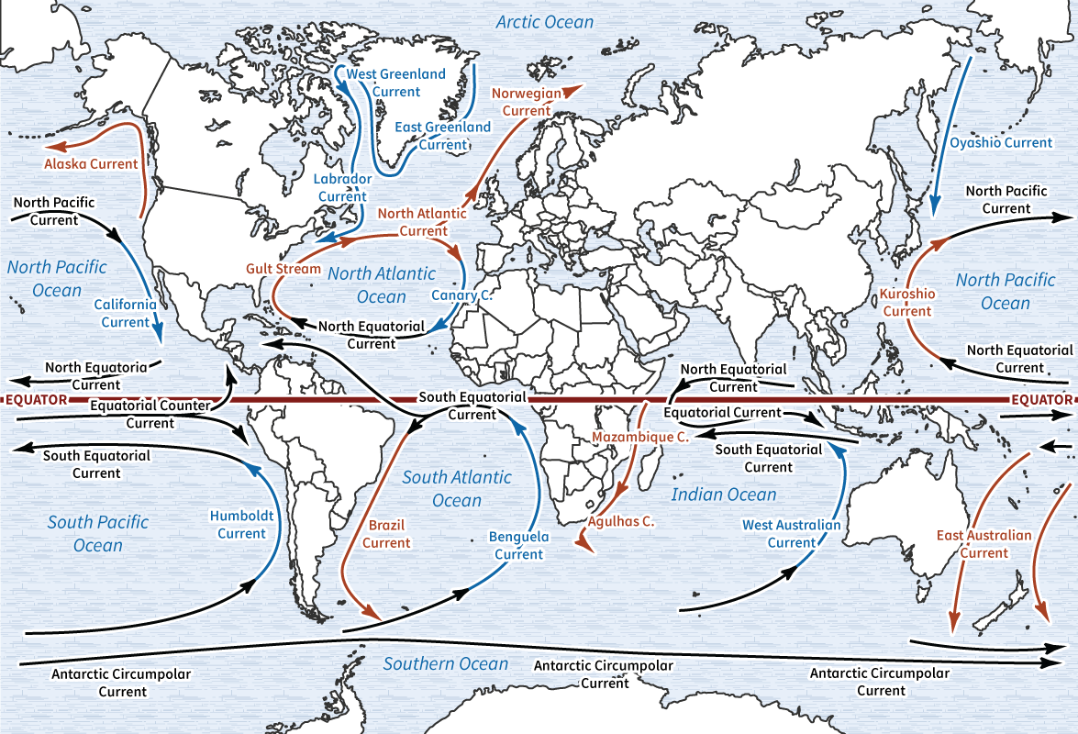

**Real World Examples:**

1. The mild climate in Iceland, with warm, damp summers and mild, windy winters, is due to the __________ __________ surrounding the island with warm, moist water, despite its location near the Arctic Circle.

2. San Francisco, California, has cooler July temperatures and a smaller difference between average high and low temperatures compared to Wichita, Kansas, because the __________ __________ influences San Francisco's climate.

**Guided Notes: Thermal Energy**

The flow of thermal energy, transferred through radiation, conduction, and convection, drives weather patterns and climate on Earth.

**Key Concepts:**

* _______________ is the transfer of thermal energy by waves that does not need a medium.
* _______________ is the transfer of thermal energy when particles come in contact.
* _______________ is the transfer of thermal energy by moving particles in a fluid.
* _______________ is the energy of the motion of particles in a substance at a given temperature.
* _______________ is the transfer of thermal energy.
* _______________ refers to the long-term weather patterns in a specific place.

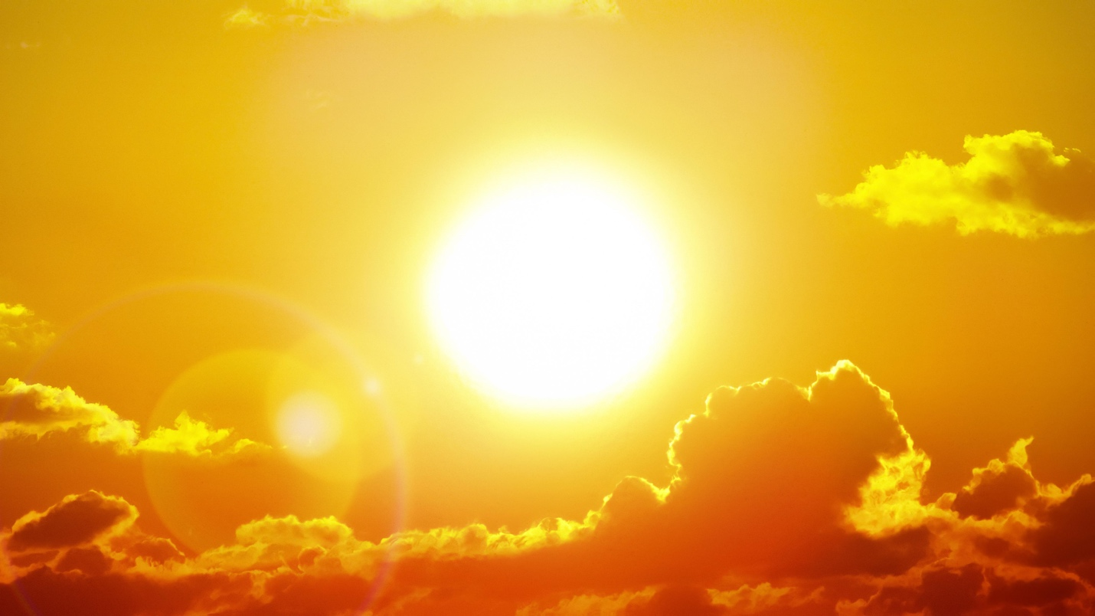

**Real World Examples:**

1. When you run across a hot parking lot barefoot, the heat from the pavement is transferred to your feet by __________.

2. During the day, the land heats up faster than the water. The __________ air over the land rises, and the __________ air from over the water moves in, creating a sea breeze.

**Guided Notes: The Climate System**

The climate system is an interconnected set of parts, driven by the sun's uneven heating of Earth's surface, that regulates long-term weather patterns and climate across the globe.

**Key Concepts:**

* ______________ is a description of long-term weather in one place.
* A ______________ is a set of parts working together as an interconnected whole.
* ______________ gases trap heat in the atmosphere, contributing to the greenhouse effect.
* ______________ is the process used by plants and algae to make their own food, using the energy of sunlight.
* The sun's uneven heating of Earth's surface creates __________ __________ that drive atmospheric circulation.
* Atmospheric circulation generates ______________ winds and ______________ currents.
* Warm ocean currents transport heat towards the ________, while cold currents move towards the ____________.
* Human activities like burning __________ __________ release greenhouse gases into the atmosphere.

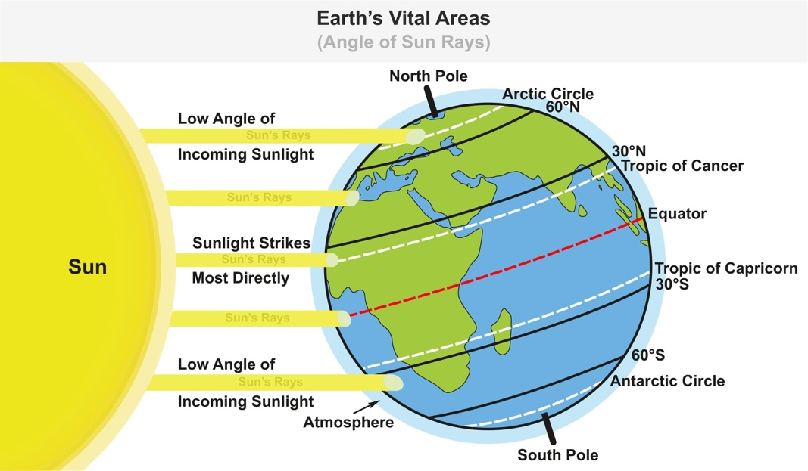

**Real World Examples:**

1. The __________ __________ is a warm ocean current that brings warm temperatures from the equator to Northern Europe, allowing certain marine life to travel farther north than usual and creating a milder climate in areas like Iceland.

2. In the fall, many areas experience stronger winds than in the summer months. This is because the increased temperature difference between the equator and the poles leads to more intense convection currents in the atmosphere, generating stronger prevailing winds.

**Guided Notes: Earth’s Biomes**

A biome is a group of regions on Earth that have similar plant and animal life due to similar climatic conditions.

**Key Concepts:**

* A ____________ is a group of regions on Earth that have similar plant and animal life.
* The major terrestrial biomes include tropical rainforest, _____________ _____________ forest, grassland, taiga, desert, and tundra.
* Tropical rainforests receive over _____ cm of precipitation per year and have warm temperatures year-round.
* Deciduous forests have _____ summers but cold winters, with trees shedding leaves seasonally.
* Grasslands receive _____ to _____ cm of precipitation per year and have grasses and flowering plants.
* The taiga gets _____ to _____ cm of precipitation, mostly in summer, and has pine, spruce, and fir trees.
* Deserts are the driest biomes, receiving no more than _____ cm of precipitation per year.
* The tundra is extremely cold, with permanently frozen soil called ______________.



**Real World Examples:**

1. The ________ trees found in tropical rainforests are among the tallest in the world, with kapok trees able to grow over ________ feet tall.

2. In the ________ biome, trees and plants cannot grow deep roots because of the layer of permanently frozen soil called ______________.