**Guided Notes: Tracking Earthquakes**

**Big Idea:** Scientists use seismic data from instruments like seismographs to identify areas prone to earthquakes and volcanic activity.

**Key Concepts:**

* An ____________ is the part of Earth's surface directly above where an earthquake began.
* A ____________ is a tremor preceding a larger earthquake.
* ____________ is the effect of an earthquake on Earth's surfaces, humans, and structures.
* ____________ is a measure of the maximum motion or energy released by an earthquake.
* The ____________ ____________ ____________ rates earthquakes by measuring the total amount of energy released.
* The ____________ ____________ ____________ describes the effects of an earthquake based on observations of shaking and damage.
* ____________ are waves that push or pull particles in the direction the wave is traveling.
* ____________ are waves that shake particles at right angles to the direction the wave is traveling.
* ____________ ____________ are waves that travel along the surface of Earth.

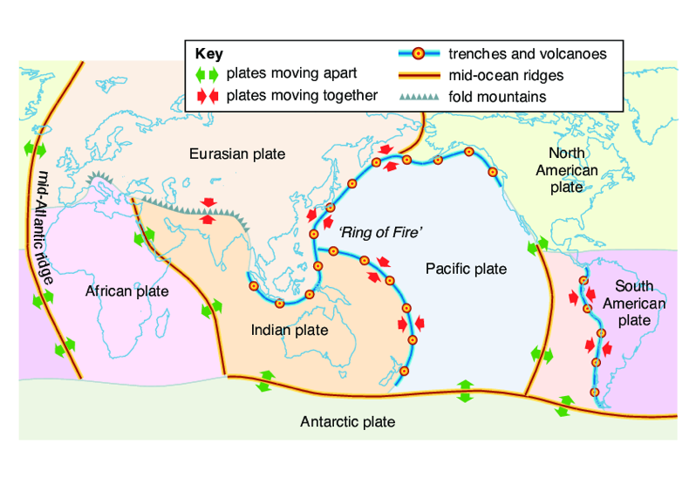

**Real World Examples:**

1. Video Games: Many games involve knocking opponents off platforms. Characters initially resist changes to their motion until hit by an unbalanced force, similar to how earthquakes occur from built-up forces.

2. Tsunami Buoys: Just like seismic stations detect earthquakes, tsunami buoys placed in oceans around the world help track tsunami wave movements to better warn coastal areas.

**Guided Notes: Volcanic Eruptions**

**Big Idea:** Scientists cannot prevent volcanic eruptions, but people can take steps to mitigate (reduce) their effects to prevent loss of life and property.

**Key Concepts:**

* _________________ are scientists who study volcanoes.
* A _________________ is an instrument used to measure vibrations inside Earth.
* The __________ _________ __________ is a geographic location where a lot of earthquake and volcanic activity occurs.
* __________ is fine particles of rock from a volcano.
* __________ is the act of reducing loss of life or property from natural hazards.
* __________ __________ __________ is equipment used to minimize exposure to hazards.

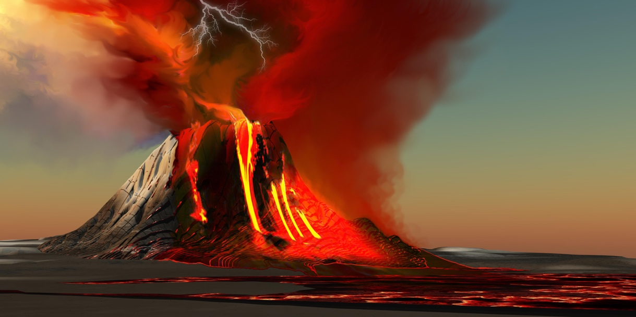

**Real World Examples:**

1. In 1980, there were warning signs like ________________ and earthquakes that Mount St. Helens was going to erupt. Volcanologists ordered people to leave the area, which helped prevent more loss of life when it did erupt on May 18, 1980.
2. If you live near a volcano, you should have an emergency "go-bag" ready with supplies like food, water, _________________, and other essentials in case you need to evacuate quickly. Following instructions from officials can help _________________ the risk.

**Guided Notes: Tracking Hurricane Dorian**

**Big Idea:** Understanding how hurricanes are tracked and their intensity is predicted to mitigate their devastating effects.

**Key Concepts:**

* ____________ __________ is a measure of air pressure in the atmosphere.
* The ____________ ____________ is the apparent curve of winds or objects due to Earth's rotation.
* The ____________ is the region of calm weather at the center of a hurricane.
* The ____________ is a band of very strong winds surrounding the eye of a hurricane.
* A ____________ is a tropical storm with winds of 119 kph (74 mph) or greater that also has rain.
* ____________ refers to reaching land.
* The ____________ ____________ ____________ ____________ is a rating scale for hurricanes that uses wind speed.
* A ____________ ____________ is an abnormal rise of water generated by a storm.
* A ____________ ____________ is a weak storm with sustained winds of 61 kph (38 mph) or less.
* A ____________ ____________ is a storm with winds of 62–117 kph (about 39-73 mph) or less that also has rain.
* A ____________ ____________ is an area of low pressure that moves from east to west.

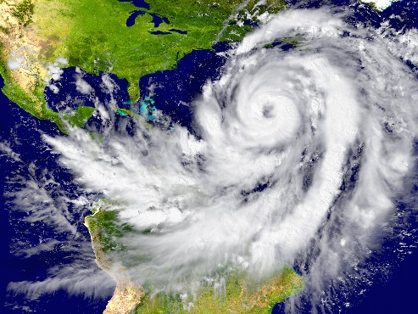

Hurricanes form over warm ocean water. Source: Tomas Griger/123RF

**Real World Examples:**

1. When Hurricane Dorian made landfall in the Bahamas as a Category 5 storm, it caused catastrophic damage, destroying many homes and leaving areas uninhabitable for weeks or months due to its extremely high winds of 185 mph, as predicted by the _________ _________ __________ __________ _________.

2. As Hurricane Dorian approached the eastern coast of the United States, meteorologists used data on__________ __________, wind speed, and the storm's path to predict its intensity and potential impact, allowing government agencies and first responders to prepare and warn residents in affected areas.

**Guided Notes: Learning From Hurricane Katrina**

**Big Idea:** Learning from past failures in hurricane response can lead to better preparation and mitigation of future hurricane impacts.

**Key Concepts:**

* ____________ __________is a special form of radar that uses echoes from radio waves to track air movement inside a storm.
* A ____________ is a storm with winds of 118 kph (about 74 mph) or greater that also has rain.
* ____________ refers to reaching land.
* ____________ are walls of earth designed to regulate water levels.
* ____________ is the act of reducing loss of life or property from natural hazards.
* A ____________ is a fictional disaster used to evaluate the effectiveness of a response.
* A ____________ ____________ is an abnormal rise of water generated by a storm.

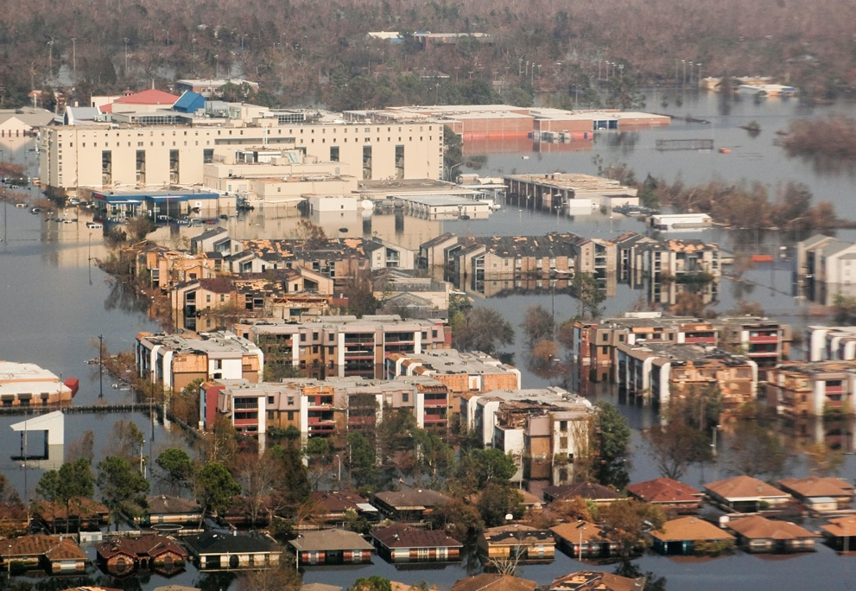

**Real World Examples:**

1. During Hurricane Katrina in 2005, the __________ system protecting New Orleans failed, leading to catastrophic flooding in the city. This highlighted the need for stronger and better-maintained levees to mitigate the effects of future hurricanes and storm surges.

2. After the failures in the response to Hurricane Katrina, government agencies and first responders learned the importance of effective communication, proper evacuation planning, and having emergency supplies and personnel readily available to help people quickly after a hurricane strikes.

**Guided Notes: Using Data to Predict Wildfires**

**Big Idea:** Using various data sources and technologies can help predict and mitigate the impacts of wildfires.

**Key Concepts:**

* ____________ is the criminal act of deliberately setting a fire.
* ____________ means in the direction the wind is blowing.
* A ____________ is a period of abnormally low rainfall.
* ___________ __________ is a weather pattern that causes unusually warm ocean temperatures in the Pacific Ocean.
* A ____________ is a prediction about a future event.
* ____________ ____________ __________are strong, hot, dry winds that originate inland and move toward the coast.
* ____________ refers to the plant species that cover the ground.

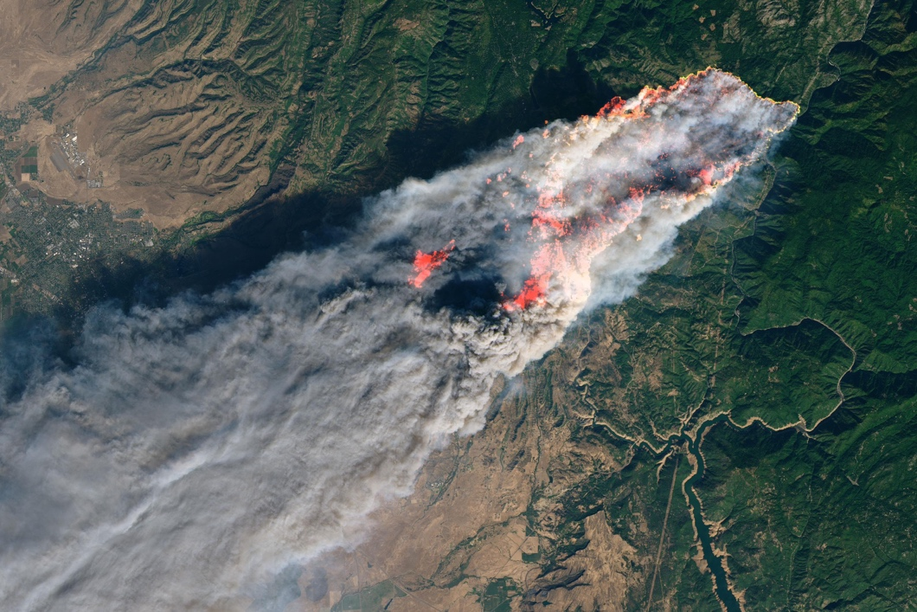

**Real World Examples:**

1. During the 2018 Camp Fire in Northern California, a combination of __________ conditions, dry vegetation, and strong Santa Ana winds allowed the fire to spread rapidly, destroying the town of Paradise within hours.

2. Meteorologists use data from satellites, radar, and other technologies to forecast drought conditions and predict areas at high risk for __________, allowing officials to prepare and warn residents in those areas.

**Guided Notes: Mitigating the Effects of Wildfires**

**Big Idea:** Using various technologies and mitigation strategies can help reduce the devastating effects of wildfires.

**Key Concepts:**

* ____________ ____________ are planned fires set to manage forests.
* A ____________ is a period of abnormally low rainfall.
* To ____________ means to make something less severe.
* A ____________ ____________ is an area around a building where vegetation and combustible materials are cleared to prevent wildfire spread.
* ____________ refers to cutting down and removing smaller and younger trees in a forest.
* A ____________ is an unplanned and unwanted fire.

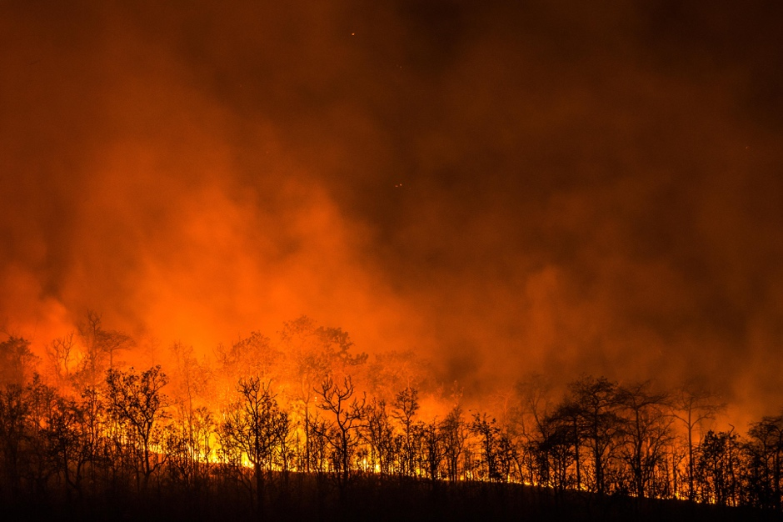

**Real World Examples:**

1. After devastating wildfires in recent years, many communities in wildfire-prone areas are now requiring homeowners to create __________ spaces around their properties by clearing brush and combustible materials within a certain perimeter of the home. This provides a buffer to help stop or slow the spread of wildfires.

2. In areas with high wildfire risk, utility companies are increasingly using technology like weather monitoring stations, cameras, and drone inspections to proactively identify potential wildfire hazards like dead trees or vegetation too close to power lines. They can then mitigate these risks through vegetation management programs before a fire starts.