**Guided Notes: Relative Humidity**

**Big Idea:** Relative humidity is a measure of the amount of water vapor in the air compared to the maximum amount the air can hold at a given temperature.

**Key Concepts:**

* _____________ is the measure of the amount of water vapor in the air.
* Warm air can hold more __________ __________ than cool air.
* When air is _____________, it contains as much water vapor as it can hold.
* Relative humidity is a _______________ of the amount of water vapor in the air compared to the maximum saturated amount.
* At 100% relative humidity, the air is _____________ and cannot hold any more water vapor.
* The ________ ________ is the temperature at which the air becomes saturated.
* ____________ _______________ is the process of making sense of data and evidence to develop scientific explanations.

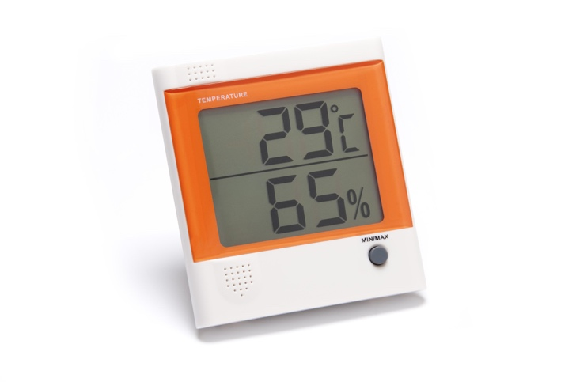

**Real World Examples:**

1. Feeling sticky on a hot summer day is due to high __________ __________.

2. Water droplets forming on grass in the morning is because the cool night air became ______________ with water vapor.

**Guided Notes: Air Pressure**

**Big Idea:** Air pressure systems are used to describe and predict weather patterns.

**Key Concepts:**

* Air pressure is the ________________ that air exerts as it is pulled towards Earth by ________________.
* A high-pressure system is associated with ________________ air, resulting in ________________ weather.
* A low-pressure system is associated with ________________ air, resulting in ________________, rainy or snowy weather.
* In a high-pressure system, surface air moves ________________ from the center.
* In a low-pressure system, surface air moves ________________ toward the center.
* Meteorologists study the movement of ________________ and ________________ systems to predict weather.

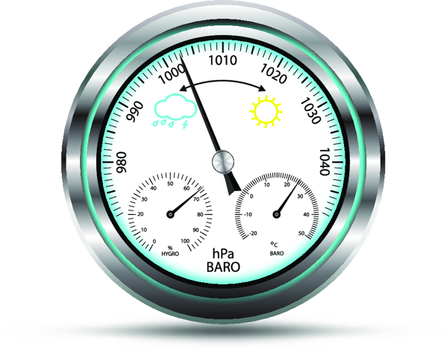

**Real World Examples:**

1) When you drink through a straw, you are decreasing the air pressure inside the straw which allows the higher air pressure from the atmosphere to push the liquid up the straw.

2) When a weather report calls for a high-pressure system over your area, you can expect ________________ and ________________ weather conditions.

**Guided Notes: Air Masses**

**Big Idea:** How air masses interact and change over time plays a major role in the weather we experience on earth.

**Key Concepts:**

• An air mass is a large body of air that has uniform _______________ and _______________.

• A front is a _______________ between two or more air masses.

• Continental air masses form over _______________, while maritime air masses form over _______________.

• Air masses can be classified as polar, tropical, maritime or continental based on their ____________ and _______________.

• Air masses take on the characteristics of the _______________ over which they form.

• When different air masses meet, the warmer air mass is forced to rise, causing _______________ formation.

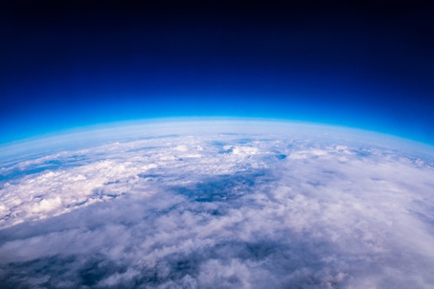

**Real World Examples:**

1. When you're having a family reunion on a warm, sunny day and suddenly the temperature drops and dark clouds start moving in, it means a new ____________ is moving in. The colder air mass is pushing under the warmer one, forcing it to rise and form clouds.

2. If a continental tropical air mass moves out over the ocean for a few days, it would pick up moisture from the ocean, becoming a _____________ air mass.

**Guided Notes: Air Mass Interactions**

**Big Idea:** When air masses interact, they cause changes in the weather.

**Key Concepts:**

* Air masses are large bodies of air with similar _______________ and _______________ levels.
* The boundary between two air masses is called a __________________.
* A cold front occurs when __________ air moves under __________ air, pushing the warm air upward.
* A warm front occurs when _____________ air moves over ____________ air.
* Energy from the ______________ provides almost all the energy for weather events like winds, precipitation, and storms.
* Two types of reasoning used in science are _______________ reasoning and _______________ reasoning.

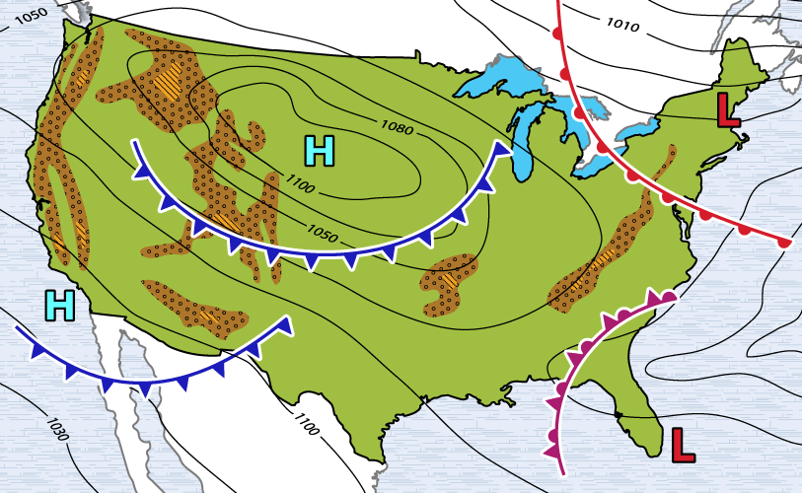

**Real World Examples:**

1. You're enjoying a sunny day at the beach when suddenly dark clouds roll in, the temperature drops, and it starts raining heavily. This dramatic weather change was likely caused by a cold front (cold air mass) overtaking the warm _____ _________ that was present.

2. Meteorologists track patterns of how air masses move to _________________ weather changes.

**Guided Notes: Predicting Weather**

**Big Idea:** Weather can only be predicted based on how likely it is to happen because it is complicated and has multiple causes.

**Key Concepts:**

* A weather ______________ is a prediction about future weather.
* A weather ______________ is a computer simulation of future weather.
* The most recent forecast is the most ______________ because it has the most recent data.
* Scientists gather data on ______________, ______________, _____________, ______________, and ______________ to predict weather.
* Scientists use tools like ______________ and ______________ to gather weather data.
* Weather forecasts are just ______________, they can never tell you exactly what will happen.
* The further out a forecast is made, the __________ __________ it will be.
* New technologies like _____________ _____________ may lead to more accurate forecasts.

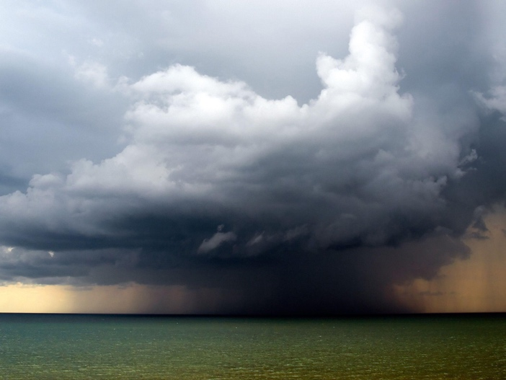

**Real World Examples:**

1) Planning a vacation - You would want to check the weather forecast for your travel dates to help decide the best time to go based on typical weather patterns for that area. The closer you get to your trip dates, the more accurate the forecast will be.

2) Severe weather events like hurricanes - Meteorologists use satellite data, weather models, wind speed measurements and more to predict the path and intensity of hurricanes. The forecast cone gets wider the further out it projects, since accuracy decreases over time.

**Guided Notes: Many Things Affect Weather**

**Big Idea:** Many factors affect weather, including the sun, landforms, and bodies of water.

**Key Concepts:**

* The sun warms the __________ unevenly, causing differences in __________ which result in warm and cold air masses.
* Day/night cycles and the cycle of __________ also impact weather by causing changes in temperature and precipitation.
* Land heats __________ than water and also cools off faster, leading to uneven pressure distribution and wind.
* Landforms like __________ can cause wind to lift and lose intensity, resulting in precipitation on one side and little rain on the other (rain shadow).

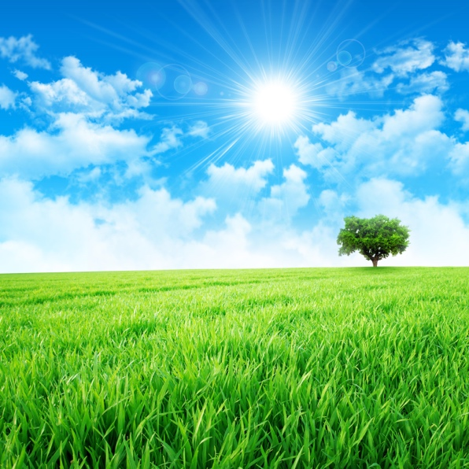

**Real World Examples:**

1. When you walk on hot sand at the beach, the sand feels much __________ than the water because land heats up faster than water bodies. This uneven heating contributes to changes in air pressure and wind patterns that affect weather.

2. In areas with mountains, one side often has more __________ growth than the other due to the rain shadow effect. As wind hits the mountain, it is forced upward, cools, and releases moisture as rain/snow on that side. The other side receives much less precipitation.