**Guided Notes: Atmospheric Layers**

**Big Idea:** Earth's atmosphere is divided into five distinct layers, each with its own unique properties.

**Key Concepts:**

* _______________ is the distance from Earth's surface.
* The _______________ is the layer closest to Earth's surface, extending up to about 12 km.
* The _______________ extends from 12 km to 50 km above Earth's surface.
* The _______________ is the middle layer, from 50 km to 80 km above Earth's surface.
* The _______________ is the very hot layer from 80 km to 700 km above Earth's surface.
* The _______________ is the outer layer that extends from 700 km to outer space.
* _______________ is a form of oxygen found in higher concentrations in the stratosphere.



**Real World Examples:**

1. When you are on an airplane, you travel through the __________, where the air pressure and oxygen levels decrease as altitude increases, making it harder to breathe.

2. Shooting stars, or meteors, often burn up in the __________ due to the thin air in this layer.

**Guided Notes: Fossil Fuels and Climate Change**

**Big Idea:** Burning fossil fuels contributes to climate change.

**Key Concepts:**

* Climate change refers to changes in Earth's climate due to increased __________.
* __________ fuels are fuels made from the breakdown of ancient plants and animals.
* __________ __________ is the increase in Earth's average surface temperature due to human activity.
* The __________ __________ is the warming effect of greenhouse gases.
* The __________ __________ was a period of increased manufacturing in factories around the world.
* When fossil fuels are burned, extra __________ __________ is added to the atmosphere, trapping heat.
* Climate change includes changes in temperature, frequency of storms, and changes in __________.

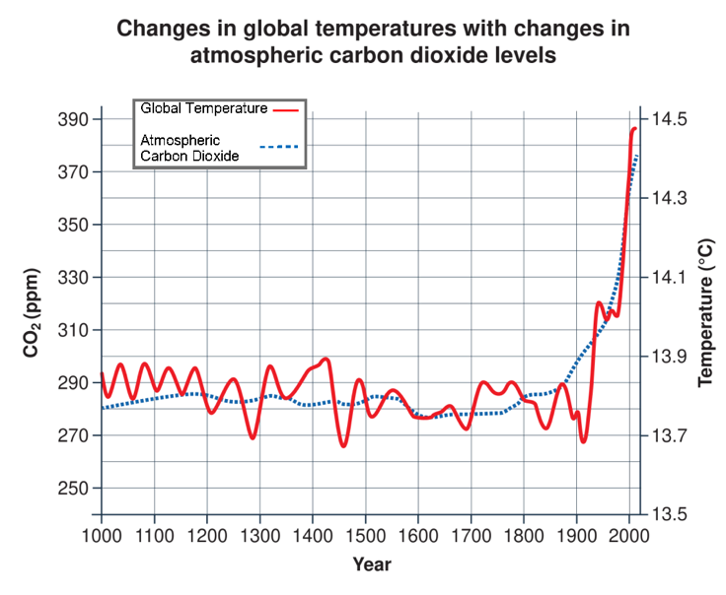

**Real World Examples:**

1. When people drive gasoline-powered cars, they release __________ __________ into the atmosphere, contributing to the greenhouse effect and global warming.

2. You could reduce your reliance on fossil fuels by riding your bike or walking. This reduces the amount of __________ you burn, which releases less carbon dioxide into the air.

**Guided Notes: Human Activities and Climate Change**

**Big Idea:** Human activities contribute to climate change.

**Key Concepts:**

* __________ is the large-scale clearing of forests by cutting or burning trees.
* The __________ __________ is the process of trapping energy.
* A __________ is a place where garbage is buried, releasing methane gas.
* __________ is a greenhouse gas released in agriculture and from livestock.
* __________ __________is a greenhouse gas released from nitrogen-based fertilizers.
* __________ is the change of land from farming or wilderness into urban areas.

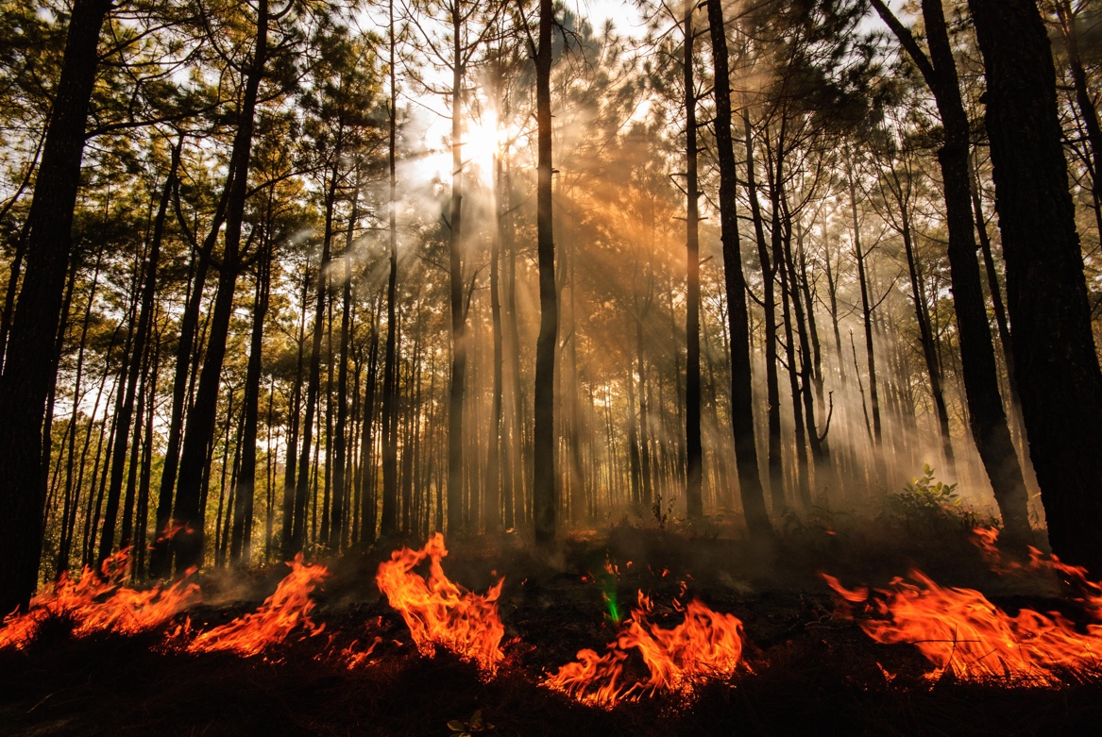

**Real World Examples:**

1. During the Industrial Revolution time period (around 1850 to 1840), factories powered by burning __________ __________ like coal and oil released extra carbon dioxide into the atmosphere, increasing the greenhouse effect.

2. Corals are small animals that build coral reefs in the ocean. Even a 1°C increase in water temperature from global warming can kill corals, causing them to turn white. Scientists predict if global warming continues, over 90% of coral reefs could die off.

**Guided Notes: Polar Ice and Climate Change**

**Big Idea:** Melting polar ice contributes to cycles that affect climate change.

**Key Concepts:**

* __________ __________ refers to areas of an ocean that are not covered by sea ice.
* __________ __________ are large amounts of ice located on the Earth's North and South poles.
* __________ __________ is ice that floats on top of sea water, blocking light and energy.
* Bright surfaces like ice and snow reflect more __________ than dark surfaces.
* Dark surfaces like ______________ absorb more sunlight which gets converted to heat.
* The higher the __________, the greater an object's ability to reflect light.
* ______________ is a measure of the mass per unit volume of a substance.
* Salt water is __________ than fresh water.
* Sea ice formation leaves behind _______________ water that is denser and sinks.
* This cold, dense water drives the _______________ currents in the ocean.
* Slowing these currents can affect coastal __________ on land.

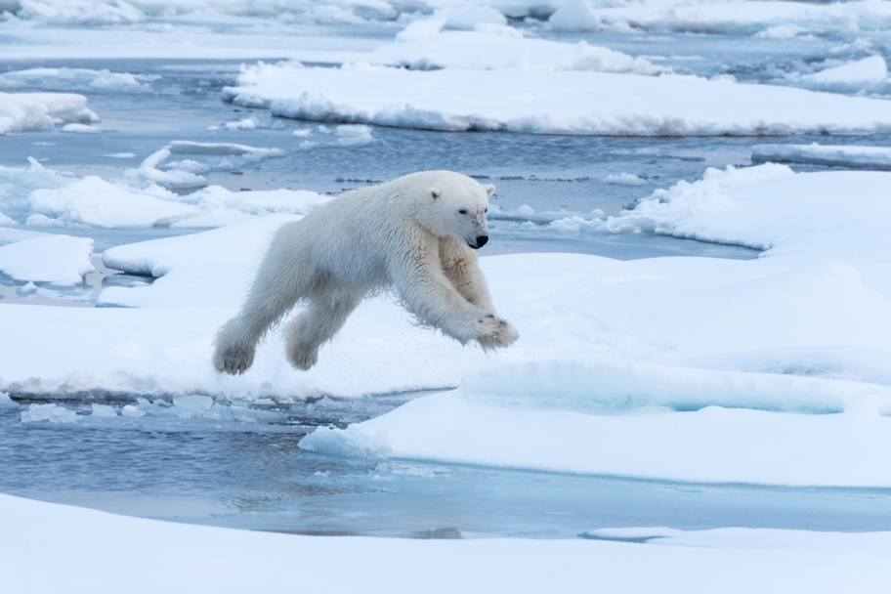

**Real World Examples:**

1. One effect of climate change is rising __________ __________, which can cause coastlines to move inward over time. Some beach areas are seeing more erosion and loss of sand as sea levels rise due to melting glaciers and polar ice caps.

2. The decline of the Atlantic cod population off the coast of Maine was caused by _______________ ocean temperatures that hampered the cod's ability to breed successfully.