**Guided Notes: Renewable and Nonrenewable Resources**

**Big Idea:** Distinguishing between renewable and nonrenewable resources based on availability and sustainability.

**Key Concepts:**

* A nonrenewable resource is one that will __________ __________or cannot be replaced as fast as it is __________.
  + Examples: petroleum, natural gas, coal, __________.
* A renewable resource is one that will __________ __________ __________.
  + Examples: __________, __________, hydro, geothermal, biomass.
* A sustainable resource is one that will last for a long time and does __________ __________ to the environment when used.
* Nonrenewable resources are in __________ __________, so we must use them __________.
* Renewable resources can be __________ if used properly without harming the environment.
* Properly __________ __________ after cutting them down is an example of sustainable use of a renewable resource.

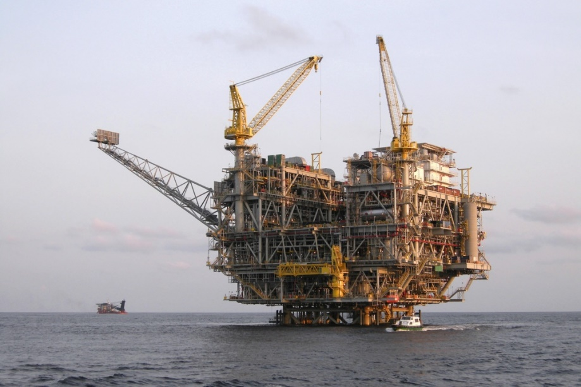

**Real World Examples:**

1) Many products we use daily are made from __________, a nonrenewable resource that will eventually run out. These include gasoline, plastics, and materials to make our electronics.

2) __________ __________ use the renewable resource of wind to produce electricity in a sustainable way without harming the environment.

**Guided Notes: Rocks and Minerals**

**Big Idea:** Rocks and minerals are important natural resources that have many useful applications.

**Key Concepts:**

* A mineral is a natural, non-living solid with an ordered internal structure and a definite __________ __________.
* Mineral resources are areas of solid __________ material found in Earth's crust that are of economic interest.
* An ore is a naturally occurring material containing __________ minerals that can be mined profitably.
* Some common uses of mineral resources include:
  + _________________ for automobiles and packaging
  + _________________ for inks, plastics, and radiography
  + _________________ for aircraft engines
  + _________________ for electric wires and plumbing

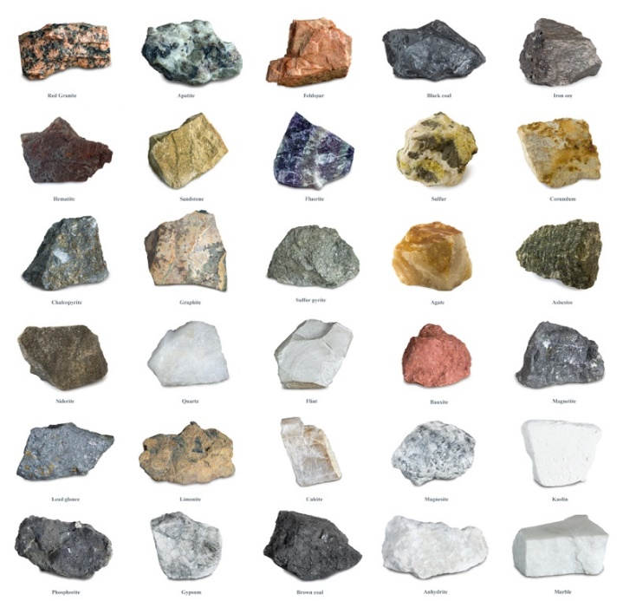

**Real World Examples:**

1. When you use your phone, laptop or game console, the computer chips inside were made from the mineral _______________. These devices rely on this mineral resource.

2. The next time you have a drink from a soda can, remember that ________________ is a mineral resource mined and used to make those lightweight cans.

**Guided Notes: Fossil Fuels**

**Big Idea:** Fossil fuels like coal, oil, and natural gas are considered nonrenewable resources because they take millions of years to form from the remains of once-living organisms.

**Key Concepts:**

* Fossil fuels are fuels formed millions of years ago from the __________ of living organisms.
* The major fossil fuels are __________, __________, and __________ gas.
* Fossil fuels release energy when _________________.
* Problems with fossil fuels include releasing toxic _________________ and _________________ dioxide into the air.
* Fossil fuels are ___________________ resources because they take so long to form and are being used up rapidly.
* Crude oil formed from the remains of tiny _________ plants and animals accumulating on the seafloor over millions of years.
* Coal formed from layers of dead ________________ material building up and being subjected to heat and pressure over millions of years.

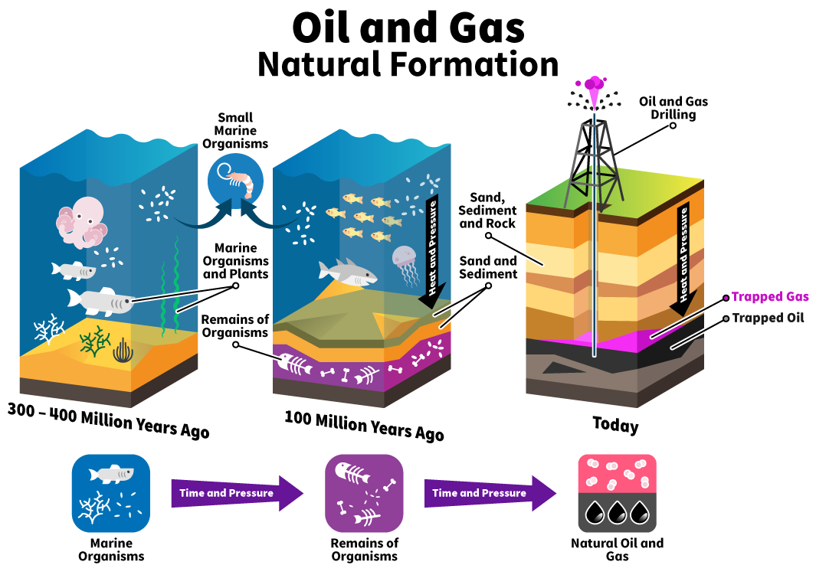

**Real World Examples:**

1. The gasoline that powers the cars/trucks we drive comes from the fossil fuel _______________ that was formed from ancient sea organisms.

2. When you turn on a light at home, the electricity may have come from burning the fossil fuel ___________ at a power plant.

**Guided Notes: Energy Exploration**

**Big Idea:** Extracting energy resources like oil, natural gas, and coal from the Earth can have major environmental impacts that need to be considered.

**Key Concepts:**

* The U.S. uses over ______ million barrels of petroleum each day from drilling on land and offshore oil rigs.
* Oil and natural gas are often found trapped in ____________ rock formations under the ocean or on land.
* Dangers of offshore drilling include ______ ____________ which can devastate marine ecosystems.
* Fracking is injecting ____________ into rock to open cracks and allow oil/gas to escape, but it can contaminate _________________.
* Oil sands are deposits of ____________ mixed into sandy sediment that require energy-intensive extraction.
* The two main ways to mine coal are ___________ mining which strips away topsoil, and ________________ mining.
* Mountaintop removal is a controversial coal mining method that __________ off mountaintops to reach coal seams.
* Environmental impacts of coal mining include acid mine _____________, heavy metal contamination, and habitat destruction.

**Real World Examples:**

1. If you've ever seen pictures or video of an ocean covered in a thick black substance, that was likely from a(n) ______ _______ caused by an offshore drilling accident.
2. When you turn on the hot water for your shower, the water is heated by a water heater that often uses __________ __________.

**Guided Notes: Using Energy Resources**

**Big Idea:** While energy resources are critical for modern life, the combustion and use of fossil fuels like coal, oil, and natural gas can have major negative environmental impacts.

**Key Concepts:**

* About ____% of the energy used in the U.S. comes from burning fossil fuels.
* The combustion, or ____________, of fossil fuels releases pollutants into the air.
* Carbon dioxide from fossil fuel combustion is a ____________ gas contributing to global warming.
* Fossil fuels also release gases like sulfur dioxide and nitrogen oxides that mix with water to form __________ __________.
* Acid rain damages _________, ____________, and soil nutrients that plants need.
* Nuclear power avoids air pollution but produces ____________ ___________ that remains dangerous for thousands of years.
* Major nuclear accidents like ________________ can spread radioactive contamination over large areas.

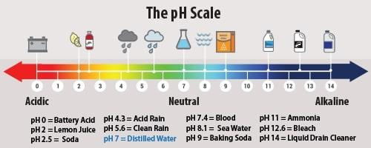

**Real World Examples:**

1. The brown haze you see over big cities is largely caused by pollutants from the _____________ of fossil fuels in vehicles and power plants.

2. If trees in a forest near you have brown, dying leaves, it could be a result of exposure to ________ _________ from fossil fuel emissions.

**Guided Notes: Land and Soil Resources**

**Big Idea:** Soil is a critical natural resource that supports plant and animal life, but it is also a nonrenewable resource that can be damaged or depleted.

**Key Concepts:**

* The "Dust Bowl" of the 1930s showed the effects of poor __________ ____________ practices on soil.
* Soil is the upper layer of Earth's crust from which __________ grow.
* About half of soil is a mix of weathered rock and __________, the decayed remains of plants/animals.
* The nutrients and ____________ in soil allow plants to survive.
* Soil provides resources for __________ production and other ecosystem services.
* Soil acts as a __________ for pollutants to protect groundwater.
* Soil is essentially a __________________ resource because it takes so long to form, about _____ years per inch.



**Real World Examples:**

1. After a heavy rain, you may see _________ water running off fields or construction sites - that's because the soil is being washed away by erosion.

2. When you buy food like fruits, veggies, grains etc. at the grocery store, those all ultimately came from _________ growing in nutrient-rich soil.

**Guided Notes: Conservation**

**Big Idea:** Conserving natural resources through methods like recycling, using renewable energy, and reducing consumption is important to make resources last longer and protect the environment.

**Key Concepts:**

* __________ is protecting a resource so it is not wasted or harmed and will be available in the future.
* Using resources more ________________, decreasing amount used, and replacing nonrenewable with renewable resources are ways to conserve.
* __________ means using a waste material to create new objects instead of extracting new raw materials.
* Using solar, wind, and other ___________________ energy conserves fossil fuel supplies.
* A sustainable resource won't be used up and doesn't ____________ the environment when used.
* Recycling conserves trees, minerals, and _____________ fuels used to manufacture and transport products.
* The U.S. recycles about _____% of its waste, though ____% could be recycled according to the EPA.

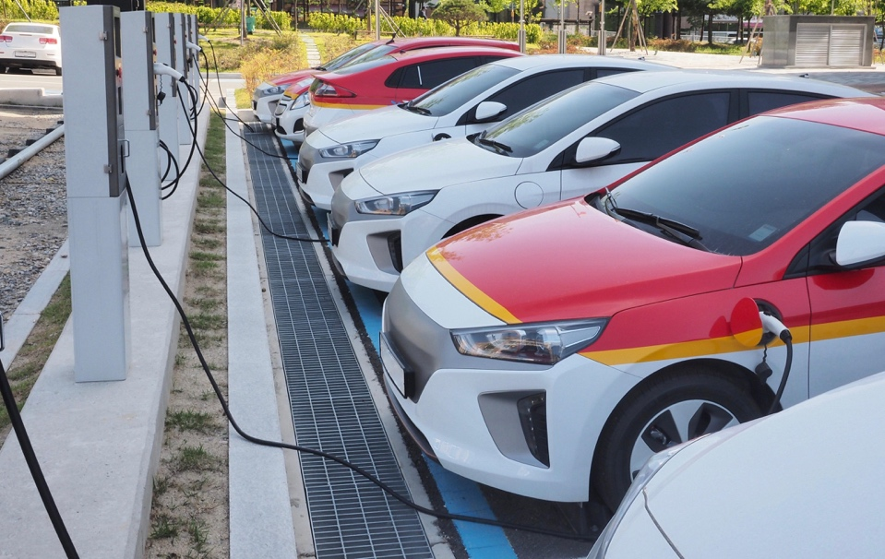

**Real World Examples:**

1. One way to conserve resources at home is to use a __________ __________ __________ instead of disposable plastic bottles to carry drinks.

2. If your community offers __________ __________, that's a way to recycle materials like cardboard, plastic, and metal instead of throwing them away.

**Guided Notes: Resource Processing**

**Big Idea:** There are many steps and processes involved in locating, extracting, and transporting natural resources like minerals and fossil fuels to be used in manufacturing.

**Key Concepts:**

* Minerals are valuable natural resources found in _____________ on or below Earth's surface.
* Concentrated mineral deposits found in small areas are called ________.
* To reach mineral deposits, drilling with machines is used to break through __________.
* The process of getting minerals from underground is called _____________.
* The three main mining methods are _____________ mining, ________________ mining, and placer mining.
* After mining, raw materials must go through processes like ______________, ______________, and ________________ to reach manufacturers.

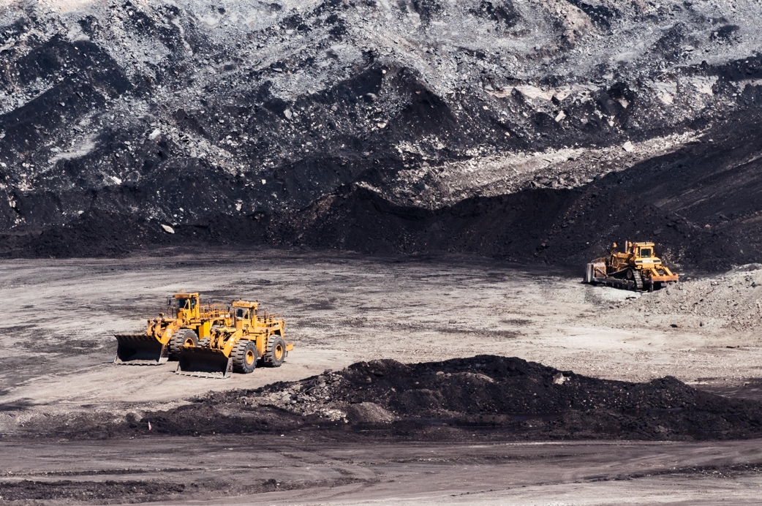

**Real World Examples:**

1. If you've ever gone panning for gold in a stream, you were taking part in _______________ mining by using water to separate the gold from sediments.

2. When the milk from your dairy farm gets delivered to the grocery store, it had to go through a complex transportation system involving _____________, _______________, and ___________________.