**Guided Notes: Consumption of Mineral Resources**

**Big Idea:** As the world's human population continues to grow, the consumption and use of natural mineral resources like metals, fossil fuels, and minerals also increases, which can have major environmental impacts.

**Key Concepts:**

* The world's _______________ is expected to grow from 6.1 billion in 2000 to 8.9 billion by 2050.
* As population increases, so does the _________________ of natural resources like minerals and fossil fuels.
* Natural mineral resources include metals used for construction like ________ as well as energy sources like _________ __________.
* Mining for mineral resources can destroy habitats, pollute ________ and __________, and release acids.
* Burning fossil fuels releases ____________ _________, greenhouse gases that contribute to global warming.
* Effects of increased greenhouse gases include melting glaciers, rising _______ _________, and changing precipitation patterns.
* Scientists sometimes use a _________ _____________ _____________ to weigh the benefits and environmental costs of mining plans.

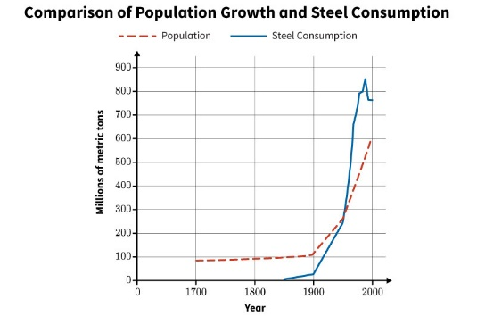

This graph compares the population size to the amount of steel consumed.

**Real World Examples:**

1. The electricity keeping the lights on in your home likely comes from burning ____________ __________.

2. Many of the bridges, buildings, and other infrastructure you see were constructed using large amounts of _________, which has to be mined from the Earth.

**Guided Notes: Conserving Mineral Resources**

**Big Idea:** Human consumption of natural mineral resources like fossil fuels can negatively impact the environment, so it is important to monitor these impacts and find ways to conserve and minimize resource use.

**Key Concepts:**

* Human ____________________ of mineral resources through mining and burning fossil fuels can damage habitats and release pollutants.
* The greenhouse effect is the trapping of the sun's __________ in the atmosphere caused by greenhouse gases like CO2.
* Scientists ____________________ environmental impacts by measuring things like air/water pH, surface temperatures, and sea levels.
* To reduce consumption, we can __________________ resources by turning off lights, using efficient appliances, recycling, etc.
* Using ______________ ___________ ______ _____________ like solar, wind, and hydro conserves fossil fuel supplies.
* Alternative energy sources are more environmentally friendly because they don't release __________________ ____________.

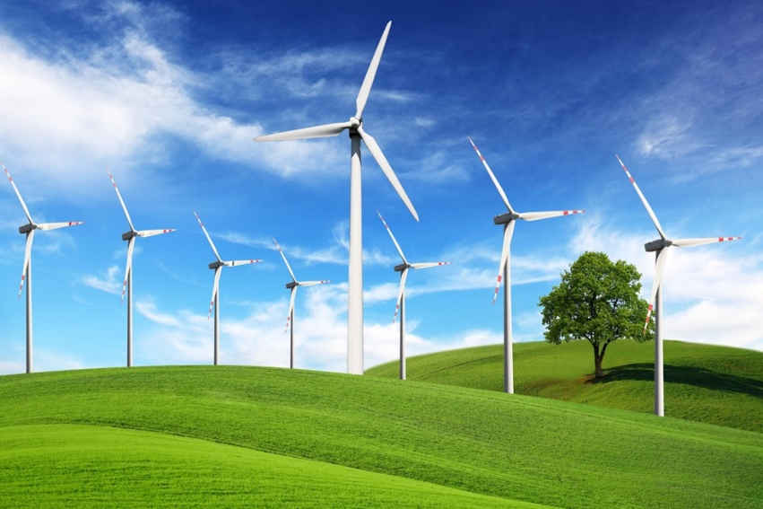

**Real World Examples:**

1. The smog and hazy air you sometimes see over cities is caused by the release of greenhouse gases and pollution from the ___________________ of fossil fuels.

2. When you recycle aluminum cans instead of throwing them away, you are helping to __________________ the mineral resource bauxite that is mined to produce aluminum.

**Guided Notes: Consumption of Bioresources**

**Big Idea:** As the world's human population continues to grow rapidly, the demand for bioresources like food, wood, and other materials from living things also increases, leading to environmental impacts.

**Key Concepts:**

* With more people, there is greater demand for ________________ to provide food, shelter, and other needs.
* To meet demand, more __________ has been converted to agricultural use by clearing forests and vegetation.
* Only about _____% of Earth's land area is actually habitable for humans.
* Today, around _____% of habitable land is used for ____________________.
* Increased urbanization and loss of vegetation can contribute to the _________ __________ ____________.
* Runoff from fertilizers can cause _________ ____________ that remove oxygen and kill aquatic life.

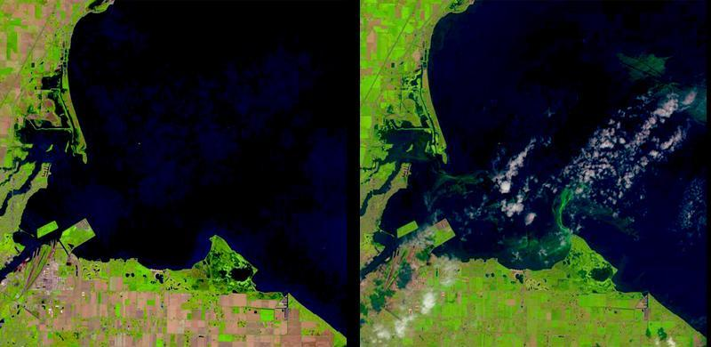

Satellite data maps of Lake Erie, near Toledo, Ohio, the urban area visible in the lower left on June 14, 2014 (left) and August 1, 2014 (right). The algal bloom is visible as green swirls on the surface of the water in the right image. The white spots above the land and water are clouds. Algae blooms commonly happen in summer on Lake Erie, but the blooms have been increasing in recent years.

Source: United States Geological Survey

**Real World Examples:**

1. The vegetables, grains, and meat that make up the food you eat every day all come from ___________________ that require land for agriculture.

2. The wooden furniture, paper products, and housing lumber you use are all ______________________ derived from forest trees that are being cut down for resource use.

**Guided Notes: Conserving Bioresources**

**Big Idea:** Humans rely heavily on bioresources from plants and animals, but activities like deforestation, urban sprawl, and agriculture can damage environments and contribute to climate change if not done sustainably.

**Key Concepts:**

• Bioresources are any ______________ or products from organisms that are useful to humans.

• Growing human _________________ has increased demand for land for urban development and agriculture.

• Clearing forests for agriculture leads to ____________ destruction and less absorption of greenhouse gases like ___________ _____________.

• Urban sprawl increases _____________, flooding, pollution of water habitats, and destroys ecosystems.

• _______________ _____________ is one proposed solution to reduce urban sprawl and concentrate cities vertically.

• Increasing ____________ ___________ can reduce urban heat island effects, absorb CO2, and provide habitats.

• Shifting to more plant-based diets could reduce agricultural land needed for _______________ grazing.

• Satellite data from programs like ______________ is used to monitor changes in land use over time.

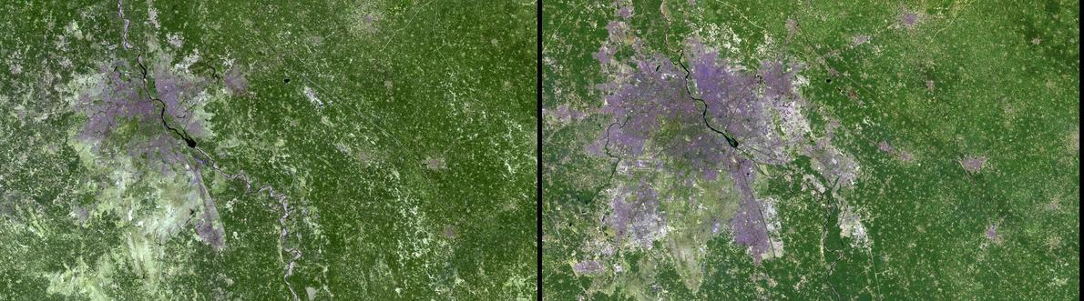

Landsat data maps of India's capital of New Delhi. The image on the left was taken in March of 1991. The image on the right was taken in March of 2016.

**Real World Examples:**

1. The paper, wood products, and prescription medications you use all come from ______________________ derived from plants and other organisms.

2. When a new housing development or shopping mall is built in your area, it likely contributes to _________________ by clearing land and habitats.