Function Analysis
Formula Sheet
Name | Definition | Formula
Average Rate of Change | The average measure of how much a function changed per unit over a given interval. | Average Rate of Change Formula: $$\frac{f\left(b\right)−f\left(a\right)}{b−a}$$  Given the interval [a, b]  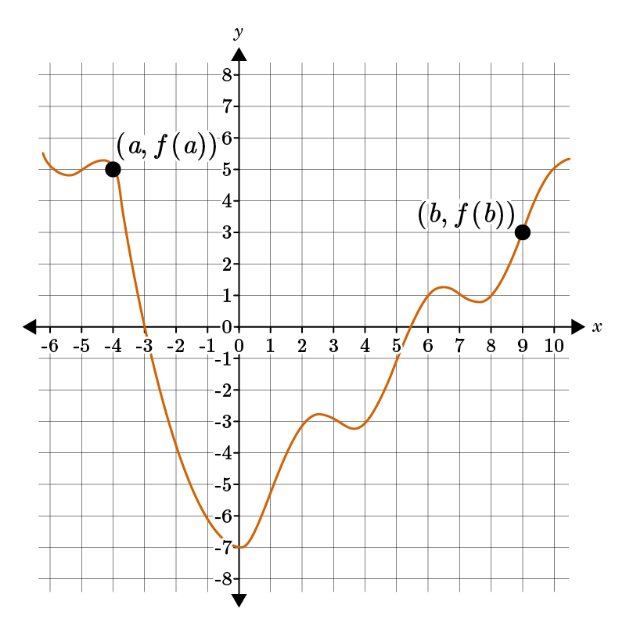
Linear Function | An equation of a form in which the variables appear only in the first degree, are multiplied by constants, and are combined only by addition and subtraction. | Function: $$f\left(x\right)=mx+b$$  Equation (slope-intercept form): $$y=mx+b$$  $$m=$$slope or rate of change  $$b=$$y-intercept  $$x=$$independent variable  $$f\left(x\right) or y =$$ dependent variable
Quadratic Equation | A quadratic equation is a two-degree polynomial that creates a parabola when graphed. | Standard Form: $$y=ax^{2}+bx+c$$  Where a, b, and c are real numbers and $$a≠0$$  Vertex Form: $$y=a{\left(x−h\right)}^{2}+k$$  - Vertex: (h, k)  - Axis of Symmetry: x = h
Vertex Formula | When a quadratic equation is in standard form, you cannot directly identify the vertex, so a formula is used instead. | Vertex Formula: $$x=−\frac{b}{2a}$$  Where b and a are values taken from the quadratic equation in standard form: $$y=ax^{2}+bx+c$$
Key Features of a Parabola | When you plot points using a quadratic equation, the graph is a parabola. It is shaped like an upward or downward U.  There are four key parts of a parabola: the axis of symmetry, the vertex, the x-intercepts (zeros), and the y-intercept. | 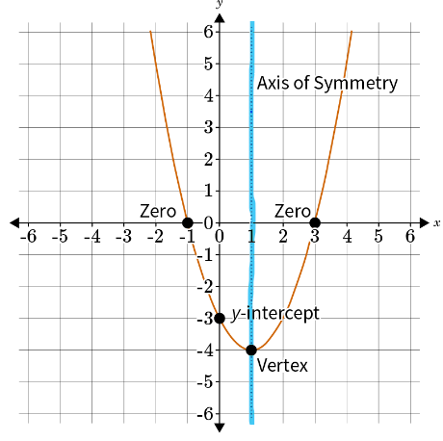
Exponential Function | Exponential functions are used to model growth and decay such as bacteria, population, interest, and depreciation. | Exponential Function: $$f\left(x\right)=a{\left(b\right)}^{x}$$  Exponential Equation: $$y=a{\left(b\right)}^{x}$$  $$a=$$initial value  $$b=$$multiplier/ growth or decay factor  The multiplier is calculated from the rate, r.  Growth Factor: $$b=1+r$$  Decay Factor:
Exponent Rules | Exponent rules are laws that are used for simplifying expressions with exponents. | 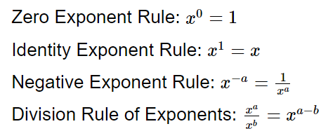
Key Features of Exponential Graphs | The graph of an exponential function may model growth or decay and shows a quick increase or decrease. | - The y-intercept is at the point $$\left(0,a\right)$$, where $$a$$is the initial value.  - The line $$y=0$$is the horizontal asymptote.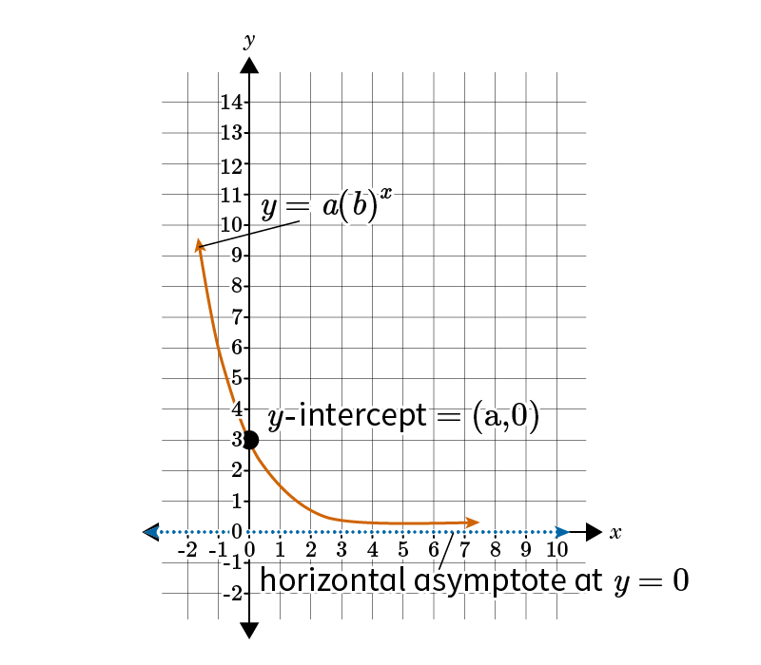
Square Root Function | A function that contains a square root with the independent variable under the square root. | Basic Square Root Function: $$f\left(x\right)=\sqrt{x}$$  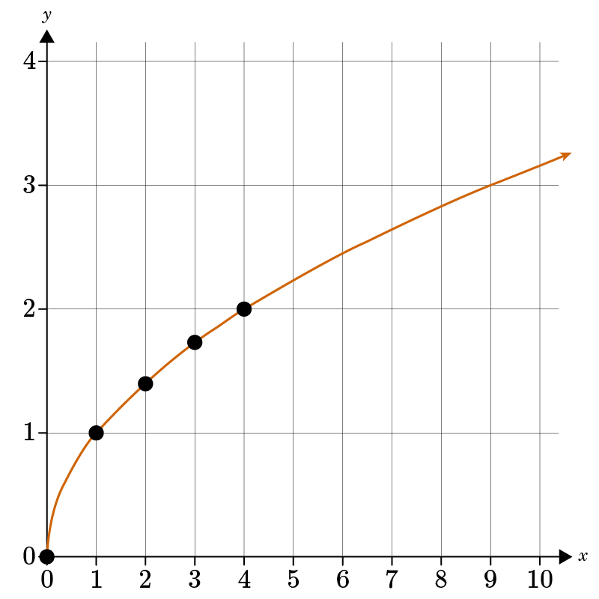
Cube Root Function | A function that contains a cubed root with the independent variable under the cubed root. | Basic Cube Root Function: $$f\left(x\right)=\sqrt[3]{x}$$  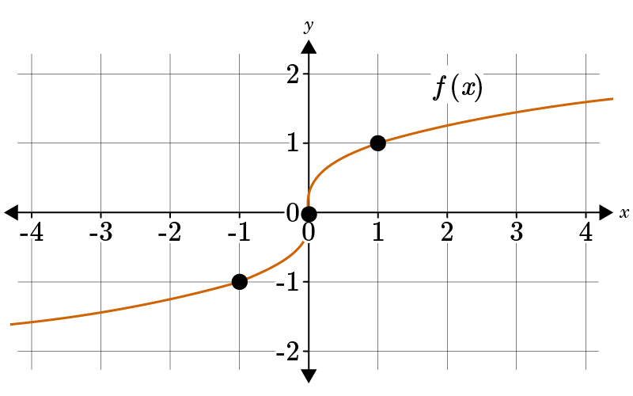  Cube Root Function: $$y=a\sqrt[3]{\left(x−h\right)}+k$$  - Turning Point: (h, k)

