Portfolio Answer Key: Storytelling with Functions

**Storytelling with Functions**

*Please review document prior to using with students.

Use the Storytelling with Functions portfolio worksheet to record your answers to the following questions. When you are finished, save your worksheet with your answers and submit it for a portfolio grade.

Where indicated, draw figures on a blank sheet of paper or on a sheet of graph paper. Be sure to label each sheet so that your teacher knows which answer goes with which question. You can scan these figures and submit them as individual documents with your portfolio worksheet, or you can take pictures of them and insert the pictures on the portfolio worksheet.

**Question 1**

On your own sheet of paper, copy and complete the following table. Summarize what you know about parent functions in the table.

|  |  |  |  |
| --- | --- | --- | --- |
| Parent Function | Equation | Sketch of the graph | Key Features and/or Distinguishing Characteristics |
| Linear | $$f\left(x\right)=x$$ |  | All functions within the linear function family create lines when graphed.  This function as a slope intercept equation: $y=mx+b$ . |
| Quadratic | $$f\left(x\right)=x^{2}$$ |  | All functions within the quadratic function family create parabolas that open upwards or downwards when graphed. |
| Cubic | $$f\left(x\right)=x^{3}$$ |  | All functions within the cubic function family create vertical S-sharped curves when graphed.  Cube and cube root functions are inverses of one another. |
| Exponential | $f\left(x\right)=b^{x}$ for $b>0$ and $b≠1$ |  | All functions within the exponential function family have a horizontal asymptote and show growth or decay that is increasing as $x$ increases when graphed. |
| Logarithmic | $f\left(x\right)=\log_{b}{x}$ (b is the base and $b>0$) |  | All functions within the logarithmic function family have a vertical asymptote and show growth or decay that is decreasing as $x$ increases when graphed. |
| Square Root | $$f\left(x\right)=\sqrt{x}$$ |  | All functions within the square root function family look like half parabolas on their sides when graphed. |
| Cube Root | $$f\left(x\right)=\sqrt[3]{x}$$ |  | All functions within the cube root function family create horizontal S-sharped curves when graphed.  Cube and cube root functions are inverses of one another. |
| Sine | $$f\left(x\right)=\sin{x}$$ |  | All graphs within the sine function family resemble a wave that goes up and down at regular intervals. |
| Cosine | $$f\left(x\right)=\cos{x}$$ |  | All graphs within the cosine function family resemble a wave that goes up and down at regular intervals.  Any function within the cosine function family could also be written as a function within the sine function family. |
| Tangent | $$f\left(x\right)=\tan{x}$$ |  | All graphs within the tangent function family resemble repeating S-shaped curves separated by vertical asymptotes. |

**Question 2**

On January 1, Lydia tells her little brother that every day for 14 days she will give him some coins to put in his piggy bank. To determine how much money she will give her brother on any given day, she cubes the number that is one less than the day of the month. Then, she adds five. Lydia gives her brother this number of cents.

1. Model this scenario with a sequence. Then, model the sequence with a function.

The amount of money Lydia gives on day ($n$) can be represented by: ${(n-1)}^{3}+5$

The sequence modeled as a function is: $f\left(n\right)={(n-1)}^{3}+5$

1. What is a realistic domain for this scenario?

Lydia gives her brother money for 14 days, starting from January 1. Therefore, the domain for this function is the set of integers from 1 to 14.

1. Use your function to determine how much Lydia will put into her brother’s piggy bank on the final day.

$$f\left(14\right)={(14-1)}^{3}+5$$

$$f\left(14\right)={13}^{3}+5$$

$$f\left(14\right)=2197+5$$

$$f\left(14\right)=2202$$

Lydia will put 2,202 cents into her brother’s piggy bank on the final day.

**Question 3**

A small object is dropped from the top of a cliff. A measuring device on the object records the distance fallen every second. The following table shows the results for the first 6 seconds.

|  |  |  |  |  |  |  |  |
| --- | --- | --- | --- | --- | --- | --- | --- |
| Time (seconds) | 0 | 1 | 2 | 3 | 4 | 5 | 6 |
| Distance Fallen (meters) | 0 | 4.9 | 19.6 | 44.1 | 78.4 | 122.5 | 176.4 |

1. Model this scenario with a function. Explain how you chose which type of function to use.

The distance fallen is increasing at an accelerating rate. This suggests that the relationship between time and distance is quadratic. The table below showing the consistent 2nd difference confirms the relationship between time and distance is quadratic.

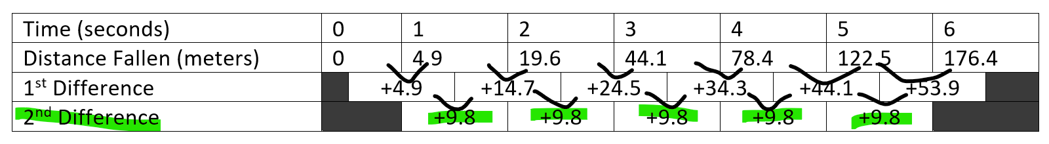

$$d\left(t\right)=4.9\left(t^{2}\right)$$

$t$ is the time in seconds

The function can be confirmed by using the data in the table and function $d\left(t\right)=4.9\left(t^{2}\right)$

For $t=0$: $d\left(0\right)=4.9\left(0^{2}\right)=0$ meters

For $t=1$: $d\left(1\right)=4.9\left(1^{2}\right)=4.9$ meters

For $t=2$: $d\left(2\right)=4.9\left(2^{2}\right)=19.6$ meters

For $t=3$: $d\left(3\right)=4.9\left(3^{2}\right)=44.1$ meters

For $t=4$: $d\left(4\right)=4.9\left(4^{2}\right)=78.4$ meters

For $t=5$: $d\left(5\right)=4.9\left(5^{2}\right)=122.5$ meters

For $t=6$: $d\left(6\right)=4.9\left(6^{2}\right)=176.4$ meters

Since the results match the data in the table, it is confirmed that the function $d\left(t\right)=4.9\left(t^{2}\right)$ accurately models the scenario.

1. Sketch a graph that highlights the key features of the scenario. As you create your graph, consider the domain for this scenario.

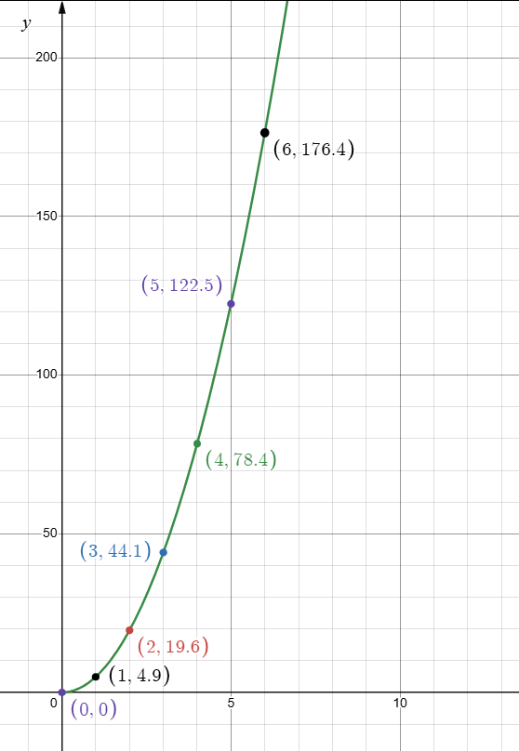

The domain is all x values greater than zero.

1. Write a question about this situation that could be answered with the help of your function and/or graph. Then, provide the answer to the question.

Question: How far will the object have fallen after 8 seconds?

Answer: Use the function $d\left(t\right)=4.9\left(t^{2}\right)$ to solve the problem.

$d\left(8\right)=4.9\left(8^{2}\right)=313.6$ meters

After 8 seconds, the object will have fallen 313.6 meters.

**Question 4**

Aiden and Mila are each growing bacteria in a lab. Aiden’s bacteria grows according to the function $a\left(t\right)=4∙3^{\frac{t}{2}},$ where $a(t)$ is the number of bacteria after $t$  hours. The growth of Mila’s bacteria is shown in the following graph:

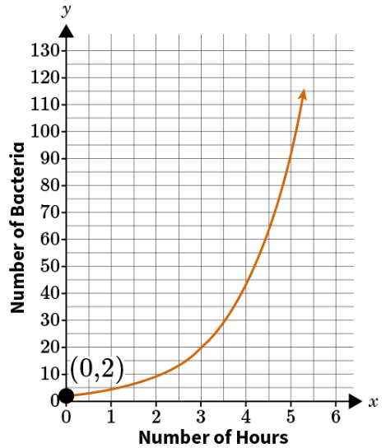

1. Who starts out with more bacteria? Explain how you know.

|  |  |
| --- | --- |
| Aiden | Mila |
| $$a\left(t\right)=4∙3^{\frac{t}{2}}$$ $$a\left(0\right)=4∙3^{\frac{0}{2}}$$ $$a\left(0\right)=4∙1$$ $$a\left(0\right)=4$$ | The graph shows Mila started with 2 bacteria. |
| Aiden started with 4 bacteria, which is more than Mila’s 2 bacteria. | Mila started with 2 bacteria. |

1. Who has more bacteria after 5 hours? Explain how you know.

|  |  |
| --- | --- |
| Aiden | Mila |
| $$a\left(t\right)=4∙3^{\frac{t}{2}}$$ $$a\left(5\right)=4∙3^{\frac{5}{2}}$$ $$a\left(t\right)=4∙3^{2.5}$$ $$a\left(5\right)=62.35$$ | The graph shows Mila has about 90 bacteria at 5 hours. |
| Aiden has 62.35 bacteria at 5 hours. | Mila has more bacteria than Aiden at 5 hours. |

**Question 5**

A computer program is gradually increasing the area of a square on the screen. Every second, the area of the square increases by 1 ${cm}^{2}$. The *x*-values in the following table represent the time in seconds. The y-values represent the approximate side length of the square shown on the screen at that time.

|  |  |
| --- | --- |
| *x* (time in seconds) | *y* (side length of square in centimeters) |
| 0 | 0 |
| 1 | 1 |
| 2 | 1.4142 |
| 3 | 1.7321 |
| 4 | 2 |
| 5 | 2.2361 |

1. Find the average rate of change between x=1 and x=3. Interpret your result.

Formula: $\frac{Δy}{Δx}=\frac{y_{2}-y_{1}}{x_{2}-x_{1}}$

$$\frac{Δy}{Δx}=\frac{1.7321-1}{3-1}$$

$$\frac{Δy}{Δx}=\frac{.7321}{2}$$

The average rate of change between x=1 and x=3 is 0.36605 cm per second.

The side length of the square increases by approximately 0.36605 cm per second between x=1 and x=3.

1. Find the average rate of change between x=3 and x=5. Interpret your result.

Formula: $\frac{Δy}{Δx}=\frac{y_{2}-y_{1}}{x_{2}-x_{1}}$

$$\frac{Δy}{Δx}=\frac{2.2361-1.7321}{5-3}$$

$$\frac{Δy}{Δx}=\frac{.504}{2}$$

The average rate of change between x=3 and x=5 is 0.252 cm per second.

The side length of the square increases by approximately 0.252 cm per second between x=3 and x=5.

1. As time goes on, what is happening to the average rate of change over intervals of two seconds? Explain.

As time progresses, the average rate of change of the side length is decreasing. The change in side length becomes smaller as the area gets larger.

**Question 6**

Between 2000 and 2020, the population of Mathville could be modeled by the function $m\left(t\right)=100\sqrt[3]{t}$, where $m(t)$ is the number of people in Mathville and $t$ is the number of years since 2000. Between those same years, the population of Calcfield could be modeled by the function $c\left(t\right)=18t$.

1. On a coordinate plane, graph each function. Approximately where do the functions intersect? What does this point of intersection represent? Be sure to consider an appropriate domain for the functions as you make your graph.

The functions intersect at approximately (13, 236) indicating that the populations of Mathville and Calcfield are about the same in 2013 with 236 people each.

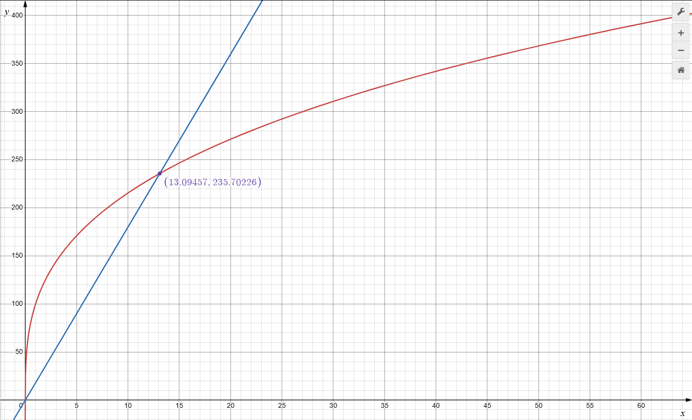

1. Write and solve an equation to algebraically confirm where the two functions intersect.

$$100\sqrt[3]{t}=18t$$

$$({100\sqrt[3]{t})}^{3}={(18t)}^{3}$$

$${100}^{3}t={18}^{3}t^{3}$$

$$1,000,000t=5832t^{3}$$

$$\frac{1,000,000t}{t}=\frac{5832t^{3}}{t}$$

$$1,000,000=5832t^{2}$$

Solve for $t^{2}:t^{2}=\frac{1,000,000}{5832}$

$$t^{2}=\sim 171.5$$

$$\sqrt{t^{2}}=\sqrt{171.5}$$

$$t=\sim 13.1$$

1. Write a few sentences comparing the relative populations of the cities over time.

From 2000 to 2013, the population of Calcfield grows linearly, while the population of Mathville grows more quickly initially but slows as time progresses due to the cubic root function. In 2013, the populations of both cities are roughly equal. After 2013, the population of Calcfield continues to grow linearly, while the population of Mathville continues to grow but at a decreasing rate compared to Calcfield. Therefore, after 2013, Calcfield's population will surpass and continue to exceed that of Mathville.

**Question 7**

Jada has some money saved in her savings account. Then, she starts a new job. She puts all the money she earns from her job in a checking account. She creates the following graph to show the total amount of money she will have saved over time.

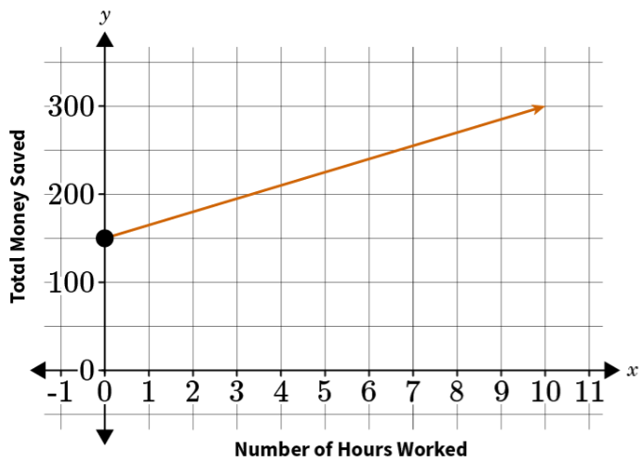

1. Build a function to represent the amount of money Jada has saved in her savings account over time.

Jada has a fixed amount of $150 in her savings account, which does not change over time. Therefore, the function representing the amount of money in her savings account over time is $S\left(t\right)=150$, where $S(t)$ represents the amount of money in her savings account and $(t)$ represents time in hours.

1. Build a function to represent the amount of money Jada has saved in her checking account over time.

From the information given, at t = 0 hours, Jada has $150 in total (which is all in her savings account). At t = 10 hours, Jada has $300 in total. This indicates that the additional $150 saved over the 10 hours is in her checking account.

We can use the two points (0, 150) and (10, 300) to determine the rate at which she is saving money in her checking account.

Rate of Change formula: $\frac{Δy}{Δx}=\frac{y_{2}-y_{1}}{x_{2}-x_{1}}$

$$\frac{Δy}{Δx}=\frac{300-150}{10-0}$$

$$\frac{Δy}{Δx}=\frac{150}{10}=15$$

Jada saves $15 per hour in her checking account. The function representing the amount of money in her checking account over time is $C\left(t\right)=15t$.

1. Build a function to represent the total amount of money Jada has saved over time in both accounts combined.

The total amount of money Jada has saved over time in both accounts combined is the sum of the money in her savings account and her checking account.

The function representing the total amount of money Jada has saved is $T\left(t\right)=S\left(t\right)+C(t)$ or $T\left(t\right)=15t+150$, where $T(t)$ represents the total amount of money saved and $(t)$ represents time in hours.

1. Write a question about this situation that could be answered with the help of your function and/or graph. Then, provide the answer to the question.

Question: How much money will Jada have saved after 20 hours of work?

Answer: After 20 hours of work, Jada will have $450 saved.

$T\left(t\right)=S\left(t\right)+C(t)$

$T\left(20\right)=150+15(20)$

$$T\left(20\right)=450$$

**Question 8**

**Philip has a goal of saving $3,000. The function $s\left(t\right)=500∙1.4^{t}$ represents the amount of money Philip has saved after $t$ months.**

1. **Build a function $r(t)$ to represent the amount of money Philip has left to save at $t$ months.**
$$r\left(t\right)=3000-(500({1.4}^{t}))$$

2. **Create a model to represent the scenario. Why did you choose the model you did? Use your own paper or graph paper if necessary.**

|  |  |  |
| --- | --- | --- |
| Months (t) | Amount saved s(t) | Amount left to save r(t) |
| 0 | $500 | $2500 |
| 1 | $700 | $2300 |
| 2 | $980 | $2020 |
| 3 | $1372 | $1628 |

The table of s(t) shows how Philip's savings grow exponentially over time.

The table of r(t) shows how the remaining amount he needs to save decreases over time, approaching zero as he gets closer to his goal of $3,000.

By visualizing these functions on a graph, we can better understand how quickly Philip is approaching his savings goal and how much he has left to save at any given time.

*(Students could also show a graph.)*