Linear & Exponential Sequences
Formula Sheet
Name | Definition | Formula
Arithmetic Sequence | An arithmetic sequence is a list of terms (numbers) that progress by adding or subtracting each term by the same amount each time, called the common difference. | For example, this arithmetic sequence has a common difference of 3.  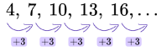  - Explicit Formula: $$a_{n}=a_{1}+\left(n−1\right)d$$  - Recursive Formula: $$a_{1}=first term$$, $$a_{n}=a_{n−1}+d$$  Where:  d = common difference  $$a_{1}$$= first term  $$a_{n}$$= the nth term  n = term number
Geometric Sequence | A geometric sequence is a list of terms (numbers) that progress by multiplying or dividing each term by the same amount each time, called the common ratio. | For example, this geometric sequence has a common ratio of 2.  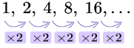  - Explicit Formula: $$a_{n}=a_{1}⋅r^{\left(n−1\right)}$$  - Recursive Formula: $$a_{1}=first term$$, $$a_{n}=r⋅a_{n−1}$$  Where,  d = common difference  $$a_{1}$$= first term  $$a_{n}$$= the nth term  n = term number
Function Notation | A way in which a function can be represented using symbols and signs read as “f of x”. Functions can be named with different letters other than f. | $$y=f\left(x\right)$$  For example:  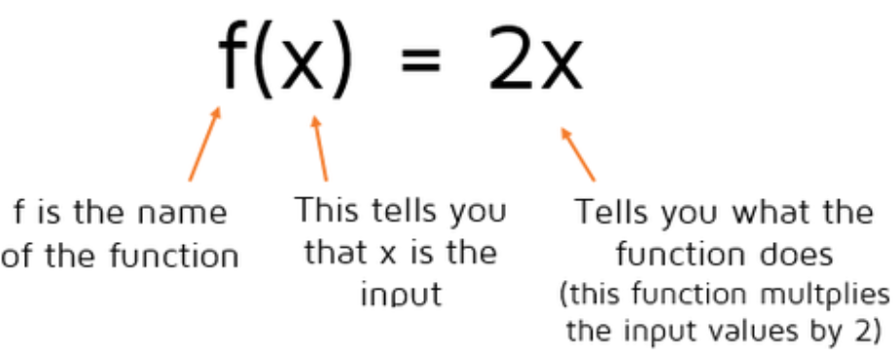
Linear Function | An equation of a form in which the variables appear only in the first degree, are multiplied by constants, and are combined only by addition and subtraction. | $$f\left(x\right)=mx+b$$  $$m=$$slope or rate of change  $$b=$$y-intercept  $$x=$$independent variable  $$f\left(x\right)=$$dependent variable
Slope Formula | The slope of a line is defined by the change in y coordinate with respect to the change in x coordinate of the line. | $$\frac{∆y}{∆x}=\frac{change in y}{chang in x}=\frac{y_{2}−y_{1}}{x_{2}−x_{1}}$$  Where $$\left(x_{1},y_{1}\right)$$ is the first point and $$\left(x_{2},y_{2}\right)$$ is the second point.
Exponential Function | Exponential functions are used to model growth and decay such as bacteria, population, interest, and depreciation. | $$f\left(x\right)=a{\left(b\right)}^{x}$$  $$a=$$initial value  $$b=$$multiplier/ growth or decay factor  The multiplier is calculated from the rate, r.  Growth Factor: $$b=1+r$$  Decay Factor: $$b=1−r$$
Key Features of Exponential Graphs | The graph of an exponential function may model growth or decay and shows a quick increase or decrease. | - The y-intercept is at the point $$\left(0,a\right)$$, where $$a$$is the initial value.  - The line $$y=0$$is the horizontal asymptote.