Additional Problems: Periodic Functions

**Phase Shifts**

**Some problems include the solution. Please remove before sharing with students.**

1. What is the phase shift of the function $f\left(x\right)=\cos{(x+\frac{π}{3})}$?

$π$

$\frac{π}{3}$

$-\frac{π}{3}$

$\frac{π}{2}$

**Solution: $-\frac{π}{3}$

1. What is the phase shift of the function $f\left(x\right)=\sin{(x-\frac{π}{4})}$?

$π$

$\frac{π}{4}$

$-\frac{π}{3}$

$\frac{π}{2}$

**Solution: $\frac{π}{4}$

1. What is the phase shift of the function $f\left(x\right)=\tan{(x+\frac{π}{6})}$?

$π$

$\frac{π}{6}$

$-\frac{π}{6}$

$\frac{π}{2}$

**Solution: $-\frac{π}{6}$

1. What is the function that correctly represents the graph of the sine function below?

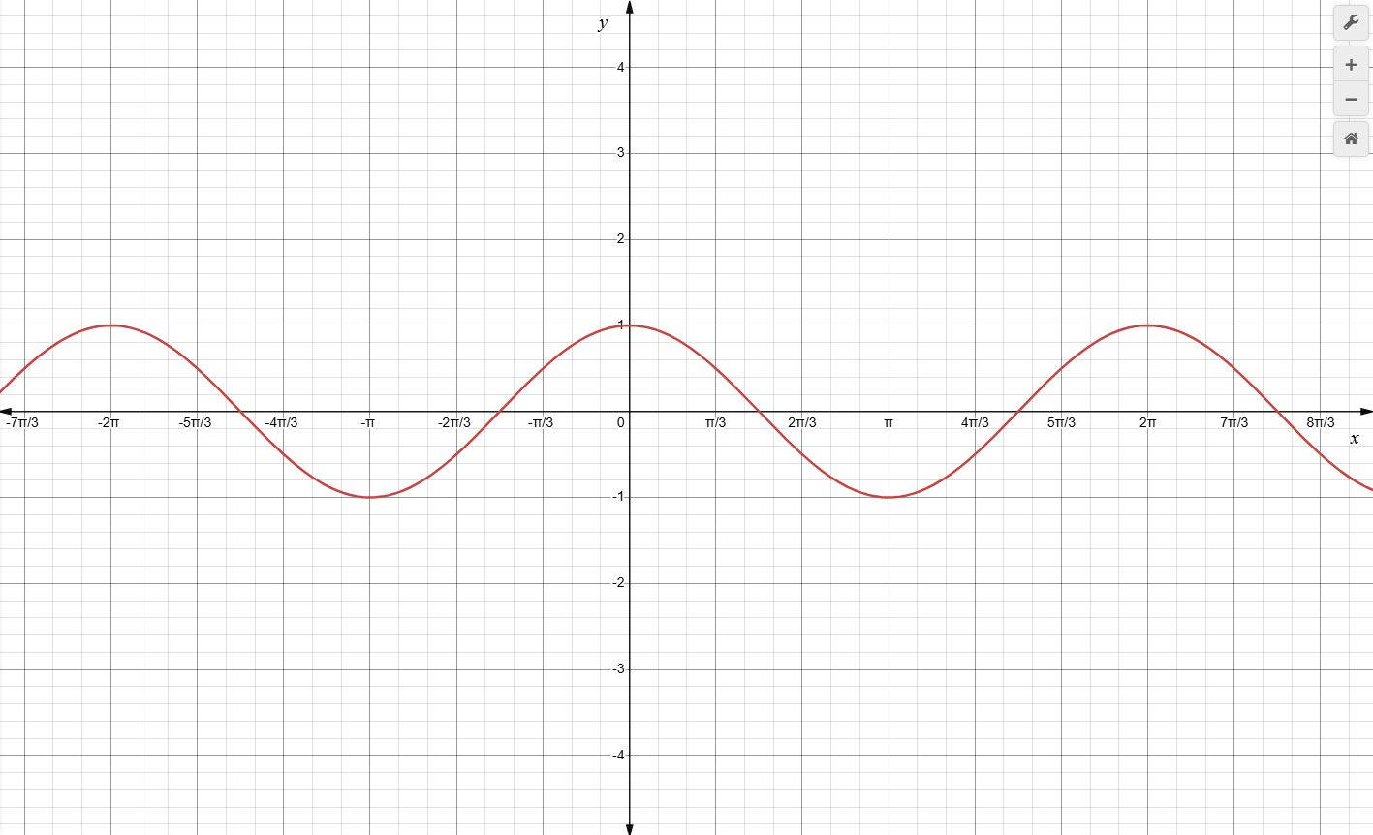

**Solution: $f\left(x\right)=sin⁡(x+\frac{π}{2})$

1. What is the function that correctly represents the graph of the sine function below?

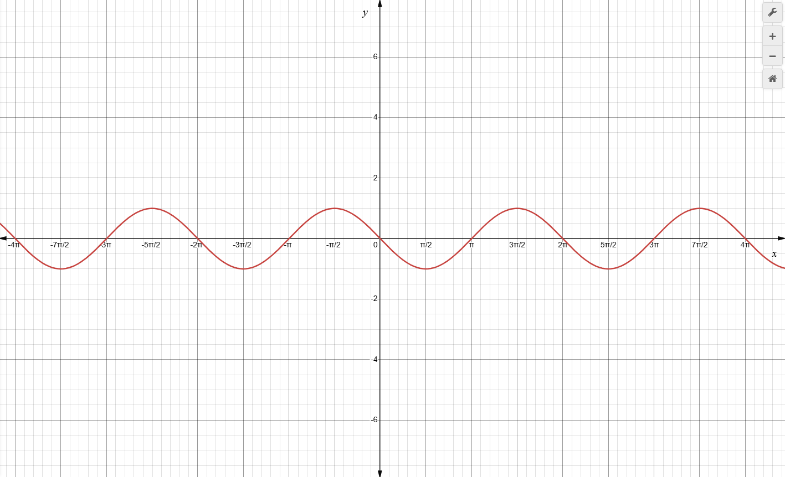

**Solution: $f9x)=sin⁡(x+π)$

1. What is the function that correctly represents the graph of the sine function below?

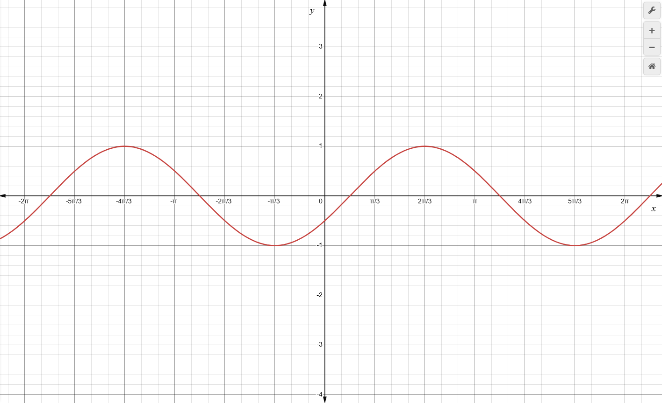

**Solution: $f\left(x\right)=sin⁡(x-\frac{π}{6})$

1. Describe how the graph of the function $f\left(x\right)=\cos{(x+\frac{π}{4})}$ differs from the graph of $\cos{x}$.

* It shifts the graph of $\cos{x}$ up by $\frac{π}{4}$ units.
* It shifts the graph of down by units.
* It shifts the graph of $\cos{x}$ to the right by $\frac{π}{4}$ units.
* It shifts the graph of $\cos{x}$ to the left by $\frac{π}{4}$ units.

**Solution: It shifts the graph of $\cos{x}$ to the left by $\frac{π}{4}$ units.

1. Describe how the graph of the function $f\left(x\right)=\sin{(x-\frac{π}{3})}$ differs from the graph of $\sin{x}$.

* It shifts the graph of $\sin{x}$ up by $\frac{π}{3}$ units.
* It shifts the graph of down by units.
* It shifts the graph of $\sin{x}$ to the right by $\frac{π}{3}$ units.
* It shifts the graph of $\sin{x}$ to the left by $\frac{π}{3}$ units.

**Solution: It shifts the graph of $\sin{x}$ to the right by $\frac{π}{3}$ units.

1. Describe how the graph of the function $f\left(x\right)=\tan{(x+\frac{π}{6})}$ differs from the graph of $\tan{x}$.

* It shifts the graph of $\tan{x}$ up by $\frac{π}{6}$ units.
* It shifts the graph of down by units.
* It shifts the graph of $\tan{x}$ to the right by $\frac{π}{6}$ units.
* It shifts the graph of $\tan{x}$ to the left by $\frac{π}{6}$ units.

**Solution: It shifts the graph of $\tan{x}$ to the left by $\frac{π}{6}$ units.

1. Determine the equation of the sine function shown in the graph below.

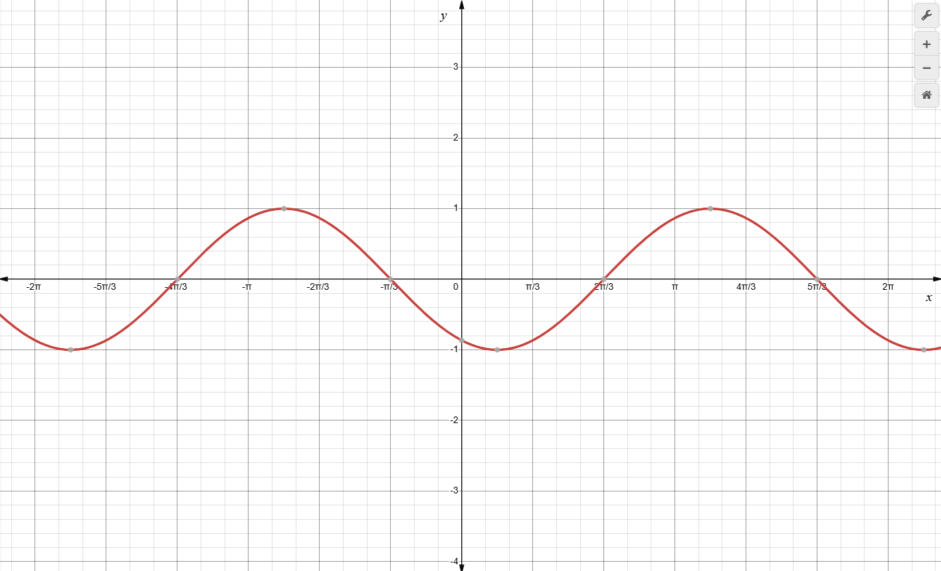

**Solution: $f\left(x\right)=sin⁡(x-\frac{2π}{3})$

1. Determine the equation of the sine function shown in the graph below.

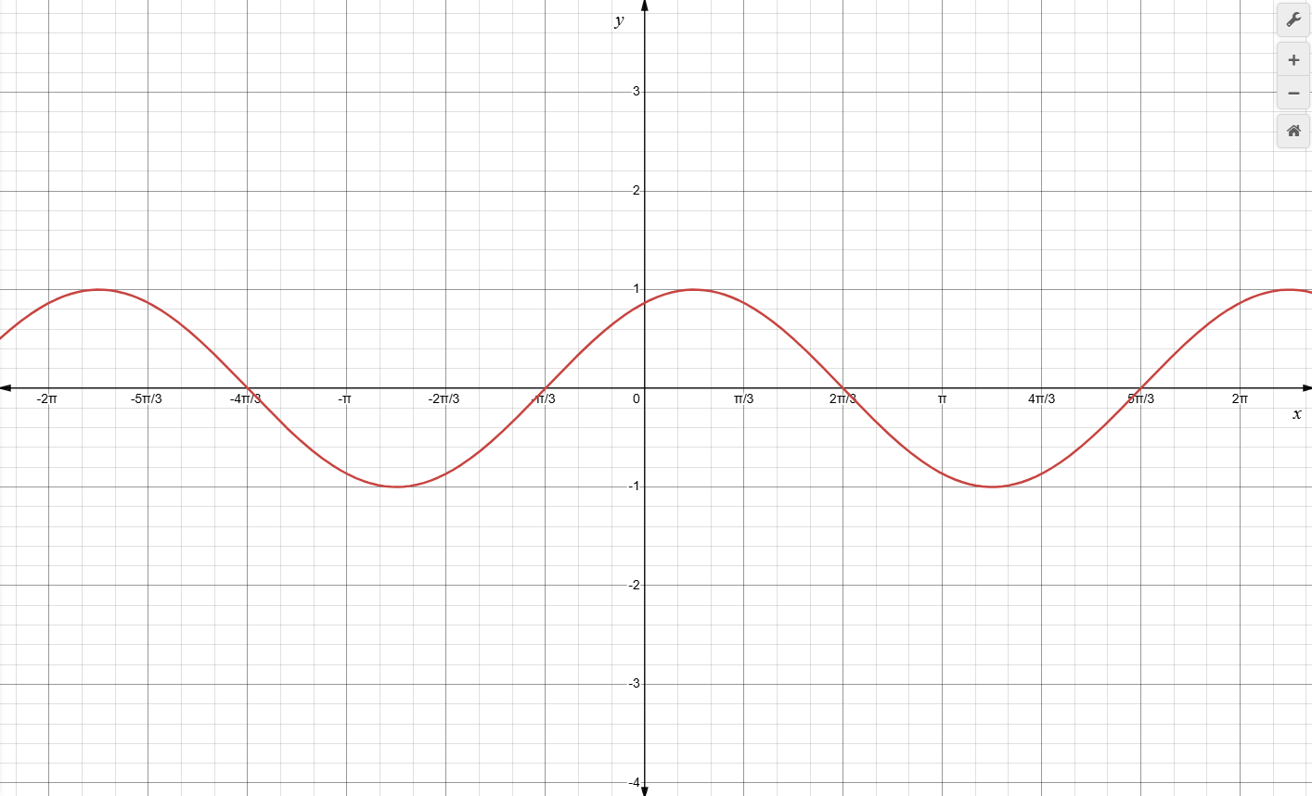

**Solution: $f\left(x\right)=sin⁡(x+\frac{π}{3})$

1. Determine the equation of the cosine function shown in the graph below.

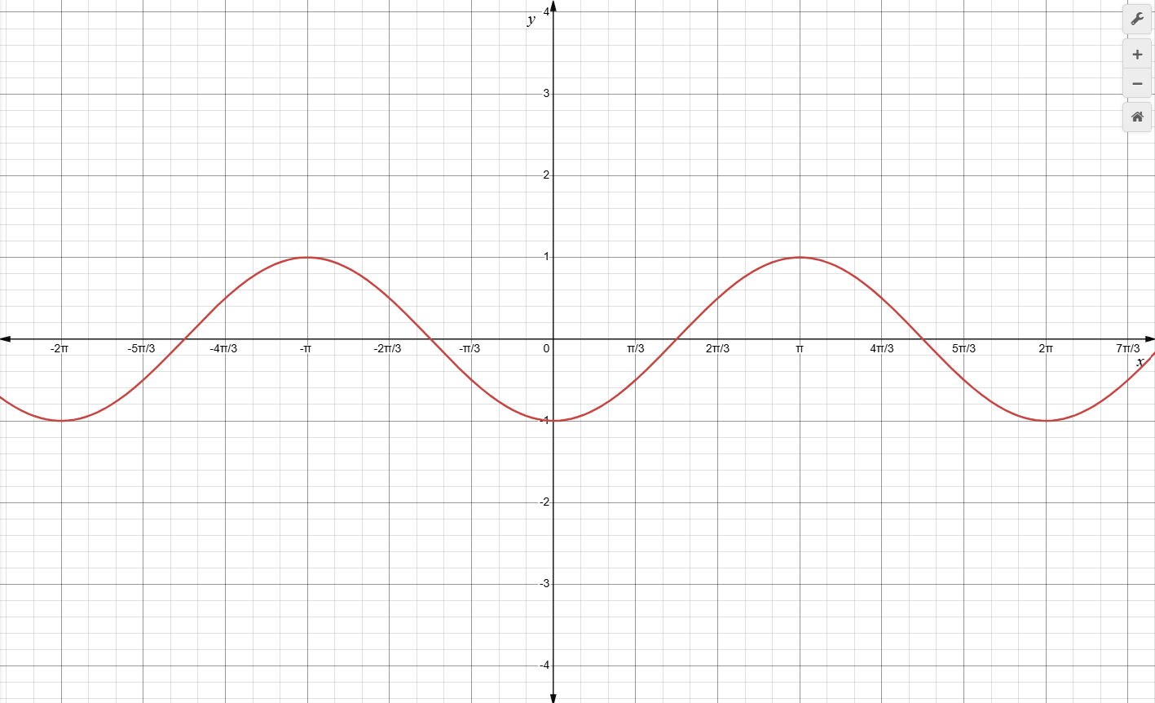

**Solution: $f\left(x\right)=cos⁡(x-π)$