Additional Problems: Periodic Functions

**Changes in Period & Frequency**

**Some problems include the solution. Please remove before sharing with students.**

1. What is the function of the graph below?

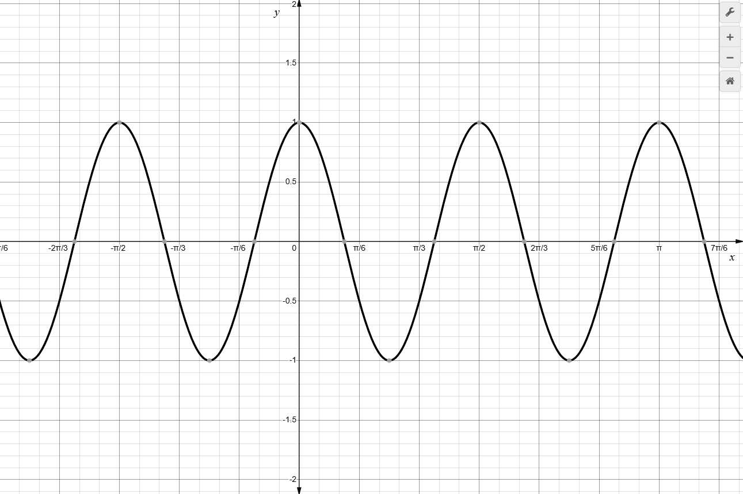

**Solution: $f\left(x\right)=cos⁡(4x)$

1. What is the function of the graph below?

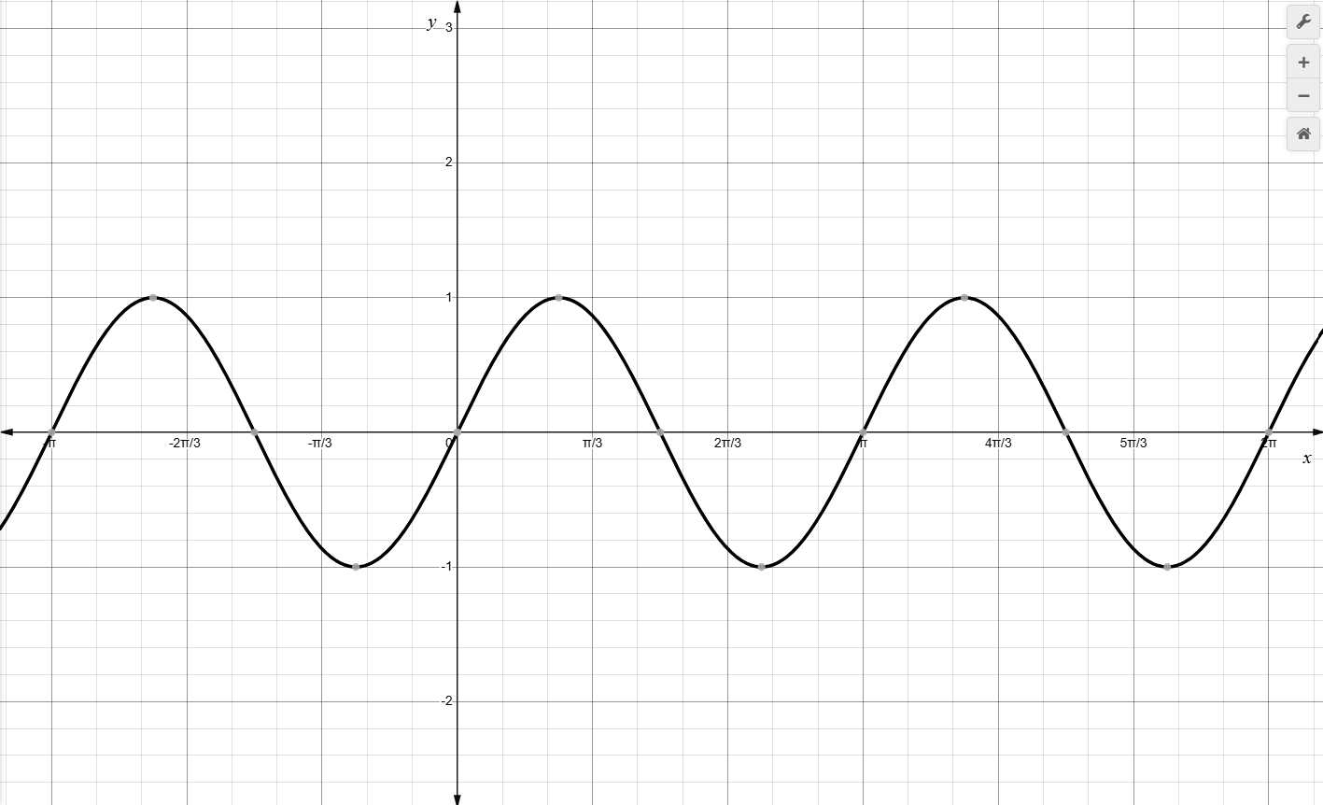

**Solution: $f\left(x\right)=sin⁡(2x)$

1. What is the function of the graph below?

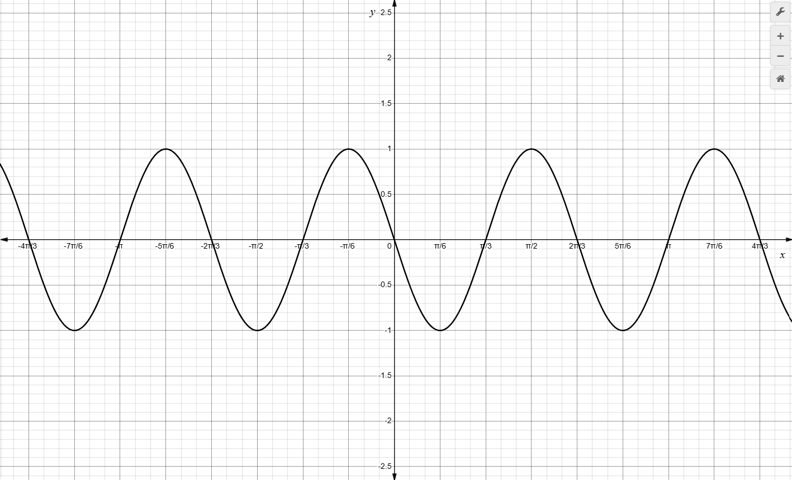

**Solution: $f\left(x\right)=-sin⁡(3x)$

1. What is the function of the graph below?

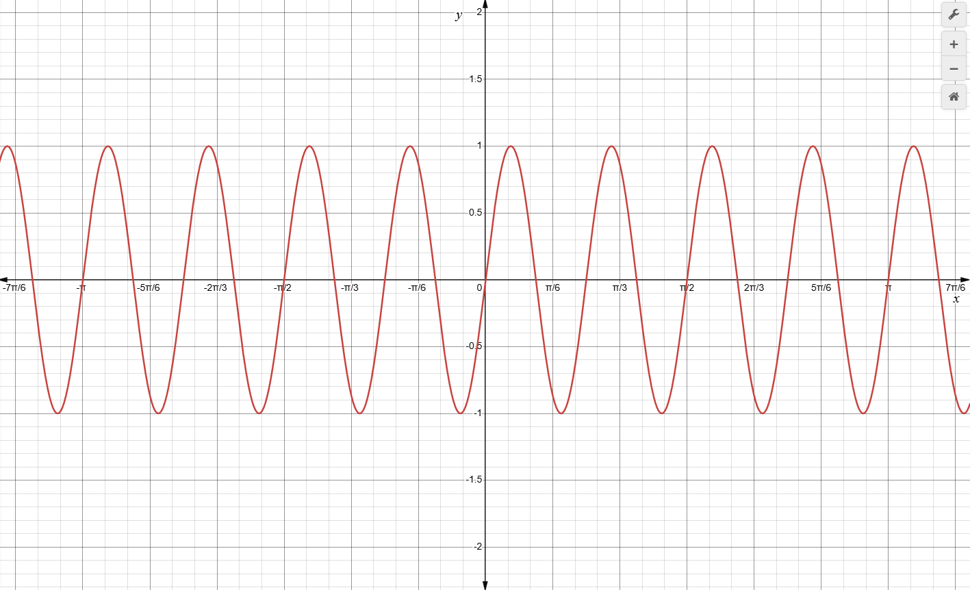

**Solution: $f\left(x\right)=sin⁡(8x)$

1. What is the equation of the trigonometric function in the graph?

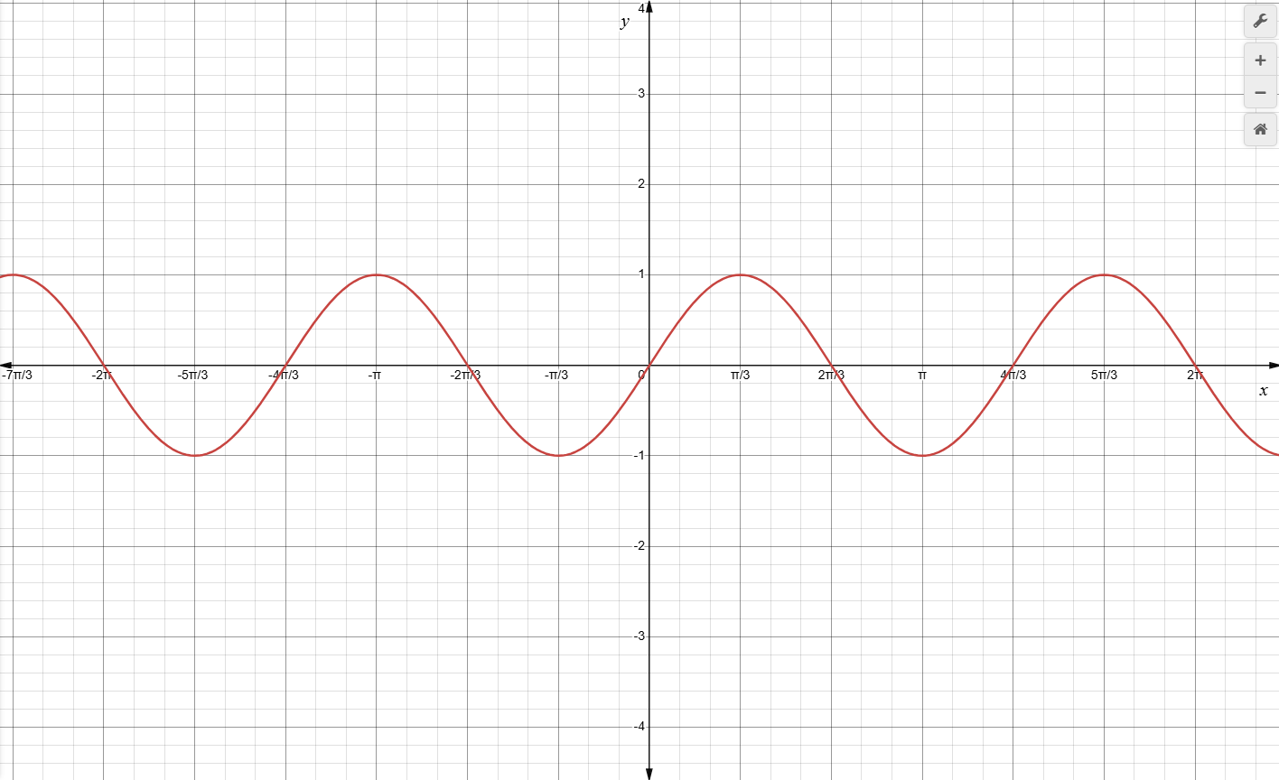

**Solution: $f\left(x\right)=\sin{\frac{3x}{2}}$

1. What is the equation of the trigonometric function of the graph below?

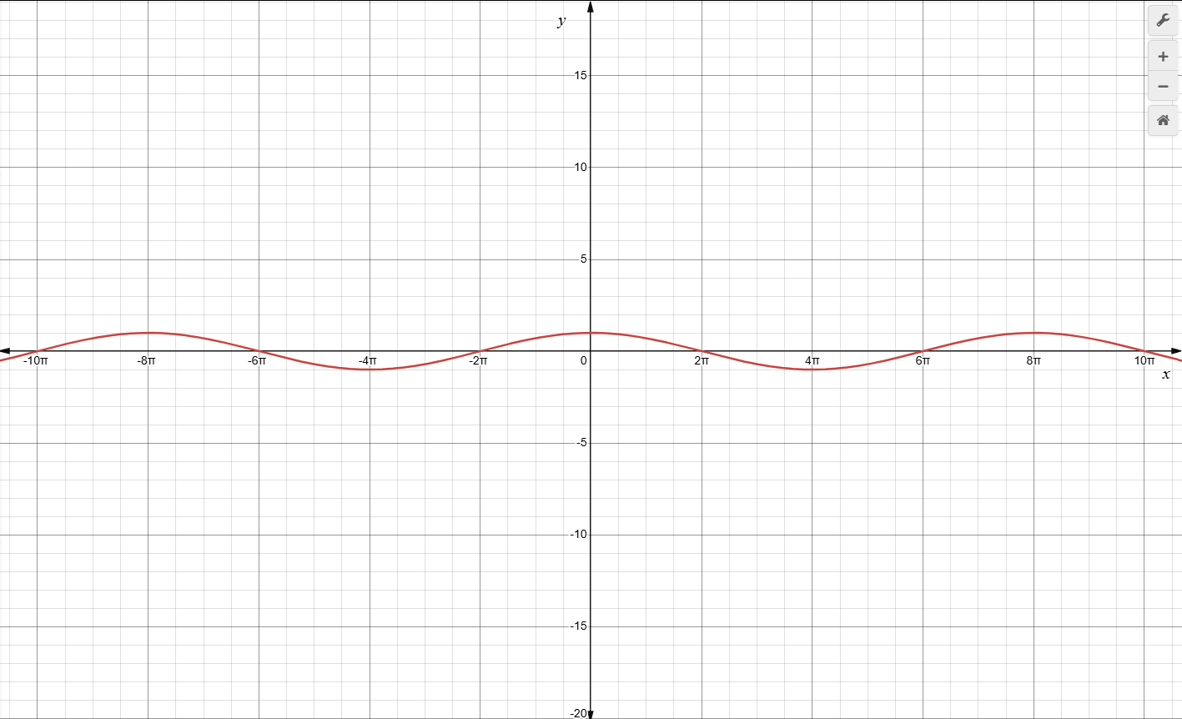

**Solution: $f\left(x\right)=cos⁡(\frac{x}{4})$

1. Describe the graph of the function $f\left(x\right)=\sin{(3x)}$ as a transformation of its parent function.

* The graph is a horizontal stretch by a factor of 3.
* The graph is a horizontal compression by a factor of $\frac{1}{3}$.
* The graph is a vertical stretch by a factor of 2.
* The graph is a vertical compression by a factor of $\frac{1}{3}$.

**Solution: The graph is a horizontal compression by a factor of $\frac{1}{3}$.

1. Describe the graph of the function $f\left(x\right)=\tan{(4x)}$ as a transformation of its parent function.

* The graph is a horizontal stretch by a factor of 4.
* The graph is a horizontal compression by a factor of $\frac{1}{4}$.
* The graph is a vertical stretch by a factor of 4.
* The graph is a vertical compression by a factor of $\frac{1}{4}$.

**Solution: The graph is a horizontal compression by a factor of $\frac{1}{4}$.

1. Which is an equation of the sine function that has a period of $\frac{π}{3}$?

$f\left(x\right)=\sin{(\frac{x}{3})}$

$f\left(x\right)=\sin{(3x})$

$f\left(x\right)=\sin{x}$

$f\left(x\right)=sin({\frac{x}{6})}$

**Solution: $f\left(x\right)=\sin{(3x})$

1. Which is an equation of the tangent function that has a period of $\frac{π}{4}$?

$f\left(x\right)=\tan{(\frac{x}{4})}$

$f\left(x\right)=\tan{(4x)}$

$f\left(x\right)=\tan{x}$

$f\left(x\right)=\tan{(\frac{x}{2})}$

**Solution: $f\left(x\right)=\tan{(4x)}$